Introducing the Modern Workplace

Student name:
Word count:

Table of Contents
1.0 Introduction 3
2.0 Discussion 4
2.1 Ways by which leadership style shape the behaviour of employees 4
2.2 Ways by which management style shape the behaviour of employees 5
2.3 Responsibilities and functions of line manager in meeting the needs 7
3.0 Conclusion 7
References: 9

1.0 Introduction
The aim of the essay is to provide a detailed analysis of the different ways through which the management and leadership styles shapes the behaviour of the employees in Tesla Company. it also aims to reflect on the responsibilities and functions of a line manager in meeting the requirements of Tesla Company.
Leadership and management styles have a huge impact on the changes in the attitude of the employees. It has been analysed that leadership can be termed as the process of providing motivation to a particular team or group for making them act properly for the obtainment of the desired objective. In the business field, the style of leadership can be defined as the methods through which a team leader directs their colleagues and workers to follow a particular strategy for meeting the goals of the organization. On the other hand, management is defined as the procedure of decision-making, planning, leading, motivating, controlling and organising the physical, financial and information resources of a company along with resources of humans for reaching to goal effectively and efficiently.
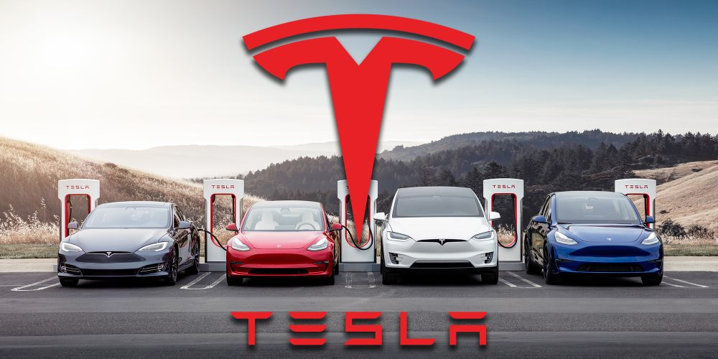
Figure 1: Tesla Company
(Source: tesla, 2021)
Tesla is the automobile company of America that deals with the manufacture and sales of electric vehicles and clean energy. It also deals with the selling of products like solar panels, electric cars, battery energy storage service, solar roof tiles and others. The company has its headquarter in Palo Alto, California and has annual revenue of 3154 crores (tesla, 2021). On the other hand, the current CEO of this company is Elon Musk and was founded in July 2003 by Marc Tarpenning and Martin Eberhard. The total numbers of employees that are working in this company are 70757.
The essay will provide a detailed discussion about the various leadership styles of Tesla that helps in shaping the behaviour of the employees. Moreover, it would also reflect knowledge about the management styles that are being adopted by Tesla along with its role in shaping the attitude of the employees that are working in the organisation. On the other hand, it would also give information about functions and responsibilities of line managers in meeting the needs. At last, it will provide a suitable conclusion about the overall lessons that had been learned from this study

2.0 Discussion

2.1 Ways by which leadership style shape the behaviour of employees
As per Chorbadzhiyska and Mironova (2021), the leadership styles of Elon Musk seem to be very aggressive and energetic, which had helped the business organisation in gaining large innovation. Moreover, it also reflects the creation of new models of electric cars with the latest facilities that he and his team had brought into existence. It has also been identified that the leadership styles that are adopted by Elon Musk are the transformational leadership style and democratic leadership style. The adoption of the transformational leadership style has created a huge impact on the behaviour and thinking of the employees. This is evident from the fact that it generates development and presence of innovation in the skills of the employees, thereby helping the organisation in achieving higher productivity and performing better. Thus, it can be said that it creates a drastic change in the outlook and thinking of the employees by making a more rational, scientific and logical approach.
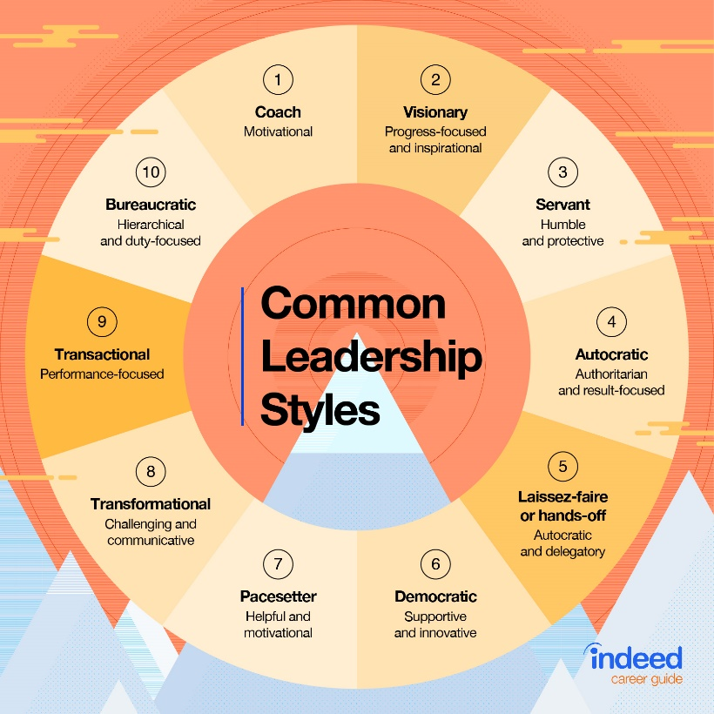
Figure 2: Leadership Styles
(Source: indeed, 2021)
On the other hand, it also builds a large competitive atmosphere and market domination for the rival companies. Thus, it can be said that the transformational leadership of Elon Musk not only generates technological and digital transformation in Tesla's electric cars and energy manufacturing but also leads to creation of a huge positive transformation in the outlook and vision of the employees too. The transformational leadership style that is adopted by the CEO Elon Musk helps the employees in gaining motivation for better efficiency and performance. Moreover, it also assists them in receiving respect and values from the senior managers and team leaders (Khan, 2021). Additional to this, transformational leadership includes everything related to the development of the new process through which the operational activities of the business could be run. This is evident from the fact that employees under the leadership of Elon Musk are being capable to generate individually the new process through their assigned tasks related to production of cars that could be completed within the deadline. Hence, it can be said that the employees' ability to maintain effective management of the time along with generating a better quality of their service to the organisation so that the company could achieve their objective.
The main cause behind the adoption of transformational leadership by Elon Musk is the aggressive attitude that he adopts for bringing innovation through adding more features to the existing modern cars. On the other hand, the democratic leadership style that is being followed by him seems to be very beneficial to the employees. This is because it provides the employees with a chance to express their views about innovative steps that are going to be taken by the team leaders including Elon Musk. Moreover, it also gives them the opportunity to display their talent, skills and ability to the team leaders and managers (Agnihotri and Bhattacharya, 2019). Hence, it can be said that the employees can have a good scope of obtaining higher positions due to the democratic form of leadership style that is being adopted by Elon Musk. Moreover, it also creates a sense of attachment among the employees for the organisation thereby changing their behaviour through increment in their dedication towards the work that is being assigned to them by their respective team leaders.

2.2 Ways by which management style shape the behaviour of employees
The management style tends to create a large impact not only on the productivity and sales performance of a company but also generates a huge influence on employees' behaviours and way of thinking. It has been observed by Saint-Martin, (2019) that the management style of Tesla was previously very autocratic in nature that led to poor management of the manufacturing works and performance of the employees. Moreover, it also created huge dissatisfaction among the employees and workers of Tesla due to misbehaviour and the dictatorial attitude of the senior manager towards them. This also led to misunderstanding and ego issues between the employees and managers of this organisation because of the hierarchical approach of authority along with existence of only single-way communication to the employees from the managers. This also reveals that autocratic management style tends to lead to poor performance of employees along with lack of trust. Thus, it created a large negative impact on the behaviour of the employees in the sense that it made them lose their interests in engaging in deep. Moreover, the operational activities of the organisation along go downfall along with degradation of their quality of performance. Moreover, as per Tsankova et al. (2017), it also led to a generation of outdated thinking among the employees in regards to the manufacturing of Tesla cars thereby, restricting their innovative power in all sense. Thus, the behaviour of employees became more frustrating and depressed that had a direct effect on their productivity.
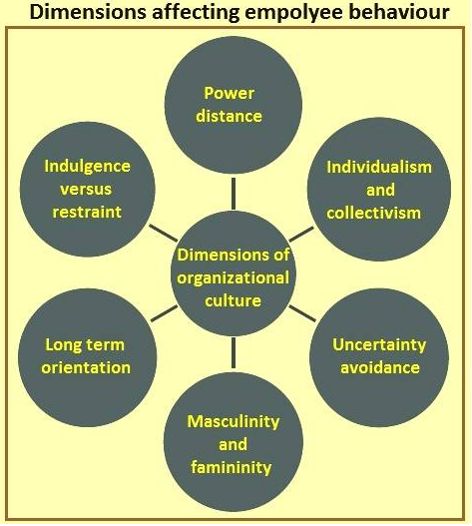
Figure 3: Dimensions affecting employee behaviour
(Source: Satyendra, 2020)
However, after the arrival of Elon Musk as the new CEO of Tesla Company, all the managers of different departments including production, sales and finance started to follow and practise a democratic management style. This created a very positive change in the behaviour of the employees of this organisation in the sense that they got the chance to express their thoughts and opinions about the new models of normal and electric cars that are going to be produced and launched in the market by Elon Musk. Moreover, their behaviour with the managers including Elon Musk seems to be very decent and ethical due to the start of two ways of communication from top to bottom and vice versa. This also led to a better understanding of each other's desires and thinking between the CEO Elon Musk and employees or engineers that make the cars for this company (Fernandez Garces, 2018). Hence, it can be said that a consultative form of management takes place under this democratic process that generates utilisation of this style in a specialised zone where recommendation and support of experts are required for the management to create informed decisions. It changes the behaviour of the employees in the sense that it makes them responsible and committed due to achievement of higher experience from the car production-based activities. The employees also gain huge knowledge about how to manage any critical and unwanted incidents that take place while making the electric cars like any minor accidents to the engineers or while working as a part of a multicultural workforce. Thus, it can be said that the overall performance of the employees has been improved due to well-defined recognition of their hard work along with feedback of constructive nature from the managerial perspective.

2.3 Responsibilities and functions of line manager in meeting the needs
As per Buhusayen et al. (2021), the line managers of Tesla have a large number of responsibilities for meeting the needs of Tesla such as they are the ones who would have to make recruitment of the right candidates for the post of the organisation. Moreover, the line managers of Tesla make a deep review of the progress of the manufacturing activities. It also looks after making a review of the increase in efficiency in performance of the employees too. On the other hand, it has also been identified that line managers create direct contact with the workers along with giving them thought and recommendation about the way through which planning related to production and marketing are to be executed. Another responsibility of the line managers of Tesla is that they have to ensure complete control and regulation in the resources of the organisation so that nobody could exploit it for their personal and illegal agenda (Russell et al., 2018). Moreover, they are also needed to check whether each employee is in compliance or not with the legislation and policies of the Tesla Company. It has been analysed that the line manager of this company makes daily meetings with the employees to discuss the progress that has been achieved in car production.
The main function of the line manager of Tesla is to make thorough scrutiny of documents and education qualification for final selection and recruitment of suitable candidates. On the other hand, they are also needed to provide on-board training to the newly selected candidates so that they could be able to habituate with the tasks or jobs for which they have been chosen. It was also observed by Brewster and Söderström (2017), that the line manager of Tesla performs the function of providing mentor and coaching to the employees so that they could be able to develop their skills. Moreover, the line manager of this company also has a function of encouraging employees through performance appraisal. On the other hand, the line manager of this organisation also needs to look after the well-being and health condition of the employees, thereby generating safety precautions. Another important function that they are required to perform is generating team connection and coordination for better working culture in the workplace (McCracken et al., 2017).

3.0 Conclusion
From the above study, it has been analysed that the leadership styles that had been adopted and practised by Elon Musk are transformational and democratic leadership styles. Moreover, it also helped in observing that the transformational leadership styles helped the employees in obtaining innovation and developmental skills thereby making manufacture and launch of high-tech innovative electric cars in the market. On the other hand, it also supported in understanding that the management style that is being followed by Elon Musk and other senior managers is democratic management styles which generated greater bonding and connection between the employees and them due to two-way channels of communication between top authority and workers. Moreover, the above study also helped in analysing responsibilities and functions of line managers like generating close links with workers, providing them guidance and ideas about the execution of the plan, understanding their issues and grievances and others. It also helped in evaluating that the line managers are also needed to enhance complete control of their resources so that they do not get exploited for illegal activities.

References:
Agnihotri, A. and Bhattacharya, S., 2019. Elon Musk: Saving the Fate of Tesla. Ivey Publishing.
Brewster, C. and Söderström, M., 2017. Human resources and line management 1. In Policy and practice in European human resource management (pp. 51-67). Routledge.
Buhusayen, B., Seet, P.S. and Coetzer, A., 2021. Front-Line Management during Radical Organisational Change: Social Exchange and Paradox Interpretations. Sustainability, 13(2), p.893.
Chorbadzhiyska, D. and Mironova, N., 2021. Communication As A Factor Of Leadership Style. Economics and Management, 18(1), pp.72-80.
Fernandez Garces, P., 2018. Tesla Motors and Lean Manufacturing.
Khan, M.R., 2021. A critical analysis of Elon Musk’s leadership in Tesla motors. Journal of Global Entrepreneurship Research, pp.1-10.
McCracken, M., O'Kane, P., Brown, T.C. and McCrory, M., 2017. Human resource business partner lifecycle model: exploring how the relationship between HRBPs and their line manager partners evolves. Human Resource Management Journal, 27(1), pp.58-74.
Russell, Z.A., Steffensen, D.S., Ellen III, B.P., Zhang, L., Bishoff, J.D. and Ferris, G.R., 2018. High performance work practice implementation and employee impressions of line manager leadership. Human Resource Management Review, 28(3), pp.258-270.
Saint-Martin, A., 2019. Elon Musk: the High-Stakes Gambler of Technological Capitalism.
tesla, 2021. About Tesla. [Online] Available at: https://www.tesla.com/about [Accessed on 19th June 2021]
Tsankova, R., Marinov, O., Durcheva, M. and Varbanova, E., 2017, November. Synergy Effect of the TeSLA Project in Management of Engineering Higher Education. In Proceedings of the 9th International Conference on Management of Digital EcoSystems (pp. 259-264).

