Name | Student Number | Date | Lecturer’s Name | Your score
Milan Miko | 2439928 | 27\06\2025 | Ellie Ristic | To be filled by the marker  ___/40
You will have 75 minutes to complete this assessment. It is divided into three sections: note-taking, paraphrasing and writing a paragraph.
---------------------------------------------------------------------------------------------------------------------
1. Take diagrammatic notes from the passage below using the space provided:

As a student you've got a lot on your plate - academic work, social life, work commitments, career plans, relationships and finances - sometimes stress can get in the way of this juggling act. When you recognise that you have become overwhelmed with stress, adopt a few strategies to help you manage your triggers more effectively. Those strategies could include exercising; you simply need to get your heart racing, for example by going for a brisk walk or a bike ride. Another suggestion is to try mindfulness, a relaxation technique originating in Buddhism. It is used by clinicians to improve patients' physical and mental health as it can significantly lower stress levels. Thirdly, why not speak to your friends and family - they know you best and care about you the most. What's more, studies suggest that socialising with a friend just once a week can reduce your stress levels and improve your mood as much as therapy or counselling. Simple time management techniques can also help you to feel more relaxed and focused. Try creating a written schedule, breaking your tasks down into manageable chunks, planning accordingly and allocating yourself time every day to relax or socialise. Finally, an obvious but often overlooked solution: get enough sleep, as no one functions at 100% when they're tired.
Adapted from: https://www.prospects.ac.uk/applying-for-university/university-life/5-ways-to-manage-student-stress

Space for your notes (max 12 marks):
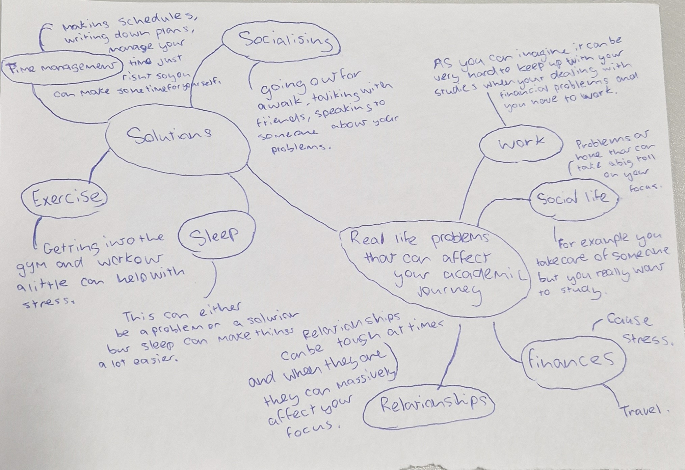

2. Paraphrase the following sentences (max 3 marks for each, max 12 marks in total):

a) Good time management techniques can help you feel more relaxed and focused.

time management can significantly improve your confidence and well being feeling in control of all your plans and most importantly reduce stress, By prioritizing certain tasks and minimizing your work load. This leads to better work to life balance and you can feel stress free and relieved.

b) Speaking to your friends and family can significantly lower stress levels.

One of the best solutions to immense amount of stress is speaking with your close family and friends about all your problems and why you feel this stressed.

c) University life offers numerous opportunities for personal growth and development.

University life can teach people a lot of new skills and give new opportunities to better themselves in many different ways

d) Attending lectures regularly is crucial for understanding course material.

Making sure you attend all of your classes and on time is one of your most important responsibilities as a student.

3. Write a well-structured paragraph (8 sentences) on the following topic:

Strategies for managing a student budget and reducing costs while at university.

Your paragraph must be written in full sentences (no bullet points) and in an academic style.

(max 16 marks in total)

While you are studying at a university, it can get very hard managing a low budget trying to attend all of your lectures and spending money on travel every week. This is the reality of many young students trying to fit in to their budget while handling their social life as well. One strategy that can help students with their travel is simply get a student bus pass, this will help any student that uses the bus travel to get to university. Other strategies that may help is getting their student finance which are almost all students eligible for. Sorting out your student finance will help you significantly with your whole budget especially for young students. Another strategy all students can use is using student discounts and coupons that can save a little out of your budget. All three of these strategies will surely help anyone on a low budget or financial problems.

