Name: Emily Price
Student number: 1802968
Course title: BA Set Design
Tutor: Julia Lockhart
Word Count: 3,031

How useful are manifestos to designers and/ or design groups?
In this essay I am going to be talking about manifestos in relation to designers and groups of designers and what the reason might be behind them and what use they may have and what the possible positives and negatives may be with manifestos. I am also going to look at many manifestos for research and focus in on the main ones that relate to my points and descriptions. I will be creating my own ten - point manifesto at the end relating mainly to design and my course I am currently studying that is set design. I will be focusing in on what a manifesto is and what they include. I will also be looking at the wide range of things to ask yourself when writing a manifesto and what the most important points are of a good manifesto when you are a designer. I will also be looking at if manifestos have to make sense to the viewers or only to the person writing them as this can change a viewer’s opinion on them completely as well as being able to tell if they are useful to specific people or not. The main theorists and manifestos I will be looking at and talking about that relate to the topics I will be discussing are; Claes Oldenburg Manifesto (I am for an Art) from 1961. This relates to designers and what things they might believe in that could relate to how design is made and dealt with also with how designers think and feel. It is art based but a designer is an artist as we all have different talents that relate to the same topic. We all have different opinions on subjects but can all relate in one way or another. The second theorist I will be looking at and their manifesto is Manifest I of The Style 1918, by Theo van Doesburg, as it looks at the discussion of how older generations of people compared to younger generations of people may relate to problems and conversations made which could impact how things could be positive or negative changes in the future of younger generations. The third theorist I will be looking at is Donna Haraway, 1991, A cyborg manifesto. She talks about cyborgs but relates to topics within her manifesto through talking about how politics have an impact on how people feel and what they decide to do with their future and opinions.
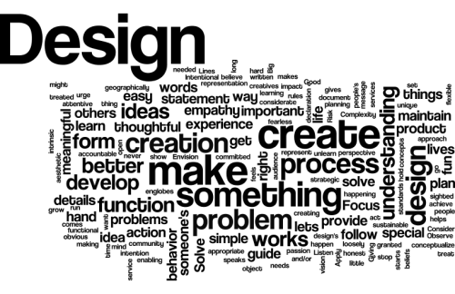

Accessed 3rd December: https://www.thedesigngym.com/design-manifestos/
A manifesto can be about anything, mainly something you believe in. They can reflect who you are. As I have found from Teresa Ebert in her writing of manifestos. She talks about what goes into manifestos.

(The Manifesto is writing in struggle. It is writing on the edge where textuality is dragged into the streets and language is carried to the barricades. It is writing confronting established practices in order to open other genre, the sign becomes, to use Voloshinov’s words, “an arena of the class struggle” (23).)

They can reflect how you learn. As Ebert states,

(The manifesto and polemic are, as might be expected, marginalized in mainstream discourses and treated in the academy and knowledge industry, in general, as modes of non- knowledge. This is because they are critique-al acts that cut through the reified layers of ruling ideas masquerading as “common knowledge.”)

In art and design it can relate to an artist’s work through what they want their work to say or tell a story or even through the process of creating their work. They can be set limits and outline how you will do something. They can be rewritten and designed as many times you want and can be a continuous working progress for as long as you want. As a designer you choose what it will be about and what it will look like and for how long you work on it. In design it can relate to what you believe in and how you will incorporate it into your art work.
As Craig Stroupe states,

(Though manifestos are by nature revolutionary, writiers ground their argumanets by basing them, says Ulmer, “on the authority of another theory whose argument is accepted as literal rather that a figurative analogy”)

It could act as a check list for what you want to do and what you will do. It can state your reasons for making the artwork and how you came up with the designs as all pieces of artwork have a meaning behind it. A manifesto can be a form of design as art in its own form. They can also imply rules or laws which can be important to groups of designers as they would be working together and it will help everyone in that group to understand and have something to look back on to remind themselves of what the goal will be at the end and throughout each project. This can be seen in a majority of manifestos as with designers they all have a similar structure and way of thinking. They can be used as a record for designers work and could be used as a backup to what each piece of work means if the designer passes away in the future it will have a record of meaning and history to look back on that relates to the artists artwork. As Oldenburg mentions in his manifesto,

Oldenburg, 1961, (I am for an artist who vanishes, turning up in a white cap painting signs or hallways.)

This sums up the feeling of passing away in the sense of disappearing and then the work lives on by reappearing again after in the form of being spoken about or shown in places for years to come. A designer can be remembered through either making or leaving an impression on the world and if a manifesto has been written their views and beliefs will stay out in the world for as long as it is around.
I like this idea of manifestos for each piece or collection of work as you can always look back on it in the future and remind yourself as an artist what you felt at that time and why you felt like making the piece of artwork or for future viewers to understand the artists point of view and feelings they felt at the time.

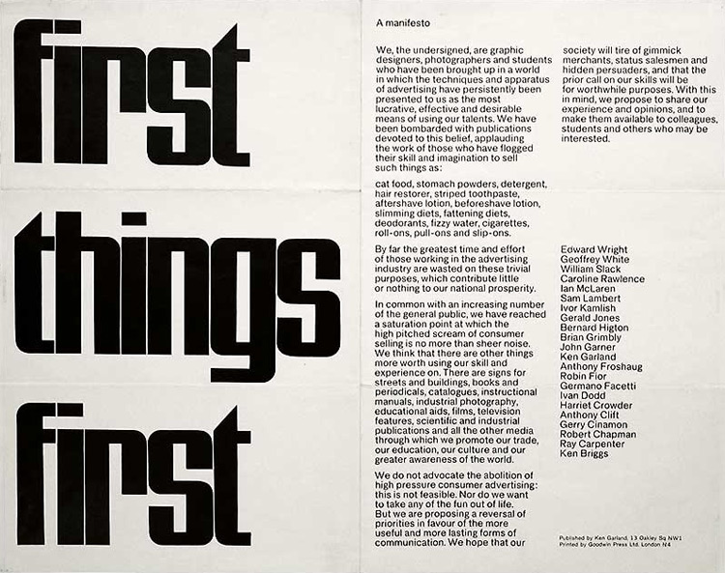

Accessed 3rd December: http://www.designishistory.com/1960/first-things-first/

A manifesto can be used as constructive thinking and lets everyone do their own thing as there is a wide variety of subjects that can be used and lets people put their beliefs and opinions in one place. People who write manifestos have their own thought of their own manifesto that they have written. Sometimes they can be honest with how they felt when writing it and whether they actually believe in some points made or not. As Oldenburg states,

Oldenburg, 1961, (There’s a lot of literary intention in that, so many of those things are said for the sound of them, and I don’t necessarily believe all those things. But I, at some point, might believe them. … It’s the sort of thing American artists are expected to say, because they want to embrace everything and they want to honor the muse of democracy. I don’t always feel that way.)

Manifestos can be repetitions and have patterns. They can repeat the same sentence at the start and finish or have patterns with use of words. This can lead to some manifestos not making sense when they are read and may be read over a few times to try and make sense and sometimes still never do.

Being a designer and artist the things that would be the most important things to include in a manifesto would be thinking about what you believe in and why and where your values come from as that shows through in your personal work and your design decisions compared to another designer and if you are working together in a group of designers each one will have a different view or opinion or way of working to you. Another thing that seems important to think about would be what do you care about and what do you ignore as that impacts your design ideas and decisions. As a designer there might be somethings that you do not enjoy doing or using compared to other techniques that you love to use. This may have a vision that the viewer sees and can show your personality through it and may have an impact on whether the viewer likes what they see or does not like what they see.
A manifesto can help create an environment that everyone thrives in when working in a group of designers.
Manifestos can be used as a form of studying the problems of life and people’s needs. Designers can use this form to see what is needed more of in the world and what is causing problems in people’s lives and try to use that to find solutions and ways to try and not necessarily solve the problem but help as best they can. Manifestos can be used as a form of motivation for designers in that way as they can get their ideas down and possible solutions to work with. This also allows the designers personality to shine through. A designer could use a manifesto as a form of instructions for how to reuse something or change and improve an object that is already in existence. It can be a form of instructions for people to follow or completely ignore and go off and their own thing using it as inspiration and thought behind why they may ignore it and maybe come up with their own manifesto of instructions based of the one they have read. A manifesto can act as a form of inspiration and may inspire young or old to go and do something for the better and make a change. As Doesburg mentions in his manifesto,

Theo van Doesburg, 1918, (1. There is an old and a new consciousness of time.
The old is connected with the individual.
The new is connected with the universal.
The struggle of the individual against the universal is revealing itself in the world-war as well as in the art of the present day.)

Manifestos that try to have a positive impact on other people are the most useful as it can change people’s thoughts on big world problems such as recycling and global warming and hopefully persuade change in people who have never given it a thought and what the world could turn into without a drastic change. Depending on the age of the person reading the manifesto, it can have an impact on how it is taken in and translated into something more than just words written down on paper, as Doesburg mentions in his manifesto, this is how I translate the words in the manifesto.

Many manifestos do not always make sense to the reader and only makes sense to the person writing it. Based on the wording that is used, if they are uncommon words they may make it hard to understand what the writer is trying to say compared to more easy words and understandings. They do not have to make sense, they are personal to the person writing them. Everyone has different opinions and not everyone will like or understand what it being said. They have a positive and negative side to them. One writer might think that the manifesto they have written is positive but someone reading it may find it negative. An example of this for me would be the political manifestos that are created for the parties to let people know wat their aims are and what they stand for to help the people already on their side know what their plan is and for people undecided, to make it easier for them to decide who they want to support and what they may or may not agree with. As Donna Haraway talks about in her manifesto with cyborgs,

Donna Haraway, 1991, (Ths cyborg is our ontology; it gives us our politics. The cyborg is a condensed image of both imagination and material reality, the two joined centres structuring any possibility of historical transformation.)

For me I am not a huge fan of politics as it brings up too many conversations but think the idea of manifestos for the parties would be an easier way for me to see and decide what I agree with and disagree with. Politics can play a large part in some designer’s work. They can be driven by what is going on in the world whether they agree with the action being taken or disagree, that that will influence what they will create as an individual designer compared to a group of designers. As Haraway states,

Haraway, 1991, (Technological determination is only one ideological space opened up by the reconceptions of machine and organism as coded texts through which we engage in the play of writing and reading the world.)

The designer will then go and create the event in either a positive light or negative piece of work. Personally, this interests me as it shows you the beliefs of the individual designer and how they feel about the situation. Design is changing all the time, like with set design, a set is always changing whether it be with the props moving or fly walls being moved in and out depending on the set. A set design will change constantly and quickly depending on a person’s opinion. Sometimes it can be a good design decision and other times it could be a decision that is not quite right. The sets can be used as multiple designs and purposes and a design group could come up with a manifesto to work out what should be done or changed to make the ideas the best they can be or even help with the design of the set. If a manifesto has one designer’s personal opinions on a set design or prop design you can get an idea of what the person has in their head and what they believe it should look like. It may not be the best or right choice but ideas do not have to be taken exactly as described from the manifesto, it can allow creative designs and choices to flow and does not have to stick to a strict idea. Ideas bounce back and forth within designing props and sets as something may not work first time and needs improvement for it to look and work perfectly for filming. The idea of the manifesto being written then taken on board by the person reading it can allow ideas like design to bounce back and forth in the same way as creating a mood board and you picking out what you may like or not like and what may work and what will definitely not work.

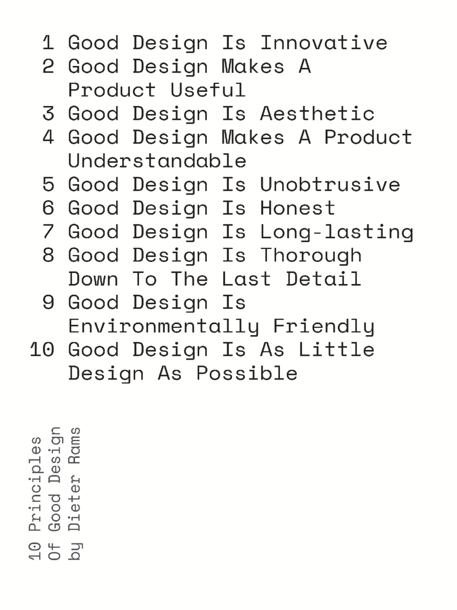

Accessed 3rd December:
https://www.themodernhouse.com/journal/design_manifestos_philosophies_principles_good_design/

Manifesto

- I believe that what can be reused should be reused
- Don’t let your creative ideas stop you from doing what you want
- Don’t let other people have a negative impact on your work, and if you do build from it
- I believe in reusing and developing old ideas to make them even better than before
- I believe in working with others on ideas and making something collaboratively
- I believe that even the simplest of things can make a huge difference
- I believe that any object can be important and tell a story about its history or leave an impression on the viewer
- I believe that negative feedback can be good feedback to develop your work and make it even better.
- I believe that reality can become made up and make people have opinions that others may or may not believe in.
- I believe that everyone’s opinions matter whether they are good or bad.

To conclude, personally as a designer, I find manifestos are very useful to designers and groups of designers. They can inspire viewers of the piece of work or even the people they are working with. They can get across their reasons and opinions without having to be there and speak in person. They do not have to make sense but only make sense to the writer. They can be negative or positive but represent what the writer stands for. Depending on the age of the viewer of the manifesto it can be read and taken in differently and have different meanings to and older age group compared to a younger age group. Sometimes a manifesto might never make any sense to the reader but it will make them think about it and try hard to work out what it meant. For set designers they can be used as a form of story board as the designer can get across their views, and ideas and then get opinions back on what could work and what might need improvements. I think for the future I will consider using the form of manifesto when thinking about my ideas and designs. I can use it as a form of story board or ideas board. I will also use the idea to get my ideas, thoughts and beliefs down and then I will be able to use it to look back on in the future and still if I still feel the same as I used to. From this and the research that has taken place, it has had an impact on my own manifesto and what I think and believe. It has impacted the thought of having an impression and giving the viewer something to think about and remember. It has also impacted the thought of everyone’s opinions and views could no matter if they are good or bad. It impacts the thoughts of designers when working in a group of designers or on your own as a designer to get the job done. It has also made the thought of leaving a lasting impression particularly on the younger generation being from the younger generation to start with.

Bibliography

(C. Oldenburg, 1961, I am for Art)
http://www.walkerart.org/magazine/2013/claes-oldenburg-i-am-for-an-art-1961

(D. Haraway, a cyborg manifesto, 1991)
http://people.oregonstate.edu/~vanlondp/wgss320/articles/haraway-cyborg-manifesto.pdf

(T.Tzara, 1918, Dada manifesto)
http://www.391.org/manifestos/1918-dada-manifesto-tristan-tzara.html#.WHZGqofIOKI

(T.V. Doesburg, 1918, De Still Manifesto)
https://en.wikisource.org/wiki/Manifest_I_of_The_Style_1918

Manifesto as the Theory and Theory as Material Force: Toward a Red Polemic
(Tessa L. Ebert, JAC, Vol. 23, No. 3 (2003), pp. 553-562)
https://www.jstor.org/stable/20866585?seq=1

Theory of the Manifesto: CATTt, Craig Stroupe
https://www.d.umn.edu/~cstroupe/ideas/cattt.html

Ethical Design Manifesto
https://ind.ie/ethical-design/

Manifesto for Radical Social Change
http://www.iicat.org/manifesto-for-radical-social-change/

The Founding and Manifesto of Futurism – F.T. Marinetti
http://www.unknown.nu/futurism/manifesto.html

The Ideal Book – William Morris
https://www.marxists.org/archive/morris/works/1893/ideal.htm

Redesign manifestos
https://www.readingdesign.org/tag-manifestos\

https://www.readingdesign.org/beyond-the-new

Images Bibliography

http://www.designishistory.com/1960/first-things-first/

https://www.thedesigngym.com/design-manifestos/

https://www.themodernhouse.com/journal/design_manifestos_philosophies_principles_good_design/

