Managing Projects in the Organization
Name: Vincent Binoburyo
ID: 1806579

Date: 05/05/2020

Table of Contents
Introduction 3
Project’s background 4
Work Breakdown Structure 6
Project Management Plan 8
Scope baseline 8
Schedule Baseline 9
Cost Baseline 10
Requirement Management Plan 10
Cost Management Plan 10
Quality Management Plan 11
Human Resource Management Plan 12
Communication Management Plan 13
Stakeholder Management Plan 14
Risk Management Plan 16
Process Improvement Plan 18
Conclusion 20
References 21

Introduction
Managing projects in the organization require many conditions and requirements where it needs to be formal and follow regulations related to the project (Harrin, 2013). For this project, a team is formed that will be responsible for conducting this project. Moreover, Burger King is such a multinational company that has a competitive position in both the local and international markets. As the competitive position is noticeable in the market, this company has some competitive strategies within the market. Work Breakdown Structure will be prepared before initiating a project management plan where such a project management plan will describe the entire process of managing the project in the organization.

Project’s background
This project has a background where Burger King is such a popular company indulge in serving different sorts of food items to the customers. This project is based on different competitive strategies taken by this company in terms of fighting against both local and global competitors (Armistead and Rowland, 2016). Burger King is known as the multinational company and its origin country was in the USA that operates its business operation as a multinational chain of hamburger fast-food restaurants. This fast-food restaurant that was found in the USA as its headquarters is in Blue Lagoon Drive in Florida and its operating income is now more than 117,700,00 US dollars having more than 37,000 employees. It has many competitors and they are KFC, Pizza Hut, McDonald’s, Subway, Taco Bell, Papa John’s Pizza. During this project, it will be tried to identify different competitive strategies taken by Burger King to sustain its competitive position in the market and the ways of tackling such competitors in the market.
Aim
There is the main aim of this project that is aimed at identifying different factors as strategies to compete within the market against other competitors where Burger King is a well-known multinational company.
Objectives
There are some objectives of this project where it is tried to make maintenance with the aim of this project. Such objectives are:
- To explore different factors that can create obstacles for Burger King in the competitive market,
- To identify different areas where the company can find itself stronger than other competitors,
- To find out different strategies taken by the company in terms of surviving within the market,
- To identify different ways of handling the competitors within the market, both local and international markets.
Business Area Analysis
This analysis normally involves the strategic goals of the project. For this project, it will aim at obtaining different strategic objectives. Considering the competitive position of Burger King in the global market, it will be identified whether the company can maximize its sales or not, whether its manufacturing process is efficient or not, whether there is any technological advancement in terms of IT, engineers of this company or not.
The rationale of the project
This project has many perspectives that have many rationales. By this project, different critical issues can be identified among them one is to identify the methodology of the project, factors that impact on conducting the project (Harrin, 2013). It helps maintain consistency in the work to mitigate any problems raised within the workplace. This project also helps to prepare any sort of research project where the main difference remains in collecting data.

Work Breakdown Structure
This WBS is such a framework that follows a hierarchical tree structure in terms of deliverables and activities that need to be performed so that this project can be completed. For this project, there is a WBS that will be followed sequentially (Norman, Brotherton and Fried, 2011). This WBS is the lowest level of work package where this work package will include allowing package in terms of considering costs, schedules, and resources. This WBS will help this project as it allows a hierarchical build-up of costs and schedule where this will be reported at any level of the WBS. For this project, such work breakdown structure looks like:
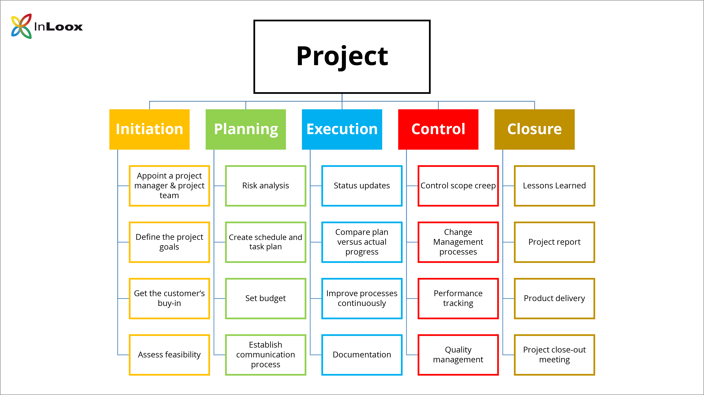
Figure 1: Work Break Down Structure
Source: (MILLER, 2017)
There are five stages of work breakdown structure and they are initiation, planning, execution, control, and closure. These are described below:
Initiation: At this stage, the first and foremost important task is to appoint a project manager and form a team that will be responsible for conducting this project by following different rules and regulations within this project. Initially, this team has been formed and the project’s goals and objectives have also been found. It is now being tried to assess the feasibility of the project; by following which it will be measured whether the project will become successful in its attempts or not.
Planning: Project planning is a crucial part where like other planning activities, in this project, it will be tried to conduct risk analysis, create a schedule and task plan, set a budget and establish a communication process (Atesmen, 2017). By risk analysis, team members of this project will try to measure different risks related to this project where the primary risk will be time restriction, lack of knowledge, experiences, skills, quality, legislative restrictions and so many other issues. Schedule and task plans need to be executed in a formal way where schedule and task will be correlated based on different activities and time frames. A proper budget needs to be formed where each element and its relative costs will be estimated. Moreover, team members who are responsible for executing the plan of this project need to have proper communication within themselves.
Execution: Project’s execution is normally dependent on its initial and planning stage where status needs to be updated, the actual plan will be compared with the expected outcomes and this will be done via cost-benefit analysis in this project. It will have to be remembered by each member of the team to improve each process continuously and make development reports on them. In the case of Burger King, different competitive strategies may be modified or changed; by considering this fact, team members need to prepare development reports.
Controlling: It is quite needed for the team to have control over each activity of the project. In this project, the change management process will be considered where each management procedure and its change will be considered properly as sometimes projects may not go according to the structure and it may raise the urgency to change different aspects of the project that will be discussed in this change management process. Performance tracking activities will help the team of this project to identify pits and falls of the team in terms of conducting the project (Badiru, 2019). Team members of this project are urged to improve their performances for having a complete project. Then, quality management needs to be conducted as this project must ensure quality where proper analysis, utilization of resources or sources need to be maintained in this project.
Closure: This is the final stage where learning outcomes will be brought about where a proper report will be prepared for this project. There are many relative products for this project and for this project, these need to be delivered. Finally, a closing-out meeting will be conducted by the team members of this project.

Project Management Plan
It is a management that is useful for getting prepared for the final project where for this project, objectives, scopes, and deliverables have been discussed already (Wynn and Guditus, 2014). This project management plan considers stakeholder including internal and external, Work Breakdown structure, project organization and resources, project costing and schedule, procurement or contract strategy, risk management, quality management, as well as change management. This rest of the part will be discussed in this part with proper discussion. For conducting this project, such project management plan will include:
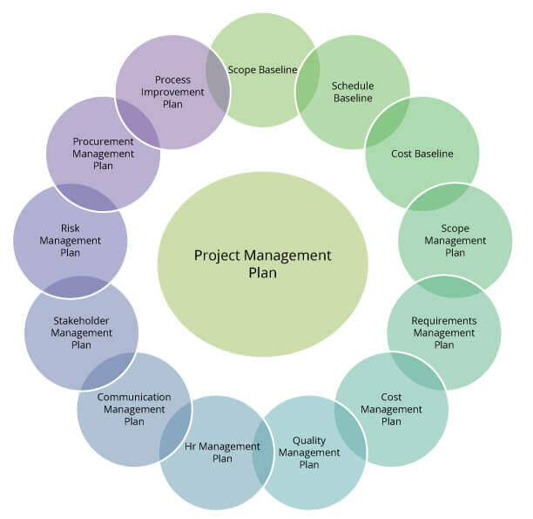
Figure 2: Project Management Plan
Source: (Heerkens, 2015)

Scope baseline
This project has a limited scope within which it will be tried to conduct this project. The scope of this project will also include time management, risk management, time scale, Work Breakdown Structure, project management plan. This project will involve different analyses for stakeholders, such as customers, stakeholders, employees as well as their performance within the marketplace. Moreover, the performance development plan, cost-benefit analysis, and responsibilities of the managers of this project will be under this project where it will be entirely considered as a unique process that includes a set of coordinated and controlled functions.
Deliverable: This project has some deliverable issues that need to be undertaken with proper importance. This project will consider some issues such as stakeholder analysis, a time scale that will be represented via Gantt chart, time management, work break down structure, risk management.

Schedule Baseline
This project needs to be conducted within the schedule where it is always tried to make a comparison between the actual and the expected outcomes. This baseline can be developed by initiating with schedule and the baselines related to the cost where it is required to find out the activities and tasks (Collins, 2011). These will be ultimately needed to generate each of the deliverables that are important for measuring the scope baselined. It will be also needed to allocate resources for each task and a time scale will be maintained. Milestone for a project is considered as the task with zero duration representing a clear and articulated sequence of various activities whereby following such phases of a milestone, a complete project will be prepared. This milestone is helpful for this project, a Gantt chart has been made considering the aim and objectives of this project:

Figure 3: Gantt Chart
Source: Self-made
This project will remain for 7 weeks that will end at the end of April where the initial stage will be designing the project. Under this project design, a structure is built up for conducting surveys or interviews or a market research or market analysis so that data or information can be collected. Then, a proper planning tool will be structured and resources will be allocated where such resources will be based on technology that will be used for establishing appropriate communication. Project management will be undertaken with proper importance where each phase is modified in terms of the project’s aims and objectives. The competitive position of Burger king will be analyzed as it is essential for identifying competitive strategies used by Burger King. By following this, a conclusion will be drawn out for preparing a final report.

Cost Baseline
Considering this time-phased spending feature for this project, the project’s cost and its performance are measured. This cost baseline will be transferred into the change management process if there is any immediate thing raised (Jayaraman, 2016).

Requirement Management Plan
This requirement management plan will consider the only introduction of the project, management overview and different responsibilities of management (Oh and Rhew, 2014). Overall, in this management, stakeholder analysis, requirements for the documents, different requirements and monitoring over such requirements will be discussed.

Cost Management Plan
This cost management plan is an essential part of the entire project that helps to identify different relative costs for this project (Khodakarami and Abdi, 2014). For this project, cost-benefit analysis. It is known that cost-benefit analysis is such an analysis that includes economic decision-making approach for assessing the proposed project’s reliability and validity of the project. Normally, this cost-benefit analysis includes the comparison process between the expected expenditures and expected benefits for observing the ultimate results. Such results show whether benefits outweigh the expenditures and project’s cost is provided below:
Particulars | Units/Hours | Cost/Unit/Hour | Total
- Project Management  Project Manager  Project Team Members | 60  150 | £50  3 | £300  450
- Hardware  Handheld Devices  Services | 10  4 | 30  200 | 300  800
- IT  License cost  Development expenditures  Testing as evaluation | 50 | 10 | 500  1000  500
- Training and Support  Trainee cost  Travel cost  Costs for the team members | 50  10 | 10  80 | 500  800  1000
Total Project Cost estimated |  |  | 7,150
Total Benefits estimated |  |  | 8,000
Cost-benefit Ratio |  |  | 1.119

On the other hand, this project can require secondary data collection and analysis for which this project will require more cost, it is assumed that this project’s entire cost will become £7,500. As a result, the cost-benefit ratio will become 1.067. That means this project will be more beneficial if it does not consider secondary sources’ analysis.

Quality Management Plan
It is the quality management plan that requires a quality system, quality assurance, quality control, and inspection. This management plan considers these phases to ensure the quality of the project. This quality management plan is mainly measured based on both quantitative and qualitative methods. For ensuring quality, there must be a system that can ensure the quality of the project. This system needs to be provided with proper design or structure so that it can assure the quality of the project. If there is no error in the quality of the project found, proper control over the quality will need to be ensured via proper monitoring and inspection.
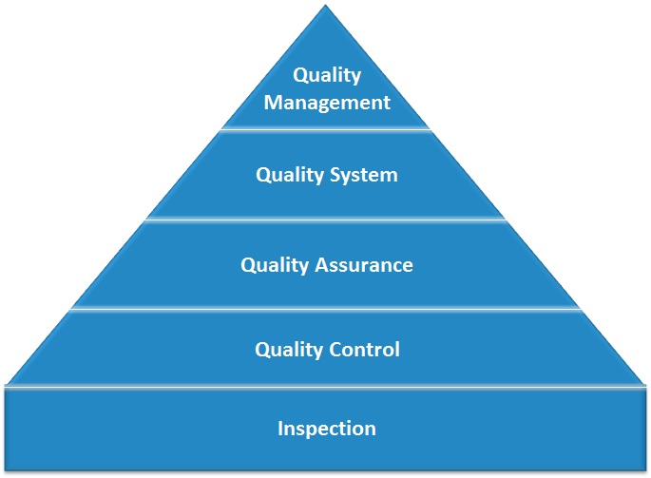
Figure 4: Quality Management Plan
Source: (Indelicato, 2013)
This quality management plan is important as it forces the managers to consider quality planning in conjunction with the project planning where other factors like costs, schedule, scope baseline is also influenced (Indelicato, 2013). Without a quality management plan, there will be a high chance of risk that may fluctuate while conducting the project. This will continue in making the project incomplete and its result as vague.

Human Resource Management Plan
Under this management plan, it is very helpful in terms of defining different sorts of responsibilities or roles of the human resources within the project as well as it indicates proper allocation and the way of obtaining each resource that is related to the activities of the project. Such resources are quite important as it helps to be specialized in terms of training requirements. For this project, such HRM plan looks like:
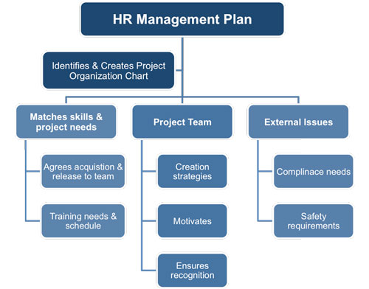
Figure 5: HRM plan of a project
Source: (Dwivedula, 2019)
This is quite needed for this project as it has been undertaken as the HR management plan to find out and create a project chart considering the team members’ performance within the project. This requires three major portions for this project and they are matching skills and project needs; project team as well as various external issues.
- Matching skills and project needs: In this phase, the entire team agrees to terms of acquisition to release different directional activities to the teams. Moreover, it is quite needed to have proper training arrangements for the members of the team by following the schedule. This training is essential for the team members so that they can accomplish the project’s activities.
- Project team: Each member within the team needs to think about the background of the project and its aims along with different objectives. They are urged to bring different as well as creative strategies while conducting the project so that the project accomplishment can be accurate and bring under the time frame of this project. For bringing creative strategies for the project, team members need to be motivated so that they can feel free to show interest in working for the project (Dwivedula, 2019). It will be tried to ensure recognition of the team members’ activities.
- External issues: To conduct the HR management plan, there are some external issues related to this project that should be considered for team members of this project. Compliance needs to be undertaken where each should be valid, reliable and relevant. Safety requirements have to be provided with proper judgment and clarification.

Communication Management Plan
Like other management plans of this project, this communication management plan is also important in this project as it involves identifying different data or information that is used to communicate with stakeholders via the project, determining the receiver of the information, their ways of receiving such information, time scale, their expectation (Badiru, 2019).
This management Process requires different phases and they are communication planning, information distribution, performance reporting, and administrative closure. In the case of communication planning, it will be tried to determine information and communications that are needed to the stakeholders. In the case of information distribution, it will be tried to make the needed information available on time. Administrative closure includes generating, collecting as well as disseminating information to formalize different phases or project completion.
There are some contents of this communication management plan. Firstly, it starts with the stakeholder communication requirements, different information to be communicated where it includes format, content, and level of detail. This communication management plan needs to conducted in terms of making a relationship with stakeholder analysis. For this project, a sample of stakeholder analysis that establishes proper communication management plan within the group conducting this project. Such as:
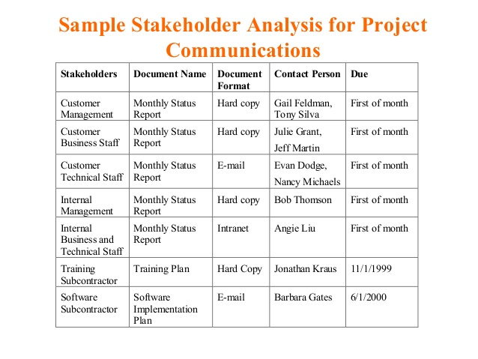
Figure 6: Communication Management Plan
Source: (Badiru, 2019)
For this project, different communication methods will be used including interactive communication, push communication and pull communication. Interactive communication will indicate two or more people interact to exchange information for which such members will involve themselves in a meeting, phone calls or video conferencing so that effective communication can be established while conducting the project. Push communication requires information that is sent to different recipients without their request through emails, faxes, voice mails, and other means (Wells and Kloppenborg, 2018). It ensures the effectiveness of the project where each information will be distributed or sent to the receivers. In the case of pull communication, information is distributed to different recipients at their request through web sites, bulletin boards, e-learning, different blogs, etc.
Media: For establishing proper communication within the team, different media like emails, social media or websites, mobile phones, laptops, etc. That means technology will be very helpful to establish proper communication among the team members.

Stakeholder Management Plan
It is known that stakeholder consists of persons in a group who will have a profound interest in obtaining success for the company and its environment (Eskerod, Huemann, and Ringhofer, 2015). Within the stakeholder engagement process, it is tried to identify stakeholders, assess the needs by defining actions. In this case, proper communication channels are needed to identify stakeholders of Burger King. It will be tried to collect feedback where proper monitoring and review need to conducted frequently. Under project management, sponsor, team, PMO, program managers, portfolio managers, operations managers, functional managers, customers or users, procurement, finance, government regulations, and consultants need to be considered. For this project, a stakeholder engagement plan contents normally include different items, such as:
- There must be a detailed strategy in terms of the engagement of the stakeholder so that a proper analysis of such strategies can be undertaken,
- There must be guidelines of the engagement of the stakeholder where the analysis can be conducted through following the guidelines,
- There must be insights in terms of the engagement of the stakeholders and the way of being engaged in the project,
- There will have guidelines for component level stakeholders and their engagement by following which such stakeholders can help to conduct the project (Ponnappa, 2014). Normally, they are considered important stakeholders for the research project where it is found that they help the researchers to gather primary data sources and those data are interpreted in the future.
- It is required for this project to measure the performance of stakeholders and their performance via metrics so that stakeholders’ engagement and activities can be ensured. It will be done through participation in meetings, communications, and their effectiveness of engagement activities in meeting goals.
- The stakeholder engagement plan will use it in communication planning and ongoing alignment as this will help in recognizing the completeness of the project.
Some guidelines have been talked about and now such guidelines will be discussed below with proper justification:
- This project must recognize the stakeholders who have enough power, desire or interest or influence; by using them such stakeholders can stop or cancel the work. It will be difficult for conducting this project if such stakeholders are not identified and recognized properly. It is required for this project to invest enough time on identifying such stakeholders for this project,
- A model needs to be followed where stakeholders will be classified and such groups will be busy at focusing on communications and their own time (Maylor, 2010). Such stakeholders within the group will help identify shape strategy at the initial strategy,
- There must be a contingency plan if the trust is broken and positive vibes need to be brought about within the groups of the stakeholders. It is believed that negative group members always discourage others within the team.
- It is suggested to recognize the working activities of the stakeholders and different areas of improvement whereby recognizing the activities of stakeholder, it is tried to know what is working well. The crucial part is to discuss engagement at various meetings and solicit stakeholder feedback and ask if things develop.

Risk Management Plan
This risk management is considered as the art and science that involves finding out, making analysis, and providing responses to the relative risk throughout the entire period of the project and meeting project objectives (Cheng, Carrillo and Gibson, 2016). This risk management is considered as the overlook in projects but it can aid the entire project to develop the success of the project in terms of helping an effective project, measuring the project’s scope and improving realistic estimates. This risk management includes methodology, roles and responsibility, budget and schedule, risk categories, risk probability and impacts, revised stakeholders’ tolerances and tracking and all this discussed below:
Methodology: This is an essential part of any project as methodology indicates different phases including research approach, research methods, sampling methods, data collection approach. There are different types of approaches, for a research project, qualitative as well as quantitative methods are considered. Qualitative methods will consider different theoretical aspects, views, previous research conducted by different authors where the quantitative method will include data analysis of different data on the numerical data analysis process (Collins, 2011).
Roles and responsibility: Several roles responsibilities will be conducted by the team members of the project, such as:
- To conduct each phase according to the planning and redesigning of the project,
- To collect secondary data from different secondary sources that will be interpreted further,
- To conduct qualitative and quantitative methods efficiently and effectively so that any error cannot occur,
- To monitor the entire project and review it for identifying any error of the project,
- To provide feedback on each phase of the project.
Budget and schedule: This project will consider different key factors as costs under the budget to prepare the entire project. This budget will consider designing the cost of the project, project planning, communication tools, travel costs where the total costs will be £2,500 and it will end in the middle of May.
Risk and its impacts: There will be financial, marketing, HRM, IT-related risks that may arise during the project (Harrin, 2013). For this project, the major risk will be IT risk that will become obstacles in terms of establishing communication, interpreting the results or outcomes. This will have ultimately negative impacts though there will be some positive risks that will maximize the project’s effectiveness and efficiencies. A sample of tracking risk will be followed over the four weeks, such as:
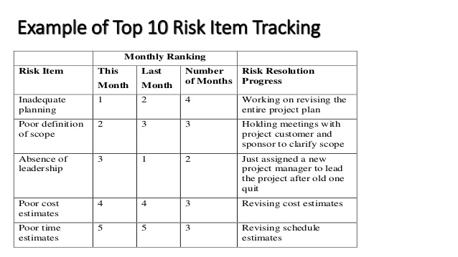
Figure 7: Risk measurement in a project
Source: (Collins, 2011)
Tracking: By interviewing the people within or outside the team, this interview is a very effective tool to measure or identify the risk for the project where it is conducted on a face-to-face meeting.
Procurement Management Plan
This procurement management plan will show what, why, when and who will conduct in this project considering the aim and objectives of the project. For this project, it looks like:

Project Name: |  | “Competitive strategies of Burger King to tackle both local and international competitors in the UK.’’
What |  |  | Why | When | Who
Description | Type |  | Reason | Timing | Owner
The competitive market position of Burger King analysis | Qualitative analysis |  | For identifying the genuine status of the company | By the first week of April | The entire team
Competitive strategies analysis over Burger King | Qualitative analysis |  | For exploring the strategies comparing with other competitors | By the 2nd week of April | The entire team
Secondary data sources | Both quantitative and qualitative |  | For identifying the reasons for such strategies and competitive position | By the end of April | The entire team
Interpreting the results | Qualitative |  | For concluding the results | By the first week of May | Project manager

Process Improvement Plan
Before conducting a process improvement plan, the entire team must identify the strengths and weaknesses of the team that conducts this project (Willoughby, 2015). Such as:
Strengths: the major strengths can be team spirit by using which team performance can be maximized. Moreover, proper communication will be helpful in terms of the blessing of technology.
Weaknesses: The major weaknesses of this project will be in lack of skills, lack of experiences that will lead to falling in the trap of time restrictions. This should be improved. This improvement plan will be conducted by each member of the team whereas team member, a process improvement plan is provided below:
Area of improvement | Actions to improve | Date to complete
Time management skills | To practice working within the strict schedule daily | 7th April 2020
Communication skills | To improve social networking, tendency to enhance networking, to be friendly all the parties related to the project | 29th April 2020
Psychological strength | To exercise or to read positive journals or books | Daily
Mental strength | To try to be patient | Daily

Conclusion
Throughout this project, it has been tried to conduct the project effectively and efficiently where it has been tried to make consistency between the work breakdown structure and the project management plan. A milestone in terms of the Gantt chart has been prepared that indicates the time frame of each activity of the project related to the aims and objectives of this project. Then, a cost management plan has been conducted where the cost-benefit analysis of this project has been conducted. Quality management, time management, risk management have been conducted where a procurement management plan and procurement improvement plan has also been conducted. It has been tried to show the different strengths and weaknesses of the project.

References
Armistead, C. and Rowland, A., 2016. Managing Business Processes. Chichester [England]: Wiley.
Atesmen, M., 2017. Project Management Case Studies And Lessons Learned. Boca Raton: Auerbach Publishers, Incorporated.
Auch, F. and Smyth, H., 2010. The cultural heterogeny of project firms and project teams. International Journal of Managing Projects in Business, 3(3), pp.443-461.
Badiru, A., 2019. Project Management. Milton: CRC Press LLC.
Chapman, C. and Ward, S., 2013. How To Manage Project Opportunity And Risk. Hoboken, N.J.: Wiley.
Cheng, L., Carrillo, E. and Gibson, M., 2016. APPLYING THE PROJECT MANAGEMENT PRINCIPLES FOR RISK MANAGEMENT PLAN IN CHEMICAL INDUSTRY. International Journal of Strategic Management, 16(2), pp.71-76.
Collins, R., 2011. Project Management. New York: Nova Science Publishers.
Dwivedula, R., 2019. Human Resource Management in Project Management: Ideas at the Cusp. European Project Management Journal, 9(1), pp.34-41.
Eskerod, P., Huemann, M. and Ringhofer, C., 2015. Stakeholder Inclusiveness: Enriching Project Management with General Stakeholder Theory1. Project Management Journal, 46(6), pp.42-53.
Finkbeiner, B. and Finkbeiner, C., 2020. Practice Management For The Dental Team. St. Louis, Mo.: Elsevier.
Harrin, E., 2013. Managing Project Teams. Swindon: BCS Learning & Development Limited.
Heerkens, G., 2015. Project Management. [Place of publication not identified]: Mcgraw-Hill Education.
Indelicato, G., 2013. Total Quality Management for Project Management. Project Management Journal, 44(4), pp.e1-e1.
Jayaraman, R., 2016. Project cost control: a new method to plan and control costs in large projects. Business Process Management Journal, 22(6), pp.1247-1268.
Kerzner, H., 2014. Project Management.
Khodakarami, V. and Abdi, A., 2014. Project cost risk analysis: A Bayesian networks approach for modeling dependencies between cost items. International Journal of Project Management, 32(7), pp.1233-1245.
Lewis, J., 2013. How To Build And Manage A Winning Project Team. New York: AMACOM.
Lai, S., 2014. A WBS-Based Plan Changeability Measurement Model for Reducing Software Project Change Risk. Lecture Notes on Software Engineering, pp.94-99.
Maylor, H., 2010. Project Management. Harlow: Financial Times Prentice Hall.
MILLER, D., 2017. BUILDING A PROJECT WORK BREAKDOWN STRUCTURE. [Place of publication not identified]: CRC Press.
Mizouni, R., 2015. Project Schedule Simulation: Incorporating Human Factors’ Uncertainty and Features’ Priority in Task Modeling. Journal of Software, 10(8), pp.939-960.
Norman, E., Brotherton, S. and Fried, R., 2011. Work Breakdown Structures. Hoboken: John Wiley & Sons.
Oh, D. and Rhew, S., 2014. An Empirical Study on the Requirement Management Process for Implementation Project of Information System. Lecture Notes on Software Engineering, pp.31-36.
Ponnappa, G., 2014. Project Stakeholder Management. Project Management Journal, 45(2), pp.e3-e3.
Tracy, B., 2014. Management. New York: AMACOM.
Wells, K. and Kloppenborg, T., 2018. Project Management Essentials, Second Edition. New York: Business Expert Press.
Willoughby, K., 2015. Process improvement in project expediting: there must be a better way. International Journal of Project Management, 23(3), pp.231-236.
Wynn, R. and Guditus, C., 2014. Team Management. Columbus, Ohio: C.E. Merrill.

