
This Photo by Unknown Author is licensed under CC BY-ND

toyota - Assessment 2 - Environmental Analysis of an industry

Student Name: Valeria Peeva
Programme: BA Business Management
Module: The Global Business Environment
Module code: LCCB4005
Module Coordinator/Lecturer: Nadeem Mirza

Table of Contents

INTRODUCTION 3
IMPACT OF THE PANDEMIC 4
Technological impact 4
Shutting down of manufacturing 4
Limited supply of vehicle parts 5
Economic impact 5
Demand of new cars 5
SURVIVAL AND SUCCESS FACTORS 6
Digitalization 6
Embracing e-commerce 6
Connectivity 6
Sustainability 6
Driving efficiency 6
Competition analysis 7
Strategic management 7
Upgrading the underwriting process 7
Maximizing virtual interactions 9
Promotional strategy 9
CONCLUSION 10
REFERENCES 11

introduction
Initially the concerns over the disruptions in the Chinese exports pivoted quickly to interruptions in large scale manufacturing within Europe. The closure of the assembly plants within the United States is also adding intense pressure on a global supply base that is increasingly distressed with companies within the automobile industry being at risk of defaulting on convents thus calling for banks to step in. Toyota was invented by Sakichi Toyoda in 1918 in Japan and the first oversea production was in Brazil in 1959. This report will focus on the analyzing of the impact of the pandemic on Toyota’s business and it will develop survival and success factors.

impact of the pandemic
The effects of COVID-19 for the car industry started in China and the sales were down by 70%. After that in the United States sales dropped 47 percent and in Europe – 80%. The car industry slowly but surely started to increase production again after people realizing it is best and safer to travel with your own vehicle than public transport. Toyota had to cut back on production because of the risk of coronavirus to make sure the staff is safe.

Technological impact
Due to pandemic situation, trends of using technology for business increase rapidly. Technology not only provide competitive advantage for a company but also create threat for privacy of an organisation. In pandemic, cybercrime and data breaching cases has rapidly increasing which create threat for company. The Covid pandemic improved rapidly the need of phones, TVs and games that uses chips. 2021 the production for Toyota was recovering despite the continuous pandemic impacts to all businesses around the world.

Shutting down of manufacturing
The slower the closures go on, the further possible around will be a lasting force on a business that has by now been battling, and components of an if not sustainable supply chain might be gone, in turn affecting on the capability of assemblers to resume manufacture effortlessly. Toyota had to not only cut down production but also to shut down some factories as the pandemic impact continued to be around us affecting the companies globally.

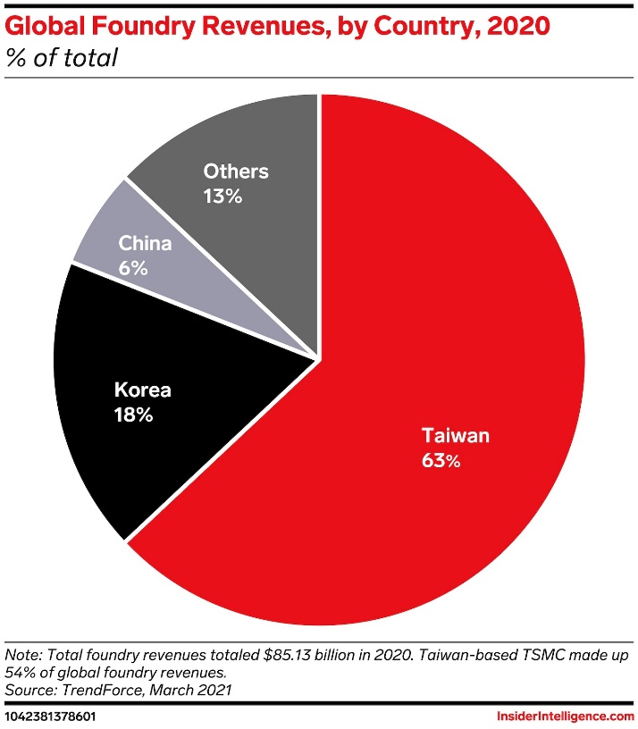
Figure 1

Limited supply of vehicle parts
For instance, imposing legal and trade restrictions on various countries such as the closing of borders led to a shortage in the required parts along with limited distribution of supplies required within the industry. Due to COVID-19 a lack of the pc chips applied broadly in automobiles has been difficult for months as the planet began to arise from the epidemic and need risen. Toyota had not been reached as tough as several more main carmakers, and currently the expand of the variation has created brand more obstacles. The parts center of Toyota is in Europe, Belgium launched in 1992 where all parts are distributed around the world.

Regulation of government
Carmakers in Europe have the biggest challenge now in terms of demand and selling of products and services. On another note, there is a massive look into making people’s workplace safe and better which cost money and time to consider, traffic and avoiding pick hours, changing of working hours.
At the same time, businesses must meet the requirement for clear and reliable supply chains, greener procedures, and better community progress. The COVID-19 virus has taken a rapid and serious effect on the worldwide multicultural automotive business. Indications involve an interruption in Chinese components transfers, huge measure industrial intrusions around Europe, and the shutting of fabrication factories in the United States. Toyota has started to support the medical sector by producing medical face shields and all necessary products like thermometers and protective equipment required for times like now.

Economic impact

Across the past few months, the vehicle trade has demonstrated remarkable strength. After the financial complexities faced in 2020, it has recovered to provide year-over-year expansion in new-car deals around the past few months throughout China, Europe, and the US. Nevertheless, even with positive statements on development in the direction of a vaccine, many threats stay, and we remain to estimate that trades in Europe and the US will not return to pre-COVID stages until 2023 at the quickest. For the meantime, China’s return maintains to increase speed, with the possibility to move towards 30 million new cars sold by 2025.

Demand of new cars

Even now we know how to get a major influence of the disease to the business: Manufacture stops, but also decrease GDP and user insecurity will run to a reduction in international transactions in 2020. Every single disaster holds a chance. The upturn is even now happening in China, and makers should get ready for the ramp-up. COVID-19 lays the world in front of a massive wellbeing task with top urgency but still further so currently is the moment to concentrate on the day after the catastrophe and find dimensions on how to protect careers and route all the way through these chaotic moments in the best imaginable sense.

SURVIVAL AND SUCCESS FACTORS

Digitalization and connectivity are the most significant prerequisite for the provision of additional services and content within the vehicles.

Digitalization
Invention is bringing new ideas in business which is important in auto-mobile industry as it can be done through digitalization. Its tactics differ through various working regions at numerous stages involving national, regional, and global stages. They take effect built on the evaluation concerning the direct clients’ options, buying power, and the market situation in a particular region. They are the main components in constructing Toyota’s marketing approaches.

Embracing e-commerce
Embracing e-commerce provides a vital opportunity for businesses within the automobile industry to develop click and collect services aimed at adapting to the expedited digitalization of vehicle sales. Toyota has started to adapt in a different way taking under consideration the impact of COVID-19 and the new demand and need of its clients.

Connectivity
That implies that mobility will remain to develop more digital, extra connected, and particularly more electric. Customers who factored sustainability keen on their purchasing choices improved electric-car deals growth by 43 percent in 2020. Ever since shifts in mobility involve adjustments in abilities, it is as well obvious that carmakers will need to tweak their businesses, such as by storming up the total of software technologist’s comparative to mechanical engineers, drastically. In all, auto manufacturer might require reskilling up to one-quarter of their existing employees. These developments will persist to increase speed as the trade progresses beyond from the COVID-19 catastrophe. Innovative capital providing in the car segment is likely to be improved due to expanded connectivity. It will as well enhance just owing to the sense that the creditors will need a clearer knowledge of every car and the credit on it. This will make the facilities further broad but highly importantly it will get it progressively more viable for the car finance firms soon to know exactly when, where, and how a certain vehicle has been driven while it turned off the assembly building line for the first time. There will be numerous various such developments observed and used by the auto finance firms in the commercial lending sector which is likely to dictate in future.

Sustainability
It is not only including natural resources but also economic resources and social resources.
Toyota Industries will bring on more challenges to guarantee environmental development in a period of growing insecurity whilst creating Group-wide, collaborative endeavors to reduce the influence of the COVID-19 disease.

Driving efficiency
Toyota Hybrids are several of the best fuel-effective vehicles in their grade. For quick trips at slow speed, or in stop-start traffic, they apply no fuel at all. That’s because, wherever probable, they operate merely on their electrical engine and Hybrid battery. As an illustration, a Toyota Hybrid such as the energetic Corolla Hybrid features fuel saving as low as 3.4l /100km. And since all Toyota Hybrids are self-charging, they contain recovering braking equipment, which involves electricity generated when you brake, or coast is kept in the battery. This prevents you to tour even more on natural electric power and does your trip much extra fuel economical.

Competition analysis
Competition create impact over business negatively as it does not allow company to increase their marketing share and reduce their profitability level in market.

Strategic management
Its company to gain sustainable competitive advantage in market by developing effective strategies. Toyota has a powerful manufacture method, and it generates benefits against the competition.

Urbanization
With increasing urbanization, there is improvement in living standard of people and they are moving to normal products to luxurious products.

Upgrading the underwriting process
The automobile providing analytics remain greatest applied by simply a portion of banks, financial companies, and credit unions. Others are still to take the complete benefit of the strength of auto loaning analytics. In addition to that, the legacy offering structures presents a provisional obstacle to understanding the possible advantages of car lending analytics. All these outcomes in disturbing the marketplace. Nevertheless, the gains appreciated by moving to a more improved loan origination result with addition of auto lending analytics may usually have an immediate and long-lasting effect on the total income of a creditor and collection expansion. Auto lending analytics is a valuable instrument that can be used to every stage of the lending phase, together with the underwriting process. There are typically two methods in which using auto lending analytics can improve auto finance businesses to boost their company earnings.

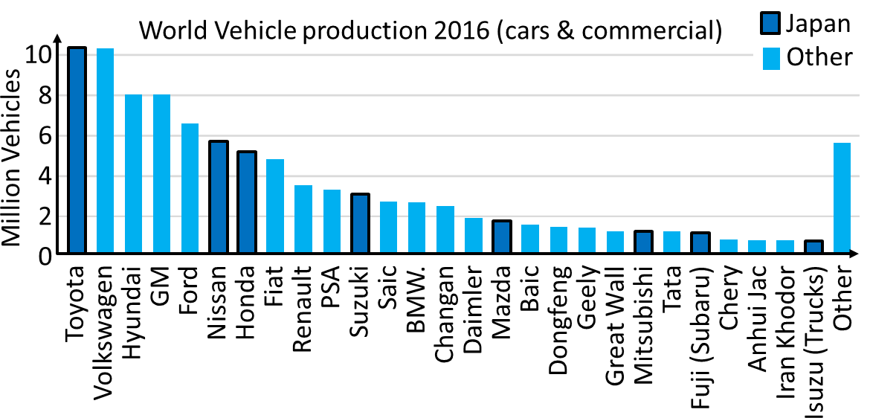
This Photo by Unknown Author is licensed under CC BY-SA
Evaluating the development productivity and reducing the causes of threats are the methods of Toyota. The situation can be extremely remarkable but is not simple to make such a difference. There will be plenty disputes further when the car investment businesses will require to assess the complicated companies’ versions of the whole fleets of vehicles. All of this will demand for a strong information managing and evaluation ability of the vehicle investment firms. This can just be created utilizing auto lending analytics. This will improve and boost both the underwriting processes as well as the credit standards. The auto lending analytics will assist car financing firms to evaluate the effectiveness of the underwriting process. It will guarantee quicker reaction to vehicle loan requests which is a key element in reporting such advances. It will also assist them to put up a clearer judgment whilst creating the regulations for providing and auto-shaping. Extremely crucially, the auto financers will react to simply those loan applications that will meet with their determined credit guidelines completely. Nevertheless, for nearly all vehicle finance businesses auto loan agreement is merely a small percentage of the whole decision-making method. In most of the circumstances, a main portion of the ruling as to whether authorize a loan request is conditional on the underwriters who evaluate the loan claim. Purpose of auto lending analytics will guarantee development of projects and modernization, simplification of the loan initiation method, respect of specific production and its impacts and assessment of the effectiveness both jointly as well as separately.

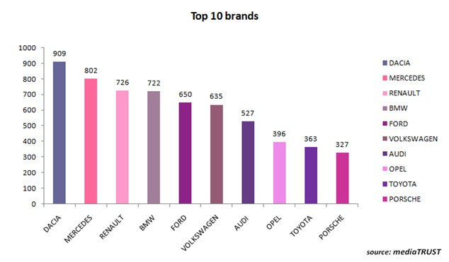
This Photo by Unknown Author is licensed under CC BY-SA

Maximizing virtual interactions
The virtual interactions have increased due to pandemic so the technology had to improve so all clients have better vies of the cars on their phones, laptops and can buy different versions in simulated showrooms via WhatsApp video, Facebook Live, web chat or mobile. Online shopping has increased rapidly as more and more people prefer to be safe and to buy everything online.

Toyota supports procedures for the vanguards of the health division and medical goods.

Promotional strategy

It holds additionally discovered that recent clients considering purchasing a new vehicle to prevent utilizing public transport would like to get additional promotions or flexible funding. “We had to come up with new financing packages that are easier on the pocket and increase the supply of our most affordable models. We get this customer feedback mainly through our digital channels and we have had to respond through the same channels as well.”

conclusion
The pandemic has a great impact on all industries, not only the automobiles but on the majority. With time and with great adjustments, businesses can start make profits again. Some of the businesses even made better profits than before the pandemic. It all depended on the market and on the demand of the clients. Toyota Motor Corporation is a Japanese automotive manufacture and trades corporation headquartered in Aichi, Japan. Established by Kiichiro Toyoda in 1837, Toyota is the biggest automotive producer. Its group of specialists creates every Toyota numerical advertising approach corresponding towards the evaluation of options and beliefs of the clients.
With the correct approaches on social media and advertisements, Toyota holds a major spot in the marketplace. By operational innovative subject motivating individuals, attracting additional communities across social media, being an eco-friendly trademark, and desirable advertisements, Toyota will remain standing as one of the greatest favored automotive firms.

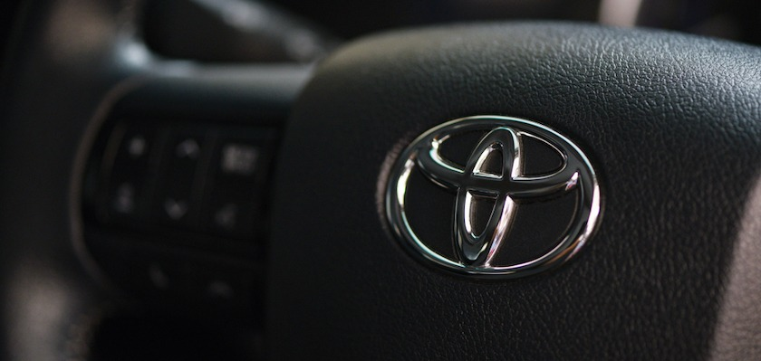

References

History of Toyota, Available at: https://www.toyotauk.com/about-toyota/history-of-toyota (Accessed: 03/01/2022)

How Toyota Philippines increased its customer outreach during the COVID-19 pandemic, Available at: https://martechasia.net/case-study/how-toyota-philippines-increased-it-customer-outreach-during-the-covid-19-pandemic/ (Accessed: 26/12/2021)

Strategies and Businesses, Available at: https://www.toyota-industries.com/investors/items/TICOReport2021_E_p12-38_strategies_and_businesses.pdf (Accessed: 28/12/2021)

Sustainability Report 2021, Available at: https://media.toyota-forklifts.eu/published/25785_Original%20document_toyota%20mh.pdf (Accessed: 26/12/2021)

Toyota cuts down production by 40%, shuts down factories due to chip shortage and surge in COVID-19 cases, Available at: https://www.emarketer.com/content/toyota-cuts-down-production-japan-north-america-by-40-shuts-down-factories-due-chip-shortage-surge-covid-cases (Accessed: 05/01/2022)

Toyota Develops Just-in-Time Efficient Operating System for Mobility Services Provided by its e-Palette Autonomous Electric Vehicle, Available at: https://media.toyota.co.uk/toyota-develops-just-in-time-efficient-operating-system-for-mobility-services-provided-by-its-e-palette-autonomous-electric-vehicle/ (Accessed: 27/12/2021)

Toyota Group Announces Support Measures for the Frontlines of the Medical Sector and Medical Products, Available at: https://global.toyota/en/newsroom/corporate/32232533.html (Accessed: 29/12/2021)

Toyota Lifts Forecast Despite Pandemic's Supply Chain Damage, Available at: https://www.mbtmag.com/home/news/21809102/toyota-lifts-forecast-despite-pandemics-supply-chain-damage (Accessed: 04/01/2022)

Toyota's response to the spread of COVID-19 (Novel Coronavirus) infections, Available at: https://global.toyota/en/newsroom/corporate/31893143.html (Accessed: 04/01/2022)

Toyota slashes production as pandemic strains supply chain, Available at: https://www.pbs.org/newshour/economy/toyota-slashes-production-as-pandemic-strains-supply-chain (Accessed: 03/01/2022)

