Karen Anne Windsor
Student Number 1918576
Email:1918576@student.uwtsd.ac.uk
Abstract
This assignment covered 4 tasks which included:
i. writing up a summary using information and skills learnt in Unit 1
ii. Creating a Mind Map using skills and knowledge gained in Unit 2
iii. Creating a video presentation using skills and knowledge gained in Unit 3
iv. Creating a collaborative Team Poster using skills and knowledge gained in Unit 4
Assignment l4 m1 ucm Assignment 1
Learning in the Digital Era
BSc Computing (Data and Information Systems)

Contents
1.Home Page 2
2. Unit 1 Essential Skills Summary 3
3. Mind Map 4
4. Presentation 5
5.Team Poster 7
6 SCREEN SHOOTS 9
6.1 Word document Unit 1 9
6.2 Mind Map Unit 2 9
6.3 Presentation Unit 3 10
6.4 Team Poster Unit 4 11

1.Home Page

On the Home Landing page there is a menu at the top of the screen



The user will then have the choice of how they access each individual Unit Task
You can either scroll down the home page to access each task or go to the task page.
For the purpose of this document I will proceed with the idea that the user will make use of the page tabs found on home page menu (see above)
Screen shot of home page
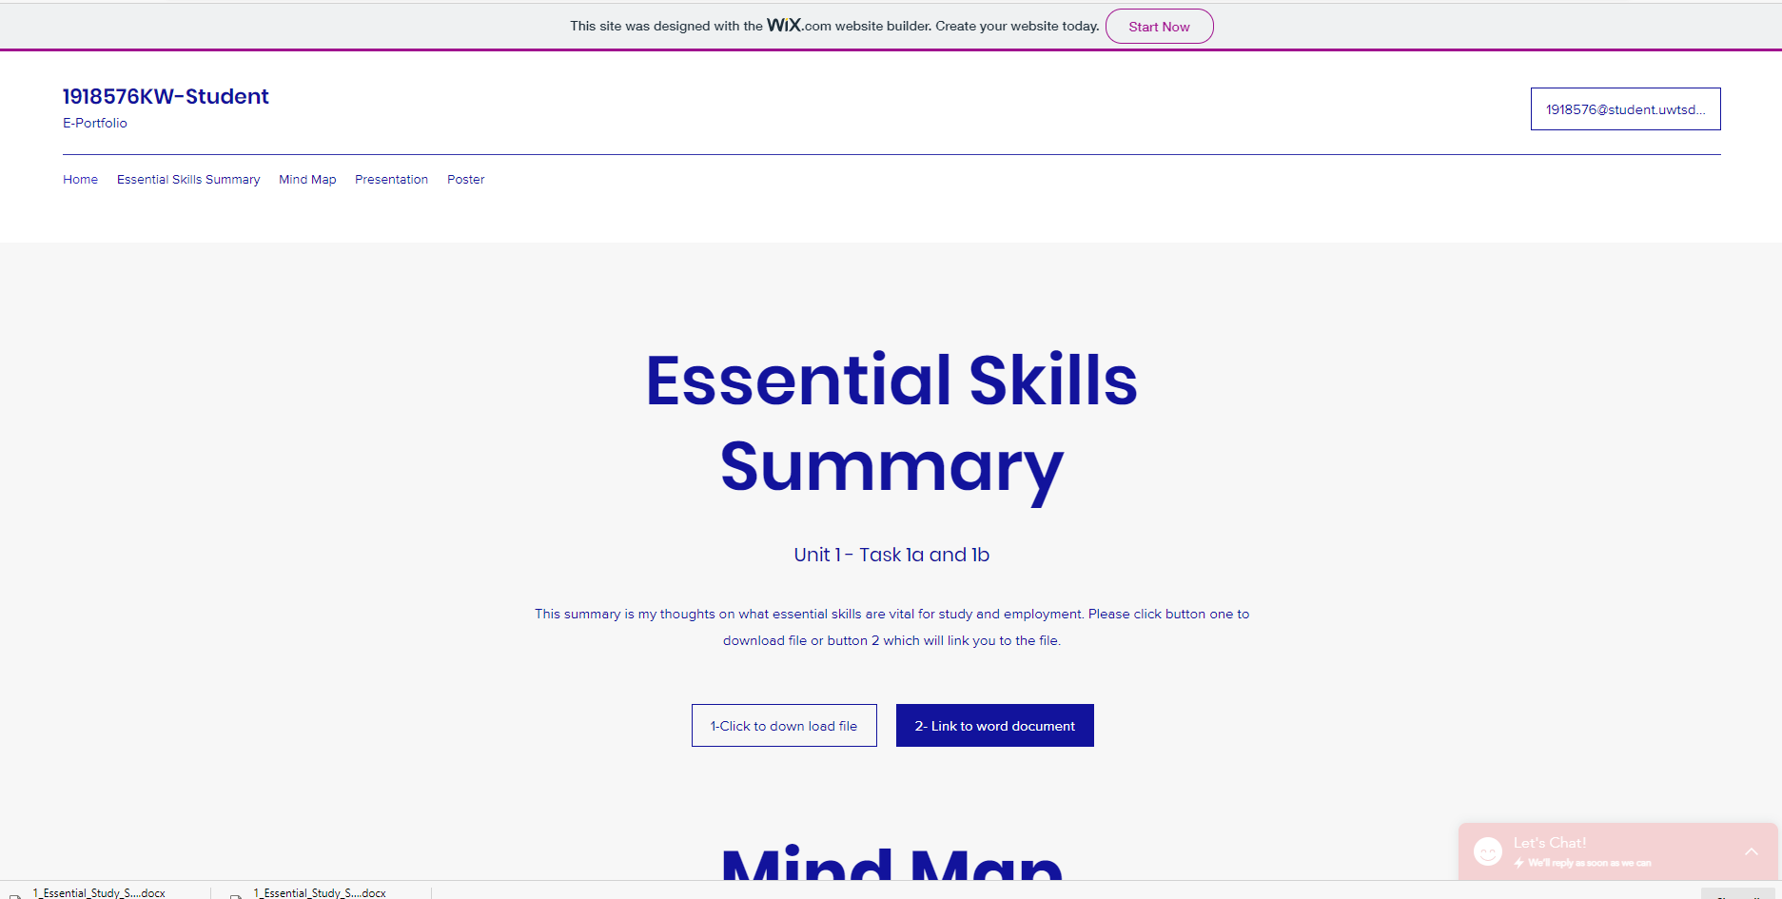

2. Unit 1 Essential Skills Summary
Link to Essential Skills Summary web page
https://1918576.wixsite.com/website/blank-page
Link to work document Unit 1 Task 1a and 1b (you will need to cntrl and right click on below link)
Essential_Study_Skills_1918576_K Windsor.docx (sharepoint.com)
You can navigate to web page for task 1 by choosing “Essential Skills Summary” off the menu on the landing page
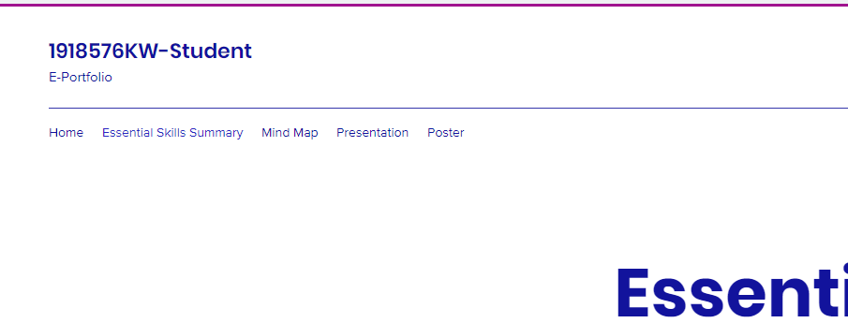
The page will load and you will have 2 options on how you would like to view the document:
- Button 1 – will download the document
- Button 2 – will activate the link to the document
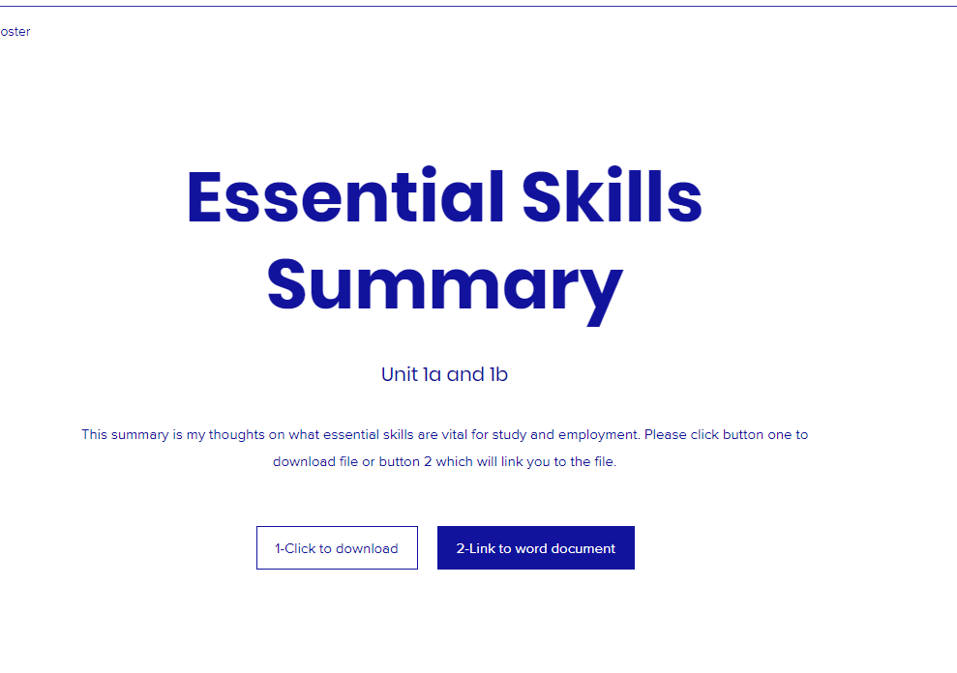

3. Mind Map
Direct link to Mind Map web page
Mind Map | 1918576KW-Student (wixsite.com)
Link to Unit 2 Mind Map Task in coggle.it
Heathy MIND and Body for Success (coggle.it)
You can navigate from the home page menu by choosing the option Mind Map (see below)
In the Mind Map web page you can go directly to the Mind Map by clicking on the Mind Map button
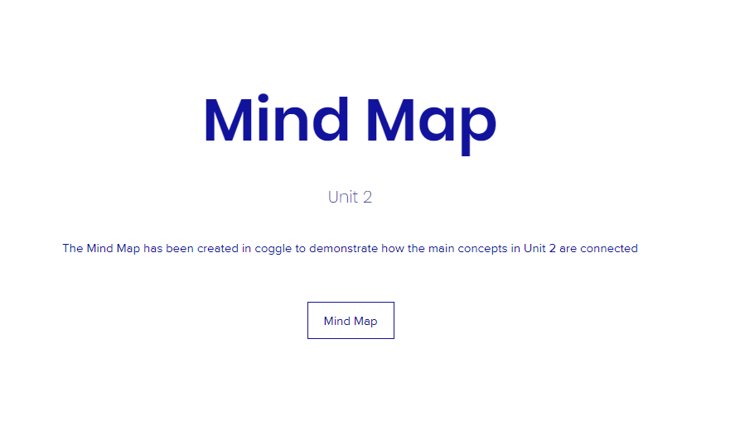

4. Presentation
Direct link to Presentation web page
Presentation | 1918576KW-Student (wixsite.com)
Link to video presentation Unit 3 task
https://uowtsd-my.sharepoint.com/:v:/g/personal/1918576_student_uwtsd_ac_uk/EW9fOfI36JJBoKqn9R5YNucBlVKPBgJOF5QZqP2zmLmq7g?e=JDMKkf

You can navigate from the home page menu by choosing the option Presentation (see below)

In the Presentation web page you can click directly on Video to get it to play automatically (see below)
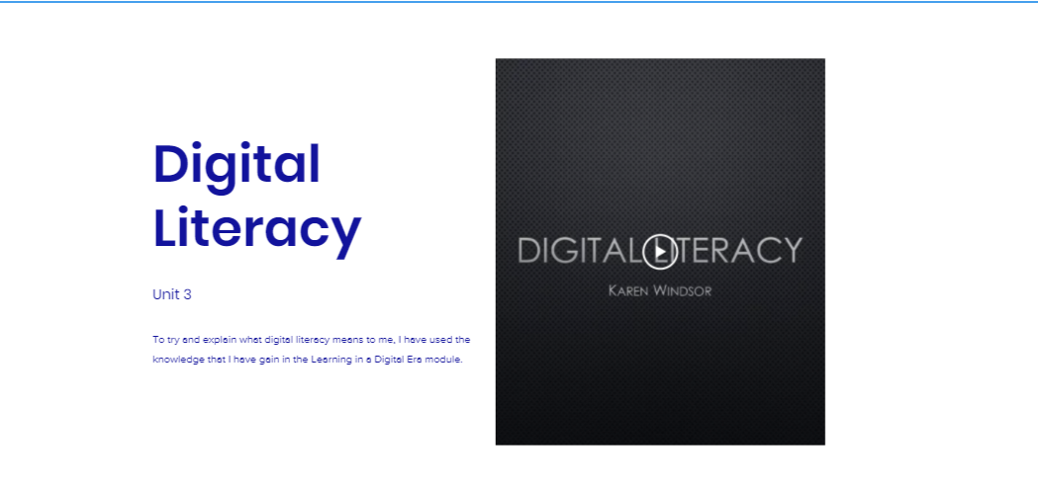

The other section on this page – contains the presentation in its power point media and a word document which contains all the references as I was concerned that they would be difficult to read in both the video and power point form of the presentation (see below)
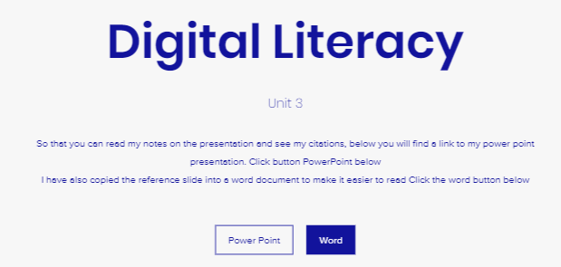

5.Team Poster
Direct link to Poster web page
Poster | 1918576KW-Student (wixsite.com)
Link to the Team Poster (see below)
Word_Team_Player_4.docx (sharepoint.com)
You can navigate from the home page menu by choosing the option Poster (see below)
There are 3 sections on the Poster web page:
- Allows you to either to link to the Poster in a PowerPoint format or link to it in a Word format (see below)
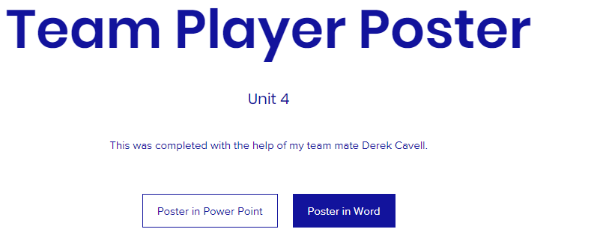
- The second section contains a separate word document that contains all of the poster’s references as I was aware that they were small on the poster and I wanted them to be totally accessible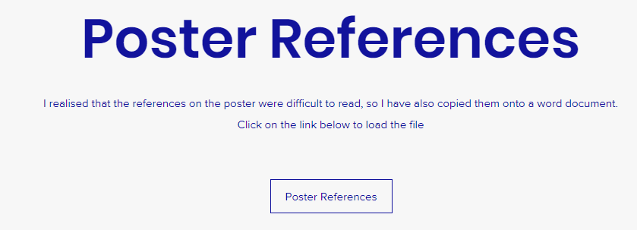

- The third section of the Poster website contains the document that shows the collaboration between Derek Cavell and myself unfortunately we both unable to make contact with the third member of our team.



6 SCREEN SHOOTS

6.1 Word document Unit 1

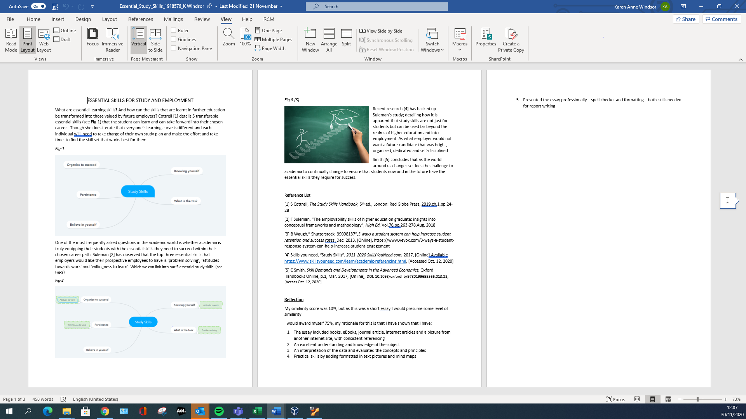

6.2 Mind Map Unit 2
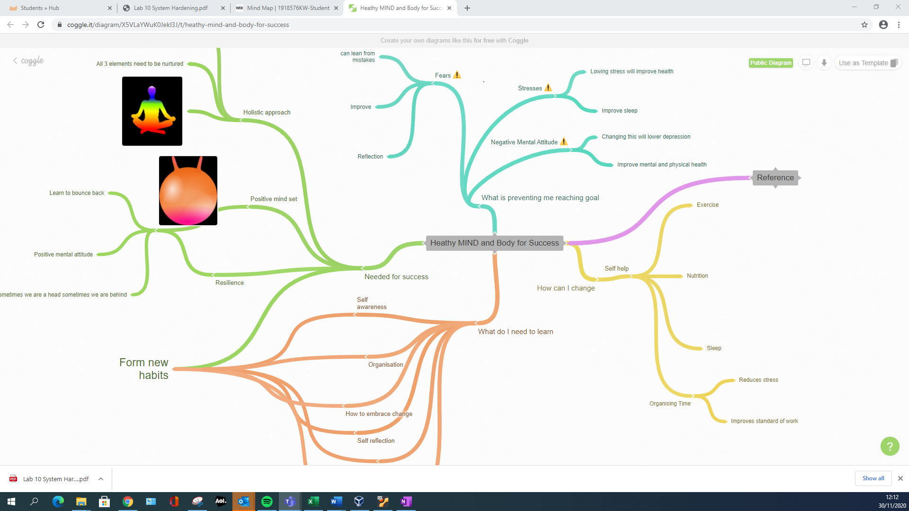

6.3 Presentation Unit 3

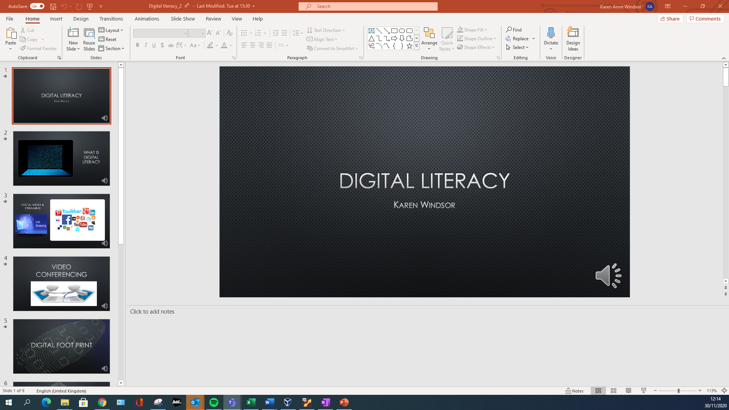
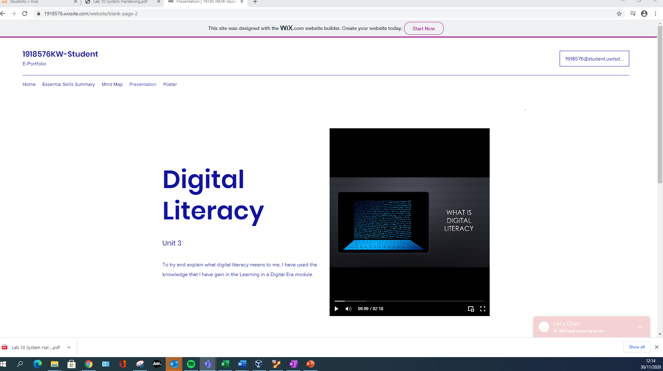

6.4 Team Poster Unit 4



