Internet Technology and Security – ACCA4018
By Connor Ellement 1803452
Web Development
Submission date: 10th January 2019

Table of Contents
1) Introduction 3
2) Wireless Networks 3
3) Cloud Storage 3
4) Bring your own technology/device 3
4.1) Advantages 4
4.2) Disadvantages 4
5) Data flow diagram of BYOD implementation 4
6) Implementation 4
7) Mobile Device Management 4
8) Data Retention 5
9) Data leakage 5
10) Personal/Office life 5
11) Device brands 5
12) Operating systems 5
13) Applications 5
14) Dismissal/Employee leaves 6
15) Comprehensive Security Policy 6
16) Conclusion 7
17) Bibliography 7

Introduction
In this assignment my goal is to demonstrate a good systematic understanding of security policies and measures to mitigate internal and external attacks and threats in a network. I will attempt to develop my own bring your own technology framework that covers all of the aspects of the company’s enterprise network.

Wireless Networks
Wireless networks are literally what the name says, they are networks that connect together without the use of wires/cables. Wireless networks can be quite cost effective for businesses as they take away the cost of running cables/wires throughout a building connecting devices to the company network. The most common versions of wireless networks are wireless local area network (or LAN for short), wireless metropolitan area networks (or MAN for short), wireless wide area networks (or WAN for short) and wireless personal area network (or PAN for short). Wireless networks can also be quite mobile, and they can be adapted for most situations. They are also very easily formed and can just as easily be dissembled. However, they can be at risk to security issues if not maintained regularly and properly. Tracy and John say [1], “The absence of physical wires makes this kind of network very flexible. For example, you can move a laptop from room to room without fiddling with network cables and without losing your connection.”

Cloud Storage
A popular way of storing data for both small and large company’s alike, is via the cloud. There are many different versions of cloud storage run by different companies as well, for example, One Drive by Microsoft, Google Drive by Google and iCloud by Apple. Cloud storage is often used because the data stored there can be accessed from anywhere with an internet connection. Cloud storage is also cost effective, as businesses would no longer need to manage servers to keep the data stored. Most cloud storage software/websites come with a back-up system in place also. This means that companies would be very unlucky to experience data loss with cloud storage. Andreas from Business News Daily says [2], “Small businesses experience a number of benefits from storing their data in the cloud, including cost savings and the ability to access data from anywhere with an internet connection.”

Bring your own technology/device
Bring your own technology or bring your own device is becoming increasingly more popular with companies with technology having an ever-bigger presence on the modern-day world. It allows anyone with the correct authentication details, (Possibly just a correct username and password) to access a business/company’s network. RTI stated [3], “The traditional workplace is quickly becoming a thing of the past. One policy gaining rapid popularity is Bring Your Own Device (BYOD) or Bring Your Own Technology (BYOT), which refers to employees bringing their personal devices (such as smartphones, laptops, and tablets) into the workplace and using those devices to access their company’s data, systems, and applications.”
Bring your own device or bring your own technology is still a fairly new concept, with the terms really only recently being said back in 2009. This fairly new policy stops the need for IT to keep up with the latest technology coming out, which has been more challenging for companies in recent years. The policy was originally thought to be too big of a security risk until companies started to want bring your own technology policies in the workplace [4]“with a staggering 95% of respondents saying their organizations permit employee-owned devices in some way, shape or form in the workplace.”

4.1) Advantages
There are certainly advantages and disadvantages. Some of the advantages include saving on costs, this is because businesses don’t have to buy individual devices for each individual employee, as they can use their own devices. RTI also says [3], “Plus, employees are generally more likely to take better care of their own devices, which saves money on repairs.” Employees are also more likely to have increased productivity working with their own devices as most people are more comfortable with their own device rather than anything else. This also increases and employee’s satisfaction, which in turn with make them more effective at work. bring your own technology (or bring your own device), offers flexibility to a company’s employees as it offers the ability to work from anywhere at their own given time. RTI said [3], “With increased flexibility, organizations are more likely to attract more top-performing employees.”

4.2) Disadvantages
Some of the disadvantages begin with security problems. Employees using their own devices on the network means that employees are accessing sensitive information and controlling this can be rather difficult. When a company owns the device accessing the network it can be quite easy to contain and dictate who can access what, by monitoring what is been looked at. Another problem that arrives, is that a lot of different devices, which means a lot of support for these devices is required. By using own personal devices, many people own multiple. This not only adds to the problem of supporting different devices, but also adds to a stability problem. Many organizations networks may not have enough stability to handle, for example, 50 different employees on 3 different devices each.

Data flow diagram of BYOD implementation
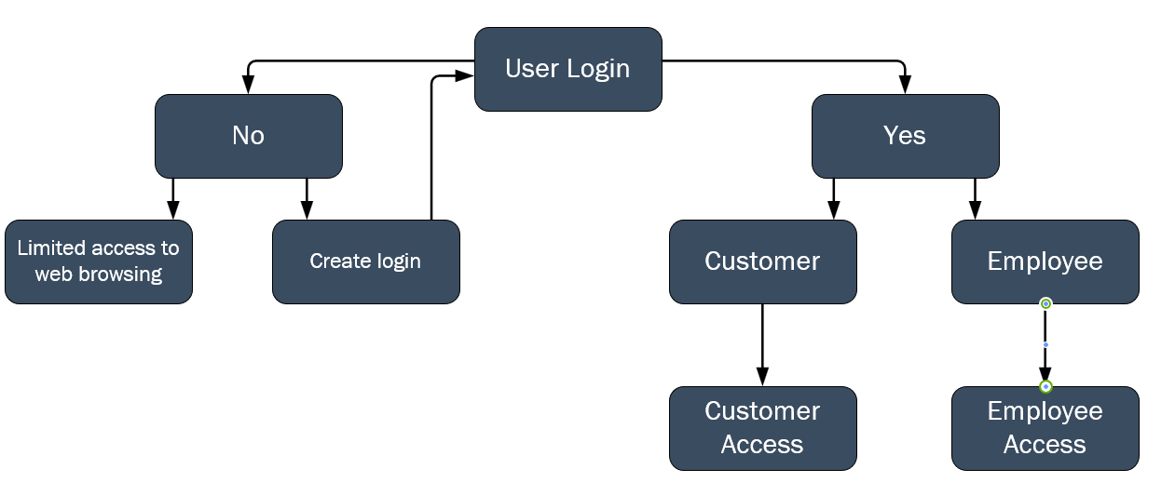

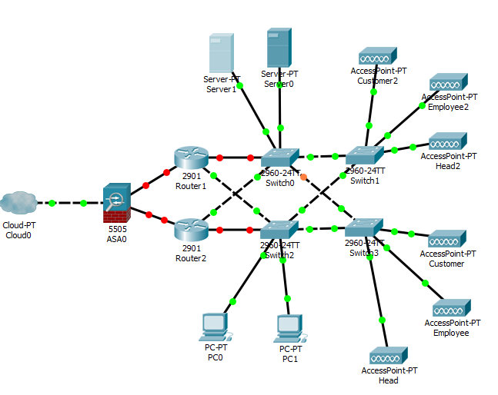
Implementation

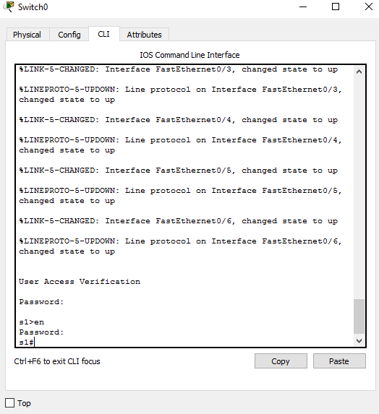

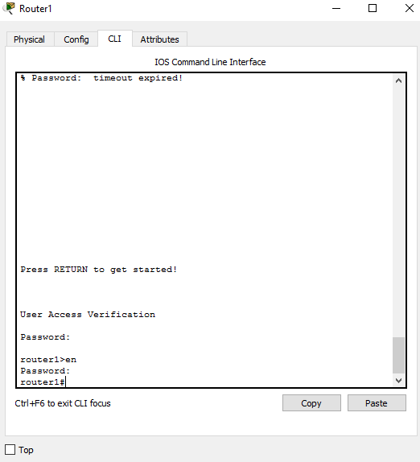

For my implementation sample, I used Cisco Packet Tracer to show an example of how Hyper-forts network for their business could look. I used a design that I learnt in class called a 3 tier hierarchical model (Shown in the red box on the screen capture). The basic design is with 2 routers and 4 switches connected together. The routers are called the core layer, the middle switches are my distribution layer and the last 2 switches are the access layer, shown by the fact that wireless access points are connected to them. Security has been applied with the requirement of a password, in all cases with my routers and switches, my password is “cisco”. According to Cisco Press [5] “The Cisco hierarchical (three-layer) internetworking model is an industry wide adopted model for designing a reliable, scalable, and cost-efficient internetwork”

Mobile Device Management
Mobile Device Management software (or MDM for short), is a software that businesses use to keep tabs and secure any mobile devices (E.g. Laptop, phone, tablet etc.) an employee may use. MDM’s are capable of monitoring devices across different operating systems, as well as different service providers. Comtact says [6]“With the rapid rise in mobile security threats, together with the increased compliance requirements from GDPR, every company should have some form of mobile management strategy.” This is a good way of keeping a network and its data secure when using BYOD/BYOT as it would allow Hyper-fort to monitor what is being viewed on employee’s personal devices. Vangie says [7], “Most mobile device management solutions provide organizations with end-to-end security — meaning the mobile apps, network and data used by the mobile device (in addition to the mobile device itself) are managed by an organization's IT department with a single mobile device software product.”
A good version of MDM is IBM MaaS360. As a whole, the software is pretty cheap, also including a 30-day free trial for a company to get a feel for the software and see if it is right for them, and if it is, the pricing starts as low as £3.20 per device a month. MaaS360 allows companies to identify endpoint vulnerabilities. It is also the only MDM to use an AI approach, meaning it comes with an advisor to help with anything a user may need, as well as pointing out possible threats. It comes with metrics also to give a company accurate data on what is being viewed.

Data Retention
The data retained by mobile devices when connecting to the Hyper-fort network would be data such as:
- Media files
- Location
- E-mails
- Messages
- Internet history (So activity on the network can be monitored)

Data leakage
Any data being taken from a work place via an employee’s personal device has a high risk of being leaked. As Hyper-fort wouldn’t have much control over what an employee keeps on their mobile device (Such as a laptop or phone), they could take any number of sensitive information data with them. All it would take would be a misplacement of said device or a hack on the device for a chance for these documents to be leaked.

Personal/Office life
Hyper-fort should take action against the use of social media in the workplace while accessing the network. This is required to try and keep a difference between work life and personal life. This would also reduce distraction and improve productivity and effectiveness. A social media policy could be used to achieve this. Jimmy says [8] “A social media policy outlines how an organization and its employees should conduct themselves online. It helps safeguard your brand’s reputation and encourages employees to responsibly share the company’s message.”

Device brands
One employee may be less financially challenged than another. Knowing this, one employee could buy a powerful mobile device (E.g. Razer laptop) which can access more aspects of the network and handle it a lot better than another employee who doesn’t have an as powerful device. Minimum requirements would need to be stated so that an employee can make the conscious decision whether to use their own devices or not. Hyper-fort could make a small list of recommended brands of devices that match most if not all of their minimum requirements.

Operating systems
Hyper-fort should document what operating systems are the most used, and recommend them to their employee’s for use. This recommendation should be decided on what operating system is most suitable for Hyper-fort.

Applications
Similarly, Hyper-fort should look at different applications and decide what is most appropriate for them to use, and then recommend them to their employees. These applications could be word processing software, presentation software, cloud storage software etc.

Dismissal/Employee leaves
If in the case of someone leaving the company, or dismissal of an employee, a vital obligatory term and condition should be signed before given the access to the network that states if the employee leaves or is dismissed that their personal devices must be wiped by Hyper-fort’s technicians to reduce the risk of data leakage. Refusal of this term and condition should result in refusal of access to the network.

Comprehensive Security Policy
So, as there are some issues with bring your own technology (or bring your own device), a policy should be set to try and restrict the amount of problems Hyper-fort run into. Using the information above, a policy should be able to be formed.
- Hyper-fort should implement a username and password system for each employee and customer. This way, they can restrict the access to who they want, and keep sensitive information from leaking and getting out to non-users of the network. Also, with individual logins, accounts can be monitored. This can help Hyper-fort stop any browsing of inappropriate data/websites and sensitive information, and if any of it is accessed, they will be able to tell exactly who it is and take appropriate and swift action.
- With the number of devices out there, the network may not be able to support everyone of them. To solve this, the lead technicians along with Hyper-fort higher ups, need to come up with a list of supported devices and in turn, operating systems that their network is going to support. Typically, these would be the most popular, such as IOS for Apple devices, Android for other mobile devices and Windows for most computers and laptops. This should help with stability on the network and keep it from getting overloaded.
- A limit must be set to how many devices a user can be logged into at one time. This is needed to keep stability in the network. One user doesn’t need to be logged in at more than 2 places a time, and even that may be excessive. By keeping the number of devices logged in at a time, there is less need for lots of operating systems to be supported.
- A set of minimum requirements should be set for the employee’s devices. Two sets of requirements should be set for computers/laptops and mobile devices as obviously a handset isn’t going to have the same amount of power as a PC or laptop. This should be in place, so that no employee is too far above one another when it comes to power. Someone may not be able to spend as much money on a device as someone else, and this may stop an employee from being able to access to network on their own device if it doesn’t have the system capabilities to use the network.
- An acceptable use policy (or AUP) should also be incorporated. This is an agreement that users would have to agree to follow the rules of the network have been set (For example, using the network to browse for any data not related to Hyper-forts organisation).
- A social networking policy (or SNP) can also be used, as it could be prohibited to use social media in the office or at home while signed into the network. This also helps keep the blending of personal and business usage separate.
- A obligatory T&C should have to be signed before given the access to the network that states if an employee is let go or leaves their position, their personal device should be handed in to be wiped.
- When a user logs out of the network, and has sensitive data files on their personal device, those files should become encrypted so they cannot be viewed outside of the office. Only members of staff with the correct authentication should be able to log back into the network and decrypt the files.
- Data retained on mobile devices should be quite limited. Unless a user has direct access to the network using their log in credentials, only local access of the network should be allowed. This means that users will still be able to access the network, but just not files from the office.

Conclusion
After this assignment, I can conclude that bring your own device or bring your own technology is helpful and worth it for companies to use. I feel in the long run, it has more advantages to disadvantages, in the ability for employees to access work anytime and anywhere, as well as the cost effectiveness with the company not having to shell out for as many devices themselves. I feel that if Hyper-fort can follow the policy I have suggested, they will be able to contain any potential data leaks, as well as keep a well-structured network for employees and customers to use. I would recommend BYOD/BYOT to any business who wants to improve productivity and effectiveness along with saving some finances along the way.
To improve my findings, I would go to different businesses and companies and ask if they use BYOT/BYOD policies and get their views on it. If they do have the policy, ask how they’ve found it since it has been implemented and see if they regret their choice. If they don’t have the policy, ask why they opted against it and ask if they could see themselves maybe implementing it in the future.

Bibliography

[1] | T. V. Wilson and J. Fuller, "How Home Networking Works," howstuffworks, [Online]. Available: https://computer.howstuffworks.com/home-network3.htm. [Accessed 5 January 2019].
[2] | A. Rivera, "8 Benefits of Online Data Storage," Business News Daily, 6 September 2017. [Online]. Available: https://www.businessnewsdaily.com/6294-benefits-of-online-data-storage.html. [Accessed 05 January 2019].
[3] | R. Team, "The Advantages & Disadvantages of BYOD," RTI, 26 July 2018. [Online]. Available: https://www.1rti.com/the-advantages-disadvantages-of-byod/. [Accessed 4 January 2019].
[4] | C. S. Jose, "Cisco Study: IT Saying Yes To BYOD," Cisco, 16 May 2012. [Online]. Available: https://newsroom.cisco.com/press-release-content?articleId=854754. [Accessed 6 January 2019].
[5] | C. N. Academy, "Cisco Networking Academy Connecting Networks Companion Guide: Hierarchical Network Design," Cisco press, 9 May 2014. [Online]. Available: http://www.ciscopress.com/articles/article.asp?p=2202410&seqNum=4. [Accessed 6 January 2019].
[6] | Comtact, "5 benefits of implementing a Mobile Device Management (MDM) platform," Comtact, 12 January 2018. [Online]. Available: https://www.comtact.co.uk/blog/key-benefits-of-implementing-a-mobile-device-management-mdm-platform. [Accessed 5 January 2018].
[7] | V. Beal, "MDM - mobile device management," Webopedia, [Online]. Available: https://www.webopedia.com/TERM/M/mobile_device_management.html. [Accessed 5 January 2019].
[8] | J. Thomson, "How to Write a Social Media Policy for Your Company," Hootsuite, 22 May 2018. [Online]. Available: https://blog.hootsuite.com/social-media-policy-for-employees/. [Accessed 06 January 2019].

marking criteria and Student FEEDBACK

This section details the assessment criteria. The extent to which these are demonstrated by you determines your mark. The marks available for each criterion are shown. Lecturers will use the space provided to comment on the achievement of the task(s), including those areas in which you have performed well and areas that would benefit from development/improvement.

Common Assessment Criteria Applied (Assignment 1) | Marks available | Marks  awarded
1. Research-informed Literature
Extent of research and/or own reading, selection of credible sources, application of appropriate referencing conventions.
Evidence of background reading and good critique/analysis of literature. It would be good to see more references from journals/conference proceedings as this would add more credibility to your work. You can access many journals from the online library - https://www.uwtsd.ac.uk/library/online-library/, IEEE and ACM are the main ones for computing. Avoid using all websites (Grade mark: 66.67%) | 15 | 10
2. Knowledge and Understanding of Subject
Extent of knowledge and understanding of concepts and underlying principles associated with the discipline.
You have demonstrated knowledge of the underlying concepts and principles. (Grade mark: 66.67%) | 15 | 10
3. Analysis
Analysis, evaluation and synthesis; logic, argument and judgement; analytical reflection; organisation of ideas and evidence
You have explained and discuss very well all areas required for this assignment. (Grade mark: 75.00%) | 40 | 30
4. Practical Application and Deployment
Deployment of methods, materials, tools and techniques; application of concepts; formulation of innovative and creative solutions to solve problems.
In your report you have included the packet tracer design diagram but you have not submitted the implementation. (Grade mark: 25.00%) | 20 | 5
5. Skills for Professional Practice
Attributes in professional practice: individual and collaborative working; deployment of appropriate media; presentation and organisation.
A presentable work with some grammatical errors. Avoid 1st person writing and the use of contraction grammar. (Grade mark: 70.00%) | 10 | 7

Assignment Mark (Assessment marks are subject to ratification at the Exam Board. These comments and marks are to give feedback on module work and are for guidance only until they are confirmed. ) | Late Submission Penalties (tick if appropriate) |  | 62%
 | Up to four weeks late |  | 62%
 | First Attempt? |  | 62%

