Harvey Langston (1901416)

Canolfan Carwyn

Post 1:
It became apparent that Canolfan Carwyn was a developing centre trying to appeal to the local community whilst in the long run appealing to a larger community across the entire demographic of the area. As a new community run centre it has had to face the adversities of the demographic of the immediate area. A typical issue that I expected to see with Canolfan Carwyn was the support it would receive from its local environment to enable it to ensure its growth. However, what Canolfan Carwyn has done excellently well is adapt to its local demographic.
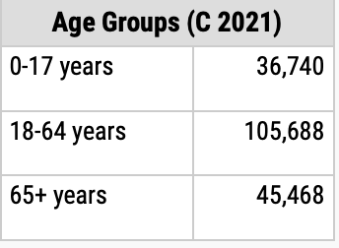
City Population (2021) declared this graph as their representation of the ages of the people living in Carmarthenshire. As you would expect the largest bulk sitting in the 18-64 range therefore that would be primarily the target audience. The next issue that would need to be faced would be what activities would appeal to that target audience. Sport is always the easy option to appeal to the masses as sport plays an integral part specifically in this age range however it cannot always be relied on. As a whole community, other hobbies and interest would need to be considered. There was a surprising amount in the 65+ category and from my personal research into the tighter community of Drefach it became apparent there was a higher elderly community. This needed to be considered as this could be another challenge that was faced. Covid 19 is another challenge that community centres would have had to face and are still facing the effects of today. As shown by Sported (2021), arears such as funding, staffing, re-engagement, and maintaining that engagement would be difficult to uphold due to Covid 19.
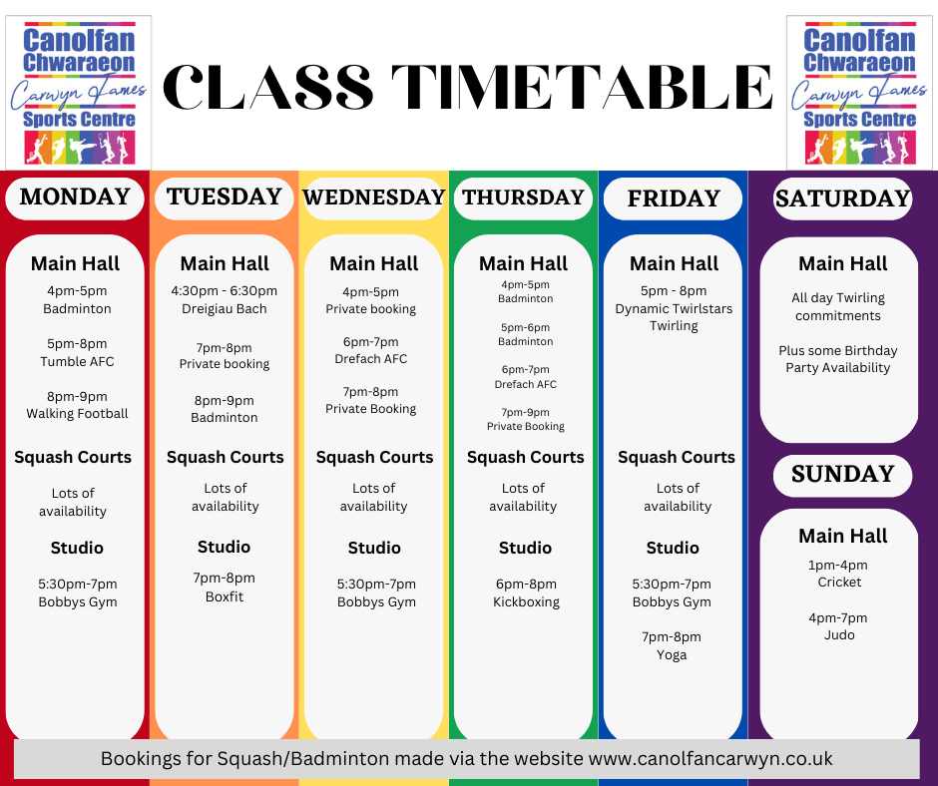Post 2:
The roles that community centres play is detrimental to its local community. If run correctly and for the right reason they provide many benefits to their community. Canolfan Carwyn is one of the best examples I have experienced due to its new revival.
The timetable of activities listed for Canolfan Carwyn show the importance behind a community centre. Due to Canolfan Carwyn being a community run centre it has allowed clubs such as Tumble AFC, the Batton Twirling and Drefach AFC to be able to continue with the facilities they need whereas before this may not have been the case. Although the timetable appears to be primarily sporting events, from my personal experience of the centre there are many opportunities for other events to occur. Afternoon teas, which appeal more so to an elder generation to allow social interactions. Community centres open a magnitude of opportunity from all aspects as shown by Refworld’s “One-stop-shop” idea which refers to the ease of access community centres give people of all demographics. Those less fortunate can travel a short distance to have equal opportunity to those around. This also allows social interaction between the whole demographic of an area whether that be social background, race, gender, or age. Through this, it will also be a source of education particularly for the younger generations. The nurture centre in Carmarthen is another example of a community centres every changing role as this centre moves away from a sporting demeaner into a relaxation aura. Nuture’s “Home from home” slogan epitomises what this community centre means. A place in which you can relax and feel comfortable in whilst being surrounded by others. The main benefit I have seen from community centres are their capabilities of bring communities together as a whole instead of individuals in an area.
Post 3:
Our group wanted to achieve an idea that we thought was lacking in a community centre and that was an activity that would appeal to a ranging demographic much like the Gwendaeth Valley. From our research and visit to Canolfan Carwyn it appeared there are a vast range of activities that occur within the community centre for all sorts of people. However, no activities that bought all demographics in that area together. Therefore, our idea of a quiz was with the intention to do just that. The thought process behind our ideas from the start was to not limit ourselves to whom our event would benefit, allowing us to appeal to a greater audience. We believe a quiz was the best option for this as it did not limit us to a specific sector of the demographic of that area nor did it mean restricting anyone. We could include everyone from that community in the same space to allow diversity within the community. For me it highlights what is important for a community centre in that it appeals to the whole community for a wide range of reason whether that be reducing social isolation, approvement on mental health, or just for entertainment. Before finalising our idea, we had to consider the longevity of our event as we would want it to be something that the community centre could consider continuing to further benefit the community, which is another reason we finalised a quiz. The simple organisation and relatively little equipment needed for such event, it was a low-cost event that can reap the rewards to be able to invest back into our community therefore not only would individuals receive the benefits from the event, but the centre itself could also benefit. The quality of the event is important as this is what will encourage the outcome of the event. After looking closer into the larger community of Carmarthenshire, there are many places that do quizzes on a weekly basis, but none close by to the Gwendraeth Valley that we could see which also provided us which another great reason to organise this event. It’s a concept that many know about however may not have access to therefore our aim is that those within the Gwendraeth Valley are able to access this. After speaking to Jess and Kelly about our event ideas, it was bought to our attention that a gentleman had been trying to organise a quiz night for some time without success which opened even more of an opportunity to organising this event. Business (2023) highlights the importance of advertisement as a vital way of reaching out to a larger range of people, and as a community that rely quite heavily on social media nowadays, we thought it best to go along that route to reach out to as many as we can. From working with someone from the local area benefits us and the community. It can benefit us as they will have an even larger knowledge of the area to us which will work in our benefit as well as benefitting the community because as a resident, they will have more of an understanding what is potentially needed for that area.

References:
City Population (2021) Retrieved from: https://citypopulation.de/en/uk/admin/wales/W06000010__carmarthenshire/

Sported (2021), Community sports groups face biggest challenges yet, as they prepare to reopen. Retrieved from:
https://sported.org.uk/community-sports-groups-face-biggest-challenges-yet-as-they-prepare-to-reopen/

Refworld (2021), Community Centres, UNHCR. Retrieved from:
https://www.refworld.org/pdfid/573d5bc64.pdf

Nurture, Home From Home. Retrieved from:
https://www.nurturemagu.com/about

Business, Advertise your business, Australian Government. Retrieved from: https://business.gov.au/marketing/advertise-your-business

