3. In the light of one of your visits, examine the arguments for and against removing monuments OR buildings from their sites in the landscape to the safekeeping of the museum.

Buildings are sometimes moved from the locale in which they originate to a more secure environment so that they may be better preserved. This is what happens at sites such as St. Fagans, an outdoor museum that houses many buildings from around Wales. Whilst examining the arguments for and against removing buildings from their sites in the landscape to the safekeeping of the museum, in this case St. Fagans, it is important to also look at monuments that have been moved elsewhere. This is a much more common occurrence and the arguments apply similarly in both instances. By removing a building is the history gone from it or can it still retain its spirit and the memories? This is one of the main issues with the moving of buildings and what shall be looked at here. Ford W. Bell states that a museum’s ‘single greatest asset is authenticity’, a point which shall be explore in greater detail here. [Bell.2012]

Since being established in 1948, St. Fagans National Museum of History has acquired many buildings from around Wales rehoming them in the grounds of St. Fagan Castle. This not only preserves the building, but also helps to educate visitors on the history of Wales and Welsh culture. In 1948 Iorwerth Peate, Welsh scholar, poet and co-founder of St. Fagans National History Museum, said:

‘[The task] was not to create a museum which preserved the dead past
under glass but one which uses the past to link up with the present to
provide a strong foundation and a healthy environment for the future
of their people.’
[Iorwerth C. Peate. 1948]

Having the various buildings relocated to the site of St. Fagans created a place that people could visit to stroll through time, visiting different parts of Wales and different centuries all in one afternoon. This gives one the opportunity to better understand what life has been like for different people and how homes and technologies have changed. There is no doubting that the educational benefit of sites such as St. Fagans, however, does this excuse the removal of buildings from their original site? This is the main question which must be addressed here.

Buildings can hold great value within communities, the removal of such historic and important buildings from a community may take away the connection they have with their original locale possibly lessening their importance. However, this can often be done in the interest of the building, to be conserved in such a way that would not be possible locally. Here, examples such as ‘Seahenge’, may give a relevant insight into the reasons for the removal of societal icons in the interest of conservation and research.
The site dubbed ‘Seahenge’ by the media, but was also known as Holme I, was discovered in 1998. [Pryor. 2012] The uncovering and subsequent excavation of the site was heavily documented by the media, it was also heavily criticised by local and national communities alike. [Pryor.2012] The most controversial part being the exhuming of the henge to place it in a national museum away from the town with whom it shared an almost spiritual connection. However, despite the backlash, this was thought to be the best decision for the delicate wood as the local museum would never be able to curate and maintain the artefact in the way it needed, making it necessary to move ‘Seahenge’ to protect it. There was another henge found at the site, it was decided that this one be left in situ, thus giving the local people and others who connected spiritually to the site, a chance to hold ceremonies and the like with the remaining henge. This of course meant that the wood would be slowly taken by the sea and soon be lost forever. Here seeing that it is not always best for items to be left where they were found as in many instances, local museums and communities who desperately want to hold onto part of their heritage, cannot provide the appropriate care.
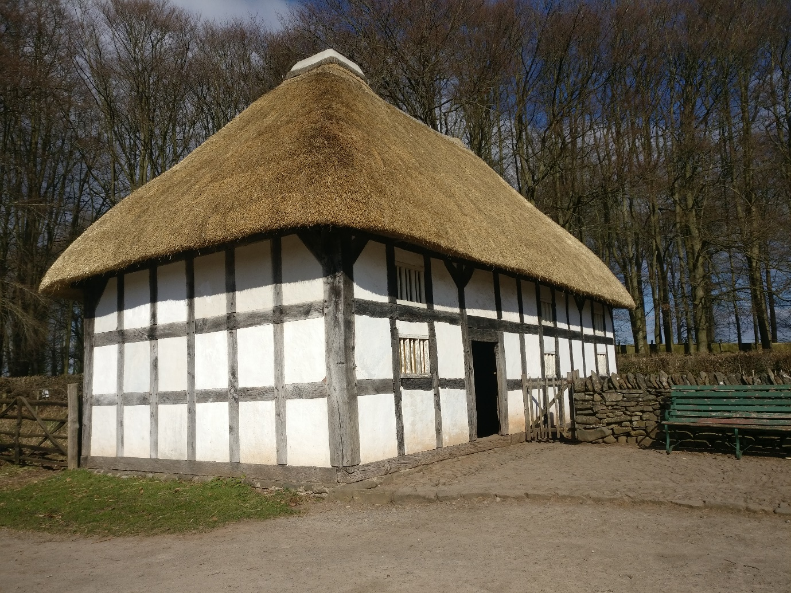
Fig. 1 - A picture showing an example of a building that has been rebuilt at St. Fagans museum, specifically the Abernodwydd Farmhouse from Llangadfan

Buildings cannot be so readily placed within a museum, places such as St. Fagans are quite a rarity in their ability to house relics of such size. Although the buildings homed at St. Fagans haven’t all remained within the communities they originated, they have at least all remained within Wales; and while they are being kept nationally, rather than locally, Wales being such a small country holds onto all its heritage so intently that these buildings still retain their cultural history.
It can be very easy for old buildings, especially those which are no longer in use, to fall into disrepair and perhaps even collapse altogether. Had they been left some of these buildings may well have been condemned, but, by rebuilding them at a site such as St. Fagans they not only get a new lease of life, but also the best conservation possible. Here again we must ask if removing the buildings from their original locale for the sake of conservation in some way removes the purpose and significance that they held. Away from the community with whom they share their history, they just become another building. However, this isn’t to say they aren’t still a useful educational tool to teach about the rich history of Wales.

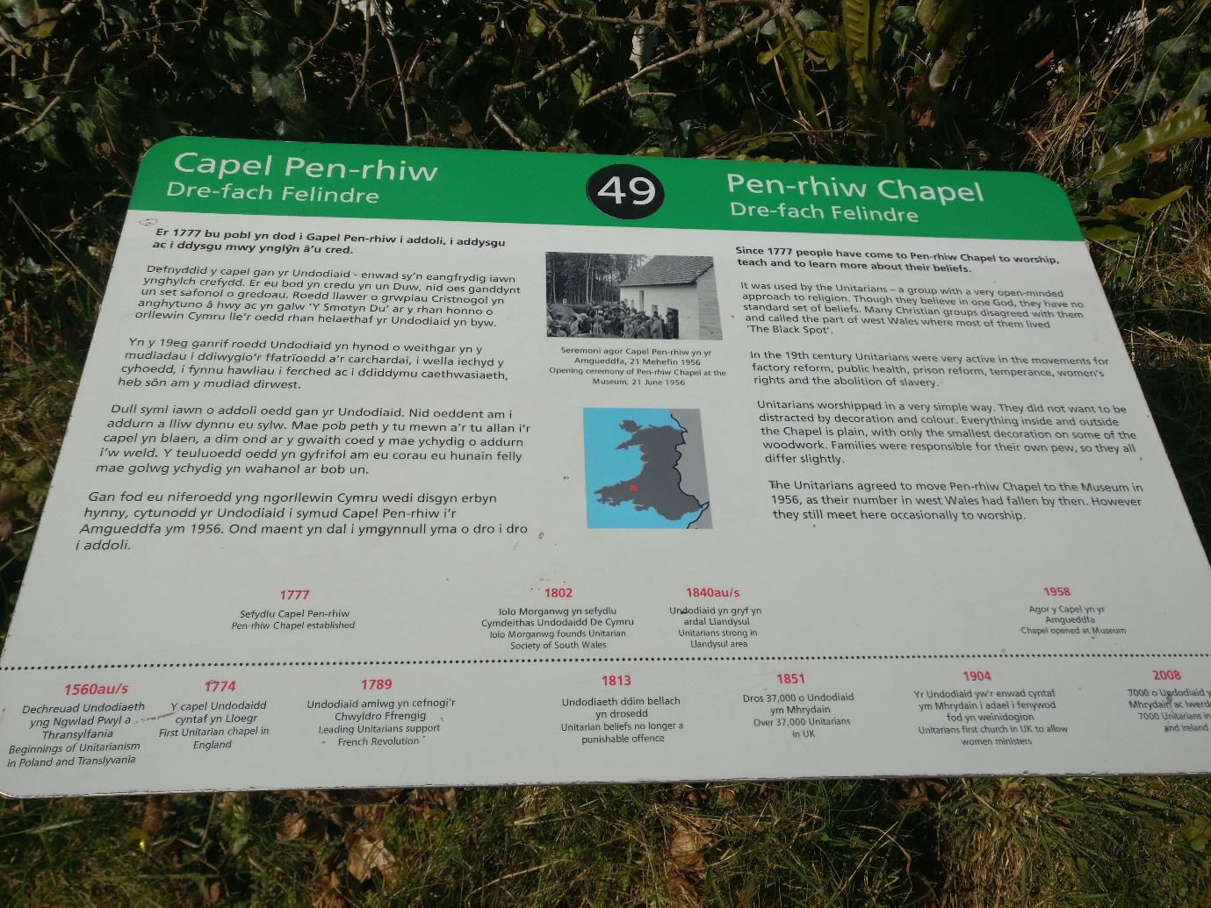
All the buildings at St. Fagans are distinct from one another. As such each will have presented its own unique problem when it came to their moving. For some, like the round houses, it was not a case of moving anything but instead an experimental reconstruction of the Iron-Age round house based on archaeological evidence from Bryn Eryr. [St. Fagans – Bryn Eryr] In the case of the stone buildings they will have been removed brick by brick and pieced back together much like a jigsaw puzzle, arguably this makes these the most authentic in terms of the building structure, as all that is different is the material holding the bricks together. [BBC.2012] However, there are some buildings in-between completely re-built brick-for-brick and completely reconstructed, these are the buildings that were made from mainly wood. In these instances, once the building had been chosen to be relocated there became the problem of how one disassembles and reassemble the wood and cladding of a building made of such delicate material. Here, the answer was to take the main timbers and to create the frame of the building, from there most of what we see now has been recreated using the same techniques and materials we think would have been used on the original. [Walker.2018: pers comm] This brings with it the question that if a building has had to have so much of its material replaced is it still the same building that was so important it needed moving? It would seem, at St. Fagans at least, that although these buildings may not be one-hundred percent the same as the ones that originally stood, they do look the same and the same atmosphere is recreated. This is something that, had they been left where they were, would have been lost as they could have fallen into disrepair or been completely gutted out and their purpose changed completely.
Fig. 2 - A photograph of the signage outside each of the buildings at St. Fagans, specifically the one outside Pen-rhiw Chapel
Although, there could perhaps be better information about what had to be done to construct the buildings and what had to be changed, one aspect that St. Fagans must be commended for is the way the information is presented about each of the buildings. As one meanders their way around the “museum” one will be confronted by the signage outside each of the buildings. These signs follow a common format, that can be seen in fig. 2, which not only presents the history of the building but also includes maps showing its original site. On the left-hand side of the sign is the story and history of the building in Welsh, with the English translation on the right-hand side. In the central part is an unlabelled map of Wales with a red dot where the building originated from, this means that even those too young to be able to read can see how far away the building is from where it is now. At the bottom there is also a timeline of the buildings history, right from when it was built to its move to St. Fagans. All of this means that although the building may not be at its original site it at least pays homage to the history of the building and makes sure that the visitors know about where the building is from, thusly insuring that the building’s heritage is not forgotten and understood to some degree by all that visit no matter their age.

A building which is in the process of being moved, to St. Fagans from Cardiff, is the Vulcan Hotel. This gives an insight into what happens during the moving of these buildings, as well as how they intend to furnish and use the building upon its completion. The Vulcan Hotel was originally built in 1853 and has since stood witness to Cardiff’s many changes over the years. However, the plan isn’t for the building to be presented how it was when it was built, or even how it was when it closed in 2012, but rather to present the building as it was in 1915. This marked an important year for the hotel, also a popular public house, as this marked the year that it reopened after having had a major renovation by its owners at the time (the McCarthy family who also lived in the hotel). [St. Fagans – The Vulcan Hotel] [BBC.2012]
Like many of the buildings at St. Fagans the Vulcan Hotel will not just be a shell for people to walk around, but a functioning establishment. Doing this not only creates an atmosphere for the customers and visitors to the site, but it also helps generate an income for the museum. Amongst other ventures they hope to have a selection of beers from history. This isn’t to say they will have a Theakston’s beer that was discontinued five years ago, but rather that they will be having beers brewed using different methods and different ingredients from throughout history. The aim is to have an Iron Age beer alongside a Medieval beer, and so on. This will hopefully not only provide interesting drinks for the customers but also a learning curve for the museum as they see how different people may have made beer. This should help tie together a lot of the buildings on the site as the different aged beers will hopefully match the ages of the other buildings. Although this is not what would have originally been served in the Vulcan Hotel, by mixing it up and presenting something a bit different it helps aid the educational angle of the place and give the building a function again. [Walker.2018: pers comm]
However, it becomes clear that there is a wider problem of authenticity, not just of the buildings but also in how they are used. Although this is an important issue, much like the argument for or against the moving of buildings, it seems to culminate in questioning if the problems out way the educational value. The site is one of learning and it does this in such an effective way that the aspects of the buildings that are not traditional, be it new beers created from various times in history, or the experimental roofing techniques they have employed on the round-houses, are less of a concern. Issues of authenticity have also been discussed by academics. Valerie Casey, for example, explores authenticity and aura, stating that as soon as an object enters a museum it is validated by its presence in that location. [Casey.2003] This suggests that it is not about the originality but that the museum is deciding what to present and thus authenticating the items for the public. The value these objects have is greatly aided by the way the museum presents certain objects such as St. Fagans’ shops that function as shops, giving them a greater value to the public than just having a shop shell. In fact, these constructed buildings are in some may more important than they were where they stood previously as they not only hold the history and spirit of the building it once was, but they also have the added value of having taught us how these buildings were made and the ability to observe the aging process on various materials. There is however one aspect of Casey’s thesis that does not necessarily apply to St. Fagans and this is the aura. She speculates that part of what helps the museum give an object authenticity and sense of aura is the fact that the engagement with the object is restricted and controlled. [Casey.2003] This however, is not something that can be done at St. Fagans, when one walks around you can very merrily run up to a building and touch it, you can feel the brick and the mortar. This, by her definition would remove the aura of the building. What St. Fagans do is place certain restrictions on one’s ability to access certain objects within the buildings. Although these are not necessarily the actual objects that St. Fagans is presenting this does in some way remind the visitors that this is a museum and that there are certain restrictions. Were they to restrict visitors from touching and going near the actual buildings it would defeat the whole purpose of what Peate had created, as we must not forget that they are the actual items that the museum is presenting.

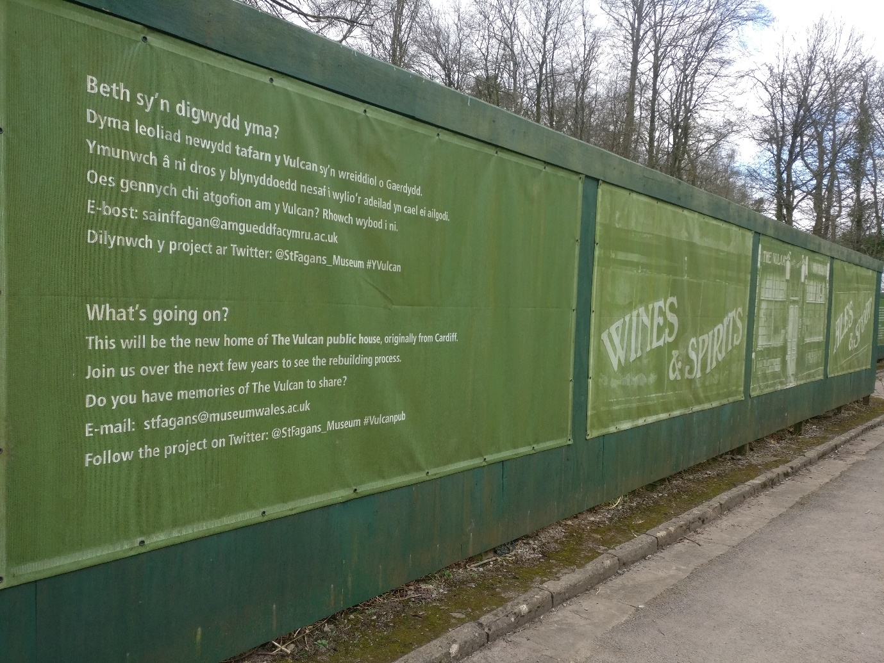
Ultimately, although at St. Fagans the buildings may not be used in the exact manner in which they once were, and they may not be wholly the same building they were, these buildings are serving a different purpose to educate the old and the young. This means that it does not matter as much if they are not completely accurate, or if they are completely out of their original context as they are serving their new purpose regardless. The very fact that these buildings are still standing, all be it in a new location, is evidence enough that the relocation has been successful for these buildings. And, those being built from scratch allows for this experimental archaeology which educates even the specialists as new things are discovered all the way through the construction process.
Fig. 3 - A picture showing the signage at St. Fagans that tells the visitors about upcoming buildings and projects, specifically the Vulcan Hotel

Bibliography

BBC. 2012. Work starts to move Cardiff’s Vulcan pub to St Fagans museum. Available from http://www.bbc.co.uk/news/uk-wales-south-east-wales-18816130 Accessed 02/04/18
Bell, F.R. 2012. Speaking at the Museum of New Mexico Foundation’s 50-Year-Thank You!. Santa Fe, New ,Mexico: American Alliance of Museums 22nd September
Casey, V. 2003. The Museum Effect. Presented at the ICHIM 03 conference in Paris at the Louvre. Available from http://www.valcasey.com/thesis/thesis_effect.html Accessed 23/03/18
Peate, I.C. 1948. Available from https://museum.wales/stfagans/stfagans-history/ Accessed 31/03/18
Pryor, F. 2012. Seahenge: a quest for life and death in Bronze Age Britain. United Kingdom: Harper Press
National Museum Wales. Historic Buildings at Saint Fagans: Bryn Eryr Iron Age Farmstead. Available from https://museum.wales/stfagans/buildings/bryneryr/ Accessed 02/04/18
National Museum Wales. Historic Buildings at Saint Fagans: The Vulcan Hotel. Available from https://museum.wales/stfagans/buildings/the_vulcan_pub/ Accessed 02/04/18
Walker, E. 2018. Personal communication. 14th March

Images

Fig.1 - Abernodwydd Farmhouse from Llangadfan. ©Martha Warren. 16th February 2018. St. Fagans Museum National Museum of History, Cardiff, Wales.

Fig. 2 – Sign outside Pen-rhiw Chapel. ©Martha Warren. 16th February 2018. St. Fagans Museum National Museum of History, Cardiff, Wales.

Fig. 3 – Sign advertising the building of the Vulcan Hotel. ©Martha Warren. 16th February 2018. St. Fagans Museum National Museum of History, Cardiff, Wales.

