Strategic development and implementation for SMEs

Student Name: Mihaiela Petreanu
Student ID: 2030622
Module lecturer: Faizu Edu
Programme Name: BA (HONS) Leadership and Management Skills for The Workplace
Module: Strategic Management for SMEs
Module Code: BMSW6104

Executive Summary

This report highlighted the importance of SMEs in the UK’s economy showing their contribution to the country’s GDP. It was found that after so many financial and political obstacles in the country, the rate of economic development of these SMEs is promising. During the time of Covid, many SMEs faced several challenges to survive and many SMEs were closed. Moma Foods is one of the SMEs of the UK which is trying to improve its market in the country by innovating different kinds of oats-based diet products.
In this study, the mission, vision, aim and objectives of the company were highlighted from which it is clear that the company wants to expand the business and wants to deliver an innovative range of products that can impress customers and make their life healthy. In order to analyse the current business situation of the company, internal and external environmental analyses were conducted.
On the other hand, the role and power of the stakeholders were shown through the “Power-Interest Grid” from which it was found that employees, customers, the Government and the board members of the company are the main stakeholders of this business.
Lastly, a future development plan was given to suggest the goals and strategies that the company can use for its future growth.

Table of Contents
Executive Summary 2
a) Introduction/ Overview of the case study 4
b) Strategic Direction of the Organisation 4
Mission 4
Vision 5
Values 5
Goals and Objectives 5
c) Business Environmental Analysis 6
External Environment Analysis 6
Internal Analysis 12
d) Strategic Growth Evaluation 13
Implementation of Porter’s Generic Strategies 14
Implementation of Ansoff Matrix 15
Proposed Strategy 16
e) Stakeholder Analysis 16
Types of Stakeholders 16
Stakeholder Assessment with Power-Interest Grid Analysis 17
Analysis of the stakeholders’ expectations and power on the business 19
f) Strategic Recommendations and Future Development Implementations 21
Challenges of SMEs 21
Recommendations 21
Future Development Plan 23
g) Conclusion 23
References 25

a) Introduction/ Overview of the case study
Managing a business strategically is quite a difficult task because business professionals have to do a detailed environmental analysis of the internal and external environment of an organisation (Saeidi et al. 2019, p. 3). Moreover, the functional analysis, the strategic growth analysis and analysis of the mission, vision and aim of the company need to be done properly. In this report, the business analysis will be done on Moma Foods, a UK-based organisation that is known for selling diet-based foods such as, oat drinks, oat milk, muesli and porridge (Moma Foods About, 2023).
This organisation was established in 2006 by Tom in South-East London and now the oat products of Moma Foods are available in almost all the supermarkets and health food shops in the UK.
The report will highlight the market size and growth potential of the UK’s SMEs along with discussing the average revenue earned by the SMEs. Apart from that, the challenges faced by the SMEs will be highlighted by analysing the internal and external situation of the chosen company. The growth potential of the chosen company will be discussed using Porter’s Generic strategies and the Ansoff matrix. The stakeholder analysis of the company will be given highlighting the stakeholders and their power and contribution to this business. Lastly, some recommendations are given to the company analysing its present situation along with a future development plan.

b) Strategic Direction of the Organisation
Moma Foods is a medium-sized enterprise situated in the UK which is known for selling healthy food products. In order to evaluate the strategic direction of the company, the mission, vision, values, goals and objectives will be analysed.

Mission
The mission of the company is to craft and deliver the tastiest food items and drinks from the “wholegrain British Oats” which have the finest quality (Moma Foods, 2023).

Vision
The vision of the company is to become one of the leading food companies producing healthy food items of the finest quality. Many food brands are producing healthy and tasty food and drinks such as, Misfits Health, Hungry Monkey Snacks and many others. Moma Foods wants to become the leading food brand among them that will not only give the option of healthy foods but will also prove that healthy foods can be tasty.

Values
Though it is a medium enterprise, but it values sustainability in the business. The organisation is accountable to the communities and is committed to its school breakfast clubs. The company delivers almost 45000 breakfasts all over the UK for school-going children (Moma Food Sustainability, 2023). Considering the food wastage issue in the UK, the company closely operates with Fareshare and other food charity organisations to reduce the wastage of food.
Apart from that, the company uses a green packaging policy and reduced 6000 kilograms of plastic pollution by entering the market as it stopped using plastic packaging since 2019 (Moma Foods Sustainability, 2023). Following the values of sustainability, the organisation is using recyclable materials for packaging to save the environment.

Goals and Objectives
- To serve the tastiest and healthiest oat-based food products and drinks to people at affordable price
- To increase more branches of the company
- To follow the recycling and reusing policy maintaining sustainability in business
- To innovate new flavours of healthy drinks and foods to make breakfast delicious for all age groups
- To reduce food wastage and recycle food products

c) Business Environmental Analysis
In order to analyse the business environment of the organisation, it is important to understand the internal environment as well as the external environment. Therefore, the environmental analysis will be divided into two sections which are as follows:

External Environment Analysis
PESTLE Analysis
Political
In order to define the political condition of the UK, it is important to understand its “political stability index” which defines how safe the political condition of the country is currently. Presently, the “Political Stability Index” of the company is, 0.54 indicating not a suitable political condition for the SMEs in the UK (The Global Economy, 2023). The stability score is not so high which can assure that the political condition of the country is stable.
Currently, almost 5.55 Million small and medium-sized enterprises (SMEs) are operating in the UK (Clark, 2023). Micro-sized companies have 8.77 Million employees, small companies have 4.35 Million people and medium-sized companies have 3.6 Million people (Clark, 2023). Therefore, having this poor score can be problematic for the SMEs of the UK as well as for Moma Foods. The reason for this political unstability is, Brexit and the sudden outbreak of Covid which created tension between the Government and other political parties.
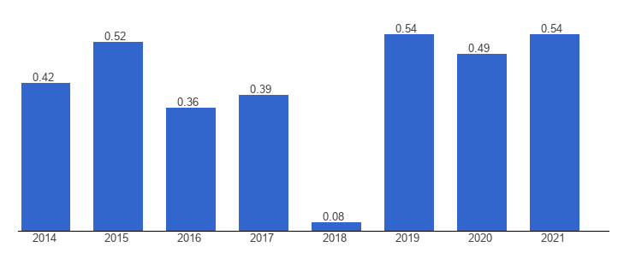
Figure 1: Political Stability Index of UK
(Source: The Global Economy, 2023)

Economic
Due to Covid and Brexit, the economy of the country is severely affected and the GDP growth rate has also become negative. Currently, the rate of GDP growth is -0.1% which is a matter of concern (Trading Economics, 2023). On the other hand, it has been observed that the SMEs of the UK are achieving quite a decent profit despite such economic condition of the country. The average profit made by the UK SMEs is “approximately 12,000 British Pounds” (Clark, 2023).
Moreover, the combined turnover of all the UK SMEs is ￡2.41 Trillion which indicates that the SMEs of this country are growing (Clark, 2023). Therefore, if the GDP growth is high, then the scope of growth will be stronger for all the SMEs of the UK including the selected company.

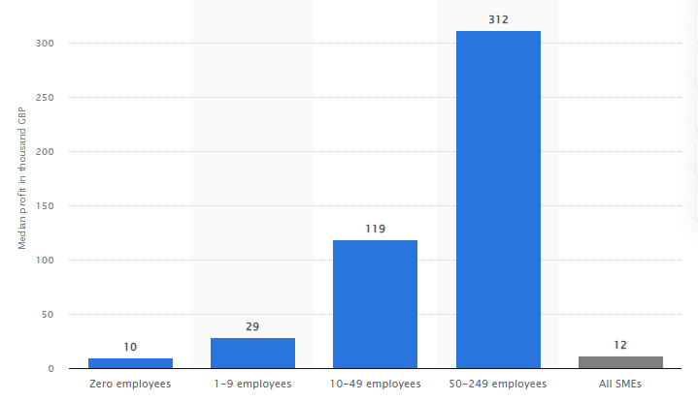
Figure 2: Median Profit achieved by the UK SMEs by size in 2022
(Source: Clark, 2023)
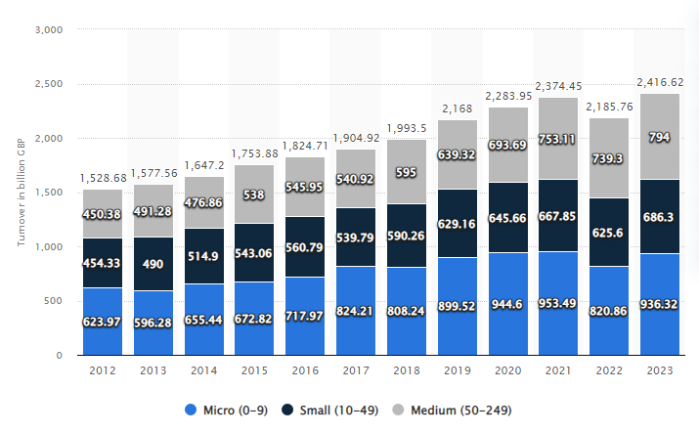
Figure 3: Turnover of the UK SMEs from 2012-2023 (in Million GBP)
(Source: Clark, 2023)
On the other hand, inflation is another economic issue in this country that is not letting the business firms grow faster. Presently, the rate of inflation has reached 3.9% which is positive news for the country’s economy as inflation is decreasing, but the price of grocery and food items are still on a rising trend (Clark 2023 and Partington, 2023).
The inflation rate for food items and drinks has reached 19.1% which is raising concerns for food companies that are start-ups as it will be difficult to manage the business (Partington, 2023). Therefore, the overall economic condition of the country can create very trouble for this SME to manage the business.
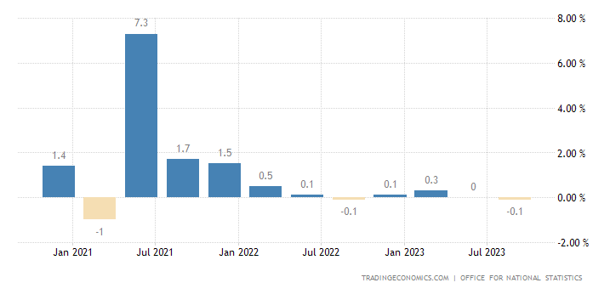
Figure 4: GDP Growth Rate of the UK
(Source: Trading Economics, 2023)
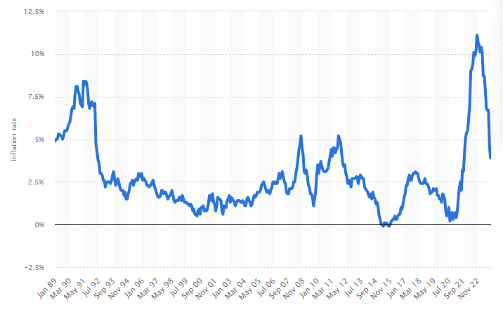
Figure 5: Inflation rate of United Kingdom from 1989 to 2023
(Source: Clark, 2023)

Social
The society of the UK is very progressive, but the problem observed when people became depressed due to the outbreak of the pandemic and the sudden lockdown (Pieh et al. 2021, p. 6). It was very poor for the small and medium enterprises, but currently, situations are changing and the rate of unemployment is decreasing.
Currently, the unemployment rate of the country is 4.3% which is the lowest since 1971 (Statista, 2023). It is a positive sign for SMEs including Moma Foods because a decreasing unemployment rate indicates the purchasing power of people is increasing. Increasing purchasing power will enhance the life standards of people which will divert their minds to invest in other needs like focusing on a healthy and balanced diet increasing the company’s sales.
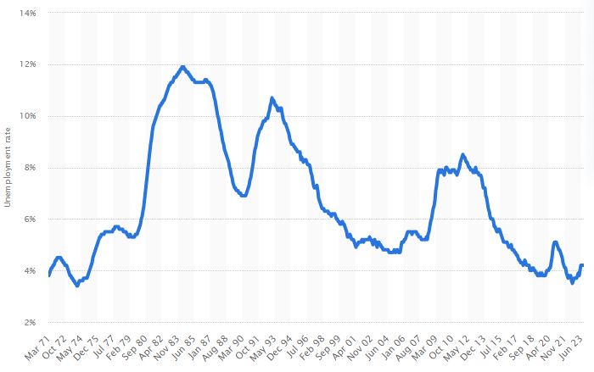
Figure 6: Unemployment rate in the United Kingdom from 1971-2023
(Source: Statista, 2023)
Technological
The technological infrastructure of the UK is in a progressing phase where the Government is investing a large amount in technological giants to improve the technological infrastructure of the company. The government has invested £375 million in all the massive technological giants to improve the technological infrastructure of the business firms (Davies, 2021). However, the SMEs will not be benefited majorly because the benefit will be mainly availed by the multinational companies.
On the other hand, the investment in digital technology has been accelerated and it has been assumed that the GDP will increase by 2.8% by 2025 and 7% by 2040 due to technical investments (Statista, 2023). This will be a major support to the technological infrastructure of the country as well as its economic infrastructure. Improving technological infrastructure will encourage the brand to improve its technologies and facilities seeking help from the Government so it can improve the business.

Legal
The country is very particular about its rules and regulations and the Government has instructed all business firms to follow the “Fair Trading Act 1973” maintaining transparency and honesty in business (Legislation.Gov.UK, 2018). Moma Foods is also accountable for following the policies under this act and maintaining its transparency and integrity in business. However, the Government has also constructed the “Employment Rights Act 2002” which states the rights of employees (Legislation. Gov.UK, 2023).
However, it has been observed that despite this act, many companies like Marks and Spencer, WH Smith and Argos are not providing the minimum wage to employees (Saker-Clark, 2023). However, the Government has taken a drastic step and fined £7 Million to these companies for not paying the minimum wage to almost 63000 workers (Saker-Clark, 2023).
This is a huge step taken by the Government to be aware that every organisation has to pay ethically to their employees. Therefore, the organisation is bound to follow all the legal considerations for its business strictly.

Environmental
In terms of analysing the environmental condition of the country, it has been found that the ratio of food wastage is reaching an alarming phase in the UK. A recent report says that European Households are producing “c.70kg of food waste every year” which means a family of four people is producing more than “280 Kgs of wastage every 12 months” (Circular, 2022).
This statistic is very shocking because food wastage creates a huge social and environmental degradation in a society. Excessive amounts of food waste release greenhouse gases creating high pollution in the environment (Jeswani et al. 2021, p. 2). As discussed earlier, Moma Foods follows a sustainable business and promotes green packaging which will help to reduce food wastage, but this kind of environmental situation can be harmful to the business if not controlled in the future. Excessive greenhouse emissions or landfills can create soil erosion degrading the farming of the country.

Internal Analysis

SWOT Analysis

Strengths
- Innovative business idea to make oats healthier and tastier for children and the young generation. It has been often assumed that oats cannot be that tasty, but this company has changed the concept of oats and innovated many oats-based products like oat drinks, oat milk, oat porridge and oat muesli (Moma Foods About, 2023)
- The quality focus strategy of the brand is another advantage of it because the company never wants to compromise on quality and always tries to deliver superior products.

Weaknesses
- The online presence of the company is very poor because it is a SME and affording digital marketing or social media marketing can be risky for the brand. This is a major weak point because digital marketing will increase the brand’s awareness faster and will convey its messages directly and quickly in an innovative way to people (Kingsnorth, 2022, p. 24).
- Another weakness of the company is its availability in the market because it is available in many stores in the country; still, many firms do not keep Moma Food products due to the low popularity of the brand. Moreover, the stocks are also low so there is a supply issue.

Opportunity
- The positive turnover of the UK SMEs is a huge strength for the company because it will give motivation to the brand that it is going in the right direction
- Digital marketing will create a huge opportunity for promotion for the brand and the products will be displayed on different social media platforms which will make the brand more popular (Erlangga, 2021, p. 2).

Threats
- There are already many healthy and diet food-producing companies like Misfits Health, Hungry Monkey Snacks and many more which are producing almost equivalent products and there will be tough competition among them.
- Apart from that, the unstable political and economic condition of the country is a major concern for this SME as there is a chance of financial loss which is hard to afford for the brand.

d) Strategic Growth Evaluation
In terms of analysing the strategic growth of SMEs in the UK, it has been observed that SMEs mainly follow the product development strategy through which they focus on improving the products or services that they offer. For example, Moma Foods is a food and drink-based company that usually focuses on its product development rather than developing the market.
During the time of Covid, many small and medium-sized enterprises were closed due to a lack of funds and human resources (Juergensen et al., 2020, p. 3). The role of the SMEs is observed in the GDP growth of the UK because the SMEs play a significant role in terms of supporting the economy of the country. The contribution of SMEs to the economy of the UK is £6.9 Billion and they support almost 106,000 jobs (Oxford Economics, 2023). Therefore, it is clear that the economy of the UK is highly dependent on the growth of SMEs.
There are many types of strategic growth options that SMEs can follow including market growth, market penetration, product development, cost leadership, differentiation focus and many more. However, mainly product development strategy is used by these firms to bring more products and services to the market. However, these SMEs can focus on other strategic growth options also which are evaluated below:

Implementation of Porter’s Generic Strategies
“Porter’s Generic Strategy” is a strategic growth model analysing the potential growth of a business as well as a competitive advantage (Islami et al., 2020, p. 6). There are two parameters available in this model which are- costs and differentiation.
Two types of markets are focused on this strategic growth model based on which four different strategies are analysed to improve a business. Cost focus and differentiation focus are the two strategies which are based on the narrow market. On the other hand, cost leadership and differentiation leadership are the two strategies used for the broad market.
All of these four strategies are capable of giving the right direction of growth to a business, but a cost leadership strategy will be the best option from this model to improve the SME's business growth.
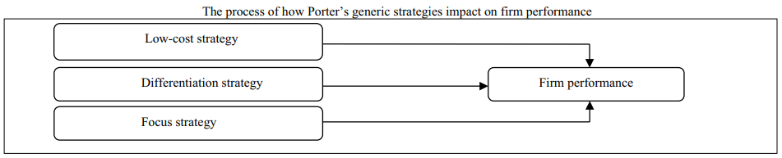
Figure 7: Implementation of Porter’s Generic Strategies to a Firm’s Performance
(Source: Islami et al.,. 2020, p. 6)
Cost Leadership strategy will be the suitable option as per this model to define the potential of Moma Foods because it is an SME and during the time of inflation in the country, implementing a cost leadership strategy will be a suitable option. As per the research findings obtained from Varadarajan (2020, p. 6), cost leadership strategy means focusing on reducing the production cost of an organisation and the leaders maintain this approach to reduce any kind of unnecessary expenses. At this time, it is important to reduce the cost of production so it will be a good strategy for the strategic growth of this business.

Implementation of Ansoff Matrix
Ansoff Matrix is a strategic growth analysis model defining different types of strategic growth options for a business. There are two main sections in this model which are market and products. Markets and products are divided into two sections such as, new products and existing products and new markets and existing markets (Khajezadeh et al., 2019, p. 2).
In order to improve the market of the business, market development and market penetration strategies are available. On the other hand, product development and diversification strategies are available for product development. After analysing all types of strategies in this model, it can be said that the market penetration strategy will be the suitable strategy for the brand.
This strategy will help to increase the sales of the existing products of the company in the existing market as the market trends are well known and it will improve the grip of marketing of the company.

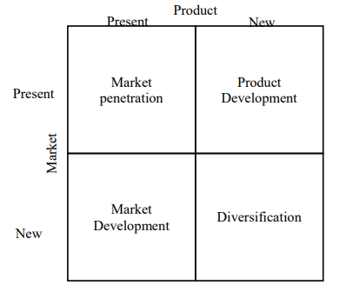
Figure 8: Ansoff Matrix
(Source: Khajezadeh et al., 2019, p. 2)

Proposed Strategy
After analysing the two strategic growth models, a suitable new strategy can be proposed for this SME which will focus on the market penetration strategy by maintaining a cost leadership approach. This strategy will be the best strategy at this point for the company because it will focus on cost management as well as improve sales in the existing market.
“Cost leadership-based market penetration strategy” is the new proposed strategy for the company in which leaders will help to reduce the production cost of business without compromising the quality of products (Keiningham et al., p. 15). On the other hand, the business professionals and the sales and marketing department will increase sales in the existing market using market penetration techniques.

e) Stakeholder Analysis

Types of Stakeholders
There are mainly two types of stakeholders in business who are known as internal stakeholders or direct stakeholders and external stakeholders or indirect stakeholders. ‘

Internal Stakeholders
Internal stakeholders are the stakeholders who are directly connected to the business, belong to the company and have greater contributions to the business (Santoro et al., 2020, p. 4). The internal stakeholders are- employees, staff, the owner of the company and the board members.

External Stakeholders
External stakeholders are those who are indirectly connected to the business but have a greater impact on the business (Santoro et al., 2020, p. 4). The external stakeholders of the company are- customers, the Government, suppliers of raw materials, investors of the business and the local charities.

Stakeholder Assessment with Power-Interest Grid Analysis
The Power-Interest Grid is the stakeholder analysis tool through which the power and interest of the stakeholders can be evaluated (Silvius and Schipper, 2019, p. 14). Power and interest are defined as high and low to analyse the influence of the stakeholders in the business.

High Power High-Interest
In this parameter, the stakeholders have high power over business decisions and their interests are also high. The owners of the company, employees and the board members have high power as well as a high interest in the business

High Power Low-Interest
In this parameter, the stakeholders have high power, but their interest in business management is not that high. Government, Customers and suppliers have high power to influence business decisions but have less interest in business management.

Low Power High-Interest
In this parameter, the stakeholders have very little power to influence the business decisions, but their interest level is high. The investors and the local communities have low power to influence business decisions, but their interest level is high towards the business. The local charities have low power to influence business decisions, but their interest level is high.

Low Power Low-Interest
In this parameter, stakeholders have low power to influence a business decision and low interest in the business. The distributors of this company have low power to influence the business and low interest in it.

High
Low
Power
Low
High
Interest
Manage Closely  - The Owner (Power 5 and Interest Level 5 = 25)  - Board Members (Power 4 and Interest Level 5 = 20)  - Employees (Power 4 and Interest Level 5=20) | Keep Satisfied  - Government (Power 5 and Interest Level 3 = 15)  - Customers( Power 4 and Interest Level 3 = 12)  - Suppliers (Power 4 and Interest Level 3=12)
Keep Informed  1. Local Charities (Power 2 and Interest Level 3 = 6) | Monitor  - Distributors (Power 2 and Interest Level 2=4)

Figure 9: Power-Interest Grid Analysis
(Source: Created by Learner)

Analysis of the stakeholders’ expectations and power on the business

Manage Closely
The stakeholders with high power and high interest belong to this category because their power fulfills their expectations so they can manage the business closely. For example, the business owner and the board members are the main decision-makers in Moma Foods. On the other hand, the employees and staff are the human resources of the business without whom the business cannot operate properly (Malik and Gerg, 2020, p. 3).
Therefore, the owner, employees and board members of this business come under this category who are very closely attached to the business and their expectations and power are high.

Keep Satisfied
Stakeholders having high power and low interest come under this category and it is very important to keep these stakeholders satisfied as they have high power to influence the business. For example, customers are one of these stakeholders who have high expectations and power, but they are not interested in any particular business and always prefer more choices (Hallencreutz and Parmler, 2021, p. 3). Similarly, the Government has the power to change business rules, but their focus is not limited to only one business.

Keep Informed
In this category, the stakeholders have high interest and expectations towards the business, but not much power to change any decisions. Local charities which are connected with this company belong to this category because they are always interested in how the company can help them, but they do not have any major contribution to the business.

Monitor
These types of stakeholders do not have any major contribution to the business and they do not have any kind of interest what is happening to the business. However, they can be affected due to the ups and downs of the business as they are connected with it. Distributors of the firm fall under this category because less stock of Moma Food products will affect their sales a little, but it will not create any drastic change in their businesses.

SFA Matrix

Parameters of SAF Matrix | Strategic Options and Their Scores
Parameters of SAF Matrix | Option 1 (Cost Leadership Strategy) | Option 2 (Market Penetration Strategy) | Option 3 (“Cost leadership-based market penetration Strategy”)
Suitability | 3 | 4 | 5
Feasibility | 4 | 4 | 4
Acceptability | 4 | 4 | 5
Total | 11 | 12 | 14

Table 1: SFA Matrix analysing the Strategic Growth options of the company
(Source: Self-Developed)
Based on the power and interest of the stakeholders, the suitability, feasibility and acceptability of the above-discussed strategic options are given. Depending on “Porter’s Generic Strategies” and “Ansoff Matrix” two strategic options have been identified that can be implemented for the growth of the firm. Analysing from the perspectives of power the stakeholders, both of the strategies are capable, but the most capable strategic option can be the proposed strategy which is a combined strategy based on cost leadership and market penetration.
For example, in terms of adjusting the costs in all aspects may not be possible which is why this cannot be suitable for the business in all conditions. On the other hand, a market penetration strategy is more capable than cost leadership because it will prepare the market for increasing sales.
Lastly, the combined strategy which is the proposed strategy will address all the requirements of the business and can fulfill the demand and expectations of stakeholders by managing the costs and the market needs. This is why it will be the most suitable, feasible and acceptable strategic option for the company.

f) Strategic Recommendations and Future Development Implementations

Challenges of SMEs
There are many challenges that the SMEs of the UK face among which financial crisis is a vital challenge because the shortage of funds can cause business loss (Brown and Lee, 2019, p. 2). This company is not exceptional and this problem may occur in the future. On the other hand, the lack of promotion and advertisements is another issue for which people are not aware of many small and medium enterprises in the UK (Thaha et al., 2021. p. 3).
Technological adaptations are another issue for which the SMEs of the UK lose the competition against the big firms (Elhusseiny and Crispim, 2022, p. 865). Apart from that, internal conflicts, improper business management structure and incapability of making the right decisions at the right time are major challenges that most of the SMEs in the UK face.

Recommendations
After analysing the challenges of the UK SMEs, some strategic recommendations can be given to improve the business of the company which are as follows:
- The proposed strategic option will help the company to grow in the future because it will influence the leaders to manage costs. The strategy will also enhance the focus on penetrating the market to increase sales.
- The company should bring more innovation in its product development. A product innovation strategy can be a good option for bringing a more diversified range of products into the market.
- Focusing on quality management and enhancing the checking parameters before final product delivery will be required.
- Improving the skills of employees so they can also actively participate in innovating new business management ideas.
- Digital marketing needs to be followed to increase the awareness of the brand as well as the products
- Maintaining sustainability is a good approach, but it should also focus more on green marketing and green production so there will be minimal impact on society and the environment.

Future Development Plan

Goals | Strategies | Responsible Person | Time Required
To become the leading healthy and diet food-producing company in the UK | Bringing more variety in products and research more | Production and Research Development Head | 6 months
To increase the awareness of the brand | Implement a digital marketing strategy and give advertisements on different social media platforms | Marketing and Promotion Head | 6- 8 months
To decrease the cost of business | Tracking the costs of each area and maintaining a strict budget so that unnecessary expenses can be recorded. | Financial and Accounts Head | 3 months

Table 2: Future Development Plan
(Source: Created by Learner)

g) Conclusion
After analysing the entire report, it can be said that the organisation can grow rapidly but due to lack of strategic implementation, it is not progressing properly. The organisation is well aware of the SMEs' challenges, so it should follow all the given recommendations and the future development plan properly. These will help the company avoid any kind of risks in the future. The report has highlighted the contribution of SMEs to the GDP of the UK from which the significance of SMEs can be understood. Understanding the importance of the SMEs in the market of the UK, internal and external environmental analysis of the SME Moma Foods has been conducted. These analyses show there are some risk factors for this company as well as other SMEs in the country including financial, political and environmental risks.

The company's stakeholders play an important role in decision-making and business management. The power and influence of the company’s stakeholders have been analysed through the “Power-Interest Grid”. It has been found that from the stakeholders' perspective, the proposed strategic growth choice is more suitable, feasible and acceptable than the other two strategies discussed above. Therefore, it can be said that the company has to follow the development plan and suggestions properly to improve the business.

References
Brown, R. and Lee, N. (2019) 'Strapped for cash? Funding for UK high growth SMEs since the global financial crisis'. Journal of Business Research, 99, pp.37-45.
Circular. (2022) 'The financial and environmental impact of food waste'. [Online] Available at: https://www.circularonline.co.uk/opinions/the-financial-and-environmental-consequences-of-food-waste/ [Accessed: 29 December 2023].
Clark, D. (2023) 'Inflation rate for the Consumer Price Index (CPI) in the United Kingdom from January 1989 to October 2023'. [Online]. Statista. Available at: https://www.statista.com/statistics/306648/inflation-rate-consumer-price-index-cpi-united-kingdom-uk/ [Accessed: 29 December 2023].
Clark, D. (2023) 'Median profit made by small and medium enterprises (SMEs) in the United Kingdom in 2022, by enterprise size(in 1,000 GBP)'. [Online]. Statista. Available at: https://www.statista.com/statistics/291299/average-profit-of-smes-in-the-uk-by-enterprise-size/ [Accessed: 29 December 2023].
Clark, D. (2023) 'Number of people employed by small and medium-sized enterprises (SMEs) in the United Kingdom from 2010 to 2023, by enterprise size(in millions)'. [Online]. Statista. Available at: https://www.statista.com/statistics/936843/employment-by-smes-in-uk/ [Accessed: 29 December 2023].
Clark, D. (2023) 'Number of small and medium-sized enterprises (SMEs) in the United Kingdom from 2010 to 2023, by size(in 1,000s)'. [Online]. Statista. Available at: https://www.statista.com/statistics/880155/number-of-smes-in-united-kingdom-uk/ [Accessed: 29 December 2023].
Clark, D. (2023) 'Turnover of small and medium-sized enterprises (SMEs) in the United Kingdom from 2012 to 2023(in billion GBP'). [Online]. Statista. Available at: https://www.statista.com/statistics/687367/uk-sme-turnover/ [Accessed: 29 December 2023].
Davies, R. (2021) 'Government sets up £375m fund for ‘gamechanging’ UK tech firms'. [Online]. The Guardian. Available at: https://www.theguardian.com/technology/2021/jul/20/government-sets-up-375m-fund-for-gamechanging-uk-tech-firms [Accessed: 29 December 2023].
Elhusseiny, H.M. and Crispim, J. (2022) 'SMEs, Barriers and Opportunities on adopting Industry 4.0: A Review'. Procedia Computer Science, 196, pp.864-71.
Erlangga, H. (2021) 'Effect of digital marketing and social media on purchase intention of Smes food products'. Turkish Journal of Computer and Mathematics Education (TURCOMAT), 12(3), pp.3672-78.
Hallencreutz, J. and Parmler, J., (2021). 'Important drivers for customer satisfaction–from product focus to image and service quality'. Total quality management & business excellence, 32(5-6), pp.501-10. Available at: https://doi.org/10.1080/14783363.2019.1594756
Islami, X., Mustafa, N. and Topuzovska Latkovikj, M. (2020) 'Linking Porter’s generic strategies to firm performance'. Future Business Journal, 6, pp.1-15. Available at: https://doi.org/10.1186/s43093-020-0009-1
Jeswani, H.K., Figueroa-Torres, G. and Azapagic, A., (2021). The extent of food waste generation in the UK and its environmental impacts. Sustainable Production and Consumption, 26, pp.532-47. Available at: https://doi.org/10.1016/j.spc.2020.12.021
Juergensen, J., Guimón, J. and Narula, R., (2020). European SMEs amidst the COVID-19 crisis: assessing impact and policy responses. Journal of Industrial and Business Economics, 47, pp.499-510. Available at: https://doi.org/10.1007/s40812-020-00169-4
Keiningham, T., Aksoy, L., Bruce, H.L., Cadet, F., Clennell, N., Hodgkinson, I.R. and Kearney, T., (2020). Customer experience driven business model innovation. Journal of Business Research, 116, pp.431-40.
Khajezadeh, M., Niasar, M.S.F., Asli, S.A., Davari, D.D., Godarzi, M. and Asgari, Y., (2019). Application of neural network in portfolio product companies: Integration of Boston Consulting Group Matrix and Ansoff Matrix. International Journal of Economics and Management Engineering, 13(6), pp.821-25.
Kingsnorth, S. (2022) Digital marketing strategy: an integrated approach to online marketing. London: Kogan Page Publishers.
Legislation.Gov.UK (2023) 'Employment Act 2002'. [Online]. Available at: https://www.legislation.gov.uk/ukpga/2002/22/contents [Accessed: 29 December 2023].
Legislation. Gov.UK. (2018) 'Fair Trading Act 1973'. [Online]. Available at: https://www.legislation.gov.uk/ukpga/1973/41 [Accessed: 28 December 2023].
Malik, P. and Garg, P. (2020) 'Learning organization and work engagement: The mediating role of employee resilience'. International Journal of Human Resource Management, 31(8), pp.1071-94. Available at: http://dx.doi.org/10.1080/09585192.2017.1396549
Moma Foods Sustainability. (2023) 'Sustainability at MOMA'. [Online]. Available at: https://www.momafoods.co.uk/pages/sustainability [Accessed: 29 December 2023].
Moma Foods. (2023) 'Home'. [Online]. Available at: https://www.momafoods.co.uk/ [Accessed: 29 December 2023].
Oxford Economics. (2023) 'Powering SMEs and the UK economy: Funding Circle’s 2022 impact'. [Online]. Available at: https://www.oxfordeconomics.com/resource/powering-smes-and-the-uk-economy-funding-circles-2022-impact/#:~:text=Lending%20through%20Funding%20Circle%20helped,payments%20to%20the%20UK%20exchequer. [Accessed: 30 December 2023].
Partington, R. (2023) 'Why are UK food prices up by 19% – and which foods are worst affected?' [Online]. The Guardian. Available at: https://www.theguardian.com/business/2023/apr/19/why-are-uk-food-prices-up-by-19-and-which-foods-are-worst-affected [Accessed: 29 December 2023].
Pieh, C., Budimir, S., Delgadillo, J., Barkham, M., Fontaine, J.R. and Probst, T., (2021). Mental health during COVID-19 lockdown in the United Kingdom. Psychosomatic medicine, 83(4), pp.328-37. Available at: https://doi.org/10.1097/psy.0000000000000871
Saeidi, P., Saeidi, S.P., Sofian, S., Saeidi, S.P., Nilashi, M. and Mardani, A., (2019). The impact of enterprise risk management on competitive advantage by moderating role of information technology. Computer standards & interfaces, 63, pp.67-82. Available at: https://doi.org/10.1016/j.csi.2018.11.009
Saker-Calrk, H. (2023) 'WH Smith, M&S and Argos fined as companies ‘named and shamed’ for failing to pay minimum wage'. [Online]. Independent. Available at: https://www.independent.co.uk/news/uk/home-news/minimum-wage-wh-smith-lloyds-argos-b2361300.html [Accessed: 29 December 2023].
Santoro, G., Bertoldi, B., Giachino, C. and Candelo, E. (2020) 'Exploring the relationship between entrepreneurial resilience and success: The moderating role of stakeholders' engagement'. Journal of Business Research, 119, pp.142-50. Available at: DOI:10.1016/j.jbusres.2018.11.052
Silvius, G. and Schipper, R. (2019) 'Planning project stakeholder engagement from a sustainable development perspective'. Administrative Sciences, 9(2), p.46. Available at: http://dx.doi.org/10.3390/admsci9020046
Statista. (2023) 'Long-term gross domestic product growth from investment in digital technology in the United Kingdom from 2020 to 2040(in billion British pounds)'. [Online]. Available at: https://www.statista.com/statistics/1295712/uk-gdp-growth-from-investment-in-digital-tech/ [Accessed: 29 December 2023].
Statista. (2023) 'Unemployment rate in the United Kingdom from March 1971 to September 2023'. [Online]. Available at: https://www.statista.com/statistics/279898/unemployment-rate-in-the-united-kingdom-uk/ [Accessed: 27 December 2023].
Thaha, A.R., Maulina, E., Muftiadi, R.A. and Alexandri, M.B. (2021) 'Digital marketing and SMEs: a systematic mapping study'. Library Philosophy and Practice, 2021, pp.1-19.
The Global Economy. (2023) 'United Kingdom: Political stability'. [Online] Available at: https://www.theglobaleconomy.com/United-Kingdom/wb_political_stability/#:~:text=Political%20stability%20index%20(%2D2.5%20weak%3B%202.5%20strong)&text=The%20latest%20value%20from%202021,to%20compare%20trends%20over%20time [Accessed: 29 December 2023].
Trading Economics. (2023) 'United Kingdom GDP Growth Rate'. [Online]. Available at: https://docs.google.com/document/d/145NAL5SA4bP-QxQRk_WNzw38y8T1sxZ77CsAezj7Crw/edit [Accessed: 27 December 2023].
Varadarajan, R. (2020) 'Customer information resources advantage, marketing strategy and business performance: A market resources based view'. Industrial Marketing Management, 89, pp.89-97. Available at: https://doi.org/10.1016/j.indmarman.2020.03.003

