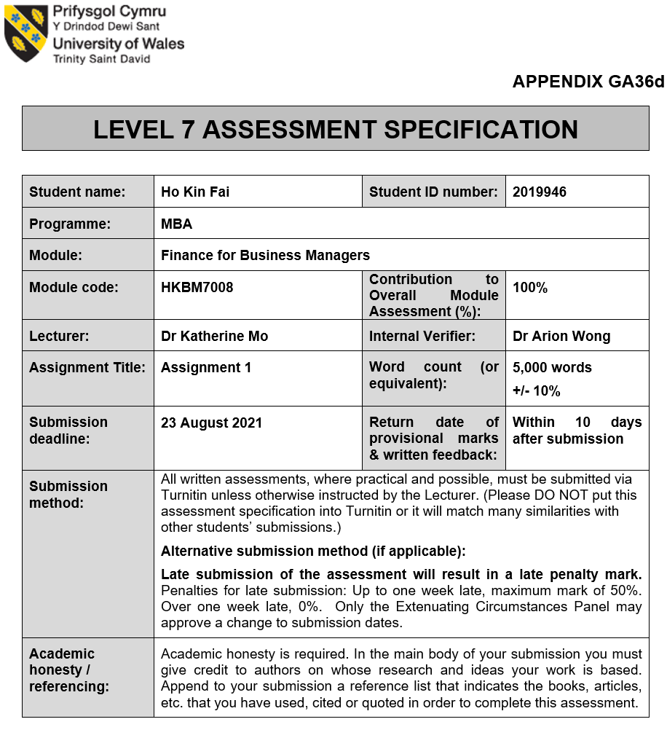

Executive summary

Since the impact of social events in 2019 and the COVID 19 epidemic in 2020, the overall revenue of Hong Kong's catering industry has dropped by nearly 30% (Cannix, 2021). Fulum Group is one of Hong Kong's Chinese food and catering companies and bears the brunt of its overall performance, and various financial data are displayed as negative values. This report analysis is according to the Group annual report financial statement to compare with another two same industry listed competitors economic structure by the Z-score, Profitability, Solvency, Liquidity and Efficiency, Growth and Stock Market prospects. Also, the report has studied the Group corporate governance and recommended improving internal control and risk management. After the analysed the financial structure, an investment project will propose to the Group for future development. The proposal has to analyse the project initial cost and calculates the cash flow, ARR, NVP, IRR and PBP to determine the project's feasibility to propose a recommendation on the financing and working capital management for the new project and provide an annual audit plan to monitoring the new investment.

Even the report pointed out that Fulum Group may face a bankruptcy crisis in the coming year, in fact, the business environment of the catering industry will start to improve in 2021 as the epidemic is under control. The Group will reorganize various businesses and use reserved funds Open a new food court. The report also provides reference and improvement for the group's internal management and annual audits, thereby enhancing investor confidence. It is also expected to drive the stock price to rise to the re-sale of stocks to raise new sources of funds.

Table of Contents
Table of Contents
Executive summary ii
Table of Contents iii
List of Tables iv
List of Figures iv
Chapter 1. Introduction 1
1.1 Company Background 1
1.2 Microeconomic Environment 2
1.3 Business Overview 3
Chapter 2. FULUM Group's financial analysis 4
2.1 Listed companies of Bankruptcy Index Z-Score comparison 4
2.2 Financial Structure 5
2.3 Profitability Analysis 6
2.4 Solvency Analysis 8
2.5 Liquidity Analysis 9
2.6 Growth Analysis 11
2.7 Stock Market prospects analysis 12
Chapter 3. FULUM Group's corporate governance assessment 14
3.1 Internal control 14
3.2 Risk management 15
3.3 Recommendation for governance improvement 16
Chapter 4. Investment project proposal 17
4.1 Food Court project proposal 18
4.2 Limitation of project proposal 23
Chapter 5. Financing and working capital management 24
5.1 Adopting credit rating 24
5.2 New round of equity fund-raising 26
5.3 Working capital management 26
Chapter 6. Annual action plan 28
Chapter 7. Conclusion 29
Reference 30
Appendix 35
Z-score Calculation 35
Ratio Calculation 36

List of Tables
Table 1. The average Stock exchange price.
Table 2. The value and volume index of Food and beverage services.
Table 3. Comparison of different competitors businesses.
Table 4. The Z score comparison.
Table 5. Table of financial structure comparison.
Table 6. Table of profitability analysis.
Table 7. Table of Solvency analysis
Table 8. Table of Liquidity analysis.
Table 9. Table of Growth analysis.
Table 10. Table of Stock market prospects analysis.
Table 11. The board member type of professional and meetings attendance record 2020.
Table 12. The planned use of proceeds.
Table 13. Primary income from business operation.
Table 14. Food Court income.
Table 15. The Project Initial Cost.
Table 16. Estimation of Total Sales.
Table 17. The ratio of EBITDA margin, Depreciation rate and Tax.
Table 18. The project Growth Rate (HKD' 000).
Table 19. Computing Tax Cost with EBIT and EBITDA (HKD' 000).
Table 20. Cashflow calculation (HKD' 000).
Table 21. The calculation of NPV and ARR (HKD' 000).
Table 22. The calculation of PBP and IRR (HKD' 000)
Table 23. A suggested action in each period (month).

List of Figures
Figure 1. The historical stock data for Fulum Group.
Figure 2. Three Lines of Defense model.
Figure 3. The new "Three Lines Model".
Figure 4. Moody's Restaurant Methodology Factor Scorecard.
Figure 5. Three fundamental building blocks of effective cash management.

Chapter 1. Introduction
This chapter will introduce the case study company "FULUM Group" company background and the microeconomic environment by analysing their performance the firm's suppliers, competitors, marketing intermediaries, customers, and public. In the end, the report has to look at the Chinese Banquet industry overview in Hong Kong.

1.1 Company Background
FULUM Group is one of the Hong Kong Chinese Banquet restaurants established in 1992. And set up the first Chinese restaurant in Tsui Sha Tsim. In the past year, the Group continued to expand its business and opened several different restaurants. The Group decided to open a central kitchen and logistics centre to process ingredients centrally in 2013. In November 2014, the Group successfully listed the Hong Kong Stock Exchange (Stock Code: 1443) and issued shares of 1,300,000,000 (as of 30 June 2021) (HKEX, 2021a).
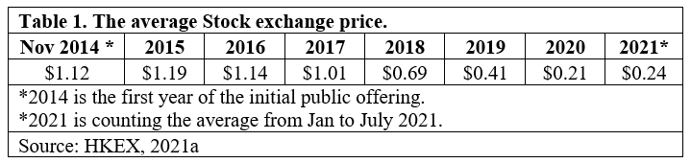
The Group foreseeable the demand for fusion cuisine has grown faster in local consumers. So they differentiate the product line into three series. The "Fulum" series of restaurants mainly provides Cantonese cuisine, community banquets and wedding banquet services. The "Taoyuan" series of restaurants mainly provides Cantonese cuisine for mid-to-high-end markets. And the "Fulum Concept" series of restaurants specifically cater to fusion cuisines such as Food Mall, Korean cuisine and Fast Food. So far, it has grown to a catering group with 14 restaurants of different brands, with more than 4,000 employees (Fulum 2020).

1.2 Microeconomic Environment
According to the data about the food and beverage sector released by Census and Statistics Department in 2021. The food and beverage services generated a value-added of about $53.0 billion in 2019, and it accounted for 1.9% of Hong Kong's Gross Domestic Product. And the value of total receipts of the restaurant's sector in 2020 was $79.3 billion. Compared with 2019, it dropped 29.4% in value and 30% in volume in 2020. The decline in the food and beverage business has been impacted by COVID 19 pandemic and the social distancing measures (C&S Dept, 2021a).
Table 2 shows that the Food and beverage services decline on restaurant receipts, and value and volume started from 2019. The F&B industry is facing a very severe business environment.
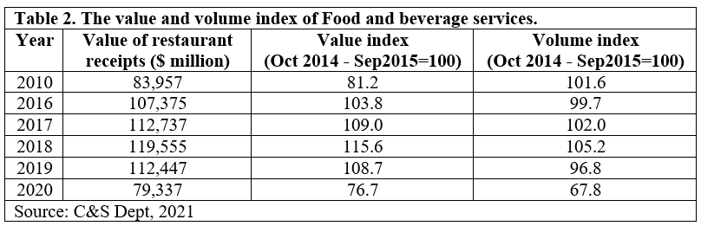
Analysed by type of restaurant, comparing 2020 with 2019, the total revenue of Chinese restaurants in terms of value and volume has dropped significantly by 38.2% and 38.9%, respectively. The total revenue of non-Chinese restaurants fell by 25.7% and 25.2% in value and volume. The total revenue of fast-food restaurants calculated by value and quantity are respectively down 19.1% and 20.5% (C&S Dept, 2021).

1.3 Business Overview

However, there are uncertainties in the Hong Kong economy, including China and the United States unclear trade relations. The local consumer market was affected by social unrest in the second half of 2019. In addition, the COVID-19 outbreak in early 2020 has exacerbated the downturn. It has been challenging the Hong Kong catering market in the future.

Since the COVID-19 epidemic spread in early 2020, the Hong Kong government has implemented different control measures to prevent the pandemic. There has been a decrease in consumers going out to eat or party, which has had a short-term impact on the Hong Kong catering market.

Fulum Group keeps providing customers with quality catering services amid the unstable and challenging environment. During the epidemic, the Group have adopted different operational strategies to keep the revenue income to support the business. For example, increase the choice of take-out menus and provide more discounts to encourage customers to stay at home to dine and maintain social distancing. Table 3 show the competitors also running a similar business model. That means the competition is intense. The Group must have well planning to develop the future business.
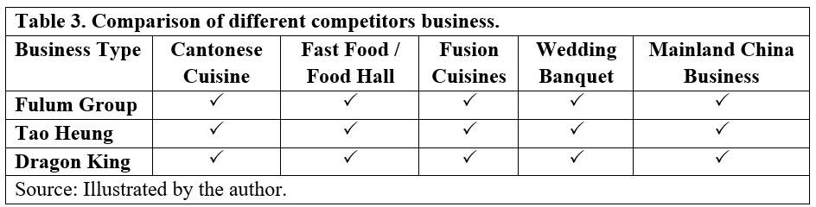

Chapter 2. FULUM Group's financial analysis

This chapter is the financial analysis of the consolidated financial statements of the Group based on the annual report (2018-2020), finds some data to calculate the Z-Score, analyses its economic structure, and looks at the profitability, solvency, liquidity and efficiency capabilities, and growth capabilities. And stock market outlook analysis.

2.1 Listed companies of Bankruptcy Index Z-Score comparison

The model of z score is using the Altman (1968) formula to calculate. This formula is used to determining whether a listed company, notably in the manufacturers or non-manufacturer, is headed for bankruptcy. According to Altman definition, the z- score >2.99 indicates a lower probability of bankruptcy. If between 1.81 and 2.99 is a grey area when the score is <1.81, the company has a high probability of bankruptcy — Table 4 shows three companies z-score values.
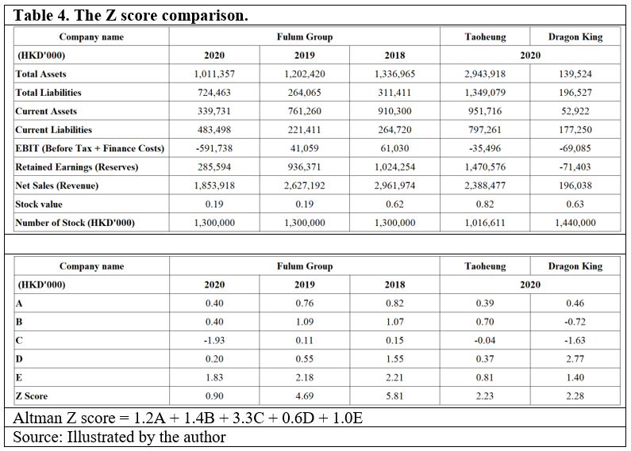
Table 4 listed company Tao Heung and Dragon King z-score in 2020 are between 1.81 and 2.99, so they are in the grey area. And the Fulum Group is 0.90 in the Year 2020. According to the Z-score definition, the Group must pay attention to the high probability of bankruptcy.

2.2 Financial Structure1.
According to the Fixed Asset to Long Term Liability Ratio, the Financial structure is Current Liabilities to Net Asset Ratio Current Liabilities to Stock Ratio to analyse a company's financial situation on solvency, pressure on future cash flow, and the stock capital ratio. The annual report in 2020 was stated the financial resources and liquidity counted to 31 March 2020, the total asset value of the Group decreased to approximately HK$1,011.4 million (2019: about HK$1,202.4 million). The total equity decreased to approximately HK$286.9 million (2019: about HK$938.4 million) (Fulum, 2020).
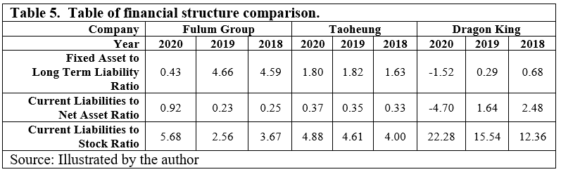
Fixed Assets to Long-Term Liabilities - The ratio of fixed assets to long-term debt is a way to measure a company's solvency. The company's long-term debt is usually secured by fixed assets, which is why creditors are interested in this ratio. As this ratio, the larger the number is better (Blanchard, 2014). Tao Heung is the best company to maintain a stable balance. Fulum in 2018 and 2019 can have around 4.6 but in 2020 declined to 0.43, a smaller number will indicate that the Group fixed assets may not cover the debt.

Current Liabilities to Net Asset Ratio - It is one of the indicators to measure a company's solvency. According to experience, it should not exceed 0.6 or 60% (Adam, 2020a). Fulum in 2018 and 2019 can maintain a ratio below 0.6, and Taoheung has the best balance between 2018-2020. And Dragon King has a negative ratio in 2020 is -4.7. The Group ratio in 2020 is 0.92. A higher percentage means the company has tremendous pressure on future cash flow.

Current Liabilities to Stock Ratio - The ratio refers to the percentage of current liabilities to the company's total assets, reflecting the company's dependence on short-term creditors. A higher ratio indicates the company's reliance on short-term funds derived from the performance of its assets and liabilities. Dragon King has a higher ratio compared with the other two companies. And Fulum began in 2018 is 3.67 descended to 2.56 in 2019, but in 2020, the ratio rebound to 5.68. This reflects that the company is very dependent on short-term funds evolved from assets and liabilities.

2.3 Profitability Analysis
Profitability refers to the company's ability to make profits in a certain period. The higher the profit rate, the stronger the profitability. Through the profitability analysis, the operators can help find problems in the operation and management. The analysis of the company's profitability is an in-depth analysis of the company's profitability.
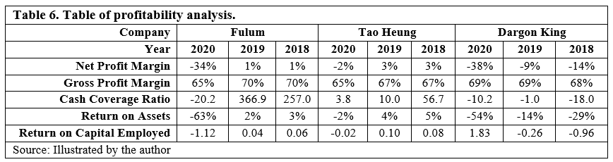
Net Profit Margin - Due to the impact of social unrest in 2019 and epidemic in 2020, Fulum turnover began to decline from the end of 2019. In 2020, Net Profit Margin recorded a -34%. However, the impact of Dargon King also fell to -38%. On the contrary, the impact of TaoHeung is less and only a -2% drop. Fulum and Dargon King also have a lower rate, indicating a higher probability that a decline in sales will decrease revenue, eventually leading to net losses and negative returns (Murphy, 2021b).

Gross Profit Margin – Although the net profit margin has fallen in the past year. However, the Group's gross profit margin shows that they are effectively controlling costs. The ratio shows three companies have a high percentage of Gross Profit margin in 2020 (Fulum 65%, Tao Heung 65% and Dargon King 69%). If there is not much change in operations in the coming year, unless the Group finds a way to reduce production costs to make up for the loss of gross profit margin, otherwise increases product prices to increase revenue. But the high price will backfire on customers, making the Group lose the gross margin and market share (Bloomenthal, 2020).

Cash Coverage Ratio - The cash coverage ratio can determine the cash used to pay the borrower's interest expenses. If the ratio is greater than 1:1, it shows sufficient ability to pay (Bragg, 2019). Since the cash coverage ratio of the Group in 2020 is only -20.2 (Tao Heung 3.8, Dargon King -10.2), the occurrence of a negative ratio to the amount of interest payment indicates that the Group may not have sufficient payment capacity. But lenders usually use this ratio to see whether existing borrowers are experiencing financial difficulties and whether they should lend to new loan applicants. If the Group needs to borrow money, be aware that it may encounter resistance.

Return on Assets – ROA is used to measure how much net profit can create per unit of asset. It can interpret the ratio of corporate profits to average corporate assets (Harhrave, 2020). The data shows that the ROA of the three companies in 2020 is all negative (Fulum -63%, TaoHeung -2% and Dargon King -54%). It shows that the utilisation efficiency of corporate assets is not high. Because due to the impact of the epidemic, operating hours have been shortened, making operators unable to use assets to create profits. It does not mean that the level of business management has decreased.

Return on Capital Employed - ROCE is used to evaluate a company's profitability and capital efficiency. This ratio can help understand how the company generates profits from its capital (Hayes, 2020b). As the catering industry is affected by the epidemic, the Group cannot effectively use its existing assets to create profits and thus influence the ultimate profitability. The data shows that the three companies' ROCE, Fulum and Tao Heung, are all negatives (-1.12 and -0.02). On the contrary, Dragon King is positive (1.83) because they have few stores and relatively little influence.

2.4 Solvency Analysis

Solvency refers to the company's ability to repay long-term debts and financial obligations. The fastest way to assess a company's solvency is to look at the shareholders' equity on the balance sheet, the total assets minus its total liabilities.
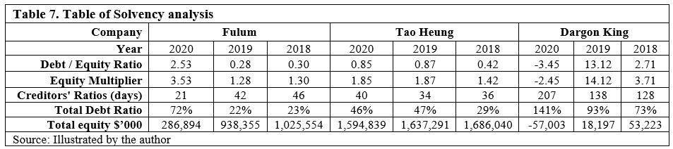

Debt / Equity Ratio - The data show Dargon King is the best company on this ratio because one board member has sold all equity, so that the company recorded a -3.45. Although Fulum can keep the balance smaller than 1 in 2018 and 2019, but affected by 2020, the ratio increased to 2.53. The best ratio should be 0.5 or below, and when the debt ratio is greater than 1.0 (100%), a company has more debt than assets (Turits, 2020).

Equity Multiplier - The equity multiplier is a risk indicator that measures the portion of a company's assets financed by shareholders' equity rather than debt. Generally, a high equity multiplier indicates that the company uses much debt to finance assets. A lower equity multiplier means that the company is less dependent on debt (Nickolas, 2019). Fulum is the more considerable risk on using debt to finance the company asset in 2020, and the ratio is double from 2018 and 2019.

Total Debt Ratio - The ratio is the percentage of total assets to total liabilities. The ratio is generally positively correlated with the long-term solvency, so it is regarded as the long-term solvency ratio of the enterprise in the analysis of financial ratios. According to data, Fulum's debt-to-asset percentage jumped from 22% in 2019 to 72%, while Dargon King increased from 93% to 141%. The other rival Tao Heung's situation in 2019 is similar to that in 2020, respectively 47% and 46%. According to the ratios of 0.4 or lower, when the ratio is higher than 0.6, it won't be easy to borrow money (Hayes, 2020a).

Creditors' Ratios -The ratio is used to estimate the average number of credit days an organisation receives before making payments to creditors. A shorter average payment period may indicate that the company's liquidity status is better (Oxford, 2021). Fulum compared with another two companies, the Group had a shorten ratio (21 days), so the Group can enjoy a shorter credit period

Total Equity -Total Equity is a fast way to measure the solvency capacity. The equity can be negative or positive. If it is positive, it means that the company has enough assets to pay its liabilities. If it is negative, the company's liabilities exceed its assets; if it delays, it will be considered a balance sheet bankruptcy (Bragg, 2021). Generally, investors view companies with negative shareholder equity as risky or unsafe investments. Fulham and Tao Heung can maintain the Equity positive, but the total equity has dropped YoY, And Dargon King recorded a negative -57,003. Although Fulum can keep a positive number, the Group must note that the Total Equity had fallen from 938,355 in 2019 to 286,894 in 2020, a 70% drop will increase the Group's debt crisis

2.5 Liquidity Analysis
As of 31 March 2020, the available cash and bank balances of the Group were approximately HK$116.4 million (2019: about HK$496.9 million). The data shows below can use to determine the liquidity and efficiency capacity.
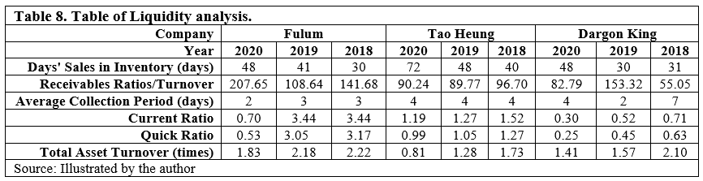

Days' Sales in Inventory - DSI is used to represents the average of the day it takes for a company to convert its inventory into sales. A high DSI indicates a company may not make good use of its inventory, or inventory is difficult to sell (Hayes, 2019b). Compared to 2020, Tao Heung is the higher DSI got 72 days, Fulum and Dargon King are 48. Although Fulum only took 48 days to clear its inventory, the reason could be Fulum's reduction of business to reduce the purchase of raw materials. But also because of this, the total income will be affected.

Receivables Ratios/Turnover - The ratio is used to quantify the effectiveness of a company's collection of accounts receivable or the amount owed by customers or customers. It is beneficial to compare the competitor's ratio to measure whether it is on par with the competition (Murphy, 2021a). Fulum has always maintained a high turnover rate (207.65), indicating that the Group's accounts receivable collection efficiency is high. The Group has a high proportion of high-quality customers, which can quickly repay debts.

Average Collection Period - The average collection period is indicative of the effectiveness of a company accounts receivable management practices. It is most important when a company relies on receivables for its cash flows (Kenton, 2021). Fulum can keep the average day between 2-3 days as the lower average period indicated the Group could collect the payments faster.

Current Ratio - This ratio is a liquidity ratio that measures the company's ability to pay short-term debt or debt maturity within one year. When the current ratio is greater than 1, it indicates that the company can only use short-term assets to repay short-term debts (Fernando, 2021a). It also represents the company's ability to pay for items in the short term, including food, beverages and employee salaries. But the current ratio of Fulum is 0.7 in 2020 (2019: 3.4), and Dargon King was 0.30 in 2020 (2019: 0.52). A low current ratio may indicate a higher risk of getting into trouble or defaulting.

Quick Ratio - Quick ratio is an indicator of a company's short-term liquidity, which measures the company's ability to repay short-term debt with its most liquid assets. A good quick ratio is 1 or higher (Seth, 2021). The greater number means the more liquid assets a company has to cover its short-term obligations and debts (Grunert, 2020). Among the three companies, only Tao Heung can maintain a ratio closer to 1. Dargan King's small ratio means that a company doesn't have enough liquid assets to cover its current liabilities. Fulum in 2020 also recorded a small ratio is 0.53.

Total Asset Turnover - The ratio can measure the value of a company's sales or income relative to the value of its assets. This ratio indicates how a company uses its assets to generate revenue (Hayes, 2021). Compare with 2020 on three companies, relative to Tao Heung and Dargon king, Fulum has higher times with 1.83, represents that the Group efficiency in generating income from its investments is reasonably satisfactory.

2.6 Growth Analysis

This session has to analyse the growth by asset utilisation, operating period, cash period, and self-sustainable growth rate to compare how companies maintain the development in a challenging business environment. But from the data point of view, 2020 is the most difficult for the catering industry.
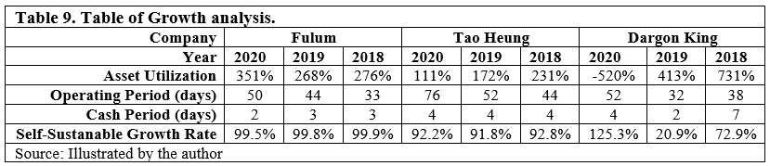

Asset Utilisation - The ratio is used to calculates the total revenue earned for every asset a company owns. This ratio is often used to compare the efficiency of a company over a period of time (Schmidt & Wright, 1996). The percentage of Fulum in 2020 is 351% that means the Group earned $.351 per dollar of assets. Although 2020 is a challenging year for business, the Group can make a higher ratio than other companies. Dargon King is the most critical ratio in 2020 (-520% = -0.520 per dollar).

Operating Period - The operating period is the operating activity cycle in a company that uses cash to purchase resources, convert the resources into products or services, and then sell them in cash (Lutwidge, 2021). Three companies can maintain the days within a year, proving that everyone can turn the purchased inventory into a product to sell within one year or before the annual settlement.

Cash Period – Cash Period is an indicator that represents the length of time (in days) it takes for a company to convert its investment in inventory and other resources into cash flow from sales. When the day has declined or stabilised over multiple periods, the rising period value should lead to more investigation and analysis based on other factors (Hayes, 2019). Both companies can make the cash period stabilise, such as Tao Heung, Fulum and Dargon King are making the day decline shorter.

Self-Sustainable Growth Rate – The SGR refers to the maximum growth rate that a company can maintain without additional equity or debt to finance growth. High SGR companies often focus on selling high-margin products and have the best inventory, accounts payable, and accounts receivable (Murphy, 2021b). Since Dargon King is selling high-margin products, it has the highest SGR reaching 125.3% in 2020, and Fulum keeps the rate stable at 99%, Tao Heung is keeping at 92%. However, due to various reasons, including a competition to enter the market, changes in economic conditions, and the need to increase R&D, it is difficult for the company to maintain a high SGR for a long time. To operate above its SGR, it needs to maximise sales and focus on high-margin products and services. In addition, inventory management is very important, and management must understand the continuous inventory required to match and maintain the company's sales level (Al-Nasser and Al-Jubouri, 2020).

2.7 Stock Market prospects analysis

The epidemic in Hong Kong has stabilised, and the government's ban on the catering industry has begun to relax, conducive to the industry's recovery. The volatility of the Hong Kong food and beverage stock market has always been fierce, coupled with the addition of Chinese food and beverage stocks, making local food and beverage stocks unable to gain greater appeal from investors. Figure 1 shows the Fulum stock market price starts from listed on HKEX. The figure presented the price is declined for YoY at the top price 1.2 to the previous close of 0.22.
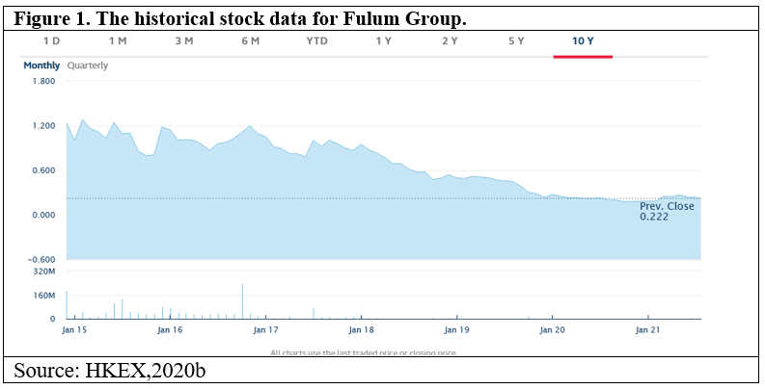

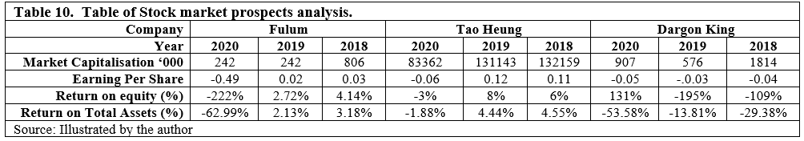

Market Capitalisation – This is a value that refers to the total dollar market value of the company on the issued shares. The MC is calculated by multiplying the current price of a single share. The market value of a company is easily affected by the stock price. Regardless of the shareholders or stock holdings, the market value will fall when the stock price falls. Fulum MC fell from 2018 (806 million) to 2020 (242 million).

Earnings per share – The EPS is calculated by dividing the profits by the outstanding shares of the common stock. The figures can use to indicate the company's profitability. The higher EPS means the company is considered more profitable (Fernando, 2020b). However, since food and beverage stocks are not popular in the Hong Kong market, most will decline yearly, except for the high subscription period for the first year of listing. Three companies have a significant drop between 2018 to 2020. Figure 1 shows Fulum's stock market price. Except for 2015 and 2017 have a higher price, the price declined from 2018 and up to 2021 Jan only 0.22.

Return on equity – ROE is a measure of financial performance by dividing net income by shareholder equity. Since shareholders' equity equals the company's assets minus debt, ROE is considered the return on net assets. Investors can consider ROE close to the S&P 500 long-term average (14%) as an acceptable ratio and any ratio below 10% as poor.

As Fulum has negative growth in its performance in 2020, negative net income and negative shareholders' equity will lead to high ROE. If the company has a net loss or negative shareholders' equity, ROE should not be calculated (Fernando, 2020a).

Chapter 3. FULUM Group's corporate governance assessment

This chapter is talking about risk management and internal control. The risk management and internal control systems are designed to promote the Group's strategy, protect the Group's assets, ensure proper accounting records, and comply with relevant laws and regulations.

The Group adopts a "Three Lines of Defense model (Figure 2)" for the risk management and internal control framework to ensure that it complies with regulatory and legal requirements while achieving business goals and fulfils responsibilities to the shareholders, customers and employees. The operation managers of each business unit are responsible for managing the risks of the first line of defence. In contrast, the management has set up a risk management team as the second line of defence to supervise effective risk management and internal control systems. The internal audit department acts as the third line of defence, independent of the first and second lines of defence (The Institute of Internal Auditors, 2013).
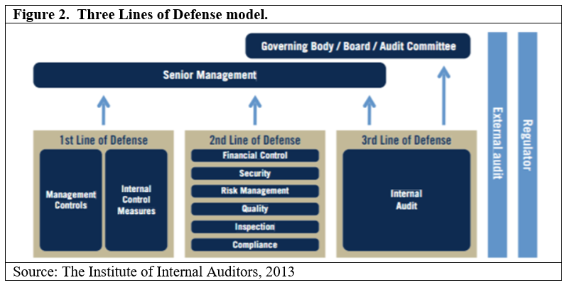

3.1 Internal control

The Board of Directors is solely responsible for maintaining comprehensive and effective risk management and internal control system for the Group. The system includes a defined management structure and related authority to ensure the proper accounting standards, provide reliable financial information for internal use and external release, and Ensure compliance with relevant laws and regulations.

The group request all member have related training on understanding the business and operation. As the responsibilities and obligations of directors of listed companies, the Group also encourages participation in continuous professional development to enhance and update their knowledge and skills.
Table 11 shows the Group has called 15 times meeting within 2020, and the Group has delegated each director to have a specific role in attending the board meeting. The member has participated in all board meetings.
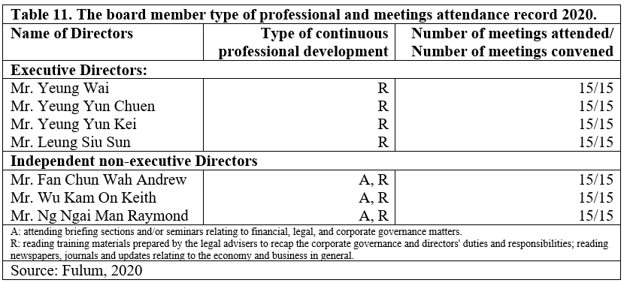

3.2 Risk management

An established risk management system is designed to manage rather than eliminate significant risks in the business environment. The Group's risk management framework includes the following main parts:

To identify the significant risks in the operating environment and assess the impact of these risks on the business, including the consumer behaviour change, the consumer's segment change by demographic, the quality of ingredients and materials, the mediator risks on transportation, financiers and retailers, and financial risks associated with various processes and practices.

Formulate necessary measures to manage these risks such as making procedures and compliance, purchasing enough insurance, conducting market research and ensuring sufficient assets to support the entire business.

After the risk management plan is formulated, the management team must monitor and review the program's feasibility to measure the effectiveness and make appropriate adjustments when the risk occurs to minimise the loss as much as possible.

3.3 Recommendation for governance improvement
According to the annual report, Mr Yeung is the chairman of the board of directors and the Group's chief executive officer. However, according to Rule A.2.1 of Rules and Guidance, the chairman and chief executive officer roles should be separate and not performed by the same person. The division of responsibilities between the chairman and chief executive officer should be clearly defined and set out in writing (HKEX, 2021). Although Mr Yeung has senior experience and expertise in the catering business, one of the main benefits of inviting independent board members is that they have different perspectives and can use their diverse backgrounds and experience to enhance business operations (Deloitte, 2016).

The annual report also mentioned the Group applied the Three Lines of Defense Model for risk and internal control. Still, researchers said that the "three lines of defence approach has not been entirely effective and has given a false sense of assurance." (Chambers and Odar, 2015). A new Three Lines Model (Figure 2) was created by IIA's in 2020. Under the new model, first-line and second-line roles "may be mixed or separated". The second line position can be a specialist to provide expertise, support, monitoring, and challenges to those with first-line roles. However, managing risk is still part responsibility of the frontline role and is within the management scope. The model also encouraged the third line to collaborate with management and remain independent to maintain objectivity, authority, and credibility (Chambers, 2020).
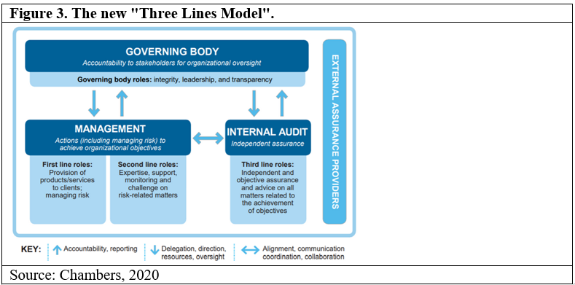

Chapter 4. Investment project proposal

With the continuous changes in local consumers' catering rhythm and preferences in recent years, the demand for fusion food increased significantly, prompting the Group to develop the "Fulum Concept" series to cater to a different segment of customers to increase market share. In addition, the food hall brand "Foodeli" planned to open the second branch. This chapter has to forecast the financial on this project proposal investment.

According to Fulum annual report in 2019/2020 (Table 12), the Group has reserved HK$64.8 million to develop speciality cuisine restaurants under "Fulum Concept".
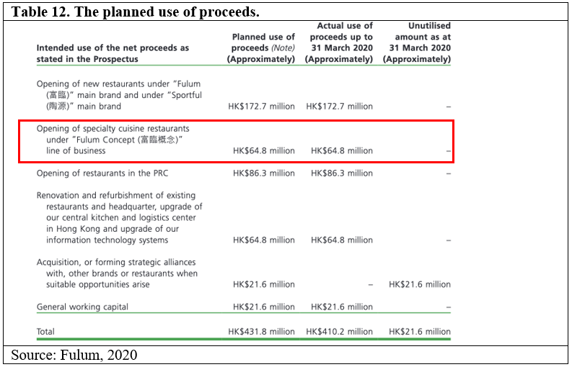
The Group's various businesses were not ideal in 2020, but the Food Court business is growing. Table 13 shows the primary income from the different product lines. As shown in Table 13, most of the operations running in Hong Kong and Mainland China has declined year-over-year. However, the Group's Foodeli beginning in 2019 with a 4% growth rate from 2020 (Six months ended 30 September) (Table 14).

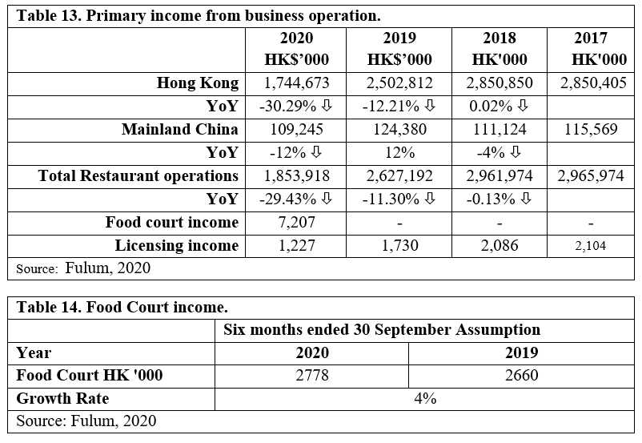

4.1 Food Court project proposal

Most of the food courts are located in the central area of the shopping centre, with large-scale rooms and seats. The food court needs to apply for a restaurant license and the public health and safety requirement. Tang (2020), a director of JLL, suggested that the owner choose a shop with an area of 10,000 square feet (including seats). "It is imperative to maintain a flexible kitchen layout. In addition, the owners should set certain requirements for the restaurant to maintain the freshness of the food court. (JLL, 2020)".

The following table shows the data about initial Cost, total sale estimation, Growth rate estimation, Depreciation Cost, EBITDA, the NPV and ARR, the payback period and IRR.
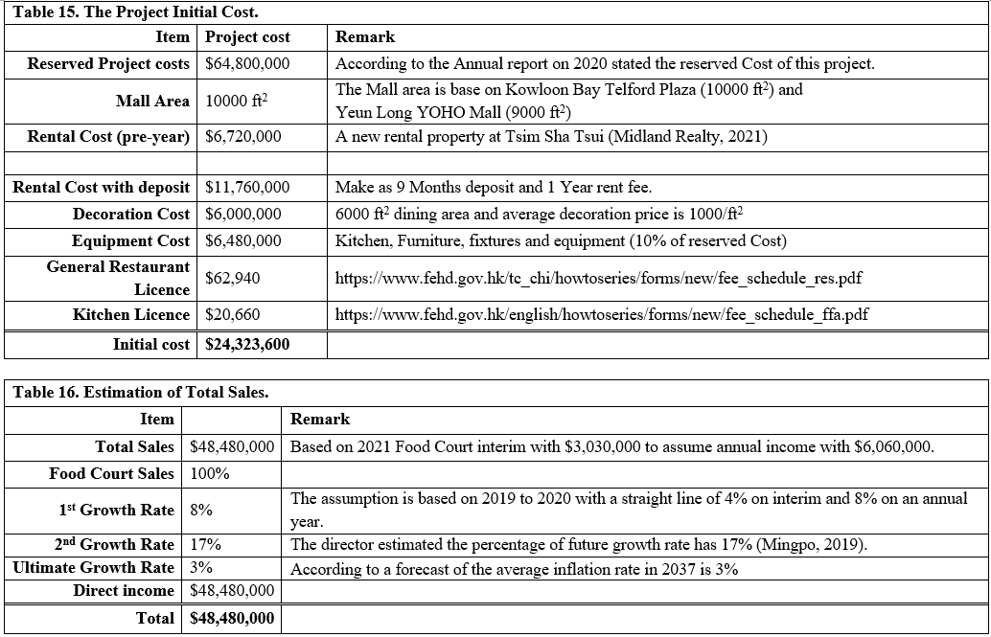

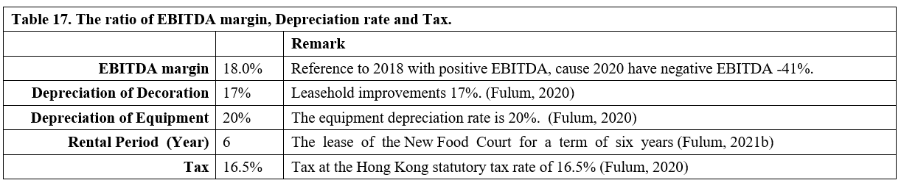
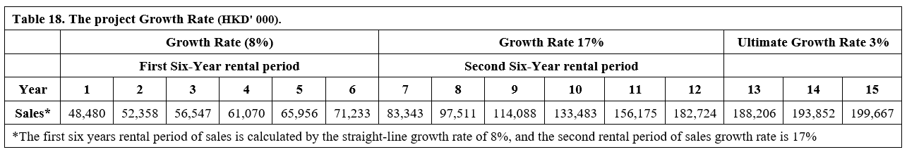

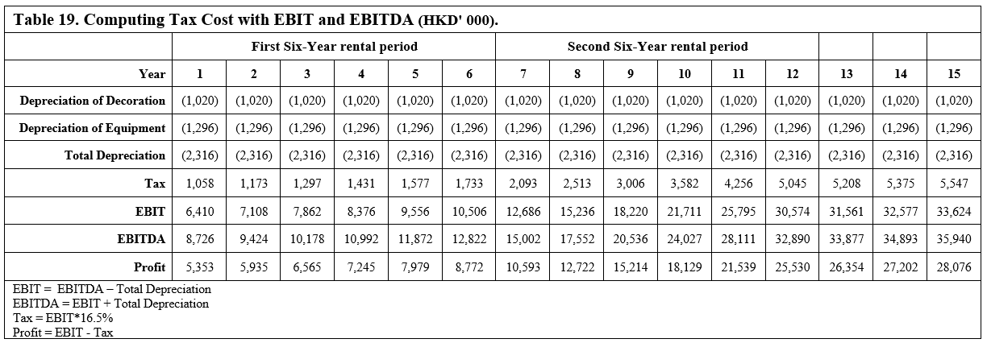

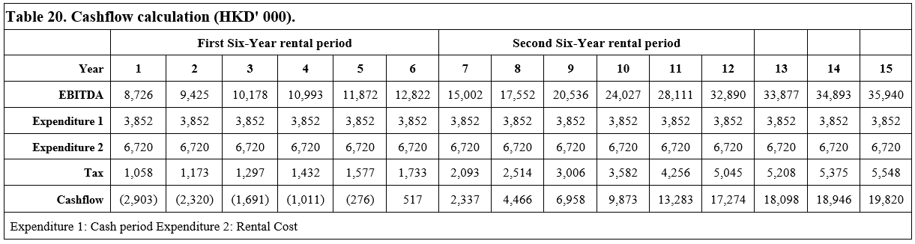
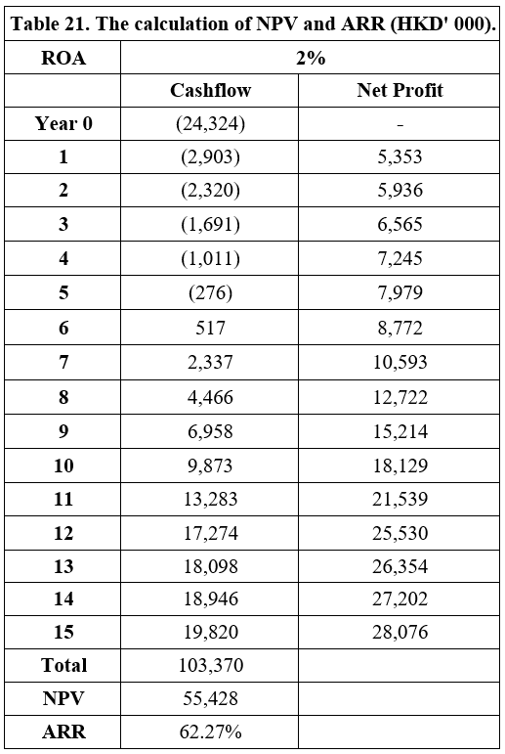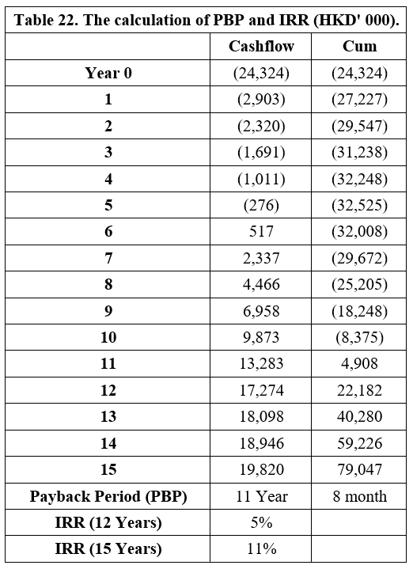

4.2 Limitation of project proposal

Since the total income of the food court only accounts for 0.39% of the Group's total revenue, the actual lease and shop scale are also individually referenced to the opened shops in Yuen Long and Kowloon Bay and the rental price index. There is no accurate data to support renovation costs, Furniture and equipment, and kitchen appliances, and the actual charges may be lower than estimated. In addition, the depreciation rate of shop equipment is also described in the Group's 2020 annual report, and the depreciation rate is the sum of the entire Group. Therefore, EBIT and EBITDA will not be able to turn losses into profits in the short term. Coupled with the impact of social events and epidemics in the year, the results of the 2019 and 2020 interim reports for the growth rate were 4% growth.

When the Group opened its first food court in mid-2019, it mentioned that this business accounted for approximately 17% of overall revenue and expected that the proportion would increase to 30% within two financial years (Yahoo Finance, 2019). With the improvement of the business environment in 2021, the growth rate should also be different. One of the primary incomes of the food court is the fixed rent of tenants. The Group can choose some higher profit tenants and provide shorter or more flexible leases for them, which can cater to the tastes and seasons of different diners or directly run by other sub-brands of the Group to create synergy effects (Holubčík and Soviar, 2016). So the project is still lucrative.

Chapter 5. Financing and working capital management

Although the Group has reserved spare funds to develop new projects or expand existing businesses, from the financial analysis in Chapter 2 and the new project budget data in Chapter 4 of the article, the Group still risks a new round of fund-raising or bank borrowing.

This chapter will advise Fulum on finding financing and working capital management funds to operate the project.

5.1 Adopting credit rating

Since the Group may need to finance, the credit rating is equivalent to the label obtained through the quality certification for the company. With the development of the corporate bond market, especially for listed companies, the large-scale opportunities for bond financing through the capital market can rapidly increase capital. Providing companies with good opinions and establishing a good credit status through credit ratings can enhance companies' credit, expand the investor base, and promote the success of the financing.

Moody's proposed a rating reference for Restaurant Industry in 2015, and this rating explains the method of assessing credit rating for the global restaurant industry companies. The rating provides general guidance to help companies, investors and other interested market participants and quantitative risk characteristics how to affect the rating results of companies in the industry. Figure 4 is a scorecard for measuring the Restaurant Industry by five factors: Scale, Business Profile, Profile-Ability & Efficiency, Leverage & Coverage and Financial policy to estimate the credit status of the catering industry, providing guidance and important factors when rating the catering industry. And the weight shown for each element in the scorecard represents the approximation of importance ratio to the rating decision (Moodys, 2018).

Figure 4. Moody's Restaurant Methodology Factor Scorecard.
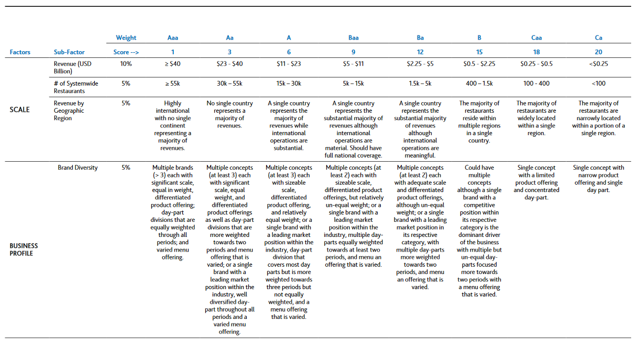
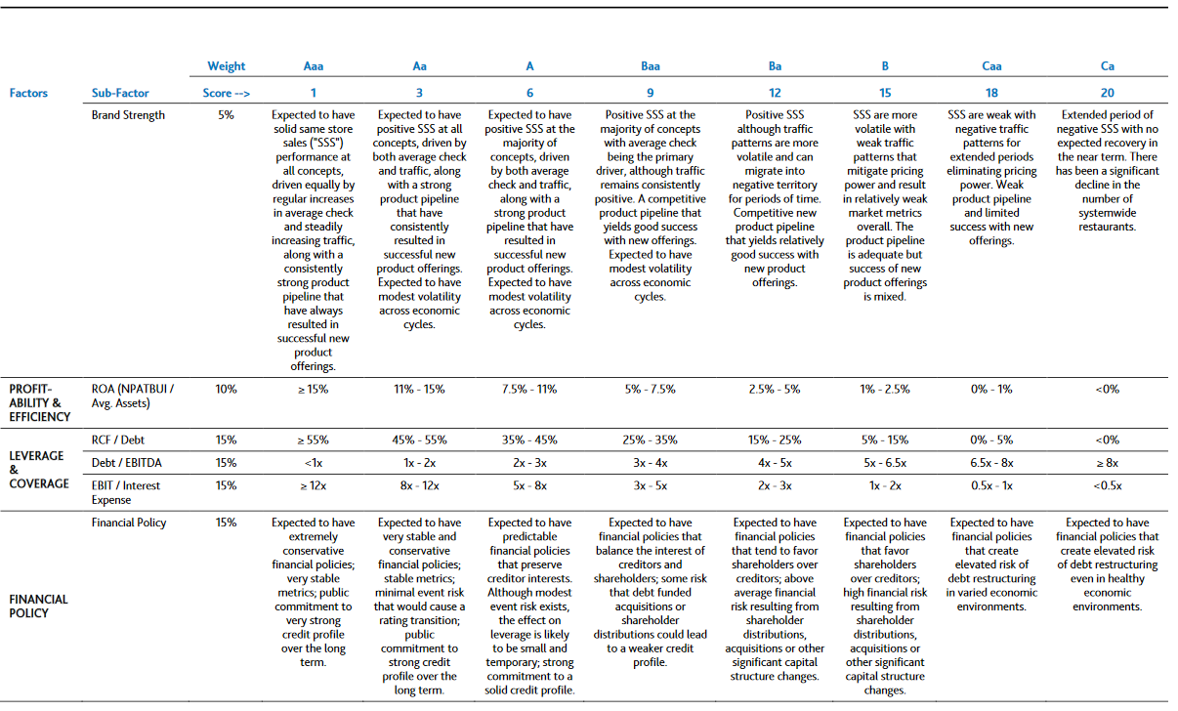
Source: Moodys, 2018.

However, since the current environment is still unstable, a stable outlook can indicate that the possibility of a change in the rating in the medium term is very slight. Negative, positive, or developing prospects indicate a higher probability of mid-term rating changes. The Group should wait for the business data to turn a profit before making a rating.

5.2 New round of equity fund-raising

Although credit rating agencies are not stock analysts, and credit ratings are not a substitute for stock research, stock investors can also use credit ratings as a way of considering many factors when deciding whether to purchase a company's equity securities. However, stock investors may be interested in these opinions and may use them to reflect in their assessment of the value of stock securities.

Fulum has fallen 52% in the value of its shares in the past three years (Yahoo Finance, 2019b). But in 2021, all types of catering industry performance will improve, hoping to drive the Group's share price increase. If the Group issued shares at this stock price ($0.212), it might not be attractive. Secondly, there was no substantial fund-raising income. Therefore, the Group can wait until the stock price rises to a certain level of attractiveness before issuing shares.

5.3 Working capital management

"Working capital" is a measure of the company's efficiency and short-term financial health, usually defined as current assets (cash, securities, accounts receivable, and inventories) minus current liabilities (Protiviti, 2011). The composition of working capital allows investors to understand the company's primary operating efficiency.

APQC and Protiviti (2011) provided three fundamental building blocks of effective cash management (Figure 5) for companies to improve their working capital management.

The first block is working capital optimisation. By accelerating the conversion of operating capital to cash and effectively managing expenses, the Cash Conversion Cycle (CCC) is one measurement that can apply to this block. The lower number for the CCC is better for the company.

The second block is cash flow forecasting. Use the first block and other cash management activities to predict the cash cycle to estimate the company needs and expected earnings.

The third block is liquidity management. Use the forecast of the second block to formulate investment and financing strategies to maximise cash returns.
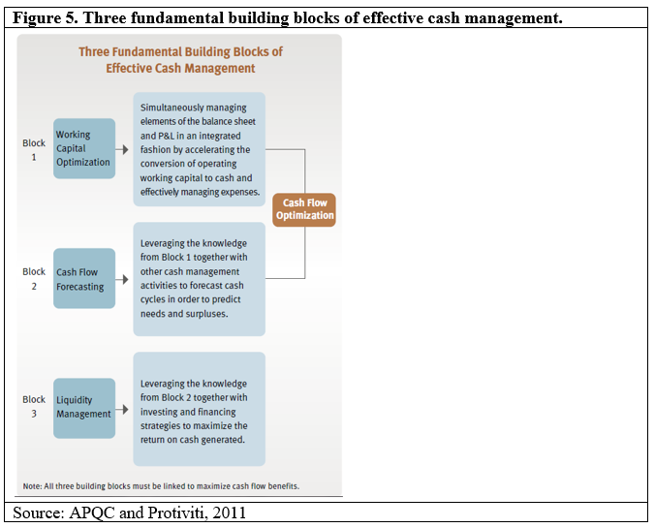

According to the annual report 2020, as of 31 March 2021, about HK$21.6 million of the General working capital is unused (Fulum, 2021). But that is reserved for whole business operation, and the Group can't use this reserve fund unscrupulously. The Food court project must use its business environment to create profits.

Chapter 6. Annual action plan

The annual audit plan should cover all activities and procedures of all operation units, and the audit plan needs to be reviewed and approved by the audit committee. The audit committee should report the result to the members of the executive and senior management.

To properly implement audit matters, those matters should be trackable and follow up by assigned personnel. The progress needs to be reported to the audit committee and the executive and senior management regularly. The risk management and internal control systems are continuously reviewed and evaluated by the management team. The audit committee and the board of directors recommend conducting further review and evaluation every six months.
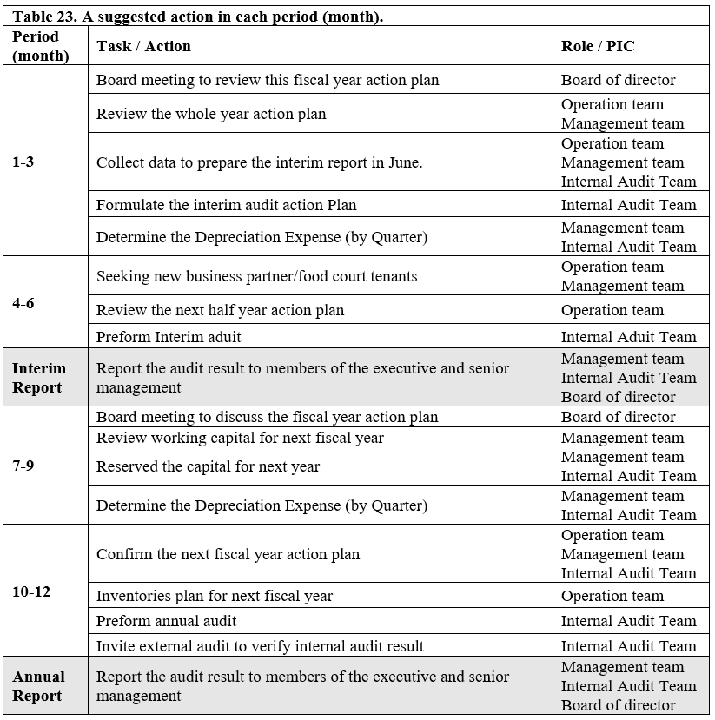

Chapter 7. Conclusion

This report concluded from several data that Fulum's catering business originally had good profits, although this article found that the Group's z-score value is facing bankruptcy. However, because the report only focuses on the data for 2020, and the Group's business has been good in 2018 or before, since the Hong Kong social movement in 2019 and the impact of the new crown epidemic, various business operations have fallen, resulting in tight cash flow and a negative effect on the future. There is a high-risk financial crisis in the process. However, as the epidemic slows down and social distancing measures have brought good news to the catering industry, the opportunities for consumers to eat out have increased, which has given a boost to the Group's various businesses. The Group predicts that its business volume can improve in 2021. However, the Group still needs to do an excellent job in risk management and internal control and keep abreast of the crises brought about by various changes. Under the economic recession, the operating environment of the catering industry is still tricky in the short term. Faced with the volatile market, the Group still has confidence in the industry's prospects.

Even though the Group has reserved capital to develop new businesses, such as the Food Court business mentioned above, it can help the Group bring in the Chinese restaurant business and hope to attract other customers through the project to bring income. Since different operators rent venues in Food Court, an operator with a relatively low income will affect the total annual profit. Therefore, the Group should choose potential tenants, which can attract more customers and drive revenue.

Reference

Afonso, A., Gomes, P. and Rother, P. (2007). Working Paper Series No.711. January 2007. What "Hides" Behind Sovereign Debt Ratings? [online] . Available at: https://www.ecb.europa.eu/pub/pdf/scpwps/ecbwp711.pdf.

Al-Nasser, A.H.H. and Al-Jubouri, A.D.M.A. (2020). Use analysis of internal growth rate and sustainable growth rate and its relation to performance. International Journal of
Psychosocial Rehabilitation, 24(04).

Altman, E.I. (1968). FINANCIAL RATIOS, DISCRIMINANT ANALYSIS AND THE PREDICTION OF CORPORATE BANKRUPTCY. The Journal of Finance, [online] 23(4), pp.589–609.
APQC and Protiviti (2011). Protiviti - United States |. [online] www.protiviti.com. Available at: http://www.protiviti.com/en-US/Pages/ [Accessed 6 August 2021].

Bantleon, U, d'Arcy, A, Eulerich, M, Hucke, A, Pedell, B, Ratzinger-Sakel, 2021. NVS. Coordination challenges in implementing the three lines of defence model. Int J Audit. 2021; 25: 59– 74.

Blanchard, S. (2014). The Differences Between Interest Coverage Ratio & Fixed-Assets- to Long-Term-Liabilities Ratio. [online] Chron.com. Available at: https://smallbusiness.chron.com/differences-between-interest-coverage-ratio-fixedassets-longtermliabilities-ratio-80903.html [Accessed 25 July 2021].

Bloomenthal, A. (2020). Why Gross Profit Margin Matters. [online] Investopedia. Available at: https://www.investopedia.com/terms/g/gross_profit_margin.asp [Accessed 25 July 2021].
Bragg, S. (2019). AccountingTools. [online] AccountingTools. Available at: https://www.accountingtools.com/articles/2017/5/5/cash-coverage-ratio [Accessed 25 July 2021].

Bragg, S. (2021). How to calculate total equity. [online] AccountingTools. Available at: https://www.accountingtools.com/articles/how-to-calculate-total-equity.html [Accessed 26 July 2021].

Chambers, R. (2020). New IIA Three Lines Model Offers Timely Evolution of a Trusted Tool. [online] iaonline.theiia.org. Available at: https://iaonline.theiia.org/blogs/chambers/Pages/New-IIA-Three-Lines-Model-Offers-Timely-Evolution-of-a-Trusted-Tool.aspx [Accessed 21 July 2021].

Dragon King Group Holdings Limited (2021). Annual Report 2020. [online] Available at: https://www1.hkexnews.hk/listedco/listconews/gem/2021/0331/2021033103050.pdf [Accessed 8 July 2021].

C&S Dept, 2021. Statistical Digest of the Services Sector Available online at:
https://www.censtatd.gov.hk/en/data/stat_report/product/B1080007/att/B10800072021AN21B0100.pdf [Accessed 16 July 2021].

C&S Dpet, (2020). HKSAR Provisional statistics of restaurant receipts and purchases for the second quarter of 2020 [online] Available at: https://www.censtatd.gov.hk/tc/press_release_detail.html?id=4667 [Accessed 27 July 2021]

Chambers, A. D., & Odar, M., (2015). A new vision for internal audit. Managerial Auditing Journal, 30, 34– 55.

Deloitte, (2016). Independent board members can be a valuable resource for private companies.

Dragon King Group Holdings Limited (2020). Annual Report 2019. [online] Available at: https://www1.hkexnews.hk/listedco/listconews/gem/2020/0331/2020033101844.pdf [Accessed 8 July 2021].

Dragon King Group Holdings Limited, (2019). Annual Report 2018. [online] Available at: https://www1.hkexnews.hk/listedco/listconews/gem/2019/0329/gln20190329421.pdf [Accessed 8 July 2021].

Fernando, J. (2020a). How Return on Equity Works. [online] Investopedia. Available at: https://www.investopedia.com/terms/r/returnonequity.asp [Accessed 28 July 2021].

Fernando, J. (2020b). Understanding Earnings Per Share – EPS. [online] Investopedia. Available at: https://www.investopedia.com/terms/e/eps.asp [Accessed 28 July 2021].

Fernando, J. (2021a). How the Current Ratio Works as a Liquidity Ratio. [online] Investopedia. Available at: https://www.investopedia.com/terms/c/currentratio.asp [Accessed 26 July 2021].

Fernando, J. (2021b). Market Capitalisation. [online] Investopedia. Available at: https://www.investopedia.com/terms/m/marketcapitalization.asp [Accessed 28 July 2021].

FEH Dept., (2021a). HKSAR Food and Environmental Hygiene Department, Fee Schedule for Restaurant Licences https://www.fehd.gov.hk/tc_chi/howtoseries/forms/new/fee_schedule_res.pdf [Accessed on 2 August 2021].

FEH Dept., (2021b). HKSAR Food and Environmental Hygiene Department, Fees for Grant or Renewal of Full Licence for Food Factory
https://www.fehd.gov.hk/english/howtoseries/forms/new/fee_schedule_ffa.pdf [Accessed on 25 July 2021].

Fulum Group, (2021). Annual Report 2020. [online] Available at: http://media-fulum.todayir.com/2020072716480163869371149_en.pdf [Accessed 8 July 2021].

Fulum Group, (2020). Annual Report 2019. [online] Available at: http://media-fulum.todayir.com/2019072616480212153568281_en.pdf [Accessed 8 July 2021].

Fulum Group, (2019). Annual Report 2018. [online] Available at: http://media-fulum.todayir.com/2018072619470100033212494_en.pdf [Accessed 8 July 2021].

Fulum, (2021). List of Directors and their Roles and Functions. Available online at: http://iis.aastocks.com/20210513/9765907-0.pdf (Accessed 29 July 2021).
Grunert, J. (2019). Quick Ratio Definition & Example | InvestingAnswers. [online] Investinganswers.com. Available at: https://investinganswers.com/dictionary/q/quick-ratio [Accessed 27 July 2021].

Fulum, (2021b). DISCLOSABLE TRANSACTION IN RELATION TO THE LEASE OF THE TUEN MUN FOOD COURT [online] Available at: http://media-fulum.todayir.com/2021071220400265479848704_en.pdf [Accessed 12 August 2021].

Hargrave, M. (2020). How to Use Return on Assets When Analysing a Company. [online] Investopedia. Available at: https://www.investopedia.com/terms/r/returnonassets.asp [Accessed 25 July 2021].

Hayes, A. (2020). Understanding Return on Capital Employed. [online] Investopedia. Available at: https://www.investopedia.com/terms/r/roce.asp [Accessed 26 July 2021].

Hayes, A. (2019a). Cash Conversion Cycle - CCC. [online] Investopedia. Available at: https://www.investopedia.com/terms/c/cashconversioncycle.asp [Accessed 9 August 2021].

Hayes, A. (2019b). Why You Should Use Days Sales Of Inventory – DSI. [online] Investopedia. Available at: https://www.investopedia.com/terms/d/days-sales-inventory-dsi.asp [Accessed 26 July 2021].

Hayes, A. (2020). Debt Ratio. [online] Investopedia. Available at: https://www.investopedia.com/terms/d/debtratio.asp [Accessed 25 July 2021].

Hayes, A. (2021). Asset Turnover Ratio. [online] Investopedia. Available at: https://www.investopedia.com/terms/a/assetturnover.asp [Accessed 26 July 2021].

HKEX, 2020a. Overview of the Catering Industry in China. Available online at: https://www1.hkexnews.hk/app/sehk/2021/103319/a108153/sehk21033000100.pdf
[Accessed 16 July 2021].

HKEX, (2020b). FULUM GROUP HOLDINGS LTD. (1443) Ten Year Stock data. Available online at: https://www.hkex.com.hk/Market-Data/Securities-Prices/Equities/Equities-Quote?sym=1443&sc_lang=zh-HK ]Accessed 16 July 2021].

HKEX, (2021). the Consolidated Main Board Listing Rules Page A14 – 5
https://en-rules.hkex.com.hk/sites/default/files/net_file_store/consol_mb.pdf [Accessed 19 July 2021].

Holubčík, M. and Soviar, J. (2016). (PDF) The growing importance of synergy effect in a business environment. [online] ResearchGate. Available at: https://www.researchgate.net/publication/315657493_The_growing_importance_of_synergy_effect_in_business_environment [Accessed 1 August.2021].

JLL (2020). 香港引入美食廣場 food hall 概念. [online] www.jll.com.hk. Available at: https://www.jll.com.hk/zh/trends-and-insights/investor/why-hong-kong-is-embracing-the-modern-day-food-hall [Accessed 25 July 2021].
Kenton, W. (2020). Understanding Total-Debt-to-Total-Assets. [online] Investopedia. Available at: https://www.investopedia.com/terms/t/totaldebttototalassets.asp [Accessed 25 July 2021].

Kenton, W. (2021). Average Collection Period. [online] Investopedia. Available at: https://www.investopedia.com/terms/a/average_collection_period.asp [Accessed 26 July 2021].

Lutwidge, C. (2021). What Is an Operating Cycle and How to Calculate It? [online] BooksTime. Available at: https://www.bookstime.com/articles/operating-cycle [Accessed 9 August 2021].

Midland Realty. (2021). Tsim Sha Tsui Lease price. https://www.midlandici.com.hk/ics/property/details/shops/Tsim-Sha%20Tsui/HANKOW-ROAD/131748 [Accessed 10 August 2021].

Moodys, (2021). Rating Symbols and Definitions issued on 29 June 2021. [online]
https://www.moodys.com/researchdocumentcontentpage.aspx?docid=PBC_79004 [Accessed on 2 August 2021].

Murphy, C. (2021a). Why the Receivables Turnover Ratio Matters. [online] Investopedia. Available at: https://www.investopedia.com/terms/r/receivableturnoverratio.asp [Accessed 27 July 2021].

Murphy, C.B. (2021b). How to Calculate Net Profit Margin Using Apple's Revenue and Profit. [online] Investopedia. Available at: https://www.investopedia.com/terms/n/net_margin.asp [Accessed 25 July 2021].

Nickolas, S. (2019). Which is better: A high or low equity multiplier? [online] Investopedia. Available at: https://www.investopedia.com/ask/answers/042115/which-better-high-or-low-equity-multiplier.asp [Accessed 26 July 2021].

Oxford, (2021). Oxford Reference Creditor–days Ratio. https://www.oxfordreference.com/view/10.1093/oi/authority.20110803095646928

Protiviti (2011). Improving Working Capital Management Processes | Protiviti - Hong Kong. [online] Protiviti.com. Available at: https://www.protiviti.com/HK-en/insights/improving-working-capital-management-processes [Accessed 6 August.2021].

Schmidt, R.A. and Wright, H. (1996). Analysis of Asset Utilisation, Profitability and Performance. Financial Aspects of Marketing, 2, pp.58–67.
Seth, S. (2021). How the Quick Ratio Works. [online] Investopedia. Available at: https://www.investopedia.com/terms/q/quickratio.asp [Accessed 28 July 2021].

Simply Wall St, 2019. Introducing Fulum Group Holdings (HKG:1443), The Stock That Slid 52% In The Last Three Years, https://yhoo.it/2VhlE9j [Accessed 1 August 2021].

Tao Heung Holdings Ltd. (2021) Annual Report 2020 & Interim Reports 2020. Available at: https://www.taoheung.com.hk/en/investors_relation/annual_interim_reports/index.html/
[Accessed: 10 July 2021].
Tao Heung Holdings Ltd. (2019) Annual Report 2019. Available at: https://www.taoheung.com.hk/filemanager/annualreport/tc/upload/36/1.%202019%20Annual%20Report%20C.pdf [Accessed: 10 July 2021].

Tao Heung Holdings Ltd. (2018) Annual Report 2018. Available at: https://www.taoheung.com.hk/filemanager/annualreport/tc/upload/33/1.%20Annual%20Report%20C.pdf [Accessed: 10 July 2021].

The Institute of Internal Auditors (2013). IIA Position Paper: THE THREE LINES OF DEFENSE IN EFFECTIVE RISK MANAGEMENT AND CONTROL. [online] Available at: https://na.theiia.org/standards- guidance/Public%20Documents/PP%20The%20Three%20Lines%20of%20Defense%20in%20Effective%20Risk%20Management%20and%20Control.pdf [Accessed 9 August 2021].

Turits, M. (2020). Equity Ratio: Definition, Formula, and Examples. [online] Fundera.com. Available at: https://www.fundera.com/blog/equity-ratio [Accessed 26 July 2021].

Wa Yip, (2021). Service fee for Restaurants and kitchens. Available at: https://www.wayip.com.hk/en/service-fees/ [Accessed on 29 June 2021].

Yau, C. (2021). Hong Kong restaurant earnings dived nearly 30 per cent in 2020. [online] South China Morning Post. Available at: https://www.scmp.com/news/hong-kong/hong-kong-economy/article/3120524/hong-kong-restaurant-earnings-log-record-decline [Accessed 10 July 2021].

Appendix

Z-score Calculation

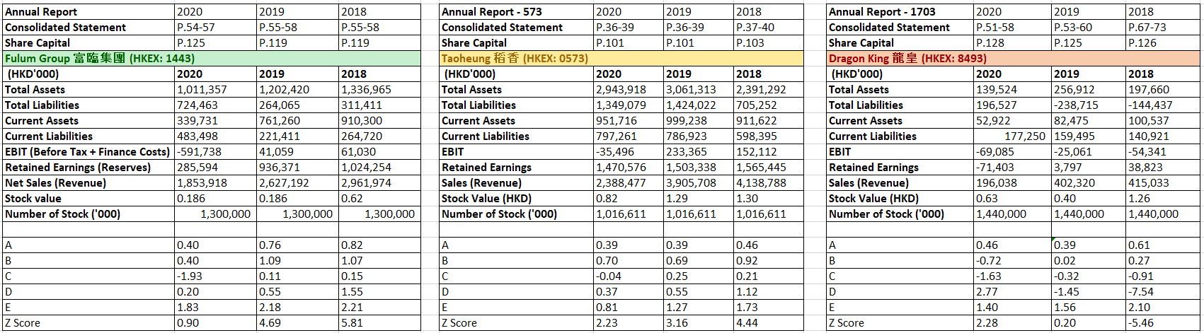

Ratio Calculation


