Curtis Rees
2003711

Micros Peripherals and Interfaces

Using and programming the 7 segment display prototype circuit

Bibliography

[1] | A. Augustyn, “Britannica,” [Online]. Available: https://www.britannica.com/technology/voltage-regulator.
[2] | E. Bureau, “electronicsb2b,” [Online]. Available: https://www.electronicsb2b.com/important-sectors/components-fast-growing-sectors/why-capacitors-are-important-components-in-electronic-circuits/#:~:text=The%20importance%20of%20capacitors&text=The%20main%20function%20of%20capacitors,hazardous%20breakdown%.
[3] | L. George, “electrosome,” [Online]. Available: https://electrosome.com/topic/why-crystal-oscillators-are-used-in-microcontrollers/#:~:text=Oscillators%20provide%20the%20basic%20timing,principle%20of%20Piezo%20electric%20effect..
[4] | “Rapid tables,” [Online]. Available: https://www.rapidtables.com/electric/capacitor.html.

Section 1:
Firstly we were introduced to the “count” project which runs on the 7 segment display prototype board. Our first job was to produce a proteus simulation that matches the original as closely as possible. Proteus supplies us with many different components that can be used in order to simulate the circuit we were given. There are numerous customisable parts of the circuit, one being the seven segment display which can showcase all the hexadecimal values Secondly there are two push button switches which can be used for numerous things. Finally a sounder which can be used to make constant pitches.
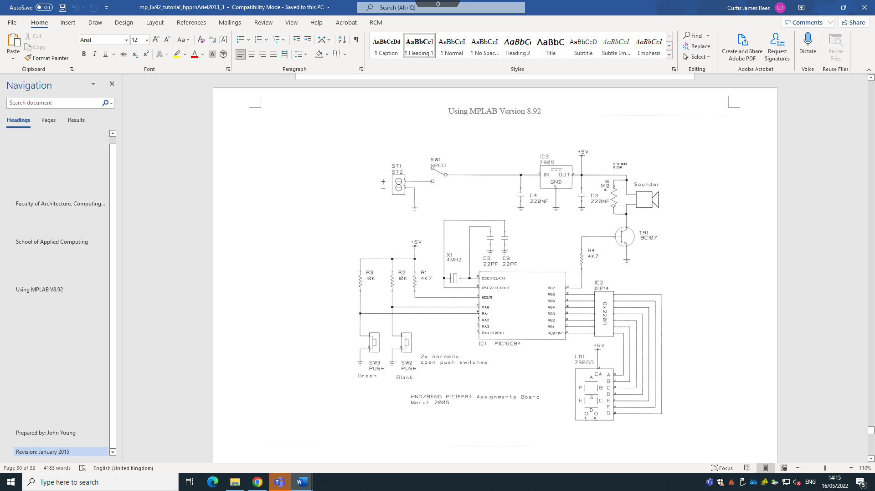

Figure 1

Figure 1 above, is the circuit we were given that needed to be simulated into proteus. The proteus simulation needed to match the circuit as closely as possible and carry out the 7 segment display. So I then inserted all the parts and components and give them the correct value as you can see below in figure 2.
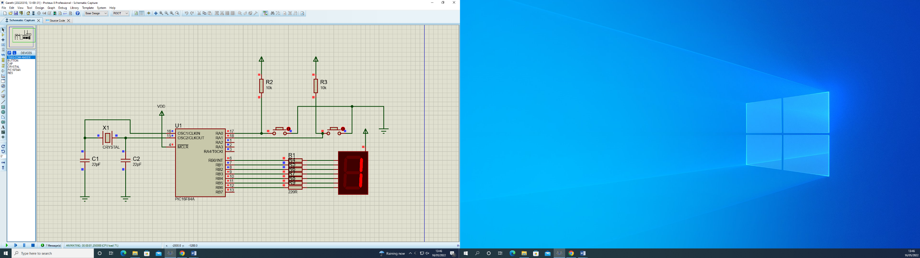

Figure 2

Figure 3

The first component in the circuit I am going to talk about is the seven-segment display used for displaying 1-digit numbers and all hexadecimal values. Each of the seven segments is connected to a separate pin. The seven-segment display is connected to a power supply. Using this screenshot of the seven-segment display displaying the number ‘1’, you can see that two of the pins are off, that being ‘RB1’ and ‘RB2’. The seven-segment display is powered by 5 volts, and port B of the pic has been set as an output. The current flows from the seven-segment display to the pic if a pin is set to 0. This is how the segment lights up in the display. If the pin is set to 1 then this stops the current flowing therefore not lighting up the segment. The resistors are included to limit the current and to protect the pic, limiting the current to the safe rated value of the pic.

Next component I am going to talk about is this voltage regulator, a voltage regulator is any electrical or electronic device that maintains the voltage of a power source within acceptable limits. It’s important to have in our circuit as it is needed to keep voltages within the prescribed range that can be tolerated by the electrical equipment using that voltage. Additionally, there are used when it is necessary to have a steady and reliable output voltage [1] The reason it is necessary for this circuit to have a voltage regulator is because it’s between the power supply and the sounder, so ensuring the voltage is steady and reliable is important.
Figure 4

Figure 5
From the screenshot you can see there are two capacitors. A Capacitor is an electronic component that stores electric charge. The capacitor is made of 2 close conductors (usually plates) that are separated by a dielectric material. The plates accumulate electric charge when connected to power source. They allow the alternating current to pass but block the flow of the direct current to avoid a hazardous breakdown of the circuit. [2]

Additionally, from this screenshot you can see a crystal oscillator. Oscillators provide the basic timing and control for a microcontroller and its peripherals. Commonly used oscillators are of crystal because of its well-known stability and durability. It produces stable output for prolonged time. [3]
Figure 6

Figure 6 shows the push button section of the circuit. I made the pins on port A input pins with two push button pins connected to a power supply. I then made it so that when one push button switch is pressed it clears whatever is on the seven-segment display and displays a ‘1’ and then if the other push button switch is pressed then it clears the seven-segment display and displays ‘2’. Again you can see each power supply is connected a resister which limits the current and protects the pic.

Figure 7

Task 5 and 6 is focusing on the sounder connect to pin 7 on port B. Firstly there is a power supply which leads directly into a switch. This then leads into a voltage regulator which I have previously talked about. The sounder has a capacitor connected to the positive and negative side which stores and releases energy which gives the sounder the constant pitch. The transistor is then used for altering the sound that’s produced. Finally a resistor which limits the current to protect the circuit.

Section 2:
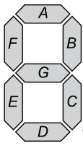
In section 2 of my report I am going to explain how I got the circuit to display the Hexadecimal characters 0-F on my seven segment display. Now that the circuit has been produced into proteus with the seven-segment display connected and each segment connected to a different pin, we need to work out which segments need to be turned on/off to show each of the hexadecimal characters. My first step was to work out what each hexadecimal character was in binary:
Figure 8
Display Number | Binary
0 | 1 0 1 1 1 1 1 1
1 | 1 1 1 1 1 0 0 1
2 | 1 0 1 0 0 1 0 0
3 | 1 0 1 1 0 0 0 0
4 | 1 0 0 1 1 0 0 1
5 | 1 0 0 1 0 0 1 0
6 | 1 0 0 0 0 0 1 0
7 | 1 1 1 1 1 0 0 0
8 | 1 0 0 0 0 0 0 0
9 | 1 0 0 1 0 0 0 0
A | 1 0 0 0 1 0 0 0
B | 1 0 0 0 0 0 1 1
C | 1 1 0 0 0 1 1 0
D | 1 0 1 0 0 0 0 1
E | 1 0 0 0 0 1 1 0
F | 1 0 0 0 1 1 1 0

I calculated the binary value of each of the hexadecimal values by using the template in figure 8. You calculate it by each letter in the segment representing a digit in the binary value. Writing right to left, you start with A then B and then C and so on. Giving the value 0 if you want the segment to light up and 1 if you don’t want it to light up. The far left digit is always 1 as it’s a seven segment display so eighth digit doesn’t represent a segment.
Now that I have the value of each hexadecimal character in binary I can convert the binary into hexadecimal. Below are the results:

Binary | Hexadecimal
0100 0000 | 40
1111 1001 | F9
1010 0100 | A4
1011 0000 | B0
1001 1001 | 99
1001 0010 | 92
1000 0010 | 82
1111 1000 | F8
1000 0000 | 80
1001 0000 | 90
1000 1000 | 88
1000 0011 | 83
1100 0110 | C6
1010 0001 | A1
1000 0110 | 86
1000 1110 | 8E
Example workings for changing the binary code for ‘F’ into hexadecimal
1 0 0 0 1 1 1 0
8 4 2 1 8 4 2 1
=8 =E (8+4+2) =14
Hexadecimal value= 8E

Now that I have worked out the hexadecimal value for each of the values I can now write the relevent code into proteus to make it ‘count’.

I would do this by the following coding:
Movlw 0xB0
Movwf Port B
Call pause

- So this loads the value ‘0xB0’ (being the pattern for 3 in the seven segment display) into the wokring register.
- Then copy the working register into the specified register, being Port B.
- Finally call the pause function which delays it so that the number can be visable before displaying the next number.
- Finally move onto the next hexidecimal value in the sequence or use ‘goto’ which can then restart the count, this making it a continual loop.

Section 3
Task 1
For section 3 of the assignment we were given six tasks to carry out on the proteus circuit we have already made in section 1. So the first task we had was modifying the “count.asm” so that the seven segment display counts from 0 to F in hexadecimal numbers in 0.5 second increments. I found it useful to produce pseudo-code for this task before starting the coding on proteus. Pseudo code really helps plan the code and gives you a baseline when starting the actual coding. So the pseudo-code for my first task is shown below:
pseudo-code
‘count’
Move 0 to working register
Output working register to port B (display 0)
Pause |(0.5 seconds)

Move 1 to working register
Output w reg to port B (display 1)
Pause |(0.5 seconds)

Move 2 to working reg
Output w reg to port B (display 2)
Pause |(0.5 seconds)

Move 3 to working register
Output w reg to port B (display 3)
Pause |(0.5 seconds)

Move 4 to w reg
Output w reg to port B (display 4)
Pause |(0.5 seconds)

… Continue this code until F

After F – goto ‘count’ to restart

‘count’

Move 0 to working register
Output working register to port B (display 0)

Pause |(0.5 seconds)

Move 1 to working register
Output working register to port B (display 1)

Pause |(0.5 seconds)

… and so on until it reaches F

Move F to working register
Output working register to port B (display F)

Pause |(0.5 seconds)

Goto ‘count’

Additionally for task 1 of section 3 I decided to make a flow chart as well as the pseudo-code as it clearly lays out the intention of the code and clearly shows each step. The flow chart I made is on the previous page (9).

Task 2
The second task is to write a program so that when you press one of the buttons, it displays “1” on the 7 segment display, then when you press the other button, it displays “2”. So now that I have the two push button switches incorporated into my proteus circuit I can now produce pseudo code to again make it clear on what is needed when I come to the actual coding.

Test button 1
if pressed go to sub routine “button 1”
If not
test button 2
if pressed go to sub routine “button 2”
if not
loop/goto the top of the code

“Button 1” sends binary for ‘1’ into the working register then to port B so it displays 1 on the seven segment display.

“Button 2” sends binary for ‘2’ into the working register then to port B so it displays on the seven segment display.

This is the flow chart I made showing the steps of the coding for task 2

Button check

Button 1 has been pressed
Button 2 has been pressed

No buttons have been pressed

Goto subroutine when button 1 has been pressed
Continue checking to see if buttons have been pressed
Goto subroutine when button 2 has been pressed

Move literal value of 0xF9 into working register then move in port B
Move literal value of 0xA4 into working register then move in port B

Test single bit in port A and if bit is ‘0’ then skip the next instruction
Test single bit in port A and if bit is ‘1’ then skip the next instruction

Task 3
The third task of section 3 is to modify my program further, so when one button is pressed is causes all the segments to light up, and when the other switch is pressed it turns them off (the switch activations should be 'latching' i.e. you don't have to hold the button down for the on/off effect to remain). Similarly to the other tasks I produced pseudo code to make it clear what I intend for the programme to do and so it’s easier to visualise. Below is my pseudo code for task 3:

Pseudo-code
Check buttons
If button 1 is pressed goto “button one”
If button 2 is pressed goto “button one”

“button one” puts 00 into the working register
-output on Port B so all segments are off
Go back to the top of the code

“button two” puts FF into the working register
-output on Port B so all segments are on
Go back to the top of the code
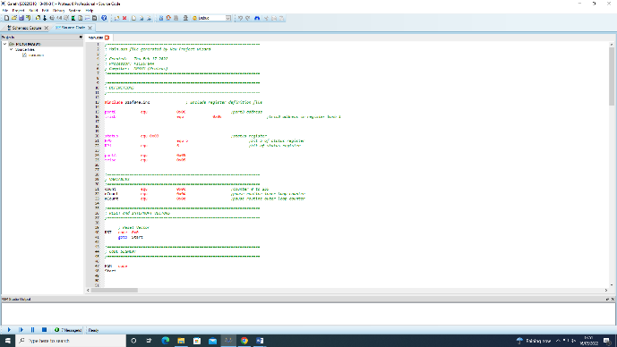

This is the flow chart I made for the task 3 in section 3

Output onto Port B so all lights are on
Output onto Port B so all lights are off
Puts FF into working register
Puts 00 into working register
Button check
Button 1 has been pressed
Button 2 has been pressed
Goto subroutine when button 2 has been pressed
Goto subroutine when button 1 has been pressed

Task 4
The fourth task was to Combine everything together so you have a program that starts by displaying '0' but you can count up if you press one button, and count down if you press the other. Again I produced pseudo-code to help understand the task and make it clear.

Pseudo code

Move 0 to working register
Output working register to port B (display 0)

If button 1 is pressed go to “count up”
If button 2 is pressed go to “countdown”

“Count up”
Increment count by 1
Check buttons

“Countdown”
Decrement count by 1
Check buttons
(Assuming that I have a ‘count’ routine working)

This is the flowchart that I produced for the task 4 in section 3

Decrement “count” by 1
Increment “count” by 1
Call in sub routine “countdown”
Call in sub routine “count up”
Move 0 to working register
If Button 2 is pressed
If Button 1 is pressed

Output working register to port B (display 0)

Check buttons

