Paula Smith 1903588 10-10-2021.
- How useful is the emerging field of Digital History? Answer with reference to different consumers of 'history' and the examples we discussed in class.

This essay will discuss the usefulness of the emerging field of Digital History with an eye to the consumers of ‘history’, and using the examples discussed in class will argue that this is an exciting addition to the traditional dissemination of historical information.
Firstly, it is important to define what Digital History is- it examines and represents the past using new technologies . It sits “between the traditional historical and the computational or digital” depending on the needs of the research and interdisciplinary engagement . Therefore, it could be digitisation of archives, researching using computers and the internet, or teaching and dissemination of historical information. This essay examines two Digital History websites, one of which is a collaborative project serving several needs, from boosting tourism to creating a hybrid digital resource , the other being of more focused format and purpose.
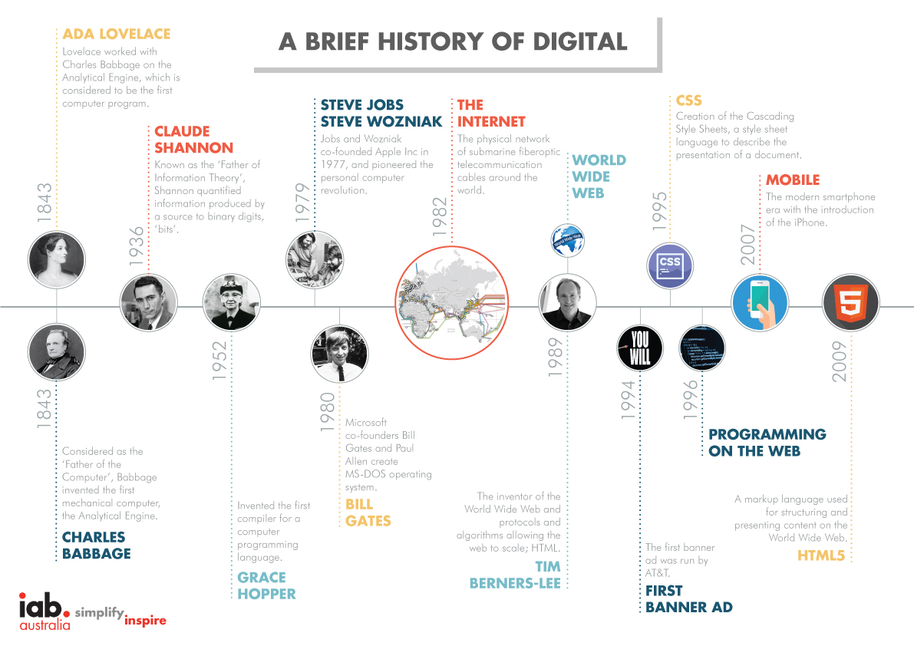Fig 1. A Brief History of Digital.

With its roots in the 19th Century when the friendship between two mathematicians, one being also a writer, created the first computer and programme, the digital world has changed the way we gather and disseminate information. The previous image only goes as far as 2009, and does not consider all subsequent changes, particularly with the Coronavirus pandemic forcing many aspects of our lives into the digital space. For example, Museums and Galleries have had to adapt and create an online presence for themselves for fear of closure , so this is a good time to evaluate how we present historic information.
When thinking about how useful Digital History is, the consumer needs to be considered. If the information is for academic circles only, the current system of Journal article publication, research and writing papers, works. It is an established, validated system using the ‘research excellence framework’ and the work that succeeds this process can be part of an academics output and raise their status in that world. Perusing the wealth of information contained in the academic world is exclusive to those who have access to the channels- Journals, Libraries- and the published work can potentially never gather the momentum to escape this closed-circuit community.
If the information is for interested non-academic groups or the public and has an agenda for engaging future interest in ‘history’, the availability and interface needs to be different. If the information is widely accessible through the internet, classrooms, tour guides and local public groups, people have a chance to engage with it. The way we engage is also particular to the way we learn.
People have individual learning styles which can change through life, but there is an established understanding of the distinctly different abilities across this spectrum . Text using long words in the concentrated style of the academic can be inaccessible to many people, such as those with dyslexia. Listening in a passive relationship to an expert is difficult for someone with ADHD. These barriers to enjoying learning are discouraging, and although recall memory is positively affected by experiencing strong emotions at the same time , it is generally more productive to stimulate happy emotions than unhappy ones, by being inclusive in style and language.
The ways of establishing facts varies across the historical disciplines and this merging of techniques must hold tensions, from which the creation of a Digital History website must emerge. This is a behind the scenes issue but must be very challenging when each discipline has a justifiable style, and breaking tradition takes courage.
There are some negatives with Digital History being the repository of historical information. Another thing the pandemic taught us is how insecure it is to be reliant on equipment, technology and power supply. Glitches in internet transmission and links breaking can cause devastation in the progress of research, and ‘live’ online interactions. Affording the connection and suitable I.T. equipment and having the skill and constant learning ability to use it can be a barrier.
Websites must also be paid for and maintained. There is not the material security of paper and libraries and if not updated, work could be lost for ever. There is significant cost in gathering the diversity of skills together and the length of time it takes to create a website. Funding may only be possible in large institutions or spread between institutions, which could be complex particularly as there needs to be an ongoing commitment to regularly update the site required for it to function through time.
The work done by academics for the Digital History websites is not currently recognised as part of their academic output. This can be experienced as undervaluing the huge amount of work done, and if the individual academics want or need to gather status for employability, it may feel futile.

This brings us on to looking at the examples of D.H. discussed in class.
Monastic Wales is focussed website detailing the Monasteries in Wales and is a good source of information for people already interested in this part of our culture. It has an interactive element, even a Choir who sing in the Monasteries, and it is updated by the supporters who can add their own appropriate unpublished research. By being a hub for a wide community of interested historians, with the future plan of outreach into schools, the website does make a wealth of information easily available and may cultivate a passion for this aspect of our past. It is unlikely, however, to connect with non-historians who are not obliged to see it through their schooling. The pages are fairly uniform in presentation and use text with some pictures as the only style. It could appear uninviting to young consumers or those who have reading or visual challenges.
The other example is City Witness-Swansea . This site has a lot more going on. The landing page links to different options that speak to different interests and ages- the game appealing to visual learners, and it leads to detailed information presented in an almost comic form. In learning that the images used for the witnesses came from the doodled faces in the margins of the original manuscript, gives another glimpse into the real story. If people can imagine a hanging and resurrection of a notorious rebellious bad-boy, they are connected to a 700-year-old manuscript in Latin kept in Rome under armed guard, without the years of study needed to understand and access it. The story, fact checked and cross referenced, is presented in an easily digested form enabling a person to be inside the history. By imagining how they would have understood and judged the events creates a relationship with the people described which aids personal understanding, which can lead to a deeper interest.

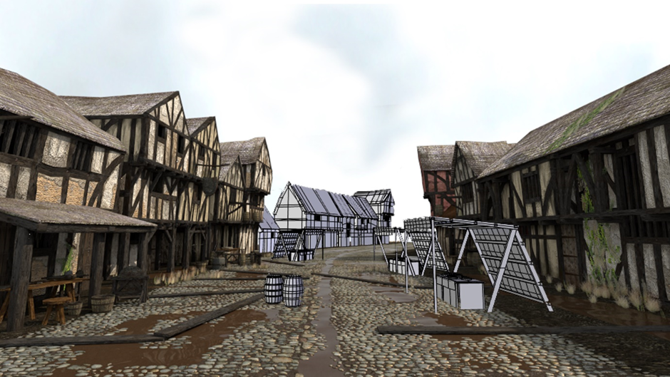
Interactive maps literally layer information to describe the changes the city has gone through, as well as the progress of the story of William Craig and the ‘miracle’ of his coming back to life. The 3D visualisations capture a different sort of learning attention and makes the text come to life.
Fig 2. View North from Wind Street

For the complex level of detailed information to be available in such a digestible form, is an entertaining and active way of cultivating interest in the past. The project was put forward for the NCCPE Engage Award in 2016 and there had been 65,000 visits from 35,000 users up to this time. Unfortunately there have been no updates for a while- it would be good to know how the site fared during lockdown when the popularity of virtual tourism blossomed .

Conclusion.
If the purpose of research and dissemination of the resulting information is to bring new people from the general population into the academic community, or to spread the knowledge for the interest of the public, Digital History has a new and important role. It is exciting to consider the reach of the internet into people’s homes and classrooms, engaging people of all ages by presenting the well-researched information in a form palatable to so many more than the traditional audience. To resist this development would be missing a great opportunity to reach out to a new generation of potential historians who have adapted to learning online through media other than books.
It is not to replace the traditional methods and preservation of knowledge, but to flesh out the bones of this often inaccessible and dry work with colour and informed imagination that allows the consumer to briefly step into the time described. By understanding the perspective of individuals at the time, they could relate to the story. Through the brief 700 years since the City Witnesses had their words recorded, humans have evolved little, but our resources and ability to communicate has evolved so much to be almost a miracle itself.

Word count 1596

Bibliography.

City Witness- Swansea. The Project. Available at: About / The Project | City Witness (medievalswansea.ac.uk) Accessed on 09-10-2021.
Fridlund, M., Oiva, M., & Paju, P. (2020). Digital histories : emergent approaches within the new digital history. HUP, Helsinki University Press (p.4) Available at: https://librarysearch.uwtsd.ac.uk/permalink/44WHELF_UWTSD/11c0l68/alma99100341358002421 Accessed on 09-19-2021.

G.Reid, Learning Styles and Inclusion (London: Paul Chapman, 2005). Available at: https://librarysearch.uwtsd.ac.uk/permalink/44WHELF_UWTSD/11c0l68/alma99100107725202421

Kelly, T. Mills, Teaching History in the Digital Age (Ann Arbor, Michigan: University of Michigan Press, 2013) https://librarysearch.uwtsd.ac.uk/permalink/44WHELF_UWTSD/11c0l68/alma99100240065402421

Kemman, Max. Trading Zones of Digital History, Berlin, Boston: De Gruyter Oldenbourg, 2021. https://doi.org/10.1515/9783110682106

Monastic Wales. Available at: https://www.monasticwales.org/ Accessed on 05-10-2021.

Nawrotzki, Kristen, and Jack Dougherty, Writing History in the Digital Age (Ann Arbor: University of Michigan Press, 2013) https://librarysearch.uwtsd.ac.uk/permalink/44WHELF_UWTSD/11c0l68/alma99100101922602421

S.Ings, How the pandemic is revolutionising art galleries and museums. New Scientist. Available at: https://www.newscientist.com/article/mg24933202-100-how-the-pandemic-is-revolutionising-art-galleries-and-museums/

The Telegraph. Available at: Rise of the digital holiday as locked down jetsetters turn to virtual reality (telegraph.co.uk)

Tyng, Chai M et al. “The Influences of Emotion on Learning and Memory.” Frontiers in psychology vol. 8 1454. 24 Aug. 2017. Available at: https://www.ncbi.nlm.nih.gov/pmc/articles/PMC5573739/

Images.
Fig 1. A Brief History of Digital A Brief History of Digital – It’s Always Good to Reflect - IAB Australia Accessed 05-10-2021.
Fig 2. View North from Wind Street. Available at: https://www.medievalswansea.ac.uk/en/mapping/visualisations/index.html Accessed 08-10-2021.

Fridlund, M., Oiva, M., & Paju, P. (2020). Digital histories : emergent approaches within the new digital history. HUP, Helsinki University Press (p.4)
Kemman, Max. Trading Zones of Digital History, Berlin, Boston: De Gruyter Oldenbourg, 2021. https://doi.org/10.1515/9783110682106
City Witness- Swansea. The Project. Available at: About / The Project | City Witness (medievalswansea.ac.uk) Accessed on 09-10-2021.
S.Ings, How the pandemic is revolutionising art galleries and museums. New Scientist. Available at: https://www.newscientist.com/article/mg24933202-100-how-the-pandemic-is-revolutionising-art-galleries-and-museums/
G.Reid, Learning Styles and Inclusion (London: Paul Chapman, 2005). Available at: https://librarysearch.uwtsd.ac.uk/permalink/44WHELF_UWTSD/11c0l68/alma99100107725202421 Accessed on 05-10-2021.
Tyng, Chai M et al. “The Influences of Emotion on Learning and Memory.” Frontiers in psychology vol. 8 1454. 24 Aug. 2017. Available at: https://www.ncbi.nlm.nih.gov/pmc/articles/PMC5573739/ Accessed on 07-10-2021.
Monastic Wales. Available at: https://www.monasticwales.org/ Accessed on 05-10-2021.
City Witness-Swansea. Available at: https://www.medievalswansea.ac.uk/en/index.html Accessed on 08-10-2121.
City Witness-Swansea
The Telegraph. Available at: Rise of the digital holiday as locked down jetsetters turn to virtual reality (telegraph.co.uk)

