Mathematical play activity
Portfolio EAEE410/C- Fruit Snakes.
By Elektra Dee Smith
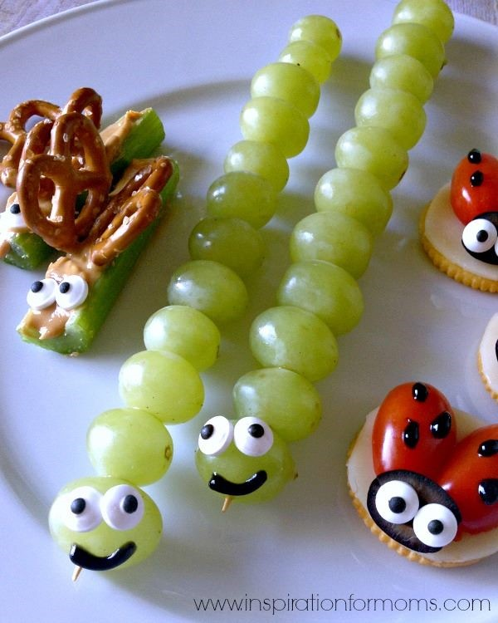 Source: Annie, (2015). Available at: http://mothersoftheyear.weebly.com/stories/if-one-more-person-shares-this-smiling-caterpillar-lunch-im-going-to-lose-my-shit
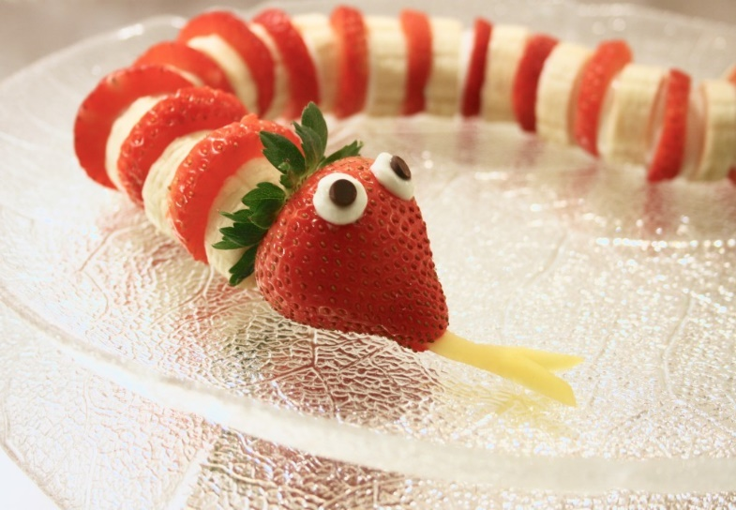

Source: Vuket, (2016). Available at: https://www.lovefromtheland.com/strawberry-banana-snake/
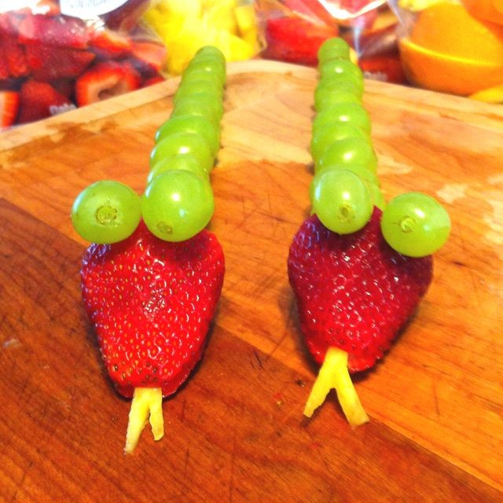 Source: Lynn, (2021). Available at: https://www.pinterest.co.uk/pin/239253798924591208/
Content Page

Activity plan 3
Evaluation 5
Discussion 8
Explanation 10
References 12

The Activity Plan
Activity Plan
Activity:

Cooking- Fruit Snakes
Number of children:  4 | Age of children:  3-4 year olds | Number of adults:  1-2
Location:  School Classroom  or  Dinner Hall | Preparation time:  8-10 mins | Activity time:  10-15 mins
Resources:

Table, Chairs, Chopping Boards, Aprons, Peelers, Knives, Bowls, Plates, Spoons, Strawberries, Banana’s, Grapes, Raisons, Chocolate Drops, Red and Green Grapes, Apples, Carrots.

After activity:- role play area.
Aim/s of activity:

For children to independently and enjoy creating a fruit snake.
Addition and subtraction. Fractions. Shapes. Sizes. Colours. Symmetrical. Fine motor skills. Creativity and Imagination.

Links to outcomes:

Supports child’s Holistic development, Social and Cognitive Development, supports Creativity and Imagination. Helps and supports with adding and subtracting. Promotes healthy eating.
Differentiation:

Supporting the children when they ask for help and support. By allowing children to control their own outcomes. Asking children open-ended questions to make them think out side the box. For children to becoming problem solvers.
Health and safety:

Monitor that the children are correctly using knives and peelers, support and assist if children need help with chopping or carving. Check for any children’s allergies.
Role of adult/adults:

To monitor, support, advise and to praise the children.
To ask questions, and to support children when they request it.
Observe and Acknowledge the children’s achievements.
The activity:

Practitioner :- Prepares and wipes, sets up the table for the children, ensuring there is enough space between each child allowing enough room to chop. Lay out chopping boards, knives peelers plates and bowls. Supporting the children as and when they ask for support.

Children:- Allows for addition and subtraction, to know how many of each slice they want and need. helps children understand about fractions how one banana cut in half gives you two slices, or one grape cut in half is two halves of one grape. Understanding of shapes each item of fruit has its own unique size and shapes and discovering smaller sizes when chopped. Colours variety of colours from all the different fruits. Understanding or getting to grips with symmetrical, for example snakes and humans have two eyes, humans have two legs and arms snakes have none some animals have four legs some have tails some don’t. Draws curiosity to what else we have the same as animals. Fine motor skills complies with chopping and peeling. Supports children with their imagination and curiosity, to be able to create their final outcomes of their snakes. Promotes health eating.

Evaluation

Stuart (2010) suggests that Over all children should enjoy any activity while learning otherwise children will possibly get bored lose concentration and cause distractions in class. Each activity needs to be planned carefully with each child’s best interests at heart and to tailer all children in class setting. One way to evaluate is for practitioners to observe all children that enter the setting to assess what stage or level of understanding the children are at to prepare the level of activity for children. Practitioners observing the children’s activity might ask themselves questions during activities:- Are children interested in the activity? Are the children enjoying themselves? Did the children stay engaged in the activity? At the end of the activity practitioners might ask themselves Did it give the children opportunities to be creative? To explore? Discover? Work independently? Work with someone or with another child or maybe even an adult supporting them? Did the children complete the end goal? If not why? If practitioners did this activity again what would you do different? With this in mind practitioners need to use each experience as an opportunity to see what the children can do and getting them ready for the next future planning and skills to develop. Supporting children who need to extra support to flourish on to the next steps. (teachpreschool.org)

Strengths to activity would be addition and subtraction of fruit discovering and understanding light fractions for example one whole banana makes two halves put them together to make one full banana. Colour all fruits have their own individual unique colour some shading from light to dark some may have two different colours for example kiwi fruit brown on the out side green on the inside. It touches within all five of the children’s senses, each fruit has their own unique smell, feel and taste they also all have their own individual looks and sounds an apple is hard and crunchy where as a raspberry is soft and squidgy. Shapes and sizes how all fruits have their own individual Shapes the problem would be for the children to overcome with getting the fruit roughly the same shape and size. Symmetry to know how many eyes a snake has. May draw curiosity to children asking questions to what else may have two eyes or maybe what other things may have two of everything. You would touch on the topic of hygiene with regards to handwashing and not eating the fruit and putting it back in the bowl. Washing dishes and cleaning the mess away after ourselves. Also the important aspects of promoting health eating. Supports children’s fine motor skills with the chopping and the holding of the knife, the peeler and the fruit. Supports the holistic development by creating and engaging in cooking activities, asking open-ended questions. Supports the child’s social and cognitive development. This activity also supports the child’s creativity and imagination allowing them to express their own imagination and creating their own individual snakes.

Donald (2011) suggests that Tucker (2010) Lindon (2005) Haylock and Cockburn (2008)all believe that children learn best through practical, meaningful experiences that are purposeful to the child. Similar to them wood and Attfield (2005) argue that early years are important for developing children’s abilities and enthusiasm in mathematics. Wood and Attfield (2005)also believed that the more practical the activity is the more success and experience the children gain out of the activity. (mathematicsinearlyyears.com)

There is no need to evaluate everything a child does as it is a long process and when recording information you may miss the important information the child is using to show their best potential. Practitioners also need to remember to focus on the most important factor keeping the child’s best interests at heart. (TheChildAtTheCenter:-Self-EvaluateinEarlyYears 2007, P10-11)

Weaknesses/Disadvantages of activity would be if any children have any allergies causing the practitioner to re-think the whole activity plan or remove the fruits from the setting. or work with the group of children with allergies first and then carry on the activity as normal without the fruits to cause har to any children. A child having an accident with a peeler or a knife. As suggested previously practitioners must observe and asses the children to see if they are at the right age stage and the capability to complete the task. Children not being interested or taking part in the activity. Practitioners should of already observed and assessed the children to figure out what the children’s interests may or may not be.

According to EarlyYearsMatters (2021) mathematics is broken down in to two aspects:- first one being numbers, second one being shapes, spaces and measurements. Mathematics isn’t just about numbers. Mathematics is about understanding shapes, Space, and measurements to solve everyday problems too.

UNICEF.org.uk (2016) states ‘All children have the right to be treated with dignity and fairness to be protected to develop to their full potential and to participate in all actives including children with additional learning needs and disabilities. The convention sets out the civil, political, economic, social and cultural rights that everyone under the age of 18 is entitled to’. Article 2 states that ‘ The convention applies to every child without discrimination, whatever their ethnicity, gender, religion, language, ability’s or any other status. Whatever children may think say or do and whatever the family background maybe’. Article 3 states ‘ the best interests of all children must be on top priority in all actions and decisions that affect children’. Article 23 states ‘ a child with disabilities and additional learning difficulties has the right to live a full and decent life with dignity and, as far as possible to support their own independence and to play an active part in the community’. There for practitioners need to support and help children with additional learning needs and disabilities in mind with this play activity practitioners could use hand on hand support with the peeling and the chopping of the fruit. (childsright.org.uk.., 2016)

Discussion

Goddard (2019) Supports using role play recourses to support children after this activity to have role play area turned in to a kitchen/restraint allowing children to create their own imaginative play allowing them to re-call any information or skills they wish to develop, trial/error new ways to express themselves or the activity in some sort of way. In the role play area children could be chefs, waitresses, shop keeper mums dads or children entering the café. Benefits of this will allow children to use their creative and imaginative side, be creative story tellers, become problem solvers, understanding mathematical concepts, language and communication, self-regulation through co-operation and conflict resolutions as children agree their own roles and responsibilities of the play. gross and fine motor skills. Role play allows children to take risks in a safe environment to be able to express their feelings. Learn about other children’s cultures and engaged in sustained shared thinking. (nursaryworld.co.uk)

Tucker (2016 P13) suggest to provide areas within the environment where children can count interesting aesthetic objects and label them with the corresponding numeral. provide opportunities for children to see numbers along side written word. Display numbers una useful way for example numbers on draws or trays, numbers on plant pots. A certain number sits with a certain pencil colour. Posters and number work on walls and pegs. Counting sticks. Sets of 2D and 3D shapes throughout setting. Provide lots of number puzzles and books through out the setting.

Littlewood (2021)suggests that Nicholson (1970) believed ‘That it is loose parts in your setting and environment is what empowers and allows children to have imaginative possibilities allowing children to learn and develop in their own unique ways’. (thesupplyroom.com).

According to Solly (2017) He believed that Nicholson (1970) states ‘everyone can be creative and inventive, you can see this when you observe children of all abilities playing with lose parts. Lose parts are various can conclude in a lot of different objects to expand their creativity and to the environment around them’. Nicholson (1970) also suggests that ‘withing lose parts everything has a specific place and what may work on for inside environment may not work on an outside environment allowing children to become problem solvers’. (creativestarlearning.com).

According to Martin (2021) he believed that ‘Piaget (1896)and Vygotsky (1962) believed that children are actively constructors in the world’. On their thought and process they saw learning as a ongoing progress where children make use of their ‘schema’ to construct their learning. (earlyyearseducation., 2021)

Pacey (2016:5) Suggests that practitioners can develop children’s thinking access the curriculum through the process of planning, developing and reflecting. This allows children to enquire deeper to understand and enables them to explore and make sense of the environment and the world around them. (foundationphaselearning/welshgov.com)

In the foundation phase by observing children while they are involved in a play activity allows practitioners to get the best result and outcomes from the child/children they are observing. By observing children it shows what skills, and how much more independent the child has become or maybe if a child needs a little more support in specific areas. Observing the children will also give practitioners to help to gather information to what the child’s personal preferences may or may not be. (observingchildren.org. 2008)

According to Kelly (2016) Bandura (1925) states ‘central to the foundation phase the practitioners are the facilitators of learning with the child at the heart of all learning, care should be taken to ensure that the teaching approach that practitioners use is based on the needs of the children in each area of learning’. (earlyyearscareers.com; 2016).

Explanation

Scottish government (2011;1) states that ‘ parents are the first educators in a child’s learning. Parents have a key role in developing the children’s skills as children move on through education. (Learningteachingscotland.org.uk)

Tucker (2010:P140) states that ‘Parents can do greater significance with children at home than what any other educational influencer’. Tucker (2010) also suggests that any parent working along side a practitioner should be a learning stone for both practitioner and parents leading to improved learning for children. (earlyyearseducators.com)

Kimberley (2016) states ‘There are many different approaches to help support practitioners to promote mathematical development. For practitioners it is most important to find the most effective approach for the individual child. Confident that the children approaching the task has achievable challenges. Ideas to improve help within mathematical development could include: Group activities, Dominoes, Bingo, child led activities, numbers and colours on draws. Technology, there are many computer and tablets out that have so many app’s on to help with numeracy. Practitioner interactions by asking numerous open-ended questions, cooking helps with maths skills, counting, shapes, sizes and colour. Some studies have shown that soe children have difficulty keeping up with the demands of understanding mathematics in early years settings. This shows maybe that ta child has a problem and may need some extra support with their academic work. The most effective way to promote mathematical activities in settings is to give a verity of different mathematical learning activities, interactions and supportive recourses with in a early years setting. this allows children to reach and achieve the goals practitioners set for children. (earlyyearscareers.com, 2016).

Kelly (2016) states that it is important for practitioners working with children are fully aware of their role in supporting children and identify children’s needs including children with learning difficulties and disabilities. It is important to have an effective assessment process in place not only to show the children’s progress but to be able to adapt the setting to tailor the children’s needs. (creatingeffectiveassesmentsystem.org., 2016 )

Learning and teaching pedagogy (2008:P13-31) supports that ‘Practitioners might want to take discreet plan or a map of their setting to determine what sections are used the most to be able to adapt the section to tailor progress or adapt to allow a little more support’. ‘Their should be a flexibility to be responsive to children’s interests, their choice of activities, their need for support as activities progress and time for children to continue with unfinished activities. Relevant and engaging learning experiences will allow children to make steady progression to their development’.

Learning and teaching pedagogy (2008) ‘Space should be organised to facilitate: planned and spontaneous activities for indoors and outdoors, to encourage all area of learning. Activities that cater for different learning styles. A wide range of recourses that are accessible for children to select and return after use. Physical and social activities. Independent learning. Collaborative group work. Larger groups with practitioner. Active and quiet learning. Mark-making and righting. Interactive displays for exploring and investigating. Multi-sensory resources for stimulating creativity and imagination. Storage of work in progress. Displays of children’s completed work for motivation. Opportunities for accessing books. Opportunities for using ITC with practitioners support or independent use.

Learning and teaching pedagogy (2008) ‘Practitioners can support or scaffold learning effectively by working along side and individual child or small group of children, observing and participating and intervening when necessary’. ‘interactions between and adult and child should promote language and communication skills at every opportunity. Practitioners should be skilled at matching language to children’s understandings, and introducing new vocabulary.

Burner (1943) supports and couldn’t stress enough about the importance adult interventions to support scaffolding, to enable children to make progression. He said in order to effectively scaffold the practitioner needs to be aware of what the child already knows in order to build on it. Burner (1943) is also wildly known for his ‘spiral curriculum’ where a topic that can be re-introduced to children to develop and expand their knowledge and thinking skills.

Reference list
https://teachpreschool.org/2010/11/04/evaluating-lesson-plans-in-preschool/
https://education.gov.scot/Documents/TheChildattheCentreSelfevaluationintheEarlyYears.pdf
https://www.earlyyearsmatters.co.uk/our-services/school-and-nursery-improvement-partner/mathematics-ma/
http://workforcesolutions.sssc.uk.com/new/docs/research/Mathematics_in_the_Early_Years.pdf
https://www.thesupplyroom.co.uk/step-away-from-the-plastic-loose-parts-play-in-early-years-2/
https://www.earlyyearseducator.co.uk/features/article/following-in-froebel-s-footsteps
https://www.pacey.org.uk/Pacey/media/Website-files/PACEY%20member%20practice%20guides%20(PDFs)/PG28-Theories-of-child-development.pdf
https://www.earlyyearseducator.co.uk/features/article/pioneers-jean-piaget-and-lev-vygotsky
https://www.earlyyearscareers.com/eyc/enabling-environment/how-should-mathematics-be-promoted-within-early-years/
https://www.earlyyearscareers.com/eyc/send-support/identifying-and-supporting-all-childrens-individual-needs/
https://www.earlyyearscareers.com/eyc/latest-news/creating-an-effective-assessment-system/
https://www.unicef.org.uk/child-rights-partners/wp-content/uploads/sites/3/2016/08/CRC_summary_leaflet_Child_Rights_Partners_web_final.pdf
https://www.nurseryworld.co.uk/features/article/eyfs-best-practice-in-schools-role-play-home-and-away
https://creativestarlearning.co.uk/early-years-outdoors/simon-nicholson-and-the-theory-of-loose-parts-1-million-thanks/
https://www.lovefromtheland.com/strawberry-banana-snake/
https://www.pinterest.co.uk/pin/239253798924591208/
http://mothersoftheyear.weebly.com/stories/if-one-more-person-shares-this-smiling-caterpillar-lunch-im-going-to-lose-my-shit
learning and teaching pedagogy welsh assembly government., 2008 p 1-33
mathematics through play in early years, 3rd edition, Tucker, 2006

