Kushba Begum- 1713328
Lecturer- Dr Besty Jose
Public Health Policy Report
Module/Code- Public Health Policy/ BMHP 5013

Contents

Introduction 2
Covid-19 2
Incidence and issues identified with domestic violence during the pandemic 2
PHE Response to suppress Covid-19: 3
PHE policies 7
Face masks: 8
Face masks changed lifestyles: 8
Shielding: 8
Impacts of shielding 9
Closure of all academic institutions 9
Effects on children from non-schooling 10
Health Belief Model 10
Government’s response to tackling violence on women 10
Prominent research on vaccines 11
Recommendations 12
Conclusion 12
References: 13

Introduction

This report investigates Public Health England’s (PHE) management strategies to control the spread of covid-19, specific objectives were to identify and discuss the impacts domestic violence (DV) had on women, also, it mentions current legislation on DV, the report next goes on to explain prevention policies introduced by PHE. An explanation about Health Belief Model and how it can be used to understand public perception towards covid-19 measures. The report mentions 2 prominent vaccines which are UK funded and endorsed, finally, recommendations for improving health and well-being and conclusion end the report.

Covid-19

Covid-19 pandemic placed scientists from Public Health England (PHE) at the core of international health challenges. An outbreak of Covid-19 disease was initially detected in the city of Wuhan, China back in December 2019, within a month the outbreak rapidly spread across China resulting in an epidemic, soon after, countries across Asia started seeing rising cases of the virus and subsequently all around the globe all within a short period of its onset. (Shereen, et al., 2020). The World Health Organisation (WHO) declared covid-19 a global pandemic in March 2020. To date, figures from WHO’s weekly epidemiological update recorded that the covid-19 virus has infected over 49.7 million people and caused over 1.2 million fatalities globally. (World Health Organization, 2020). Cases of Covid-19 are rapidly raising and death rates have increased across the UK, it is estimated over 48000 deaths have occurred since the start of the pandemic, and over 1 million positive cases have been identified, experts are still warning these numbers are most likely to increase significantly during the next few months. (European Centre for Disease Prevention and Control, 2020).

Incidence and issues identified with domestic violence during the pandemic

As the UK went into lockdown, many vulnerable women were trapped at home with their abusers (Andrew, 2020). the stay-at-home policy exposed them to dangerous situations (parliament. UK, 2020) (1). The research found women suffered abuse at the hands of their abusers on a more frequent level. However, the research found that even though their’s and children's safety, was compromised, women remained in the abusive environment to keep a roof over their heads, (Afshar, 2020). Many agencies were forced to limit their services, this enabled abusers to control daily activities, as a result, the devastating impacts on the women went beyond immediate physical injuries, their mental health deteriorated and caused emotional and financial worry. Many victims are still suffering from a range of psychosomatic illnesses, most common eating disorder, insomnia, and generalised chronic pain with devastating mental health problems like post-traumatic stress disorder. (Sacco, et al., 2020).

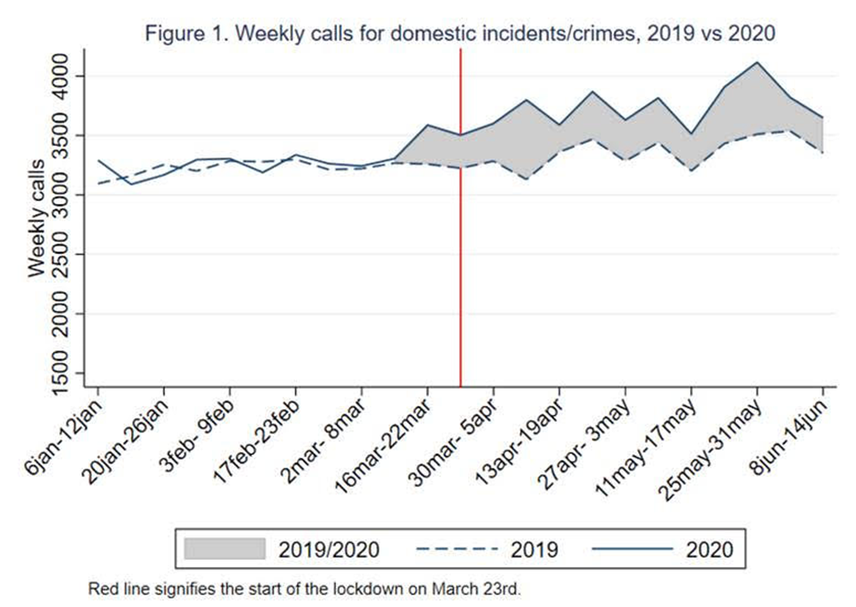

during the lockdown calls to the police about DV increased by 12% weekly compared to the previous year. (Ivandic & Kirchmaier, 2020)

PHE Response to suppress Covid-19:

PHE involves improving the wellbeing of the general population, Practical steps are taken by various bodies from PHE to strengthen and develop services across the counties to achieve goals by implementing the 10 essential public health operations (EPHOs), which are a set of detailed checklists for assessing services from PHE organisation. (World Health Organization Regional Committee for Europe, 2012).
Public health includes everyone around you and the community, public health must be effective as this helps the NHS to save a significant amount of funds. (National Conference of State Legislatures, 2014).
PHE identifies and detects diseases and problems within the community by surveillance and monitoring the health status, mortality rates, and incidence of communicable and non-communicable diseases, in particular, looking for patterns and trends, then comparing to other communities, this enables them to understand and control the prevalence of the disease. Preventive measures are undertaken to reduce or eradicate the dangers of the manifestations of a disease spreading to the whole population, Surveillance of diseases is a fundamental task at the heart of PHE operations, and having real-time data at the right time, to decide and pass decisions across the sectors is crucial, this vital role includes sourcing and gathering pivotal information such as geographical variations of outbreaks, ranges in particular age groups most affected, the severity of symptoms and links to types of people most effected,(e.g.: elderly, critically ill, ethnicity, etc..) this mix of data is collected from laboratories with confirmed cases, also, syndromic surveillance using anonymised real-time well-being information from GPs and hospitals, This information enables PHE to act accordingly with suitable approaches. (PublicHealth England, 2017).

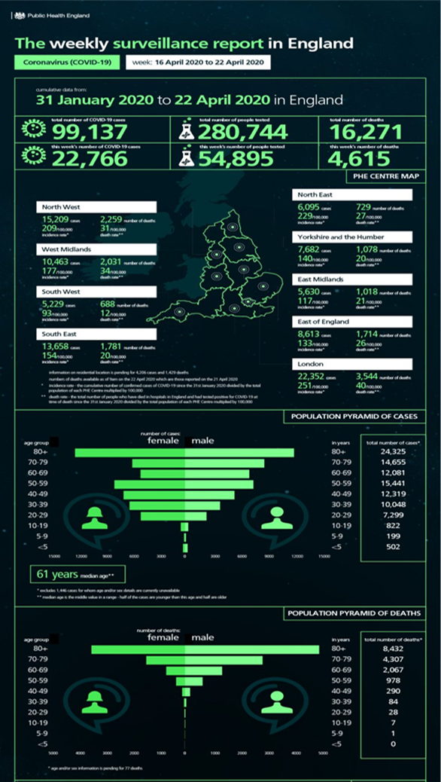

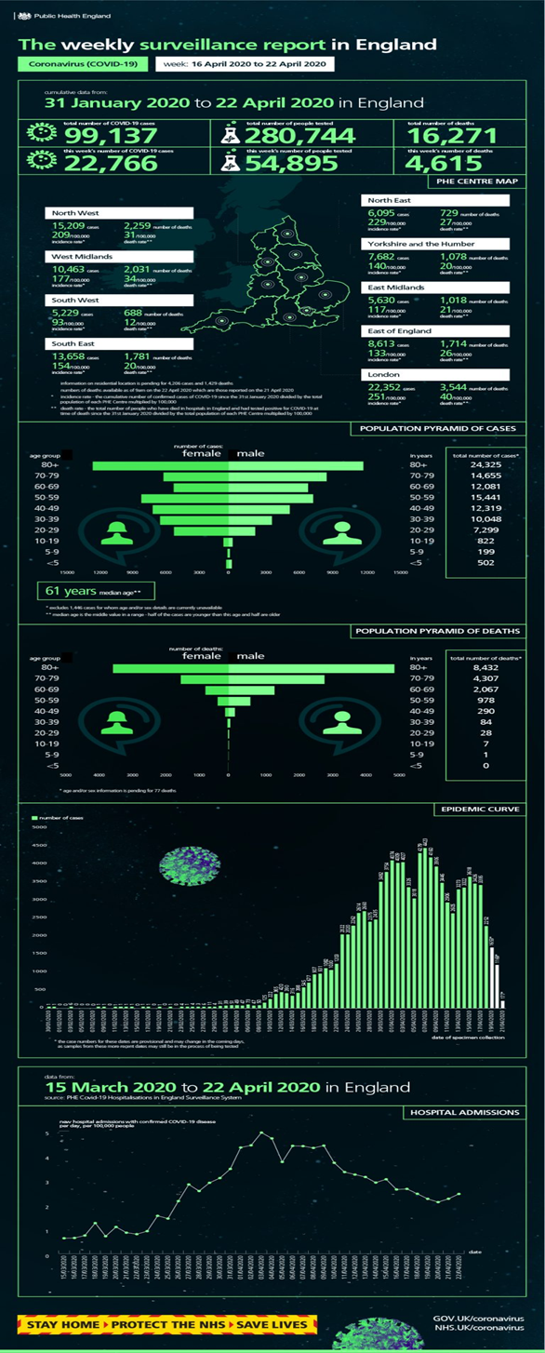

(Public Health England, 2020) (2)

Similar steps are being taken to understand the spread of Covid-19 by PHE, both on a local and national level. For consistency and measures, surveillance systems are chosen, however, due to different cases for some, symptoms may be mild to no symptoms at all, not every positive case will be reported to the health services and this leads to inaccurate analysis of a definitive figure of confirmed covid-19 cases. (Public Health England, 2020) (1).
It is a great concern for PHE with the current epidemiological situation and the risks imposed on the population from all divisions. Infection prevention and control (IPC) measures are critically important, they help with protection and smooth functioning of healthcare services at all stages and mitigating the effect on defenceless populations. Many guidances have been developed to help with IPC and healthcare providers are expected to consider and follow as many measures possible when working within the community, national lockdown aimed to contain covid-19 also, to control transmission rates social distancing was applied, further measures to monitor the situation contract tracing and mass testing was developed. Staff from all health sectors dealing with the public are being informed and trained on various measures such as hand hygiene practices, the use of PPE, cleaning and disinfecting practices, physical distancing practices, recognising symptoms and risk of transmission from asymptomatic and pre-symptomatic individuals, and respiratory hygiene practices. Although the risk of transmission may be controllable to a certain extent, unfortunately, it is not a definitive guarantee that the preventive measures will stop the incidences, that is why it is paramount that everyone must slow the spread and protect the communities. (Centers for Disease Control and Prevention, 2020).

PHE policies

PHE introduced various measures to slow the spread of covid-19, (Dunn, et al., 2020). 3 early policies to help reduce the rate were:
- face mask’s
- shielding
- closure of all educational institutions
Early measures were subsequently modified when new evidence and understanding of the virus emerged.

Face masks:

COVID-19 devastated and destroyed many lives on a global scale. (Gaspar, et al., 2020). Governments response to the face of this unprecedented rapid spread within communities is the proposal of face coverings, reviewed and affirmed by experts, facial masks are a critical tool in the fight against COVID-19 and people are urged to adapt to using a face covering or masks in all public places to reduce transmission from person to person. (Gandhi, et al., 2020). Experts have said a mask has the potential to stop the virus from transmitting to everyone, this is mainly because the novel coronavirus is a respiratory virus and it spreads through respiratory droplets, so if an infected person is wearing a mask when they exhale the mask will catch the larger droplets, stopping the droplets to go beyond the mask into the air, if the virus is aerosolised and a person who is not wearing a mask, risks inhaling the toxic air and catching covid-19 (Lustig, et al., 2020).

Face masks changed lifestyles:

many people have reported feeling claustrophobic due to wearing a face covering. Symptoms include breathing difficulty from lack of oxygen due to the increased resistance to inhaling and exhaling, also due to prolonged usage of face mask many causes such as skin problems, glasses steaming up, having to repeat or talk louder, is having a direct impact on peoples mental health, resulting in increased anxiety levels and socio-psychological stress. (Chistiansen, 2020; Morin, 2020). Facial coverings prevent the mirroring of facial expressions and cause suspicions, empathetic Connexions and trust between person to person is diminished. Several studies indicate young people are at risk to neuro epigenetics scars that often escalate into mental health problems and develop a weakened immune system due to long term exposure from socio-psychological stress (Westhizen, et al., 2020; Javid, et al., 2020).

Shielding:

As the UK went into lockdown the elderly and the critically-ill were identified as extremely vulnerable with a high risk of catching and not recovering from this virus. (GOV.UK, 2020). To mitigate any risks to them, they were placed under the shielding rules which meant there are not allowed to go out unless it is important, to keep safe, their lives had turned into total isolation from family, friends, work and the outside world. Socialising, work, education, shopping, all daily routines came to abrupt halt although, provisions were put in place by various agencies to help them, care workers were still able to attend the Care receivers in their own home, but with caution, also, for many food parcels and prioritised supermarket delivery slots were arranged. 2.2 million people were advised to stay at home and shield, 95% followed the government guidance and only left home for exercise, shopping or medical purposes. Sadly 785,000 people suffered from a various degree of mental health issues since being advised to follow the guidance. (Gibbs, 2020).

Impacts of shielding

when comparing mental health challenges due to shielding we can see diverse age groups were affected differently. elderly were affected by loneliness, for many, not being able to see loved ones took a toll on their well being so when the guidance was updated in the summer national restrictions were relaxed for shielding people to be allowed to see people from their support bubble, it was a great relief for the elderly, to be able to see love ones and chat also being allowed outside. (Gibbs, 2020). People with chronic illnesses, shielding had a devastating impact, being advised to stay home for their safety and work from home if they can, for many it started fine, being home, enjoying family-time and time to reflect, however, such bliss was short-lived as many struggled, financial problems, family problems, not being able to see elderly relatives, the constant news about daily deaths and rapid increase in cases, a majority felt anxious and scared. Many had critical hospital appointment’s cancelled and GP's work profoundly changed they were dealing with chronic patients online or over the phone, for many, this was difficult especially non-English speaking communities they felt abandoned by the government. (Thorlby, et al., 2020; Marshall, et al., 2020).

Closure of all academic institutions

Covid-19 brought the UK to a halt stopping all forms of daily activities and the most crucial and major daily routine to drastically stop was the closure of all schools in England, from March 2020. The only exception was vulnerable children and children of key workers could attend school. The main reason to close schools were children were classed as super spreaders and were thought to be risking vulnerable adults, however, since the outbreak sage experts have researched and said no evidence prove that children pose a risk to the vulnerable community (Chalmers, 2020; Munro & Faust, 2020).

Effects on children from non-schooling

children have had to bear the brunt of this pandemic, with so many months of education lost and vital important exams missed, children of all ages have not socialised with children of their age groups this has harmed their social and learning skills. children need routine but staying home and indoors children have become lazy, less motivated, bored and anti-social. Many schools provided their students with learning packs to continue their studies from home however, the younger age groups were less more interested than their older peers this proved a challenging time for both parents and child. (Royal College of Paediatrics and Child Health, 2020).

Health Belief Model

Health Belief Model (HBM) is a psychological model initially developed in the 1950s. HBM is a tool that frames and predicts peoples health behaviours, the HBM is intrapersonal which means based on a persons knowledge and understanding. By applying the 6 constructs it allows experts to understand the determinants to blame for individuals resistance to engage with any preventative approaches against the spread of the virus (Tong, et al., 2020; Broucke, 2020).
- understand their vulnerability to the virus
- understand the negative consequences
- realising there are benefits of adopting a new practice
- realising and identifying potential difficulties towards health behavioural changes
- cues to encourage an individual to take action towards the health concerns
- when a person is confident in their ability to make changes

Government’s response to tackling violence on women

- domestic abuse bill 2019 to 21 was introduced in March 2020 several provisions to tackle domestic abuse were made such areas covered were preventing, detecting, investigating, and prosecuting DV related issues
- April 2020, guidance on support for victims of abuse during the pandemic states victims who are in danger are exempt from “stay-at-home” rules as this does not apply to them,
- provided information on support services
- a total of £30,000,000 funding was provided by the government to help all essential services to continue and provide access for victims and families
although emergency packages were provided by the government many charities and MPs criticised how the government dealt with this crisis, they have said help came too late for victims at a time when they needed it most. (Waitzman, 2020; Parliament.UK, 2020 (2); Grierson, 2020; Coyne, 2020).

Prominent research on vaccines

The introduction of the new coronavirus vaccine is anticipated to be accompanied by a variety of challenges. UK scientists are currently working full steam ahead to develop a successful vaccine. UKRI is supporting vaccine development and manufacturing research. Millions have been invested, the complexity of developing a vaccine requires time, money and strict protocols are to be followed. Two UKRI funded vaccines now in the human trial stage.
University of Oxford’s vaccine: Pfizer
Since January 2020 professor Gilbert and her team have been working on a vaccine with the genetic code of SARS-COV-2, using chimpanzee adenovirus, researchers were able to modify it and create a viral vector which functions as a vessel to deliver genetic code into the cells, once injected this triggers cells of the body to produce spikes which enables the immune system to respond and make antibodies just like as if it was encountering the real virus. Adenovirus vector cannot multiply so it will not remain in the body however, if the vaccine is successful then the immune system would have the antibodies needed to fight the real virus.
Imperial College London vaccine’s: RNA
Professor Shattock and his team are using genetic material called Ribonucleic Acid (RNA) and storing it inside a spiked shell, by isolating and manipulating the RNA code to reproduce the spikes, this will enable the immune system to boost the response and create antibodies that provide immunity. (UK Research and Innovation, 2020).

Recommendations

Women of any age can be affected by domestic abuse, many factors prevent them from leaving abusive situations due to the pandemic, women are forced to shelter with their perpetrators and access to resources were limited, so when agencies weren't able to offer face to face support DR O’Campo and her team put together new safety strategies, (Sarrouh, 2020).
- Replace phone calls with texting and emailing
- plan a physical safety escape route in case of emergencies
- health workers should proactively identify victims
- The government should consider social detriments of health when creating crisis levels of care
- The government should establish robust legal frameworks to address DV issues

For balanced health and well being of people many strategies are implemented, initiatives such as programmes, services and research all aim to reduce health inequality.
it is recommended by PHE a community-based approach will help minimise abuse.
a call to action to integrate communities into the society to help improve the help and well-being of people.
However, due to COVID-19 restriction rules the community centred approach can be delivered digitally using various online platforms to improve the health and well-being of people. (Public Health England, 2015; National Institute for Health and Care Excellence, 2017; GOV.UK, 2018).

Conclusion

The coronavirus pandemic has brought various continuing public health disasters to our attention, including surges of domestic violence within the home. As government restrictions relax and society begins to move around and live a new kind of normal, roles of the government and policymakers must not stop tackling the issues of health inequalities in our society and the way people receive care. Lessons are to be learnt from this pandemic to ensure that in future health crises, access to support and refuge is still available for people who experience domestic abuse and mental health at the same time.

References:
- Afshar, P., (2020) Domestic violence survivors need more help than ever during the pandemic. [Online]
Available at: https://www.miamiherald.com/living/helping-others/article246265185.html
[Accessed 14 11 2020].
- Andrew, S., (2020) Domestic violence victims, stuck at home, are at risk during coronavirus pandemic. [Online]
Available at: https://edition.cnn.com/2020/03/27/health/domestic-violence-coronavirus-wellness-trnd/index.html
[Accessed 10 11 2020].
- Broucke, S. V. D., (2020) Why health promotion matters to the COVID-19 pandemic, and vice versa. Health Promotion International, 35(2), pp. 181-186.
- Centers for Disease Control and Prevention, (2020) Interim Infection Prevention and Control Recommendations for Healthcare Personnel During the Coronavirus Disease 2019 (COVID-19) Pandemic. [Online]
Available at: https://www.cdc.gov/coronavirus/2019-ncov/hcp/infection-control-recommendations.html
[Accessed 07 11 2020].
- Chalmers, V., (2020) Are children silent super-spreaders of Covid-19? Scientists find youngsters with mild symptoms have bigger viral loads than hospitalised adults. [Online]
Available at: https://www.dailymail.co.uk/news/article-8644059/Children-silent-super-spreaders-Covid-19-scientists-claim.html
[Accessed 14 11 2020].
- Chistiansen, S., (2020) How to Deal With Irritation from Face Masks and Coverings. [Online]
Available at: https://www.verywellhealth.com/face-mask-skin-irritation-4843754
[Accessed 10 11 2020].
- Coyne, E., (2020) Government criticised for lack of domestic abuse refuge spaces. [Online]
Available at: https://www.independent.ie/news/government-criticised-for-lack-of-domestic-abuse-refuge-spaces-39729458.html
[Accessed 17 11 2020].
- Dunn, P., Allen, L., Cameron, G. & Alderwick, H., (2020) COVID-19 policy tracker. [Online]
Available at: https://www.health.org.uk/news-and-comment/charts-and-infographics/covid-19-policy-tracker#:~:text=The%20full%20policy%20tracker%20with%20a%20more%20detailed,New%20versions%20of%20the%20tracker%20are%20uploaded%20fortnightly.
[Accessed 11 11 2020].
- European Centre for Disease Prevention and Control, (2020) COVID-19 situation update for the EU/EEA and the UK, as of 7 November 2020. [Online]
Available at: https://www.ecdc.europa.eu/en/cases-2019-ncov-eueea
[Accessed 07 11 2020].
- Gandhi, M., Beyrer, C. & Goosby, E., (2020) Masks Do More Than Protect Others During COVID-19: Reducing the Inoculum of SARS-CoV-2 to Protect the Wearer. Journal of General Internal Medicine, 35(10), pp. 3063-3066.
- Gaspar, V., Medas, P., Ralyea, J. & Ture, E., (2020) Fiscal Policy for an Unprecedented Crisis. [Online]
Available at: https://blogs.imf.org/2020/10/14/fiscal-policy-for-an-unprecedented-crisis/
[Accessed 11 11 2020].
- (1) Gibbs, T., (2020) Coronavirus and shielding of clinically extremely vulnerable people in England: 28 May to 3 June 2020. [Online]
Available at: https://www.ons.gov.uk/peoplepopulationandcommunity/healthandsocialcare/conditionsanddiseases/bulletins/coronavirusandshieldingofclinicallyextremelyvulnerablepeopleinengland/28mayto3june2020
[Accessed 12 11 2020].
- (2) Gibbs, T., (2020) Coronavirus and shielding of clinically extremely vulnerable people in England: 9 July to 16 July 2020. [Online]
Available at: https://www.ons.gov.uk/peoplepopulationandcommunity/healthandsocialcare/conditionsanddiseases/bulletins/coronavirusandshieldingofclinicallyextremelyvulnerablepeopleinengland/9julyto16july2020
[Accessed 12 11 2020].
- GOV.UK, (2018) Community-centred practice: applying All Our Health. [Online]
Available at: https://www.gov.uk/government/publications/community-centred-practice-applying-all-our-health/community-centred-practice-applying-all-our-health
[Accessed 17 11 2020].
- GOV.UK, (2020) Guidance on shielding and protecting people who are clinically extremely vulnerable from COVID-19. [Online]
Available at: https://www.gov.uk/government/publications/guidance-on-shielding-and-protecting-extremely-vulnerable-persons-from-covid-19/guidance-on-shielding-and-protecting-extremely-vulnerable-persons-from-covid-19
[Accessed 12 11 2020].
- Grierson, J., (2020) Labour urges Patel to act on domestic abuse during the lockdown. [Online]
Available at: https://www.msn.com/en-gb/news/uknews/labour-urges-patel-to-act-on-domestic-abuse-during-lockdown/ar-BB1aLjRl
[Accessed 17 11 2020].
- vandic, R. & Kirchmaier, T., (2020) Home is not a safe place for everyone: domestic abuse between partners increased during lockdown. [Online]
Available at: https://blogs.lse.ac.uk/covid19/2020/06/30/home-is-not-a-safe-place-for-everyone-domestic-abuse-between-current-partners-increased-during-lockdown/
[Accessed 17 11 2020].
- Javid, B., Weekes, M. P. & Matheson, N. J., (2020) Covid-19: should the public wear face masks?. BMJ, pp. 1-2.
- Lustig, S. R. et al., (2020) Effectiveness of Common Fabrics to Block Aqueous Aerosols of Virus-like Nanoparticles. ACS NANO, Volume 14, pp. 7651-7658.
- Marshall, L., Bibby, J. & Abbs, I., (2020). Emerging evidence on COVID-19’s impact on mental health and health inequalities. [Online]
Available at: https://www.health.org.uk/news-and-comment/blogs/emerging-evidence-on-covid-19s-impact-on-mental-health-and-health
[Accessed 12 11 2020].
- Morin, A., (2020) How the Coronavirus Pandemic Is Affecting Mental Health, According to Therapists. [Online]
Available at: https://www.verywellmind.com/coronavirus-mental-health-according-to-therapists-4843697
[Accessed 10 11 2020].
- Munro, A. P. S. & Faust, S. N., (2020) Children are not COVID-19 super spreaders: time to go back to school. Archives of Disease in Childhood, 105(7), pp. 618-619.
- National Conference of State Legislatures, (2014) Sustaining and Increasing the Benefits of Public Health. [Online]
Available at: https://www.ncsl.org/research/health/public-health-infrastructure-webpage.aspx
[Accessed 07 11 2020].
- National Institute for Health and Care Excellence, (2017) Community engagement: improving health and wellbeing. [Online]
Available at: https://www.nice.org.uk/guidance/qs148/chapter/About-this-quality-standard
[Accessed 17 11 2020].
- (1) Parliament.UK, (2020) Home Office preparedness for Covid-19 (Coronavirus): domestic abuse and risks of harm within the home. [Online]
Available at: https://publications.parliament.uk/pa/cm5801/cmselect/cmhaff/321/32104.htm
[Accessed 14 11 2020].
- (2) Parliament.UK, (2020) Home Office preparedness for Covid-19 (Coronavirus): domestic abuse and risks of harm within the home. [Online]
Available at: https://publications.parliament.uk/pa/cm5801/cmselect/cmhaff/321/321.pdf
[Accessed 17 11 2020].
- (1) Public Health England., (2020) Coronavirus (COVID-19): Using data to track the virus. [Online]
Available at: https://publichealthmatters.blog.gov.uk/2020/04/23/coronavirus-covid-19-using-data-to-track-the-virus/
[Accessed 08 11 2020].
- Public Health England, (2015) A guide to community-centred, England: PHE Publications.
- Public Health England, (2017) Guidance Public Health England: an approach to surveillance. [Online]
Available at: https://www.gov.uk/government/publications/public-health-england-approach-to-surveillance/public-health-england-approach-to-surveillance
[Accessed 08 11 2020].
- (2) Public Health England, (2020) The weekly surveillance report in England. [Online]
Available at: https://assets.publishing.service.gov.uk/government/uploads/system/uploads/attachment_data/file/923665/COVID19_Weekly_Report_30_September_2020.pdf
[Accessed 19 11 2020].

- Royal College of Paediatrics and Child Health, (2020) RCPCH responds to new Ofsted reports regarding the impact of COVID-19 on children. [Online]
Available at: https://www.rcpch.ac.uk/news-events/news/rcpch-responds-new-ofsted-reports-regarding-impact-covid-19-children
[Accessed 13 11 2020].
- Sacco, M. A. et al., (2020) The impact of the Covid-19 pandemic on domestic violence: The dark side of home isolation during the quarantine. Institute of Legal Medicine, 88(2), pp. 71-73.
- Sarrouh, M., (2020) New research shares safety strategies for women experiencing domestic violence during the COVID-19 pandemic. [Online]
Available at: https://medicalxpress.com/news/2020-10-safety-strategies-women-experiencing-domestic.html
[Accessed 14 11 2020].
- Shereen, M. A. et al., (2020) COVID-19 infection: Origin, transmission, and characteristics of human coronaviruses. National Library of Medicine, 24(16), pp. 91-98.
- Thorlby, R., Tinson, A. & Kraindler, J., (2020) COVID-19: Five dimensions of impact. [Online]
Available at: https://www.health.org.uk/news-and-comment/blogs/covid-19-five-dimensions-of-impact
[Accessed 12 11 2020].
- Tong, K. K., Chen, J. H., Yu, E. W.-Y. & Wu, A. M. S., (2020) Adherence to COVID‐19 Precautionary Measures: Applying the Health Belief Model and Generalised Social Beliefs to a Probability Community Sample. International Association of Applied Psychology, pp. 1-19.
- UK Research and Innovation, (2020) Creating new vaccines. [Online]
Available at: https://www.ukri.org/our-work/tackling-the-impact-of-covid-19/vaccines-and-treatments/creating-new-vaccines/
[Accessed 17 11 2020].
- Waitzman, E., (2020) Covid-19: The impact on victims of domestic abuse. [Online]
Available at: https://lordslibrary.parliament.uk/covid-19-the-impact-on-victims-of-domestic-abuse/
[Accessed 17 11 2020].
- Westhizen, H.-M.V. D. et al., (2020) Face coverings for covid-19: from medical intervention to social. The BMJ, pp. 1-6.
- World Health Organization Regional Committee for Europe, (2012) European Action Plan for Strengthening Public Health Capacities and Services. [Online]
Available at: https://www.euro.who.int/__data/assets/pdf_file/0005/171770/RC62wd12rev1-Eng.pdf
[Accessed 07 11 2020].
- World Health Organization, (2020) Weekly epidemiological update - 10 November 2020. [Online]
Available at: https://www.who.int/publications/m/item/weekly-epidemiological-update---10-november-2020
[Accessed 12 11 2020].

