

Ultraviolet-Visible Spectroscopic Analysis of the Structure Regulation of Dissolved Organic Matter by Cadmium

By： LI YU

University of Wales Trinity Saint David
September 2022

DECLARATION SHEET – this sheet MUST be signed and included within the MSc dissertation
This work has not previously been accepted in substance for any degree and is not being concurrently submitted in candidature for any degree.
Signed: LI YU (candidate)
Date: 07.09.2022

STATEMENT 1
This dissertation is the result of my own investigations, except where otherwise stated. Where correction services have been used, the extent and nature of the correction is clearly marked in a footnote(s).
Other sources are acknowledged by footnotes giving explicit references. A
bibliography is appended.
Signed: LI YU (candidate)
Date:07.09.2022

STATEMENT 2
I hereby give consent for my dissertation, if accepted, to be available for
photocopying and for inter-library loan, and for the title and summary to be made available to outside organisations.
Signed: LI YU (candidate)
Date: 07.09.2022

Abstract: Dissolved Organic Matter (DOM), although less in soil, is more active. When DOM enters the soil with natural or artificial sources, it interacts with heavy metals in the soil, affecting the adsorption and transformation. Cadmium is one of the five toxic elements, and Hunan Province is also the hardest hit by cadmium pollution. Therefore, in this experiment, the soil samples from Shizhuyuan, Chenzhou City were used as research objects to analyze the effects of cadmium ion concentration and pH on the regulation of DOM by UV spectral analysis. The experiment shows that as the concentration of cadmium ions increases, the content of dissolved organic matter first decreases and then increases, indicating that there are two mechanisms of action of Cd on DOM. In the pH regulation experiment of DOM, it was found that under the neutral condition, the DOM will have the largest peak area and half width which means the highest activity.

Key words: Soil dissolved organic matter; Ultraviolet spectrum; Cadmium; Interaction

Content
Content 4
1. literature review 1
1.1. The introduction of DOM 1
1.1.1. Sources and characteristics of DOM in soil 1
1.1.2 Classification and components of DOM 2
1.2. Overview of heavy metal cadmium pollution 4
1.2.1 The status of cadmium pollution 4
1.2.2 The harm of cadmium pollution 5
1.2.3 Occurrence forms and factors of cadmium in soil 7
1.3. Conventional cadmium contaminated soil remediation technology 10
1.3.1 Physical repair technology 11
1.3.2 Chemical remediation technology 12
1.3.3 Bioremediation technology 13
1.4. Interaction between Dom and DOM in soil 15
1.4.1 Effect of DOM on adsorption/desorption of heavy metals 15
1.4.2 Effects of soil DOM on the migration of heavy metals 16
1.5. Brief introduction of UV-VS spectrum 17
1.6. Research purpose and significance 18
2. Research materials and methods 20
2.1. Research materials 20
2.1.1 Chemical Reagents and Experimental instrument 20
2.2. Research methods 21
2.2.1 Sample pretreatment 21
2.2.2 Regulation experiment of Cd concentration on soil DOM 21
2.2.3 Regulation experiment of pH on soil DOM 23
2.3. Sample pretreatment, total element analysis and TOC content Report 23
2.3.1 Full elemental analysis report (unit: mg/L) 24
2.3.2 TOC content reporting 25
3. Effect of $Cd2+$concentration on DOM 26
3.1. Characteristics of ultraviolet visible absorption spectrum 26
3.2. Logarithmic transformation of the effect of Cd concentration on DOM concentration 29
3.3. Slope of the absorption spectrum curve of the experiment on the effect of Cd concentration on DOM concentration (DSlope) 32
4. Effect of solution pH concentration on DOM 35
4.1. Experimental visible spectral waveform fitting of pH-influenced conditions for samples outside the Shizhu Park 35
4.2. Experimental visible spectral waveform fitting of pH-influenced conditions for samples in the Shizhu Park 38
5. Conclusion 41
Reference 42

literature review
  - The introduction of DOM
    - Sources and characteristics of DOM in soil
Soil dissolved organic matter (DOM) refers to the organic matter components in the soil that can be dissolved through the combination of aqueous solution or dilute salt solution [1], mainly soil dissolved organic carbon (DOC), so it is generally simple to use doc to represent the concentration of DOM. However, in a sense, "dissolved organic matter" is not clearly defined, but operationally refers to organic mixtures with different molecular sizes and structures that can pass through 0.45-micron membrane [2], which is a continuous unity of low molecular weight organic matter and high molecular weight organic matter suspended in soil solution in colloidal state [3].
There are two sources of soil DOM, one is from nature, mainly including soil organic matter, the products of death and secretion of plants, animals and microorganisms, and the other is from human society, including farm manure, organic fertilizer and waterway sludge.
From the perspective of chemical composition, DOM contains a variety of polar functional groups. Zhou Jiangmin [4] et al. Obtained through infrared spectrum analysis that the main functional groups of soil are -OH and -C-O, with more polysaccharide components and less unsaturated aromatic compounds. Xia Weixia et al. [2] pointed out in their report that the main functional groups of DOM include amino group, carboxyl group, amide, hydroxyl group, hydrogen sulfur group, aromatic hydrocarbon and fatty hydrocarbon, and this method has also been widely recognized.
In terms of composition, DOM components in soil solution include small molecular organic acids such as monosaccharides, oligosaccharides, sugars, fatty acids, aromatic acids and amino acids, and complex fulvic acid (FA) and humic acid (HA), among which fulvic acid accounts for the largest proportion of DOM [5,6]. Zhang Mengmeng [7] found that humus and fulvic acid accounted for 25% ~ 50% of DOM, and the rest were mainly polysaccharides, proteins and hydrophilic organic acids.
Although the general functional group composition of DOM is known, the composition and content of DOM in soil are closely related to the region where the soil is located, and the specific component molecular structure of DOM is still unknown. In short, DOM is the result of the combination of biological and abiotic processes, so there are many factors affecting its composition and content [8].
    - Classification and components of DOM
DOM components are very complex. If they come from different sources, their composition is also very different. Therefore, the classification of DOM components has always been a controversial issue. At present, there are four kinds of DOM component division methods [9]: 1) grouping of single compounds; 2) Biochemical grouping; 3) Grouped by molecular weight; 4) Group according to adsorption chromatography.
All kinds of division methods have their disadvantages. Methods 1) and 2) [10] can only divide small molecular organic matter. This kind of DOM has few molecules and is easy to detect. When the molecular weight of DOM is too large, its structure is very complex and cannot be separated and analyzed. According to method 3), DOM can be divided into three groups: < 1 kDa, 1 ~ 10 kDa and > 10 kDa [11]. According to method 4), leenbeer et al. used resin and anion and cation exchange resin according to the condition of polarity, and divided it into 6 components as shown in Figure 1-1 [5, 9, 12]
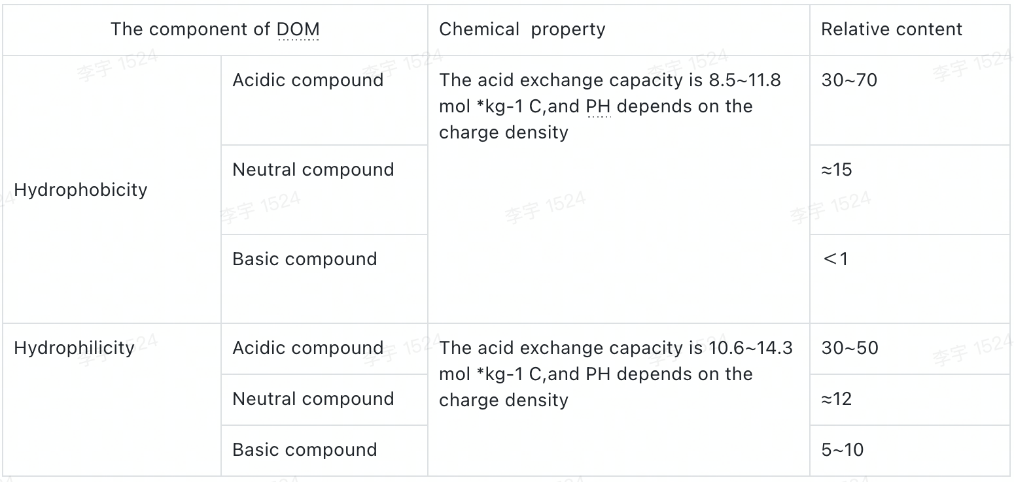
Figure 1-1 general composition of soil dissolved organic matter
Although it is more practical than methods 1, 2 and 4, it will also have shortcomings. For example, when the pH changes greatly, it will affect the composition and activity of DOM, which may lead to less content of alkaline components [13].
  - Overview of heavy metal cadmium pollution
    - The status of cadmium pollution
On April 17, 2014, China's Ministry of environmental protection and the Ministry of land and resources issued the national survey bulletin on the current situation of soil pollution, reporting many problems existing in China's soil environment. The current situation of heavy metal pollution in China's soil should not be underestimated [14]. At present, heavy metals in environmental pollution research mainly refer to mercury, cadmium, lead, chromium, copper and zinc, including metalloid arsenic and non-metallic fluorine [15]. Cadmium is a non-essential element in the process of biological growth and development. It is also one of the most harmful heavy metals in nature. It is called "five toxic elements" together with Hg, as, Cr and PB [16].
Since the occurrence of bone pain disease in Japan in the 1950s, the global emission of heavy metal cadmium to the environment has reached 2.2×${10}^{4}$ in more than 50 years [17], and most of the CD discharged into the environment will enter the soil. According to the survey of China's Ministry of agriculture, the land area polluted by heavy metals accounts for 64.8% of the sewage irrigation area, among which the pollution area of Hg and CD is the largest [18]. Figure 1-2 shows the current exceeding standard of soil heavy metal pollutants in China (2014). Cadmium has the highest exceeding standard rate, becoming the primary pollutant of soil in China. Cadmium in many local crops exceeds the standard, which not only seriously endangers public health, but also causes huge economic losses. The treatment of soil cadmium pollution needs to be solved urgently.
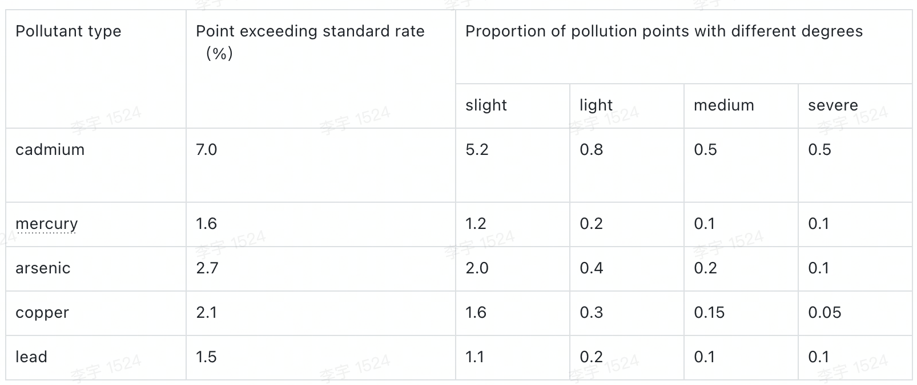
Figure 1-2 soil heavy metal pollution in China (Ministry of land and resources and Ministry of environmental protection, 2014)
    - The harm of cadmium pollution
The toxicity of cadmium to human body is second only to mercury [19] among many metals. Because of its strong toxicity, cadmium cannot be degraded by microorganisms and can only be converted between various forms and valence states [20]. Compared with other non-essential elements, cadmium has stronger ability to migrate from soil to plants and is easier to be absorbed and accumulated in plants. Precisely because of this, when the content of cadmium exceeds the standard, it will affect the yield and quality of crops, and the harm of cadmium to people is mainly through the respiratory tract and digestive tract into the body, causing damage to organs [20].
The harm of cadmium to plants is mainly reflected in the phenomena of leaf fading, plant Dwarfing and delayed waiting period [21], which is physiologically reflected in the inhibition of transpiration and photosynthesis and causes oxidative stress and membrane damage [22]. The accumulation of cadmium in plants will inhibit the absorption capacity of plants to minerals such as sodium and magnesium, resulting in plant malnutrition. Moreover, when the content of cadmium in plants exceeds a certain concentration, it will destroy chlorophyll [23]. Other scholars have found that plants under cadmium stress will increase stomatal resistance of their leaves, thus increasing respiratory resistance [24].
The harm of cadmium to human body can be divided into acute and chronic. The acute toxicity is mainly caused by inhalation to the lungs and other respiratory organs, mainly caused by exposure to cadmium containing substances with high concentration due to occupational needs [25]. The toxicity of soil cadmium pollution to human body is mostly chronic toxicity. Through the food chain or web, cadmium enriched in plants enters the human body, poisoning the human skeleton, kidney, liver, immune system and reproductive system [26]. Cadmium in human body will combine with hydroxyl, amino and sulfur groups of protein molecules, thus disturbing the enzyme system, affecting the normal function of liver and kidney, interfering with the absorption of nutrients by human body, and causing a variety of diseases [25]. The most typical example is the pain disease in Japan in the 1950s.
    - Occurrence forms and factors of cadmium in soil
(1) Speciation of cadmium in soil
Cadmium generally accumulates at 0~15 cm of the soil surface, mainly in the form of ${\text{C}\text{d}\text{CO}}_{3}$、${\text{C}\text{d}}_{\text{3}}$(${\text{PO4}\text{)}}_{\text{2}}$and $\text{C}\text{d}$ (${\text{OH}\text{)}}_{\text{2}}$. Most of them are in the form of soil, and the adsorption rate of cadmium is 80% ~ 95% [27]. Globally, the Cd content in natural soil is 0.01 ~ 2 mg/kg, the internationally recognized soil Cd background value is 0.3 ~ 0.4 mg/kg, and the cadmium background value in China's main agricultural soil is 0.01 ~ 0.34 mg/kg, with an average of 0.12 mg/kg.
There are five kinds of cadmium in soil: exchangeable state, carbonate bound state, iron manganese oxide bound state, organic matter and sulfide bound state and residue bound state [28]. Among them, exchangeable cadmium is sensitive to environmental changes and easy to migrate and transform. This kind of cadmium is easy to be absorbed by plants. This is because it can be adsorbed on the surface of clay particles, hydrated oxides and organic matter particles under the action of electrostatic attraction, and this adsorption is relatively weak [29]; Cadmium in carbonate bound state is sensitive to ph. when pH increases, free cadmium can coprecipitate with carbonate and is not easy to be absorbed by plants. When pH decreases, carbonate coprecipitation of cadmium is easier to dissolve, thus returning cadmium to the environment [29]. Oxide bound cadmium can be combined or precipitated by oxides and hydroxides of iron, manganese and aluminum. Due to the large specific surface area of this kind of oxide, it has strong adsorption capacity for Cd2 +, so cadmium ions are not easy to be released. Normally, this kind of cadmium is not absorbed and used by plants; There are two types of organically bound cadmium. One is to combine with the active groups of organic matter to form chelates with cadmium ions as the center. The other is that heavy metal cadmium is bound by sulfur ions to form substances that are insoluble in water. If oxidized, the organic matter in it will be decomposed, so that part of cadmium will return to the environment; Residual cadmium comes from soil minerals and generally exists in the lattice of silicate and other minerals. It is the most stable cadmium form, which is not easy to be absorbed by crops and has the lowest toxicity [30].
(2) Factors affecting cadmium speciation
The influencing factors of cadmium speciation include soil pH, soil organic matter humus content, cation exchange and redox potential value [28].
Soil acidity and alkalinity (pH) the pH of soil can affect the content of inorganic salts, especially the formation of carbonate. At this time, the forms of cadmium are mainly converted between exchangeable and carbonate bound states. Yang Zhongfang [31] et al. Investigated the effect of soil pH on the content of different forms of cadmium in three different soils. The results showed that under alkaline conditions, the content of exchangeable forms of cadmium decreased sharply with the increase of soil pH, while under acidic conditions, the content of exchangeable cadmium increased with the increase of pH; The combined content of carbonate and iron manganese oxide increased with the increase of soil pH.
Soil organic matter / humus content soil organic matter contains a large number of functional groups. The adsorption of cadmium by these functional groups is much stronger than that of other colloids. They form complexes with cadmium ions, thus reducing the mobility of cadmium [32]. Gaoshan [33] and other experimental results show that under the condition of submerged culture, adding quantitative DOM to the soil can increase the content of organic bound cadmium in the soil and reduce the exchangeable form of cadmium.
Soil cation exchange capacity soil cation exchange capacity is mainly related to the content of organic matter or humus in the soil. Cations are mainly provided by minerals in the soil. Because the specific surface area and exchange sites of fine minerals in the soil are higher than those of coarse minerals, the exchange capacity of soil cations will gradually decrease with the increase of soil particle size [28].
Soil redox potential value (Eh) in the reduction environment, cadmium ions are easy to form sulfide precipitation with sulfur in the soil, so the effectiveness of cadmium will be reduced. However, with the increase of soil oxidation, insoluble CdS will be oxidized to ${CdSO}_{4}$ and become soluble. If the oxides of iron and manganese are reduced to divalent iron and manganese in highly reducing soil, many ${Fe}^{2+}$,${Mn}^{2+}$ and so on to compete with ${Cd}^{2+}$ and form complexes with organic matter, which will release cadmium in oxide bound or carbonate bound state and increase the content of exchangeable and water-soluble cadmium [34].
  - Conventional cadmium contaminated soil remediation technology
Remediation of heavy metal pollution in soil refers to the transfer, absorption, degradation or transformation of heavy metals in soil by physical, chemical or biological methods, so as to reduce the concentration of heavy metals in soil to a safe level or convert toxic and harmful heavy metal pollutants into harmless substances [35]. At present, cadmium contaminated soil remediation has the following ideas: first, by changing the form and state of cadmium in soil, or fixing it, so as to reduce its migration and bioavailability; The second is to remove cadmium from the soil by biodegradation or engineering methods; The third is to change the planting methods and cut off or reduce the way of cadmium entering the biological cycle or food chain to reduce the harm of cadmium to human health. According to the principle of improvement and remediation technology, the conventional improvement and remediation technology of heavy metal cadmium contaminated soil can be divided into physical, biological and chemical remediation.
    - Physical repair technology
The physical remediation methods of cadmium contaminated soil mainly include traditional physical methods such as soil dumping method, guest soil method and deep tillage method, as well as new methods such as electrochemical method and heat treatment method.
The results of traditional physical methods in the treatment of cadmium contaminated soil are obvious. As mentioned above, cadmium is mainly distributed on the surface of the soil, which can be replaced in whole or in part (waste), or a large amount of uncontaminated soil can be added to the surface (guest soil) or mixed evenly, so as to reduce the cadmium concentration and avoid causing harm, so as to reduce the harm [36]. However, this method consumes a lot of money, and the removed contaminated soil is easy to leak and cause pollution again. Therefore, it is difficult to apply it to the treatment of large-scale contaminated soil.
Electrochemical method refers to the method of inserting an electrode into the soil and giving a DC electric field. Under the action of electrolysis, diffusion, electroosmosis and electrophoresis, soil heavy metals flow to the directional electrode chamber of the soil, undergo redox reaction and enrichment, and are collected through the engineering collection system for treatment, so as to purify the soil [21, 37]. Although electrochemical remediation has the advantages of convenient follow-up treatment and less re pollution, it is only suitable for the remediation of polluted soil with small area. The large area of polluted soil and the existence of insulation will affect the remediation effect. Moreover, there are still many technical immaturities in electrochemical repair [38].
In the heat treatment method, the soil is heated by low-frequency waves such as microwave and infrared radiation, or the heated steam is introduced to make the soil volatilize pollutants while evaporating the water vapor. This method is suitable for treating soil with volatile pollutants. The disadvantage of this method is that it will affect the content of soil organic matter and water, destroy the original fertility of the soil, consume a lot of energy, and make the heavy metal vapor enter the atmosphere to form secondary environmental pollution [39].
    - Chemical remediation technology
Soil chemical remediation method is to apply chemical agents and modifiers to polluted soil, change the physical and chemical properties such as soil redox potential and pH value, and make the redox and other effects of soil heavy metals, so as to change its form and reduce its bioavailability, so as to reduce its harm [40, 41]. Common chemical reagents for cadmium pollution remediation include alkaline modifiers (lime, inorganic silicon fertilizer, etc.), clay minerals (zeolite), antagonists (zinc sulfate, rare earth lanthanum, etc.) and organic matter (peat, animal compost) [42,43]. The combination of organic matter and soil can affect the adsorption and desorption kinetics of heavy metals, and then change the balance between solid and liquid. When organic matter is just applied to the soil, it can greatly enhance the adsorption and fixation capacity of soil for heavy metals, so as to reduce the bioavailability of heavy metals. However, with the mineralization and decomposition of the agent, the drug power decreases or even disappears, which may lead to the release of heavy metal ions again, but make the crops begin to absorb more heavy metals [44]. Therefore, although the chemical remediation method has the advantages of convenient operation, low treatment cost and remarkable treatment effect, it has certain risks. It is more suitable for the treatment of large-area heavy metal polluted soil, especially medium and light polluted soil. The heavily polluted soil may have the phenomenon of reverse increase of heavy metal content.
    - Bioremediation technology
Bioremediation refers to the treatment method of adding or planting some specific microorganisms, animals or plants, adsorbing and degrading soil pollutants and reducing the biological activity of soil heavy metals through their metabolism. It is divided into three kinds: microbial remediation, animal remediation and phytoremediation [21].
Phytoremediation is an in-situ treatment method that uses the tolerance or super rich characteristics of some plants to absorb and accumulate heavy metals in the soil through plant growth or root system, or take them out of the soil, and then harvest and centralized treatment. Common hyperaccumulation plants include vetiver, centipede and Indian mustard. Ferns of Fern Fern Fern, wild amaranth and cruciferous plant blue repressor have strong cadmium enrichment ability. The study found that the super enriched plants are generally short, low biomass, slow growth and long cycle, so the restoration benefit is low, and there are many uncontrollable factors of planting plants, which will be affected by temperature and climate, so it is difficult to apply [45].
Animal remediation is a method to reduce or transfer the content of heavy metals in polluted soil by using the metabolism of some lower animals in the soil. Earthworms and rats are commonly used. Earthworms have a strong enrichment effect on Zn and CD. Earthworms are cultured on heavy metal polluted soil. After a period of cultivation and enrichment, earthworms are driven out by electric stimulation, irrigation and other methods, and then earthworms and soil are intensively treated [46]. However, since the growth of lower animals is greatly affected by environmental factors and is prone to biological death, this method is not widely used in practice [47].
Microbial remediation refers to the cultivation or release of soil microorganisms to fix, migrate or transform heavy metals in soil, so as to reduce the toxicity or content of heavy metals. It mainly includes two modes of action: bioaccumulation and biotransformation. Bioaccumulation refers to the accumulation and adsorption of microorganisms; Biotransformation refers to the redox effect of microorganisms on heavy metals, the dissolution of heavy metals and organic complex coordination [48]. It was found that some strains isolated from the rhizosphere of Typha can passivate and fix Cu and Cd in soil and reduce their exchangeable content [49].
  - Interaction between Dom and DOM in soil
    - Effect of DOM on adsorption/desorption of heavy metals
According to the experimental research of Liu Jingjing [50], the adsorption of heavy metals by soil is similar with or without DOM, which increases with the increase of the concentration of heavy metals in the solution, but the increase speed decreases. This shows that the equilibrium concentration of the solution after adsorption equilibrium will affect the adsorption capacity of heavy metals, but with the increase of equilibrium concentration, the adsorption capacity of heavy metals in the soil reaches the maximum adsorption capacity, and then it will not increase. The addition of DOM changes the physical and chemical properties of soil, such as pH value, organic matter content, etc. [51].
In addition, the properties of DOM will also affect the adsorption of heavy metals in soil. On the one hand, the adsorption capacity of DOM to heavy metals is greatly reduced under different acid and alkali sources [52], and the adsorption capacity of DOM to heavy metals is also greatly reduced under different acid and alkali sources. Many components in DOM can adsorb heavy metals. Low molecular weight and hydrophilic components can complex heavy metals themselves, so they will inhibit the adsorption of heavy metals by soil, while high molecular components will promote the adsorption of heavy metals by soil because they are difficult to complex with heavy metals.
As mentioned above, the functional groups contained in DOM also have different affinity for heavy metals. Zhang [53] et al. Through the reaction of C=O, C-O, O-H and other functional groups analyzed by infrared and nuclear magnetic resonance spectroscopy with divalent mercury, the macromolecular surface of humic acid is changed, which is probably the reason for the improvement of adsorption capacity.
    - Effects of soil DOM on the migration of heavy metals
Studies have found that if the content of DOM in soil is too high for a long time, heavy metals will migrate deeper into the soil, which indicates that DOM in soil has a certain impact on the migration of heavy metals [54]. Pan Yi et al. [55] found that dissolved organic matter can significantly promote the activation of copper in soil and the of cadmium, but the effect is not as significant as that of copper. This shows that if there is a risk of heavy metal pollution in drylands, the use of a large amount of organic fertilizer will increase the probability of heavy metal pollution. Some foreign scholars analyzed the correlation between the content of some heavy metals in soil and the content of DOM through experiments. The result is that the content of DOM and the content of heavy metals show a certain positive correlation [56], which also preliminarily predicted the impact of DOM in soil on the migration of heavy metals.
  - Brief introduction of UV-VS spectrum
UV-visible spectroscopy (UV-VS) is a kind of molecular absorption spectrum. When a substance is irradiated by ultraviolet light (its wavelength range is 190~400 nm) or visible light (its wavelength range is 400~800 nm), its valence electrons are excited and transition to high energy level, resulting in light absorption. According to different bonding conditions in the molecule, light absorption with different intensities appears at different wavelengths to form the absorption spectrum, so it can be analyzed qualitatively. Quantitative analysis can be carried out by measuring the absorbance at the selected wavelength. It can be used to determine unsaturated bonds, aromatic hydrocarbons, organic pollutants containing miscellaneous elements, metal, non-metal and ionic complexes in the environment.
Ultraviolet visible spectrum is realized by Lambert Beer law. As the basic law of light absorption, it is an important basis for absorption spectrophotometry. The physical meaning of this law is that for a uniform non scattering light absorbing substance, when a beam of parallel monochromatic light passes through the substance vertically, its absorbance a can be calculated from its concentration c and optical path L, and the formula is
$$A=\lg^{\frac{l_{0}}{l_{t}}}=\lg^{\frac{1}{T}}=KLc$$
Where $I_{0}$、$I_{t}$ is the light intensity before and after passing through the light absorbing material, T is the transmittance, K is the absorption coefficient, which is related to the properties of the light absorbing material, and l is the optical path [57].
If the light absorbing material contains a variety of light absorbing components, it can be calculated according to the additivity of absorbance, that is, if the components are evenly mixed, there is no interaction between them, there is no fluorescence or photochemical reaction with the incident light, and there is only light absorption, the total absorbance of the mixed medium at a certain wavelength is the addition of the absorbance of each component at this wavelength [58].
  - Research purpose and significance
Heavy metal pollutants produced by mining and chemical wastewater discharge are highly toxic and exist stably in the environment, posing a great threat to the ecosystem. Dissolved organic matter widely existing in the environment contains many chemical groups, which can form organometallic complexes with heavy metal ions, and then affect the latter's environmental behaviors such as morphology, migration and transformation, biological adaptability and so on. Due to the lack of effective spatio-temporal resolution analysis methods in the current research on environmental interaction, the molecular mechanism of dissolved organic matter regulating the morphological transformation of heavy metal pollutants is still unclear.
The project plans to take Shizhu Park, Chenzhou City, a typical heavy metal contaminated mining area in Hunan Province, as the research area. Through the interaction process between heavy metal Cd and organic matter in the mining area by spectral titration and using the improved environmental spectral econometric analysis methods such as DSlope, E2/E3 and ${SUVA}_{254}$, the regulation mechanism of dissolved organic matter in the mining area on the morphological transformation of Cd heavy metal pollutants is deeply studied, and the effects of various environmental factors are investigated.

Research materials and methods
  - Research materials
The experimental samples came from the mixed samples randomly taken inside and outside Chenzhou persimmon and bamboo garden. The wet weight of the samples in the persimmon and bamboo garden was 1072.6 g and 1045.5 g respectively.
    - Chemical Reagents and Experimental instrument
Table 2-1 list of chemical reagents
Experimental reagent | Purity | Manufacturer
$${\text{C}\text{d}\text{C}\text{l}}_{\text{2}}\text{∙}{\text{2}\text{H}}_{\text{2}}\text{O}$$ | AR | Shanghai Jinshan Tingxin Chemical Reagent Factory
$$\text{N}\text{a}\text{OH}$$ | AR | Xilong Chemical Co., Ltd
$$\text{HCl}$$ | / | /
Table 2-2 list of experimental instruments
Name of instrument and equipment | Model
Electronic balance | AL-204
Thermostatic oscillator | ZD-85
A magnetic stirrer | JK-MSH-Pro-6B
Ultraviolet visible spectrophotometer | UV-2600
Digital display ultrasonic cleaner | KQ3200DE
Circulating water vacuum pump | SHZ-D(III)
Vacuum drying oven | DZF-6050
  - Research methods
    - Sample pretreatment
1.Measure the wet weight $M_{11}$and $M_{21}$of the samples collected inside and outside the persimmon bamboo park in Chenzhou City, and then dry the samples at 60 ℃ until the mass difference obtained by two weighing is less than 0.1 mg, and the dry weight is $m_{12}$and $m_{22}$. The mass ratio before and after drying is the dry wet weight ratio.
2.Take 400 g of dry weight samples inside and outside the park and dissolve the samples in the ratio of 1g to 2.5 ml. Constant temperature oscillation for 24h. After that, stand for 2h, take the supernatant and centrifuge at 2800 rpm for 5 min. Using 0.45 μM filter membrane and suction filter. Take the filtrate for total element analysis, pH measurement and TOC measurement.
    - Regulation experiment of Cd concentration on soil DOM
1.Weigh 0.05 ${CdCl}_{2}∙2.5H_{2}O$ and dissolve it in a 100 ml volumetric flask, dilute it to volume as #1 stock solution, then measure 2ml from #1 stock solution in a 100 ml volumetric flask, dilute it to volume as #2 stock solution, and its concentration is 10 mg/L.
2. Configure the reaction solution group at pH=7
Take 10 ml of #2 stock solution, adjust its pH to 7, then take 1.25 ml of pH 7 solution from it, and fix the volume to 25 ml with deionized water with pH 7, which is the stock solution #3. Its concentration is 500 μg/L.
According to the measured TOC of the sample solution, take about 50 ml of the sample solution inside and outside the persimmon bamboo garden, and adjust the pH to 7. Take 22 colorimetric tubes, add 5 ml DOM solution in persimmon and bamboo garden to 11 of them, which is group A,and add 3.7ml DOM solution outside persimmon and bamboo garden to the other 11, which is group B. Then adjust the Cd concentration of AB and ab groups to 0 in turn μg/L、1 μg/L、5 μg/L、10 μg/L、20 μg/L、40 μg/L、60 μg/L、80 μg/L、100 μg/L、250 μg/L、500μg/L。
The configuration method is as follows:
500 μg/L: take 1.25 ml #2 stock solution and dilute it to 25 ml;
250 μg/L: take 0.625 ml #2 stock solution and dilute it to 25 ml;
100-1 μg/L: take #3 5 ml, 4 ml, 3 ml, 2 ml, 1 ml, 0.5 ml, 0.25 ml and 0.05 ml of stock solution respectively. Dilute to 25 ml.
0 μg/L: directly dilute to 25 ml.
Send the two groups of standard solutions to UV-VS spectrum analysis to compare their binding degree.
3. Configure the reaction solution group at pH=5
The method is the same as above. Adjust the pH of stock solution and deionized water used for constant volume to 5.
4. Configure the reaction solution group at pH=9
The method is the same as above. Adjust the pH of stock solution and deionized water used for constant volume to 9.
    - Regulation experiment of pH on soil DOM
Set 10 pH experimental conditions with pH from 3-12 to ensure that the DOM concentration of the solution at each pH is the same, but the pH is different. The specific configuration method is as follows:
Take 30ml of solution in persimmon bamboo garden, adjust the pH to 5, take 5ml of solution into 25ml colorimetric tube, and then fix the volume to 25ml with deionized water with pH 5; Then adjust the pH of the solution in the persimmon bamboo garden to 4, take 5 ml of the solution into a 25 ml colorimetric tube, and then fix the volume to 25 ml with deionized water with pH 4; Then configure the experimental sample with pH 3 as above.
Take 70 ml of the solution in the persimmon bamboo garden again, adjust the pH to 6, take 5 ml of the solution into a 25 ml colorimetric tube, and then fix the volume to 25 ml with deionized water with pH 6, and then configure the experimental samples with pH 7, 8, 9, 10, 11 and 12 in turn according to the above method.
The configuration method of pH experimental group outside persimmon bamboo garden is the same as above, and the sample solution added to each sample is 3.7 ml.

  - Sample pretreatment, total element analysis and TOC content Report
Dry the sample at 60 ℃ to constant weight, and weigh the dry weight of the sample in the persimmon bamboo garden as $m_{12}$=870.9 g； The dry weight of the sample outside the persimmon bamboo garden is $m_{22}$=778.1 g.
    - Full elemental analysis report (unit: mg/L)
Table 2-3 List of all-element analysis reports
Element | Shizhu Park- Inside | Shizhu Park- Outside | Element | Shizhu Park- Inside | Shizhu Park- Outside
Ag | --- | --- | Mn | 0.05 | 0.06
Al | 0.07 | 0.07 | Mo | 0.006 | 0.03
As | 0.005 | 0.01 | Na | 4.0 | 4.1
B | 0.6 | 1.0 | Ni | 0.002 | 0.004
Ba | 0.02 | 0.002 | P | 0.02 | 0.3
Be | --- | --- | Pb | 0.006 | 0.003
Ca | 70.8 | 50.1 | S | 18.0 | 8.2
Cd | --- | --- | Sb | --- | 0.003
Ce | --- | --- | Sc | --- | ---
Co | 0.002 | 0.001 | Se | --- | 0.003
Cr | --- | 0.001 | Si | 0.4 | 3.2
Cu | 0.03 | 0.03 | Sn | --- | ---
Fe | 0.007 | 0.02 | Sr | 0.09 | 0.07
Hg | --- | --- | Ti | 0.001 | 0.001
In | --- | --- | V | 0.004 | ---
K | 3.2 | 3.2 | W | 0.2 | 0.2
La | --- | --- | Zn | 0.1 | 0.04
Mg | 0.7 | 1.2 | Zr | --- | ---

From the report of the total elemental analysis, it was concluded that the heavy metal content of the soil samples inside and outside the persimmon and bamboo garden was low, some even below the lower limit of detection, and the sulfur content was within the normal range. This indicates that the heavy metal content in the sample collection area is not high.

    - TOC content reporting
Table 2-4 TOC content reporting
The name of item | Shizhu Park- Inside | Shizhu Park- Outside
TOC(mg/L) | 34.5 | 25.4
pH | 5.39 | 5.31

Effect of ${Cd}^{2+}$concentration on DOM
  - Characteristics of ultraviolet visible absorption spectrum
The UV-visible spectra were measured from 200 to 800 nm for the experimental sample groups of 0~500 μg/L at pH=5, 7 and 9, respectively, and the samples were taken at 0.2 nm intervals with a slit width of 2 nm, and the measured absorbance was scanned from 800 nm to the front. The measured absorbance values at 220-600 nm of the solution with Cd2+ and the solution without Cd2+ were plotted by origin9.1 as the wavelength-absorbance two-dimensional coordinates shown in Figures 1 and 2.
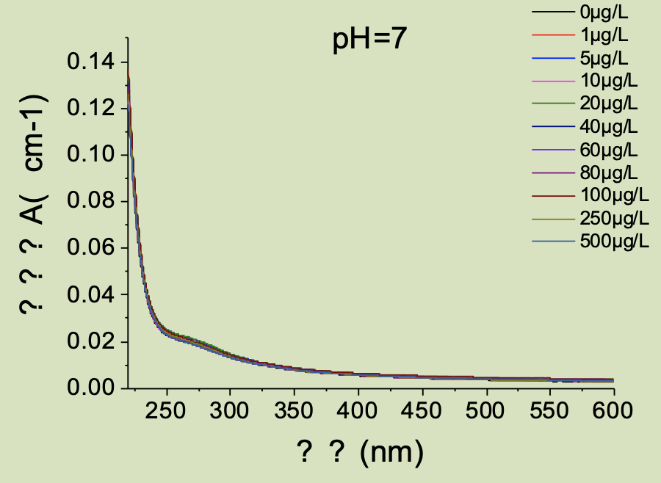
- （b）
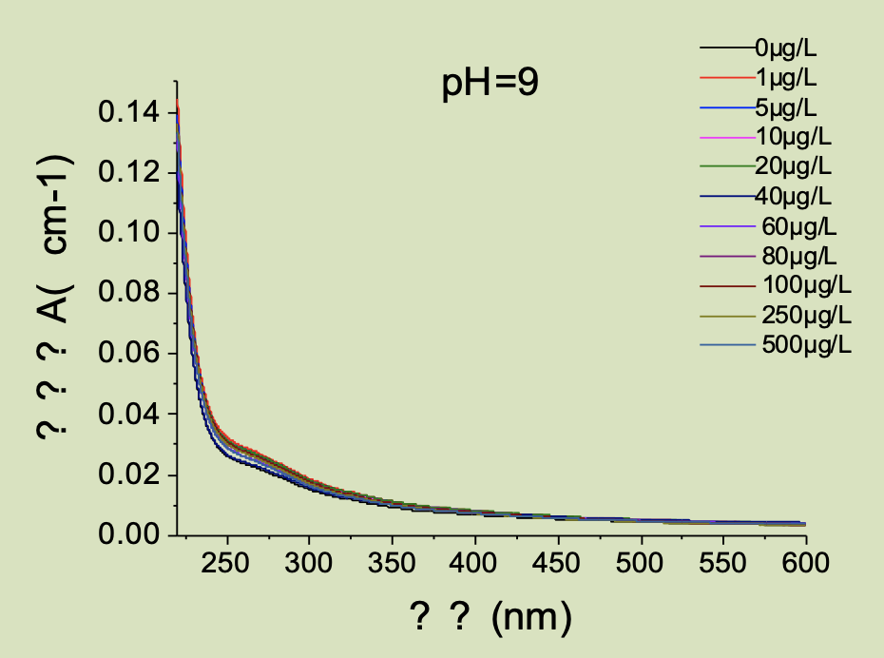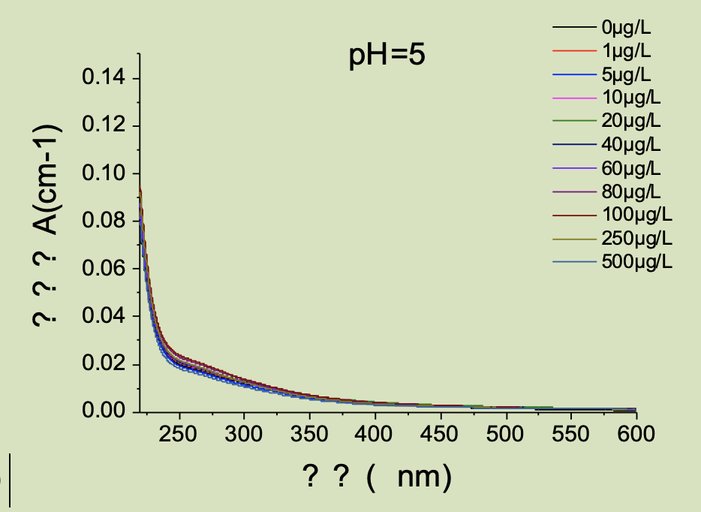
（c） （d）
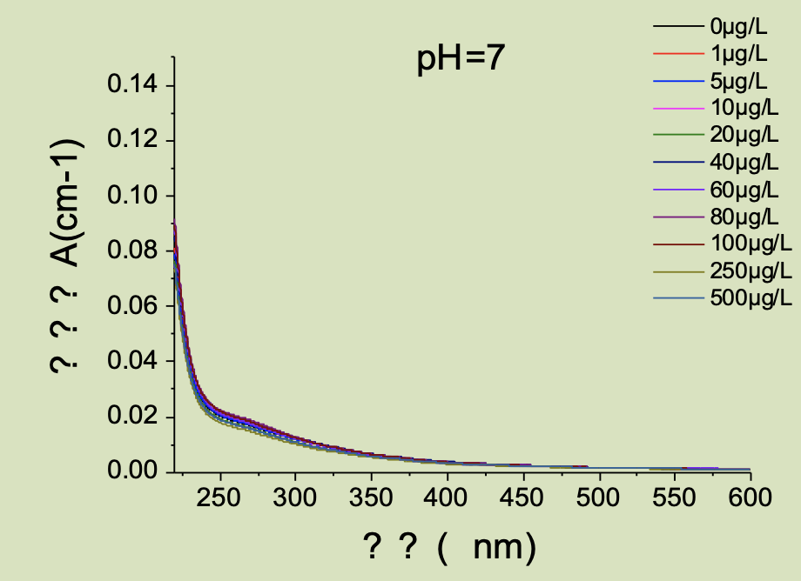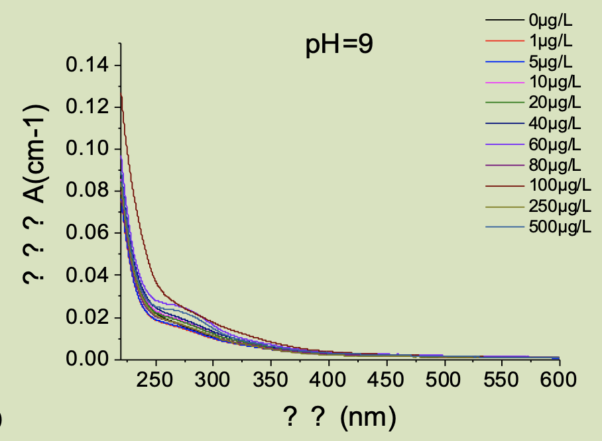
（e） （f）
Figure 3-1 UV-vis absorbance of experimental samples in the persimmon and bamboo garden (a, b, c) and outside the garden (d, e, f) at 220~600 nm.
From Figure 3-1, it can be seen that the absorbance of the solutions showed an exponential decrease with the increase of wavelength. After 450nm, the absorbance of the solution basically does not change; The absorbance of the solution increased rapidly before 230 nm; Between 230-450 nm, the absorbance of solutions containing different concentrations of ${Cd}^{2+}$ varies greatly, indicating that the concentration of cadmium ion has a certain impact on the amount of soil DOM, which will be the main wavelength segment of our study. With the increase of cadmium ion concentration, the absorbance in the 230nm-450nm section will first decrease and then increase, which is more obvious, indicating that the cadmium ion concentration will first combine with Dom and consume part of DOM. With the increase of concentration, it will inhibit this combination.
Because DOM has complex components and no obvious spectral characteristic peak, in order to characterize the spectral properties of DOM, the ratio of absorbance at 250nm to absorbance at 365nm ($E_{2}$/$E_{3}$) is commonly used as the characterization of DOM molecular weight [59].
Table 3-1 below shows the mean values of $E_{2}$/$E_{3}$at each pH. (a) is the sample inside the persimmon and bamboo garden and (b) is the sample outside the Shizhu Park. The $E_{2}$/$E_{3}$ values of the samples used in this experiment ranged from 3.2856 to 5.0759, with the mean value of 3.3453 ± 0.0473 for the samples inside the Shizhu Park and 4.5612 ± 0.3732 for the samples outside Shizhu Park, which is closer to the study done by Lulu Li et al [60], indicating that, DOM is similar to HA and FA in the soil of this experiment. Also because when this value <3.5, it means that the content of humic acid in DOM is greater than that of fulvic acid [61], therefore, the content of humic acid in DOM of soil inside the persimmon and bamboo garden is dominant; conversely, when the $E_{2}$/$E_{3}$ value >3.5, it means that the content of humic acid in both is less than that of fulvic acid, therefore, the content of fulvic acid in DOM of soil outside the Shizhu Park is dominant.
Table 3-2 The mean value of $E_{2}$/$E_{3}$ratio of each experimental sample
 | pH=5(a) | pH=5(b) | pH=7(a) | pH=7(b) | pH=9(a) | pH=9(b)
$E_{2}$/$E_{3}$ | 3.40135 | 4.4.4818 | 3.349009 | 4.202823 | 3.285608 | 5.075925

In addition, the ratio of absorbance at 254nm to TOC content in solution is positioned as molar absorbance at 254nm (${SUVA}_{254}$), which can be used to indicate the degree of aromatization or humification of DOM, because at 254nm, it is mainly compounds containing unsaturated carbon carbon double bonds such as benzene ring. The greater this value, the higher the aromaticity. The ${SUVA}_{254}$ measured in this experiment is shown in Table 3-2, and the calculated ${SUVA}_{254}$ was 0.07161 ± 0.00723 for the sample inside the Shizhu Park and 0.08121 ± 0.00635 for the sample outside the Shizhu Park, compared to the experiment done by Lulu Li et al. The soil aromatization inside and outside the Shizhu Park was lower, indicating that the soil sampled this time was not very fresh.
Table 3-2 Average value of ${SUVA}_{254}$ ratio for each experiment
 | pH=5(a) | pH=5(b) | pH=7(a) | pH=7(b) | pH=9(a) | pH=9(b)
$${SUVA}_{254}$$ | 0.06793 | 0.07706 | 0.06519 | 0.07638 | 0.08171 | 0.09019

  - Logarithmic transformation of the effect of Cd concentration on DOM concentration
The transformation of the measured absorbance by the formula shown below is called logarithmic transformation：
$${∆A}_{i}\left(λ\right)=A_{i}\left(λ\right)-A_{ref}(λ)$$
$${∆L}_{n}A_{i}\left(λ\right)=L_{n}A_{i}\left(λ\right)-L_{n}A_{ref}(λ)$$
Among them, $A_{i}\left(λ\right)$ indicates the absorbance at a certain wavelength,
$A_{ref}(λ)$ indicates the absorbance measured by the selected control experimental group at the same wavelength. The experimental sample of 0 μg/L was used as the control experimental group in this experiment. Log-transformed plots of the inside and outside of the Shizhu Park were made using origin 9.1, as shown in Figure 3-2.
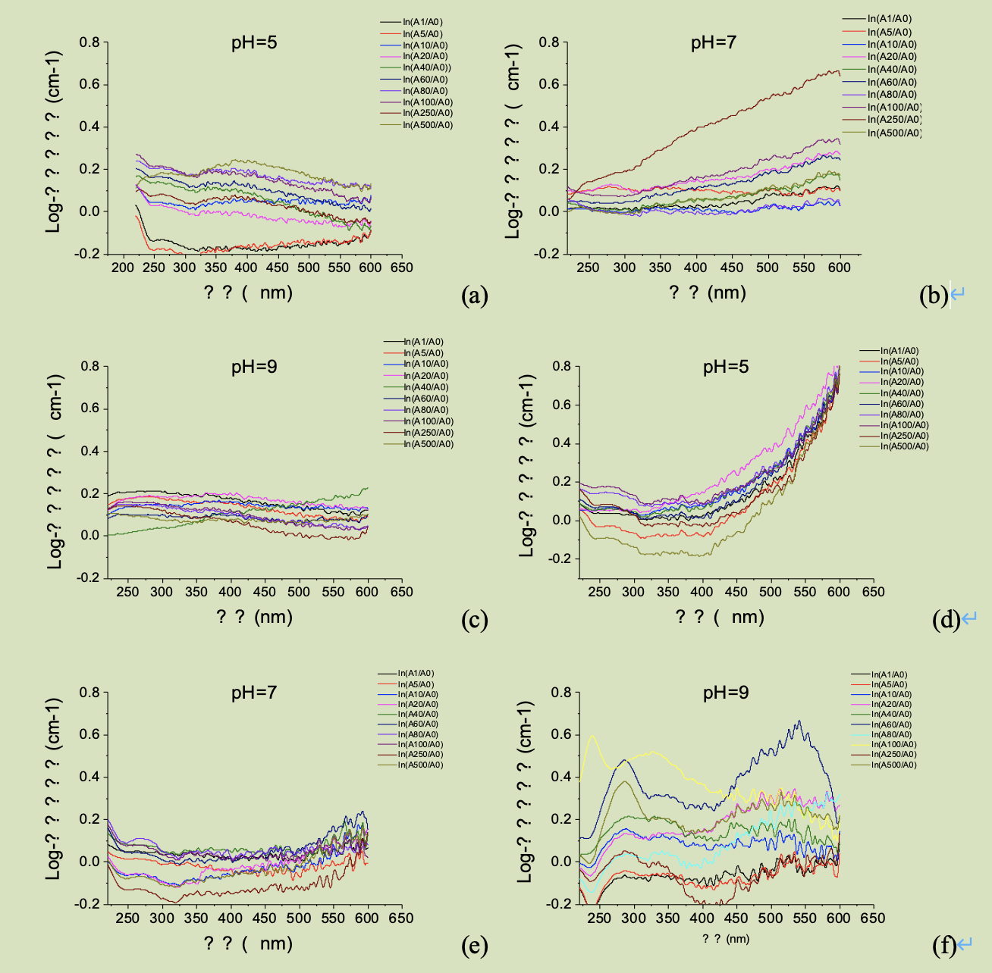
Figure 3-2 Log-transformed absorbance at 220~600 nm for experimental samples from inside (a, b, c) and outside (d, e, f) of the Shizhu Park
For the raw data in Figure 3-1, the absorbance at 600 nm at the same pH was first fine-tuned to be consistent, and the errors arising from instrument drift were excluded to find $A_{i}$/$A_{0}$, and Savitzky-Golay smoothing was performed on $A_{i}$/$A_{0}$, using 15-point smoothing before and after and one polynomial order (polynomial order). The resulting data were plotted after logarithmic transformation. In the process of data processing, it was found that the logarithmically transformed data fluctuated greatly, so Savitzky-Golay smoothing was performed again, using 19-point smoothing and one polynomial order before and after, and the above figure was obtained.
From the above figure, it can be seen that the log-conversion absorbance of the samples inside and outside the Shizhu Park differed greatly at different pH. In addition to the errors generated during the experimental measurements and data processing, the log-conversion inside the Shizhu Park showed a decreasing or slightly increasing trend, while the log-conversion absorbance outside the Shizhu Park showed an increasing trend with wavelength and the phenomenon was obvious.
From the trend of the samples inside and outside the Shizhu Park, a plateau of more significant changes in log-transformed absorbance occurs at 250 nm or at 350 nm. Combining the significance of the measured absorbance at each wavelength, we selected the data in the 240-280 nm band, and the 325-375 nm band for the next step of spectral slope analysis.
  - Slope of the absorption spectrum curve of the experiment on the effect of Cd concentration on DOM concentration (DSlope)

The slope of the absorption spectral curve (DSlope) is another one of the important analytical methods in DOM spectroscopy, which can reflect the fast response and molecular weight of DOM, independent of the concentration of DOM [63]. In this experiment, the data of two wavelengths, 240-280 nm and 325-375 nm, were used for slope finding. The equations used are as follows.
$${DSlope}_{240-280}={DSlope}_{240-280，i}-{DSlope}_{240-280，ref}$$
${DSlope}_{240-280，i}$，${DSlope}_{240-280，ref}$ denote the slopes obtained by linear fitting of the selected curves and the reference group to the 240-280 nm wavelength band at log-transformed absorbance, respectively, to obtain Figures 3-3 , 3-4.
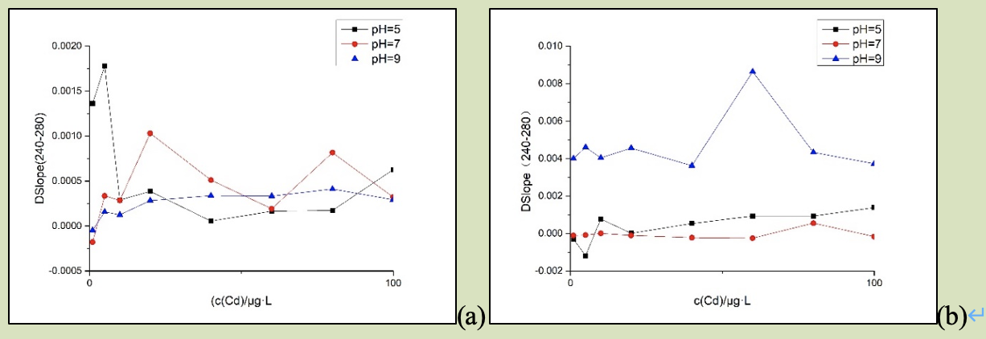
Figure 3-3 DSlope plots at 240-280 nm inside (a) and outside (b) of the Shizhu Park
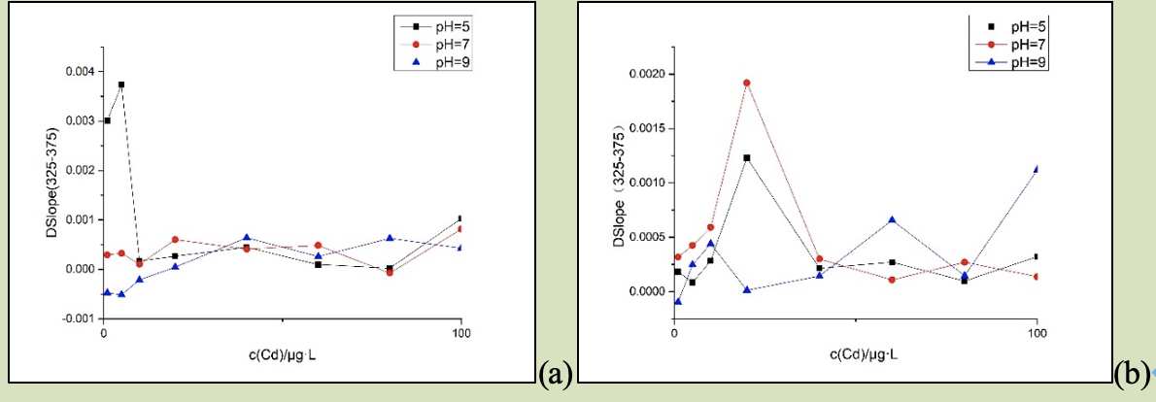
Figure 3-4 DSlope plots at 325-375 nm inside (a) and outside (b) of the Shizhu Park
The slope obtained from the fit at 250 μg/L and 500 μg/L was discarded because of the drastic changes in the slope, and the initial inference of the error was large. The slope of the spectra obtained at 240-280 nm showed a trend of increasing with the concentration of cadmium ions, and the position of the maximum point of the slope appeared differently at different pH, and there was a trend of the maximum point of the slope moving backward as the pH increased. In the 325-375 nm wavelength band, there was still a trend of slope increasing with the concentration of cadmium ions, but it was more fluctuating, and the trend of slope going backward with the increase of pH was not obvious. The slope shift of the sample inside the Shizhu Park was more stable than that outside the Shizhu Park and the slope shift in the wavelength range of 240-280 nm was more stable than that in the wavelength range of 325-375 nm.
${DSlope}_{240-280}$ and ${DSlope}_{325-375}$ were able to characterize the binding affinity of metal ions to certain groups such as phenolic hydroxyl groups and carboxyl groups during the reaction. pH=5, the highest slope was observed at 5 μg/L in the persimmon garden sample at two wavelengths and at 10 μg/L and 20 μg/L outside the persimmon garden sample, respectively; at pH=7, the highest slope was observed at 20 μg/L and at 80 μg/L and 20 μg/L outside the persimmon garden sample. = 7, the highest slope point appeared at 20 μg/L for samples inside the persimmon garden and at 80 μg/L and 20 μg/L for samples outside the persimmon garden at both wavelength bands; at pH = 9, the highest slope point appeared at 80 μg/L for samples inside the persimmon garden and at 60 μg/L for samples outside the persimmon garden at both wavelength bands. It indicates that at these points, the most affinity of ${Cd}^{2+}$ binding to the moiety occurs. The slopes at all three pHs, both inside and outside the persimmon and bamboo gardens, increased slightly with the concentration of ${Cd}^{2+}$, indicating that the concentration of ${Cd}^{2+}$ promotes the binding of heavy metals and organic groups in DOM, and also that ${Cd}^{2+}$ decreases the molecular weight of DOM

Effect of solution pH concentration on DOM
The wavelength absorbance diagram of 220-600 nm is drawn for the UV-Vis spectrum measured in the pH influence condition experiment, and the peak analysis is made for the drawn curve. According to the research of Yan Mingquan et al. [60] of Peking University, five points of 210nm, 242nm, 276nm, 314nm and 375nm are used as the wave peak hypothesis points. Fit control the fitted curve to ensure that R-square > 0.9999. During the experiment, considering that too much is added at pH 12, which will affect the DOM content of the solution, pH12 is omitted.
  - Experimental visible spectral waveform fitting of pH-influenced conditions for samples outside the Shizhu Park
Figure 4-1 Gauss fits of UV-visible wave peaks outside the perspex at different pHs.
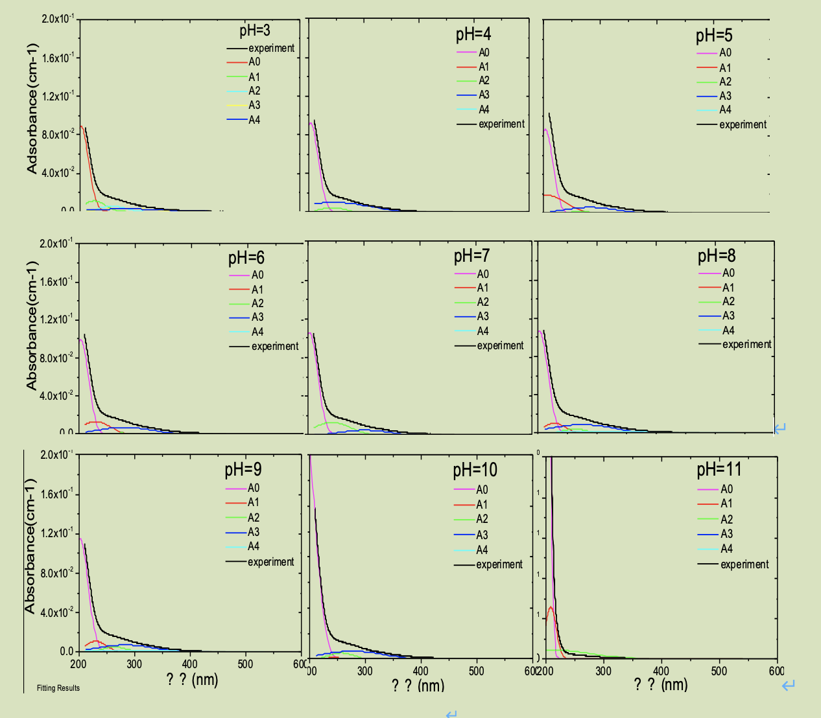
Figure 4-1 Waveform fitting of UV-Vis spectra of the Shizhu Park ex-samples at pH 3-11
The centers of the wave peaks obtained by fitting the wave peaks of the Shizhu Park outer sample are 202 nm, 226 nm, 250 nm, 321 nm, and 378 nm in order. from the comparison of the wave peaks at nine pHs in the above figure, it is found that the fitted wave peak at 210 nm is beyond the given range of 220 nm-600 nm, and the half-peak width of the wave peak at 375 nm is either too large or too small, so there is no wave peak formation at this point either. The wave peaks are not formed at this point. The peak area (A) and the half-peak width (w) of the peak in Fig. 7 are plotted as a line about the center of the peak (A_0), and the half-peak width is set to 0 for the peak at 375 nm.
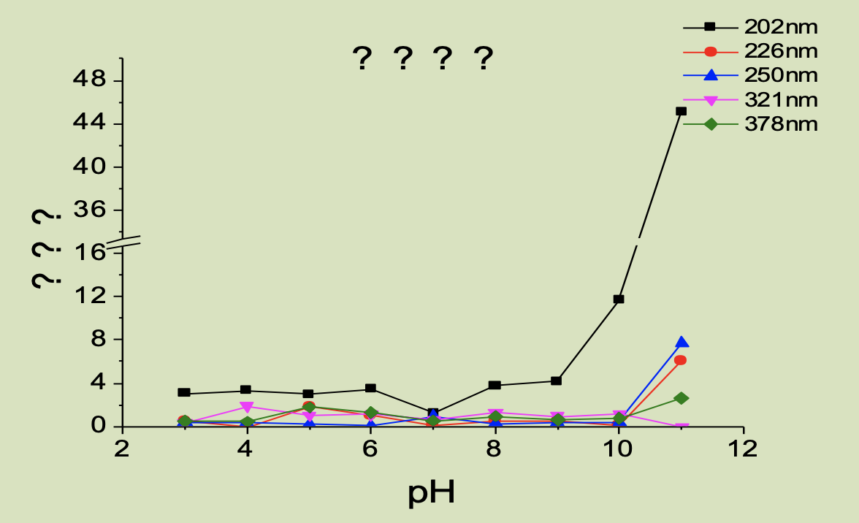
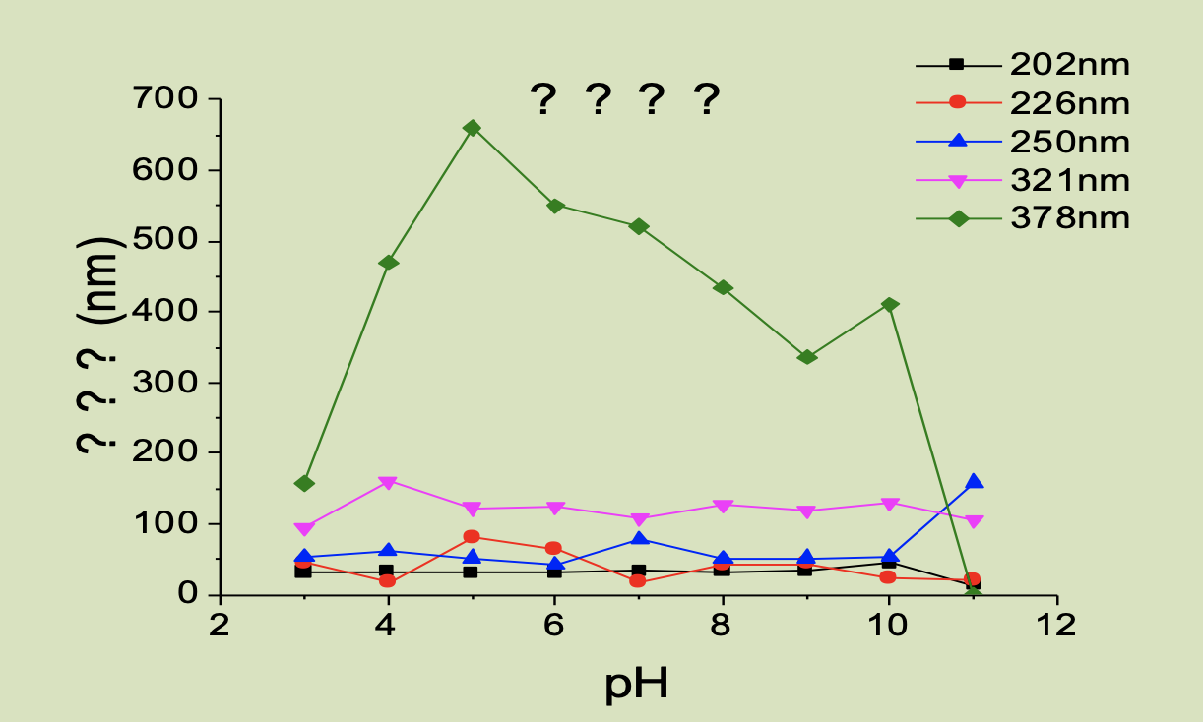
Figure 4-2 Plot of the change of peak area (top) and half-peak width (bottom) outside the Shizhu Park
Observing the pictures, it was found that the peak areas of the fitted wave peaks decreased with increasing wavelength, while the half-peak widths increased with increasing wavelength,378 nm was negligible. At pH 3-9, the shift of the peak area of the wave peaks was gentler, and at pH 10 and 11, the peak area varied more. The half-peak width increased gradually with increasing pH and was negligible at 378 nm. pH 7 or so had a maximum half-peak width, and this phenomenon was especially obvious at 250 nm, while the peak at 202 nm was basically invisible with pH. It is clear from the half-peak width that it is mainly the functional groups at 250-321 nm that act in the soil in the Shizhu Park.
  - Experimental visible spectral waveform fitting of pH-influenced conditions for samples in the Shizhu Park
Similarly, the Gauss waveform was fitted to the samples within the persimmon and bamboo garden to obtain Figure 4-3.
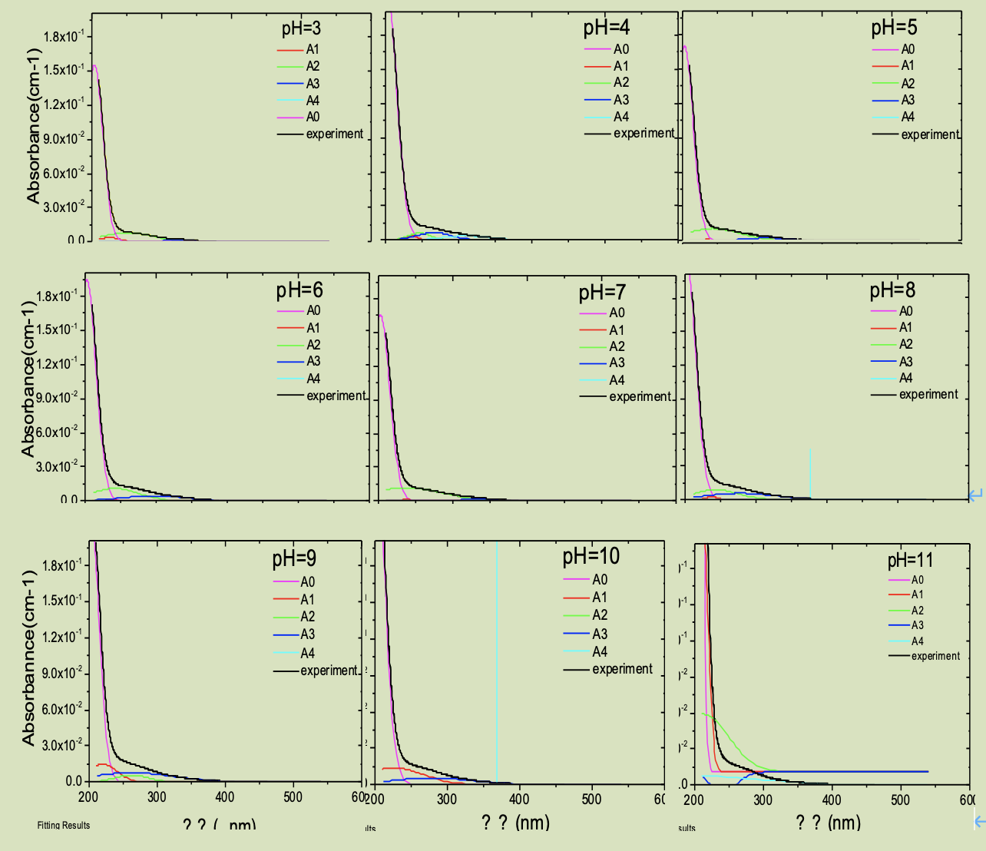
Figure 4-3 Wave Gaussian fit of UV-Vis spectra at pH 3-11 for the in-sample of the Shizhu Park
During the fitting process, the peak at 210 nm drifted out of the given wavelength range, and the peak at 375 nm was also too wide or too small, so we set the peak to zero manually. The same manual setting of zero was performed. The peak area (A) and half-peak width (W) of the peaks in Figure 4-3 are plotted as line points about the center of the peaks, and Figure 4-4 is obtained as follows.
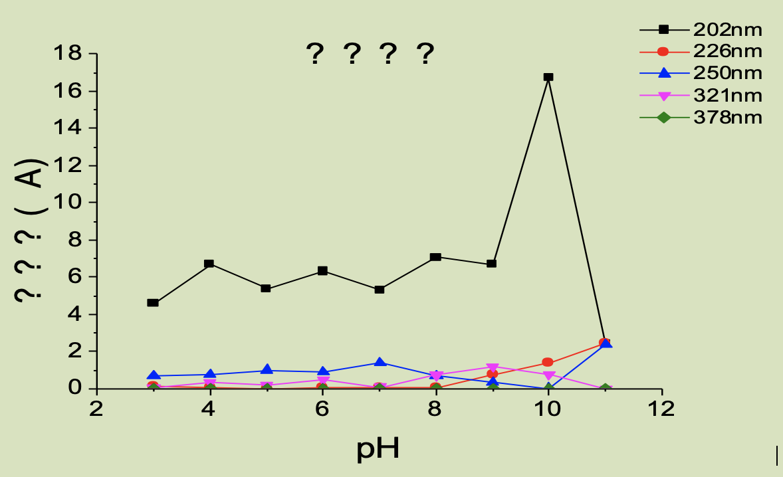
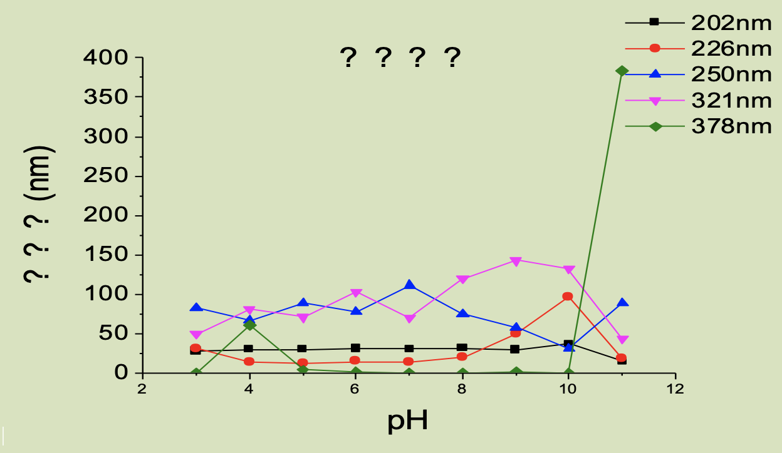
Figure 4-4 Plots of peak area variation (top) and half-peak width variation (bottom) within the Shizhu Park
From the graph, it can be seen that with the increase of pH, the peak area of wave peaks at different wavelengths should increase, and the maximum peak area mainly appears at pH =7 and 9. It is speculated that from the half peak width, the peak width at 250nm and 321nm is relatively large, indicating that it is mainly the corresponding functional groups at this wavelength that play a role.
Combined with the peak area and half peak width of the characteristic peak, it will be found that under the influence of pH, the changes at 220nm and 250nm are the most obvious. Under these two wavelengths, hydroxyl and unsaturated carbon bonds are mainly used, indicating that these groups play a major role in DOM. In case of multiple pH changes, the samples inside and outside persimmon bamboo garden have the maximum values at pH 5 and 7 respectively, indicating that the reaction degree is the greatest at this pH.

Conclusion
(1) The $E_{2}$/$E_{3}$ value of the sample can show that the main component of DOM inside and outside the persimmon bamboo garden is fulvic acid or humic acid, the main component of DOM inside and outside the persimmon bamboo garden is humic acid, and the value of suva254 shows that the aromatization and humification degree of samples inside and outside the persimmon bamboo garden are not high, which can indirectly prove that the soil sample is not fresh.
(2) The concentration of cadmium ion will have some effects on the structure of DOM. If the concentration of cadmium ion in soil is higher, the combination of soil DOM will be more stable, which is not conducive to the removal and conversion of heavy metals in soil. And cadmium ion will reduce the molecular weight of DOM and reduce the activity of soil.
(3) PH also affects the structure of DOM. In the range of pH 5-7, the molecular weight of DOM is the largest, indicating its strongest activity, while peracid or alkali will affect the structure and activity of DOM, which is consistent with the data consulted before

Reference
[1]Zhao Manxing，Zhou Jianbin，Chen Wenzhu et al.Adsorption characteristics of soluble organic nitrogen and carbon by different types of farmland soils [J] .Journal of Applied Ecology 2008, 19(1): 76-80.
[2]Xia Weixai，Tan Changyin，Wan Dajuan et al. Research Progress on the effects of soil dissolved organic matter on the environmental behavior of heavy metals [J] Comprehensive utilization of resources in China 2014(1): 50-54.
[3]Yang Jiabo，Zeng Xibo. Chemical behavior of water-soluble organic matter in soil and its impact on environment [J] Chinese Journal of ecological agriculture 2007(5): 206-211.
[4]Zhou Jiangmin，Dai Jingyu，Pan Genxing. Structural characteristics of water-soluble organic matter in soil and its comparison with fulvic acid and humic acid [J] Soil 2004(1): 46-50.
[5]Strobel B W, Hansen H, Borggaard O K, et al. Composition and reactivity of DOC in forest floor soil solutions in relation to tree species and soil type[J].
[6]Wei Jing，Song Jing，Huang Yujuan et al. Effect of dissolved fulvic acid on the migration of polycyclic aromatic hydrocarbons in soil [J] Journal of soil science 2013(2): 230-236.
[7]Zhang Mengmeng.Effect of dissolved organic matter on mercury adsorption by soil and its mechanism [D] Shandong University, 2011.
[8]Ling Wanting，Xu Jianmin，Gao Yanzheng，et al. Effects of dissolved organic matter on environmental behavior of organic pollutants in soil [J] Journal of Applied Ecology 2004(2): 326-330.
[9]Zhao Jinsong，Zhang Xudong，Yuan Xing， et al. Characteristics and environmental significance of soil dissolved organic matter [J] Journal of Applied Ecology 2003(1): 126-130.
[10] Herbert B E, Bertsch P M, Mcfee W W, et al. Characterization of dissolved and colloidal organic matter in soil solution: a review. [J]. Carbon Forms & Functions in Forest Soils. 1995: 63-88.
[11]Wang Meili，Li Jun，Zhu Zhaozhou，et al. Research progress of soil dissolved organic matter [J] Bulletin of mineral and rock geochemistry 2010(03): 304-310.
[12] Lenheer J A, Huffman E W D. Classification of organic solutes in water by using macroreticular resin[J]. J. R. Stat. Soc.; (United States). 1976, 4:6.
[13]Wang Liying，Wu Fengchang，Zhang Runyu. Research Progress on separation and enrichment of dissolved organic matter in natural water by XAD series resins [J] Earth and environment 2006(1): 90-96.
[14] Yu Haiying. Current situation and control measures of soil heavy metal pollution in China [J] Resource conservation and environmental protection 2017(12): 44, 47.
[15] Chen Bingyi，Zhao Anfang. Effects of heavy metal contaminated soil on agricultural production and measures for sustainable utilization [J] Journal of Pingdingshan Institute of technology 2003(2): 31-33.
[16] Wang Ziwei，Lin Qing. Current situation and Prospect of soil cadmium pollution and its remediation technology at home and abroad [J] Green technology 2017(4): 90-93, 102.
[17] Singh O V, Labana S, Pandey G, et al. Phytoremediation: an overview of metallic ion decontamination from soil[J]. Applied Microbiology & Biotechnology. 2003, 61(5-6): 405-412.
[18] Wang Haihui，Luo Ying，et al. Soil heavy metal pollution and phytoremediation technology [J] Bulletin of Chinese agronomy 2009(11): 210-214.
[19] Liu Xu，Fan Zhongxue，Zhang bin，et al. Study on soil cadmium pollution and its remediation in China [J] Shandong Agricultural Science 2007(6): 94-97.
[20] Ding Huayi. Environmental adsorption behavior of biochar and its application in the treatment of soil heavy metal cadmium pollution [D] Xiamen University, 2014.
[21] Li Jing，Zhou Yanwen，Chen Sen，et al. Review on the current situation, harm and treatment methods of soil cadmium pollution in China [J] Anhui Agricultural bulletin 2015(24): 104-107.
[22] Toppi L S D, Gabbrielli R. Response to cadmium in higher plants[J]. Environmental & Experimental Botany. 1999, 41(2): 105-130.
[23] Li Haihua，Liu Jianwu，Li Shuren，et al. Research Progress on heavy metal pollution and crop enrichment in soil plant system [J] Journal of Henan Agricultural University 2000(1): 30-34.
[24] Wang Yiqun，Zheng Jingui，Chen Wenlie，et al. Ultrastructural observation on the damage of ${Hg}^{2+}$ and ${Cd}^{2+}$ pollution to rice mesophyll cells [J] Journal of Fujian agriculture and Forestry University (NATURAL SCIENCE EDITION) 2004(4): 409-413.
[25] Valverde M, Fortoul T I, Díazbarriga F, et al. Induction of genotoxicity by cadmium chloride inhalation in several organs of CD-1 mice. [J]. Mutagenesis. 2000, 15(2): 109.
[26] Peng Shaobang，Cai yue，Li Siqing. Research Progress on remediation methods and bioremediation of soil cadmium pollution [J] Environment and development 2014(3): 86-90.
[27] Huang Yajun，Qu Ming. Study on environmental chemical behavior and toxicology of heavy metals [J] Environmental sanitation engineering 2003(2): 80-82.
[28] Zhang Zhenyu. Effects of biochar on the bioavailability of cadmium in paddy soil [D] Shenyang Agricultural University, 2013.
[29] Li Yuqing，Chen Ling，et al. Speciation analysis of heavy metal elements in soil of Shanghai Chemical Industry Zone [J] Ecological environment 2004(2): 154-155.
[30] Zhou Guohua，Huang Huaizeng，et al. Occurrence forms and changes of CD under the influence of natural soil and simulated pollution in the southeast suburb of Beijing [J] Journal of agricultural environmental science 2003(1): 25-27.
[31] Yang Zhongfang，Chen Yuelong,et al. Simulated experimental study on the effect of soil pH on the existing forms of cadmium [J] Geoscience frontier 2005(1): 252-260.
[32] Ding Jianghua，Shu Qiang，et al. Discussion on speciation transformation of cadmium and zinc in soil environment [J] Urban environment and urban ecology 2001(2): 47-49.
[33] Gao Shan，Chen Jianbin，Wang Guo. Effects of organic materials on the forms and chemical properties of exogenous cadmium in fluvo aquic soil under flooding conditions [J] Journal of plant nutrition and fertilizer 2003, 9(1): 102-105.
[34] Neumann G, Römheld V, Waisel Y, et al. Root-induced changes in the availability of nutrients in the rhizosphere. [J]. Cheminform. 2003, 34(4): 617-649.
[35] Xu Yingming，Lin Dasong，et al. Effects of chemical regulation on the forms and plant availability of heavy metals in vegetable soil polluted by CD, Pb and Cu [J] Journal of agricultural environmental science 2006, 25(2): 326-330.
[36] Wu Yanyu，Chen Tao，Kong Qingxin，et al. Cadmium pollution and its improvement in Zhangshi irrigation area [J] Journal of environmental science 1984, 4(3): 275-283.
[37] Lageman R. Electroreclamation. Applications in the Netherlands[J]. Environmental Science & Technology. 1993, 27(13): 2648-2650.
[38] Virkutyte J, Sillanpää M, Latostenmaa P. Electrokinetic soil remediation - Critical overview[J]. Science of the Total Environment. 2002, 289(1-3): 97.
[39] Gu Jiguang，Lin Qiuqi，et al. Treatment approaches and research prospects of heavy metal pollution in soil plant system [J] Soil bulletin 2005(1): 128-133.
[40] Yu Guifen，Qing Changyue，et al. Research status of heavy metal contaminated soil treatment [J] Agricultural environment and development 1998(4): 22-24.
[41] Wu Shuangtao. Research Progress on treatment of cadmium contaminated soil [J] Guangdong chemical industry Co., Ltd 2005(4): 40-41, 50.
[42] Gao Siwen. Study on the remediation effect of several common plants on heavy metal cadmium contaminated soil [J] Anhui agricultural science 2015(7): 91-93, 103.
[43] Yi Zefu，Yu Xing，Wu Jing. Research Progress on remediation technology of cadmium contaminated soil [J] Modern agricultural science and technology 2014(9): 251-253.
[44] Du Zhimin，Hao Jianshe，Zhou Jing，et al. Field in situ remediation of copper and cadmium contaminated soil by four modifiers [J] Journal of soil science 2012(3): 508-517.
[45] Wan Yunbing，Qiu Rongliang，Chen Zhiliang，et al. Discussion on improving the effect of plant extraction and remediation in heavy metal contaminated soil [J] Environmental pollution control technology and equipment 2002(4): 56-59.
[46] Wang Xin，Zhou Qixing. Ecological process, effect and remediation of soil heavy metal pollution [J] Ecological science 2004(3): 278-281.
[47] Peng Shaobang，Cai Yue，Li Siqing. Research Progress on remediation methods and bioremediation of soil cadmium pollution [J] Environment and development 2014(3): 86-90.
[48] Lu Hongling，Xiao Guanghui，Liu Qingshan，et al. Research Progress on soil cadmium pollution and its control measures [J] Journal of southern agriculture 2014(11): 1986-1993.
[49] Tiwari S, Kumari B, Singh S N. Evaluation of metal mobility/immobility in fly ash induced by bacterial strains isolated from the rhizospheric zone of Typha latifolia growing on fly ash dumps[J]. Bioresource Technology. 2008, 99(5): 1305.
[50] Liu Jingjing. Study on competitive adsorption and desorption characteristics of Pb (Ⅱ), Cu (Ⅱ) and CD (Ⅱ) on Loess [D] Zhejiang University, 2014.
[51] Guo Wei. Study on the effect mechanism of dissolved organic matter on the adsorption of Cu~ (2 +) and Pb~(2 +) by different types of soils [D] Shandong University, 2011
[52] Chen Tongbin，Huang Zechun，Chen Huang. Effect of water-soluble organic matter in waste on Cd adsorption by soil and its mechanism [J] Journal of environmental science 2002(2): 150-155.
[53] Zhang J, Dai J, Wang R, et al. Adsorption and desorption of divalent mercury (Hg 2+) on humic acids and fulvic acids extracted from typical soils in China[J]. Colloids & Surfaces A Physicochemical & Engineering Aspects. 2009, 335(1): 194-201.
[54] Fu Chuan. Study on time-space distribution of heavy metals in soil and their interaction with DOM environmental behavior in the drawdown area of the Three Gorges reservoir [D] Chongqing University, 2010.
[55] Pan Yi，Zhou Lixiang.Dynamics of soil water-soluble organic matter in wheat field and its effect on soil copper and cadmium activity: field micro plot experiment [J] Environmental science 2007(04): 4859-4865.
[56] Kalbitz K, Wennrich R. Mobilization of heavy metals and arsenic in polluted wetland soils and its dependence on dissolved organic matter[J]. Science of the Total Environment. 1998, 209(1): 27-39.
[57] Zhu Xiaoli. Chemometrics method and molecular spectral analysis technology [M] Chemical Industry Press, 2011.
[58] Dai Leilei. Research on abnormal detection method of organic pollution in water quality based on UV spectrum [D] Zhejiang University, 2014.
[59] Chen W, Qian C, Zhou K G, et al. Molecular Spectroscopic Characterization of Membrane Fouling: A Critical Review[J]. 2018.
[60] Yan M, Dryer D, Korshin G V, et al. In situ study of binding of copper by fulvic acid: comparison of differential absorbance data and model predictions. [J]. Water Research. 2013, 47(2): 588-596.

