Student Name: Jack Rowland

P Number: 1701980

Programme of Study: BA Illustration

Module: L5 - Research Practices (ADAD5001)

In this dissertation proposal, I am going to explore three words that I have chosen based upon my practice with references and imagery and contextualise these in order to establish a question for my dissertation.

The first key word I will explore in this proposal is “absurdist” as I feel as though my work very much dabbles in the unorthodox and wacky. To me, the word absurdist refers to channelling the weird or unconventional in order to make an allusion to the natural chaos of real life, and that trying to find any kind of order will leave you even more confused. This was put nicely by contemporary artist Darren Bader, who states ‘he is always looking for where meaning can be found and how to define it, but he often comes to the realization that this attempt is kind of a fool's errand.” (Saval, N. (2018). The Absurdist. New York Times Magazine). An example of this kind of work could be this untitled painting by Tim Burton.

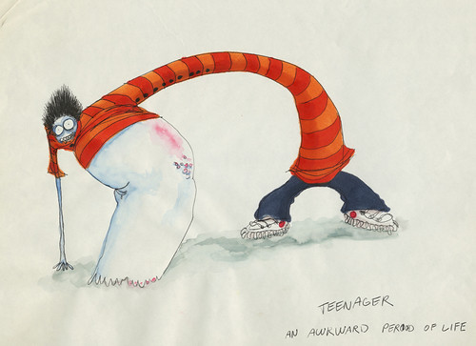
Untitled (Boy Series) 1980–1990
© 2010 Tim Burton

This painting features a bizarre disproportionate character hunched over with “Teenager, An Awkward Period of Life” captioned underneath. By taking the painting at face value we can clearly recognise the absurdist nature of the image due to the contrast of bright and muted colours, the layers of watercolour stains and of course the creepy and twisted qualities of the main character. A general theme through Tim Burton’s work is the absurd outsider. A reject, loner character who is mis-understood by those looking at them. The only viewer with any real understanding being Burton (the artist) himself. During the time period in which this work was created, Tim Burton has been quoted as saying “If I look at certain Van Gogh paintings, they’re not real, but they capture such an energy that makes it real” which I interpret as through the use of the absurd and out of this world, there is still a commentary there on human nature and society.

The second key word I am going to explore in this proposal is “disorganised” for the reason that my work is always left untidy without any real coherent colour palette or use of the formal elements. I would personally define the word disorganised as describing something lacking in structure or discipline however not necessarily in a negative way or to the work’s downfall and can open up new avenues without limitations or staying within the lines if you will. To quote Jamie Hewlett, an artist who I look up to and whose work inspires me, when asked if his creative process is disorganised, he states, “It’s a little bit chaotic, but it always comes together…I’m just drawing, and everyone else in our studio is doing what they do. It’s quite exciting and fresh.” (Gorillaz Talk Plastic Beach, Subtle Environmentalism and ‘Sunshine in a Bag’. WIRED (2010). An example of this would be the cover of Tank Girl – Tome 1 by Jamie Hewlett.

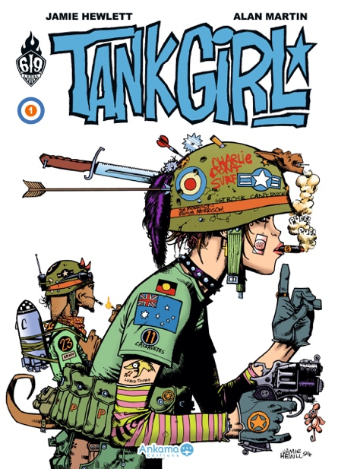
Tank Girl
Hewlett, J. and Martin, A. (2010)
Titan Publishing Group

I have chosen this image because I feel as though it relates to the key word of “disorganised’ as it is the kind of illustration in which after the general planning you can see how Hewlett has added more and more random objects and accessories to the image as he has gone along to make the work more and more disorderly and visually stimulating to end up with a heavily detailed piece of art despite the wide open block colour comic book style.

The final key word I have chosen to explore in this proposal is “dystopian” because I consider the context of my work to often link to or dramatize the occurrences that I see every day within my own surroundings. For me, the word dystopian relates to a conceptualised reality in which the people are down-trodden and the state of society is bleak, often as a kind of commentary or satire on real world issues or historical periods. After researching classic dystopian novels, I found that the best metaphor of this is George Orwell’s novel, “Animal Farm” (1945), a political satire in which the farm animals rise up against their human master in order to reflect the conditions of Stalinist Russia. A work that could also be a good reflection of this similar concept would be Banksy’s pop-up art exhibition “Dismaland”.
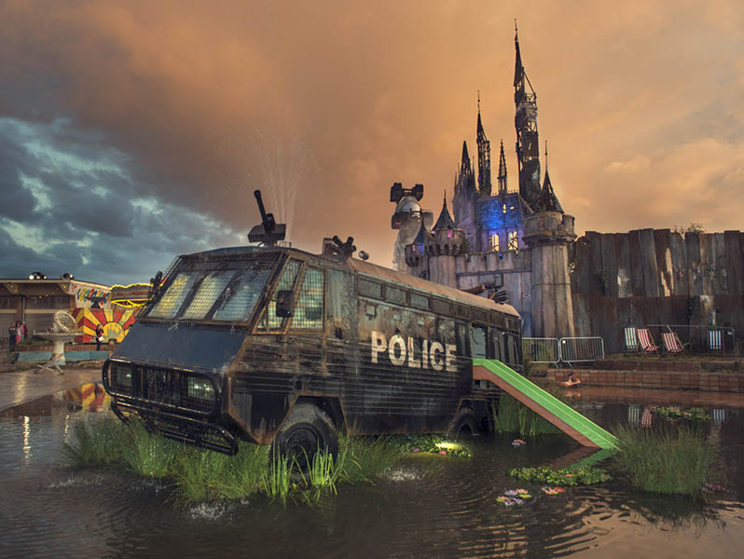
Dismaland.co.uk (2015)

Dismaland was a temporary art project created by Banksy in which he created a seamy parody of Disneyland and filled it with anti-consumerism messages as well as the awareness of world issues such as immigration and law enforcement as well as highlighting social blights such as racism. This relates to the theme of dystopia as the exhibition encapsulated the complete opposite of Disneyland’s utopian child-friendly paradise, and instead created a dreary and miserable atmosphere.

From exploring each of the keywords I have looked at for this proposal, I have decided that next year I wish to research and write about how through the disorganisation of human nature as well as the natural chaos of real life, in terms of world issues such as hunger, disease, war, poverty, equality, climate change, population or technology, we as humans have almost created and are living in our own modern dystopian world and go on further to detail how this has been applied within my own practice of Illustration. Therefore, the question I have decided on would be “How have contemporary real world issues shaped the topical evolution of Illustration?”

Bibliography:
Saval, N. (2018). The Absurdist.

Van Buskirk, E. (2010). Gorillaz Talk Plastic Beach, Subtle Environmentalism and ‘Sunshine in a Bag’. [online] WIRED. Available at: https://www.wired.com/2010/04/gorillaz/ [Accessed 9 May 2019].

Hewlett, J. and Martin, A. (2010). Tank Girl. Roubaix: Ankama éd.

https://2015.acmi.net.au/media/428206/edkit-burton-fantastical.pdf

https://www.thisiscolossal.com/2015/08/dismaland/

https://www.theguardian.com/artanddesign/2015/aug/20/banksy-dismaland-amusements-anarchism-weston-super-mare

https://en.wikipedia.org/wiki/Dystopia

