Database Concepts
Design and Access Solutions for Celtic Caterers
2023506
David Cornelius
BSC-PT Computing (Computer Networks & Cybersecurity)

Contents
Context Diagram 4
Level 0 Diagram 5
ERD 6
Access Solution 7
Tables 7
Forms 7
Queries 8
Reports 9
User Guide 10
Main Menu 10
Booking Form 10
Food Order Form 10
Delivery Order Form 10
Inventory Order Form 11
Customer Bookings Daily Report – HAS CRITERIA – DATE REQUIRED 11
Customer Bookings Overview 11
Print & View Customer Invoice - HAS CRITERIA – BOOKING ID REQUIRED 11
Inventory Orders 11
FORMS 12
Bookings 14
Food Orders 15
Delivery Orders 16
Inventory Orders 17
REPORTS 18
Customer Booking Overview 19
Customer Daily Booking Overview 19
Invoice 20
Invoice can be printed to screen or printed to PDF or from a printer 20
Inventory Orders 21
Provisioning Overview 22
Resources Used 23

Context Diagram
Context diagram giving a top-level overview of the catering booking and provisioning system. Tries to encompass all areas highlighted in initial spec and pay consideration to how these would interact.
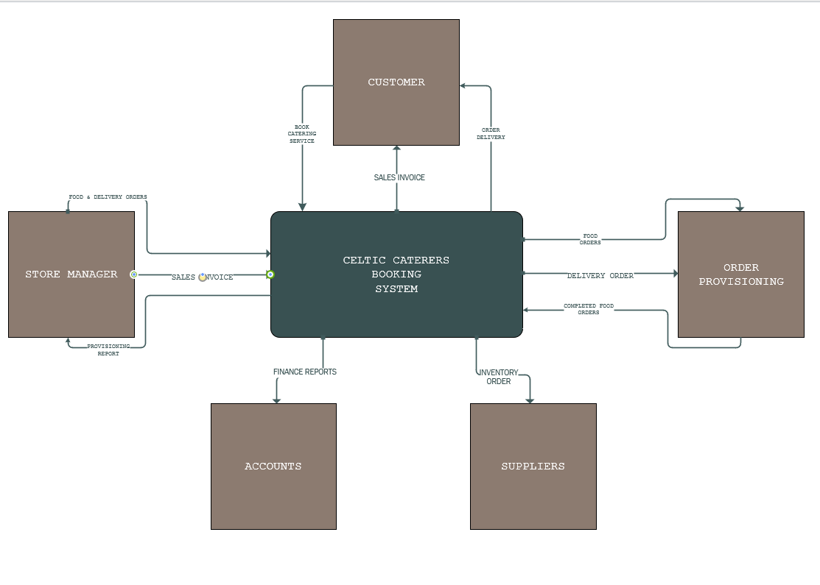

Level 0 Diagram
Level 0 Diagram outlining the external entities, data flow and processes. Tries to give an overview of the system and highlight where manual generation of items would take place. I have tried to replicate these items in the access database to show proof of concept.
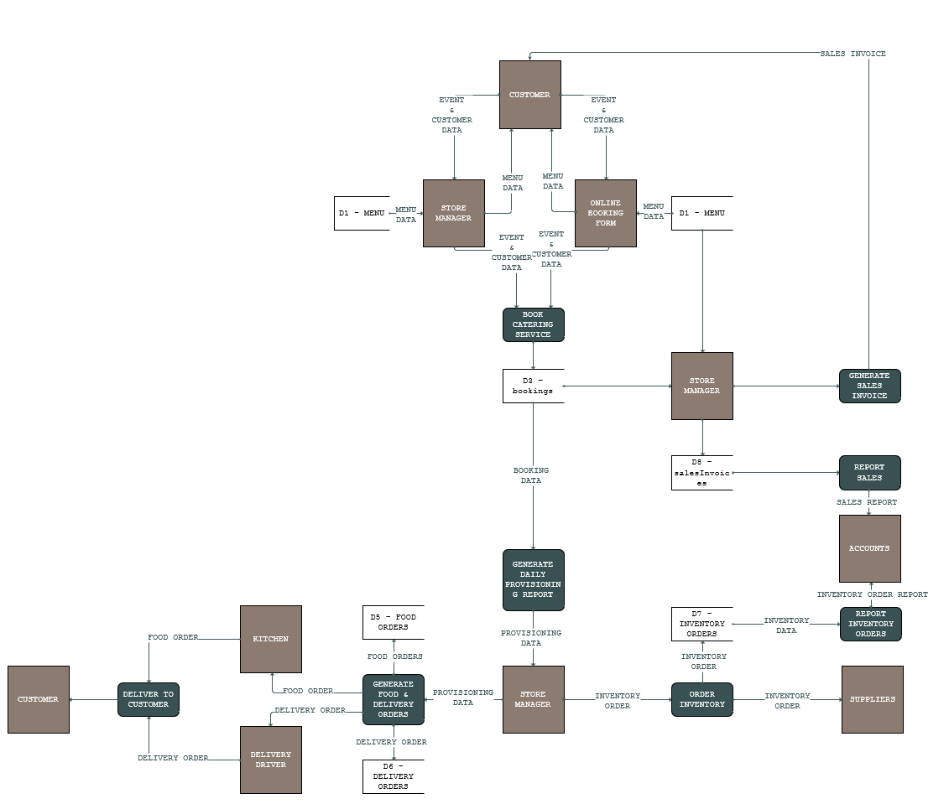

ERD
Annotated ERD outlining the relationships between different tables. The primary keys and foreign keys.

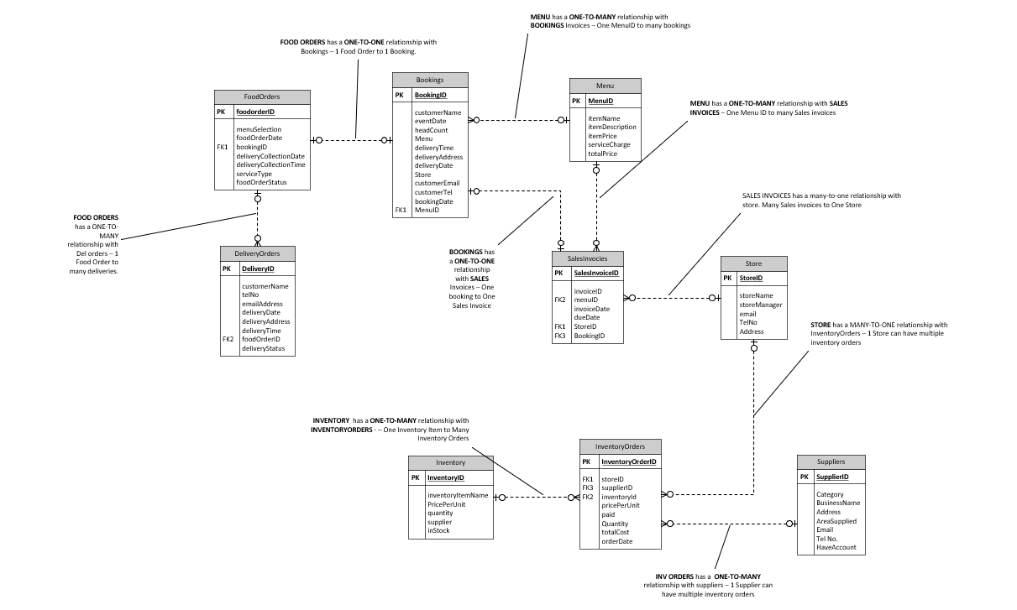

Access Solution
As part of the access solution I have generated several forms and queries to report on the data contained in my tables. I have tried to show a logical workflow from customer booking to delivery of an order. Below is a summary of the tables, forms, queries, and reports you can use within the system. System will open to a main Menu and present you with options relevant to assignment spec.

Tables
Bookings | Menu | FoodOrders | DeliveryOrders | SalesInvoices | Store
Inventory | InventoryOrders | Suppliers

Forms
- Main Menu
  - Main Menu form to present other forms in a logical way.
- Create Inventory Order Form
  - Inventory log form – Used for managing supplier orders.
- Customer Bookings
  - Customer booking form – Allowing for new entries and traversing previous entries.
- Provision Delivery Order
  - Form showing the mechanics of how a delivery would be scheduled manually by the store manager using the “Provisioning Report”.
- Provision Food Order
  - Form showing the mechanics of how a food order would be scheduled manually by the store manager using the “Provisioning Report”.

Queries
- Customer bookings by date
  - Query to fuel the report “Customer Bookings Daily Report” – This report would be printed manually and used to create food and delivery orders for any scheduled events.
- Customer bookings Overview
  - Query to fuel “Customer Bookings Overview” which provides an summary of all bookings.
- Generate Customer Invoice
  - Used as the initial query for generating an invoice based on Bookings and Menu data
- Inventory Orders
  - Utilised to create a report on previously placed inventory orders.
- Provisioning Report
  - Query is used to show an overview of all previous and currently book food and delivery orders in relation to their booking.

Reports
- Customer Bookings Daily Report
  - This report would serve as the main driving force of the bookings process – Printed daily Store manager can they use this to provision food orders and delivery orders in line with system capabilities.
- Customer Bookings Overview
  - Provides a wider range of data than the daily report and can be used to gain a top-level overview of all current bookings.
- Generate Customer Invoice
  - Report used to generate a customer invoice from a booking ID with all relevant information from attached tables. Included the capability to send directly to print or view.
- Inventory Orders
  - Shows an overview of all current and previous inventory orders with a cost total. Date has been included which could be filtered at a future date for financial reporting.
- Provisioning Report
  - Used to show an overview of all active and completed delivery and food orders. This could be used to find any issues – as a measure of a day’s activities and planning purposes.

User Guide
Summary of functionality of user interface. What items produce which output and how this can be replicated.

Main Menu
Provides access to all other forms and reports – Providing different options for printing and viewing. Some items are bound to criteria such as Invoice which requires a booking ID to process.

Booking Form
Straightforward booking form used to capture customer data and event information. I opted not to have a customers database and deal with every customer individually. Allocating them a booking ID. When completing the booking form you can use the drop downs which pull data from the menu to provide booking options. Delivery information is also included to pass to the provisioning report at a later date to be used in conjunction with delivery orders form.

Food Order Form
Food order form which is manually inputted from the “Provisioning Report”. Food orders are then stored in a database and can be queried as required.

Delivery Order Form
Delivery order form which is manually inputted from the “Provisioning Report”. Food orders and delivery orders are linked to provide every food order with a suitable DeliveryID. Delivery orders are then stored in a database and can be queried as required.

Inventory Order Form
Used to log Inventory orders which are made to suppliers. This is a manual process and would be captured by the person ordering. Inventory order data is then stored for future reporting.

Customer Bookings Daily Report – HAS CRITERIA – DATE REQUIRED
Bookings daily report drives the mechanics behind the workflow – This report outlines all booking information for upcoming events and is used to enter information into food and delivery orders.

Customer Bookings Overview
Non constrained booking overview which provides information on all current and previous bookings. Can be opened from the Menu.

Print & View Customer Invoice - HAS CRITERIA – BOOKING ID REQUIRED
Main menu buttons provide you with a easy to operate invoice print functionality which is based on a booking number. Invoice has been designed to show only information pertaining to customer and no captions. Can be used also to print to pdf and email.

Inventory Orders
Orders report gives a breakdown of any current and previous orders placed with a total that can be used for reporting. This can be further reported on by date to get an accurate quarterly spend.
Provisioning Report
Provides information relating to food and delivery orders which have completed or are ongoing. Provides a status overview and can be used for reporting purposes.

FORMS
Main Menu
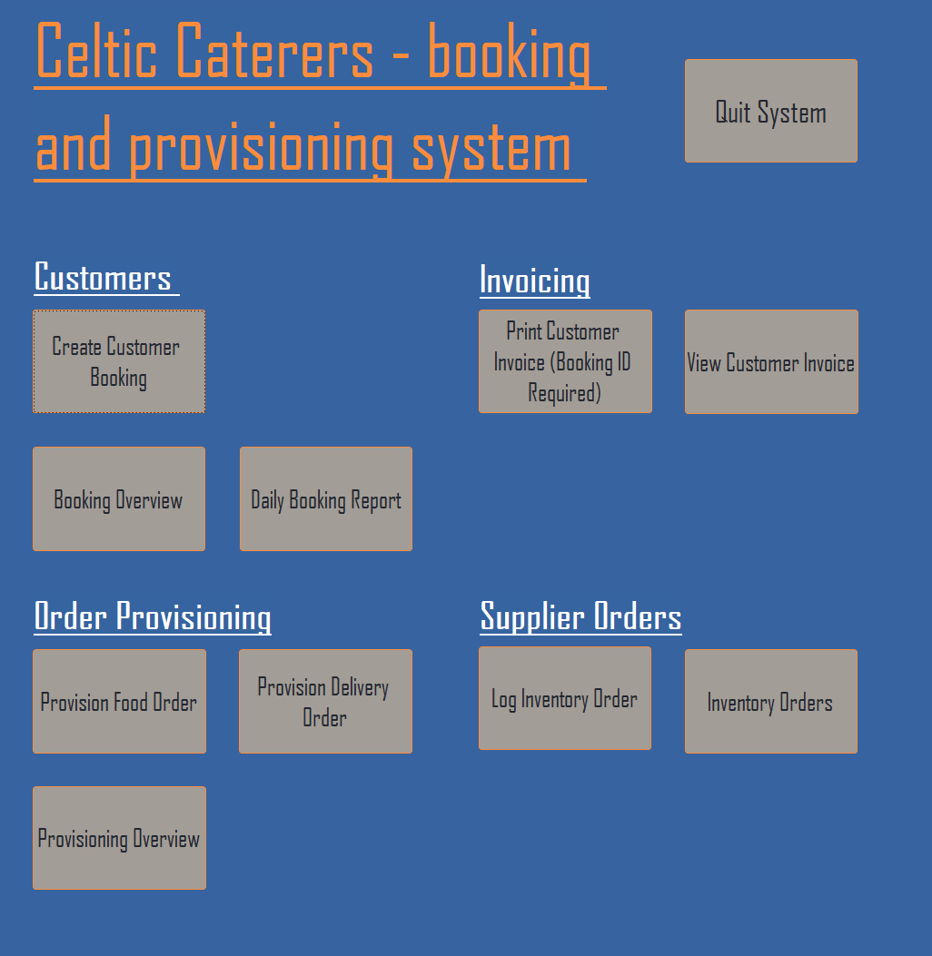

Bookings
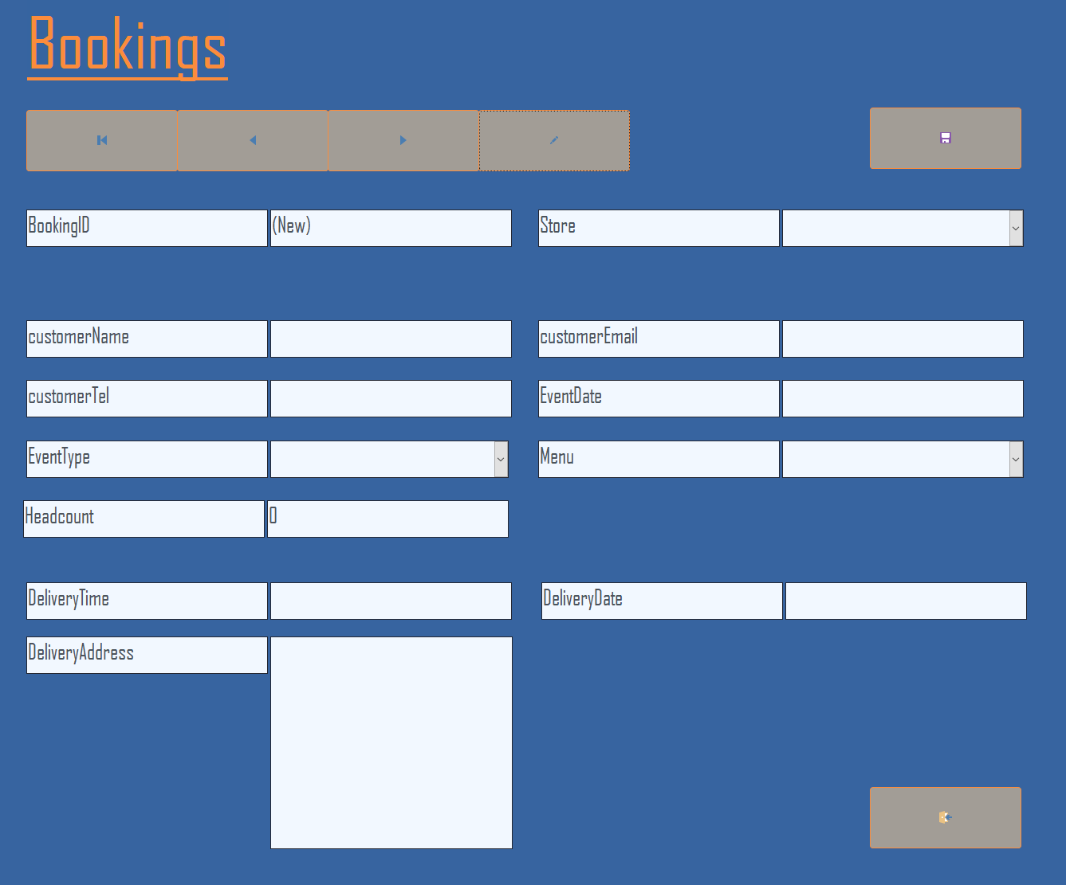

Food Orders
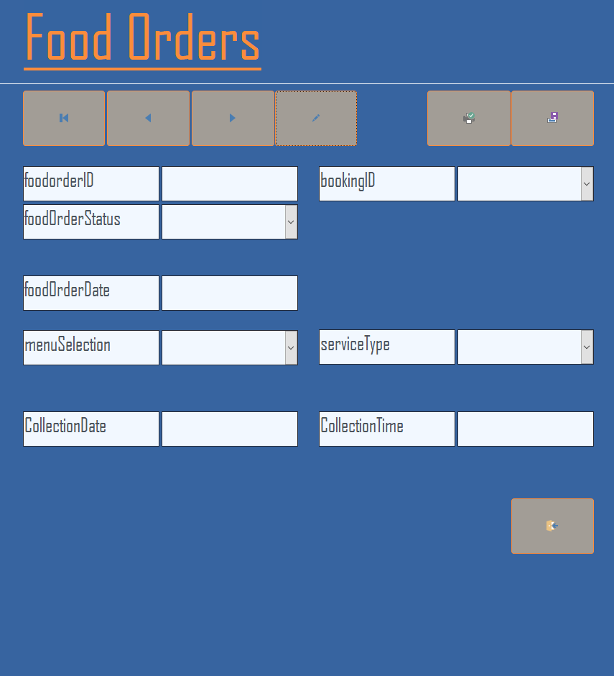

Delivery Orders
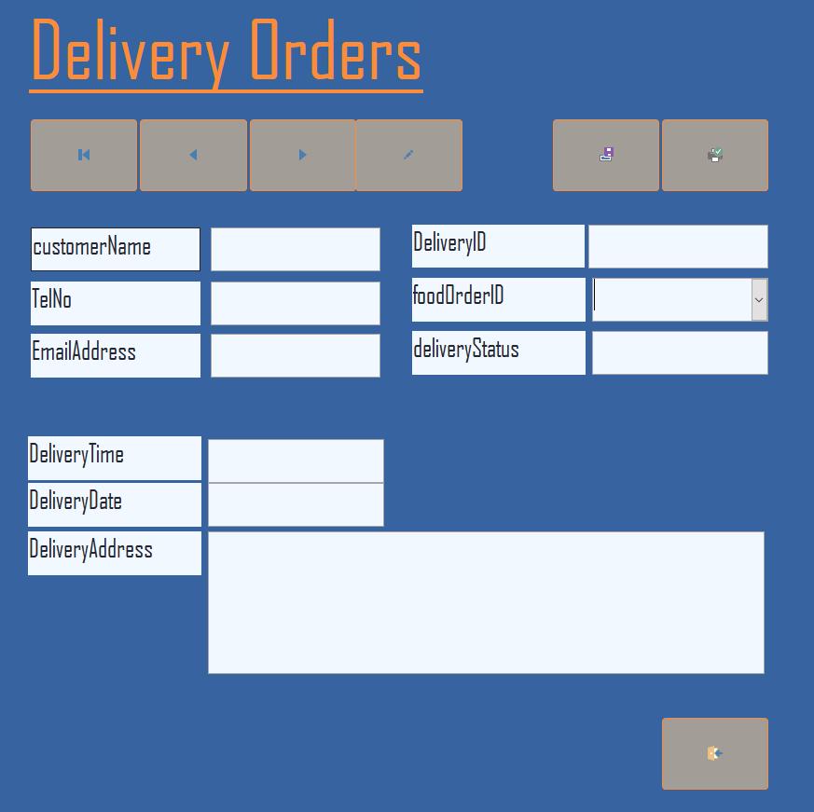

Inventory Orders
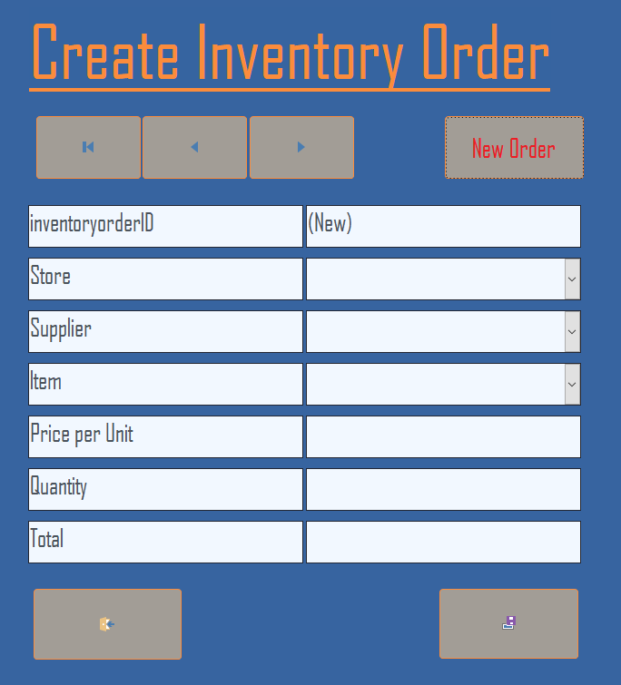

REPORTS

Customer Booking Overview
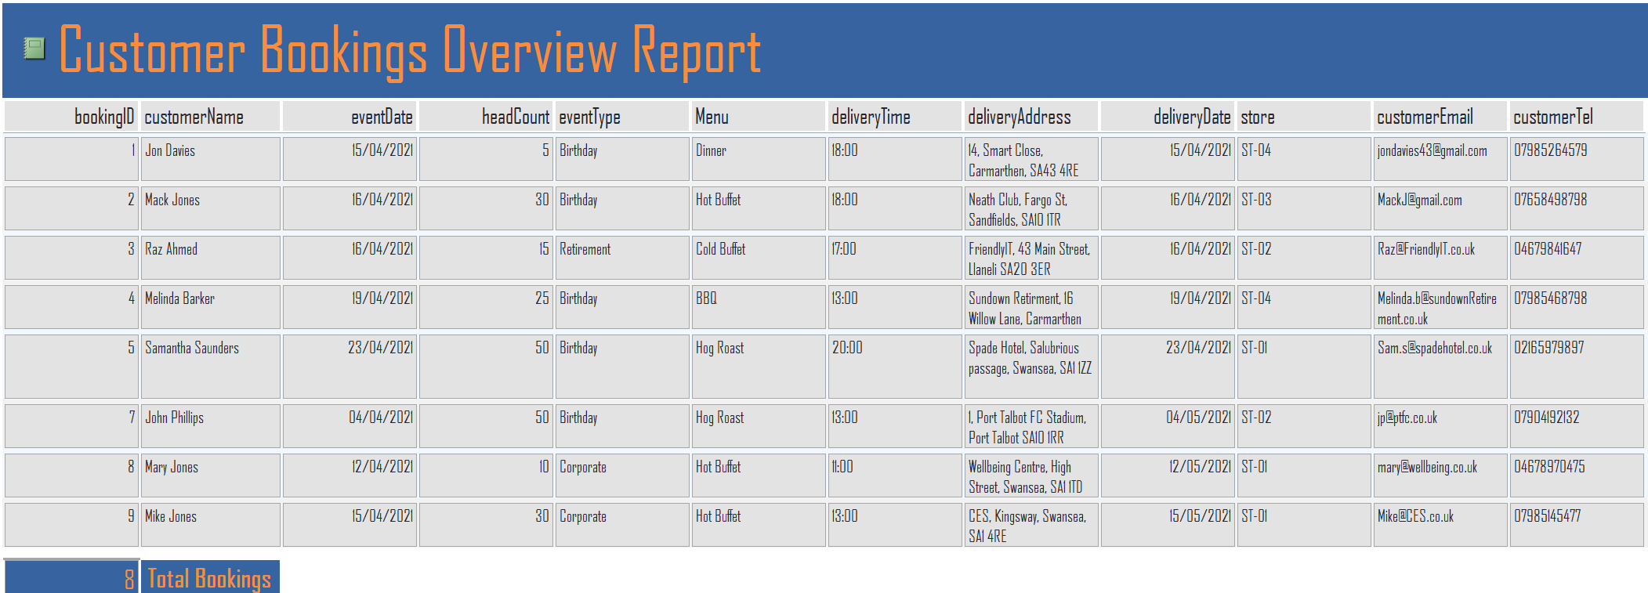
Customer Daily Booking Overview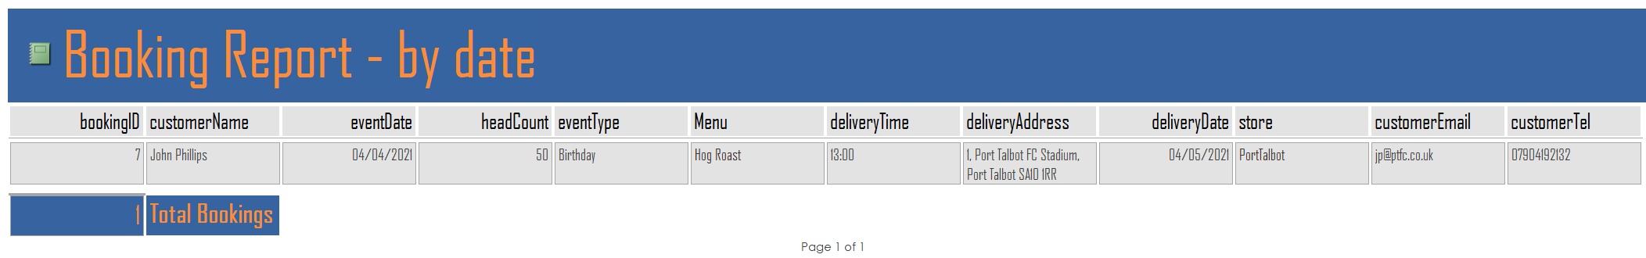

Invoice
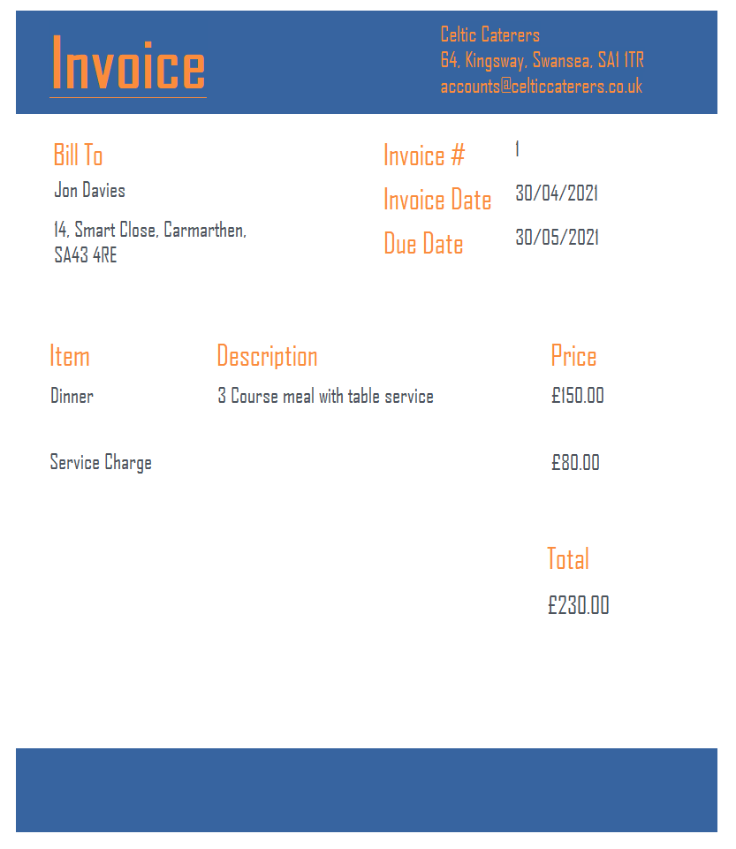
Invoice can be printed to screen or printed to PDF or from a printer

Inventory Orders
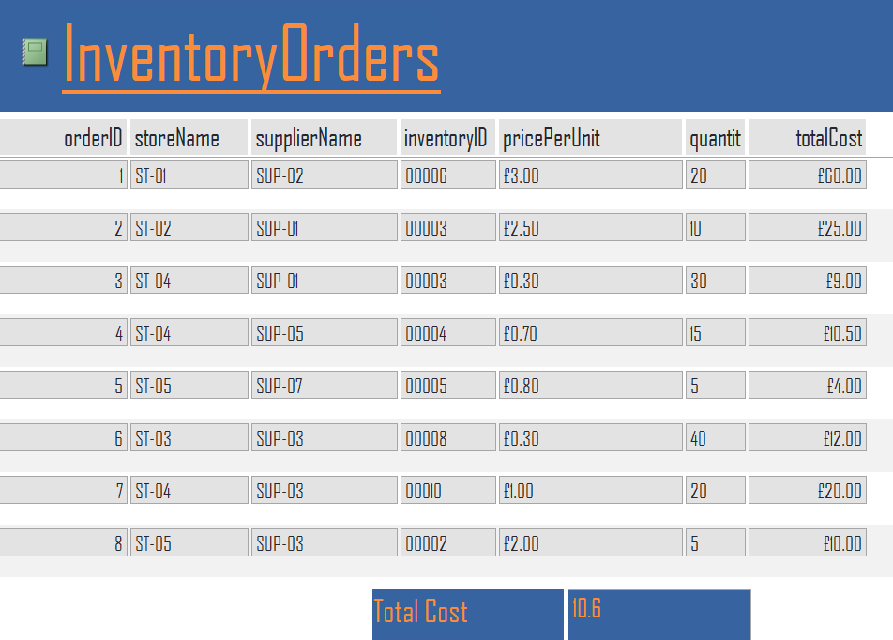

Provisioning Overview
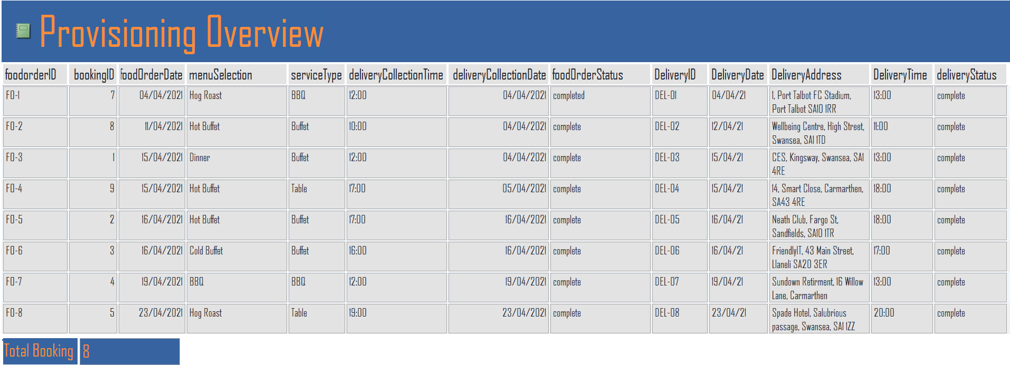

Resources Used
[1] Visual Paradigm – What is entity relationship - Available: https://www.visual-paradigm.com/guide/data-modeling/what-is-entity-relationship-diagram/ [Accessed Apr 30, 2021].
[2] Reading University – MS Access Guide - Available: https://www.reading.ac.uk/web/files/its/AccessEssen2013.pdf [Accessed Apr 30, 2021].

