Georgia Hall
Ghall.152192@student.uwtsd.ac.uk
Abstract
The theme of the proposed research is the impact of proactive school leaders. This has been narrowed down to the impact of the presence of senior and middle leaders throughout the school day, with a focus on the impact of learning walks during lesson times on teaching and learning. The theme has been narrowed and focused due to the multiple variables applicable to proactive leadership in schools which would make the research too comprehensive to be carried out by an individual researcher in a single setting and would not be able to have an immediate impact on current practice. The presence of middle and senior leaders during lesson time in corridors and in classrooms is larger in this setting than in the researcher’s previous school in Wales. The research aims to collect data from a range of perspectives including from pupils, classroom teachers from different disciplines and from middle and senior leaders. Topics expected to arise are behaviour for learning, expectations, teaching standards and pressure.
An investigation into “proactive leadership” in the form of learning walks
WITH AN ANALYSIS OF THEIR IMPACT ON THE QUALITY OF TEACHING AND LEARNING IN THE CLASSROOM

Table of Contents
Introduction 1
Why is educational research important? 1
Current Examples 2
Key Terms 3
Methods and Approaches 3
Context 5
Ethics 6
Literature Review 7
Proposed Methodology 8
Data Sources 9
Collection Techniques and Instruments 10
QUESTIONNAIRES 10
Interviews 11
Quantitative data 12
Analysis of Data 12
Reliability and Validity 13
Work Plan 14
Appendices 16
References 22

Introduction

Why is educational research important?
Educational research has a very broad scope, internationally to individually, government policy to classroom practice, though all research is based on the systematic collection and analysis of data, the interpretation of the findings and the construction of the argument (Sharp, 2012). All of this can influence elements of the educational sector therefore must be logically systematic, self-critical and dependable.
Every child has the right to the best education and that is the key to creating social justice and mobility (Gibb. N, 2016). Educational research improves the sector’s understanding of learning and teaching and therefore informs decision making about how to meet the needs of learners (Welsh Government, 2015).
For years there have been calls for governments to improve the quality of education and teaching across the UK. Proposals focus on strengthening teacher training and investing in continuous professional development for teachers and school leaders (Department for Education DfE, 2017). In the Welsh government’s report for their educational vision 2017-21, one of their highlighted key priorities is to “enhance the use of evidence and research … at all levels of the system” (Welsh Government, 2017). They are willing to invest in professional development for teachers that is based on pedagogical research and effective collaboration to raise standards and reduce the attainment gap through offering equal opportunities and high-quality education.

Current Examples
Research does not just shape classroom interventions; educational studies are one of the leading influences of educational policy across the world. Other influences include non-profit organisations, governmental establishments and people such as elected officials and representatives of government agencies. Following the release of PISA statistics in 2015 (see appendix 1) where Wales scored significantly lower than many countries including England, Scotland and Wales, Welsh government knew they had to improve levels of literacy and numeracy across the country (Hume, 2016). Therefore, the Literacy and Numeracy Framework in Wales was created based on research into effective teaching practice, assessment techniques and successful evidence of similar policies internationally (Welsh Government, 2013). Finland and Japan are countries with the highest average maths and reading scores so Welsh education systems can learn from how research is used to enhance learning outcomes in these countries. The next PISA study and data collection is to be conducted this year and the results will be released at the beginning of 2019.
The Education Endowment Foundation (EEF) have funded projects across the country for six years aiming to improve outcomes for disadvantaged pupils. This is part of a trial using funding from the department for education to improve the sector’s engagement in robust educational research. This has generated a bank of evidence reporting on ‘what works’, available publicly so that everybody in the sector can benefit from access to evidenced based interventions (EEF, 2018). Due to this availability and the ongoing assessment of interventions, matched with teacher expertise, the EEF have forecast positive progress for socio-economically disadvantaged pupils in GCSE English and Maths attainment over the next five years. This in turn will help create a more mobile society which offers equal opportunities to young people regardless of socio-economic backgrounds.
BERA and the RSA (2014), a charity committed to addressing social challenges, found in their review of the role of research in education that there needs to be more of an emphasis on research and evidence rather than just data in schools and classrooms. It was found that at present teachers can produce data and describe trends however they need to be able to examine and translate the data into practice that has an impact on teaching and learning. It is understandable then that the relationship between research and classroom practice continues to evolve.

Key Terms
Consequences – the behaviour management system designed to give pupils choices and tackle low level disruptions therefore support learning. Per lesson pupils will get three warnings (C1, C2, C3) before a C4 which results in an afterschool detention the following day. These can be given for poor behaviour for learning, including interruptions and lack of effort.
Learning Walk – In this context, a learning walk is where a member of SLT or Head of Department goes in and out of lessons across the school. They happen randomly throughout the school day, normally multiple times and sometimes multiple times per lesson.
Learning Managers - non-teaching members of staff, responsible for the wellbeing, behaviour, learning and achievement of the students in their year group. They work closely with teachers, Heads of Departments, , the Attendance team, other agencies and parents/carers.
SLT – Senior Leadership Team. Includes the principal, assistant and associate principals and learning managers.

Methods and Approaches
Past literature about improving the impact of research has advised researchers to be objective rather than subjective when evaluating evidence. This means focussing on facts and data rather than thoughts and opinions, however this is difficult in research involving humans (McMillan and Schumacher cited in Opie, 2004). Interpretivist approaches can have several consequences; the human data sources interpret and give meaning to their interactions with situations and others and then the researcher acts as a second level interpreter when analysing the data in which the analysis is subject to understanding and personal paradigms. Within social research, the researcher needs to acknowledge these consequences and aspire to objectivity although in turn this could lead to the detachment from the practical interests of the research.
There are many stages in the research process from planning the research to presenting the findings. The planning stage includes thinking about the sample and participants, and how you will collect the data needed to fulfil the aims and objectives of the research.
Quantitative methods of data collection produce quantifiable, reliable data that can usually be generalised to a larger context. The greatest weakness of the quantitative approach is that it ignores human behaviour and the effects of variables that have not been included in the research.
Qualitative research methodologies provide the researcher with different perspectives through direct interaction with participants although measurement of these perspectives tend to be subjective and results may differ depending upon who conducts the research. Qualitative methods generate rich and comprehensive data which can explain reasons behind trends in quantitative data. Unfortunately, qualitative data analysis can be demanding and time consuming and results can be challenged according to bias and validity.
Since both methodologies have strengths and weaknesses it is recommended to take advantage of the strengths of several approaches collectively.
Questionnaires are a particularly versatile and adaptable research tool; there are three basic types: structured, unstructured and semi-structured (Sharp, 2012; Cohen,et al., 2013). Structured questionnaires are commonly used with large samples as they are easier to analyse since the questions are closed and the form of answer is determined by the researcher. The term unstructured is deceptive as unless participants can write about whatever they want, there will be some form of structure albeit a topic or title. Unstructured questionnaires are normally used with small samples as they are harder to analyse since the questions are open and the form of response in determined by the respondent, nevertheless this allows for honest and authentic responses which may not surface from closed questions.
A questionnaire’s purpose must be clarified prior to design, so that all questions are necessary and relate to the aims of the research (Cohen, et al., 2013). Researchers must plan the sequence of questions with data analysis in mind so that they can anticipate the form and range of responses that will be given.
Similar to questionnaires, research interviews can be structured, unstructured or semi-structured with a clear purpose and structure. Interviewers should be attentive and listen carefully to the interviewee, showing awareness of possible interview stress; practicing interview techniques is recommended prior to formal interviews. They should be used to provide supplementary information to clarify or triangulate initial findings (Sharp, 2012).
Computer software is used more frequently at present to not only collect data but analyse it. Many programmes will produce charts, graphs and statistics based on responses given. These statistics though must be carefully considered, and interpretation of these results must be evidenced based and factual. Both the normative and interpretive paradigm are complimentary when interpreting results and findings from research. The Interpretive paradigm suggest that there will be many solutions and generalisations will be difficult – the interpretations will look at factors such as behaviours, motivation and values. The normative paradigm is based on providing logical proof through objective, structured and positivist research. Generally, normative perspectives are factual and numerical however when researching in a social environment there are many influences so both the normative and interpretive paradigm must be used in conjunction.
Research matters most when the findings are put into place and often the language used in educational research papers makes it very difficult to translate into classroom strategies which can have a significant effect on outcomes. Since some aspects of living in the UK are changing fast, current and future research must give structured approaches to implement their findings conducive to having an instant impact. Teacher led communities that discuss and explore educational research, often online through social media, are education’s biggest hope for ensuring that research reaches classrooms (Gibb. N, 2016). The Education Endowment Foundation (2018) also provide opportunities for teachers and schools to engage with current research as well as have access to more high-quality reports and findings than ever before. This allows schools to save money whilst implementing findings which could have tremendous potential to improve pupil attainment.
Cai, et al (2017) found that for the field of educational research to improve its impact on practice, school leaders and policy leaders need to create a space in the sector for reflection at all levels.

Context
The research will be conducted in a successful small school where pupils make outstanding progress, well above the national average (Gov.uk, 2017). The progress 8 score for the year 2017 was +0.83 meaning that on average pupils gain 0.83 of a grade on their target from Key Stage 3. It is worth noting that the progress 8 score in maths is +1.52 and +0.46 in English. Despite this, the percentage of pupils eligible for the pupil premium funding is higher than the national average with a significant proportion from service families or in care. The progress 8 score for disadvantaged pupils in 2017 was +0.94. The school is part of a multi academy trust (MAT) under central leadership with consistent procedures and policies throughout all its schools. There are lots of opportunities for development and teachers quickly promote to more senior roles making some members of SLT relatively young with less experience than traditional SLT members. Unfortunately, this also means turnover of staff is high although they generally stay within the trust. With an abundant management structure, middle leaders are given accountability for actions to address pupils who are not making sufficient progress. Learning walks are conducted multiple times a day by different members of the leadership team including the head teacher, assistant and associate heads, heads of departments, subject directors and learning managers. The researcher is strongly committed to self-improvement and hopes to be in a middle leadership role in the near future hence this research will influence personal practice when successfully promoted.
Anybody new to the academy chain is taken aback by the amount of times a member of SLT walks in and out of their classroom, it is a big talking point by new members of staff. This research proposes to evidence the impact of such learning walks to provide teachers with confidence and minimise anxiety and negativity towards them. The research also aims to find areas in which the learning walks can be improved to have maximal impact on the quality of teaching and learning in all classrooms.
This research will contribute to the field of Welsh education since learning walks appeared in England succeeding OFSTED’s new policy of no notice inspections to ensure capture of the reality of classroom teaching (O’Leary, 2017). In Wales Estyn give notice in advance of an inspection allowing schools and teachers to perhaps enhance their practice for the inspections. If schools in Wales aim for such high standards always, learning walks could be a way to analyse and promote this. There is currently some literature available about the process and planning of learning walks however without regard to the impact that they have on teaching and learning. Welsh schools and English schools will be able to use the findings to support teachers and support leaders when taking responsibility and accountability of the quality of teaching and learning in their classrooms.

Ethics
The researcher will maintain awareness of cultural sensitivities throughout the research and respect autonomy of leaders and persons equally, for example the values of the multi academy trust and permission will be sought from the Principal and Chief Executive Officer prior to undertaking the research.
The research aims to benefit others and avoid harm. This study will be granted ethical approval by the University of Wales Trinity St. David and all procedures will be in line with BERA’s best ethical practice within educational research (Bera, 2014). Prior to any undertaken research, all participants will be given an information letter (see appendix 3) outlining the aims of the research alongside the benefits and possible discomforts that may arise as well as the recommended ethical procedures, for example their right to remain anonymous and right to withdraw from the study at any time (Cohen, et al., 2013). There is always a “costs to benefits” ratio in research with the obvious aim that the benefits greatly outweigh the costs, through crucial findings that lead to significant advances in knowledge and practice, as well as the satisfaction of personal contribution to such findings (Cohen, et al., 2013). Participants will have to sign a consent form (see appendix 2) to be part of the study which will be stored under lock and key during the research and destroyed once the research has been completed. For reasons of confidentiality and anonymity in accordance with the BERA guidelines, the report of findings will not reveal the identities of participants, nor the school where research was undertaken (Bera, 2011; Cohen, et al., 2013). Any information of a legal nature however may be disclosed if the participant is at risk, although the researcher aims to minimise this risk by carefully planning questions and structuring sources to be used in the research.

Literature Review
Learning walks should be structured classroom visits conducted by senior teachers, leaders and other stakeholders intended to gather a reflective view of the quality of teaching and learning throughout the school (Bloom, 2007). Learning walks should encourage conversations about student outcomes and expectations besides facilitating support where needed and therefore informing practice.
A preliminary literature review shows that past studies focus on the ways to undertake learning walks based on improving professional development (O’Leary, 2017; Fisher and Frey, 2014). They suggest that learning walks only work under a specified set of conditions.
Estyn provided a report in 2017 linking learning walks to lesson observations however it was aimed at inspectors to provide guidance when inspecting observations in schools. Alternatively, Welsh government (2017) have a short guidance presentation on their Learning Wales website for learning walks aimed at all school stakeholders, the detail is very brief and focusses on how to organise a learning walk. It does mention in short what the outcomes might be however these are not based on evidence and are just predictions. There is more research available regarding teacher learning walks and the impact this has on personal development and improved instruction than that regarding learning walks conducted by members of leadership teams to assess teaching and learning (Fisher and Frey, 2014; O’Leary, 2017).
What is missing from past studies is a comprehensive and structured evaluation of learning walks conducted by school leaders rather than teachers and the impact they are having on the quality of teaching and learning. Also, most current research is based on infrequent, planned learning walks that are used to contribute to lesson observation and performance management procedures unlike the proposed research which will explore random and frequent learning walks (often multiple times per day) that do not contribute to performance and observation practices.
Considerable pressures to improve results and increased competition between schools has meant leaders can be more data driven than previously, in turn making them take more accountability for what is happening in classrooms (Welsh Government, 2015). Leadership within schools needs to be dynamic with a clear vision and drive to improve teaching conducive to raising achievement. It is advised that leaders analyse quantitative data alongside classroom practice to inform lines of enquiry about learning and teaching within their school (Welsh Government, 2015). This perhaps increasing the frequency of classroom walkthroughs (learning walks) in pursuit of teaching excellence.

Proposed Methodology
The following research questions reflect the aims of this study and have guided the direction of the research methodology
Main Question
To what extent are learning walks by middle and senior leaders impacting teaching and learning and how can the impact be strengthened?
Minor Questions
- Are the learning walks proactive through support and feedback?
- What are the intended outcomes of the learning walks? Are these shared with teachers and pupils?
- Who is conducting the learning walks – is this having the most impact?
- What is the impact on teachers – stress, pressure, planning, and teaching?
- What is the impact on pupils – behaviour for learning, progress?

The proposed study is an enquiry into the impact of learning walks conducted by members of leadership teams, focussing on the perspectives of leaders, teachers and pupils. This accentuates socially constructed, interactionist knowledge, which supports the interpretivist view that interaction between human beings is critical to understanding meaning and situations.
Initially, existing learning walk methods will be identified based on a comprehensive review of current sector practices and academic researches. These will be used to plan questions for the data sources as well as evaluate the methods and processes used in this context.

The main methodology of the research will be mixed methods surveys combining quantitative data from GCSE results, observations and consequences with questionnaire surveys and a small number of interviews aimed at leaders, teachers and pupils. Consequently, the methodology encompasses three different research styles. Data from standardised external assessments will be collected to measure performance as this type of quantitative data is the most reliable measurement for school and pupil achievement. Data regarding achievement and consequences will allow comparisons to the ethnographic results from surveys, both questionnaires and interviews. Ethnography is the study of people and cultures, it gathers perspectives with the aim to explain specific situations in a specific context. Unfortunately, ethnographic studies are subjective, and value bound hence the data will only be able to distinguish correlation rather than cause from effect. Therefore, optimistically, the assessment and testing data will support opinions and themes that arise in the same way that the qualitative data analysed will compliment and augment the quantitative data. Surveys will allow the researcher to gather opinions and generalise descriptions and explanations from multiple perspectives of the impact of learning walks on classroom teaching and learning.

The qualitative and ethnographic parts of the study will be based on enquiring knowledge about the influence and impact of learning walks on teaching and learning across the school. Maxwell (2005, cited in Cohen, 2013) states that qualitative research should have practical goals and intellectual goals, providing theories and results as well as forming an understanding of a situation or process. Context and situations will be carefully considered against data, for example; total teaching experience, time taught in the specific context, classes taught, demographics of pupils and so on. Data from empirical observations will be prolonged over a significant period to establish reliability and obtain averages for comparison.
Risks to validity and reliability of data come from relationships between the researcher and the participants, these include the “Hawthorne” and the “Halo” effect, where the presence of the researcher influences responses and where the researcher selects only the positive responses, respectively. All responses will be analysed and considered carefully in relation to the aims of the research, taking awareness of wider constraints and contexts.

Data Sources
The researcher plans to include a representative sample of the whole school by using a purposive sample, breaking the population into subgroups and using a random stratified sample technique, to ensure a full scope of issues can be explored. Since the aim of the research is to find out the impact of learning walks conducting my senior and middle leaders on the quality of teaching and learning, it is the pupils, leaders and most importantly teachers who have the capacity to provide the ‘richest’ data.

- Pupils - range of year group and ability, 2 pupils from each of the following groups will complete the questionnaire surveys; Year 8 top set, Year 9 Intervention class, Year 10 Foundation GCSE set, Year 11 Higher GCSE set.
- Teachers – 4 Teachers chosen randomly from different disciplines; Maths, English, Science, Technology
- Middle Leaders who conduct the learning walks – Head of Maths and Director of Maths (chosen maths for convenience to the researcher as a maths teacher)
- Senior Leaders (SLT) who conduct the learning walks – Principal, Assistant Principal x1, Associate Assistant Principal x1, Learning Manager x1
- Consequences data – used to show impact of learning walks on classroom behaviour for learning. There are numerous influences on behaviour for learning nonetheless from empirical evidence the regular presence of middle and senior leaders during lesson times is one of them.
- GCSE results and progress scores – used to show performance of the school. Although this data will be subject to many factors, learning walks may be one of them.

Collection Techniques and Instruments
Educational research is on the continuum between positivist and anti-positivist approaches (Opie, 2004). The researcher will use mixed methods to obtain both quantitative and qualitative data to triangulate findings and overcome the weaknesses of any single method.

Questionnaires
Surveys are economical and efficient, they gather standardised data as all participants who complete the survey are asked the same questions. They enable the researcher to observe patterns in responses making data generalisable and allowing the capability of presenting results statistically.
Three similar questionnaire surveys will be used, created from commercially available google forms, designed to gather perspectives about the impact of learning walks from each demographic of participant. Each questionnaire will be semi structured, with some closed questions and some open questions to allow participants to explain their views and avoid the limitations of pre-set responses. A sample sequence of questions for the teacher questionnaire is shown in Appendix 4. Participants will be self-administrating their responses via an internet survey that will be emailed to them through a link to the appropriate page. Ethically, you cannot assume that emails are completely secure, therefore it will be best to use school email accounts that have maximum security enabled and send a link to a pin protected online questionnaire. Internet surveys have a better response rate that paper-based surveys and also eliminate any associated costs of printing and posting (Cohen, 2013). Regrettably through internet questionnaires you cannot ensure that every participant understands the question as you may not be present when they complete it. Clear instructions will be given in large font, questions will be carefully considered, simple language will be used, and the researcher will be present when the pupil participants complete their questionnaire to address any issues instantly. Furthermore, there can be technical issues when administering surveys online, for example reliance on available networks or programme compatibility with different devices. Pilot questionnaires will be tested on a variety of devices and models to reduce and hopefully eliminate these risks.
- Pupil Questionnaire. This will explore an overall view of learning walks across the school, throughout the school day and in different subjects, discovering the pupil’s perspective of the impact it has on behaviour and learning. The researcher cannot assume that these participants will have clear viewpoints regarding the topic so will give an option of no opinion rather than getting a response that is not true or reliable.
- Teacher Questionnaire. This will explore personal experiences of teachers surrounding learning walks during lessons, focussing on behaviour and teaching standards.
- SLT Questionnaire. Given to those who conduct the learning walks, this will be used to discover the aims and objectives as well as the intended impact. It will also ask about their perceived impact so far.

Interviews
Interviews will be conducted on a ‘critical case’ basis, where participants in key positions who have experience and knowledge in connection with learning walks conducted by members of the senior leadership team in the school and across the trust as a culture will be chosen. They will be standardised semi-structured interviews, aiming to gather qualitative data in more depth than that provided in the responses to the questionnaires. Interviews give more opportunities for asking probing questions compared to questionnaires, so the interviewer can focus on specific themes or subjects of interest that arose in the questionnaire responses which are limited. There will be a given agenda with open ended questions, in which the wording and sequencing will be prepared in advance, allowing participants to explain their ideas and opinions as well as making analysis of results easier and increasingly comparable. If an opinion or idea is not supported the interviewer will ensure to ask the supplementary question: “Why?” as this will bring out the most important information in the study. When the questions are prepared in advance the facilitator bias and effects are reduced however it may constrain the naturalness or relevance of the answers therefore the interviewer will allow time for expansion upon responses if necessary, hence making the interview semi-structured.
The timings of the interviews will be carefully planned around the school day to avoid interruptions and distractions, making sure other staff in the vicinity are aware of the interview taking place. The interviewer will have a neutral manner, evading signs of approval or disproval in words and body language. Interviewees will have plenty of time to answer the questions so that they are able to think about their answers providing a more honest, reliable and conclusive response.
Possible risks and errors can occur mainly through the interviewer’s transcription of the interview in a variety of ways. Although the interviewer does not have to record everything that is said in the interview there is the potential that important data is missed, which will be overcome by recording the interview. There will be many possible interpretations of the data gathered so all data must be carefully and critically analysed, including tone, behaviour and body language, looking for patterns and themes that arise in the responses.

Quantitative data
- Consequences – A comparative survey will be taken counting the number of consequences given during lessons where a learning walk is conducted compared to lessons where there is no interruption to see if the number of consequences reduces after the member of SLT has been in the lesson. 2 different classes will be used in the survey, to compare the impact between behaviour in Key Stage 3 and Key Stage 4. The surveys will not look at individual pupils, just the quantitative total number of consequences issued by the teacher (researcher) per lesson. In total 16 lessons (8 per class) well be used to ensure a reliable comparative conclusion. To improve reliability and validity of results from this survey, more classes could be used over a longer period of time.
- Observation Results – a review and analysis of observation results from formal observations will indicate the quality of teaching and lessons given across the school. Each teacher has three formal lesson observations a year so there will be lots of data that is already statistically analysed ready to use. This does not link directly to learning walks however links to quality of teaching and the presence of a member of SLT in the classroom.
- Progress scores/GCSE attainment - data describing measures of progress and attainment will be collected from national tests in which the results have been standardised over many years. Allow learning walks will not directly cause these results due the vast number of factors that affect progress and results, there may be a significant correlation depending on the impact in classrooms.

Analysis of Data
Sharp (2012) suggests the five basic stages of data analysis:
- Familiarisation – The researcher uses this stage to get an overall view of the initial responses and uses this to decide if there is anything missing or if anything more needs to be done to make the research successful. This stage also encompasses finding patters and trends in the initial data, looking especially for ideas and opinions that are not expected. The questionnaire survey approach will be used to gain an overall view, identifying themes in opinions when analysed. Following this a more fine-grained analysis will be achieved through individual and group interviews.
- Synthesis/Collation – The researcher must now form a clear picture of the data collected and discuss the similarities and differences in the data found from each collection technique.
- Description – This stage is where the data and findings are summarised with statistics or tables and graphs. This information is factual and describes the concrete outcomes. The data collected in this research will have been structured to support data entry and computer analysis. The google forms programme processes data instantly and produces graphs and tables where possible to aid analysis.
- Interpretation – the researcher must provide explanations which give relevance to findings and draw conclusions about the data. All data will be used and explored critically as uncritical use of data encourages false interpretations and wrong positive or negative labelling of people or situations (Connolly, cited in Sharp, 2012). All data will be given strict confidentiality throughout the analysing process. Participants will have a chance to verify any statements before releasing the final report to ensure they are happy with analysis of their data.
Quantitative data, such as GCSE results and progress scores will be measured and compared through averages, ranges will be given to show the spread of data. The mean average will be used because it encompasses all of the data, alongside error intervals to take account of any outliers in the data. Such measures will give a surface view of the impact of learning walks however it must be considered in the research that the quantitative data will be shaped by a multitude of other factors and that learning walks have a secondary level impact on such data. One of the difficulties anticipated is that the less tangible aspects of teaching and learning might be most difficult to analyse. Participants may be reluctant to give honest opinions or may find responses hard to construct. In cases of no response, these will be recorded and examined. It is understood that there will be many other influences on teaching and learning and the results will be impacted by these.

Reliability and Validity
Since some of this research is open ended and exploratory, the researcher will make sure that all responses and data is analysed to improve reliability of explanations and interpretaitons. Conclusions drawn from this individual research study may be limited by the characteristics of the participants who will be studied and the context of the school in which the study was conducted however the researcher aims to minimise these limitations by systematically triangulating data to draw conclusions that are comparable and transferrable without bias. The researcher hopes that the findings will be transferrable to schools that are less successful, not in multi academy trusts and in more disadvantaged parts of the UK.
The researcher will evaluate the methodology concurrently to undertaking the research in order to report on reflections and explore future action necessary to provide more rigorous and robust evidence. There are some factors in the research that cannot be controlled by the researcher, for example the time constraints with one school term left before the submission date of the report, the type of school that the research is being undertaken in, this is where the researcher works and would not have access to or knowledge of other schools. The sample was chosen purposively because of the roles participants have and their interaction with the subject of the research. The views of the sample represent different groups in the population and therefore the data can be generalised to represent an overall perspective. There are some groups in the population that will not be represented in the sample, including parents and school governors. These groups will not be included because of the time constraints of the study and more importantly because they do not have experience of or direct interaction with learning walks during lesson time.
Although there is a relatively small amount of data from a small sample, this research can still have an impact because of the different perspectives that are explored. Time constraints are given to allow for impact so that findings can be implemented as suggested by Opie (2004). Open generalisations are more useful than closed generalisations as they are more relatable to different settings and circumstances. Open generalisations give higher confidence when extrapolating the data to predict outcomes in other educational environments.

Work Plan
This study will be conducted in the 2018 summer school term and data will be analysed over the 2018 summer holiday, when the national GCSE results are published.
The researcher will gain permission from the head teacher of the school prior to starting the research as there may be some minor disruption to lessons in terms of pupils taking time to contribute data.
The researcher will create a time-flow chart, annotated fully, where targets, important dates and deadlines arise. An example time-flow chart is shown in Appendix 5. This is a low budget study; therefore, data will be collected electronically through password protected programmes which are free. Questionnaires will be sent to participants via their professional/school e-mail accounts to allow participants to complete in their own time and maximise efficiency of returns. The final report will be shared with participants, school leaders, senior members of the multi-academy trust and the university electronically unless hard copies are requested, in which case the cost of printing and delivery will be covered by the researcher. Letters of thanks will be sent to all participants involved in the study to show appreciation of their contribution to the field. The cost of printing and delivery of these will be covered by the researcher.
Further work to help contribute to the field of proactive leadership in the form of classroom walkthroughs could be through a comparative case study of different schools in different contexts. This will provide more ideas for success and potential for improved impact on a wider scale.

Appendices
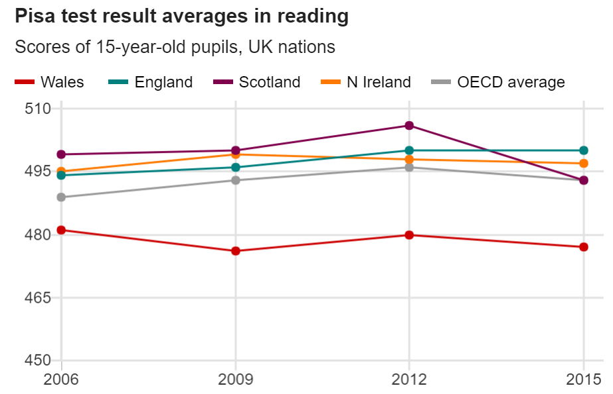
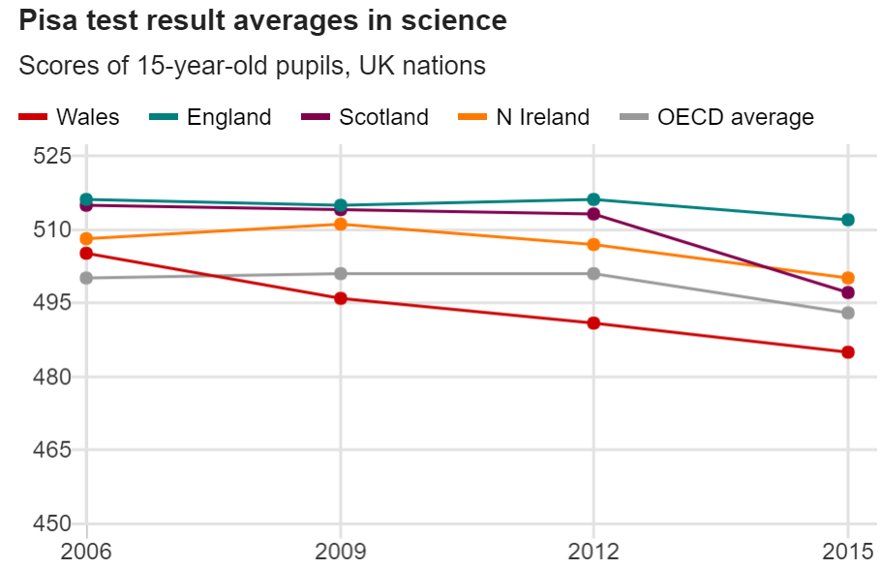
Appendix 1: Pisa test results, averages comparison of UK countries and the Organisation of Economic Co-operation and Development world average. (OECD, 2016 cited in Hume, 2016)
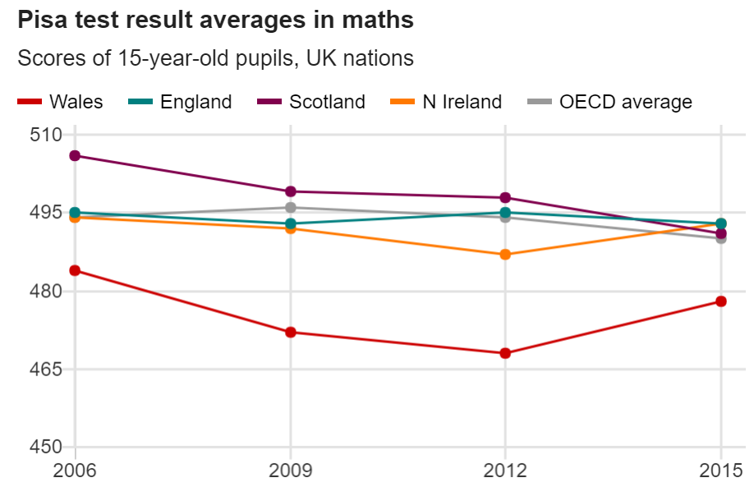

Appendix 2: Participant consent form given to all participants.
CONSENT FORM
An investigation into “proactive leadership” in the form of learning walks
WITH AN ANALYSIS OF THEIR IMPACT ON THE QUALITY OF TEACHING AND LEARNING IN THE CLASSROOM
Name of Researcher: Miss G HALL
- I have read and understand the information about the above study. I have had the opportunity to ask questions about the study and have had these answered.

- I understand that this is voluntary and I can withdraw at any time without giving a reason.

- I understand that my name will not appear in any reports, articles or presentations.

- I understand that any information given may be used in future reports or presentations by the research team.

- I agree to take part in the above study.
NAME (Pupil):
……………………………………………
SIGNATURE:
……………………………………………
EMAIL: ……………………………………………
Researcher Signature:
……………………………………………
Appendix 3: Sample Information Letter
Dear Participant,

My name is Miss G HALL and I am a maths teacher at *** School. I am studying in the Faculty of Education at the University of Wales Trinity St David.
I would like to invite you to take part in my project which aims to analyse the impact of the learning walks that are conducted my middle and senior leaders at our school. You will have to complete an online questionnaire regarding your views about the impact these learning walks have on topics such as behaviour for learning and the quality of teaching in the classroom. Teachers, pupils, heads of departments and members of the senior leadership team will be participating in the research and I will be looking to find similarities and differences between the perspectives of each subgroup.

If you would like to take part please complete the attached consent form so that I can email you the questionnaires and keep in contact with you. I believe your opinions will be very helpful to me.
All questionnaires will be kept strictly confidential to the researcher involved. This gives you a chance to express your views anonymously. This study is voluntary so you may withdraw from the questionnaires at any stage.

The questionnaires should take around 10 minutes to complete and there are no right or wrong answers.
I understand that your time is at a premium but your contribution is very valuable to me. After I have analysed the results I will be happy to share a copy of my findings. The results will help enhance understanding of how learning walks can improve teaching and learning in schools and perhaps give suggestions on how to make them even more effective. The results will be stored on my personal hard drive and fed back to my university.
I thank you in advance for your time and participation. If you have any questions, feel free to contact me at your convenience.

Yours Sincerely

Miss G HALL

Appendix 4: Example Question Sequence (Teacher Questionnaire) – Note: not complete questionnaire

- What do you perceive to be the main purpose for the regular presence of middle and senior leaders in your lessons throughout the school day?

- Do learning walks impact any of the following factors? (tick all relevant boxes)
Behaviour for learning
Pupil Engagement
Lesson Planning
Organisation of Resources
Marking
Stress levels
Feelings of Intimidation
Other factors
…………………………………………………………………………………………………………………………………………………………

- How do learning walks impact behaviour in your classroom?

- Regarding your answer to question 4, is this an immediate impact as soon as the learning walk takes place?

- Again, regarding your answer to question 4, is this impact sustained throughout the rest of the lesson after the learning walk has taken place?

Appendix 5: Work Plan

