

De-Risking 81mm Mortars

By
Paul Cartwright

Supervisor: Dr Gary Jones
Second Marker: Dr John Rees

Project submitted as part of the requirements for the award of BSc (Hons) Test Range Engineering

April 2017

Declaration FORM AND FORM OF CONSENT

DECLARATION
I, Paul Edward Cartwright, declare that I am the sole author of this Project; that all references cited have been consulted; that I have conducted all work of which this is a record, and that the finished work lies within the prescribed word limits.

This work has not previously been accepted as part of any other degree submission.

Signed: .............................................

Date: ...............................................

FORM OF CONSENT
I Paul Edward Cartwright hereby consent that my Project, submitted in candidature for the B.Sc. Test Range Engineering degree, if successful, may be made available for inter-library loan or photocopying (subject to the law of copyright), and that the title and abstract may be made available to outside organisations.

Signed: .............................................

Date: ...............................................

Acknowledgements

I would like to thank my supervisor, Dr Gary Jones for his guidance, encouragement and advice that he has provided me throughout my time as a student especially with this project. I would also like to thank Dr John Rees for his continued support throughout my three years at uwted, his all round knowledge and experience made learning what could have been difficult subject a lot easier.
I must express my gratitude to Miss Beverley Richards who is a Trials planner at Aberporth, she was tasked with guiding me through the Trials delivery process. I was amazed by her willingness to take on any task that was thrown her way and how she kept a happy medium between all the parties involved in the activity.
I would also like to thank Stuart Beynon in supporting me in the task of constructing a Trial test plan, and the countless proof readings he had to do before I got it right.
Finally I would like to thank QinetiQ for giving me the opportunity to grow my knowledge and experience in this area of the business and their continued support in my academic goals over the last 3 years.

De-risking 81mm Mortars at QinetiQ Aberporth | June 6  2017
This report will look at the processes and procedures needed to De-risk land based Trials activity at Aberporth Range. Aberporth Range is an Air Range and in not accustom to firing land based munitions. It consults with the Ministry of Defense standard to ensure the correct policies are adopted by the di-ricking activity. The main objectives are to fire up to 36 illuminating 81mm mortar round and prove that the instrumentation at Aberporth is capable of tracking the mortar from launch to parachute splash and the data produced is of a standard that would meet customer requirements. The report also focuses on the noise pollution associated with firing mortars and ensures that the Ministry of Defense and Health and Safety Executive guild lines are not breached.
Title Page
Contents

Declaration FORM AND FORM OF CONSENT 0
Acknowledgements 1
Title Page 2
1. Introduction 7
1.1. Aim of the Report 9
1.2. Objectives of the Report 10
1.3. Structure of the Report 10
2. Research and Review of Literature 11
2.1. Organization of Trials Literature 11
2.1.1. JSP Standards 12
2.1.2. QinetiQ Documentation 12
2.1.3. Quotations 13
2.2. Research Review Conclusion 13
3. Development Methodology 14
3.1. Research Flow Chart 14
3.1.1. Research Process 15
3.2. Development Methodology Conclusion 16
4. Design of the Trial 17
5. Engineering 19
5.1. Camera Shelter & Mortar Mount 21
6. Noise Assessment 24
7. Firing Danger Area 27
8. 81mm Mortars 28
8.1. Mortars Storage 29
8.2. Mortar Disposal 29
9. Range Instrumentation 29
9.1. Main Sequencer Unit MSU 29
9.2. Sensors 30
9.3. TCS 31
9.4. HTPI 32
9.5. Radar 32
10. 81mm Mortar Testing 33
10.1. Flash Detector Improvements 37
10.2. 81mm Firings Sortie 2 39
11. Findings 43
11.1. Conclusion 44
11.2. Recommendations 45
12. Reflections 46
13. Abbreviations and Acronyms 47
Works Cited 48
Annex A 50
Annex B 51
Annex C 52
Annex D 53

Table of Figures
Figure 1 Range Air-Space 7
Figure 2 Aberporth Range head 8
Figure 3 Structure of Literature 11
Figure 4 DMAIC Flowchart 14
Figure 5 Mortar Firing Locations 17
Figure 6 Camera Shelter 21
Figure 7 Mortar Mount 22
Figure 8 Shelter and PUMM C-Site 23
Figure, 9 Mortar max noise 24
Figure 10, Table of dB measurements 25
Figure 11 MET Noise Assessment 25
Figure 12 Noise Reading Locations 26
Figure 13 Sound Monitor 26
Figure 14, Mortar Safety trace. 27
Figure 15 Illuminating Mortar 28
Figure 16 Flash Detector 30
Figure 17 TCS System Diagram 31
Figure 18 Highbred Tracking Platform 32
Figure 19 MOTR 32
Figure 20 Mortar firing 33
Figure 21 TCS Display 34
Figure 22 MET Data 14/03/2017 36
Figure 23 Noise Reading Mortar Firings 36
Figure 24 Relay Circuit 37
Figure 25 Sensor Box PCB 38
Figure 26 Sensor Box Inputs 38
Figure 27 Sensor Box Front Plate 39
Figure 28 Mortar Firing S2 40
Figure 29 Sortie 1 Run C 41
Figure 30 Sortie 2 Run B 42

Table of Tables
Table 1 Firing Order 16

Introduction

The task of the QinetiQ Aberporth Range is the efficient provision of instrumented Range capability in which trials of Guided Weapon Systems, Bombs, Military Aircraft and other equipment can be conducted safely and realistically, whilst yielding data to evaluate their performance.

Aberporth range is located on the west coast of Wales and occupies 6,500km² of sanitised airspace which is illustrated in figure 1 (1). This airspace is from surface to unlimited altitude and overlaps the Welsh Military Training Area, which offers some unique low-flying options. We also have the capability to manage weapons storage and provision for helicopter landing

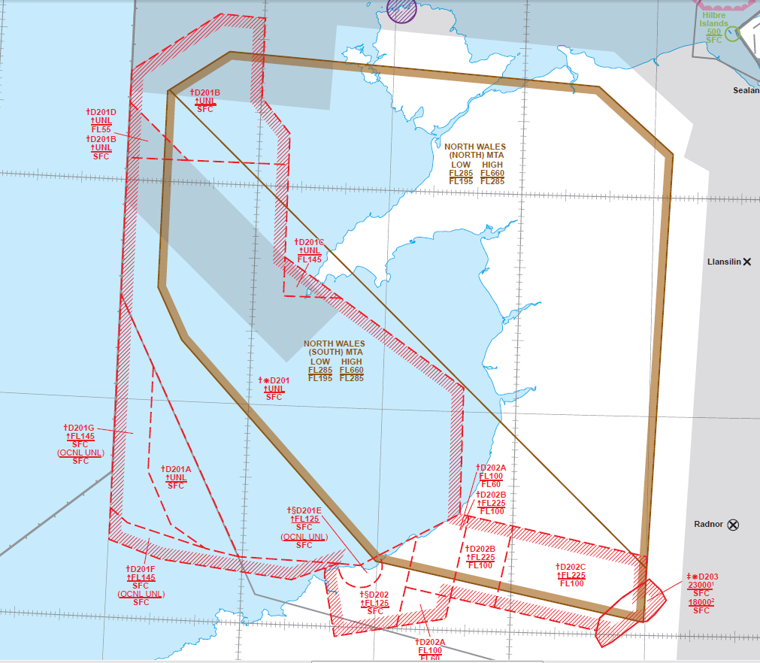
Figure 1 Range Air-Space

Aberporth provides a controlled safe environment for the release of land-, air- and sea-launched missile firings as well as instrumentation verification, passive and active IR/RF jamming and the ability to manage supersonic trials activity.

This fully instrumented controlled environment enables the evaluation of air and sea weapons, systems and training.
The image in figure 2 is an aerial view of the top camp at QinetiQ Aberporth. (1)
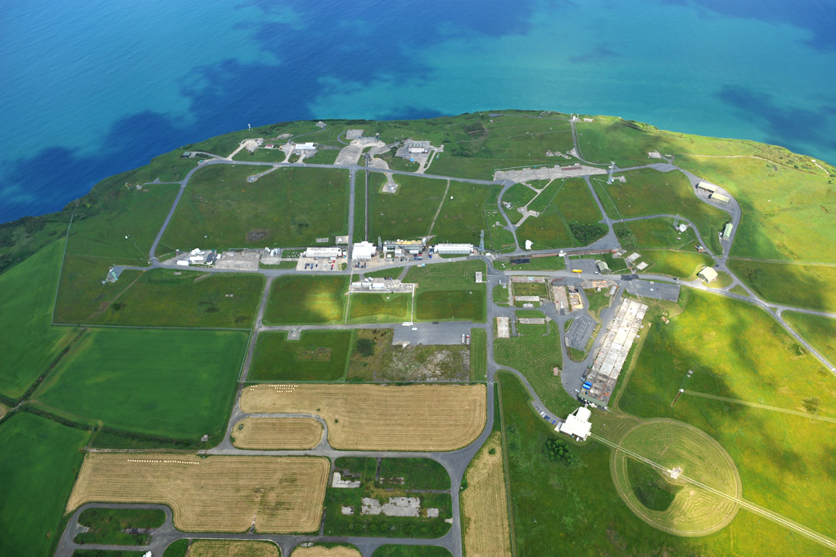
Figure 2 Aberporth Range head

Aberporth Range is predominantly an Air Range and is not accustom to providing a solution for land based weapon systems.
This report will look at the processes and procedures needed to De-risk land based Trials activity at Aberporth Range.

Aim of the Report

This report will investigate the feasibility of delivering a land base Trial at Aberporth Air Range. In order to de-risk the 81mm mortar firings at Aberporth a number of questions must be considered.
- Can this Activity be conducted on a different QinetiQ Range
- Dose the Aberporth Range Safety Case incorporate firing a land base weapon system.
  - Weapon Risk Analysis
  - Weapon Risk Failure Rate
- Is the Aberporth Trials documentation suitable to cover land based firings
  - Range Standing orders for the conduct of trials
  - Hazardous Activity Rick Assessment
  - Trials Safety certificate
  - Trials Specification
- Is the documentation transferable from land to air Ranges.
  - Range Standing orders for the conduct of Trials
  - Trials Test plan
- Dose the Range have enough space to in-compass, the mortar firing danger area and weapon impact area.
  - Joint service Publication (JSP)
  - Ministry of Defence (MOD) Mortar firing guide hand book.
  - QinetiQ safety trace construction tool
- Does the Range have facilities to store the mortars?
  - Weapon Storage Magazines, storage capacities and licences
  - Weapon Storage Magazines, location and proximity to Range Boundary
- Does the Range have correct facilities to dispose of any potential miss fired Mortars
  - Location of disposal burning pit and proximity to Range Boundary
- Has the Range the Instrumentation in place to conduct the Mortar firings.
  - Acoustic Triggers to activate a Direct Zero Time (DZT) to start all Range Instrumentation.
  - RADAR to Track and recorded Mortar trajectory
  - Hybrid Tracking Platforms (HTP) to provide optical trajectory
- Can the Range and its Danger Area contain the noise of the firing to limit noise pollution on the public and Range Workers.
  - Noise levels in the JSP standards and health and Safety (HSE) standards
  - Plan of the location of the noise monitor readings
- Environmental impact of the Mortar firings
  - Potential sea pollution from Mortar debris
  - Potential land pollution for explosive residue

Objectives of the Report

The measured out comes of the project are:-
- Prove that the Trial does not breach MOD noise regulations.
- Prove Multi Object Tracking Radar (MOTR) ability to track Mortars from launch at Aberporth.
- Prove/disprove the tracking capability of HTP’s utilising their compact tracking radar (CTR)
- Provide training opportunities across the Division for: Instrumentation Teams, Mortar firing team and Armoury/Explosive Team
- Enable the Range to augment its service to encompass Battery firing operations in conjunction with conducting its day to day service
- Relieve pressure on other Ranges that are struggling with their capacity to deliver the order book.

Structure of the Report

This report is structured in 5 main parts
- Introduction.
This will include a brief overview of the Range environment and why this investigation is being conducted.
- Literature Research.
The research will focus heavily on the MOD’s standards for operating ranges (JSP’s) and the Mod hand book for Mortar Firings and will give the reader an understanding of the documentation needed to deliver a Trial.
- Development Methodology.
The report is being developed using the systematic approach “DMAIC” which is a six sigma methodology. Define, Measure, Analyze, improve and control (DMAIC)
- Trials Design.
The will give the reader the understanding of the equipment and coordination needed to conduct a Range Trial following the MOD JSP standards.
- Findings, Recommendations and Reflections.
This section of the report will analyses the output from the investigation and recommend and improvement that could improve Trials delivery across different Ranges within the test Range environment

Research and Review of Literature

In order to conduct any Trials activity at any QinetiQ Range, there must be a documentation pack in place that consists of.
- Range Standing orders for the conduct of Trials. (RSO)
- Trials Specification (Air Range)
- Hazardous Activity Risk Assessment, (HARA).
- Trials safety certificate, (TSC).
- Trials Test plan (Land Range)

The Trial documentation pack is developed form the JSP standard.
JSP is the MOD’s safety management system for all UK Range’s there are under written by the secretary of state for defence. They apply to all Mod Ranges and provides direction on best practices to ensure that the risks associated with Mod Ranges safety are “as low as reasonably practicable” (ALARP) (2)

Organization of Trials Literature
Figure 3 Structure of Literature
The Range standing orders and Range safety case are formulated from the MOD JSP standards, as the image in figure 3 shows that information is then carried forward to develop the rest of the Trials documentation pack.

JSP Standards
JSP403 Volume I Part 1 (3) - The overarching policy which gives clear direction as to what must be followed in accordance with Legislation, Regulation, Direction, Instructions mandated by Defence or on Defence by Central Government.

JSP403 Volume 1 Part 2 (3)- Direction as to the implementation of the safe operation, use and maintenance of Defence Ranges in compliance with the policy set out in Part 1 of this JSP.

JSP403 Volume 2 (3) covers the design and construction of ranges and deals specifically with small arms, infantry and 40mm weapon systems ranges.

JSP402 Volume 2, (3) Chapter 23 covers all parameters of constructing a Mortar Range and the approved templates for the Weapon Danger Areas.

JSP402 Volume 2, (3) Chapter 31 covers the control of noise from small arms Ranges.

JSP403 Volume 3 (3) is in two parts. Part 1 covers the firing of weapon systems from fixed wing aircraft and helicopters on to MoD Ranges. It has introduced commonality into control systems, procedures and management. It also explains the terminology used in air-to-surface engagements. Part 2 details the policy and principles for the safety of surface-to-air weapon systems firing against air or surface targets on MoD Ranges.

JSP403 Volume 4 (3)covers the design and construction of demolition ranges and explosive ordnance disposal training areas, the clearance of ordnance from ranges and training areas, the safe use of ranges and training areas for demolitions and ordnance disposal training, and the safe use of explosives and pyrotechnics for battle simulation on ranges and training areas and safety of ranges and training areas used for demolitions and ordnance disposal training and for battle simulation.
JSP482 (3)Is the MOD explosives regulations for the safe storage and processing of ordinance, munitions and explosives.
JSP762 (3)Is the weapons and munitions through like capability safety management system.
The Control of Noise at Work Regulations 2005 (4)gives daily noise exposure to the public and working personnel, also gives guidance on noise control risk assessments.

QinetiQ Documentation
Range Standing orders for the conduct of Trials. (4) This outlines the rules and control measures for ensuring MOD Aberporth is operated in a safe and secure manner.
Trials Specification. (Air Range) (5) Details all parameters of the activity including customer deliverables, safety requirements the sequence of the firings and the roles and responsibilities of staff members during the activity.
Hazardous Activity Risk Assessment. (5) List all known risks associated with the task reduces them to ALARP
Trials safety certificate. (6) Issued by the Range safety committee after all the documentation has been review and the HARA has been passed by the Hazardous Activity Management Panel
Trials Test plan. (Land Range) (7) very similar to a Trail Specification but land Range has different roles and responsibilities.

Quotations

“JSP403 is designed to provide a comprehensive handbook covering safety on MoD Ranges. It provides legislation, regulation, policy, guidance and instructions on which the Services and Ministry of Defence civilian organisations and agencies can base the safe operation, maintenance and use of their ranges. There are currently four volumes issued and further volumes may be produced if required.” MOD (2)
“This JSP has been developed for use by Suitably Qualified and Experienced Personnel (SQEP) involved with Ranges Safety. It assumes that they will have a broad knowledge of Health and Safety Legislation. Simply following this JSP will not fulfil all your obligations arising from other legislation.” MOD (2)
“We first examined the measures the Services are already taking to mitigate the effects of noisy activities. We learned that steps have been taken, at an airfield where noise problems are particularly severe, to buy surrounding land to ensure that the areas most affected are not developed. This policy of sterilization can, in special cases, make a worthwhile contribution to the reduction of noise nuisance to the public; though it involves the acquisition of more defence land, this land can usually be productively used for agricultural purposes. Buffer Zones
We considered whether this policy might have wider applications. In particular, we had in mind the fact that the noise problem which already exists at firing ranges and training areas close to urban areas is likely to get worse as housing and other developments advance closer to the Service sites, even though the volume of noise may not increase. We hold very strongly that this is a matter which needs to be tackled now, and consider that if ‘buffer zones’ were introduced between Army sites where firing takes place and civilian developments, the worst features of this noise problem could be contained, and in some measure mitigated. We recognize that this poses problems for local authorities as well as the Ministry of Defence; we recommend that it should be tackled jointly, with give and take on both sides. Existing dispositions and problems of land acquisition make it unlikely that this policy can be universally applied, but we would propose its adoption wherever practicable.” Hon.Lord, Nugent of Guilford. (3)

Research Review Conclusion

The objectives of the literacy review where difficult to achieve. The MOD has a set of regulations which set the standards for all weapons testing within the United Kingdom. This means there is no other literacy for this type of testing which made compare or critical reviewing the information in the JSP’s impossible. The research element however was more attainable as there is a massive amount of information in the JSP which detail the process, procedures, construction and delivery of Trials activity. The research also involved observing mortar firings at MOD Pendine to ascertain the differences in the roles and responsibilities between the land and air domain. This also formed essential research in the equipment needed to conduct the Mortar firing and how the instrumentation on the Range is triggered.

Development Methodology

The Six Sigma DMAIC methodology can be thought of as a roadmap for problem solving. It defines 5 phase step which captures the entire formulation of the process. It is a proven methodology for improving system based processes as it allows the user to access and return to an appropriate phase in the methodology.

Research Flow Chart

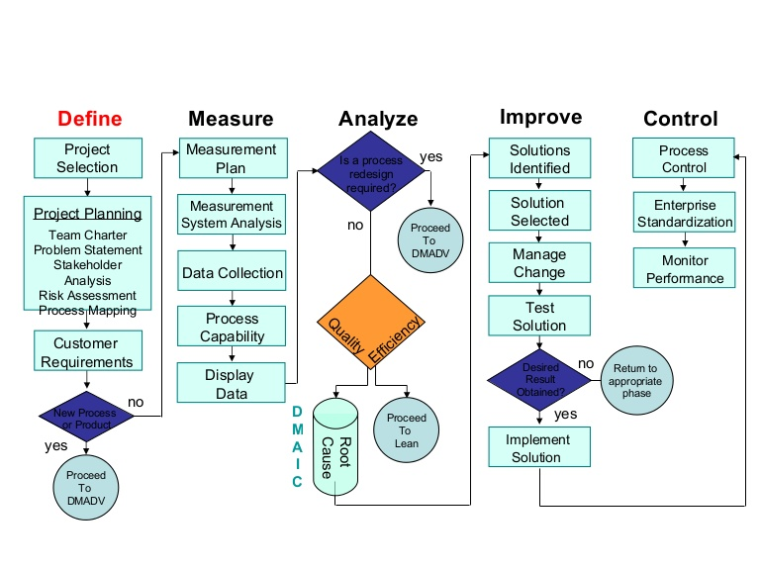Figure 4 DMAIC Flowchart

Research Process

The image in Figure 4 shows a flow chart of the DMAIC process. The various elements that make up the Range test can be detailed and formulated as it proceeds through lifecycle system.

- Define.
Deliver an understanding of the whole problem and establish whether there is a capability gap in the delivery of the activity
- Measure.
Ensure the Range as the correct skills required to complete the Activity
Ensure the concept stage has been fully understood and that all safety and environmental risk have been identified and all the hazards associated with the risk have been logged.
Ensure all documentation has been completed and reviewed at Hazardous activity Management (HAM) level.
Ensure the capabilities are in place to conduct the activity
- Analyze.
Ensure work breakdowns of the activities are in place.
Ensure risk mitigations plans are in place.
Agree monitoring and measurement procedures.
Draft Range Operational procedures
Draft disposal plan.
- Improve
Monitor testing to insure compliance and identify improvements.
Ensure environmental management plan is in place.
Ensure Range Operational procedures are in place.
- Control
Continue to monitor risk mitigations.
Continue to monitor environmental assessments.
Influence the planning process for improved performance.
Ensure waist is dispose of in accordance with the disposal plan.

The lifecycle we enable the project to be tracked through its various functional responsibilities and gate point. It will form a critical part of the project Gantt chart which can be found in Annex A.

Development Methodology Conclusion

DMAIC six sigma was chosen for this process as it is very customer driven, it addresses the entire process behind the system rather than just the final outcome. The process can also be considered to be proactive rather than reactive as it set out to determine how improvements can be made even before defects or shortcomings are found. However the process can sometime be drawn out and cause substantial cost to the business so much so that it could adversely affect profitability, in addition its customer focus could be taken to extremes and quality control may suffer as the company attempts to meet six sigma’s level of consumer satisfaction.
The methodology work particular well in the Design of the trial phase of the project. It enabled the project team to repeatedly analysis the processes involved and create workable solutions for any problem that arose. An example of this was the sensor flash detector which didn’t deliver the result required to measure the accuracy of the mortar. The DMAIC process allowed the project team to re-analysis the process and finds a solution whilst still planning the rest of the activity.

Design of the Trial

The aim of this trial is to fire up to 36 x 81mm L54 illuminating bombs at varying charge weights and elevations so the operators of the deployed radar systems and HTP's gain experience with tracking the 81mm mortar bombs.

Three locations where considered for the firings, as can be seen in figure 5 (10), the perpendicular coloured lines are the limit of the arcs of fire of the mortars. Lower C-Site was chosen as the preferred location as it is in a slight defilade and would offer the most protection against noise dissipation, it would also be the most convenient place for instrumentation to be deployed.

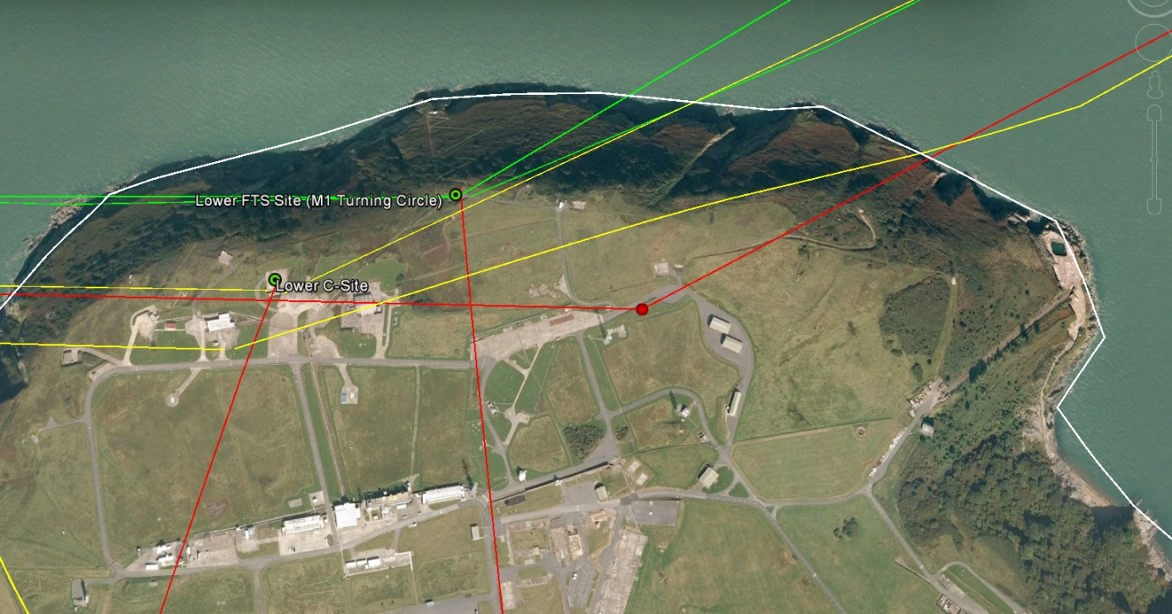
Figure 5 Mortar Firing Locations

Aberporth Range it operated differently to Pendine Range this is predominately because they have many different smaller firing range inside the Range boundary and fire small calibre weapons where at Aberporth we have one big firing Range and fire weapons with greater ballistic properties so the personnel have the same job titles but different responsibilities, in order to conduct the mortar firing the RSO’s for Aberporth would have to align with the RSO’s in Pendine, after several meeting with the Trial Safety Managers, (TSM) Range Operations Condolers (ROC) In Flight Safety Officers, (IFSO) Trials Conducting Officers, (TCO) and Trials planners, it was decided that the RSO’s could stay as they are, and all the instructions with roles and responsibilities for the mortar firing would be highlighted in the trials specification and trials test plan this would save a lot of time and energy as the RSO’s would have to be sent to the MOD for approval which could take several months. As Pendine Range had fired 81mm mortars before they agreed to supply the Range with the Trials spec, HARA and test plan. This is an ideal solution because they already have the expertise and experience in this field.
Once the documentation was formulated the Trial was presented to the QinetiQ Aberporth Hazardous Activity Management (HAM) Panel for review. The panel where happy with the routine of the Trial and the change in roles and responsibilities but insisted on two stipulations.

- Only 5 mortars are to be fired on the first sortie, the safety, trials and instrumentation team would then meet to analysis the results and implement any improvements.
- Noise meter readings would be taken and different location of the Range boundary and on the safety boat during the first firings to assess the potential of the firings beaching the MOD noise regulations.

The findings from the HAM panel formed part of the HARA and recourses where put in place to meet the two stipulations.
Once all the documentation was in place the firing order for the trial was also discussed with the instrumentation team to develop a plan which would give the Radars and HTP’s the best chance at tracking the mortars it was also designed to be the most efficient way so that the firing team only had to make minor adjustments to the mortar barrel positioning.
Serial | Charge | Degree ° | LOA  (°T)
1 | 6 | 50° | 020°
2 | 6 | 50° | 330°
3 | 3 | 55° | 330°
4 | 6 | 80° | 330°
5 | 6 | 50° | 360°
6 | 3 | 80° | 360°
7 | 6 | 80° | 360°
8 | 1 | 75° | 360°

Table 1 Firing Order

Table 1 show the firing order of the mortars for the day of the trial, the Line of Attack (LOA) is the line in degrees at which the mortars will be fired, the degrees column represents the angle of the barrel for each serial. The reason the table show eight serials but on 5 mortar are to be fired is to allow for different variation to be chosen if the instrumentation or weather preclude the firings.

Engineering

The engineering requirement for the trial cover all the hardware needed it also included applying to RAF regulators for the permissions to install a temporary firing battery on Aberporth Range head. The ADATS form 471 Engineering Appraisal Request (Annex B) gives the dimensions and location of all metallic objects being installed on the Range to allow the RAF to determine whether it will cause interference to the air surveillance Radars. A Weapons Configuration Change Proposal (WCCP) is also submitted to the Range engineering committee to highlight any issues which have not been considered. Below is the WCCP submitted to the Range.
Proposal Title: De-risking 81mm Mortar firing on C-site Aberporth |  |  | Reference:
Owning Facility or Project: De-risking 81mm Mortars |  |  | Proposer: Paul Cartwright
System Affected: There is the potential that all Range system could be affected as there will be mobile Radar the DRX-41320 CW Doppler Radar deployed on C-site. Other systems that will be directly affected by this activity are the Central timing unit (CTU) the range intercom system specifically rings 2 and the cabling infrastructure.
Sub-System/Assembly/Item:
Operational function of affected Items:
Is the modification a hardware change? | YES / NO | Will it be a new design? |  | YES / NO
Is the modification a software change? | YES / NO | In house design change? |  | YES / NO
Is the modification an infrastructure change? | YES / NO | Contractor design change? |  | YES / NO
What is the Change Category? | CAT A CAT B CAT C (tick as appropriate)
Does JSP 440/480 IT Security apply? | YES / NO | IDR required? |  | YES / NO
Does JSP 846 RSC/RSP safeguarding apply? | YES / NO | Do explosives regulations apply? |  | YES / NO
Is this a temporary installation? | YES / NO | Date for removal (temporary installation)
Does a local checklist apply, and if so, is it attached? | YES / N/A | Approval required by (date) |  | 26/10/2016
Reason for change:
To enable Aberporth Range to carry out this activity there will be equipment deployed form other Ranges.
From Pendine
Splinter camera shelter, located at lower C-Site
Mortar mount, located at lower C-Site
Flash detector, located around the Mortar barrel at lower C-site
SR Radars, located around the Mortar barrel on lower C-site and have a RADHAZ of 20m
To enable use to complete this activity the splinter camera shelter and DRX ISO container will require intercoms and a safety camera will need to be installed somewhere on c-site.
For the Range to get accurate timing for each firing a flash detector will be located around the mortar barrel on lower C-site.
Proposed solution (include details of regulatory compliance):

The instrumentation staff from Pendine will be housed in C-site block house and utilize the existing intercom.
For the DRX ISO container and splinter camera shelter intercoms will be installed using temporary connections from C-site block house.
A safety CCTV camera will be mounted to the railings on the eastern side of upper C-site and will use site cabling infrastructure to feed the image to optics.

The Range will use its own flash detector which will feed into the CTU using the existing cabling infrastructure this will be used to give the Range accurate timings for each firing.

All equipment will be operated with accordance of the operators risk assessments and work instruction, all of the deployable equipment will work independently and will not be connected to any system on the Range.

Safety, security and environmental considerations:

Safeguarding for the RADAR equipment would need to be considered.
The Range will carry out mutual interference checks in accordance with Trails Spec X1708, to confirm that the deployed instrumentation and Range systems don’t interfere with each other.
The new cabling will be installed to JSP440 and SDIP29/1 standard in accordance with Coordinating Installation Design Authority (CIDA).
Noise calculations have been done by the MET office and noise measurements will be taken at the fence line to confirm noise limits are met.
Supporting documentation (include regulatory documentation if required):
Range Standing order will be changed to incorporate the new procedures for the Mortar firings. The trial specification and test plan will be produced by the Trials Manager at Pendine.
The Range Cabling documentation IDP will be up-dated but is not submitted with this proposal.
Submitted with the CCP is a map of the proposed location for the equipment, the location of the flash detectors, SR RADARs and MV RADARs will change with each QE and LOA but they will not move from lower C-site.
Authority to submit for review (Facility Manager, Project Manager, Engineering Lead)
Name: Paul Cartwright Signed: Date: 06/08/2016
Proposal Title: De-risking 81mm Mortar firing on C-site Aberporth |  |  | Reference:

Source document: “Weapons Division – Air and Land Range Configuration Control Process” refers

Camera Shelter & Mortar Mount

The camera shelter would be supplied by Pendine Range it’s a standard mount used on previous mortar campaigns. Figure 5 is an illustration of the camera shelter.
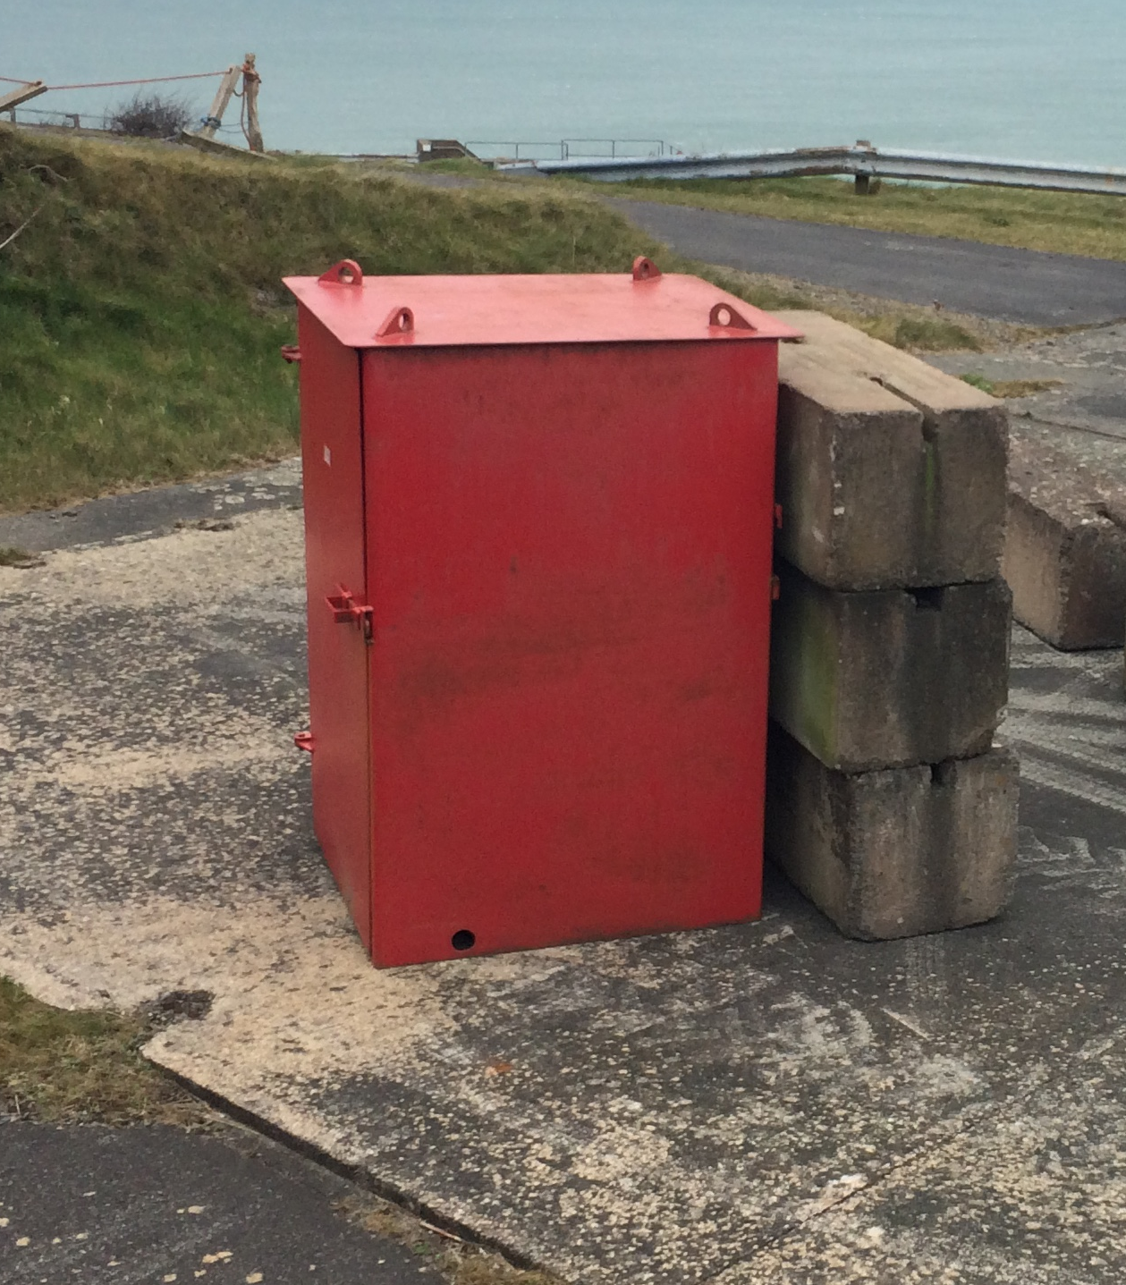
Figure 6 Camera Shelter

- The overall dimensions of the camera shelter
- 1520mm x 1830mm x 2400mm (H) (Forklift feet 200mm (H))
- Front – 1830mm x 2230mm (H) x 40mm
- Horizontal Front shutter – 1305mm x490mm (H)
- Sides – 1500mm x 2230mm (H) x 25mm
- Roof – 1520mm x 1830mm x 70mm
- Back – 25mmm thick
- Single door at back 25mm thick
- Floor – 25 mm thick
- Mass – 6 tones

The mortar mount or PUMM would be supplied by Pendine Range the PUMM as it implies houses the mortar firing tube and can be adjusted to achieve the desired firing parameters.

- Overall Dimensions
- Length 2130mm
- Breadth 1850mm
- Height 2000mm
- Weight 3.5 tones approximately
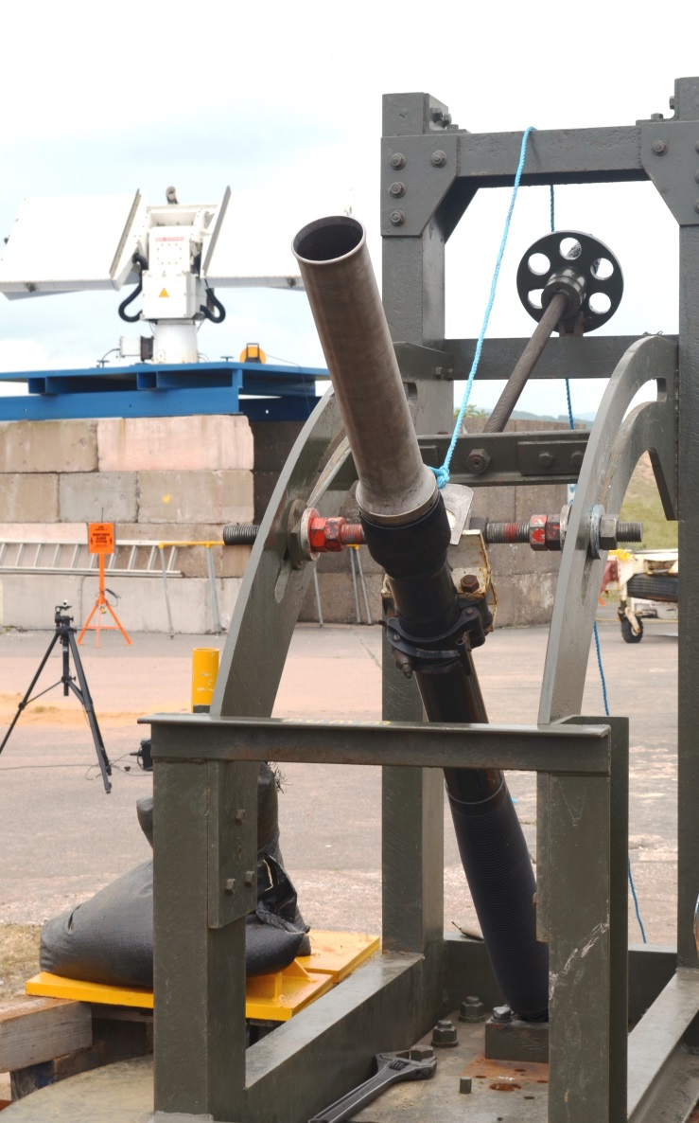
Figure 7 Mortar Mount
The image in figure 6 show the mortar mount with a mortar barrel fitted.

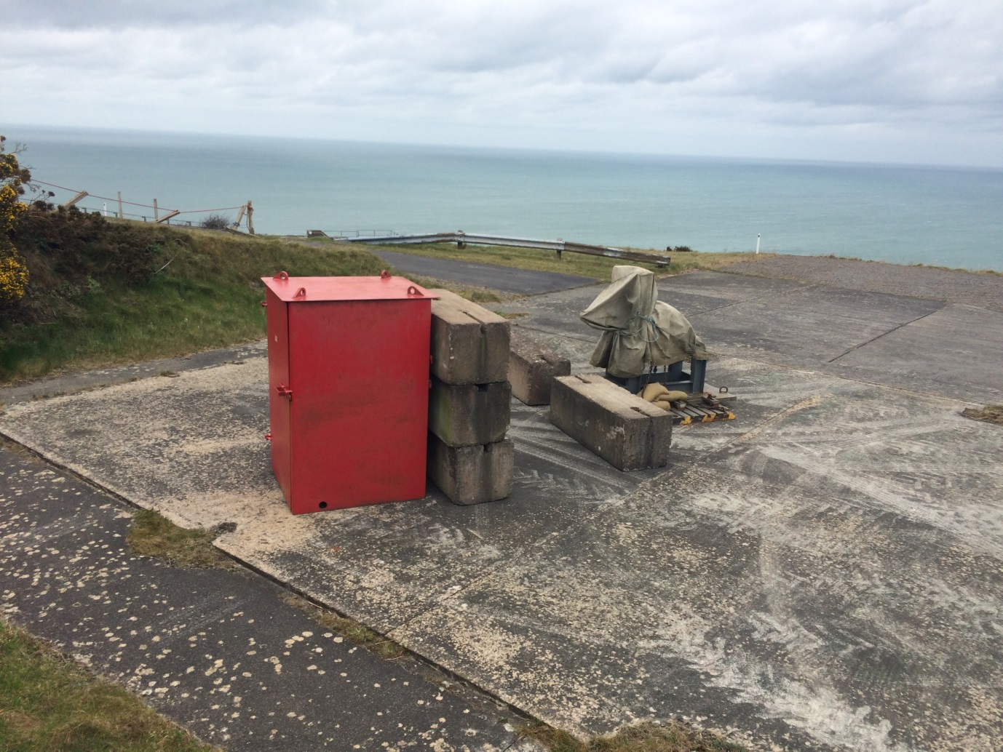
Figure 8 Shelter and PUMM C-Site

The shelter and PUMM are mounted in a configuration so that the Firing Officer (FO) in never in the line of sight of the mortar barrel, as shown in the image in figure 8, the shelter on the left is separated from the PUMM by a Pendine block wall. The FO dose not fully insert the mortar into the barrel in actually sits on a removable horseshoe shape piece of metal, the FO will the retreat inside the shelter and pull the firing cord which removes the horseshoe which allows the mortar to drop into the barrel. The mortar is initiated by striking a firing pin at the bottom of the barrel.

Noise Assessment

The acoustic properties of the mortar firing posed the greatest concern when conducting the firings. The JSP402 Volume 2, (3) Chapter 31 covers the control of noise from small arms Ranges.
JSP 403 Volume 2 Edition 3 Change 6, Chapter 31, paragraph 3106, quotes, (2) The Nugent Rule. This is a historical reference from the Defence Land Committee report 1971-73. By the right Hon.Lord, Nugent of Guilford.
“We first examined the measures the Services are already taking to mitigate the effects of noisy activities. We learned that steps have been taken, at an airfield where noise problems are particularly severe, to buy surrounding land to ensure that the areas most affected are not developed. This policy of sterilization can, in special cases, make a worthwhile contribution to the reduction of noise nuisance to the public; though it involves the acquisition of more defence land, this land can usually be productively used for agricultural purposes. Buffer Zones
We considered whether this policy might have wider applications. In particular, we had in mind the fact that the noise problem which already exists at firing ranges and training areas close to urban areas is likely to get worse as housing and other developments advance closer to the Service sites, even though the volume of noise may not increase. We hold very strongly that this is a matter which needs to be tackled now, and consider that if ‘buffer zones’ were introduced between Army sites where firing takes place and civilian developments, the worst features of this noise problem could be contained, and in some measure mitigated. We recognize that this poses problems for local authorities as well as the Ministry of Defence; we recommend that it should be tackled jointly, with give and take on both sides. Existing dispositions and problems of land acquisition make it unlikely that this policy can be universally applied, but we would propose its adoption wherever practicable.” Hon.Lord, Nugent of Guilford. (3)
The understanding that one can gather from this statement is distance is the most cost effective noise reduction measure available. As such the firing will take place at the furthest place available on the Range from the public. Below is an abstract from a table in JSP 403 Volume 2 Edition 3 Change 6, Chapter 36, page 7. (3)

10 | Mortar 81mm, QE45° L16/Charge 5 QE45° L16/Charge 5 QE45° | 183 187 183 | 11.0 3.0 2.7 | 186 -- | 8.0 -- | --- | --- | -182 183 | -3.6 2.9 | -173 170 | -4.0 4.4
Figure, 9 Mortar max noise

In Figure 2, column 3 shows the noise in dB from a mortar fired at an angle of 45⁰ with a charge 5 which is the maximum charge. The max noise level produced is potentially 187dB. If the sound of the mortar firing is represented by a point and sound is radiated equally from it in all directions. Every time the distance from a point source is doubled, the level decreases by 6dB. At point source, the mortar, which produces a level of 187dB at 10m, it will produce a level of 181dB at 20m. At a distance of 30m, the level will have fallen by 10dB. In other words, when the distance is trebled, the loudness is halved.
The minimum distance from the public to the firing point is 640 meters, calculation completed by the on-site Met office using the attenuation factor of 6 and 10 shows that the noise level would not be a hazard to the public.

Attenuation |  | Measurement at | Still Air Predictions at [metres] from mortar tube
Factor | Mic | 10 | 20 | 40 | 80 | 160 | 320 | 640
6 | 13 | 161.1 | 155.1 | 149.1 | 143.1 | 137.1 | 131.1 | 125.1
6 | 16 | 178.3 | 172.3 | 166.3 | 160.3 | 154.3 | 148.3 | 142.3
10 | 13 | 161.1 | 151.1 | 141.1 | 131.1 | 121.1 | 111.1 | 101.1
10 | 16 | 178.3 | 168.3 | 158.3 | 148.3 | 138.3 | 128.3 | 118.3
Figure 10, Table of dB measurements

The on-site Met office at Aberporth Met conducted a noise assessment and predicted the noise attenuation at different ranges around the mortar firing point.
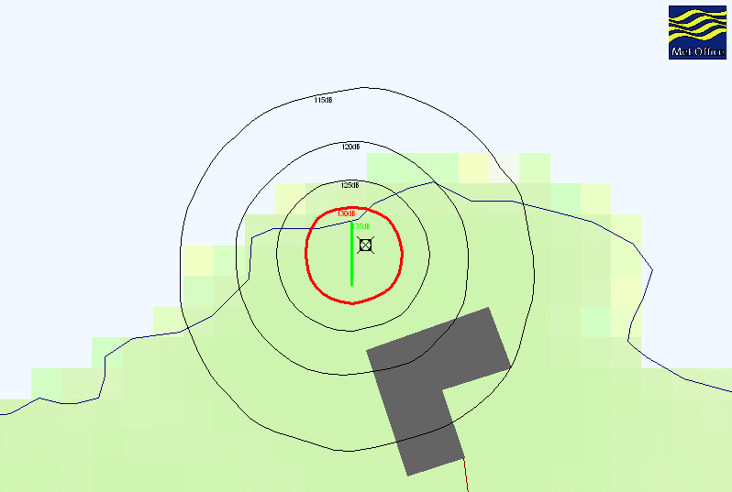
Figure 11 MET Noise Assessment
The image in figure 11 is a representation of the MET noise assessment with the cross representing the firing point, the rings radiating outward is the noise attenuation loss in dB To insure the Met prediction where correct and to satisfy the stipulations of the HAM panel noise meter reading would be taken at different location around the range boundary.
Figure 12 Noise Reading Locations
Noise measurement would be taken at various locations long the Range and Public boundary they would be conducted using a Casella Class 1 sound level meter which is has an event capture function which displayed the sound captured in dBs’ The measurement will be radioed back in real time to the Operations Room. Figure 13 show an image of the sound monitor.
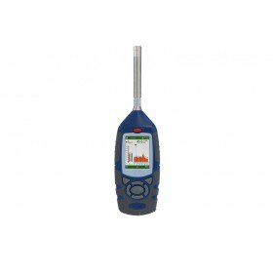
Figure 13 Sound Monitor

Firing Danger Area

The Range Danger area in compasses 6,500km² of sanitized air space, it is sanitized using a number of different Range assets, they consist of Sea surveillance RADAR, Range clearance vessels and land based spotters. The safety trace for the activity would be provided by the MOD JSP’s. The JSP contained safety traces for all types of mortar rounds for example, live, smoke, and training and illuminating, the safety trace gives the minimum and maximum firing distances for each type of round. After discussions with the safety team it was decided to use the largest safety trace this was for two reasons the first being safety, because the safety traces are built from previous firings and probability it was better to start off with the biggest trace and reduce it if needed. The second, if the Range could prove they could fire mortars at the longer distances this would be a valuable service to offer customers. Figure 14 shows the safety trace for 81mm mortar. Which can be found in JSP403 Volume 2 Edition 3 charge 6 Chapter 23, page 9 (1)
Figure 14, Mortar Safety trace.
The safety trace parameters are used to construct a safety trace on the Trials Control System (TCS) safety planning tool, the planning tool uses a standard reference point on the Range which aids in placing the safety trace very accurately in the Range Danger area.

81mm Mortars

The complete round consists of a body tube and tail cone assembly, an illuminate candle and
Parachute assembly, a time fuse with a built in expelling charge, a fin assembly with propellant charge, and an ignition cartridge with percussion primer. (11)The nose of the thin-walled steel tubing body is fitted with a steel adapter and internally threaded to accept the fuse. The tail cone may be internally or externally threaded, depending on the model. Models that are internally threaded require an adapter for attaching the fin assembly. The tail cone is attached to the body with four equally spaced shear pins. The illuminate assembly, consisting of a first-fire charge and an illuminate charge, is contained in a boxboard case and attached to the parachute with a 30-inch suspension line. Fin assembly attaches with or without adapter, depending upon design of the tail cone. (11)

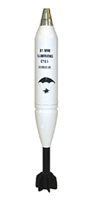
Figure 15 Illuminating Mortar
Figure 15 (12)is an image of an illuminating mortar; below is a list of the mortar
Properties (11).

- Length 24.735 inches
- Diameter (body) 81 mm
- Weight 10.1 pounds
- Filler Illuminating
- Filler weight 1.37 pounds
- Propellant M185
- Fuse Time, powder, M84A1
- Painting and markings White with black markings
- Nominal Maximum Range to Burst: 5,250 m (from L16A1 or similar mortars).
- Average Illuminating Intensity: 900,000 candelas for minimum of 35 s.

Mortars Storage

The Range has 4 purposes built explosive storage magazines which meet the standards set out in JSP 482: Ministry of Defense explosives regulations for the safe storage and processing of ordnance, munitions and explosives. (4) The Range also has a dedicated explosives team which look after the movement and handling of all ordinance from the Magazines to the Firing points.

Mortar Disposal

The Explosives team have a dedicated area on the Range head where miss fired or unused ordinance can be disposed of. The facility and disposal working instructions meet the standards in JSP 482: Ministry of Defense explosives regulations for the safe storage and processing of ordnance, munitions and explosives, (4) and JSP 762: Weapons and Munitions Through life Capability. (5)

Range Instrumentation

In order to review the instrumentation needed on the Mortar firing the project organized a trip Pendine Range. At the Range the Operational team had set up a mock firing point and went through a firing sequence. This experience was vital in enabling a Configuration Change Proposal (CCP) being written for Aberporth CCP/ABE636/81MM (6)CCP is located in Annex C. A CCP is used when there is a change in the configuration to any Range infrastructure or instrumentation. What was discovered from the visit is that 2 new intercoms needed installing on the firing point and also a safety camera to monitor the splinter cell which housed the firing officer. The Range would also need to install a flash detector which would feed into the Central Timing Unit (CTU) this would give a time stamp on the trials records at the point of launch. To track the mortars from launch to splash the Range would use the MOTR RADAR this is a mobile tracking RADAR capably of track 50 objects at a time with a very small cross sectional area. The Range would also use Hybrid Tracking Platforms (HTP) they are optical cameras capable of view tracked assets at up to 40km from the Range head. All the other equipment needed for the trial would be supplied by Pendine Range.

Main Sequencer Unit MSU

The MSU provide a means to synchronise a trial in 0.1 second intervals by switching instrumentation on and off at preselected time. These times can be anywhere between -9 hours 59 minutes 59seconds 9 tenths and +9hours 59 minutes 59 seconds 9 tenths. It consists of 120 general output channels that can be switched on and off at any time during the sequence in 1.0 second steps. For the purpose of the firing lines the output channels can be considered as two isolated banks of 60 channels working in tandem. The firing line circuit is wired through two channels, one from each isolated bank. All outputs are programmed on the IBM computer terminal prior to the trial the Flash detector would form one of the inputs channels and trigger a Data Zero Time (DZT) at the point of firing.

Sensors

The Sensor utilized for the Trial would be a type 726 flash detector it provides an output signal in response to a brief light pulse, this can be used for the detection of muzzle flash, explosion or other similar brief events, which gives accurate projectile launch time or time of flight to target. The flash detector outputs TTL via a BNC connector which connects to the Range MSU system. The MSU will use the TTL output to trigger a DZT to activate other instrumentation across the Range. This would be critical for the Hybrid Tracking Platform as they use the DZT to trigger a Pre-Determined Trajectory PDT.
The flash detector is mounted on a photographic tripod and placed in a suitable location next to the mortar barrel insuring that it is not facing the sun as this can trigger un-wanted events. Data sheet can be found in annex b. Figure 16 is an image of the Flash detector on the tripod.
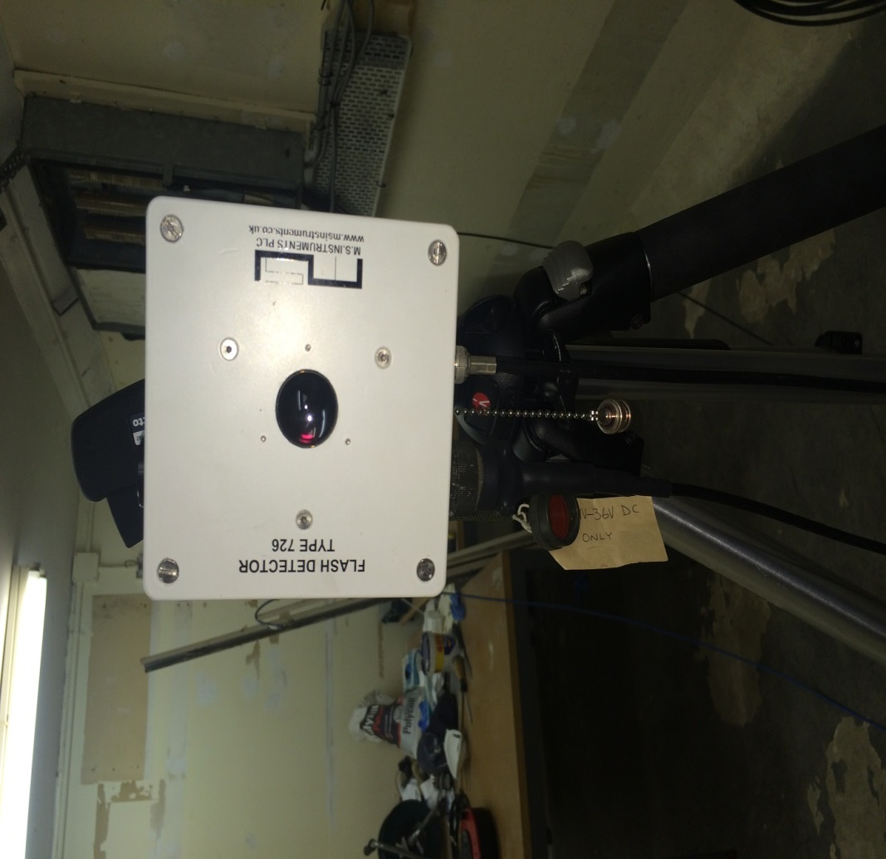
Figure 16 Flash Detector

TCS

The Trials control system (TCS) is used to provide a controlled safe environment in which to conduct trials, the safe environment is achieved by utilizing a number of interlinked sub-systems. They include sea surveillance, tracking radar, Hybrid Tracking Platform and safety related traces and maps. The information is correlated by the Configuration management and control (CMC) workstation and sent out to work stations that are used by the in flight Safety Officer and National Air Traffic Controllers.
Figure 17 shows a system diagram of how the TCS connects to its sub-systems (7)
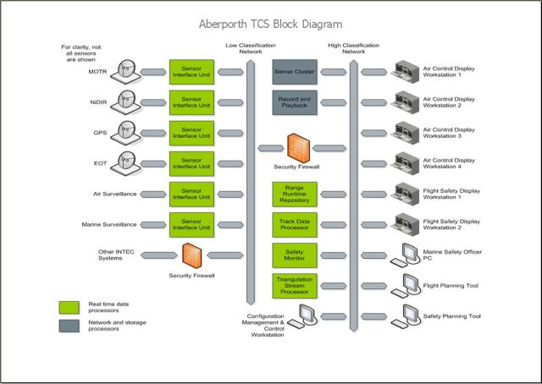
Figure 17 TCS System Diagram
The IFSO uses a function on the TCS to insert the parameters of the safety trace on to the TCS system. The TCS can then be configured to give alarm notifications using Radar data if any of the safety trace parameters are breached.

HTPI
The HTP provides a highly capable, dynamic and precise auto tracking capability, facilitating the capture of highly accurate data in a multitude of scenarios. They have an integrated video tracker for optical auto acquisition and tracking and provide highly accurate time-space-position information which can then be passed to the TCS. For the purpose of this trials activity the HTP’s would look in on firings to confirm splash position, and to improve resilience by gaining experience at tracking mortar rounds with Compact Tracking Radar (CTR). They will use an output from the MSU to trigger the PDT on the system this will give them an accurate start point on the firings. The image in Figure 18 shows an HTP at one of the observation points at Aberporth.
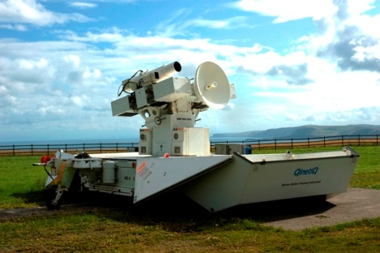
Figure 18 Highbred Tracking Platform

Radar
The Aberporth Range currently uses one Multiple Object Tracking Radar (MOTR) operating in NATO G Band and one NIDIR Single Object Tracking Radar operating in NATO I Band as the tracking sources for both real-time trials safety control and TSPI data gathering purposes. The Radars use the DZT function from the MSU to give them an accurate records start point. The Mortar firings would also be a test of tracking capability that will give the Range confidence that customer requirements could be delivered by the Radars. Figure 19 is an image of the MOTR at Aberporth.

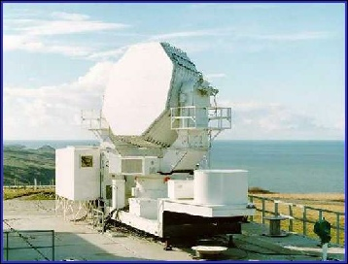
Figure 19 MOTR

81mm Mortar Testing

A week before the testing was due to begin the Pendine TCO and Aberporth TCO ran through a firing rehearsal to confirm the firing sequence of events for the Trial was correct. The active participant in the activity then joined the TCO’s for a complete rehearsal of the firing sequence plus miss fire drills. The instrumentation team also tested the Flash detector and confirmed it was triggering the correct events in the trial sequence.
The first five mortars would be fired as per serial 1 LOA 020° charge 6, as in Table 1 page 16 of the report,
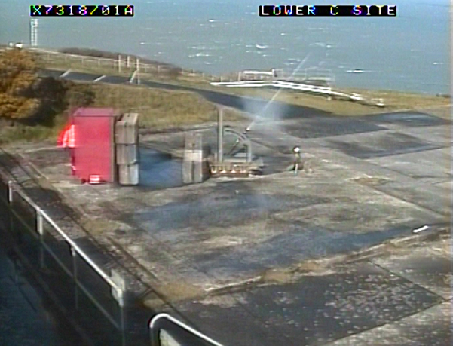
Figure 20 Mortar firing
The first of five mortar rounds was fired successful, the tracking radar acquired it from launch to flair out, and figure 20 is an image from the first mortar firing.
The flash detector had triggered and raised an event on the MSU but had not triggered the PDT on the HTP’s; the HTP has slaved to the tracking radar to acquire the mortar. The Instrumentation and trials team decided to carry on with the sortie and fired the remaining 4 mortars. On the 3 firing the flash detector became un-serviceable and would not respond to any light changes. On investigation it was found that the light sensor was outputting 4.8volts for 3 microseconds, the distance from the sensor to the MSU was approximately 480meters the signal was not off a sufficient load to trigger the relay at the MSU end of the circuit, for the next sortie of the firings a different solution would need to be found this is a good example of the DAMIC process in action as it allows for the process to be analysed at any point and re –worked in needed.
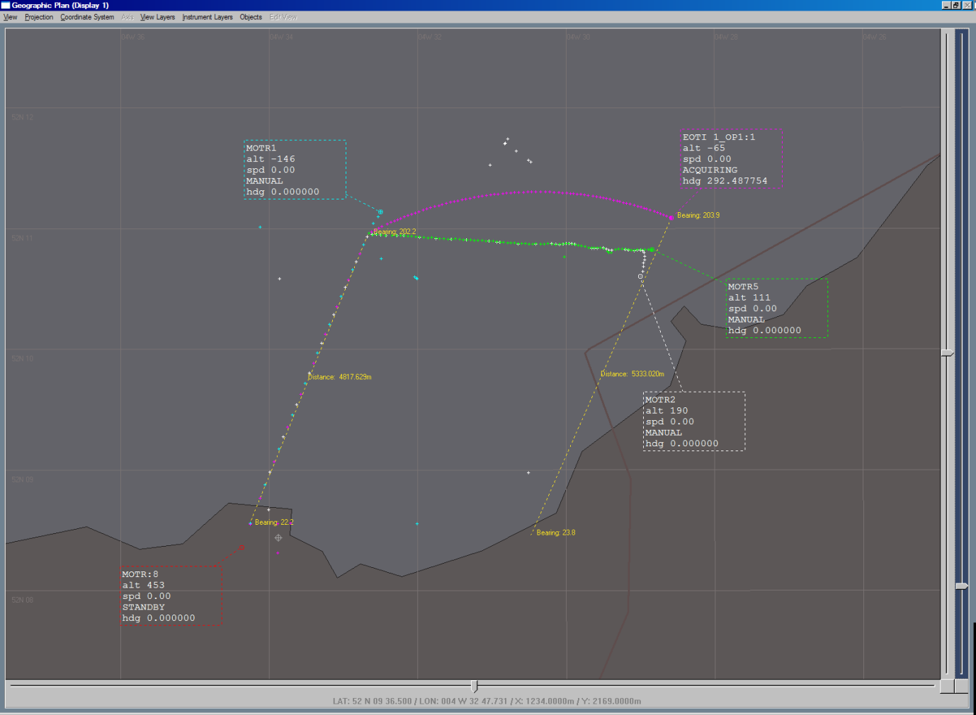
Figure 21 TCS Display
The first sortie had mixed results for the instrumentation section. The Radars successfully tracked all five mortars from launch to flair out the HTP’s had slaved to the radars on the first three firings but where able to track the last two using their own PDT. The image in figure 21 is a screen shot taken from the Trials Control System. The MOTR1 track on a bearing of 22.2° is the track of the mortar from launch to flair activation. MOTR2, 5 and EOTI1then tracked the flair and parachute as it drifted in an easterly direction. The issues with the flash detector had limited the data capture capability of the HTP’s as they were having to estimate the first four seconds of flight which when considered that the mortars travel at approx. 225meters per second on a full charge (13) the mortar would be 1000 meters away before the HTP’s acquired it. The flash detector would be critical in triggering the PDT to give the HTP’s an accurate launch time.

On the day of testing the MET office constructed and acoustic plot calculated using the wind conditions and explosive properties of the mortars.

Acoustic Plot For Aberporth (Model Run 1202)
Valid From: 14/03/2017 1030 Z |  |  | Valid To: 14/03/2017 1430 Z
Firing Point: C-SITE LOWER |  | Easting: 224146 |  | Northing: 252425
Source Name: TNT |  | Weight: 0.14kg |  | Height Above Firing Point: 1m
Forecaster: andrew.hobson |  |  | Issued at: 14/03/2017 0924 Z
E223002 N253187 | Scale 1:10000 | E225290 N253187
E223002 N251663 | Grid Spacing: 5000m | E225290 N251663

Monitor Points
Name | Easting |  | Northing |  | DB Level
PF1 | 223792 |  | 252221 |  | 121.33
FPC Fence Closest | 224137 |  | 252021 |  | 120.15
PF14 | 224147 |  | 251956 |  | 117.81
PF6 | 223910 |  | 251995 |  | 117.74
FPC MoD Bdy Closest | 223689 |  | 251831 |  | 113.66
PF31 | 224465 |  | 251590 |  | 110.8
BDY2 | 224452 |  | 251490 |  | 109.92
PF37 | 224607 |  | 251576 |  | 109.75
PF40 | 224641 |  | 251497 |  | 109.05
Figure 22 MET Data 14/03/2017

The met office predicted the noise level at the closest MET boundary to be 113.66dB. The actual noise readings take on the day of the firings can be seen in figure 22.
Figure 23 Noise Reading Mortar Firings
The noise levels readings on the day were lower than what the MET had predicted. The prediction tool does not take into consideration the undulations in the landscape and that the firing point is in a defilade which offers some nature noise absorption. This noise figure at the closest public exposure point is 35dB lower than the HSE guidance in the Control of noise at work regulations 2005 (4) this was a real positive for the firings as the noise limits where one of the major concerns and measurable outputs of the testing.
The trial configuration was also deemed as a success with the amalgamated of roles from the Land and Air Ranges combining with praiseworthy collaboration. The trial was run as a battery firing with the overall command given to the TCO on the launcher area. The second TCO acted as safety coordinator controlling movement on the Range head and insuring the Range Air and sea space remained clear for the firings.

Flash Detector Improvements

The issues with the flash detector would need to be rectified before the next sortie. The solution would be to find a way of holding the output channel closed once the flash detector had activated. The most time and cost effective method would be to use a relay, this would be activated by the flash detector and hold the line high long enough to trigger the HTP PDT.
There was not much time to conduct a full research review as the next mortar sortie had been scheduled for seven days after the first and could not be moved without financial consequences.
The relay chosen for the task was an RS product 291-9704 (18) data sheet is in Annex D, the main reasons being it was held in the stores and work with 3.7 -10 Volt input.
The circuitry would be fairly simple in design with the input connected to one side of the relay and the output connected to the other side. It was decided however to construct an interface box that could be used with multiple inputs in case more sensors needed to be added to the trial. Three of the outputs would be held normally closed meaning it takes an input signal to open the contact on the relay and three would be held normally open which takes an input signal to close the relay.

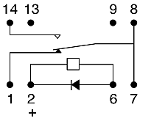
Figure 24 Relay Circuit
The image in figure 24 (18) is the internal circuitry of the relay, the input is connected to pin 2, the three output will be connected to pins 1 and 8 to hold the channel normally closed, the other three outputs will be connected to pins 14 and 8 to hold the channel normally open. The images in figures 25 (20) and 26 (20)show the construction of the sensor interface box.
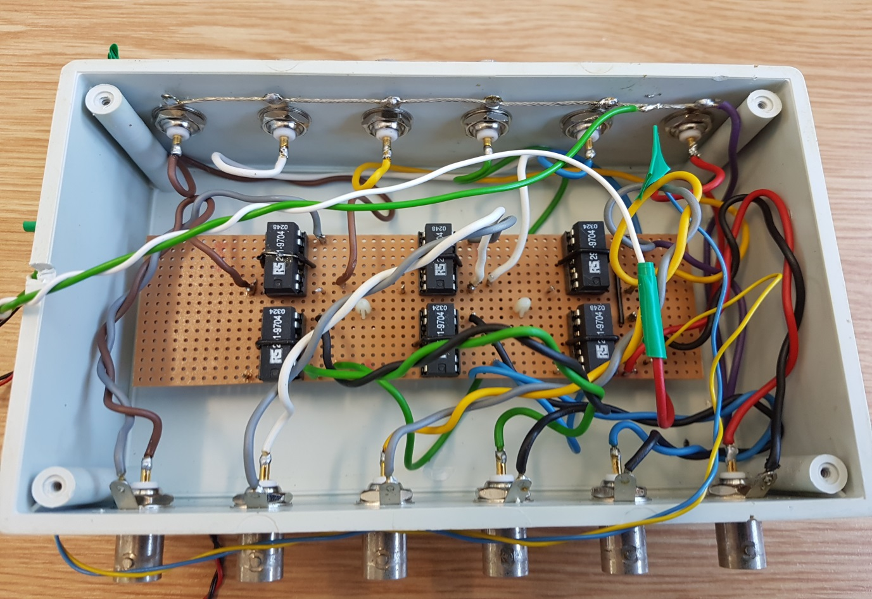
Figure 25 Sensor Box PCB
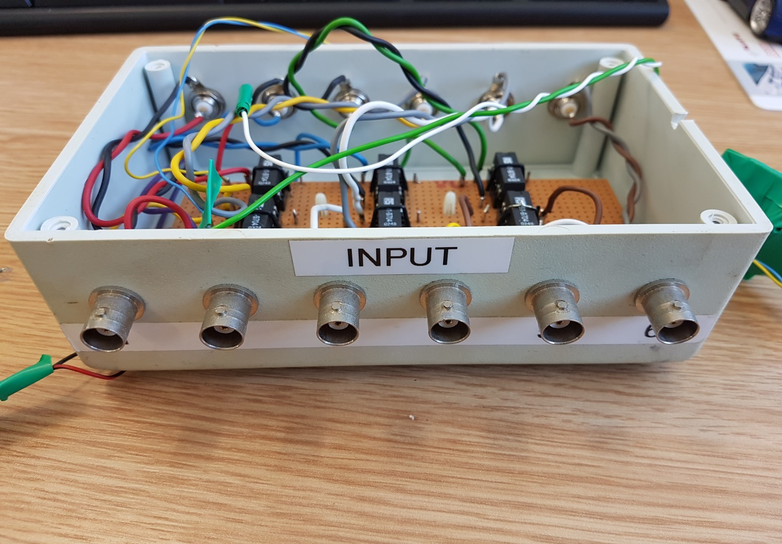
Figure 26 Sensor Box Inputs
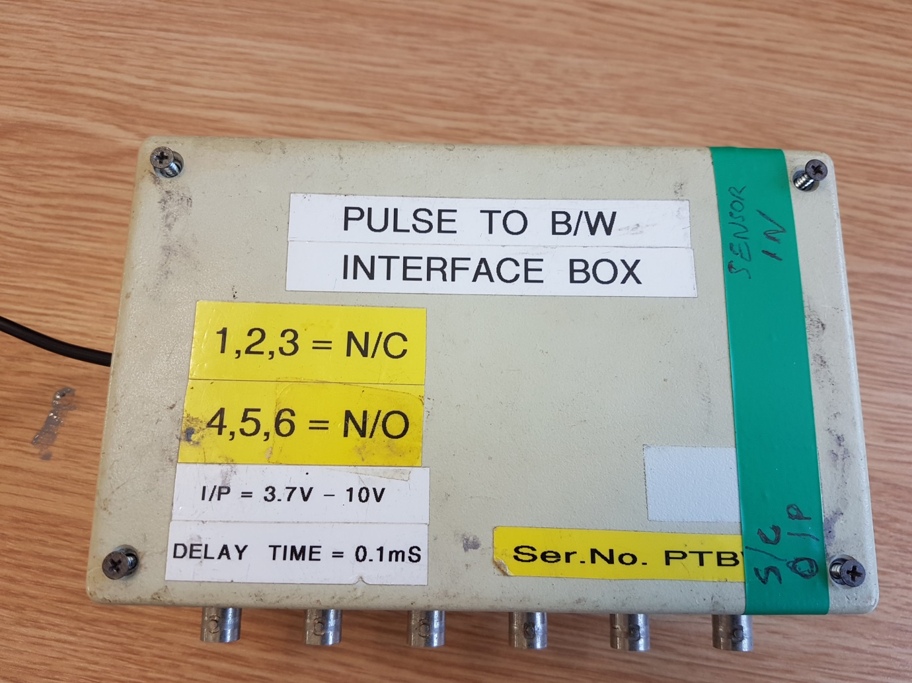
Figure 27 Sensor Box Front Plate
The interface box was bench tested and he relays triggered as expected. It had taken only three days to design and construct. The image in figure 27 (20) show the sensor box fully labelled with the 2 different types of output. The interface was connected to the flash detector and a field test was conducted using the flash from a camera with the HTP’s connected to the MSU. The results where as expected the flash detector triggered the interface box which held the channel closed long enough to trigger a PDT for the HTP’s.

81mm Firings Sortie 2

The Range convened a Trials Readiness Review (TRR) to allow every participant in the trial activity to highlight and concerns or to suggest where improvements could be made, the only issues raised was the flash detector problem which had now been rectified.
The plan for sortie two was simple fire as many mortars as was possible in the 3 hour Range slot to gather as much information and data as possible. The sortie would continue with the serials in Table 1. Serial 1 had been completed in the first sortie the instrumentation preference was to fire 5 mortars for each of the remaining serials.
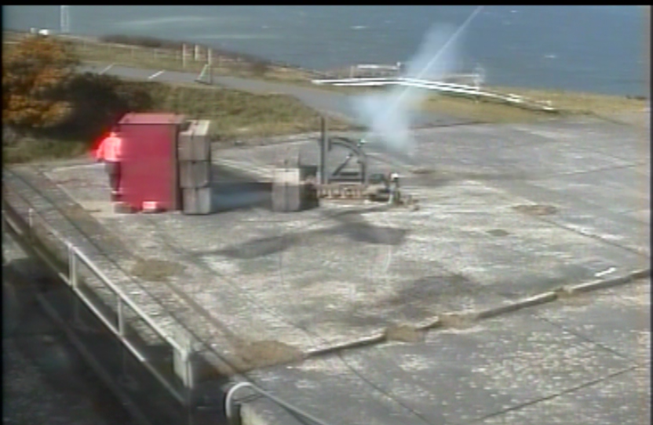
Figure 28 Mortar Firing S2
The image in Figure 28 (21) shows the first mortar fired in sortie 2 of the campaign, the flash detector can be seen on the right of the barrel it is also sporting a front cover which stops ambient light from affecting the results.
The sortie was completed with 30 mortars fired in total, the flash detector work throughout and gave the HTP’s the PDT they needed to gather data from launch to parachute splash.
The process of running the Trial as a firing battery work faultlessly, the safety TCO was able to advise the firing TCO on movements of the next mortar batch this is not normally done on the land Ranges. The Firing TCO normally has to stop the trial and request more munitions this is to limit the amount of explosive on a Range at any one time. Being able to control this speed up the firing process making it more efficient.
The data from the Radars and HTP’s was sent to the data analysis team to evaluate the accuracy of and performance of the systems. Data Centre is able to compare the data and display it the 3D models of in graphical representation.

Figure 29 Sortie 1 Run C

The image in Figure 29 (22) is a graphical illustration of the Radar and HTP data. The HTP data is in red, and as it can be seen on the graph the HTP does not achieve staple tracking of the mortar until the mortar was 2000 meters away from the launch point this data is from sortie 1 firing 3 Run C when the flash detector was not triggering the PDT. In contrast it can be seen that the MOTR Radar achieve stable tracking from launch all the way until the parachute splashed in the sea.
This mean from a customer perspective they would only receive estimated data from the launch point to the 2000 meter mark.

Figure 30 Sortie 2 Run B
The image in Figure 30 is a graphical representation of the data from Rum B in Sortie 2. The HTP is represented by the red data line which has dramatically improved from the data in Figure 29. This is attributed to the Flash detector triggering the PDT. The PDT can be used an automatic start for the HTP’s meaning the operator only need to look at the top of the mortar barrel and the system will auto start recording and slave to the direction of the mortar travel. The direction of mortar travel is already pre-determined in the serial table and in known as the LOA.

Findings

The intention of this report was to look at the proposal of completing land based weapon activity at an air Range. The process for firing the mortars was already in place on Land Ranges and the major objective of the report was to see if that process could be transferable to an Air Range with the minimal disturbance to the trials project team and trials safety team. The result where every interesting the JSP’s guided me towards using the combination of documentation meaning that the roles and responsibilities for the relevant trials participants would change instead of the range standing orders for the conduct of trials. This saved a massive amount of time and resources by not having to go to the MOD for authority to change the Range standing orders. The trial was still required to undergo the Hazardous Activity Management process which meant identifying all hazard relating to firing the mortars then identifying all the risk associated with the hazard. The hazard where then lowered to ALARP and submitted along with the test plan to the HAM panel. They did identify some issues with the firings and put in a couple of mitigation. The first being only five mortars would be fired on the first sortie this would then allow the trials team to evaluated the outcomes without wasting mortars. The second was that noise meter reading would be taken at different locations along the Range and public boundary and the readings would be reported back to the TCO in real time so the firings could be halted if the noise breached the MOD regulations. Once the process as passed by the HAM panel the test plan written by myself assisted by Stuart Beynon (Pendine TCO) was sent out for approval by all the trial participants.
It was suggested by me that the 81mm mortar firings would be conducted as a battery type firing with the responsibility for the firings given to the Firing TCO from Pendine and the safety parameters of the trial like safety trace clearance and air space clearance given to the TCO at Aberporth. The Aberporth TCO would also be responsible for coordinating all instrumentation on the Range and insuring that it was all serviceable. During the firings the Aberporth TCO would simple give the Pendine TCO a clear to Fire call and that executive command would stay active until order otherwise by the TCO. This new working process was accepted by all the Range Sections and the range safety team and work extremely well.
The main objective of the firings was to prove that the tracking radars and HTP’s could be used as viable tracking solutions for trials delivery and the data produced by both section could become a valuable customer deliverable. The Radar section had no problems tracking the mortars even when the flash detector become unserviceable and proved to be a reliable accusation source for the HTP’s. The HPT’s found it nearly impossible to track the mortars without the intervention of the flash detector providing Records start predetermined Trajectory Point. This was a really big issue at the start of the campaign as the flash detector was not outputting enough of a load to trigger the relay on the Main Sequencer unit which outputs the pulse needed by the HTP’s. The solution had to be made within seven day as this was the time programmed between each sortie and moving this programed slot could have had large cost implications. It was decided the simplest and most cost effective way to achieve this was to use a relay and hold the channel closed for a long enough length of time that would trigger the relay on the MSU, because of the sort time scale it was decided to use a relay that was already in the stores as this would save time waiting for deliveries. The circuit would use the output from the flash detector which would trigger the relay, with the relay closed the line would hold a short and the output from the relay would be connected to the input of the MSU. The MSU would then short the output channel connected to the HTP’s, which triggers the PDT. The flash detector had not worked correctly during the first sortie and it was not fully understood that the fault was so it was decided that an interface box would be constructed using the relays so if needed different sensor could be used to compare outputs. The interface box would have three normally closed outputs and three normally open outputs. The flash detector uses a normally open output which is operated like a switch. If the flash detector activates it closes the contact on the relay once the input pules finishes the relay contact re-opens. To ensure the interface box and flash detector where working correctly they were tested using a controlled lighting flash from a high speed camera, The HTP’s were also included in the testing. The interface box and detector worked as expected triggering the PDT on the HTP’s. It was discovered however that the ambient light from the room was giving false reading, to solve this a hood was constructed out of cardboard, it was a crude solution but work really well.
The second sortie concluded with 30 mortars being fired with the flash detector triggering the HTP PDT on every run. The data form the radars and HTP’s was sent for analysis and reviled that both systems could be used for delivering data to the precise customer requirements.
This activity has also given the instrumentation, explosive and magazine sections the opportunity to train operators across different sites.
The other main objective was to prove that the firing of mortars would not breach the MOD noise standards for the ranges. This was done by the MET office conducting a pre-trial noise assessment based on the explosive properties of the mortars and the weather conditions namely the wind direction on the day of the firings. The points created by the MET office where then located on a map and real time noise monitoring was conducted on the day of the firings. It was found that the noise reading where between 20 and 40dB lower than what the MET had predicted and what the Mod had stated in the JSP 403 (11) for the mortar firings. The results were attributed to the geography of the land and the firing point being in a defilade. It proves the selection for the firing point at the start of the project was correct.

Conclusion

The project delivered everything it set out to achieve.
Measured Objectives
- Prove that the Trial does not breach MOD noise regulations.
- This was proven with 35 mortars fired and 35 noise readings being taken the noise limit was not breached in fact the closest noise reading was still 15dB under the limit.
- Prove Multi Object Tracking Radar (MOTR) ability to track Mortars from launch at ABE.
- The tracking Radar preformed impeccably, MOTR was able to track the mortars from launch through to parachute splash. The data produced was of such quality it would be deliverable to customers.
- Prove/disprove the tracking capability of HTP’s utilising their compact tracking radar (CTR)
- The HTP’s where able to track the mortars once they had been acquired but they found it difficult to acquire without the input of the flash detector, with practice the HTP operators believe they would be able to acquire using their own optics.
- Provide training opportunities across the Division for: Instrumentation Teams, Mortar firing team and Armoury/Explosive Team
- This campaign provided training for all the teams involved in the firings. It will give the company greater resilience in training facilities across the division
- Enable the Range to augment its service to encompass Battery firing operations in conjunction with conducting its day to day service.
- The firings have proven that the Range can operate multiple activities in different locations within the Range air space, with more firings comes more confidence that the mortars will operate in the Range danger area.
- Relieve pressure on other Ranges that are struggling with their capacity to deliver the order book.
- The Range has now proven that the capability can be delivered at Aberporth. This will give the division the opportunity to spread the work load across the Range capabilities and ensure that customer orders are delivered.

Recommendations

The first improvement I would suggest to QinetiQ is to standardize the information in the current Trials and test plans. The roles are similar in both documents but the responsibilities are very different. The JSP’s do give guidance in this area but it’s very much up to the interpretation of the site writing the plans it’s also being done under the mentality of “that’s what we have always done” if there was one standard plan with standard roles and responsibilities it would enable any Trials activity to in theory be conducted on any Range with and Operators.
This was the first time i had taken a Trial to the HAM panel and found it as an extremely positive process. It draws in the expertise from across the business and using the experiences within the industry they were able to add a different perspective to the firings, suggesting different approaches to reduce the risk associated with the activity. I would recommend changing the non-trials Risk assessment policy to follow the HAM process. It may take more time and recourses but once the back bone of risk is captured it would only be new risk that would need to follow the process.
The instrumentation section would benefit from investment in the form of an acoustic trigger or small tracking radar system which gives a more accurate launch time than the flash detector. The flash detector did work as expected after the improvements were made to the circuity and lens cover but if the Range wanted to fire from a different battery position the sun may interfere more with the sensor than it did on this campaign.
The positions of the HTP’s could be reconsidered, currently they are located around Cardigan bay with the furthest being in New Quay approximately 14Km from the Range head, this is an ideal location for Trials conducted in the middle of the bay but not for Range head launched munitions which at most travel 7Km. It would be beneficial for customer deliverables and training that two of even three HTP system where placed on the Range Head. I believe it would also give them greater capacity in using there on board radar as a tracking source.

Reflections

The process of how a trial is taken for a concept to actually delivering it on Range was all new to me. I was not aware the project planning team use the DAMIC six sigma process to coordinate all aspects of the activity and deliver it through its life cycle. The process is very robust but I found at times that there was double handed work happening as different staff where trying to achieve the same goals but where not communicating with each other. I think this is an issue across the whole company not just the trial delivery team. The Ham process at first seemed to be very daunting prospect in that you were taking an activity to be scrutinised by the most senior engineers across the business, however this turn out not to be the case, it was in my mind an extremely positive process with lots of improvement ideas being suggested for the mortar firings. The question off communications came up again when the two site Pendine and Aberporth started organizing the delivery of the Engineering hardware no one wanted to take the responsibility of having the Camera shelter and MORT mount delivered, in the end it took some organization form myself and calling the HTP section at Aberporth as they have HGV drivers and transport capable of carrying the loads. I think if there was a customer involved in the activity and not a QinetiQ driven activity the problem would not have arisen as there would be no issues with cost.
Overall this project has given me a tremendous amount of new knowledge and experience in trials development and delivery it has also developed good working relationships across the different sites and the division. If someone was to ask me to conduct a project like this again I would jump at the change, however I would not choose it to be a college project as I had a considerable amount of trouble on what information I could and could not put in the report. Also the Trials scheduling process on the Ranges is every fluid and can change on an hour by hour basses this made it very difficult to follow a Gantt chart and the project time line.

Abbreviations and Acronyms

MOD Ministry of Defense
JSP Joint Service Publications
TSC Trials Safety Certificate
HARA Hazardous Activity Risk Assessment
RSO Range Standing Orders
MOTR Multiple Optical Tracking Radar
HTP Hybrid Tracking Platform
CTR Compact Tracking Radar
TSM Trials Safety Manager
ROC Range Operations Controller
TCS Trial Control System
CCP Configuration Change Proposal
MSU Main Sequencer Unit
DZT Date Zero Time
PDT Pre-Determined Trajectory
CMC Configuration Management Control
IFSO In-Flight Safety Officer
TCO Trials Conducting Officer

Works Cited

1. QinetiQ. Nucleus plus. QinetiQ. [Online] QinetiQ. http://whatwedo.plus.qinetiq.com/MS/MSSites/ABE/abe_site/Pages/Our-Site.aspx.
2. MOD. JSP 403. JSP 403 Volume 1 Part 1. 2015, p. ii.
3. —. Joint Service Publication. s.l. : Ministry of Defence, 11 January 2017. JSP Collection.
4. Archives, A The National. Legislation.gov.uk. The Control of Noise at Wrok Regulations 2005. [Online] 2005. [Cited: 2 May 2017.] http://www.legislation.gov.uk/uksi/2005/1643/regulation/2/made. 1643.
5. Sellwood, Rik. Range Standing Orders. Range Standing Orders for the Conduct of Trials. Aberporth : QinetiQ, 2016.
6. Beverley Richards, Paul Cartwright. Trials Specification. 81mm Mortar Trial Specification. Aberporth : QinetiQ, 2016.
7. Jones, Marc. Trials Safety Certificate. 81mm Trials Certificate. Aberporth : QinetiQ, 2016.
8. Stuart Beynon, Paul Cartwright. Trials Test Plan. 81mm Mortar test plan. Pendine : QinetiQ, 2016.
9. JSP 403, Volume 2, Edition 3, Charge 6, Chapter 31, Paragraph3106. Hon.Lord, Nugent of Guilford. Edition 3, s.l. : Report of the Defence Lands Committee, 1971 – 73, Vol. Volume 2.
10. Cartwrigh, Paul. Google Earth. Un-published photograph. 2016.
11. MOD. JSP 403, Volume2 , Edition 3, Change 6, Chapter 36, Page 7. s.l. : Crown Copyrights, 25 January 2016.
12. —. JSP403 Volume 2 Edition 3 charge 6 Chapter 23, page 9. s.l. : Crown Copyrights, 25 January 2016.
13. UNOINFO.Com. MORTAR, 81mm, ILLUMINATING, M301A3. 1987.
14. Dynamics, Genral. Large Caliber Ammunittion. 81mm Infantry Ammunition. [Online] 1995. [Cited: 28 May 2017.] http://www.gd-otscanada.com/product/81mm-mortar/.
15. MOD. JSP 482: Ministry of Defense explosives regulations for the safe storage and processing of ordnance, munitions and explosives. s.l. : Crown Copyright, 24 November 2015.
16. —. JSP 762, Weapons and Munitions through Life Capability. s.l. : Crown Copyrights.
17. P.E, Cartwright. De-Risking 81mm Mortar . s.l. : QinetiQ, 2016.
18. Young, S I. TCS block diagram.
19. Components, RS. SPDT Reed Relay, 0.25 A, 5V dc. [Online] RS. http://uk.rs-online.com/web/p/reed-relays/2919704/?sra=pstk.
20. Cartwright, Paul. Sensor interface . Un-Pulblished Photograph. 2017.
21. —. Mortar Firing Sortie 2. Un-Published Photograph. 2017.
22. Centre, Data. X v Y Plan Plot. Un-Published Graph. 2017.

Appendices

Annex A
Gantt chart

Annex B
Engineering Forms

Annex C
Configuration Change Proposal

Annex D
Flash Detector Data Sheets

