ACCA4019 - Pele Windross

Optimizing Group Project Meeting Scheduling for College Computing Students
Introduction
Group projects are an important part of computing courses because they help students develop teamwork, communication, and problem-solving skills. However, organizing meetings for group work is often difficult. Many students have part-time jobs, different class timetables, family responsibilities, or long commuting times. Because of this, it can be challenging to find meeting times that suit everyone in the group.
When meetings are difficult to arrange, communication between group members can become poor, tasks may not be completed on time, and workloads can become unfairly distributed. In some cases, projects are submitted late because students are unable to coordinate effectively.
This report analyses the scheduling problem and develops a structured solution using problem-solving and abstract thinking techniques. The report breaks the problem into smaller parts, identifies the key requirements and constraints using the MoSCoW prioritization technique, and proposes a scheduling solution supported by a flowchart. Finally, the report reflects on the methods used and explains why the proposed approach is suitable for solving the problem.
1. Problem Deconstruction
1.1 Understanding the Problem
The main issue in this scenario is that students struggle to organize group meetings that everybody can attend. Each student has a different schedule, which may include lectures, laboratory sessions, work shifts, sports activities, or personal commitments. As a result, it is often difficult to find a time when all members are available.
This problem can be viewed as a scheduling problem. In computing, scheduling problems involve arranging resources, such as time, in the most efficient way possible while working within certain limitations or constraints [1]. In this case, the system must identify meeting times that suit the majority of group members and still allow the project to be completed before deadlines.
To make the problem easier to understand, it can be broken down into smaller sections:
- Gathering timetable and availability information from students.
- Comparing schedules to identify free time slots.
- Detecting timetable conflicts.
- Finding suitable meeting times.
- Ensuring meetings happen before deadlines.
- Sending reminders and updates to students.

Breaking the problem into smaller parts is an example of decomposition, which is an important problem-solving technique in computing. It allows complex problems to be managed more effectively.
1.2 Stakeholders
Several stakeholders are involved in this problem:
Students working on group projects.
Lecturers and tutors supervising the projects.
Course coordinators responsible for deadlines.
The scheduling system itself.
Students mainly want flexibility and fairness, while lecturers are more concerned with ensuring that projects are completed on time and that all students contribute equally.

1.3 Key Variables
The scheduling process depends on several variables:
Variable Description
Student Availability | Time slots when students are free
Timetable commitments | Lectures,labs and seminars
Work schedules | Part time employment hours
Deadline dates | Weekly project submission deadlines
Meeting duration | Length of the required meeting
Group size | Number of members involved

1.4 Constraints
Constraints are factors that limit possible solutions.
Hard Constraints
Hard constraints are rules that cannot be broken:
- Meetings must take place before project deadlines.
- Students cannot attend meetings during lectures or work shifts.
- Meetings must fit within available time slots.
Soft Constraints
Soft constraints are preferences rather than strict rules:
- Meetings should happen at convenient times.
- Travel time should be minimized.
- As many students as possible should attend.
- Workloads should remain fair.
1.5 MoSCoW Prioritization
The MoSCoW method is used to organize requirements into different priority levels [2].
CATERGORY | REQUIREMENTS
Must have | Collect availability data; identify overlapping times, schedule before deadlines
Should have | Conflict detection; automatic notifications; attendance
Could have | Calander integration; mobile reminders; online meeting links
Wont have | AI prediction of future behaviours; integration with external employment.

Using MoSCoW helps focus attention on the most important features first while keeping the system realistic and manageable.

2. Proposed S2.2 Flowchart of the Scheduling Process

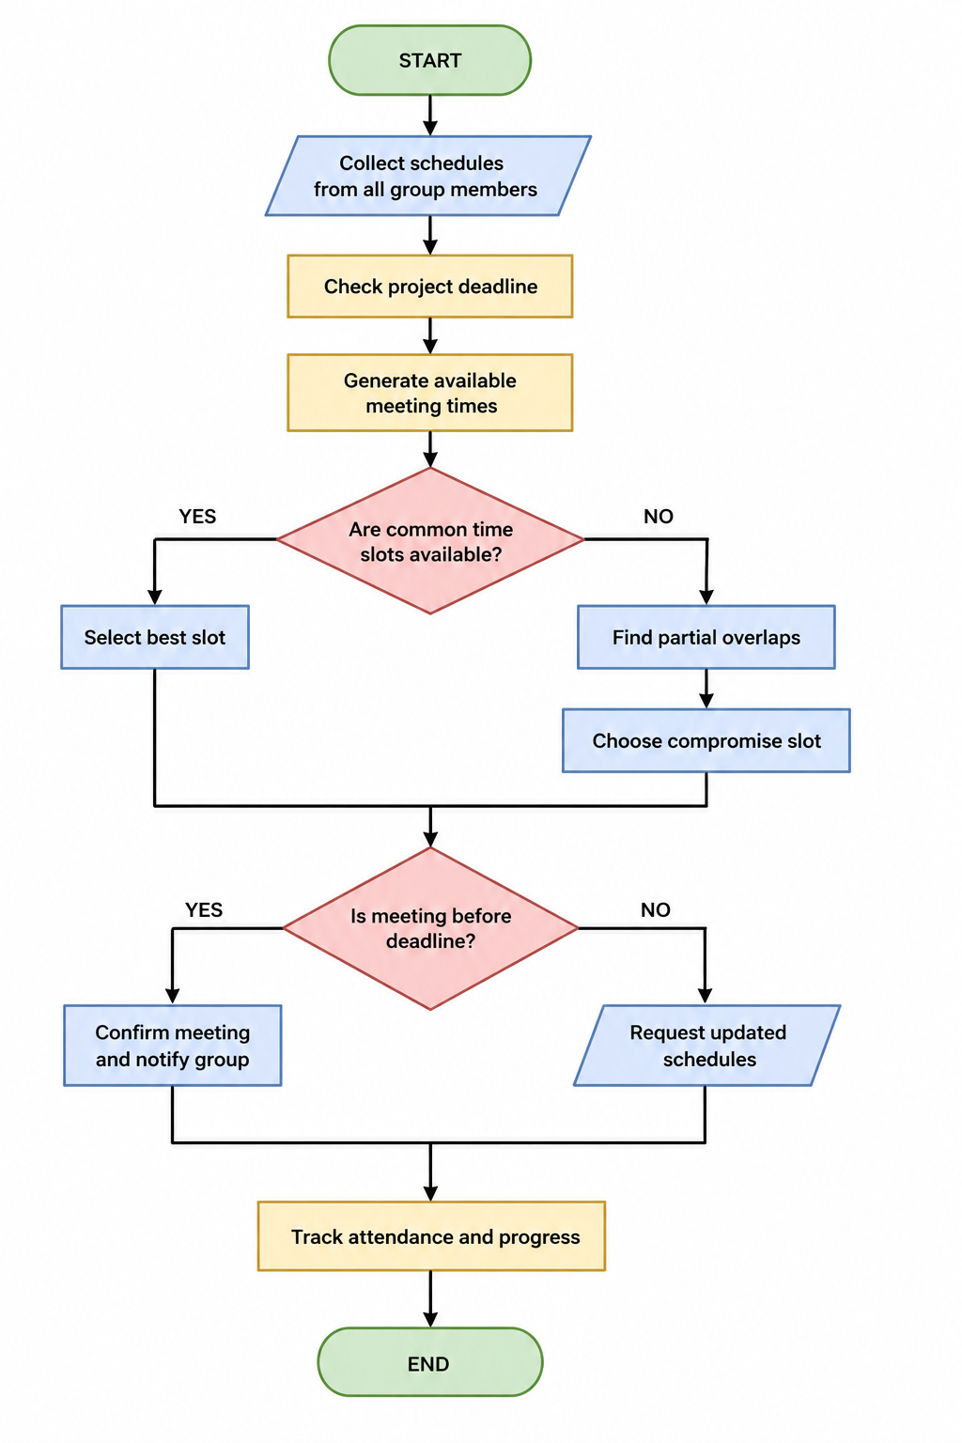
PSEUDOCODE FOR GROUP MEETING SCHEDULER
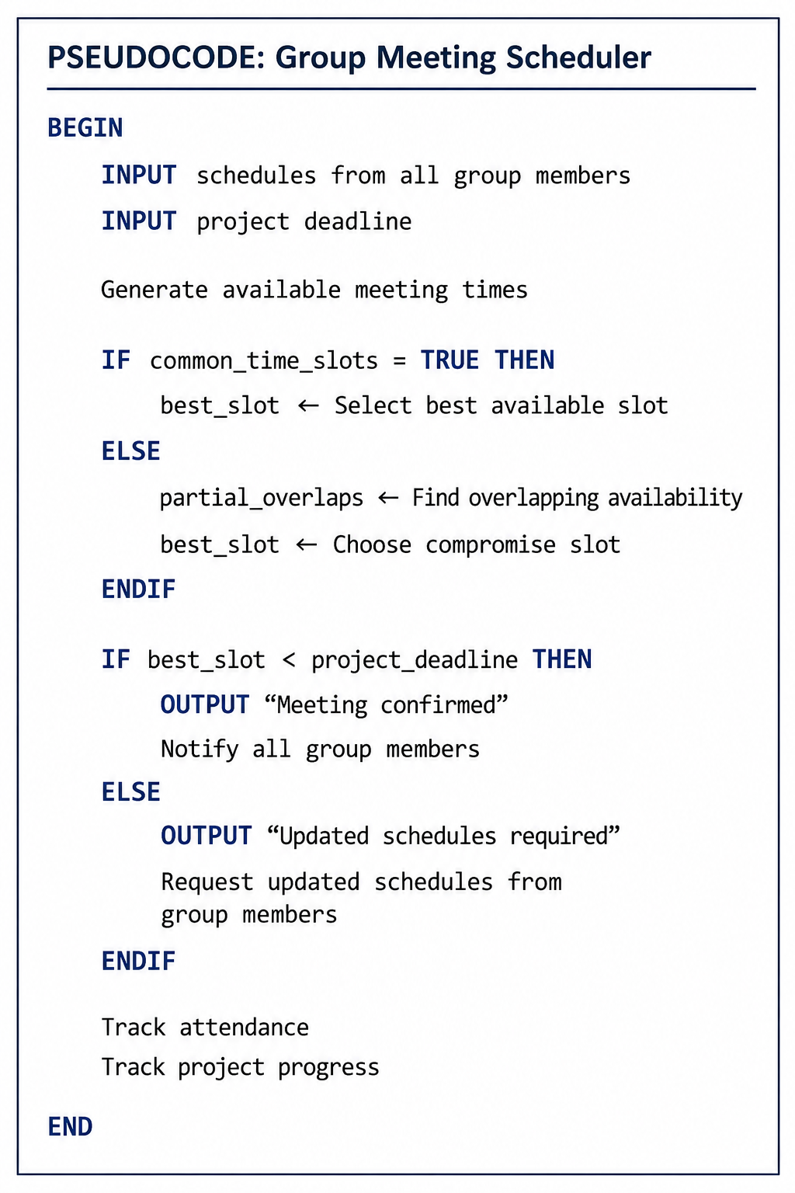

2.3 Explanation of the Solution
Stage 1: Collecting Student Availability

The first step is gathering information from all group members. Students enter:

- Their class timetable
- Work schedules
- Personal commitments
- Preferred meeting times
This information acts as the input for the system.
To simplify the process, the system converts availability into time blocks. For example:

“Available” = 1
“Unavailable” = 0
This is an example of abstraction because detailed schedules are simplified into a format the system can compare more easily.
Stage 2: Checking Deadlines
Before suggesting meeting times, the system checks the upcoming project deadline. This is important because meetings must happen early enough for students to complete their assigned tasks.
For example:
Deadline: Friday at 5 PM
Latest suitable meeting: Thursday evening
Any meeting scheduled after the deadline would automatically be rejected.

Stage 3: Comparing Schedules
The system then compares all student schedules to identify overlapping free time slots.

Example:

STUDENT | MONDAY 3-5PM | TUESDAY 4-6PM | WEDNESDAY 2-4PM
A | FREE | BUSY | FREE
B | FREE | FREE | BUSY
C | BUSY | FREE | FREE

In this example, there is no time when all three students are free. Therefore, the system moves to the next stage.
Stage 4: Conflict Resolution and Optimisation
If there is no perfect meeting time, the system searches for the best compromise. This is where optimisation techniques are used [3].
The system follows several rules:
- Choose the time with the highest attendance.
- Avoid repeatedly excluding the same student.
- Select meetings that happen before deadlines.
- Prefer online meetings if travel is difficult.
For example:

TIME SLOT | ATTENDANCE
MONDAY 3PM | 2/3 STUDENTS
TUESDAY 4PM | 2/3 STUDENTS
WEDNESDAY 2PM | 2/3 STUDENTS

If attendance levels are equal, the system chooses the option with the least timetable disruption or rotates decisions fairly between members.

This helps reduce unequal workloads and improves fairness within the group.

Stage 5: Confirming Meetings
Once the best meeting time is selected, the system:
- Sends notifications to all students.
- Adds the meeting to shared calendars.
- Sends reminders before the meeting begins.

If students reject the proposed meeting, the system asks for updated schedules and repeats the process.

Stage 6: Monitoring Progress

After the meeting takes place, the system tracks:
- Attendance
- Task completion
- Upcoming deadlines
- Outstanding work

This creates a feedback loop, which is an important concept in systems thinking [4]. The system continuously adapts to changes instead of working only once.

2.4 Key Decision Points

The scheduling process includes several important decisions.

Decision 1: Are Common Time Slots Available?
If all students are free at the same time, the system selects the best shared slot.
If not, the system searches for compromise options.
Decision 2: Is the Meeting Before the Deadline?
Meetings that happen too late are rejected automatically.
Decision 3: Is Attendance High Enough?
The system may require a minimum attendance level, such as 75%.
If attendance is too low, another time must be selected.
2.5 Assumptions
The solution makes several assumptions:

- Students provide accurate schedule information.
- Students regularly update their availability.
- Everyone has internet access.
- Students check notifications regularly.
These assumptions help simplify the design but may not always reflect real situations.

2.6 How the Solution Solves the Problem
The proposed system solves the problem in several ways:
- Finding Suitable Meeting Times
- The system automatically compares schedules to find the best available times.
- Reducing Scheduling Conflicts
- Meetings are checked against lectures, work shifts, and other commitments.
- Supporting Deadlines
- Meetings are always scheduled before project deadlines.
- Improving Fairness
The compromise system prevents the same student from being excluded repeatedly.
Improving Communication
Automatic reminders reduce missed meetings and improve organization.
3. Reflection and Justification
3.1 Problem-Solving Techniques Used
Several problem-solving methods were used when creating this solution.
Abstract Thinking
Abstract thinking helped simplify the real-world scheduling issue into a structured computing problem. Instead of focusing on every personal detail, schedules were represented as simple time blocks that could be compared logically.
Decomposition
The larger problem was divided into smaller tasks, such as collecting schedules, checking conflicts, and sending notifications. This made the problem easier to analyze and solve.
Decomposition is a common computational thinking technique because it reduces complexity [5].
Systems Thinking
Systems thinking was used to understand how different parts of the process connect together. Inputs, processes, outputs, and feedback loops all work together within the scheduling system [4].

Optimization
The solution uses optimization techniques because it searches for the “best possible” meeting time rather than a perfect one. In many situations, a perfect solution may not exist because as you can see from the report, different people live different lives so everyone schedule will always be different. So using this this method optimizes your time in the day.
3.2 Justification of the Approach
The proposed solution is suitable because it directly addresses the causes of scheduling problems:

- Different timetables
- Work commitments
- Poor communication
- Deadline pressure

Automating the scheduling process saves time and reduces confusion for students.
The use of the MoSCoW technique also helps prioritize the most important system features. This ensures that the essential parts of the system are developed first. The flowchart is another strength because it clearly shows how decisions are made within the system. This makes the solution easier to understand for both technical and non-technical users. One technological way to fix limitations could be an automated Calander sync to reduce the burden on students to manually update their info all the time. This gives students time to plan ahead and be more assertive.

3.3 Limitations of the Solution
Although the solution is practical, there are some limitations.
Reliance on Accurate Information - The system depends on students entering correct availability details.
Frequent Schedule Changes - Student schedules may change suddenly due to illness, overtime work, or emergencies.
No Perfect Solution - Sometimes there may be no meeting time that suits everyone.
User Participation - Some students may ignore reminders or fail to update their schedules.

3.4 Overall Reflection

Overall, the solution provides a practical and organized way of solving meeting scheduling problems in student project groups. The use of abstraction, decomposition, optimization, and systems thinking helped create a structured and realistic solution that could improve teamwork and reduce delays in project completion.

Conclusion

Organizing group meetings can be challenging for computing students because of conflicting schedules and external commitments. By analyzing the problem carefully and applying structured problem-solving techniques, it is possible to design an effective scheduling solution. The proposed system compares student availability, identifies suitable meeting times, reduces timetable conflicts, and ensures meetings happen before project deadlines. The use of optimization and systems thinking helps the system adapt to changing schedules while supporting fairness and communication within groups. Although the solution has some limitations, it provides a realistic and practical approach to improving group project organization in higher education. solution and Explanation

References

[1] T. H. Cormen, C. E. Leiserson, R. L. Rivest and C. Stein, Introduction to Algorithms, 4th ed. Cambridge, MA, USA: MIT Press, 2022.

[2] D. Clegg and R. Barker, Case Method Fast-Track: A RAD Approach. Boston, MA, USA: Addison-Wesley, 1994.

[3] H. A. Taha, Operations Research: An Introduction, 10th ed. Harlow, UK: Pearson, 2017.

[4] P. M. Senge, The Fifth Discipline: The Art and Practice of the Learning Organization, revised ed. New York, NY, USA: Doubleday, 2006.

[5] J. Wing, “Computational Thinking,” Communications of the ACM, vol. 49, no. 3, pp. 33–35, Mar. 2006.

