Managing People and Change
Robert James P144088

Lecturer: James Williams m6x01102
Contents
1. What is Change Management 2
1.1 Organisation in Focus 3
1.2 Identifying Change 4
2. Change Management Theories 8
2.1 Lewin’s Change Model 8
2.2 Kubler-Ross Change Curve 9
2.3 Prosci ADKAR Model 10
2.4 Beckhard Harris Change Model 12
3. Change Management Strategy 12
3.1 Kotter’s Change Management Model 12
3.2 McKinsey’s Change Management Model 14
4. Management and Leadership Styles 15
5. Conclusions 16
6. Recommendations 16
7. References 19
8. References for Figures 21
9. Appendix 22
9.1 About the TOGAF Standard, Version 9.2 22

Figures
3
- Learning Styles ………………………………………………………………………………………………………………...
4
- History of Products Manufactured by Peugeot ………………………………………………………………...
5
- SWOT Analysis on DVLA………………………………………………………………………………………………….…
6
- PESTLE Analysis on DVLA …………………………………………………………………………………………………..
8
- Force Field Analysis on Cloud Computing ………………………………………………………………….………
9
- Lewin’s Change Model ………………………………………………………………………………………………..…….
10
- Kubler-Ross Change Curve ……………………………………………………………………………………………...
11
- Bridges Transition Model ………………………………………………………………………………………………..
12
- ADKAR ……………………………………………………………………………………………………………………………..
13
- Beckhard Morris Change Model ………………………………………………………………………………………
14
- Kotter Change Management Model ………………………………………………………………………………..
15
- McKinsey 7S Change Model …………………………………………………………………………………………….
16
- Management Styles …………………………………………………………………………………………………………
17
- Leadership Styles …………………………………………………………………………………………………………….
18
- TOGAF Architectural Change Model ………………………………………………………………………………..
19
- James’ Model of Change Management …………………………………………………………………………..

What is Change Management
‘The rate of change and discovery outpaces our individual ability to keep up with it. The organizations we work in or rely on to meet our needs and wants are also changing dramatically, in terms of their strategies, their structures, their systems, their boundaries and of course their expectations of their staff and their managers’ [1].

Therefore, it stands to reason that we need processes for managing and navigating change itself. This area of work has come to be known as Change Management. The professional body for change management, the Association of Change Management Professionals (ACMP) defines change management as ‘the practice of applying a structured approach to transition an organization from a current state to a future state to achieve expected benefits’ [2].

As human beings, we are experiencing change every day in the world around us. New brands, goods and services are launching, just as old ones are dying. An example of this is John Lewis’ recent announcement to stop selling DVD players due to falling demand [3]. Another example of change in society is Kondratieff waves [34]. An economic cycle spanning between 4 to 6 decades, driven by advances in technology.

As humans we’re also experiencing change internally. We’re learning new skills and behaviours all the time. Learning and change are closely linked. We identify a reason for change and we learn new skills or behaviours, or learn to forget existing habits or behaviours as we transition from our current state to our desired state.

Cameron and Green [4] propose four approaches to change, shown in figure 1 below.

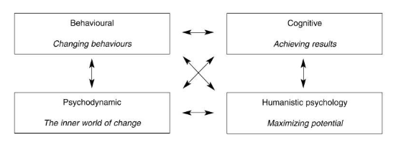

Figure 1

Throughout the change process, individuals are likely to experience common feelings, but for different amounts of time, depending on their ability to manage themselves through the behaviours along the change curve. Kubler-Ross identified emotions that regardless of the change; most of us will transition through. Kubler-Ross’ theory focuses on change as a set of experiences by had an individual. Of course, change occurs in organisations and populations too.

Therefore, we need to also consider change at a much bigger scale, affecting many people at once. At this point, we need to consider the role of culture. Specifically to this assignment, organisational culture. Organisational culture is defined as [5] ‘the organisational structure and rules, values, feelings, norms.’ The nature of the organisations business, size and age can influence how quickly it reacts to drivers of change and therefore how agile it is and ultimately how successful it is. Hofstede’s [23] cultural dimensions found societal culture can also have a significant impact on how people respond to change, their actions and their thinking. Similarly, if leaders of large organisations recognise the wealth of knowledge and experience staff at all levels within the organisation have, and how this could inform and shape change needed, the change is more likely to be a success, as evidenced in the case study on Landing Transformational Change by the HMRC [32].

Peugeot is a great example of an organisation reacting to drivers for change. It did so by diversifying its product range where it has identified opportunities for profit, see figure 3. Most significantly though, Peugeot states that although its products over its 200 year history are diverse, it’s ‘always remained industrially consistent. Our strategy has constantly been in tune with the needs of our customers and the environment’ [17].
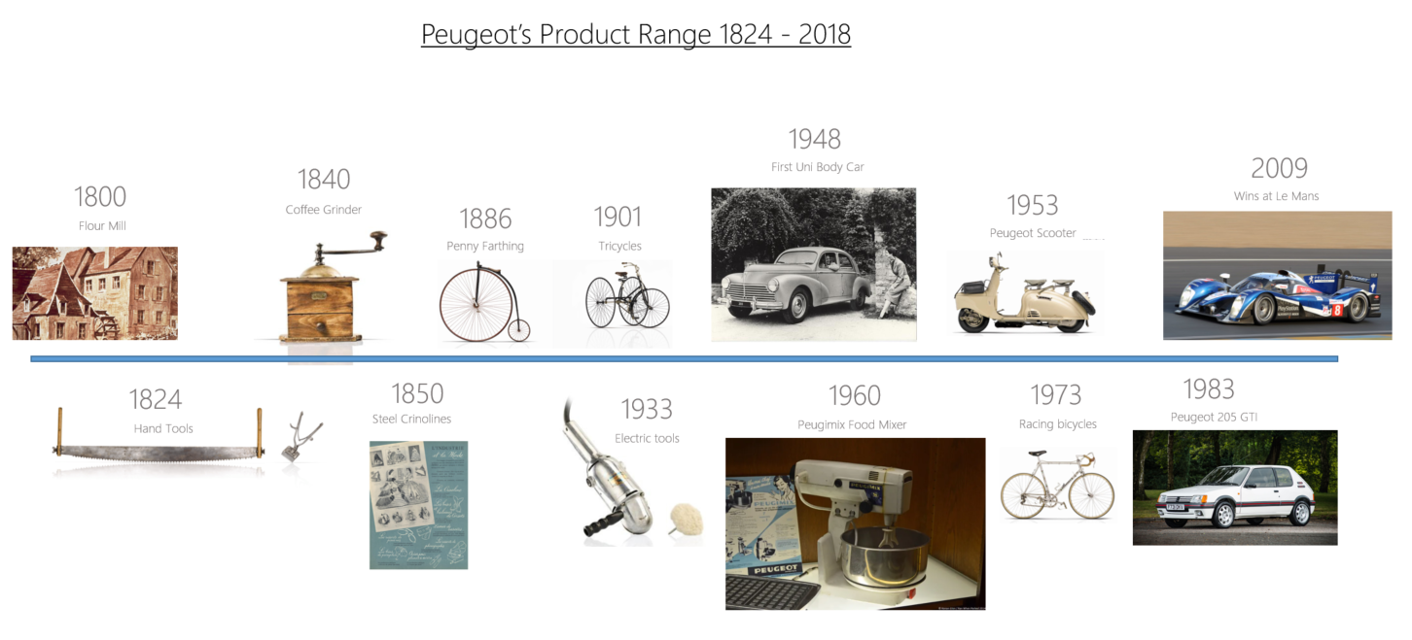

Figure 2

1.1 Organisation in Focus
The organisation in focus for this assignment is the Driver and Vehicle Licensing Agency (DVLA). DVLA is an executive Agency of the Department for Transport, which is a central department of the UK Government. DVLA is responsible for maintaining a record of driving licences and vehicles registered within the UK. DVLA’s other responsibility is to collect vehicle excise duty (VED) on behalf of Her Majesty’s Treasury. DVLA collects over £6 billion in VED annually and has over 47 million active driver records and over 38 million vehicles registered for use on the UK’s roads.

DVLA has seen many changes over its almost 50 year history. It is now a centralised operation from Swansea. Previously DVLA had a network of over 70 local offices throughout the UK delivering face to face services to its customers. The advent of the internet has meant the large majority of DVLA customers no longer want to use a face to face service, choosing to transact online instead. This has brought about a reduction in processing times and improved accuracy of the Driver and Vehicle Records. However, as a result of its 50 years providing services to the nation, DVLA has a large legacy IT estate, which has become expensive to run and maintain, technology use has grown organically and it has become inflexible to change.

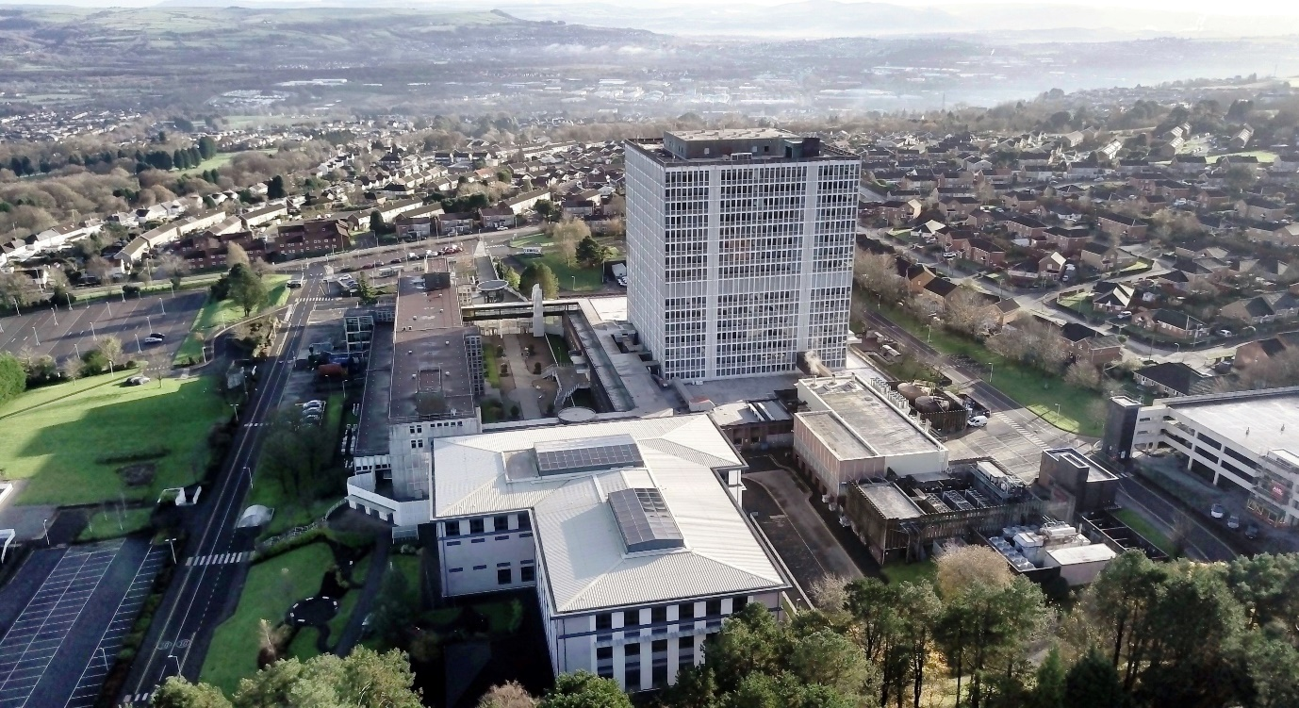

The Driver and Vehicle Licensing Agency at Swansea

DVLA now recognises it needs to modernise its IT estate by embracing cloud computing and its many benefits. DVLA has also recently ended its outsourcing of IT and brought IT back in house after more than 20 years. At the same time, DVLA is committed to making an increasing number of services available online and moving away from paper based services supported by solely on premise IT. Internally DVLA is also seeing more staff working from laptops, working flexibly from multiple locations, needing collaboration tools to communicate, document, share and update information.

The change assessed in this report is whether DVLA should move to a cloud computing model or not. It will identify the forces for and against and identify the change management theories and strategies that are the most useful for implementing this change.

1.2 Identifying Change
To provide clarity on the landscape DVLA operates within and to assist in identifying drivers for change within that landscape please see figure 4 showing a SWOT analysis and figure 5 for a PESTLE analysis. The SWOT analysis identifies DVLA strengths and weaknesses as well as some drivers for change both positive and negative. The Pestle takes a more structured view across six different categories.

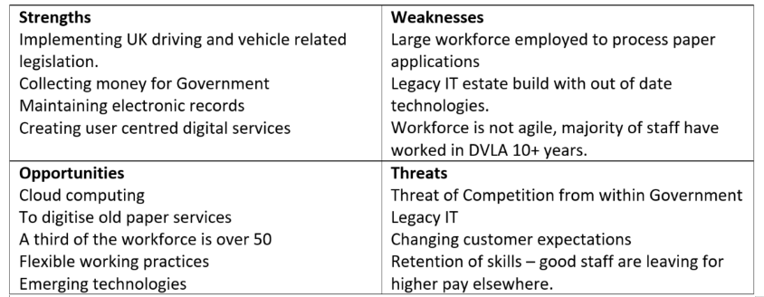

[36]
[35]

[36]
Figure 3
[7]
From the PESTLE analysis, it’s clear to see there are many drivers for change across the Agency. Lewin’s Force Field Analysis (FFA) is an analysis tool for identifying forces for and against a change [18] [24]. Another analysis tool is Porter’s Five Forces [25], it’s more structured than Lewin’s model, in as much as there are five specific sources of force to consider. These are:

- Bargaining power of suppliers
- Threat of new entrants
- Bargaining power of buyers
- Threat of substitute products or services
- Rivalry among existing firms.
In this instance, FFA has been used to identify forces for and against the change to cloud computing. See Figure 6.

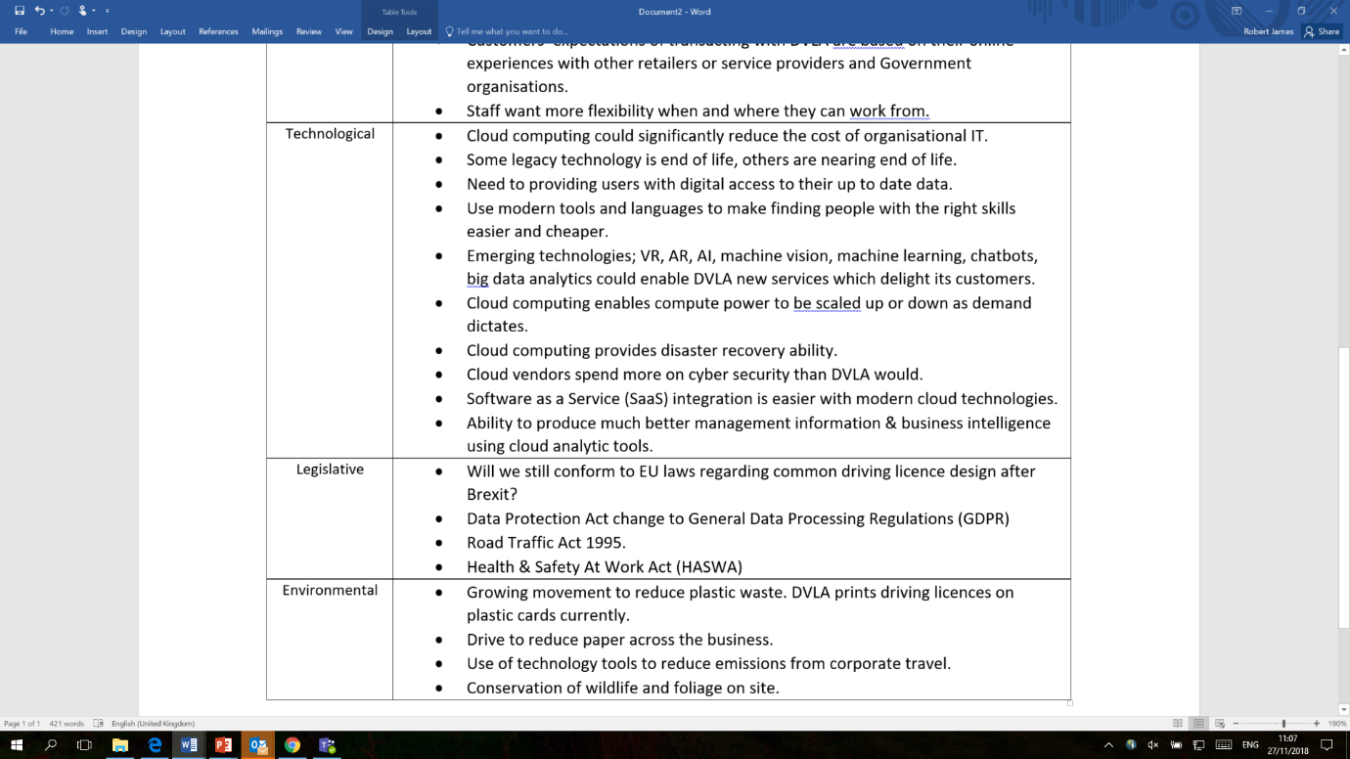
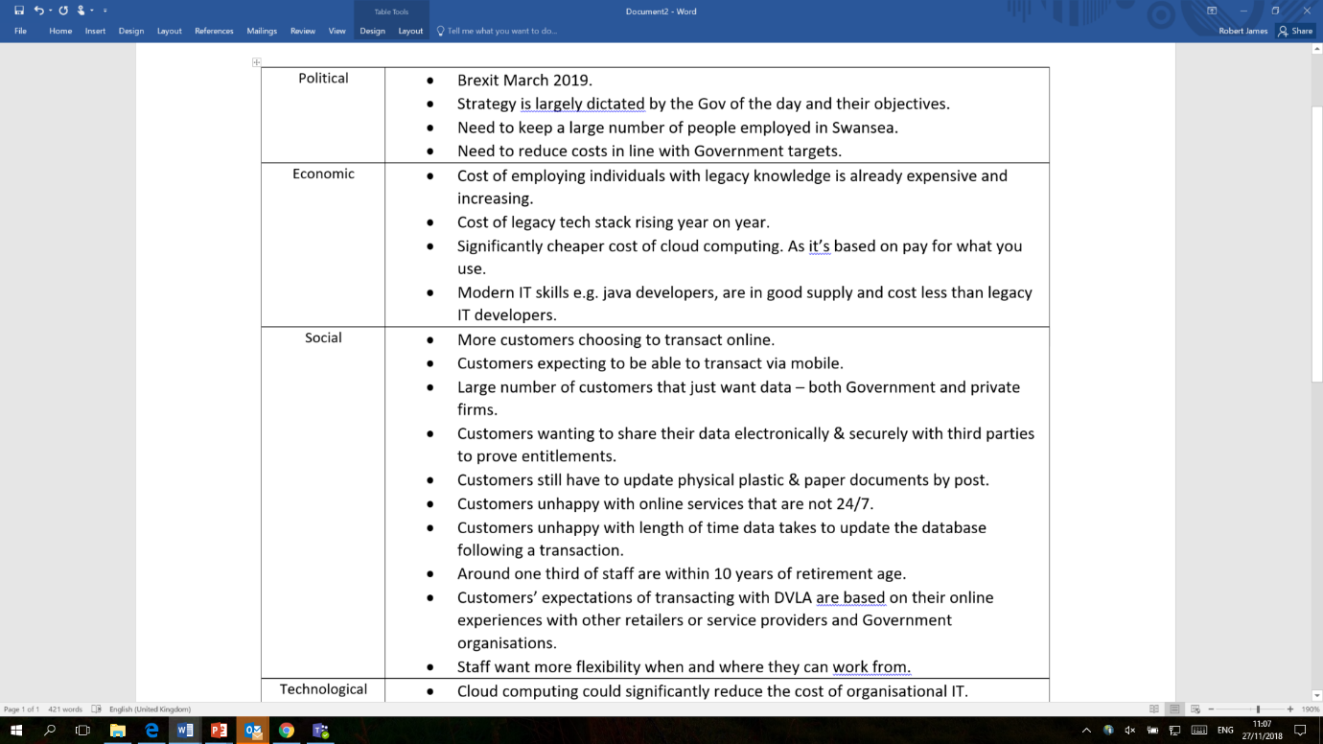
PESTLE Analysis

[36]

[36]

[7]

[35]

[36]
[36]

[37]

[7]
[7]
[7]
Figure 4

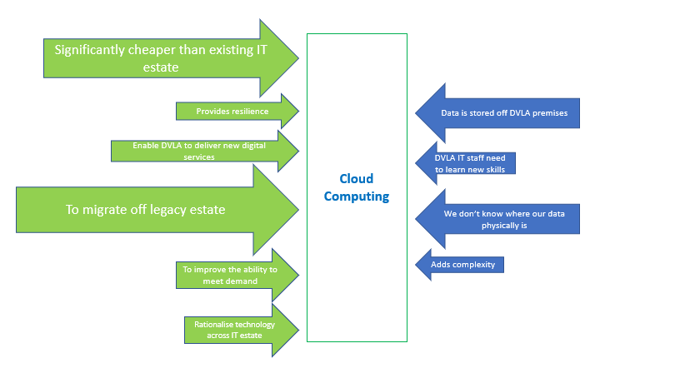
Lewin’s Force Field Analysis
Scoring:
1 – 5 Low to High Influence

3
1
3
2
3
3
2
3
5
4
Figure 5
Total for forces against the change = 9
Total for changes for the change = 20
From the FFA we can determine the forces for the change to cloud computing are greater in number and total influence. With the many benefits of moving to a cloud computing model expected to significantly outweigh the negative influences. The biggest positives being DVLA can migrate its IT from an out of date and in many cases out of support legacy IT estate, to a more modern and flexible IT model whilst realising significant cost savings. This is a key objective of DVLA set by Government.

Change Management Theories
Change management is simply the process of how to manage a change, so as you might expect there is some commonality between the different theories of change management. For the purposes of this report, we will look at the following models:

- Lewin’s 3 Stage Model
- The Prosci ADKAR Model
- The Beckhard-Harris Change Model
- The Kubler-Ross Change Curve
- Bridge’s transition model

2.1 Lewin’s Change Model
Lewin ‘believe[d] that the process of change involves three basic stages: the behavioural thaw (unfreezing), the change (transition) and the recrystallization of behaviours (change)’ [10].

[26] [27] Unfreezing is about understanding what needs to change and building support for that change. The Change stage is where the change happens. Good two way communication is absolutely key to building and maintaining momentum. The Refreeze stage is all about ensuring the new state is maintained by embedding the new state in to the organisational culture. This could be done by communicating the new values and beliefs or hiring new staff based on their alignment to the new culture.

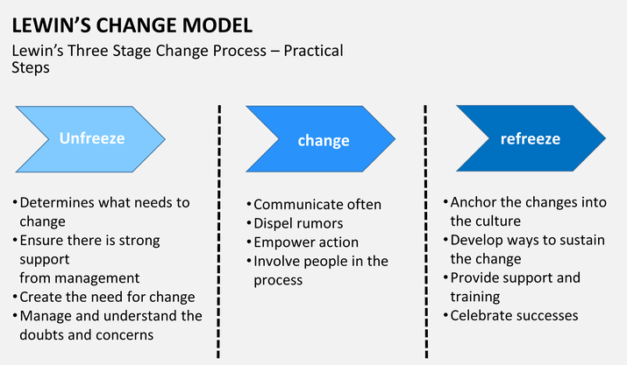

Figure 6
In a modern world of continuous improvement and iterative processes, Lewin’s model looks a little outdated as a linear process. Indeed Kotter’s model could be applied as a cyclical method also. When cycling through change it is important to allow enough time for the change to become accepted and adopted, prior to commencing another iteration and introducing more change. Lewin recognised this suggesting ‘For a change to be effective…organizational behaviours and attitudes must reinforce it’ [8]. Lewin’s model is a great introduction to the key aspects of change management but is too high level to be useful in implementing a large change at a task level. In communicating the need to change, DVLA could adopt the three phases to explain how the change will happen. What elements of our organisation need to be unfrozen, what will be changing and what DVLA expects refreezing to look like and what it expects to have delivered by this point. The case study by O2, The Transformation of O2 [33], indeed uses the above model as it’s framework for managing change within its organisation.

Lewin’s model appears to placing people at the heart of the change. Therefore, we need to understand how individuals may react to change. Kubler-Ross identified behaviours common when faced with change.

2.2 Kubler-Ross Change Curve
Kubler-Ross identified a set of emotions that most people will transition through regardless of the change they face [28] [29]. However, some individuals may not transition to the end for every change, and not everyone will spend the same amount of time in each of the phases.
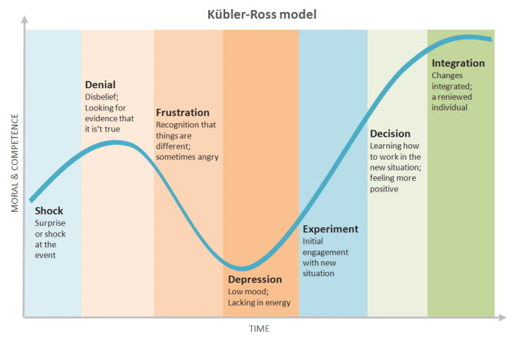

Figure 7

Some comparisons could be drawn between the stages in Lewin’s change model and Kubler-Ross’ model. Individuals could be expected to experience the emotions of Shock, Denial and Frustration during the Unfreeze stage. Depression and Experimentation could be experienced during the Change phase. As the change is unfolding, individuals are starting to experiment how the change will work best for them. Decision could occur during the Change stage or come later in the Refreeze stage. Certainly, Integration would likely come in the Refreeze stage.
The model shows the behaviours as linear but not everyone will experience all of these emotions and individuals could jump about forwards and backwards along the curve. Humans are by their very nature, sometimes completely unpredictable [6].

Kubler-Ross’ model is consistent with Bridge’s Transition Model of Change. Bridges model is also focused on how change affects individuals. It has three phases [6];
- Ending, losing, and letting go
- The neutral zone
- The new beginning
Bridge explains that change is ‘a transition is more of a journey over time than an abrupt alien shift’ [6]. The first four behaviours in Kubler-Ross’ model are likely to fit in to the Bridge’s Ending phases, Experimentation is likely to be in the Neutral Zone, with Decision and Integration becoming the New Beginning.
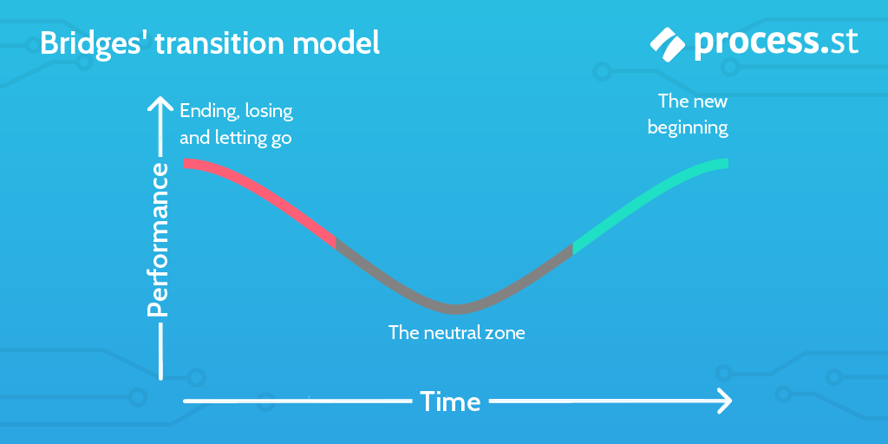

Figure 8
Both Kubler-Ross’ and Bridge’s model are particularly helpful for visualising the emotional journey individuals could experience during a change. These models would be especially helpful for change managers within DVLA. If the senior staff involved in making the change a success, whether that’s by implementing the change, or by reinforcing new values and behaviours, were trained to understand the Change Curve and how to support their staff through it, it could be a key factor in ensuring the change to cloud computing is successfully implemented. A large number of DVLA’s developers may need training, some staff may be moved to different roles and some staff will not be needed as a result of these changes. Therefore, the impact of the technical change on the individual humans involved should not be under estimated.

2.3 Prosci ADKAR Model
The ADKAR Change Model has been developed by Jeffery Hiatt, founder of Prosci Change Management consultancy. The name ADKAR is an abbreviation of the five phases:

- Awareness
- Desire
- Knowledge
- Ability
- Reinforcement
The ADKAR model focuses on the people element of change and not the process of managing the change [11] [30]. The model assumes the change has already been identified [9] as it starts with having an ‘Awareness’ of the need for change and ‘Desire’ to support the change. This is similar to Lewin’s Unfreeze stage. ‘Knowledge’ is about communicating what the change is and ensuring everyone understands what their role is within the change. Similar to Lewin’s Change stage. In the same way as Lewin’s model is too high level, this phase could be broken down in to achievable milestones, allowing individuals to change at a manageable cadence and transition through the change in line with Kubler-Ross’ and Bridge’s models. ADKAR’s final stage is Reinforcement. This emphasises the importance of rewarding changed behaviours, to embed these into the new way of working. Much the same as Lewin’s Refreeze phase.

Although ADKAR is five stages to Lewin’s 3, ADKAR’s first two phases align with Lewin’s Unfreeze stage, ADKAR’s second two phases align to Lewin’s Change stage and Reinforcement is Lewin’s Refreeze stage. Both models are too high level to be change management strategies but are a useful tool in highlighting the key phases of change. Where it differs is that Lewin focuses on change from the organisations viewpoint and ADKAR is very much about the individual. DVLA could use the ADKAR stages almost as a communication tool to its staff. To let them know what they need to know will be changing, how they can support the change, what knowledge they’ll need to gain, how they can demonstrate new skills and behaviours and how DVLA will recognise and reward individuals.

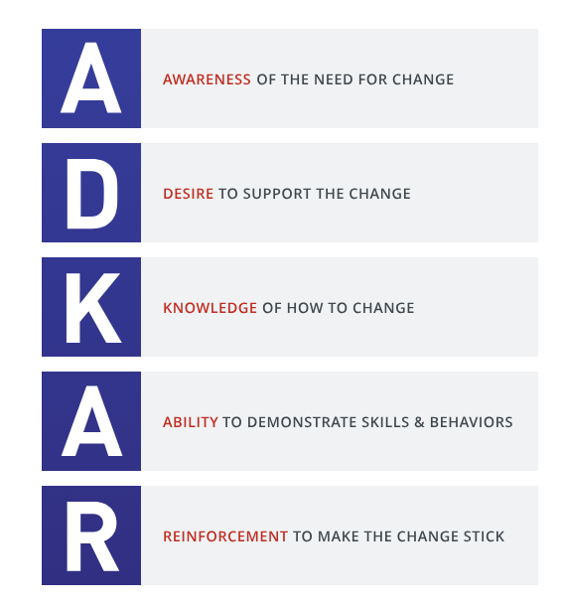

Figure 9

2.4 Beckhard Harris Change Model
The Beckhard Harris model of change predates the models previously covered. It’s from a time when change was enacted on workers without their support and buy in being recognised as a key ingredient of successful change management. It is from a time of command and control management where workers worked and managers were the only ones doing the thinking [12].

Beckhard and Harris stated there was a formula to change management, and any successful change required the following elements [13] [31];
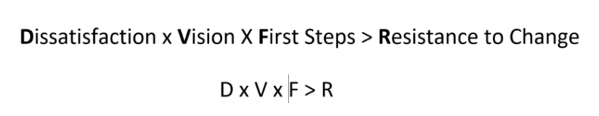

Figure 10

What Beckhard is saying is that dissatisfaction with the current state along with vision of a better state than the hardship currently being experienced combined with some positive actions towards the better state, i.e. the first steps, must be greater than the resistance to change from workers.

In the 21st century, organisations now recognise the value of involving employees in the change process. Although this model is not one organisations would want to adopt today, there is similarity with Lewin’s 3 stage model and ADKAR where the Vision element focuses individuals mind on the end state after change, recognising the need to get individuals to buy in to change early on in the process is key.

Change Management Strategy
‘Change is often accompanied by resistance as people are required to modify their behaviour.’ [14]. [15] found resistance to change was highest amongst the lower levels within the organisational hierarchy. Therefore having a strategic approach to managing change should yield a more successful change, than simply making a change with no foresight [16]. Kotter suggests there are 8 stages to managing successful change.

3.1 Kotter’s Change Management Model
The 8 stages are;
- Creating a sense of urgency
- Building a core coalition
- Forming a strategic vision
- Getting everyone on board
- Removing barriers and reducing friction
- Generating short-term wins
- Sustaining acceleration
- Setting the changes in stone
The first four stages of Kotter’s model clearly align to Lewin’s Unfreeze stage. They’re all about creating the need for change, building a strong team of influential people who buy in to and support the change. Kotter specifically states a strategic vision should be created. This is important, because it provides those involved with an understanding of what the goal of the change is.
Stages 5, 6 and 7 in Kotter’s model, closely align to the Change stage in Lewin’s model. This is where the actual change happens and change managers need to have a plan to support individuals along the steps outlined in Kubler-Ross’ change curve. Barriers need to be removed and individuals are supported in overcoming challenge to allow them to progress to the next stage.
This is where DVLA change managers will need to be communicating regularly with employees and acting on feedback to support individual’s transition through the change. It’s within stages 4,5 and six that Kubler- Ross’ model of change could be employed to identify where individuals are within the change transition and support them in progressing along the change curve.
Lastly the eighth stage is about making sure the change sticks. This corresponds with Lewin’s Refreeze phase. Where the change is embedded in to the culture of the organisation. A common theme throughout each of the five change models discussed earlier.

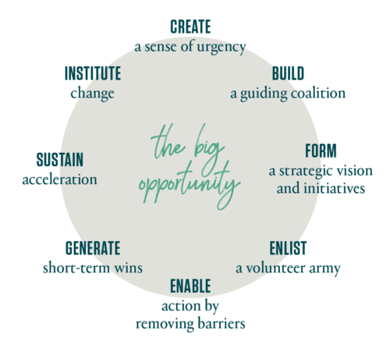
Kotter’s Change Management Model

Figure 11

Kotter’s change management strategy contrasts with McKinsey’s change management strategy, as Kotter’s focus is over the length of the change, and assumes the change is already known in part or whole. Whereas the McKinsey’s change management strategy focuses on the early stages of change. Its purpose is to enable organisations identify the change they need to make, by identifying how the change will impact on the 7 elements within an organisation [6].

3.2 McKinsey’s Change Management Model
The McKinsey model takes users through seven stages. These stages could be compared as being more detailed instructions to support the first element in Lewin’s Unfreeze Phase.

- Strategy
- Structure
- Style
- Staff
- Skills
- Systems
- Shared Values

[8] states that McKinsey’s model is best used when “you know you need to change, but you’re not sure what to do...by analysing the seven aspects of your company and how they affect each other, you will highlight the changes you need to make.”

McKinsey’s model is therefore not a model for managing the whole process of the change from one state to another. Instead it is a strategic tool to identify the appropriate strategic change, considering all areas of the organisation.

By looking across all seven areas not only is it possible to identify the change required, but the change is assessed against seven aspects of the organisation. Ensuring it’s strategic alignment to the organisations goals.

However, because of the scope of this model, it takes a long time to complete to fully analyse and it’s likely not possible for one or two people to conduct this on their own. That said, the McKinsey model is a great place to start, not just if the organisation doesn’t know what to change. It is a good analysis tool for fully understanding the need to change and may highlight the need for changes that weren’t previously identified.
McKinsey 7 S Model

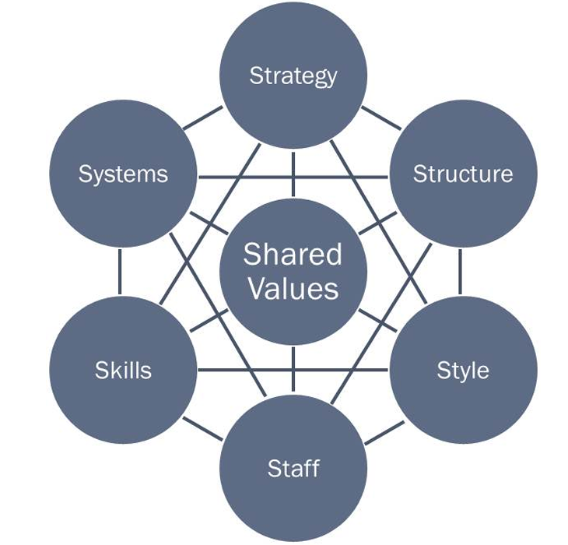

Figure 12

Management and Leadership Styles

Management is defined as ‘the act or art of managing: the conducting or supervising of something’ [19]. This differs from Leadership, which is defined as ‘the art of influencing others to their maximum performance to accomplish any task, objective or project’ [20]. Figure 14 lists some of the different styles of management and figure 15 lists leadership styles.

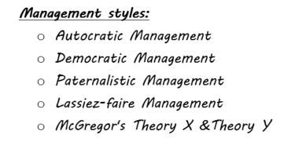

Figure 13

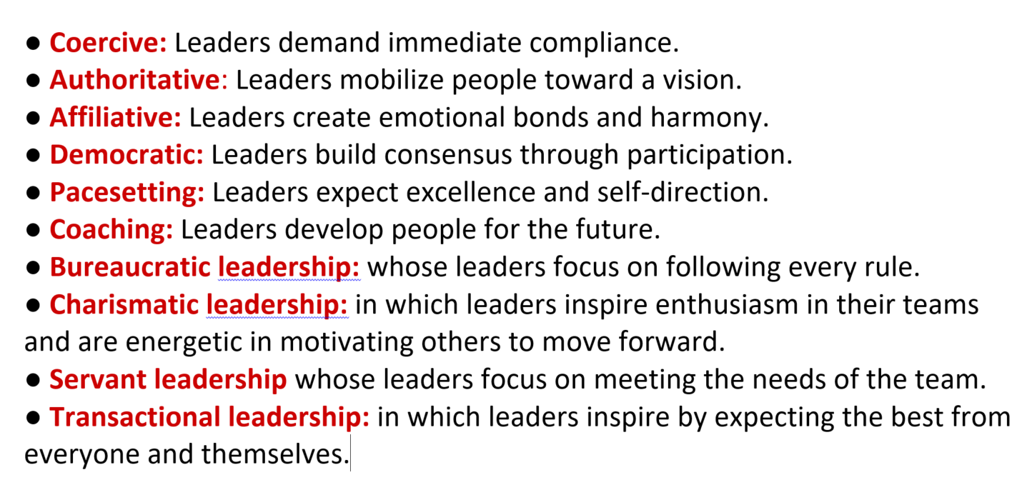

Figure 14

The type of leadership and management style required for implementation of a successful change will depend on the type of change being implemented, the organisational culture and ultimately what’s at stake if the change is not successful. For DVLA’s change to cloud computing a combination of a charismatic and authoritative leadership style could be used initially. Communicating a vision that excites, motivates and entices staff to work towards achieving the change. This would apply to the first four stages of Kotter’s eight stage model.

As the change is progressing to the implementation detail level, Kotter’s next three stages, a mix of democratic and authoritative leadership would be required. The democratic element aligns to Kotter’s and Lewin’s suggestions of two way communication, enabling participants to feel they are helping shape the change. The authoritative leadership is needed to hold people to account, ensuring deadlines are met and barriers are removed. All the while, it would be good to practice to coaching leadership throughout the process, for DVLA staff new knowledge and ways of thinking and designing services will be required. So there is an element of training and the reinforcement of the new ways of doing things that the coaching leadership would support.

Conclusions

There are common stages to any change process, which trigger common behavioural responses. Both Lewin and Kotter identify a pre-change element, a change element and an element where adoption of change must be supported to make it stick. Similarly knowing the behaviours an individual will likely be transitioning through, and the ability to identify where along the change curve an individual is and how to support them progressing through to the end stage is a valuable set of skills.

Knowledge of these elements of change and the appropriate tools to progress change are key to managing a successful change. Change leaders and lower level implementation managers should be skilled in management tools such as emotional intelligence [21] and mindful management [22] which enable managers to tailor their behaviour to maximise their employees value and reduce and remove any barriers to change that they have.

Recommendations
DVLA’s business vision is [7];
“We strive to make our services simpler for our users. We are always looking to make things better for drivers and the wider public without losing sight of our core responsibilities, which are to collect duty and help keep the roads safe.”
When creating a vision for change, it should be aligned to the organisations business vision. This helps employees understand the need for change and therefore buy in to the change because it is demonstrably aligned to where the organisation aspires to be.
In this instance the change within DVLA’s IT organisation, to move to cloud computing is necessary because it enables the IT department to deliver against the business vision because; it will enable DVLA to build simpler services that do not pass the complexity of the back end IT on to DVLA’s users. Users will find the online services an improvement over the old paper services and first generation online services. It will enable DVLA to improve road safety by having more accurate and up to date information within its system of record. All while reducing the cost and complexity of the IT estate.

Based on the models discussed previously, the author believes the best change model for DVLA to follow during the implementation of this change will be a hybrid of Kotter’s 8 stage model, Lewin’s 3 Stage Model and McKinsey’s 7S Model.

Mckinsey’s 7S model would be used to provide a sound analysis approach to identifying that the change is the correct change for the organisation. This would take place in a preliminary phase, prior to change being initiated. Kotter’s 3 step model provides the break down for high level phases within the change cycle, providing all those involved with information to manage their expectations. A slightly modified version of Kotter’s 8 steps model would provide the strategy for implementing the change, giving more detailed information as to how to implement the change. If these were visualised in a similar way as The Open Group’s Architecture Framework, which is an architectural change management for IT. It details a preliminary phase, where Mckinsey’s model could be used, change planning and then change delivery phases. Please see figure 16 for a visualisation of this. Information on Togaf can be found in the appendix.
The Togaf Architectural Framework

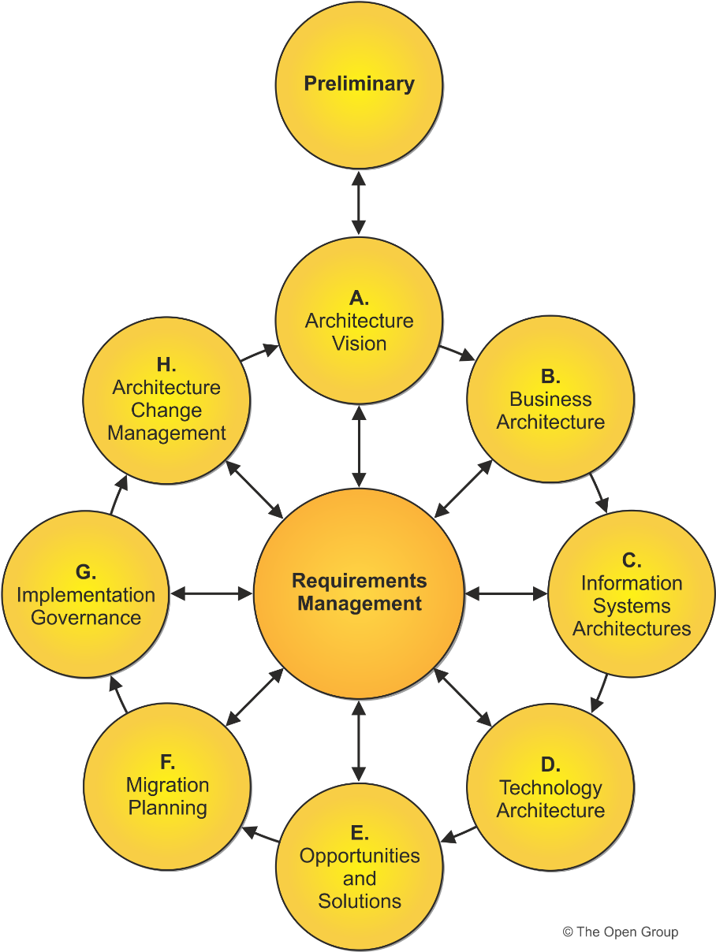

Figure 15

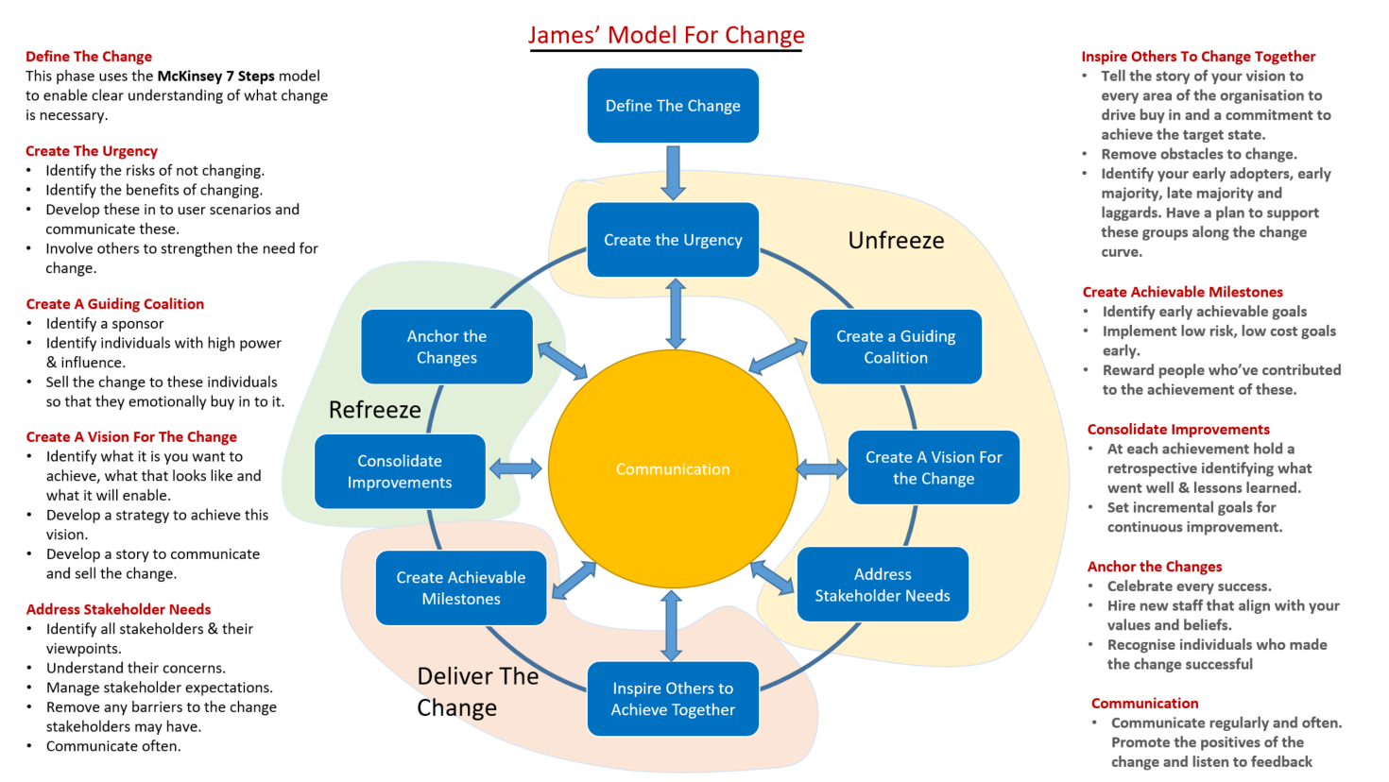

Figure 16

7. References

[1] Cameron, E & Green, M. Making Sense of Change Management: a complete guide to the models, tools, and techniques of organizational change. Kogan Page, London, 2012.

[2] Available at: https://www.acmpglobal.org/page/change_management. Accessed 11.11.18.

[3] Available at: https://www.bbc.co.uk/news/business-45950477. Accessed 11.11.18

[4] Cameron, E and Green, M. Making Sense of Change Management Second Edition. Kogan Page, London, 2009.

[5] Mead, R and Andrews, T. International Management Culture and Beyond Fourth Edition. John Wiley & Sons, West Sussex, 2009.

[6] Available at: https://www.process.st/change-management-models/. Accessed 11.11.18.

[7] Onwards> DVLA Strategic Plan. Driver and Vehicle Licensing Agency. Available at: https://assets.publishing.service.gov.uk/government/uploads/system/uploads/attachment_data/file/701287/mis899-dvla-strategic-plan-2017-to-2020.pdf.

[8] Available at: https://www.process.st/change-management-models/. Accessed 12.11.18

[9] Galli, B. Change Management Models: A Comparative Analysis and Concerns. Published in IEEE Engineering Management Review, Vol. 46, Issue: 3 , Sept. 1 2018.

[10] Talmaciu, I. Comparative Analysis of Different Models of Organisational Change. Published in Valahian Journal of Economic Studies, Vol. 5, No. 4, 2014.

[11] Available at: https://www.prosci.com/adkar Accessed 20.11.18.

[12] Available at: http://www.valuebasedmanagement.net/methods_beckhard_change_model.html. Accessed 20.11.18

[13] Available at: http://pastatenaacp.org/wp-content/uploads/2017/03/Beckhard-Harris-Change-Model-DVF.pdf. Accessed 21.11.18.

[14] Thi Van Hau, T and Kuzic, J. Change Management Strategies for the Successful Implementation of Enterprise Resource Planning Systems. Presented at: Second International Conference on Knowledge and Systems Engineering. Vietnam, 7-9 October 2010.

[15] Foster, S. Hawking, P and Zhu, C. The Human Side of ERP Implementations: Can Change Management Really Make A Difference. Published in: Research and Practical Issues of Enterprise Information Systems II. Vol. 1, 2007.

[16] Mandal, P and Gunasekaran, A. Issues in implementing ERP: A case study. European Journal of Operational Research, Vol. 146, No. 2, 2003.

[17] Available at: https://www.peugeot.co.uk/peugeot-history/diversification/17. Accessed 27.11.18.
[18] Kaiser, S and Schulzegisela, G. A Framework for Participatory Holistic Research. Published in: Gestalt Theory, An International Multidisciplinary Journal. Vol 40, Issue 1. April 2018.

[19] Engwall, L. Kipping, M and Usdiken, B. defining Management: Business Schools, Consultants, Media. Routledge, London, 2016.

[20] Cohen, W. The Art of a Leader. Prentice Hall, New Jersey, 1990.

[21] Goleman, D. Working With Emotional Intelligence. Bantam Books, London , 1995.

[22] Kehoe, D. Mindful Management: The Neuroscience of Trust and Effective Workplace Leadership 2nd Edition. Communicate for Life, Canada, 2016.

[23] Dellner, A. Cultural Dimensions: The Five-Dimensions-Model according to Geert Hofstede. GRIN Verlag GmbH. Germany, 2009.

[24] Bates, B and McGrath, J. The Little Book of Big Management Theories, 2nd Edition. Pearson Business, London 2017.

[25] Kiechel, W. The Lords of Strategy: The Secret Intellectual History of the New Corporate World. Harvard Business Review Press, Massachusetts, 2010.

[26] Cummings, S and Bridgman, T and Brown, K. Unfreezing change as three steps: Rethinking Kurt Lewin’s legacy for Change Management. Published in Human Relations, Vol. 69, 2016.

[27] Salerno , A and Brock, L. The Change Cycle,: How People Can Survive and Thrive in Organizational Change. Berret-Koehler Publishers, California , 2008.

[28] Kubler-Ross, E. On Death & dying: What the Dying Have To Teach Doctors, Nurses, Clergy and Their Own Families. Scribner Book Company, United States, 2014.

[29] Jaffe, D and Scott, C. Mastering the Change Curve 2nd Edition. HRDQ, United States, 2003.

[30] Hiatt, J. ADKAR: A Model for Change in Business, Government and Our Community. Prosci Learning Center Publications, United States, 2006.

[31] Beckhard, R and Harris, R. Organizational Transitions: Managing Complex Change 2nd Edition. Addison-Wesley, United States, 1987

[32] Available at: https://www.cipd.co.uk/knowledge/strategy/change/theory-practice-report. Accessed 08.01.18.

[33] Available at: http://www.systemsthinkingmethod.com/downloads/Vanguard-O2-case-study.pdf Accessed 08.01.18.

[34] Available at: https://www.kondratieff.net/kondratieffcycles Accessed 10.01.18

[35] Available at: https://www.gov.uk/government/news/dvla-takes-home-top-digital-prize Accessed 11.01.18

[36] Available at: https://www.gov.uk/government/publications/dvla-it-strategy-2017-20 Accessed 11.01.18

[37] Available at: http://www.hse.gov.uk/legislation/hswa.htm Accessed 11.01.18

References for Figures

[1] Cameron, E and Green, M. Making Sense of Change Management Second Edition. Kogan Page, London, 2009.

[2] Available at: https://www.cleverism.com/understanding-kubler-ross-change-curve/ Accessed 01.12.18

[3] Created by author

[4] Created by author

[5] Created by author

[6] Created by author

[7] Available at: https://change.walkme.com/functions-modeling-change/ Accessed 04.12.18

[8] Available at: https://www.cleverism.com/understanding-kubler-ross-change-curve/
Accessed 04.12.18

[9] Available at: https://www.process.st/change-management-models/ Accessed 05.12.18

[10] Available at: https://www.accipio.com/eleadership/mod/wiki/view.php?id=1705 Accessed 05.12.18

[11] Available at: http://www.valuebasedmanagement.net/methods_beckhard_change_model.html Accessed 07.12.18

[12] Available at https://www.kotterinc.com/8-steps-process-for-leading-change/ Accessed 07.12.18

[13] Available at: https://www.smartinsights.com/marketing-planning/marketing-models/mckinsey-7s-model/ Accessed 12.12.18

[14] Available at: https://www.businessnewsdaily.com/3647-leadership-definition.html Accessed 14.12.18

[15] Available at: https://www.businessnewsdaily.com/3647-leadership-definition.html Accessed 14.12.18

[16] Available at: https://www.opengroup.org/togaf Accessed 10.01.18

[17] Created by the author.

Appendix

The following is an extract from the Open Group, detailing what TOGAF is. More information can be found at https://www.opengroup.org/togaf .

9.1 About the TOGAF Standard, Version 9.2
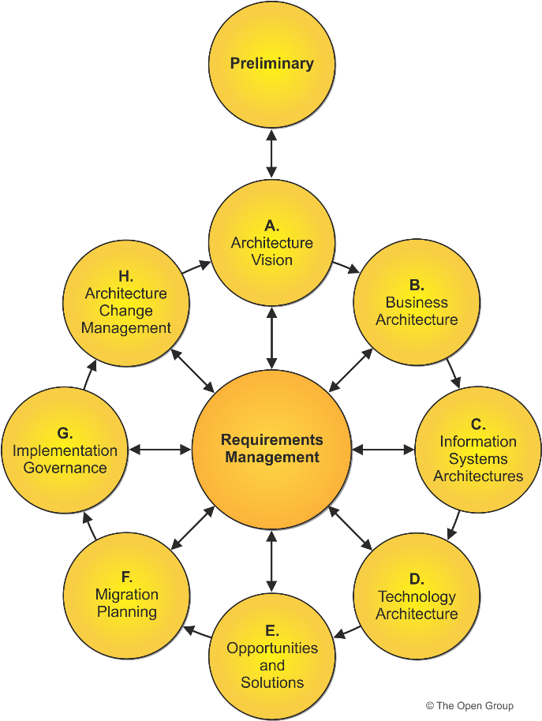

The TOGAF Standard, Version 9.2, is an update to the TOGAF 9.1 standard providing improved guidance, correcting errors, improving the document structure, and removing obsolete content. Key enhancements made in this version include updates to the Business Architecture and the Content Metamodel. All of these changes make the TOGAF framework easier to use and maintain.
It retains the major features and structure of the previous version of the standard including:

Modular Structure: The TOGAF standard has a modular structure. The modular structure supports:
- Greater usability – defined purpose for each part; can be used in isolation as a standalone set of guidelines
- Incremental adoption of the TOGAF standard
- Accompanying the standard is a portfolio of guidance material, known as the TOGAF Library, to support the practical application of the TOGAF approach
Content Framework: The TOGAF standard includes a content framework to drive greater consistency in the outputs that are created when following the Architecture Development Method (ADM). The TOGAF content framework provides a detailed model of architectural work products.
Extended Guidance: The TOGAF standard features an extended set of concepts and guidelines to support the establishment of an integrated hierarchy of architectures being developed by teams within larger organizations that operate within an overarching architectural governance model. In particular, the following concepts are included:
- Partitioning – a number of techniques and considerations on how to partition the various architectures within an enterprise.
- Architecture Repository – a logical information model for an Architecture Repository which can be used as an integrated store for all outputs created by executing the ADM.
- Capability Framework – a structured definition of the organization, skills, roles, and responsibilities required to operate an effective enterprise architecture capability. The TOGAF standard also provides guidance on a process that can be followed to identify and establish an appropriate architecture capability.
Architectural Styles: The TOGAF standard is designed to be flexible and it can be used with various architectural styles. Examples are provided both in the TOGAF standard, in Part III: ADM Guidelines & Techniques, and the TOGAF Library. Together these comprise a set of supporting materials that show in detail how the ADM can be applied to specific situations; for example:
- The varying uses of iteration that are possible within the ADM and when each technique should be applied
The various types of architecture development required within an enterprise and how these relate to one another

