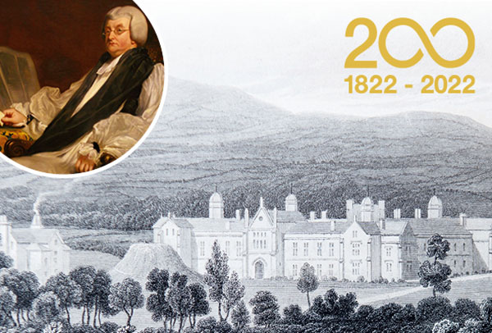
UNIVERSITY OF WALES TRINITY SAINT DAVID
STUDENT: MIHAITA GHEORGHE (2120440)
LECTURER: EJIRO ALBERT ESOWODE
BMSW4002 – EFFECTIVE TEAM WORKING AND COMMUNICATION

TABLE OF CONTENT •INTRODUCTION
•MODELS OF COMMUNICATION
•COMMUNICATION SKILS
•THE DISADVANTAGES OF TECHNOLOGY ON COMMUNICATION
•CONCLUSION
•REFERENCES

INTRODUCTION
Being able to communicate effectively is the most important life skill. Communication is a simple act of transferring information from one place to another, from one individual to another. This may be vocally (using voice), written (using printed or digital media such as books, magazines, websites or emails), visually (using logos, maps, charts or graphs) or non-verbally (using body language, gestures and the tone and pitch of voice). How this information is transmitted and received depends on your communication skills.
The information sharing in our society at national and international levels has become very smooth and efficient. With one click you can easily get any information you need. We can’t think of a world or situation without exchange of ideas, feelings, emotions, reactions, everything is possible today.

Models of communication
Shannon and Weaver Model of communication was created in 1948 when Claude Elwood Shannon wrote the article “A Mathematical Theory of Communication “in Bell System Technical Journal with Warren Weaver.
Shannon was an American mathematician and Weaver was scientist, their model was known as “THE MOTHER OF ALL MODELS”

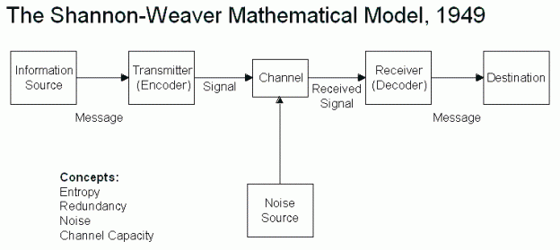

Concepts in Shannon and Weaver model:
•Sender (information source) is the person who makes the message, choose the channel and sends the massage.
•Encoder (Transmitter) is the sender who use machine, to convert message into signals.
•Channel (receiver) Decoder is the machine used to convert signals or binary data into message or the receiver who translates the message from signals.
•Receiver(destination) is the person who gets the message or the place where message reach.
•Noise is the physical disturbance like environment, people, machines, etc. Because of the noise the message was not received in same way.
•EXPLANATION OF SHANNON AND WEAVER MODEL
The sender encodes the message and send it to the receiver trough a channel like telephone or telegraph.
The sender converts the message into codes that machine understand, the message is sent in codes trough a medium.
The receiver must decode the message before understanding it and interpret.
The receptor machine can also act as a decoder in some cases, of course the channel can have noise and the receiver might not have the capacity to decode which might cause problems in communication process.
•IMPORTANT is that the Shannon and Weaver model 1949 DO NOT HAVE feedback.
We have an example of misunderstanding due to noise:
Caroline and Gabriel
Gabriel works on a building site and Caroline is his wife.
One day Caroline phoned Gabriel.
Hello, Gabriel, when you’re coming home, see if you can get me a chicken.
“Okay” replied Gabriel.
When he got home, Gabriel took of his boots and coat and went into the kitchen.
“Caroline, where are you? “He said.
“Here in the sitting room, Caroline said, “Where is the chicken?”
“What chicken? Asked Gabriel.
The one I asked you to get on your way home.
Oh, no! I thought you said when I come home, I will see you in the kitchen!
The noise of the building site could have distorted Caroline’s message and Gabriel heard” kitchen “instead of “chicken”.

SCHRAMM’S MODEL OF COMMUNICATION ,1954
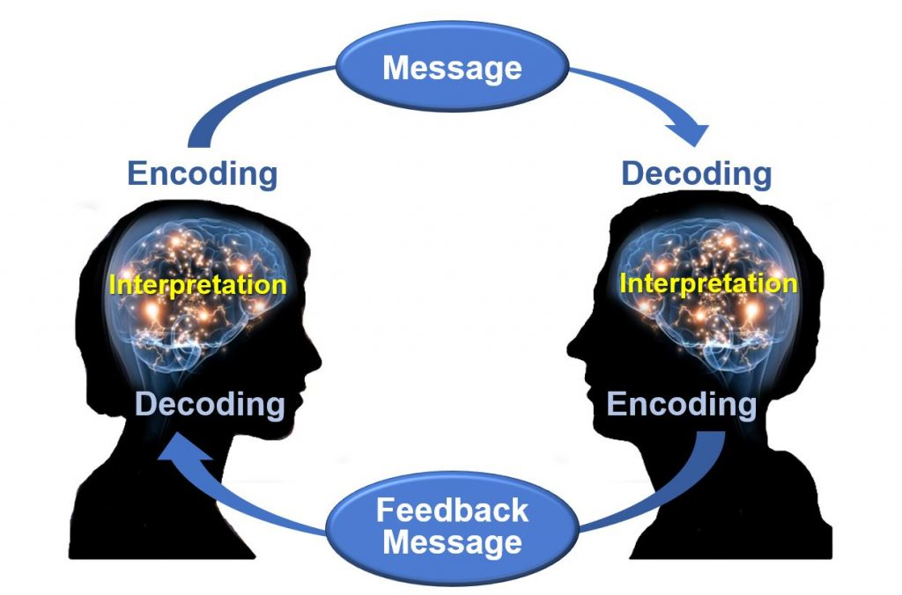•The Schramm Communication Model is a cyclical communication model containing all basic principles of communication.

•Schramm believed that an individual’s knowledge, experience and cultural background also play an important role in communication. Individuals from diverse cultures, religion or background tend to interpret the message in different ways.
The sender is the person who sends the message.
The encoder is the person who turns the message to be sent into codes. Is needed to think the right words and what order we should send our messages to communicate our ideas to the message receiver.
The decoder is the person who gets the encoded message which has been sent by the encoder and converts it into the language understandable by the person. When receiving a message, we need to use our reading skills, listening skills to decode the message so it makes sense to us.
The interpreter is the person who works to understand and analyse the message. The interpreter and receiver are the same people. One person may interpret the message in a totally different way to someone else. Or they may not understand it the same way as the encoder, meaning they have ‘misinterpreted’ the text.
The receiver is the person who gets the message. will decodes and interprets the actual message.
The message is the data sent by the sender and the information that the receiver gets.
Feedback is the process of acknowledging the received message by the receiver.
Media, PHONE is the channel used to send the message.
Noise is the interference caused during the process.
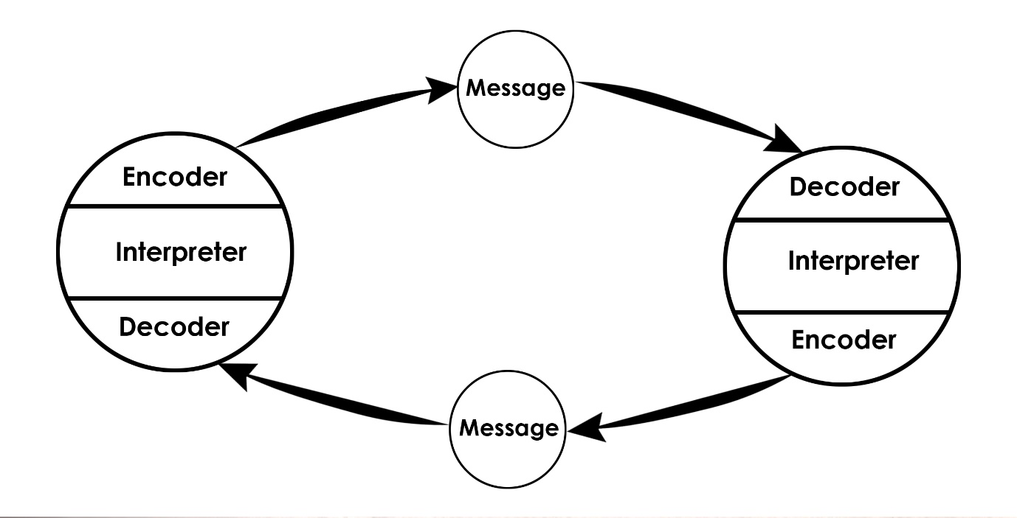
The Professor and The Village People

A Professor of English at a well-known Welsh University lived in a large house not far from a little village. He never went into the village and always shopped in the town near the university because he had nothing in common with the village people, who were largely uneducated and working manual jobs.
One night, the professor fell asleep while smoking his pipe and the pipe fell onto the carpet and started fire.
When the professor awoke and saw the house on fire, he rushed into the village, screaming:
“The edifice is being consumed by a great conflagration!”
The village people looked at him and continued doing what they were doing, don’t you understand? He spoke.
“The edifice is being consumed by a great conflagration!”
They ignored him.
When the professor returned home, he saw his house destroyed.
The next day, he went into the village crying. “Why didn’t you help me? My home has been destroyed by the fire. I came and begged you last night. “
“But Professor, why didn’t say that your house it was on fire? we would have helped.”
Professors speak in different (sophisticated) language with village people, and they do not understand what he wants from them.

THE 1960, BERLO’S COMMUNICATION MODEL


Berlo’s Model of Communication was built around the Shannon-Weaver model of communication. In 1960, David Berlo(SMCR) explained individual communication components and the factors affecting those components through the Sender-Message-Channel-Receiver communication model.
•Berlo’s model have four main components: SENDER, MESSAGE, CHANNEL and RECEIVER.
•This model is focusing on ENCODING and DECODING.

Components of Berlo’s Model of Communication
S -Sender
Sender is the source of the message or the person who SEND the message. The person or source sends the message to the receiver.

Communication Skills
Communication skills are a factor that affects the communication process. If the sender has good communication skills, the message will be communicated better than if the sender’s communication skills are not good. if the receiver cannot UNDERSTAND the message, then the communication will not be effective. Communication skills include the skills to speak, present, read, write, listening, etc.
Attitude
The attitude of the sender and the receiver creates the effect of the message. The person’s attitude towards self, the receiver and the environment change the meaning and effect of the message.
Knowledge
Familiarity with the subject of the message makes the communicated message have more effect. Knowledge on the subject matter makes the communicator send the message effectively.
Social Systems
Values, beliefs, laws, rules, religion and many other social factors affect the sender’s way of communicating the message and creates difference in the generation of message. Place and situation also fall under social systems.

Culture
Cultural differences make messages different. A person from one culture might find something offensive which is very much accepted in another culture.
M-Message
A message is the substance that is being sent by the sender to the receiver. It might be in the form of voice, audio, text, video or other media. The key factors affecting the message are:
Content
Content is the thing that is in the message.
Elements
Elements are the non-verbal things that tag along with the content like gestures, signs, language.
Treatment
Treatment is the way in which the message is conveyed to the receiver.
Structure
The structure of the message or the way it has been structured, affects the effectiveness of the message.
Code
Code is the form in which the message is sent. It might be in the form of language, text OR video.
C-Channel
Channel is the medium used to send the message. In mass communication and other forms of communication, technical machines might be used as a channel like telephone, internet, etc.

Hearing _ We receive the message through hearing.
Seeing – We perceive through seeing. We also get non-verbal messages by seeing.
Touching – Many of the non-verbal communication happens from touching like holding hands.
Smelling – We collect information from smelling.
Tasting – Taste also provides the information to be sent as a message.
R- Receiver
Receiver is the person who gets the message sent in the process. The message might not have the same effect as intended if the receiver and sender are not similar. The receiver must also have a very good listening skill.

Communication skills
Attitudes
knowledge
Social Systems
Culture
Criticisms of Berlo’s SMCR Model
There is no concept of feedback, so the effect is not considered.
There is no concept of noise or any kind of barriers in communication process.
It is a linear model of communication, there is no two-way communication.
Both people must be on same level according to all the factors mentioned above, but not true in real life.
Verbal and Non-Verbal communication
Verbal and non-verbal communication differs from each other based on means they used for a communication. Verbal is one which have both oral and written communication and involve use of words. Oral form of communication covers face to face meetings, telephonic conversations, videoconferences, presentations etc. Written communication, involve use of letters, e-mails, manuals, report, and bulletin board postings.

Non-verbal communication usually covers facial expression, hand and body movements, gestures, physical appearance, space, etc. It is a behavioural aspect of communication which includes both intentional and unintentional one.

COMMUNICATION SKILS

We use communication skills when giving and receiving different kinds of information. This can be written, spoken or even body language. You might need to communicate ideas, feelings or what's going on around you. Communication skills involve listening, speaking, observing and empathising. The skills are important if you are speaking face-to-face, on a video call or through letters and emails.
These skills allow you to understand and be understood by others.

Communication skills list:
- Active listening
- Adapting your communication style to your audience
- Friendliness
- Confidence
- Offering and taking feedback
- Volume and clarity
- Empathy
- Respect
- Understanding body language
- Responsiveness

THE DISADVANTAGES OF TECHNOLOGY ON
COMMUNICATION
We can’t deny the fact, that among all the inventions the Internet and mobile phone are the two that have changed communication completely. The devices significantly reduced the time which information is sent and they are widely available.
The most worrying is that communication with technology is becoming not common one, but the only way of communication. People tend to forget about all the values and advantages of a face-to-face conversation and meetings. People find it unnecessary to waste their time on travelling or getting stuck in traffic if they can save minutes by calling someone from the place they are.
Internet conversation: lacks true emotions, we cannot hug somebody when they are sad or observe their true feelings.

Worst use of modern communication devices is when someone wants to avoid confronting a difficult situation with another person. Nowadays, a lot of teenagers break off with their partners by texting them. The result may be that in the future they can be unable to face serious problems that cannot be dealt in other way that during a face-to-face talk.

CONCLUSION
Communication is art, also it’s the centre of developing people and organisations, probably the most important chapter of all. The entire world is connected through this powerful tool and no future is possible without Communication.

REFERENCES

•Effective communication skills; 2010; MTD Training & Ventus Publishing Aps
•Quintanilla, Kelly M, (2020) Business and Professional
Communication; keys for workplace excellence SAGE Publications, Inc.
•Nonverbal Communication Today, Mary Ritchie key editor, Reprint 2019; De Gruyter Mouton.
•Communication in everyday life: A survey of communication, Duck, Steve,, McMahan, David T,, Fourth edition., Los Angeles; SAGE, [2021].
•Listening, Communication Abilities and Success at Work; Sypher, Beverley Davenport; Bostrom, Robert N ; Seibert, Joy Hart; Journal of Business Communication (1989).

