

University of Wales
Trinity Saint David

Davis Watkins (P150289)
BSc Motorsport Engineering Level 6

GD&T and Drafting

09/03/2020

CAD & FEA (M6X02210)

Contents
1.0: Introduction ………………………………………………….. Page 1

2.0: Methodology …………………………………………………. Page 1

3.0: Research ……………………………………………………….. Page 1
3.1: GD&T Research
3.2: Tolerances
3.3: Use of a Tolerance

4.0: Parts ………………………………………………………………. Page 4

5.0: Technical Drawings …………………………………………. Page 6

6.0: List of Materials ………………………………………………. Page 7

7.0: References ……………………………………………………… Page 8

8.0: Bibliography ……………………………………………………. Page 9

9.0: Appendices …………………………………………………… Page 10
CAD Files - https://uowtsd-my.sharepoint.com/:f:/g/personal/dwatkins_150289_student_uwtsd_ac_uk/Ehgva9Eo56JGkr-hHC3kqJ4B1Qy_hZ1WtszkARp6Puju-A?e=31F2Pw
1.0: Introduction
The aim of this assessment is to do develop an understanding of the different tolerances and fitments used in industry. Every machined part will come with a tolerance to provide a minimum and maximum amount of material allowed for that part, different parts will come with a larger or smaller tolerance based on the purpose of that part. If it’s a shaft that needs to fit into a hole for example, too little material would cause excessive movement in the hole and create a loose fit. Whereas too much material would cause a lot of friction and may require a bit of force, this would therefore create an interference fit. If the shaft and hole both have a very similar diameter it may not require much force, but there wouldn’t be much movement in the shaft like a clearance fit, this therefore creates a transition fit. So, using these different fits, a motorcycle yoke and stem assembly must be put together with an appropriate fitment style labelled, followed by tolerance limits set for each component found from the references.

2.0: Methodology
Firstly, using the SolidWorks software and components provided, an assembly needs to be combined with the correct mates to assemble correctly. This means the stem must have a concentric mate inside of the yoke mount to slot into the hole, and the custom-made bolts must have a screw mate to wind inward and outwards with a limit mate to avoid the bolts pushing into the material. Once the assembly is complete, a technical drawing will be developed using SolidWorks where all parts will be dimensioned and given a tolerance based on the fit used by the connecting parts.

3.0: Research
3.1: ‘GD & T’ Signs

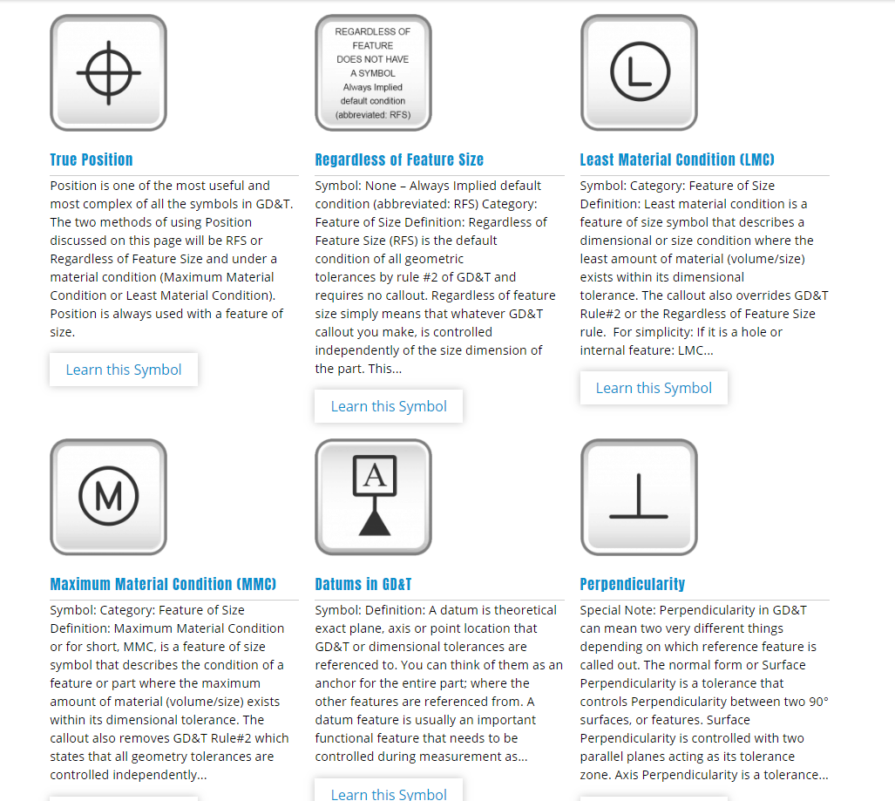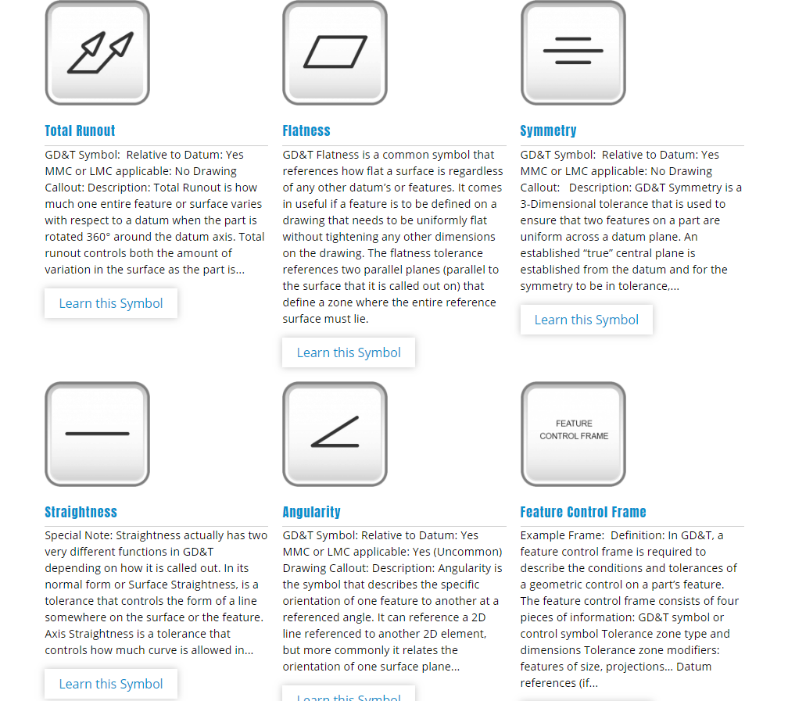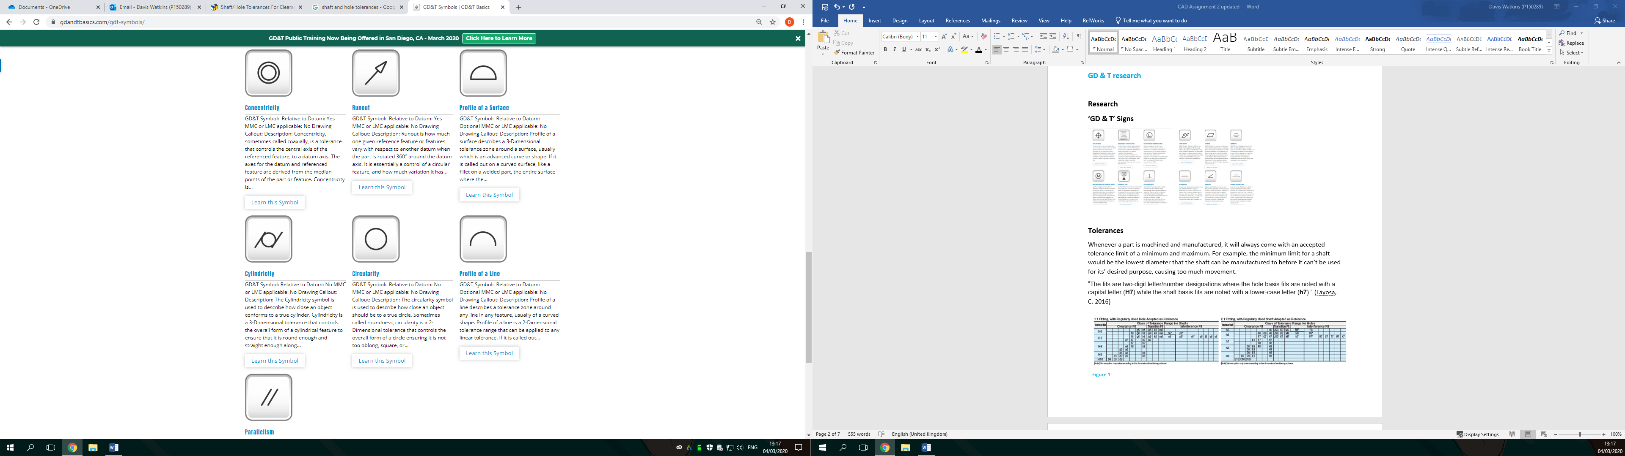
Figure 3: GD&T Symbols (gdandtbasics.2019)
Figure 2: GD&T Symbols (gdandtbasics.2019)
Figure 1: GD&T Symbols (gdandtbasics.2019)

True Position: This is used to pinpoint the centre of a hole, it represents the exact point where the hole would be placed.
1

Least Material Condition (LMC): This is used to describe a dimension when the least amount of material is used, like a shaft using the lowest diameter limit allowed by the tolerance.

Maximum Material Condition (MMC): This is the opposite of an LMC. Meaning it is used when the diameter is at its’ maximum, like a shaft at the maximum tolerance limit.

Perpendicular: This is used when a surface needs to be exactly 90ᵒ from another referenced surface, it is often used on adjoined surfaces.

Concentric: This is used when a circular face must be centralised to another circular face, like a shaft fitting into a hole, for it to fit correctly it must be aligned central to the hole.

Parallel: this is used to position a face at a similar angle to a reference face or plane, using this would position a face at the same angle of a plane or another face

3.2: Tolerances
Whenever a part is machined and manufactured, it will always come with an accepted tolerance limit of a minimum and maximum. For example, the minimum limit for a shaft would be the lowest diameter that the shaft can be manufactured to before it can’t be used for its’ desired purpose, causing too much movement.
“The fits are two-digit letter/number designations where the hole basis fits are noted with a capital letter (H7) while the shaft basis fits are noted with a lower-case letter (h7).” (Layosa, C. 2016)
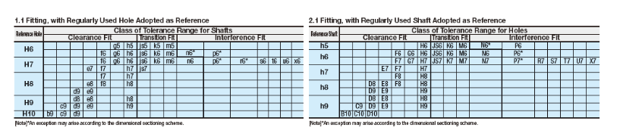
Figure 5: Size Fittings (Layosa, C.2016)

Figure 4: Size Fittings (Layosa, C.2016)

As an example, using the data from the tables in figure 4 & Figure 5, we can get a general understanding of the different fits. It shows that a H6 hole would have a clearance fit with a f6 shaft, it would have a transition fit with a m6 shaft, and an interference fit with a p6 shaft.
2
3.3: Uses of a tolerance
“The first principle to grasp is the fit designation of the shaft/hole joint. The fit designation ranges from clearance fits to interference fits. This is an intuitive concept to grasp- a clearance fit specifies a fit where there will always be a gap in the joint between the mating shaft and hole. Even at the maximum shaft and minimum hole tolerance, the shaft will be able to freely pass through the mating hole. Conversely, an interference fit is a fit where there will always be overlap in the joint between the specified mating shaft/hole, even at the minimum material condition values allowed by the shaft and maximum value allowed by the hole tolerance values (i.e., the largest hole and the smallest shaft).” (Layosa, C. 2016)
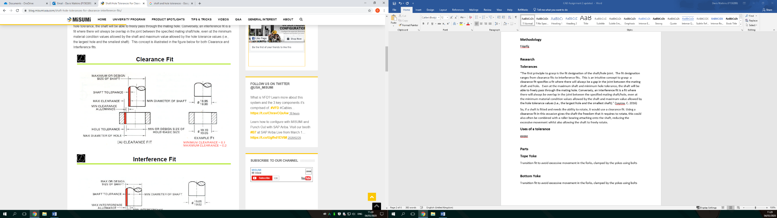
So, if a shaft is fitted and needs the ability to rotate, it would use a clearance fit. Using a clearance fit in this occasion gives the shaft the freedom that it requires to rotate, this could also often be combined with a roller bearing attaching onto the shaft, reducing the excessive movement whilst also allowing the shaft to freely rotate. Below is an example of a clearance fit that could be used in this occasion.
As shown in Figure 6, a clearance fit is where the hole has enough clearance for the shaft to slide into. For this example, the shaft has a diameter of 18.90mm +0.05mm tolerance, whereas the hole has a diameter of 19.05mm +0.05mm tolerance. Specified below the hole is a tolerance for the clearance, showing a minimum allowed clearance of 0.1mm and a maximum allowed clearance of 0.2mm. so this means the hole is a larger diameter than the shaft.
Figure 6: Clearance Fit (Layosa, C. 2016)

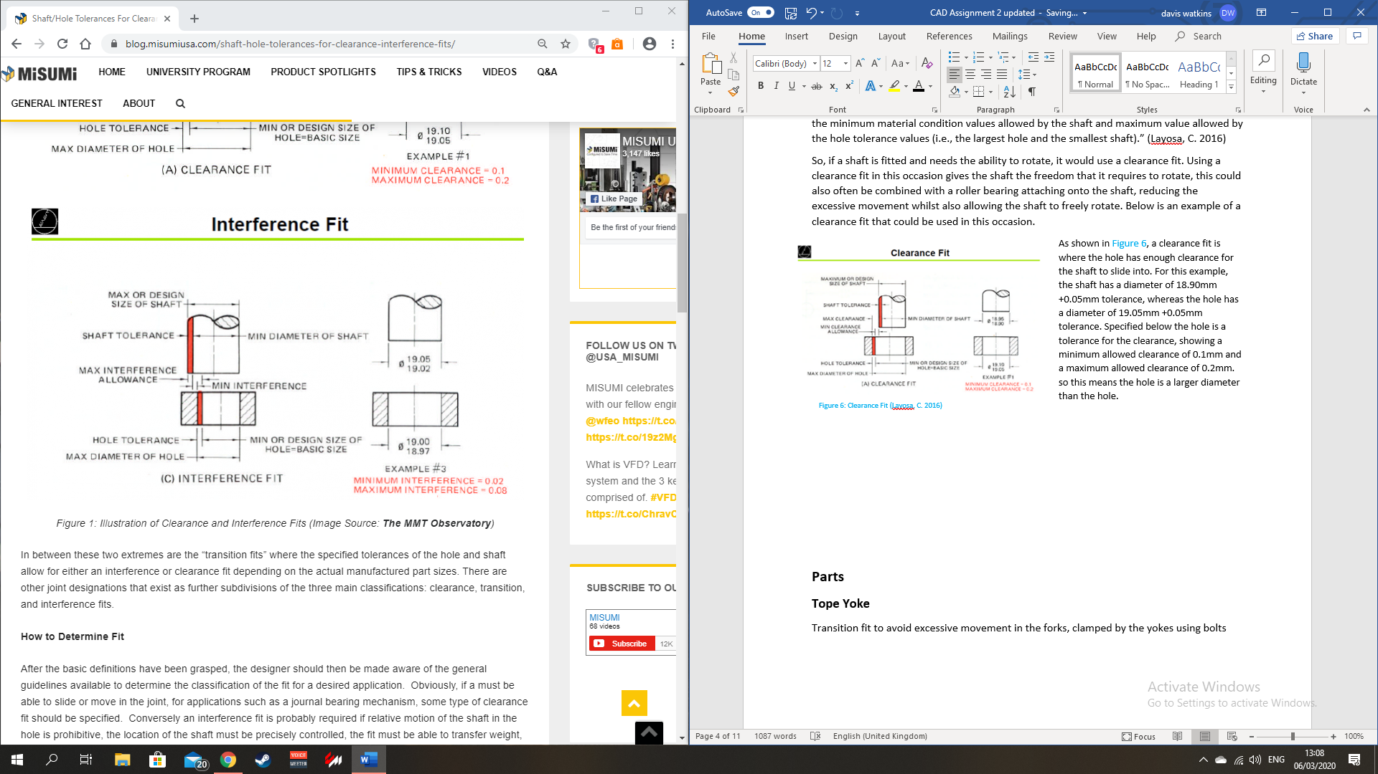
As shown in Figure 7, an interference fit is where the hole doesn’t have enough clearance for the shaft to slide into, so therefore it needs a force to fit. For this example, the shaft has a diameter of 19.02mm +0.03mm tolerance, whereas the hole has a diameter of 18.97mm +0.03mm tolerance. Specified below the hole is a tolerance for the clearance, showing a minimum allowed interference of 0.02mm and a maximum allowed interference of 0.08mm. so this means the shaft is a larger diameter than the hole.
Figure 7: Interference Fit (Layosa, C.2016)
3
4.0: Parts
Tope Yoke
Clearance fit to avoid damaging the forks, clamped by the yokes using bolts.
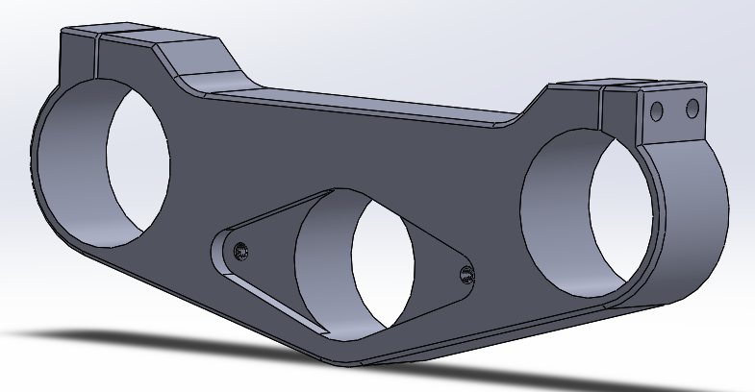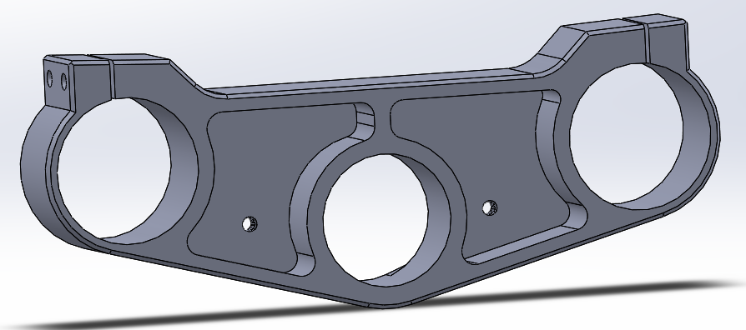
Figure 9: Top Yoke Back (Provided)
Figure 8: Top Yoke Front (Provided)
Clamp - M6x1.0 thread: 17.5mm length. Top Insert - M6x1.0 thread: 6mm length
Bottom Yoke
Clearance fit to avoid damaging the forks, clamped by the yokes using bolts.
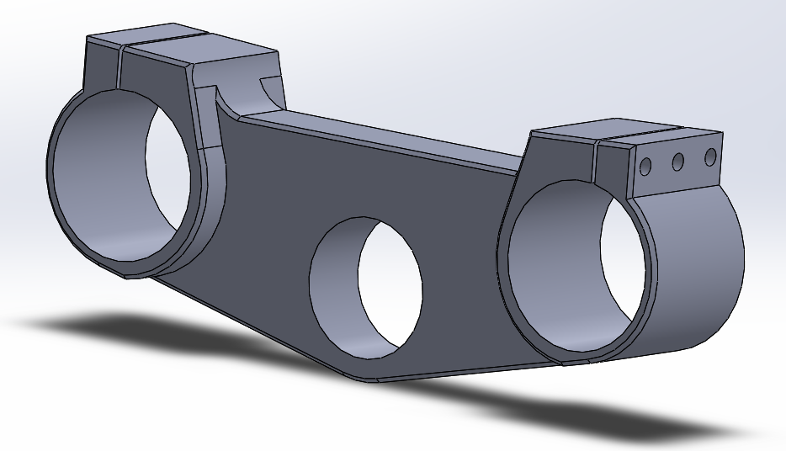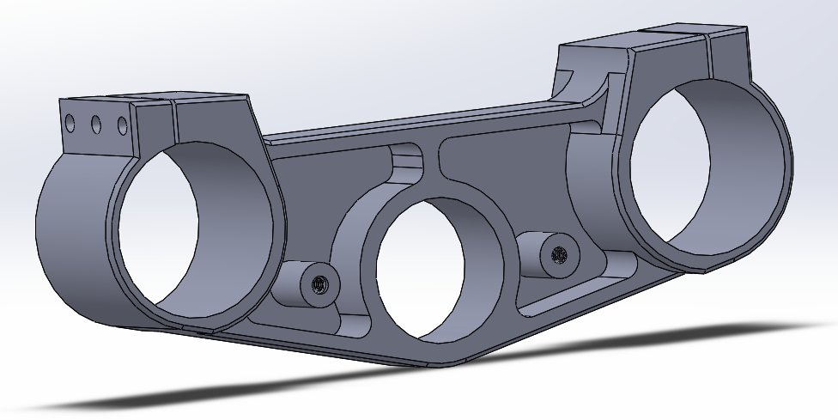
Figure 11: Bottom Yoke Back (Provided)
Figure 10: Bottom Yoke Front (Provided)
Clamp - M6x1.0 thread: 17.5mm length. Bottom Insert - M6x1.0 thread: 21mm length.

Stem
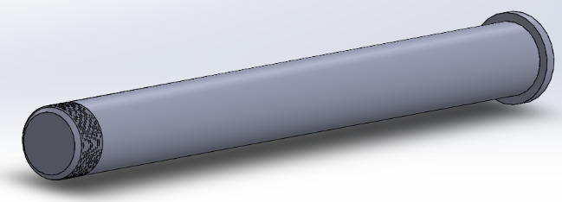
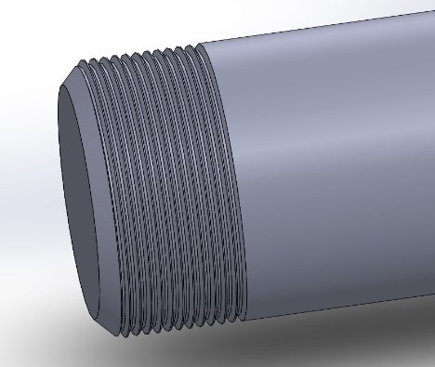
Clearance fit because the stem needs to rotate.
Figure 12: Stem (Provided)
M33x1.0mm thread: 25.90mm diameter, 13mm long
Figure 13: Stem (Provided)

4
Stem Nut
Prevents the stem from coming loose. this is important because if this came loose the adjoined components would come out, these front components hold the wheel on the bike so this would definitely cause a serious accident.
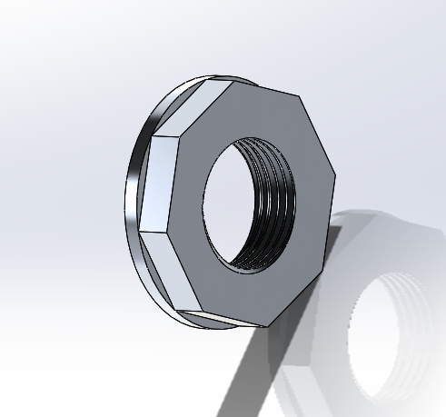 M33x1.0 thread: 26mm diameter, 10mm thick
Figure 14: Stem Nut (Watkins, D. 2020)

Yoke Bolts
Used to tighten the grip provided by the yokes around the forks, prevents the forks sliding under tension. This would be bad as the front of the bike would drop and cause the bike to become unstable, causing an accident and likely injuring the rider depending on the speed the bike is travelling at that moment.
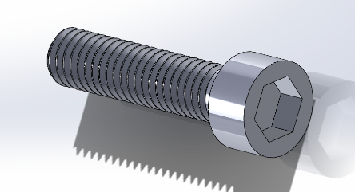
(Clamp Bolts) M6x1.0 thread: 6mm diameter x 1mm pitch, 25mm long
Figure 15: Clamp Bolt (Watkins, D. 2020)

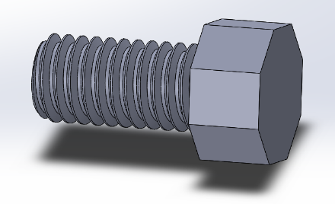
(Top & Bottom Insert Bolts) M6x1.0 thread: 6mm diameter x 1mm pitch, 20mm long
Figure 16: Insert Bolts (Watkins, D. 2020)

5
5.0: Technical Drawings
BS 4500: 1969 Standard
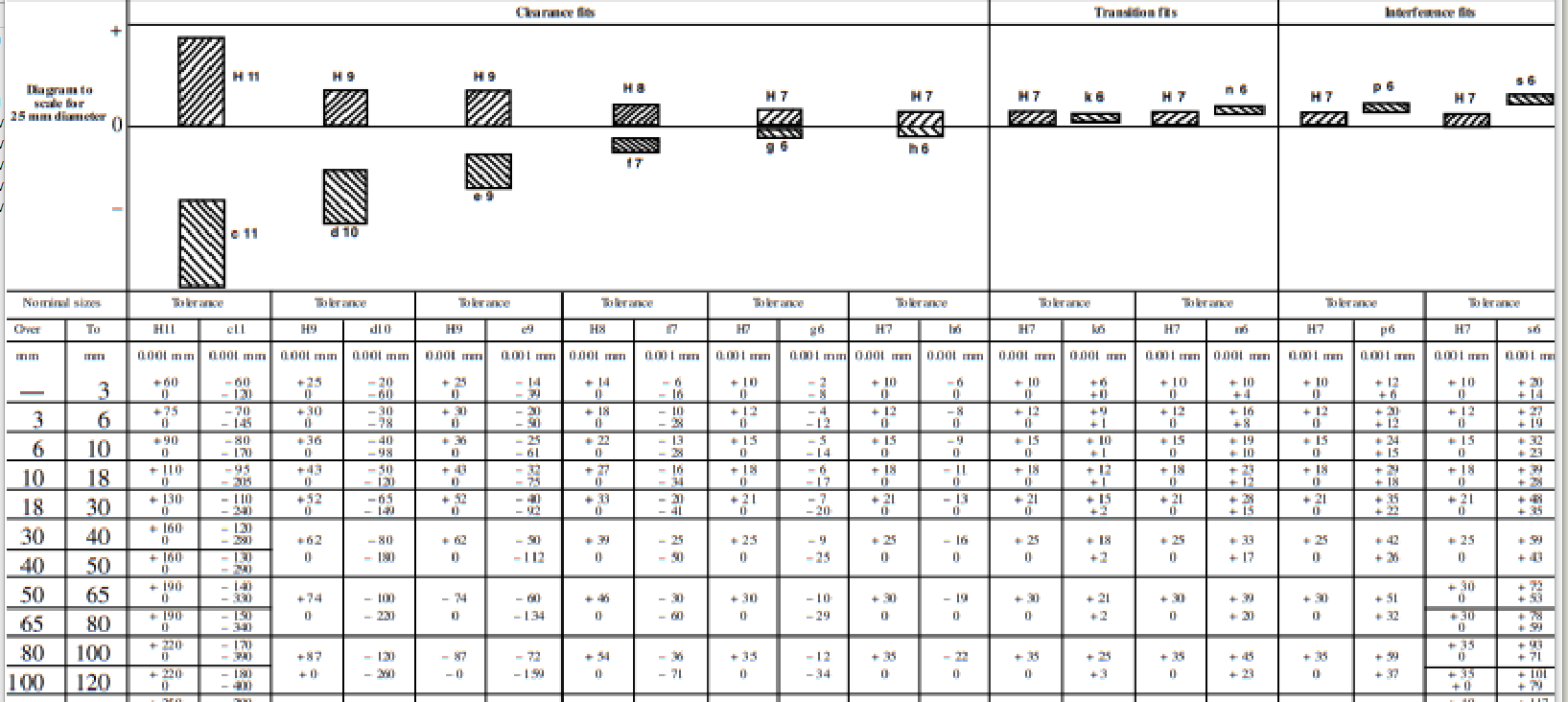
Using the referenced values provided by the BS 4500 standards, the holes with be given a tolerance to follow. Below is an example of these standards.

Top Yoke
Fork clamping holes with a diameter of 53mm, to clamp onto forks with a diameter of 52.6mm. The forks are fitted into place by 3 M6x1.0mm bolts.

Bottom Yoke
Fork clamping holes with a diameter of 58mm, to clamp onto forks with a diameter of 58.4mm. The forks are fitted into place by 3 M6x1.0mm bolts.

Stem
Stem connecting the top yoke to the bottom yoke, a bar of length 270mm, attaches to the bottom insert and then keeps both yokes in position with a metal nut of thread M33x1.0mm.

Nuts & Bolts (Self Designed)
Connecting most of the components together are M6x1.0mm bolts, 4 x bolts at 20mm length to hold the top and bottom inserts in place, and 6 x bolts at 25mm length to clamp the forks in place.

6
List of Materials
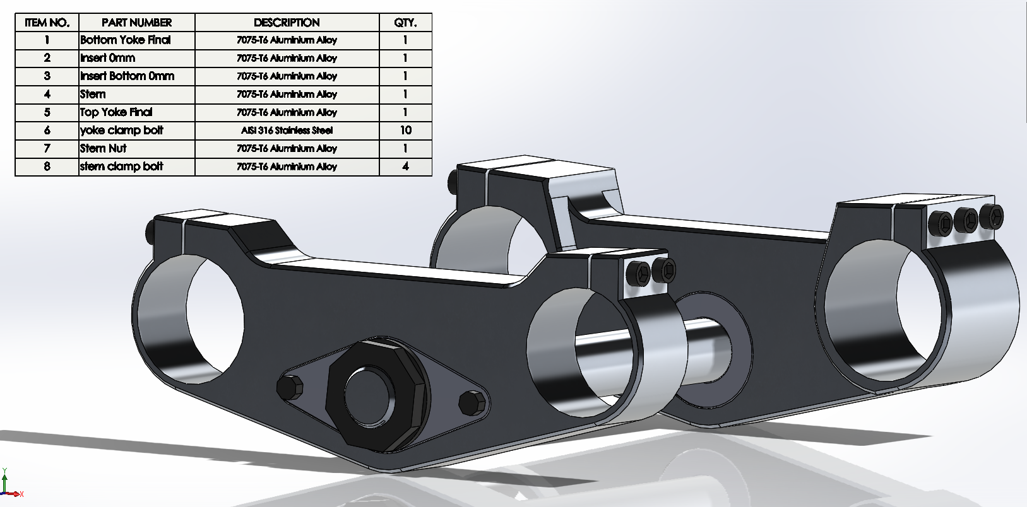
Figure 17: List of Materials (Watkins, D. 2020)
Because the main material for these parts would be Aluminium, there can’t be any stainless steel for long durations where it would be touching the Aluminium. This is due to the two different metals reacting to each other, resulting in galvanic corrosion or discolouration after a while. It is possible to mix these two metals but not for long periods of time without being replaced, if both metals are isolated correctly with a paint coating or using an insulating washer then they can be used. So, from this information, every component will be crafted using metals that don’t react badly against each other.
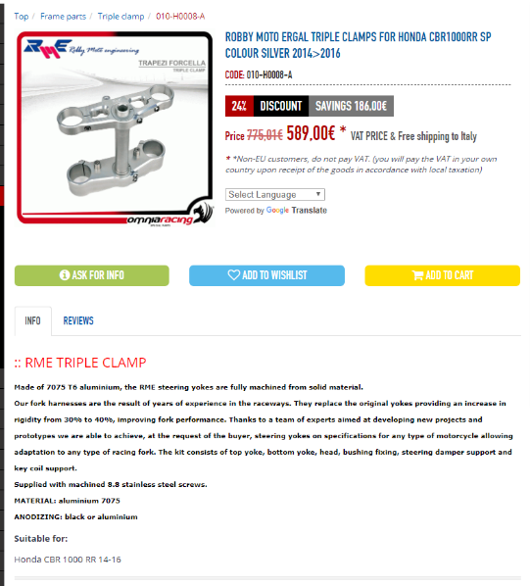
Top Yoke – 7075-T6 Aluminium Alloy, weighs. Value: 2.304/kg, Mass Density 2810kg/m3

Bottom Yoke – 7075-T6 Aluminium Alloy, weighs. Value: 2.304/kg, Mass Density 2810kg/m3

Stem – 7075-T6 Aluminium Alloy. Value: 2.304/kg, Mass Density 2810kg/m3
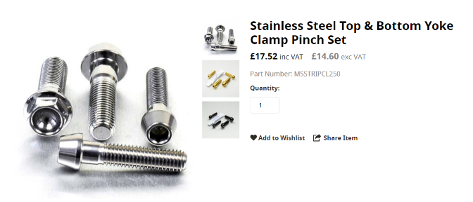
Figure 18: Aluminium Parts (OmniRacing. 2020)
7
Clamp Bolts – AISI 316 Stainless Steel. Value: 3.625/kg, Mass Density 8000kg/m3

Figure 19: Steel Bolts (OmniRacing. 2020)
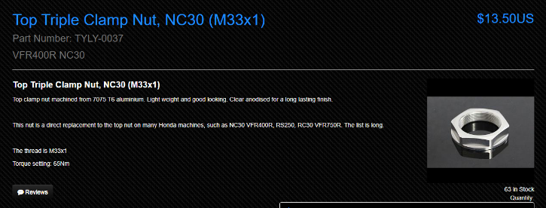
Stem Nut – 7075-T6 Aluminium Alloy, weighs. Value: 2.304/kg, Mass Density 2810kg/m3

Figure 20: Aluminium Nut (Tyga. 2020)

References:
(GD&TBasics. 2020). gdandtbasics.com. GD&T Symbols [Online]. Sourced from: https://www.gdandtbasics.com/gdt-symbols/ (Accessed 01/03/2020)
(Balax. 2011). balax.com. Metric Thredfloer Hole Size Chart [Online]. Sourced from: http://www.balax.com/catalog/thredfloer-taps/metric-thredfloer-hole-size-chart (Accessed 01/03/2020)
(Caresi. 2020). caresi.rezon.co. Uns Thread Size Chart [Online]. Sourced from: https://amesweb.info/Screws/Images/ISOThreadForm1.jpg (Accessed 01/03/2020)
(Accu. 2020). accu.co.uk. ISO Metric Thread Tolerance Tables [Online]. Sourced from: https://www.accu.co.uk/en/p/134-iso-metric-thread-tolerances (Accessed 01/03/2020)
(Deepri. 2020). Deepri.com. ISO Tolerances [Online]. Sourced from: http://www.deepri.com/technical/information/tech_iso_tolerances.html (Accessed 02/03/2020)
(Layosa, C. 2016). blog.misumiusa.co. Shaft and Hole Tolerances and Fits [Online]. Sourced from: https://blog.misumiusa.com/shaft-hole-tolerances-for-clearance-interference-fits/ (Accessed 02/03/2020)
Yokes and Stem material: (OmniaRacing.net. 2020). ROBBY MOTO ERGAL TRIPLE CLAMPS FOR HONDA CBR1000RR SP COLOUR SILVER 2014>2016 [Online]. Sourced from: https://www.omniaracing.net/en/robby-moto-ergal-triple-clamps-for-honda-cbr1000rr-colour-silver-20142016-p-31080.html (Accessed 03/03/2020)
Stem Nut material and thread: (Tyga. 2020). Tyga-Performance.com. Top Triple Clamp Nut, NC30 (M33x1) [Online]. http://tyga-performance.com/product_info.php?products_id=1141 (Accessed 03/03/2020)
Corrosion Research: (Fasteners, M. 2018). marshfasteners.com. Can Stainless Steel and Aluminum Be Used Together? [Online]. Sourced from: https://www.marshfasteners.com/can-stainless-steel-and-aluminum-be-used-together/ (Accessed 04/03/2020)
Clamp Bolts: (ProBolt. 2020). Pro-bolt.com. Stainless Steel Top & Bottom Yoke Clamp Pinch Set [Online]. Sourced from: https://www.pro-bolt.com/stainless-steel-top-bottom-yoke-clamp-pinch-set-15sstripclam250.html (Accessed 04/03/2020)
(EngineeringToolbox. 2020) Engineeringtoolbox.com. ISO 724 - Metric Threads [Online]. Sourced from: https://www.engineeringtoolbox.com/metric-threads-d_777.html. (Accessed 05/03/2020)
8
Bibliography:
“Corrosion develops when two dissimilar materials are combined in a corrosive electrolyte. This can occur when certain materials (such as aluminium) are in contact with stainless steel.

The most common solution to prevent galvanic corrosion is to select metals that are close together in the galvanic series. Separating the metals that are incompatible reduces the risk of these cells deteriorating. According to the levels of galvanic corrosion, stainless steel that comes into contact with materials such as copper is less likely to be a risk than when it is in contact with aluminium.

Although aluminium reacts negatively to stainless steel, large surface areas of aluminium to stainless steel can be acceptable depending on local environmental conditions. Severe corrosion is likely to take place in a marine environment. However, there are methods that can be used to reduce this effect. A good way to reduce corrosion is to use an isolating coating or paint on the aluminium and the steel to isolate them electrically. Insulating washers are also effective in isolating the two dissimilar materials and creating a relatively safe surface area.

Along with corrosion, discoloration of stainless steel may occur when combined with aluminium. This is also called ‘tea staining’. Discoloration can be prevented by the use of insulation and regular maintenance. Passivation can also be used to create the passive film on the fastener for better corrosion resistance.” (Fasteners, M. 2018)

9
Appendices:
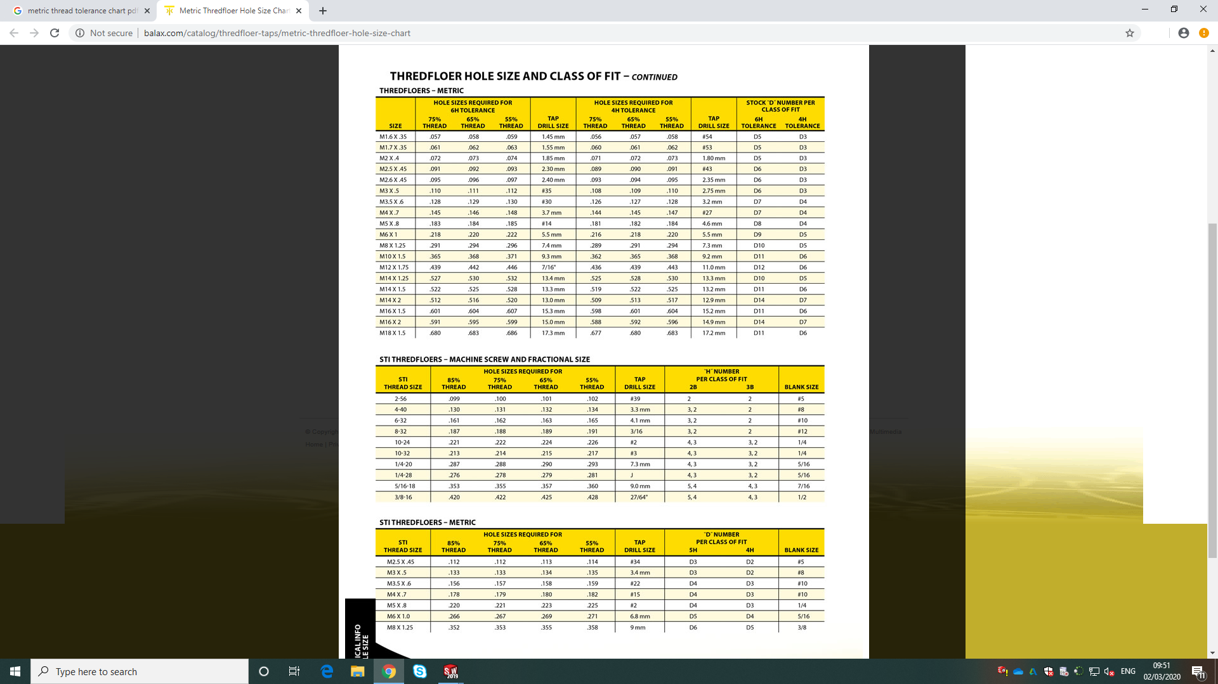
Figure 21: Threads (Balax. 2011)
10
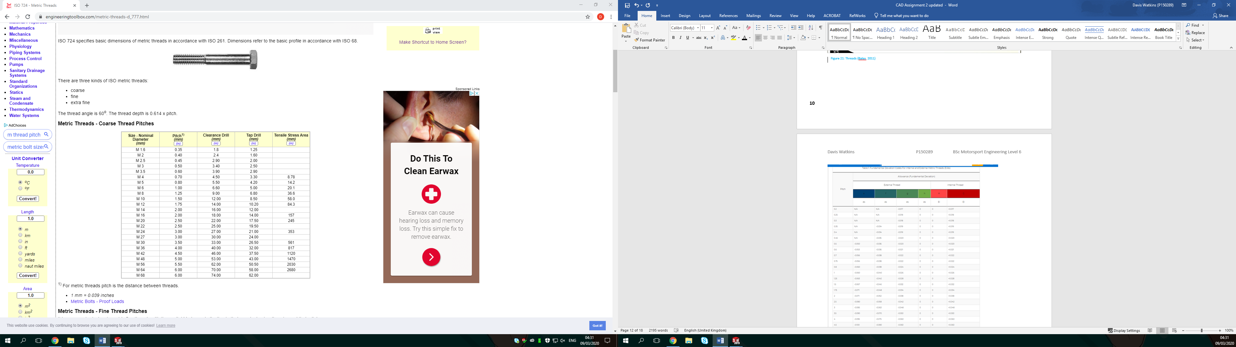
Figure 22: Bolt Thread (EngineeringToolbox. 2020)
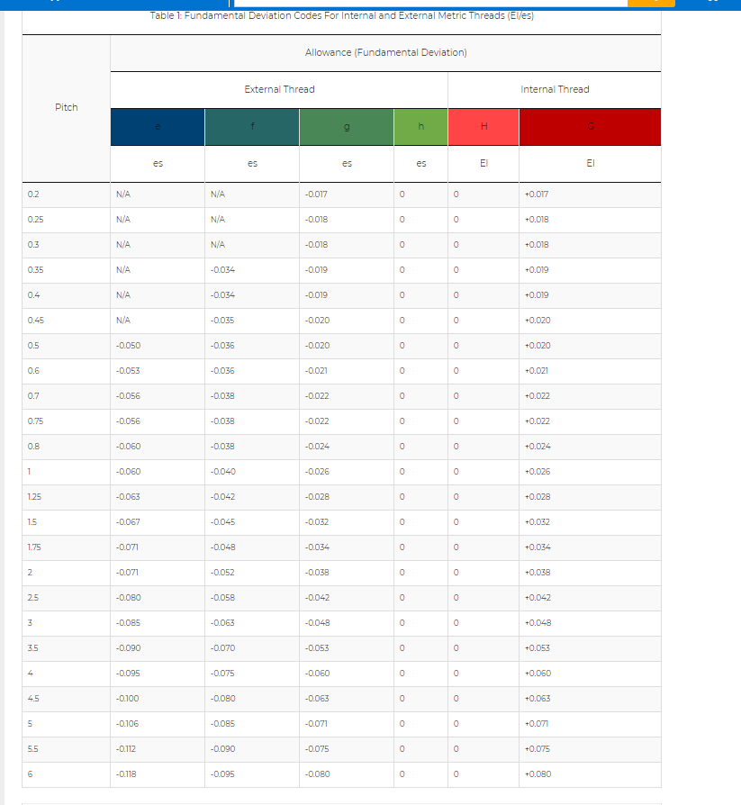
Figure 23: Hole Tolerances (Tyga. 2020)
11
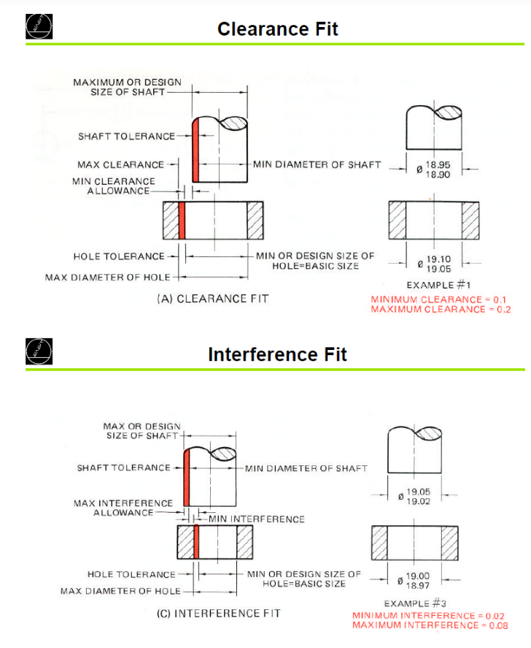
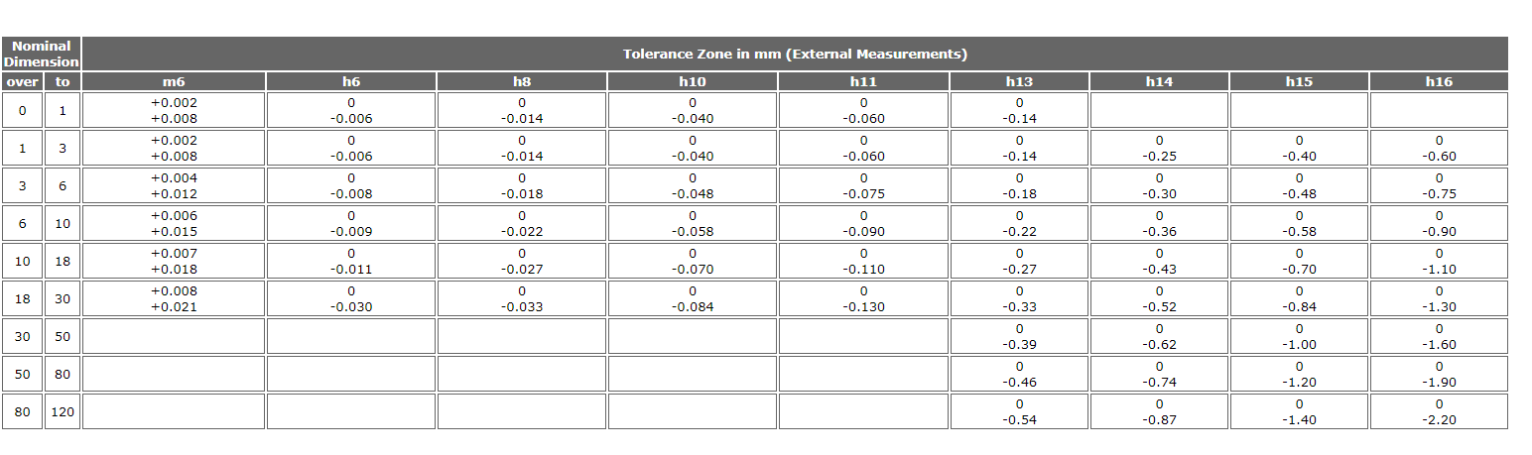
Figure 25: Shaft Fitments (Layosa, C. 2016)
Figure 24: ISO Tolerances (Deepri. 2020)
12
Figure 26: GD&T Symbols (GD&TBasics. 2020)
Figure 27: GD&T Symbols (GD&TBasics. 2020)
13
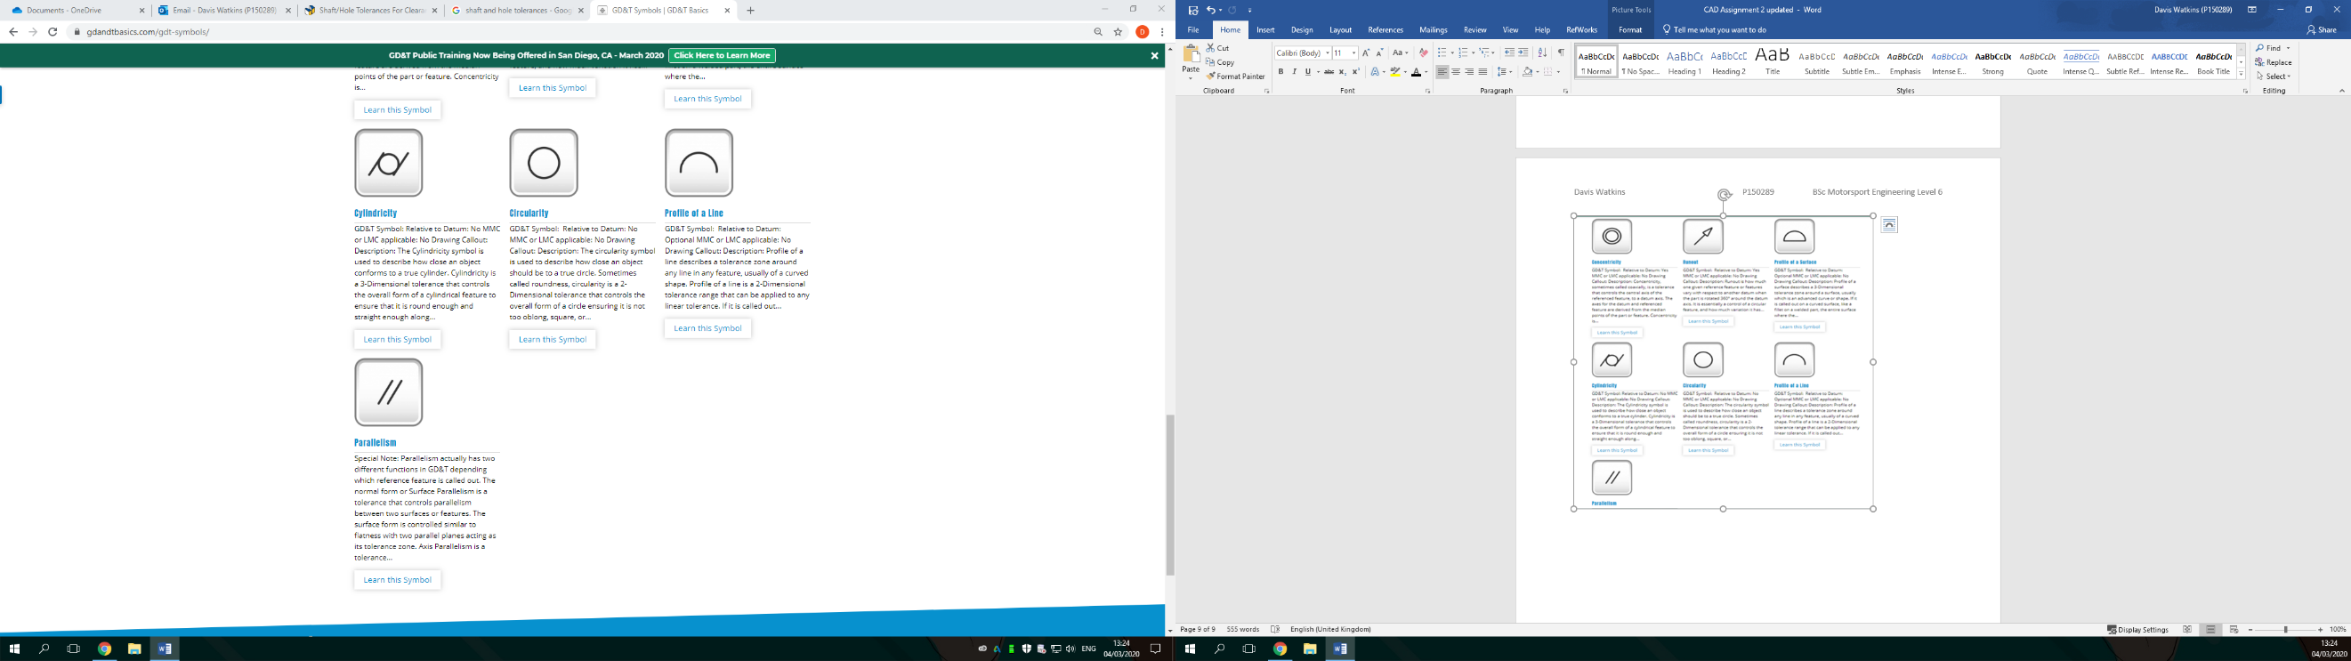
Figure 28: GD&T Symbols (GD&TBasics. 2020)

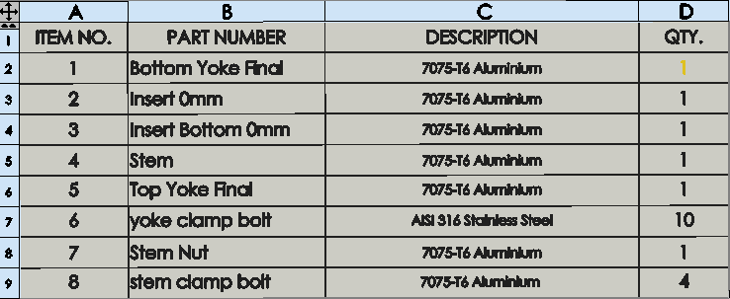
Figure 29: Material List (Watkins, SolidWorks. 2020)
14
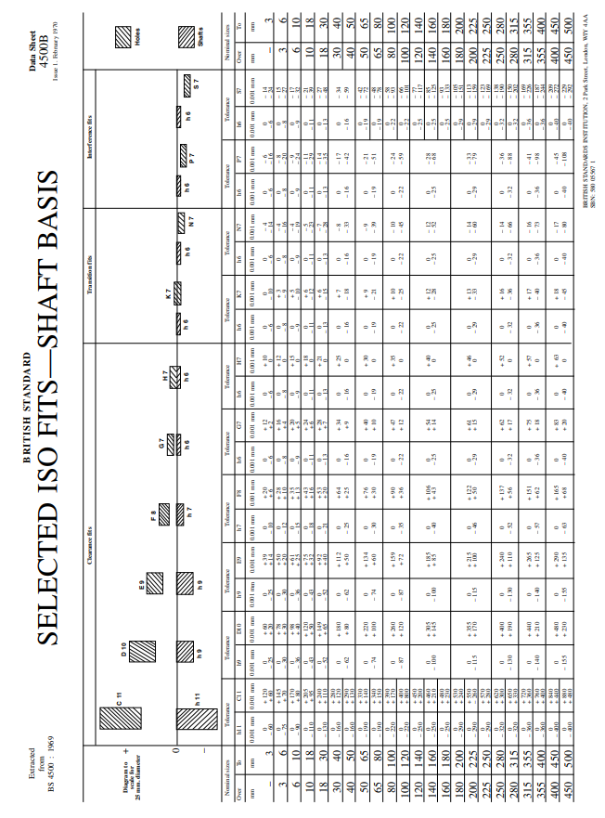
15
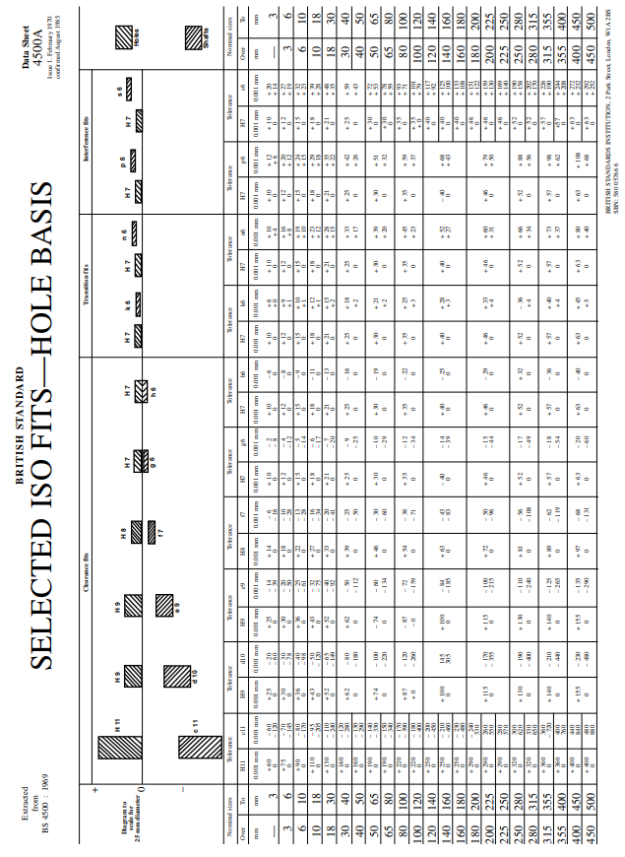
16

