Student name: Abdul Quiyum
Student ID number: 2229328
Module code: BMIH6001
Assignment Title: Assignment Two Conference Presentation
Theme: The deepening mental health crisis in the Hospitality industry
Lecturer: Natalie Brailsford

I confirm that I have not used any AI tools in the research and creation of this assignment. I confirm that I have not presented any AI generated materials as my own work. I confirm that I have copies of my drafts, notes, and other resources I used, which I may be asked to provide in evidence.
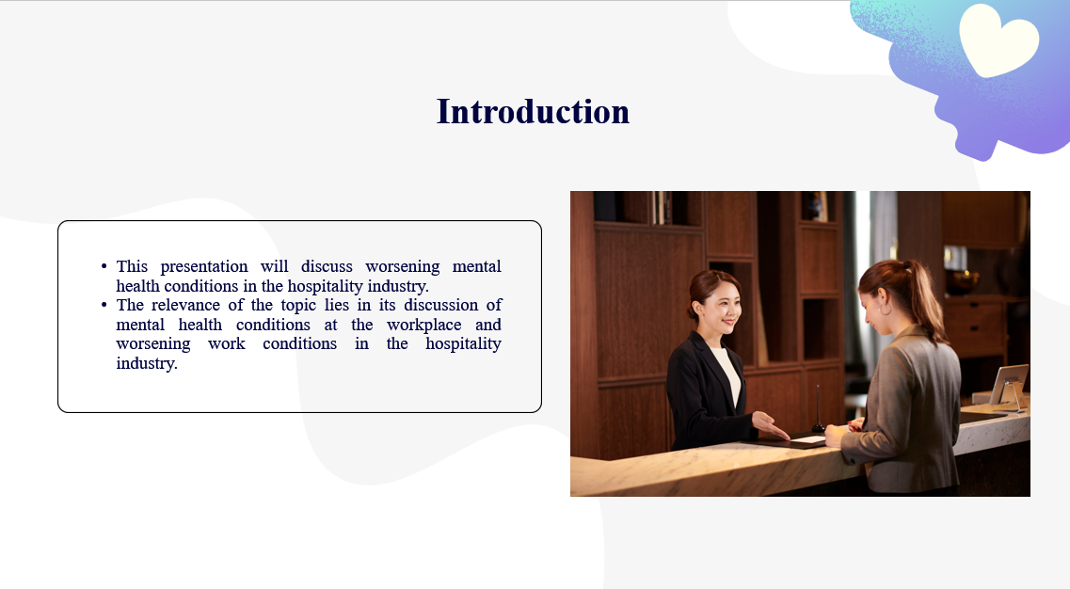
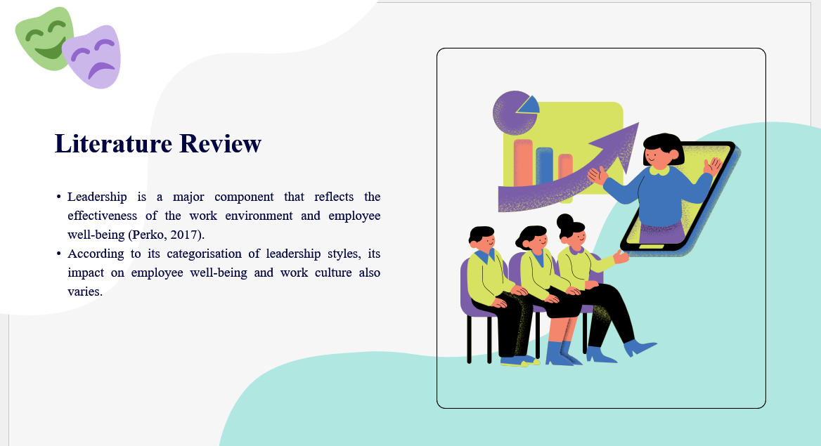
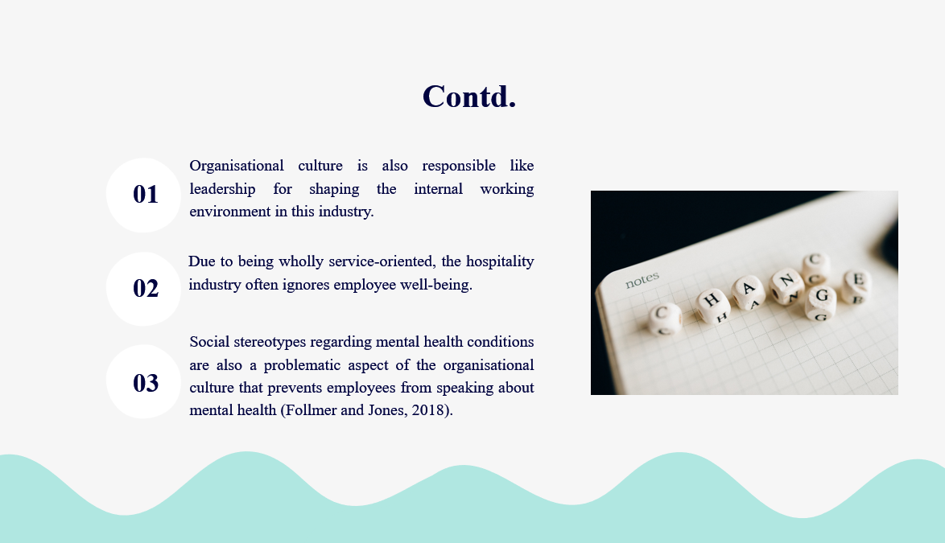
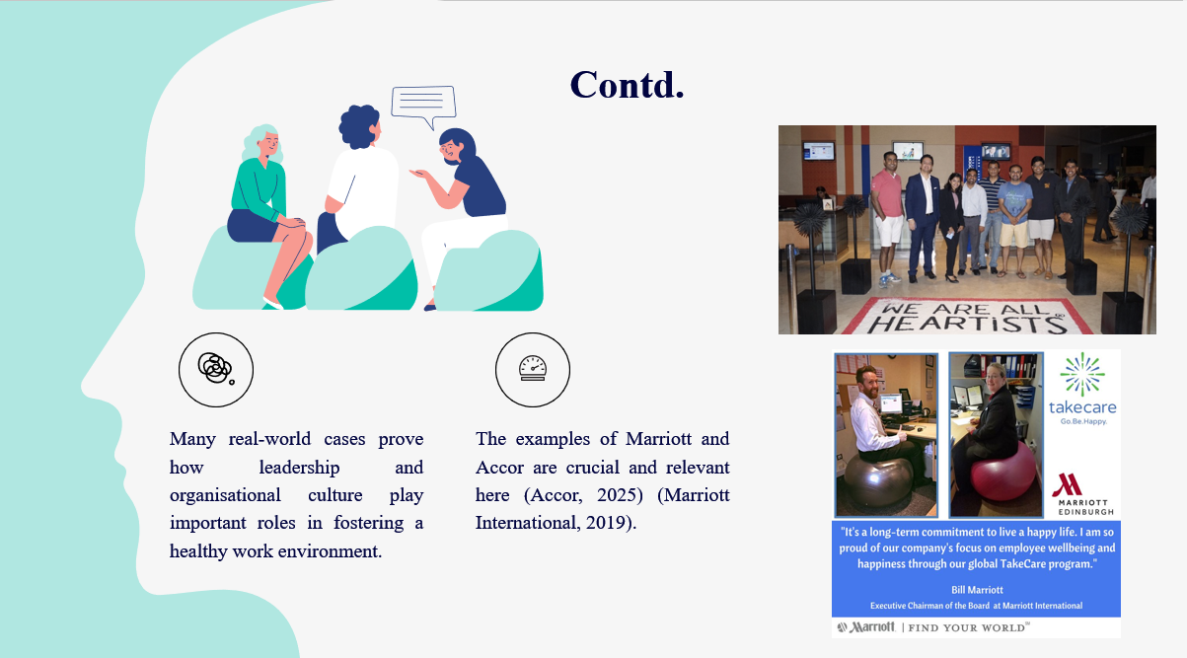
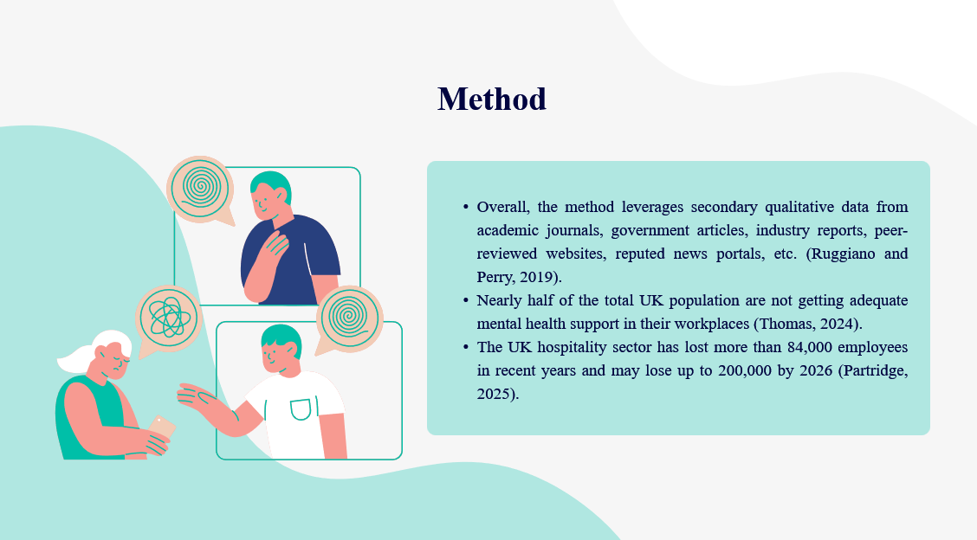
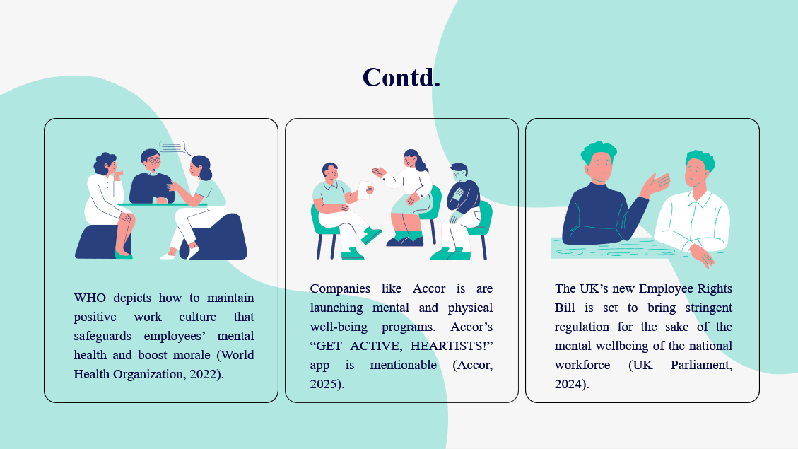
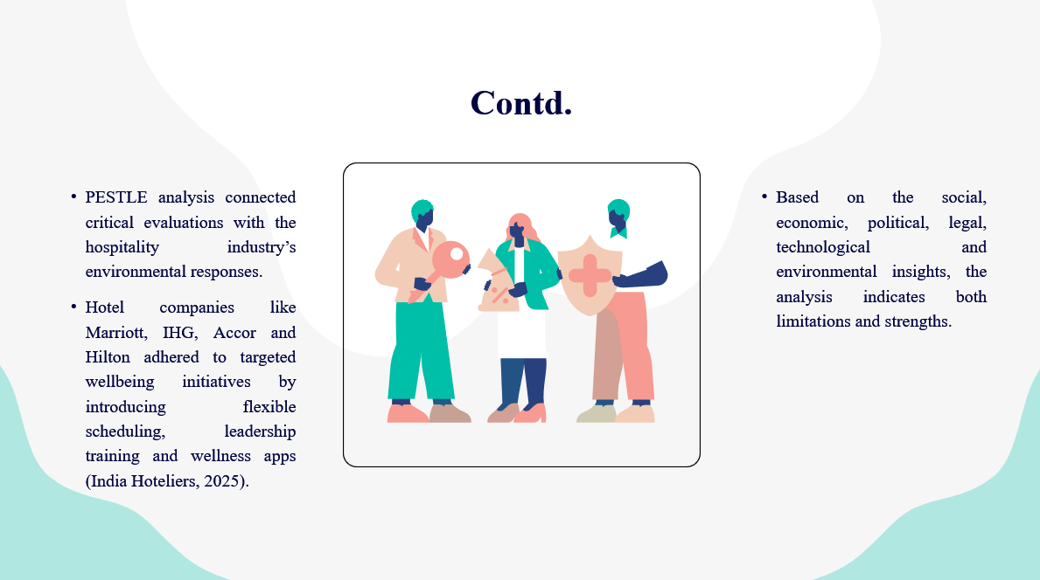
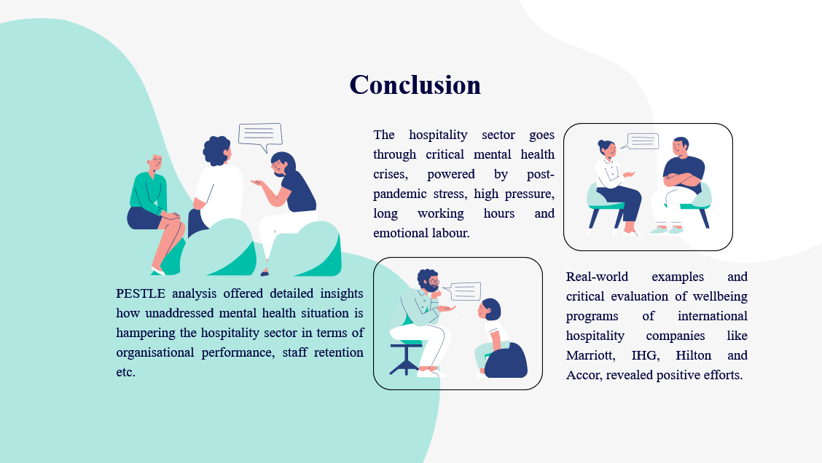
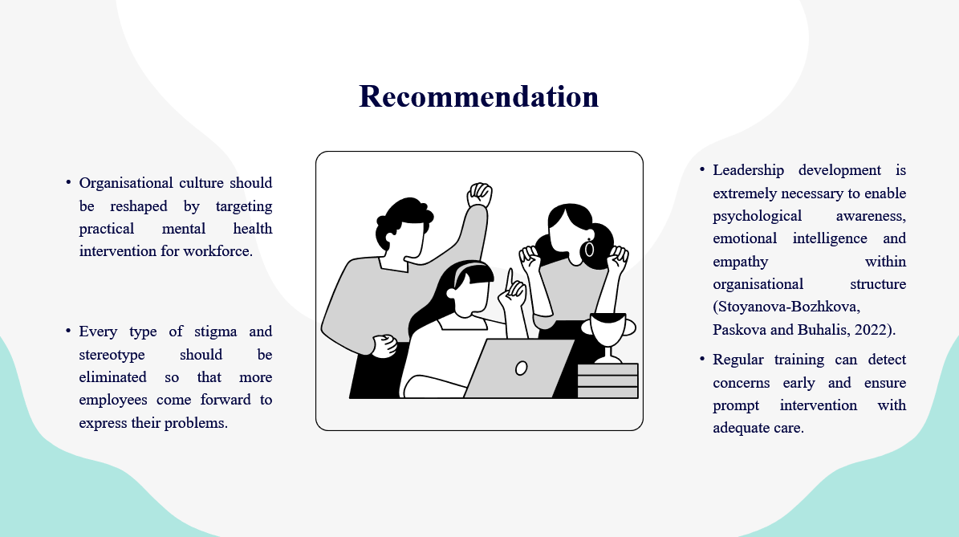
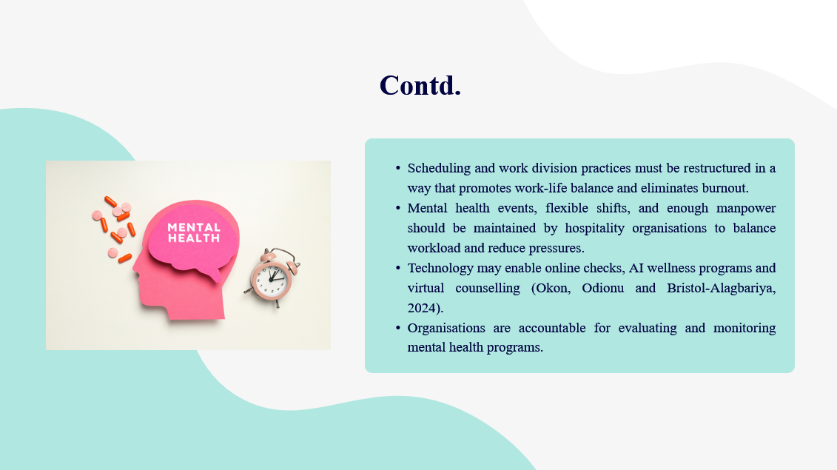
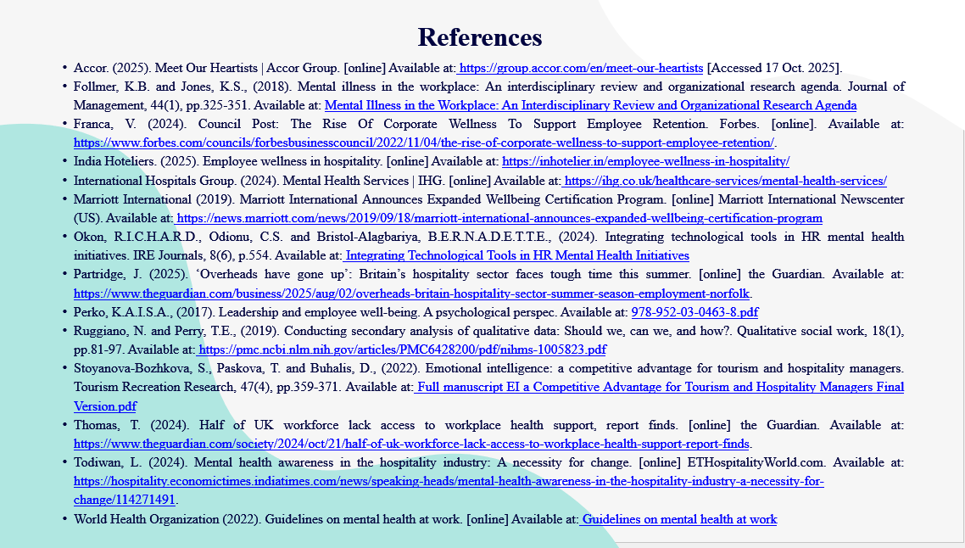
Accor. (2025). Meet Our Heartists | Accor Group. [online] Available at: https://group.accor.com/en/meet-our-heartists [Accessed 17 Oct. 2025].
Follmer, K.B. and Jones, K.S., (2018). Mental illness in the workplace: An interdisciplinary review and organizational research agenda. Journal of Management, 44(1), pp.325-351. Available at: Mental Illness in the Workplace: An Interdisciplinary Review and Organizational Research Agenda
Franca, V. (2024). Council Post: The Rise Of Corporate Wellness To Support Employee Retention. Forbes. [online]. Available at: https://www.forbes.com/councils/forbesbusinesscouncil/2022/11/04/the-rise-of-corporate-wellness-to-support-employee-retention/.
India Hoteliers. (2025). Employee wellness in hospitality. [online] Available at: https://inhotelier.in/employee-wellness-in-hospitality/
International Hospitals Group. (2024). Mental Health Services | IHG. [online] Available at: https://ihg.co.uk/healthcare-services/mental-health-services/
Marriott International (2019). Marriott International Announces Expanded Wellbeing Certification Program. [online] Marriott International Newscenter (US). Available at: https://news.marriott.com/news/2019/09/18/marriott-international-announces-expanded-wellbeing-certification-program
Okon, R.I.C.H.A.R.D., Odionu, C.S. and Bristol-Alagbariya, B.E.R.N.A.D.E.T.T.E., (2024). Integrating technological tools in HR mental health initiatives. IRE Journals, 8(6), p.554. Available at: Integrating Technological Tools in HR Mental Health Initiatives
‌Partridge, J. (2025). ‘Overheads have gone up’: Britain’s hospitality sector faces tough time this summer. [online] the Guardian. Available at: https://www.theguardian.com/business/2025/aug/02/overheads-britain-hospitality-sector-summer-season-employment-norfolk.
Perko, K.A.I.S.A., (2017). Leadership and employee well-being. A psychological perspec. Available at: 978-952-03-0463-8.pdf
Ruggiano, N. and Perry, T.E., (2019). Conducting secondary analysis of qualitative data: Should we, can we, and how?. Qualitative social work, 18(1), pp.81-97. Available at: https://pmc.ncbi.nlm.nih.gov/articles/PMC6428200/pdf/nihms-1005823.pdf
Stoyanova-Bozhkova, S., Paskova, T. and Buhalis, D., (2022). Emotional intelligence: a competitive advantage for tourism and hospitality managers. Tourism Recreation Research, 47(4), pp.359-371. Available at: Full manuscript EI a Competitive Advantage for Tourism and Hospitality Managers Final Version.pdf
Thomas, T. (2024). Half of UK workforce lack access to workplace health support, report finds. [online] the Guardian. Available at: https://www.theguardian.com/society/2024/oct/21/half-of-uk-workforce-lack-access-to-workplace-health-support-report-finds.
Todiwan, L. (2024). Mental health awareness in the hospitality industry: A necessity for change. [online] ETHospitalityWorld.com. Available at: https://hospitality.economictimes.indiatimes.com/news/speaking-heads/mental-health-awareness-in-the-hospitality-industry-a-necessity-for-change/114271491.
World Health Organization (2022). Guidelines on mental health at work. [online] Available at: Guidelines on mental health at work

