Sustainable Tourism and Hospitality in Spain

Student's Name : Daniela Dobre

Sustainable Tourism and Hospitality in Spain
Introduction
In the modern world of global warming enhanced by human pollution, countries are now adopting measures and strategies to reduce the increased negative impact. There is a significant shift from conventional tourism to sustainable or eco-friendly tourism in the tourism sector. Ecotourism is a continuous process of consuming the natural environment while protecting it and enhancing the economic wellbeing of the local communities. Conventional or mass tourism caused a lot of impacts on the environment, especially in countries that received many travellers like Spain. In Spain, ecotourism is essential as tourism is a crucial sector, and it employs millions directly and indirectly. Hence, to ensure this sector continues to play its critical part, Spain adopted ecotourism to protect attractions and communities. However, Spain's major compelling factor is embracing sustainable tourism, and hospitality is attracting millions of travellers and creating employment. Hence this per aims in evaluating and analysing the effectiveness of sustained tourism and hospitality in Spain.
Overview of Spain Tourism
Spain is known for food, unique music and dance, siesta, bullfights, arts and literature, architecture, a Moorish heritage, wines, and football. Also, it is famous for its easy-going culture, delicious food, and stunning scenery characterised by islands, gorgeous Mediterranean beaches, and beautiful cities such as Madrid, Barcelona, and Valencia (OECD, 2021). These cities are charactered by stone castles, snow-capped mountains, vast monuments, and sophisticated cities. These gorgeous beaches, cosmopolitan cities, and lively culture have made tourism a major contributor to Spanish GDP.
Spain is located in extreme southwestern Europe and occupies most of the Iberian Peninsula. Spanish tourism started to grow in the 1960s and 1970s when the government and private sector staged pro-tourism campaigns (Zimmerman, 2021). The major Spanish attractions include southern Mediterranean beaches and deserts; culture composed of Castilians, Catalonians, Lusitanians, Galicians, Basques, Arabs, Jews, and Romans (Zimmerman, 2021). All these people have created varied cuisines, customs, and prolific world's artistic heritage. Further, the unique Spanish climate attracts people; it has three climatic conditions; one is the Mediterranean climate characterized by hot, dry summers and mild, rainy winters. Continental climate, primarily experienced in inland areas like Madrid, is characterised by cold winters leading to snow-capped mountains. Finally, the oceanic climate mainly found on the west coast is characterised by relatively dry summers and chilly winters. All this weather attracts different sets of travelers, giving Spain a continuous flow of visitors all year round.
From the 1970s to 2010s Spanish tourism was at its peak, and it helped rise from the ashes of its economic crisis of 2008- to the early 2010s (Zimmerman, 2021). Further, during this period, Spain was practicing mass tourism. It helped set many records, including being ranked number one in Travel & Tourism Competitiveness Report and second most visited country after France with 83 million visitors in 2018 (Salvatierra, 2019). Mass tourism contributed immensely to building Spain's tourism sector and sustainable hospitality, characterised by small restaurants, tour agencies, and large 4-7 star chain hotels.
Growth of Sustainable Tourism in Spain
Since 2018, Spain has significantly shifted and promoted sustainable tourism. This was after the responsibility of tourism was moved to the Ministry of Industry, Trade, and Tourism from the Ministry of Energy, Tourism, and Digital Agenda (MITT, 2019). The State Secretariat for Tourism is responsible for defining, developing, coordinating, and implementing tourism policy at the national level and coordinating with State Organisation for Innovation and Tourism Technology Management (SEGITTUR), an institution responsible for developing new technologies in the tourism industry (MITT, 2019). Also, it coordinates with Turespaña, an autonomous body responsible for promoting international tourism. Further, it coordinates with Paradores de Turismo, a public entity that runs state-owned hotels (MITT, 2019). State Secretariat is responsible for the current Spain tourism movement restriction and conditions.
This is because tourism was domiciled in beaches and major cities. Rural areas were left out as well as small hotels and restaurants. Further, with mass tourism, Spain only depends on sun and bench tourism found in a few regions (MITT, 2019). Also, its key markets were the UK, France, and Germany (figure 2). Consequently, this led to the high seasonality of tourism and the development of hospitality facilities in a few cities. However, ate new Sustainable Tourism Strategy of Spain 2030 aims to become the world leader of sustainable tourism (MITT, 2019). The new sustainable model will have five pillars rather than the traditional three pillars. However, it will dwell in socioeconomic growth, preservation of natural and cultural values, and economic development.
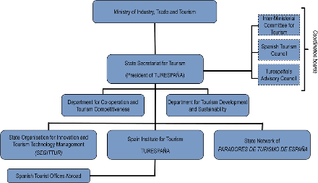
Figure 1. The coordination of Ministry of Industry, Trade, and Tourism (OECD, 2021)
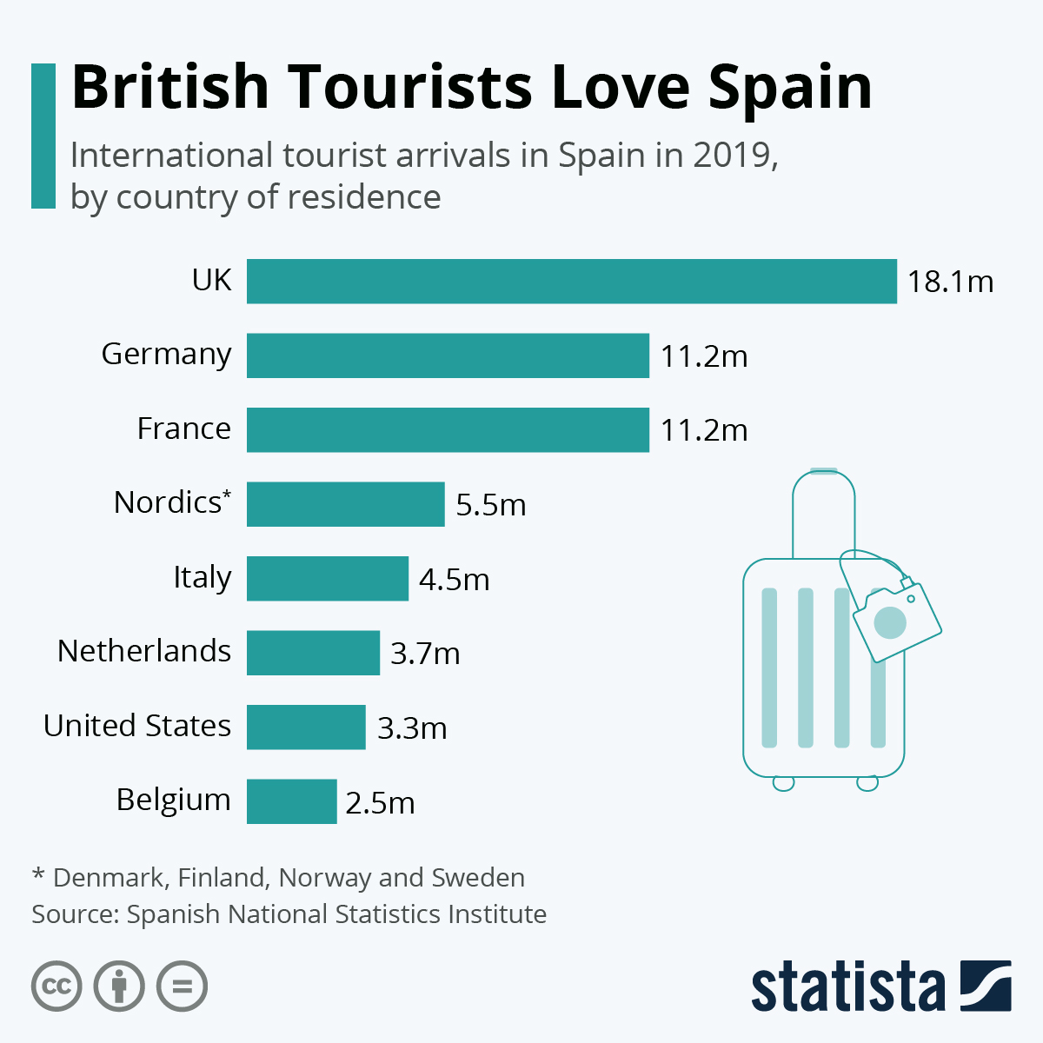
Figure 2. International Tourist Arrivals in Spain (Statista, 2020)
Socioeconomic Development
Social sustainability is the act of operating a business in the interest of your employees, stakeholders, partners, and the communities in which you operate (Gani, Awang, Samdin, and Mohd, 2012). This is based on the effects that tourism has both positive and negative impacts on the community, and it is the responsibility of active players to mitigate the negatives and boost the positives. Boosting the positive involves integrating tourism with the community's way of life and respecting them. Reducing negative impacts involves reducing pollution and indulging in acts that disrespect their beliefs and values. Popular ways people incorporate communities in society is employing locals as tour guides, creating tour products that revolve around people's culture (Gani et al., 2012).. Also, empowering locals to develop their own restaurants and tour products is part of sustainable social tourism.
In the case of Spain, the 2030 plan aims to make tourism accessible to all people, especially the rural and minority groups. Spain wants to use sustainable tourism to enhance wealth distribution by allowing rural people to tap into this lucrative business (MITT, 2019). It will help people to build small restaurants and hotels in the countryside and the cities. Also, the aim is to enhance the competitiveness and profitability of the sector and at the same time incorporate digital aspects.
Environment Conservation Aspects
This is the primary factor driving countries to shift from mass tourism to ecotourism. Mass tourism led to the destruction of the environment, especially the pristine beaches, animal habitats, and water. One of the notable characters of mass tourism is the concentration of visitors in one area or attraction (Gani et al., 2012). This leads to the destruction of the facility leading to depreciation in attraction value. Pollution emanating from the use of non-decomposable materials like plastic and non-renewable energies has led to air pollution. In essence, environmental sustainability involves reducing waste, eliminating single-use plastics, and minimising the overall carbon footprint. However, it involves the protection of the natural environment and artificial artifacts like ancestral buildings.
The Spanish environment protection pillar wants to use tourism as a tool to protect and earn from its exotic environment and cultural heritage. Spain's gorgeous beaches and exciting different climatic conditions can only be protected by reducing pollution and adopting renewable energies and resources. This is why the Spanish government is working towards ensuring it uses green electricity by developing more wind powers (MITT, 2019). Also, it is advising hotels and restaurants to start adopting green energy to reduce plastics and pollution.
Further, Spain is known for attractive roman origin architectural cities, castles, and city buildings. Madrid, Barcelona, Cordoba, and Valencia are among the attractive cities in Spain characterised by human artifacts and museums (MITT, 2019). Spain is ranked fourth globally with many UNESCO sites; 43 cultural, four natural, and two mixed sites (UNESCO, 2021). This factor attracts people from abroad, and hence they need to be protected. Hoang (2021) argues that protecting and preserving culture and values is essential as it reflects and shapes values, beliefs, and aspirations. Thus, it defines people's national and cultural identity.
Social and Ecological Benefits Aspect
Tourism is an economic activity, and hence it must benefit the majority of people. Unlike mass tourism that benefits investors and tourists, sustainable tourism and hospitality aim to benefit all people involved directly and indirectly (Gani, Awang, Samdin, and Mohd, 2012). This is based on the fact that tourism happens within an environment protected by local communities. These local communities need to be compensated for protecting and preserving the environment (Gani et al., 2012). However, economic sustainability involves maximizing the tourism industry while preserving social and environmental aspects. Hence, for a company or country to be sustainable, it must be making profits from tourism but not at the expense of social and ecological concerns. Essentially, ecotourism involves helping the locals have good access to social needs like clean water, living in a clean environment, and enhancing their businesses by buying their products and services.
Spain aims to use sustainable tourism as a tool to reduce urban-rural migration where people are moving to cities in search of jobs. Hence, Spain wants to create rural employment by using tourism, reducing inequalities in employment and tourism distribution (MITT, 2019). Essentially, Spain intends to distribute both positive and negative impacts of tourism throughout the country and all sectors.
Further, the Spanish sustainable tourism model has a participation and governance pillar that advocates for the full participation of all people and institutions at all levels (MITT, 2019). This feature is pegged on the need for sustainable tourism to involve the locals and other stakeholders in decision-making and sharing benefits. Gani et al. (2012) posit that sustainable tourism has distinct groups that must be involved or considered: present and future tourists, present host community, and future host community. Further, there is a permanent adaptation pillar that considers Spanish tourism to shift to new business models. This is the response to new disruptive such as technology and covid (Moreno-Luna et al., 2021). In this pillar, Spanish tourism must utilize modern technology like artificial intelligence and peer to peer as exhibited by Airbnb, to enhance sales. All these pillars are geared towards making Spain the world leader in tourism regarding arrivals and income earned.
Analysis of Spain Tourism Stages
Butler's Life Cycle
Butler's life cycle has six stages: exploration, involvement, development, consolidation, stagnation, and decline (Garay and Cànoves, 2011). Even with shifting to sustainable tourism, the current stage of Spanish tourism is consolidation, where the number of tourism is high, and the sector is essential to the economy. Also, in this stage, red flags of stagnation are evident and may involve a slow growth rate in arrivals and expenditure. As shown in figure 3 below, Spanish international arrivals expenditure has stagnated since 2017-2019 despite the growing number of arrivals (Statista, 2021). The Spanish tourism sector is established and is a major contributor to the global tourism sector.
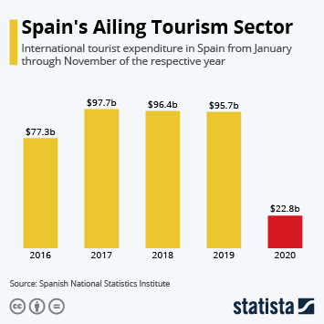Figure 3. Spain international tourist expenditure (Statista, 2021)
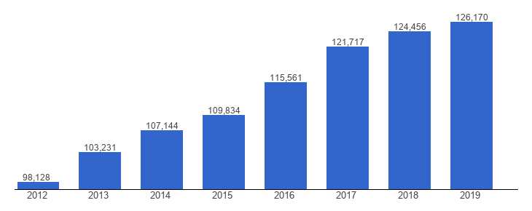
Figure 4. Spain local and international tourists (Global Economy, 2021)

Doxey Irridex Model
Doxey model analyses the host attitudes towards tourism development. Host attitudes can be classified into four stages: euphoria, apathy, annoyance, and antagonism Almeida-García et al., 2016) (Fan et al., 2018). Spanish people's attitude towards tourism is apathetic as they are emotionally and culturally intelligent to understand tourism and its potential negative and positive impacts (Zaidan & Kovacs, 2017). Since Spain is an established tourism country majority of its citizens are friendly to tourism as they know the importance to the economy. According to statistics, close to 2.2 million Spanish were employed directly in the tourism sector (Statista, 2020). Despite the seasonality of the sector, the accrued income has a significant impact on the economy (Pena-Boquete, 2013).
Recommendations
Extensive Marketing
Spain is a leading tourism destination globally, but it is only known to a few countries (Moor, 2017). According to Statista, Spain depends on European travellers, majorly from the UK, Germany, France, and Nordic countries (Denmark, Finland, Iceland, Norway, and Sweden) (2020). Spain can reach out to southeast countries as these countries' economies are growing, which will prompt the growth of the middle-class population and outbound tourists (Figure 6) (Weforum, 2020). For instance, the number of Chinese visiting other countries increases though their primary destination is in Asian countries (Xu, 2019). However, Spain can tap into this market and partner with the Chinese government to enable direct low-cost flights and take advantage of ultra-long-haul flights. As a result, Spain tourism will rejuvenate in case Europeans get used to Spanish attractions.
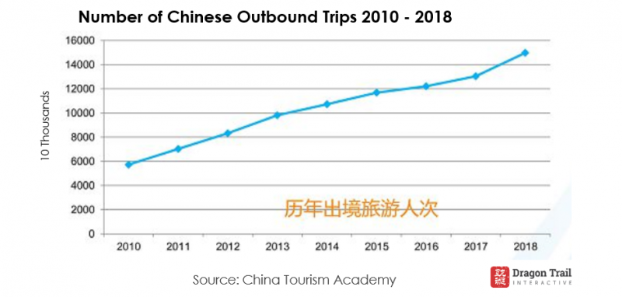
Figure 5. Number of Chinese Outbound Tourists (Xu, 2019)
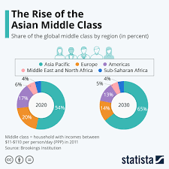
Figure 6. The Approximated Population of Middles Class Population Globally (Weforum, 2020)
Conclusion
Spain is slowly becoming the top destination of many European outbound travellers. However, with the outbreak of the covid pandemic, the sector crumbled like other sectors. Spanish tourism has depended on mass tourism for many years, which was insensitive to social and environmental wellbeing. Despite this model bringing in many benefits, including contributing to the GDP and creating jobs, the sector was not sustainable as it benefited few people. However, the Spanish government is working towards sustainability where the number of beneficiaries will increase while preserving the environment and culture. Through this, Spain will enhance income and responsibility distribution, thus eliminating any form of inequality. However, to make tourism sustainable and robust, it has to market its tourism products to other markets other than Europe by focusing on southeast countries due to an estimated increase in the middle class and outbound tourists.

Bibliography
Almeida-García, F., Peláez-Fernández, M., Balbuena-Vázquez, A. and Cortés-Macias, R., 2016. Residents' perceptions of tourism development in Benalmádena (Spain). Tourism Management, 54, pp.259-274.
Fan, D., Liu, A. and Qiu, R., 2018. Revisiting the relationship between host attitudes and tourism development: A utility maximization approach. Tourism Economics, 25(2), pp.171-188.
Gani, A., Awang, K., Samdin, Z. and Mohd, A., 2012. Local community participation in sustainable tourism planning of Malaysian protected areas. Current Issues in Hospitality and Tourism, pp.459-464.
Garay, L. and Cànoves, G., 2011. Life cycles, stages and tourism history. Annals of Tourism Research, 38(2), pp.651-671.
Global Economy, 2021. Spain Tourist arrivals - data, chart | TheGlobalEconomy.com. [Online] TheGlobalEconomy.com. Available at: <https://www.theglobaleconomy.com/Spain/tourist_arrivals/> [Accessed 20 November 2021].
Hoang, K., 2021. The benefits of preserving and promoting cultural heritage values for the sustainable development of the country. E3S Web of Conferences, 234, p.00076.
MITT, 2019. General Guidelines of the Sustainable Tourism Strategy from Spain 2030. [Online] Available at: <https://turismo.gob.es/es-es/estrategia-turismo-sostenible/Documents/directrices-estrategia-turismo-sostenible.pdf> [Accessed 20 November 2021].
Moor, R., 2017. The Troubles of the Spanish Tourism Industry | .TR. [online] Tourism-review.com. Available at: <https://www.tourism-review.com/spanish-tourism-industry-has-some-weaknesses-news5307> [Accessed 20 November 2021].
Moreno-Luna, L., Robina-Ramírez, R., Sánchez, M. and Castro-Serrano, J., 2021. Tourism and Sustainability in Times of COVID-19: The Case of Spain. International Journal of Environmental Research and Public Health, 18(4), p.1859.
OECD, 2021. Spain - Tourism in the economy. [Online] Oecd-ilibrary.org. Available at: <https://www.oecd-ilibrary.org/sites/8ed5145b-en/index.html?itemId=/content/component/8ed5145b-en> [Accessed 20 November 2021].
Pena-Boquete, Y., 2013. Effects of Tourism Wages and employment for the Spanish regions: Seasonality versus Tourism Specialization. [Online] pp.1-23. Available at: <https://www.aiel.it/page/old_paper/PenaBoquete_PerezDacal.pdf> [Accessed 20 November 2021].
Salvatierra, J., 2019. Spain sets new foreign tourist arrival record for sixth consecutive year. [online] Available at: <https://english.elpais.com/elpais/2019/02/01/inenglish/1549014848_149720.html> [Accessed 20 November 2021].
Statista, 2020. Infographic: British Tourists Love Spain. [Online] Statista Infographics. Available at: <https://www.statista.com/chart/22399/international-tourist-arrivals-in-spain-by-country-of-origin/> [Accessed 20 November 2021].
Statista, 2020. Quarterly employment in tourism in Spain 2020 | Statista. [Online] Statista. Available at: <https://www.statista.com/statistics/436304/total-number-of-employees-in-the-tourism-sector-in-spain/#:~:text=By%20the%20end%20of%202020,the%20tourism%20sector%20in%20Spain.> [Accessed 20 November 2021].
Statista, 2021. Infographic: Spain's Ailing Tourism Sector. [Online] Statista Infographics. Available at: <https://www.statista.com/chart/22324/international-tourist-expenditure-in-spain/> [Accessed 20 November 2021].
UNESCO, 2021. Spain - UNESCO World Heritage Centre. [Online] Whc.unesco.org. Available at: <https://whc.unesco.org/en/statesparties/es> [Accessed 20 November 2021].
Weforum, 2020. This chart shows the rise of the Asian Middle Class. [Online] World Economic Forum. Available at: <https://www.weforum.org/agenda/2020/07/the-rise-of-the-asian-middle-class> [Accessed 20 November 2021].
Xu, C., 2019. CTA: Annual Report on China Outbound Tourism Development 2019 - Dragon Trail International. [Online] Dragontrail.com. Available at: <https://dragontrail.com/resources/blog/cta-annual-report-on-china-outbound-tourism-development-2019> [Accessed 20 November 2021].
Zaidan, E. and Kovacs, J., 2017. Resident Attitudes towards Tourists and Tourism Growth: A Case Study from the Middle East, Dubai in United Arab Emirates. European Journal of Sustainable Development, 6(1).
Zimmerman, L., 2021. Sustainable Tourism in Spain: What It Is & How to Help. [online] Devour Madrid. Available at: <https://madridfoodtour.com/responsible-travel-in-spain/> [Accessed 20 November 2021].

