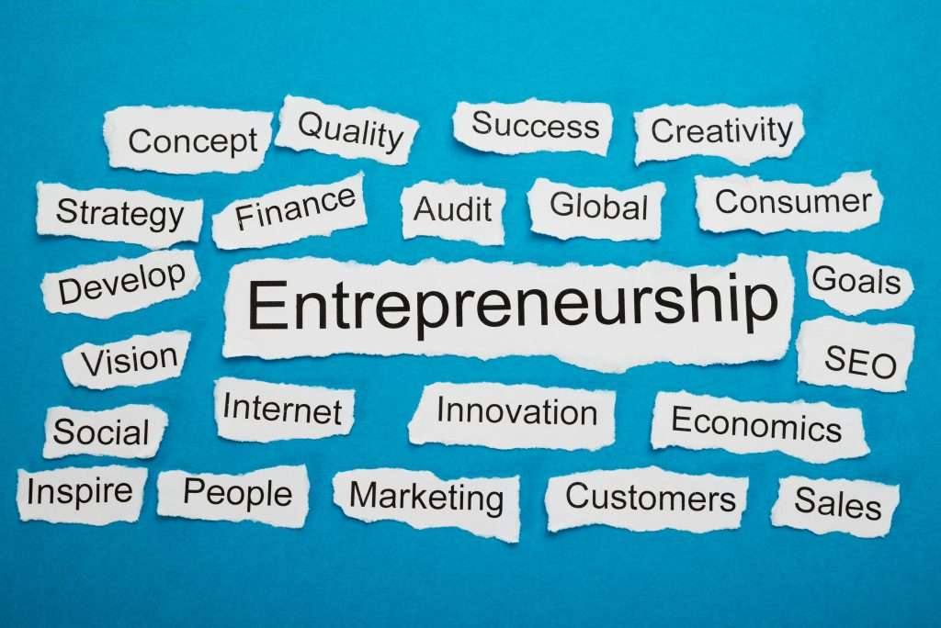
Assessment 1

Student ID: 2014060
Name: Nikola Nikolov

Table of contending
Introduction 3
Task 1 3
Marketing 3
Product life cycle 5
The feasibility of the idea. 6
Porter 5 forces for stevia plant farming 7
Feasibility analysis 8
Market research 9
Task 2 (Reflection on personal development) 10
Conclusion 12
Action plan 13
References 14

Introduction
Entrepreneurship is the process by which individuals engage in opportunities concerning resources they currently control. Hisrich et al. (2020) defined entrepreneurship as the art of transforming an idea into a business. Consequently, entrepreneurs consolidate and then integrate all the resources required to change an innovation or an idea into a viable business. Typically, these resources are money, human capital, the business model and strategy. However, it is essential to note that entrepreneurs are not born gifted but can acquire entrepreneurship skills. Frederick et al. (2018) state that successful entrepreneurs must have skills such as;
adaptability, hard work, persistence, creativity, professionalism, planning, open-mindedness(vision) etc.
Entrepreneurship usually influences new product development (NPD), which is crucial because it drives companies' competitiveness. Moreover, it helps to meet the insatiable appetites of modern consumers. Therefore, NPD is crucial for organisational survival and societal satisfaction. In accordance, the idea presented is stevia plant farming to meet the needs and desires of modern health-conscious consumers (HCC). The proposal is about growing the stevia plant because it is 200-300 times sweeter than table sugar and has no adverse health effects (Butler and Nichols, 2018).
Task 1

Marketing
The 4Ps of marketing will be the foundation model used to pursue the marketing objectives in the target market, as demonstrated in this section.
Product /services- It is considered that stevia plant farming will be a profitable idea. The stevia plant will be sold to sugar manufacturers (B2B). The stevia plant's sweetener can successfully replace table sugar, high-fructose sugar, aspartame and other sugars that have adverse health effects like diabetes, high blood pressure, obesity, cardiovascular diseases etc. (Guljakhon, 2021).
Customers will follow the proposed journey below and decide how to engage and buy the stevia plant product.

In principle, stevia sugar meets the requirements of those customers who are conscious of their health but desire sweetness in their drinks or foods (Guljakhon, 2021). Consequently, the target consumers are health-conscious consumers of all ages and genders. In addition, stevia sweetener has almost zero calories, making it ideal for focusing on those consumers who desire fitness and maintain their blood sugars within the recommended healthy ranges (Butler and Nichols, 2018).
Place; There will be physical stores across major UK cities for physical consumers. There will also be a website and mobile app to deal with remote customers. Both wholesalers and retailers will be used.
Price- The stevia plant will be sold to large-scale manufacturers and retailers who process it into healthy sugar. It will be sold using the economic strategy, including lower leading prices due to lower production costs.
Promotion- Product awareness will be achieved through social media marketing, offline and online SEO marketing, email marketing, and tv and radio marketing. Brand ambassadors will also be utilised to increase awareness and customer numbers.

Product life cycle
Hisrich et al. (2020) described the product life cycle as the length of time a product is introduced to the market until it is removed. This concept is applied by organisations to decide on the appropriate time to boost advertising, reduce product prices, or enter new markets. The life cycle of a product is grouped into four stages, as shown in
Fig.1 below.
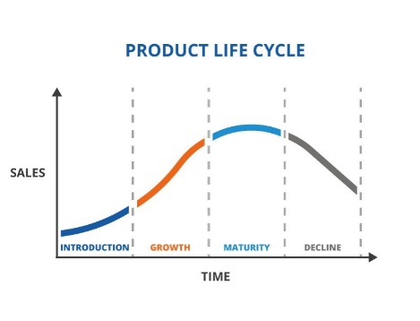
Figure 1. Product life cycle
Uniqueness and reliability of the stevia plant in supplying healthy alternative sugar. It will then be viable to apply substantial marketing campaigns and advertising for more products. Introduction- Here, customers are expected to attempt to understand the awareness (Hisrich et al., 2020).
Growth- In this phase, Hisrich et al. (2020) found that the product concept will become more popular, and sales will increase. As a result, demands for stevia plants will also grow, and there must be continuous replacement of replenished stock to offset the demand rise (Hisrich et al., 2020). However, competition will also be higher, and there will also be regular customer support and new distribution channels opening.
Maturity- Here, production costs for the stevia plant will decline. Market saturation will occur (Hisrich et al., 2020). The competition will increase significantly. This will mean that the business will have to reduce product prices, focus on differentiation rather than awareness and perform continuous upgrades (Hisrich et al., 2020).
Decline- There will be many counterfeits, vast competition, client interest loss, and brand image damage (Hisrich et al., 2020). The company will have to expand its product line and enter new markets to remain profitable and competitive.

The feasibility of the idea

SWOT analysis for stevia plant farming

STRENGTHS  - Health-beneficial effects (PR News, 2022)  - Sweet but with very minimal calories  - Huge potential market demand | OPPORTUNITIES  - Genuine, safe and approved product (PR News, 2022)  - Alternative sugar substitute  - High interest in healthy sugars alternative
WEAKNESSES  - Insufficient information  - Lack of solid research (PR News, 2022) | THREAT  - Lack of updated data  - Competition from cheaper alternatives (PR News, 2022)

VRIO analysis for stevia plant farming

Resources & Competences | Valuable | Rare | Inimitable | Organised to Exploit | Impact to Competitive Advantage
Reputation | YES | YES | NO | YES | Sustainable
Product | YES | YES | YES | YES | Sustainable
Convenience | YES | NO | NO | YES | Competitive parity
Market reception | YES | NO | NO | YES | Competitive parity
Local adaptation | YES | YES | NO | YES | Temporary competitive parity

Porter 5 forces for stevia plant farming

Supplier power | Strong:  The high availability of suppliers weakens suppliers' power in stevia plant farming.
Buyer power | Strong:  Low switching costs mean that buyers can easily change from stevia plants to artificial sugars.
Threat of substitution | High:  High availability of substitutes such as artificial and natural sweeteners.
The threat of new entrants | Moderate:  Moderate capital costs mean that new entrants can try this market.
Competitive rivalry | Strong:  High competition from rival businesses within the UK.

Feasibility analysis
Part 1: Product/service feasibility
- Product/service desirability- Stevia plants are highly desirable by the health-conscious market and hence, farming will be feasible (PR News, 2022).
- Product/service demand- There is a high demand for sugar derived from stevia plants due to growing cases of diabetes and obesity (PR News, 2022).
Part 2: Industry/target market feasibility
- Industry attractiveness- This market is expected to expand at a CARG rate of 8.8% from 2021-2028 and attain USD 11 billion (PR News, 2022). So, there is a great incentive to invest in stevia plant farming.
- Target market attractiveness- Health-conscious consumers are willing to pay for products that will improve their health (PR News, 2022).
Part 3: Organisational feasibility
- Management prowess- The business will apply employee engagement techniques such as pay incentives, awards, recognition,training and development (Sun and Bunchapattanasakda, 2019).
- Resource sufficiency- The business will deploy employees with specialised skills and also obtain intellectual property protection for the trade secrets. This will ensure the business remains for a long time.
Part 4: Financial feasibility
- Total start-up cash needed- The total costs for setting up a greenhouse and farming will be GBP 35 000.
- Financial performance of similar businesses- Tate & Lyle PLC is one of the UK's most profitable organisations in stevia businesses. It makes $ 1.3 billion in revenues and $ 42 million before tax profits (Tate & Lyle PLC, 2022).
- Overall financial attractiveness of the proposed venture overall assessment- McKinsey (2021) estimated that the wellness market is at over USD 1.5 trillion with yearly success rates of 5-10%. Therefore, it will be feasible to invest in stevia plant farming.

Market research
Primary research- data will be collected from focused interviews and surveys. Focused interviews will be used for qualitative research where a group of customers will be selected to give their opinions on the product. In addition, market surveys will be conducted to gain critical information about the buying potential and specifics of the target audience.
Secondary data- Research has already been done on stevia plant farming and its potential as a natural sweetener. Consumers have become more aware of health-conscious alternatives (Grembecka, 2015). Consumers are becoming more cognizant of dietary intake, but traditional players are overwhelming the market (Grembecka, 2015).

Task 2 (Reflection on personal development)

One of the most prominent models of reflection is the Gibbs cycle. It was developed to deliver structure to learning from experiences. In essence, this model offers a framework for assessing experiences. It allows people to learn and plan from both better experiences and bad experiences. As shown in Fig. 2 below, the model involves six stages that include: description, feelings, evaluation, analysis, conclusion and action plan. In context, I will use the six stages of the Gibbs cycle to reflect on my personal development in my participation in this module.
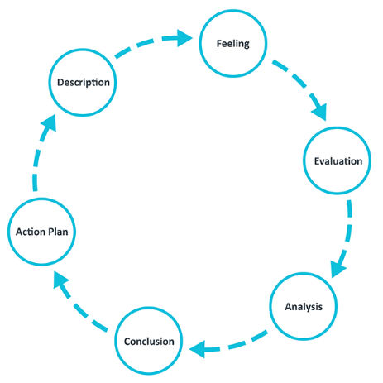
Figure 2. Gibbs's cycle
Description- Under this Entrepreneurship module, I gained an analytical skills-an essential skills for successful entrepreneurs. According to Blakey (2022), analytical skills are a wide-ranging set of professional qualities that involve the ability to think critically, analyse data, make hard decisions and solve complex problems. In addition, these skills involve digesting new information and mentally processing the information in a viable way (Blakey, 2022). In particular, the analytical skills helped me with the opportunity recognition process, where I recognised a gap in health-conscious consumption. Following this case study, I found that unhealthy sugar is abundant in most soft drinks and food-containing-sugars. I also discovered that unhealthy sugar causes diabetes, cardiovascular diseases, obesity, etc, despite its revered sweetness (Butler and Nichols, 2018).
However, upon further research, I found that this type of healthy sugar alternative is 200-300 times sweeter than regular sugar but with almost zero calories. Furthermore, this kind of healthy sugar can be obtained from the stevia plant- a native plant in South America. So, I decided to come up with the idea of stevia plant farming to meet the health-conscious market's demands, needs and desires. Essentially, I will supply stevia plants to companies that use sugar as a primary ingredient for their products. These companies include beverages, food, bakery, cereals, dairy, pharmaceuticals and others (PR News, 2022). The stevia plant business idea will be profitable currently and in the long run.
Feeling- I am very excited to be part of a revolutionary food and beverage industry idea. There has been so much negative awareness about the food and beverage industry. The pessimism emanates from the credible findings that sugar directly correlates to obesity, diabetes and heart-related diseases. So, any idea that will get rid of harmful sugar will generate an avalanche of excitement. Hence this leads to my enthusiasm because the stevia plant will be able to offer immense value in the food and beverage supply chain as well as contribute to healthy living standards.
Therefore, I plan to enter into large-scale farming of the stevia plant. This method will be achieved through greenhouse technology because stevia plant farming is sensitive to cold UK temperatures. Here, the main idea is to grow the stevia plant nine times yearly because stevia matures after forty days. This idea will ensure a continuous stream of revenue throughout the year. However, there is a general sense of anxiety because of the so-called "large Agriculture" players. These are industry players with near-monopoly in the sugar supply market and, therefore, can fight attempts to dissuade consumers from consumption of cheap, unhealthy sugar. I am also concerned about the power of established competitors in this industry because it will take a great deal of time to penetrate the market.
Evaluation- There is already a great interest in health-conscious products, and the movement is growing sustainably, which made me comfortable about making a solid case for investing in the stevia plant farming business. So, the business proposal has been made and supported by credible research. Furthermore, credible research has shown an immense return on investment for investors in the stevia plant farming business (PR News, 2022).
To ensure that my research was credible, I relied on scientific journals from Google Scholar, Elsevier and JSTOR. These online repositories contain peer-reviewed articles and journals that support the idea of stevia plant farming. In addition, I performed market research and showed that stevia farming is profitable and can generate much excitement.
Consequently, I have confidence that my proposal will result in significant returns. However, I am worried that the business might struggle to pick up due to financial constraints. The business requires upwards of GBP 35, 000 for a start. The challenge here is that I am not exceptionally versed with resource pooling, so I will have to spend lots of time attracting investors to this project.
Analysis- I have gained excellent knowledge in this research, especially in communication. I am now able to communicate clearly and with courtesy. This strength has enabled me to interact with minimal confrontation as I adhere to the active listening model. I also demonstrate contingency leadership in dealing with different kinds of situations. This strength will effectively manage employees and investors, posing various challenges that require specific solutions. I also show creativity and innovation skills, as seen in the development of stevia plant farming- a new practical idea in the contemporary food and beverage market. Finally, I also exhibit problem-solving skills because the stevia plant farming idea aims to solve nutritional well-being challenges gaps.
Additionally, opportunities that arose from this experience include vision and analytics. I have to learn more about crowdfunding, grants, loan facilities and venture capitalism to expand my business. Indeed, I must improve my time management skills to deal with the threat of procrastination. As seen in the action plan, I will forge a way forward by dealing with my weaknesses in leadership, communication, time management, analytical skills, adaptability and teamwork.
Conclusion
In order to implement the business idea explained above, I found that I need to improve specific skills. As shown below, I need to accomplish these skills in order to make myself a successful entrepreneur.
Action plan

Development objectives | Priority | Activities to be taken | Control | Time bound
Democratic leadership | Very high` | Short leadership courses online | Review progresses each week | 3 months
Digital and Offline Marketing | Very high | Short marketing courses online | Review progresses each week | 2 months
Teamwork skills | High | Short HR courses online | Review progresses each week | 1 month
Time management skills | Very high | Short IT course online | Review progresses each week | 1 month
Analytical skills | Medium | Short HR course online | Review progresses each week | 2 months
Adaptability skills | High | Short HR course online | Review progresses each week | 2 months
Communication skills | Medium | Short HR course online | Review progresses each week | 1 month
Financial skills | Very high | Short Financial literacy course online | Review progresses each week | 1 month

References

Butler, N., and Nichols, H. (2018). What is stevia? [online] Available at: https://www.medicalnewstoday.com/articles/287251. [Accessed 16 July 2022].
Barringer, B., and Ireland, D. (2019). Entrepreneurship: Successfully Launching New Ventures. Sixth edition; Global edition. Harlow, England: Pearson.
Blakey, S. (2022). Analytical Skills: How to Develop Your Analytical Skills. [online] Available at: https://www.masterclass.com/articles/analytical-skills-guide#8-examples-of-analytical-skills. [Accessed 17 July 2022].
Frederick, H., O'Connor, A. and Kuratko, D.F. (2018). Entrepreneurship. Cengage AU.
Grembecka, M. (2015). Natural sweeteners in a human diet. Roczniki Państwowego Zakładu Higieny, 66(3).
Guljakhon, N. (2021). The role of the stevia plant in the food industry. An Interdisciplinary Conference of Young Scholars in Social Sciences (pp. 334-338).
Hisrich, R.D., Peters, M.P., and Shepherd, D.A. (2020). Entrepreneurship. Eleventh edition, New York: McGraw-Hill
McKinsey. (2021). Feeling good: The future of the $1.5 trillion wellness market. [online] Available at: https://zipgrow.com/greenhouse-business-start-up-costs-profits-and-labor/. https://www.mckinsey.com/industries/consumer-packaged-goods/our-insights/feeling-good-the-future-of-the-1-5-trillion-wellness-market. [Accessed 18 July 2022].
PR News (2022). Global Stevia Markets Report 2022-2028 - Surging Demand for Natural Sweeteners, Rising Demand in Beverage Industry & Increasing Number of New Stevia-Based Products. [online] Available at: https://www.prnewswire.com/news-releases/global-stevia-markets-report-2022-2028---surging-demand-for-natural-sweeteners-rising-demand-in-beverage-industry--increasing-number-of-new-stevia-based-products-301501773.html#:~:text=The%20stevia%20market%20is%20expected,reach%2072%2C670.9%20tonnes%20by%202028. [Accessed 18 July 2022].
Sun, L. and Bunchapattanasakda, C. (2019). Employee engagement: A literature review. International Journal of Human Resource Studies, 9(1), pp.63-80.
Tate & Lyle PLC. (2022). Annual Report 2022. [online] Available at: https://www.tateandlyle.com/investors/annual-report. [Accessed 18 July 2022].

