DATA HANDLING & BUSINESS INTELLIGENCE
Student Name: Mirela Maria Dolca
Student ID: 2112412
Module Code: LCBB5000
Table of Contents
Introduction 3
5 current trends of Business Intelligence 3
Importance of this BI trends in businesses 7
Conclusion 9
References 10

Introduction
The main similarity between data and business is they never stop they grow along with time. Amidst global economic crises like covid 19 pandemic BI plays a phenomenal role in business organisation’s to survive as well as thrive. Several BI trends such as cloud, mobile analytics and automation are majorly responsible for disrupting the information industry. In 2023, the BI trends impressively rise by 23%. In this report, 5 present trends of Business Intelligence will be demonstrated. It will also elaborate on the importance of these BI tools in modern world business.

5 current trends of Business Intelligence
BI tools are responsible for understanding trends along with devising insights through data. With the help of this, the organisation's administration will be able to make strategic as well as tactical business decisions. 5 prime BI tools based on their performance and review will be demonstrated in the following.
1 SAP Business Objects: This BI tool has proven its excellence by offering comprehensive reporting, interactive data visualisation as well as analysis. The main focus of this business intelligence software can be divided into 4 main aspects (Sap.com, 2023). Those can be demonstrated as consumer experience, digital supply chain, consumer relationship management as well as ERP.
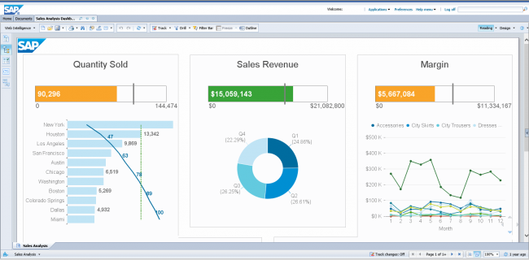
Figure 1: SAP Business objects
(Source: Sap.com, 2023)
The 2 most advantages of this tool are self-service and role-based dashboards that helps its users to construct their applications and dashboards. This is also considered as the robust software which is merged with all three roles (Sap.com, 2023). Those are IT, management and end-use. It also offers tons of functions in one specific platform. However. The price of this software is high.
2 Datapine: Many complex procedures are associated with data analytics. In this regard, the business intelligence software Datapine plays an effective role in it (Datapine.com, 2023). This is very helpful for beginners or non-technical users. This software is integrated with the self-service approach analytics approach.
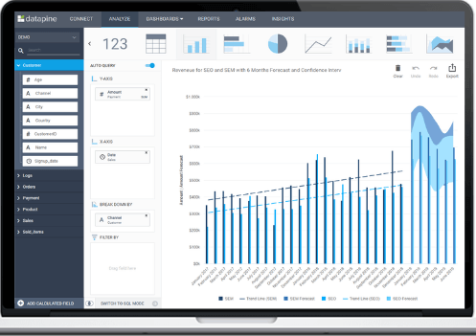
Figure 2: DATAPINE BI tool
(Source: Datapine.com, 2023)
On the other hand, it is assembled with a solution that enables data analytics as well as business users in order to indulge different information sources. Hence, they can perform advanced data analytics (Datapine.com, 2023). With the help of this, they will be able to construct interactive business dashboards. Along with this, it also generates insights which are related to business actions.
MicroStrategy: This is considered an enterprise BI tool that is responsible for offering powerful and high-speed data analytics, hyperintelligence, dashboarding and cloud solutions to its users (Microstrategy.com, 2023). With the help of this solution, business administration can identify key trends, improve productivity, recognise new opportunities and more.
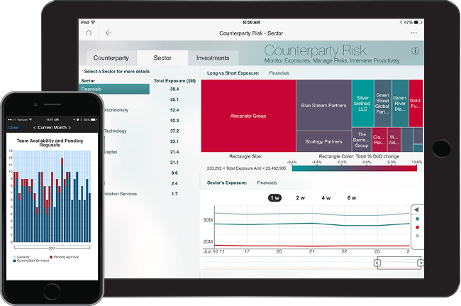
Figure 3: MicroStrategy BI tool
(Source: Microstrategy.com, 2023)
More than a single source can be connected and doesn't care about the information extracted from a spreadsheet or cloud data software (Microstrategy.com, 2023). Moreover, the user can access it through desktop and mobile. Involving multiple parties and application extensive are some drawbacks.
4 SAS Business Intelligence: The core advantage of this BI tool is it offers an advanced predictive analysis. On the other hand, it offers a great platform for business intelligence. This self-service tool was first introduced in 1970 (Sas.com, 2023). This allows users to leverage information as well as metrics for making informed decisions based on the business.
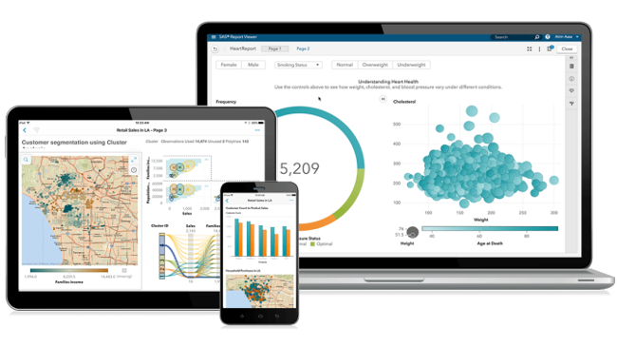
Figure 5: SAS Business Intelligence
(Source: Sas.com, 2023)
It has been done through API’s set so that its users are combined with customisation options and SAS. This enables 3 prime advantages to its users. Those are high-level information integration, reporting along with advanced analytics (Sas.com, 2023). In order to indulge more contextual insights into information the feature of text analytics is also implemented in this BI tool.
5 Yellowfin BI: This BI is combined with two main characteristics. This is an end-to-end analytics platform that merges machine learning, collaboration and visualisation (Yellowfinbi.com, 2023). It also helps filter tons of information with intuitive filtering.
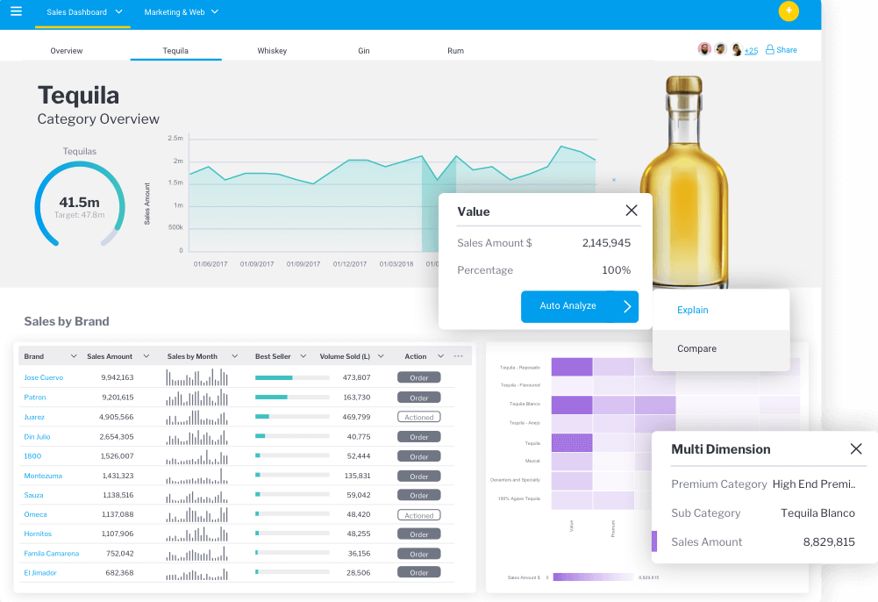
Figure 5: Yellowfin Business Intelligence tool
(Source: Yellowfinbi.com, 2023)
As an example, checkboxes and radio buttons are used. Moreover, the flexibility of this tool is very high (Yellowfinbi.com, 2023). It makes very simpler the process of taking dashboards as well as visualisation to an upgraded level. In this regard, a no code/low code is used.

Importance of this BI trends in businesses
In 2023 the use of BI tools increases from 2022 by 18.65%. One of the main BI tools that can be implemented by business organisation administration is "Cloud BI verticals”. Covid 19 introduced remote work opportunities to the world of business. Hence, huge complications are raised due to budget realignment in firms. There are 4 main key benefits which are raised through the implementation of SAP business objects in the business (Tavera Romero et al. 2021). One f the main advantage is information clarity as well as insight. It helps business users to innovate ad-hoc queries and administrate powerful information analytics for identifying deeper business insights. It is also responsible for minimising the TCO. It has been done by providing a single, scalable, integrated and highly available BI platform indulged with SOA. It also streamlines the BI operations effectively and maintains a longer, operational sustainability along with the financial growth of the business.
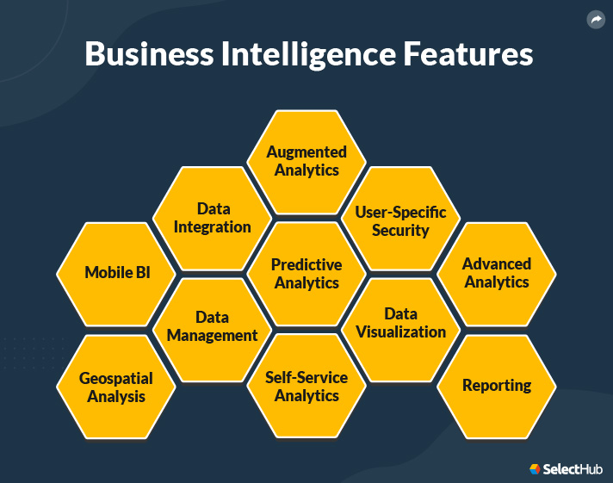
Figure 6: Benefits of BI in Business Success
(Source: Aydiner et al. 2019)
According to the Exago CEO who is Mike Brody the embedded BI software vendor also recognises as a SaaS provider and claims with this software business organisations quickly adapt to the remote work transition. They also notice that they become more effective after covid. At present ⅓ their organisation are operating remotely. It helps in every sector such as banking, healthcare, manufacturing, sector and many other industry services. On the other hand, amazon, oracle, as well as SAP, are considered as main service providers all around the world. According to the report, the use Datapine BI organisations are 19 times more confident in achieving above-average profitability. On the other hand, organisations are experiencing 55% more revenue growth. The investment in this BI tool will return the organisation over 1300% (Aydiner et al. 2019). It also helps the organisation administrators to make decisions faster in comparison with its competitors. In 2020 MicroStrategy attracts the media after the purchase meant of huge amounts of Bitcoins. In order to maintain consistency a single common metadata is used. It also provides streamlined maintenance. It helps the organisation for boosting productivity with expense-free development tools. The SAS software can be used through both the graphical interfaces as well as SAS programming language. It also encourages faster data retrieval, organisation and storage. This minimises the use of time and resources. Hence the business procedures are optimised. On the other hand, data-driven decisions can be taken by identifying paths that lead towards profits, comparing the information with competitors, optimising operations, recognising market trends, examining consumer behavior teaching performance, predicting success and discovering problems.

Conclusion
The upper information reveals the importance of BI tools in the 21st century for business. This demonstrates the innovations to incorporate unused assets which are digital in the business intelligence as well as maximising the augmented techs. As an example, those assets are the assets as well as automation. BI is considered the most rapidly evolving tech in the world. With the help of predictive as well as descriptive analysis, the professionals reveal that this industry will grow by 20%. In the future, this tool will be accessible to everyone and it will be so user-friendly that anyone who belongs to a non-technological background can use it effectively.

References
Aydiner, A.S., Tatoglu, E., Bayraktar, E., Zaim, S. and Delen, D., 2019. Business analytics and firm performance: The mediating role of business process performance. Journal of business research, 96, pp.228-237.
Datapine.com, 2023 DataPine official website Available at: https://www.datapine.com/ [Accessed on: 27.03.2023]
Microstrategy.com, 2023 MicroStrategy official website Available at: https://www.microstrategy.com/ [Accessed on: 27.03.2023]
Sap.com, 2023 SAP BI Official website Available At: https://www.sap.com/products/bi-platform.html [Accessed on: 27.03.2023]
Sas.com, 2023 SAS official website Available At: https://www.sas.com/en_us/solutions/business-intelligence.html [Accessed on: 27.03.2023]
Tavera Romero, C.A., Ortiz, J.H., Khalaf, O.I. and Ríos Prado, A., 2021. Business intelligence: business evolution after industry 4.0. Sustainability, 13(18), p.10026.
Yellowfinbi.com, 2023 Yellowfinbi official website Available At: https://www.yellowfinbi.com/ [Accessed on: 27.03.2023]

