2312419
University of Wales Trinity Saint David

ECAD7004
Professional and Pedagogic Studies: Researching the Learning: what, how and why am I teaching?
An exploratory case study arising from practice (noticing) and
investigated further through identified research tools.
Word Count: 4645

Targets from ECAD7003
 | Target | What I have done in this assignment…
Target 1 | Paraphrase the information from figures unless you decide their inclusion is essential. | I have paraphrased quotations and information in order to remain concise.
Target 2 | Ensure that you write critically. Compare sources and question some of the findings. | I have used different viewpoints from varying sources in order to remain critical.

Appendices
Appendix 1 – Interview Questions:
- Do you like reading? Why?
- What do you think of whole class reading?
  - Do you like it? Why?
  - Do you not like it? Why?
  - Do you prefer whole class reading to other types of reading?
  - Do you think it helps to improve your reading?
  - Does it help more than other types of reading (individual etc.)?
- As a learner whose first language is not English, how do you find whole class reading?
  - Do you like it? Why?
  - Do you not like it? Why?
  - Do you prefer whole class reading to other types of reading?
  - Is it difficult is it for you?
  - Do you think it helps to improve your reading?
  - Does it help more than other types of reading (individual etc.) in learning English?

Appendix 2 – Questionnaire Questions
- Do you like reading?
1 (Not at all) ----- 10 (Very much)
- Do you enjoy whole class reading?
1 (Not at all) ----- 10 (Very much)
- Do you think whole class reading improves your reading skills?
1 (Not at all) ----- 10 (Very much)
- Do you prefer whole class reading to other types of reading?
1 (I prefer other types of reading) ----- 10 (Whole class reading is my favourite)
- How difficult do you find whole class reading?
1 (Not difficult) ----- 10 (Very difficult)
- (Please only answer if English is your second language) Does whole class reading help more than other types of reading?
1 (Definitely not) ----- 10 (Definitely yes)
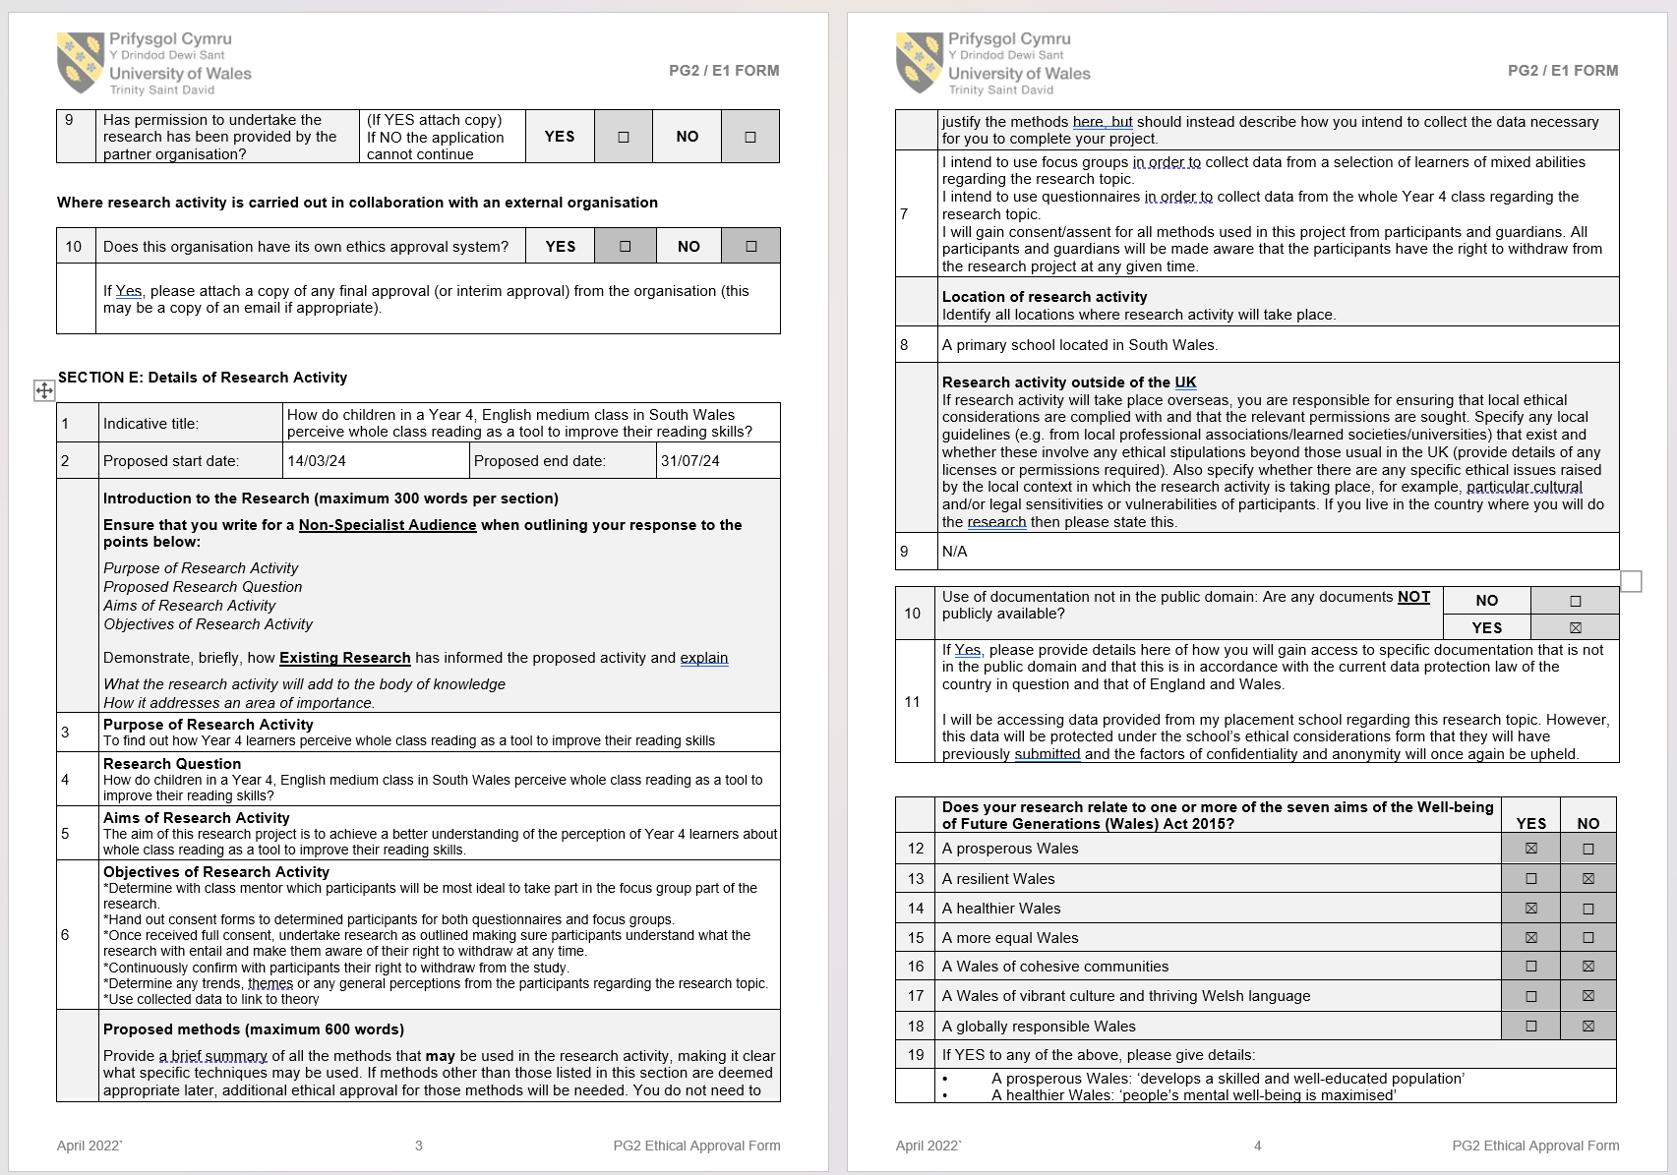
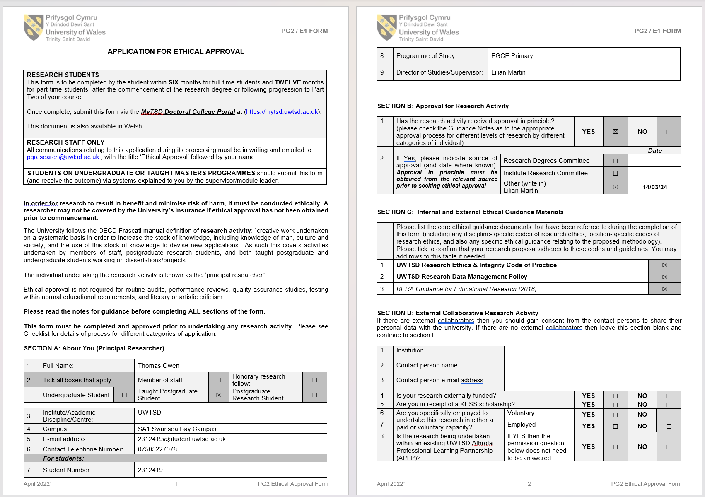
Appendix 3 – Ethics Form:
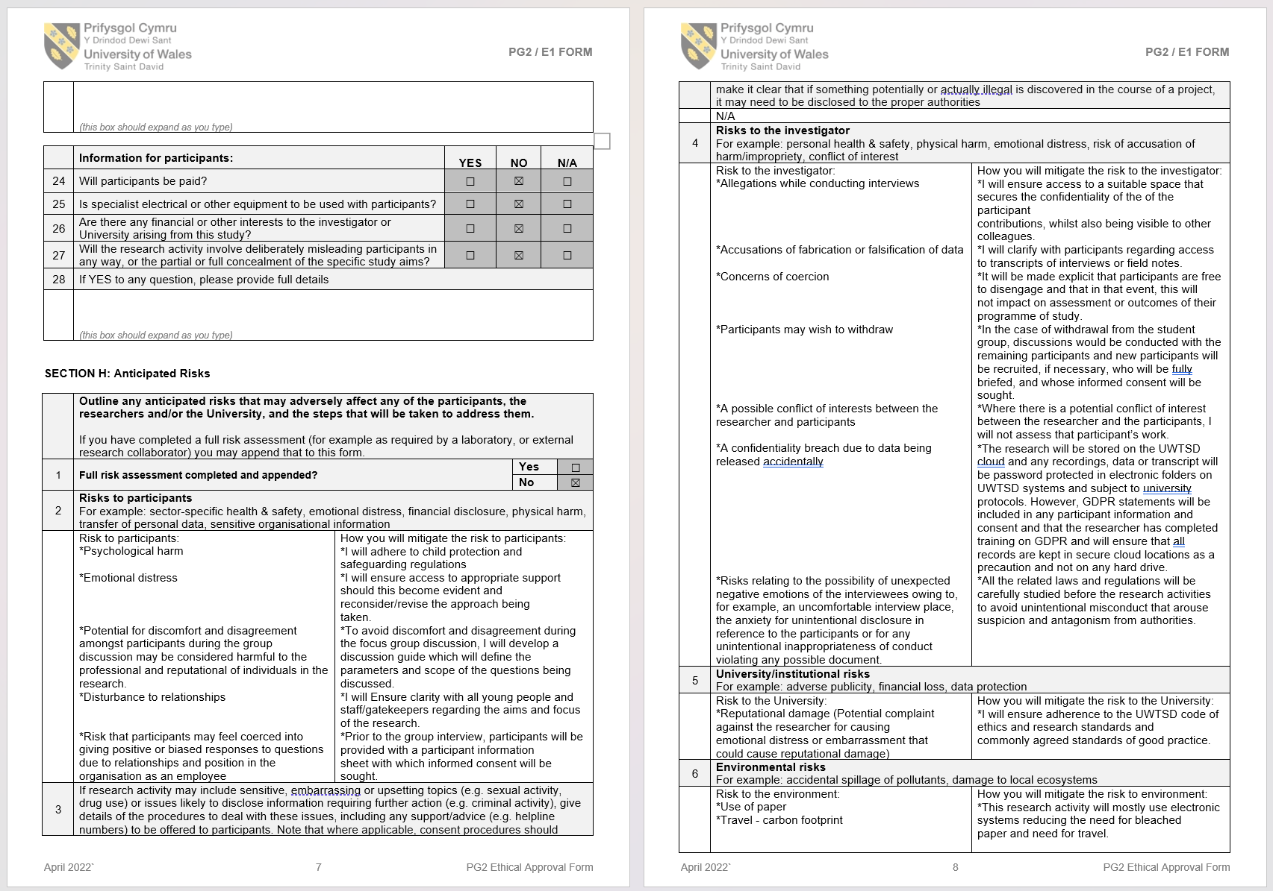
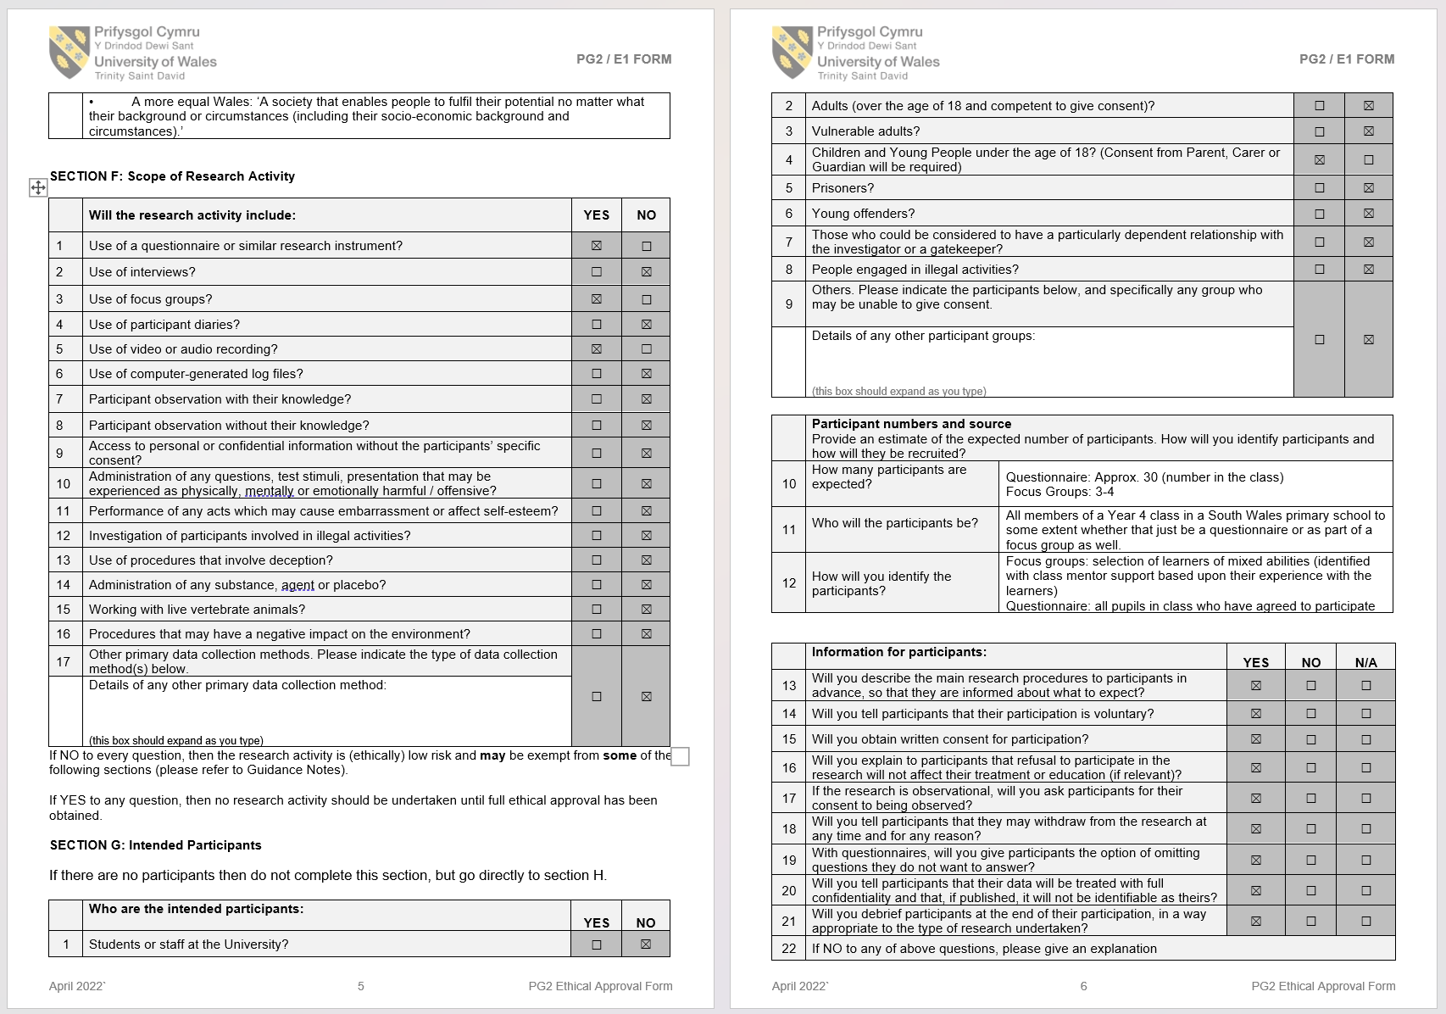

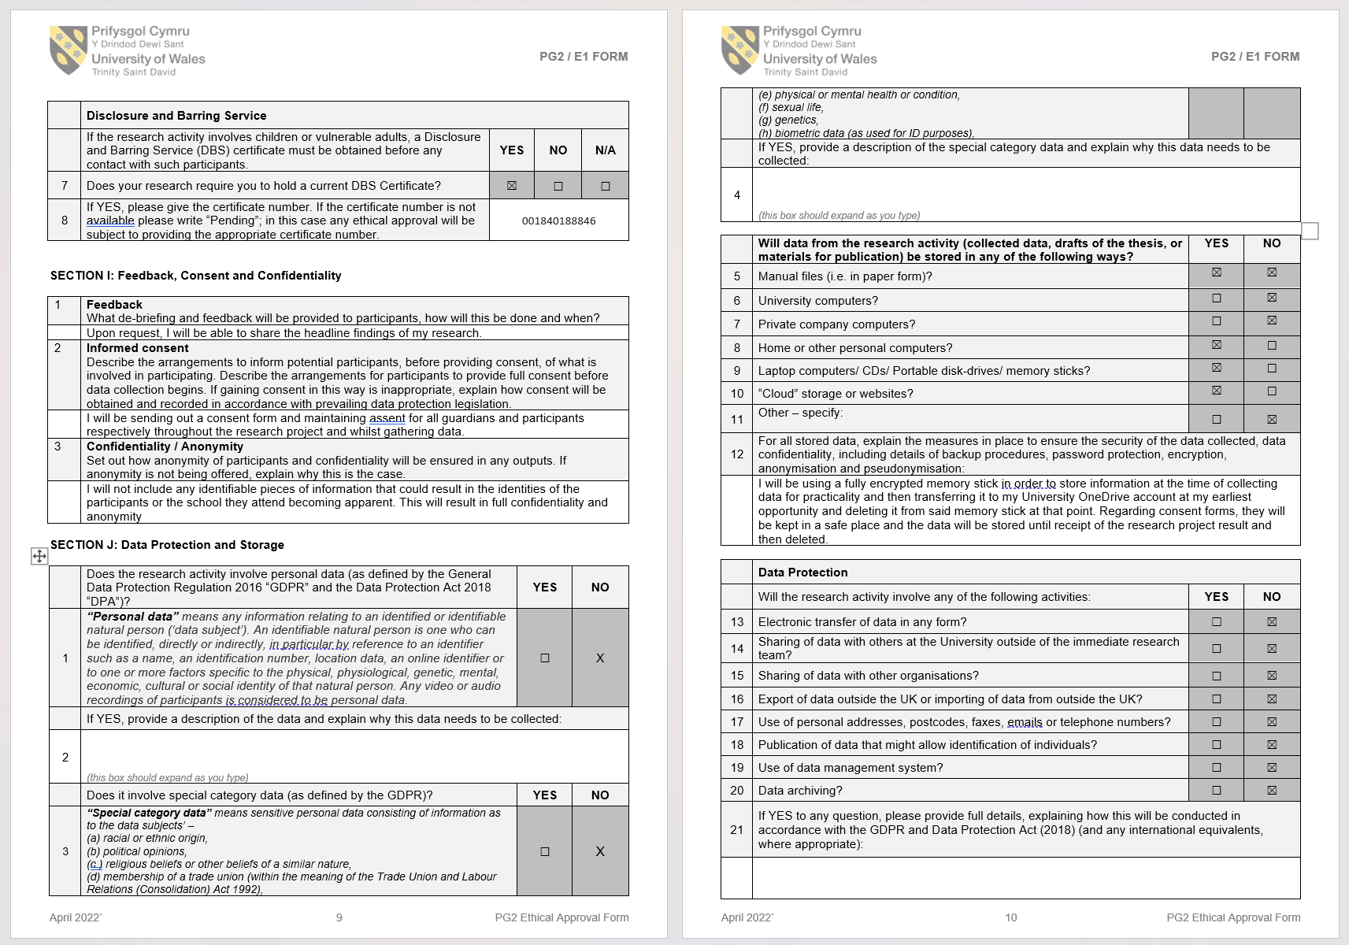
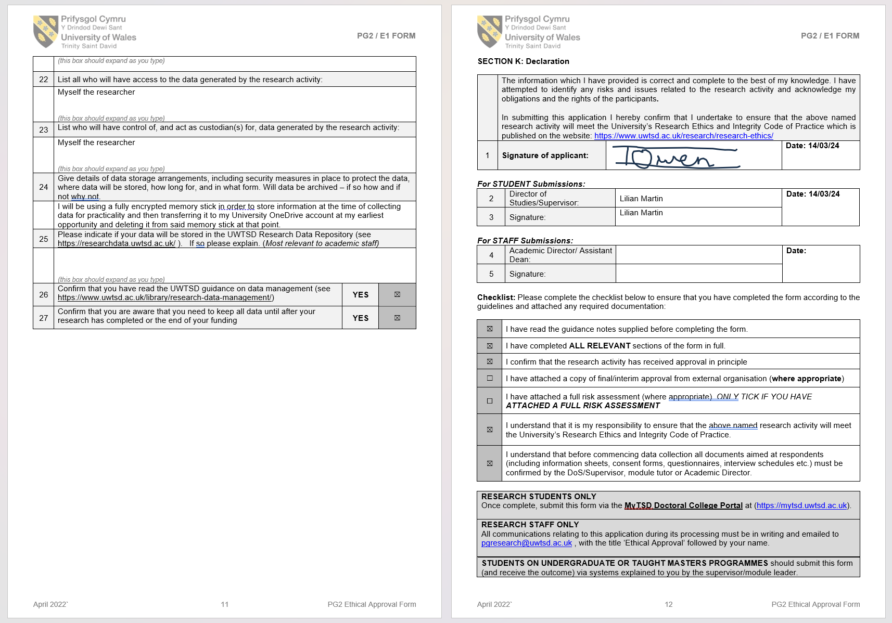

Appendix 4 – Blank Parental Consent Form and Letter:


