Managing Project in the organization
BMSK5004

Student Name: Irene Muabana Kauzeni
Student Number: 1604186
Module Title: BA leadership and management skills for the workplace

Lecture’s Name: Rexon Nting

Table of Contents
Introduction: 1
About the business project: 1
Categories of stakeholders: 2
Management tools and techniques and the usefulness of managing a project: 4
Usefulness of project-management tools and techniques: 7
Implementation of a project plan: 7
Characteristics of a project manager: 8
Project management communication: 9
Organizational structure to manage project: 10
Types of project: 11
Risk Management: 13
Skills required to a project manager: 14
Conclusion: 16
Reference: 17

Introduction:

Managing a project is an art to make the certainty from uncertainty by managing and transforming resources. From defined constraints, the project manager make the project. There are six factors to maintain while managing a project. They are time, quality, risk, scope, cost and resources. Those factors need to be consolidated when to manage a project for future success. There should be code of ethics while making the project. The task of a project manager varies from department to department or institutions to institutions. This report will contain the tools and techniques to evaluate a project management decision. Characteristics of a project manager, benefits of project manager will be shown in this report. An online business plan will be provided and there will be a project management description about the business. There will be several skills which is related to project management described. An analysis about stakeholders will be discussed also.

About the business project:
An online business includes sharing information about the business and make transactions by the help of internet. It is also called e-business. For this report there is a business project of online clothing business. The business has a name called ‘Susann’s clothing”. This business has products like- ladies tops, jeans, bags, gown, fancy party dresses etc. The marketing of the business will through online. Electronic business focuses on ICT and enables both internal and external activities through internet. There should be privacy, access control, authenticity and availability of data. In case of online business authenticity of information is vital.
Project management: A project is a unique process to coordinating and controlling activities to start something new. There are different requirements and mechanism to manage a project according to the activities. The project management is basically a combination of time, quality, cost and resources. The project management is a planned undertaking of a situation.
Project sponsor: The project sponsor has some roles like providing business context, guidance and other effectiveness. They provide funding and ensure the capacity of the project. The sponsors for this project need to be act as an additional line toward the communication process. They make link between the business community and the project.
The vision for the project sponsor of this business is to provide validity of the business and alignment of business objectives. The sponsors of this business need to be found at the initial stage of the project which will help the business to run efficiently (Harrison and Lock,2017).
Stakeholders: Group, community or organization which has interest on the outcome of the project. A good relationship with stakeholder can provide a good outcome about the project.
Stakeholders are affected by the activities, outcome and decision of the organization. There are some list of stakeholder like- project management which contain sponsor, team, PMO and portfolio managers. There are also procurement, finance and government regulators within project management. Program management involves government boards, program team members, competitors, consumer groups, environmental groups and other interests. Organizational stakeholders are communities, employees, shareholders, competitors, Governments, suppliers, media, unions, social and political groups and social & political action groups.

Categories of stakeholders:

- Key stakeholders- this party can significantly influence the success of an activity of the organization.
- Primary stakeholders- They are ultimately affected by the activities of groups or individuals either positively or negatively.
- Secondary stakeholders- all the individuals and institutions has a role in the activity.
There is another factor called stakeholder engagement plan. It is a detailed strategy about the effectiveness of stakeholders and it has the stakeholder engagement guideline.it disclose about how the components of stakeholders are engaged with one another. There is a metrics to measure the stakeholder performance.
The purpose of the stakeholder engagement is to satisfy the engagement of stakeholders. After that they analyze the engagement of stakeholders. The strategic planning related to the organization need to be discussed. It helps to maintain a balance between the activities of stakeholders.

There are level of stakeholders-
- Unaware- they are unaware about the portfolio or project and the potential impact of it.
- Resistant- Aware about the portfolio but there are resistant to change.
- Neutral- They are both unaware and not resistant about the portfolio or project.
Leading- Those activities are resistant about the engaged activities (Harrison and Lock,2017).
Project management scope:
The scope of a project contains the listing of project goals, features and functions. There are tasks and cost of the project which need to be clearly represented by the scope. Under the scope, one has to_
Define the product requirements: it is important to have knowledge about the important requirement about the project. There are some questions need to be cleared before going to the project.
Define the process requirement: the process of interacting with product and business are disclosed under the project management scope. How the business transactions flow from one corner to another is a great concern.
Involvement of correct stakeholders: there are various stages of a project. To attain success, it is important to choose right stakeholders. It involves very initially through the life of the project(Silverman,2016).

Management tools and techniques and the usefulness of managing a project:

Project management tools are used to run the project and make a useful project which is acceptable to everyone. Several project management tools and techniques are used by organizations.
TECHNIQUES
Agile-
It is considered as the most popular project management technique and accepted by maximum people. This methodology uses sprint approach where one can break the project and make a swift change. By this the methodology can gain flexibility and collaboration. It is highly appreciated for software development field.
Waterfall-
It is another technique for project management. There are some steps within waterfall technique. It is considered as the oldest project management techniques. It is also called software development life cycle(SDLC). It helps to make a solid planning about business. Within waterfall, one task need to be prepared before starting another task. There should be an appropriate planning about the project.

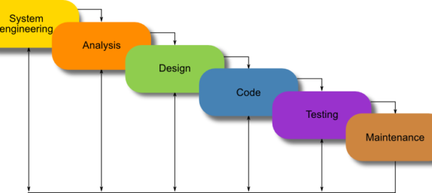
Figure: Waterfall (Project Management Institute.2018).

PRINCE2-
- It is another project management technique which means Project In Controlled Environments. There are some principles of this methodology. There are several levels of this techniques and it is suitable for an UK based organization. Every steps of this business need to be followed. The nature of the methodology is very clear (Smith,2017).
Scrum-
The main objective of this technique is to improve the teamwork, communication and the speed of the business. Another name of this technique is Subject Matter Expert. It encourage the team members to deliver a healthy result about the project. It is also used by combining with another methodologies.
Critical chain methodology-
Another methodology which was developed in 1997. The main focus of this is to plan and manage a project according to the resource level. It focuses on the resources. Thus it is unique from other methodologies.
TOOLS
Proofhub-
It is a versatile tool to be used by giant organizations and it is also considered as all-in-one tool.it has powerful features and implementations. It helps to reduce the pressure on management. It is a online proofing software which saves a lot of time.
Liquidplanner-
It provides a better way to manage a project and offers several approaches to manage the project in an effective way. The planning is constructed according to the project priorities. There is an accessibility of real-time data.
BaseCamp-
It is a good project management tool which is for a long term business planning. There are simple ideologies behind the project management. It helps to create project and teams. It has the feature of robust collaborative platform (Silverman,2016).

ClickUp-
It is the top-rated project management weapon which is highly productive and successful during the life of the project. It has focus on effective task management. It has several powerful characteristics like offer list, box and board view. It create the individual custom status.
Those are some popular tools and techniques which helps to manage a project.
For “Susan’s clothing” business the most appropriate tool is CLickUp because it provides larger facilities for an online business. It is also the top rated tool. Waterfall technique is suitable for this online clothing business. As it can make a good planning and implementation program.
There are other project management tools and techniques also considered. Like-
SWOT Analysis- It defines the strength, weakness, opportunities and threats related to the project. By analyzing this a business can get benefit in future.
- Stakeholder Matrix- It is another tools which consider the business according to the importance of each project. There is a map to develop the project. The management get involve in the project management process (Smith,2017).
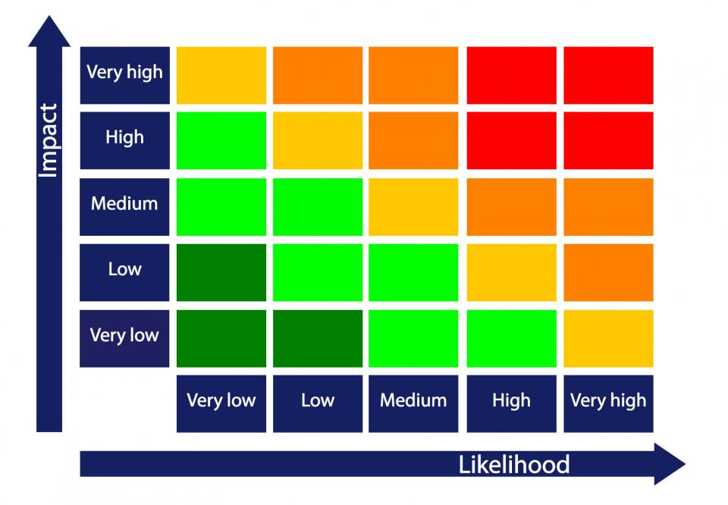
Figure: Risk assessment Map for project management (Silverman,2016).

Decision tree
It is another technique to manage a project. It helps to enable the choice making decision of a business. Susan’s clothing is an online business and need to take decision quickly but in an effective manner. So it can hire this technique. This business has different opportunities, strategies and decision tree will help it when making decision.

Usefulness of project-management tools and techniques:
Planning and estimation- project plans, task assignment and project budgeting are some ways to make a good planning and estimation about the business. It helps the managers to define the objectives and goal.
Scheduling resources- It is quite critical to evaluate the resources which are related to project management. By charts and other tools, it is helpful for the manager to schedule resources.
Time saving and expertise- It will provide expertise in case of managing a project. This tools also save the time of managers.
Tools and techniques of project management are useful enough to carry out a business.

Implementation of a project plan:
Implementation is about carrying out the project management and working plan. It is not easy to implement a given project. But it requires coordination of activities and team development. For the business project implementation of Susan’s clothing, it is required to accept some tools and techniques to drive the project.
To get started one need to be punctual enough to understand the project and coordinate the resources for final result. Technical and non-technical issues need to be clearly defined. Susan’s clothing should make SWOT Analysis to find out the necessary viewpoints about the business. Decision tree can help the business by finding out the effective decision regarding any important issue. A summary risk profile include possible threats about the business. There can be safety threats, environmental threats and other threats which are available for the organization. The risk management process should include identification of risks, impact of risks, risk management approaches and actions, monitoring and review of risk is also important. Make the risk integral of the online business and ensure the impact of time and costs. The business should be vigilant and proactive.
Project manager: a project manager is a person who has sufficient qualities to manage a project. He or she should have some qualities to run a project effectively. The main task of a project manager is to play with the art of making a project (Damanpour and others, 2018).

Characteristics of a project manager:
A good project manager should have some unique characteristics like-
- Good communicator: the project manager must have a good communication sense. Every level of the project need to be coordinated through a good communication process. There should be a clear communication toward the responsibility and performance of the organization.
- Shared vision: The project manager need to hold a shared vision. The manager should ensure the people that they have real stake in the given project.
- Integrity: It is another characteristic of a project manager. He or she should has clear knowledge about the actions and words. There should be commitments and ethics.
- Team building: The manager should hold some qualities to hold the team strongly. The leader must have the understanding about the process and dynamics which is required to moving the project.
- Problem solving skills: in case of any problem, the project manager should stay strong and try to find out some solutions. The manager should have fresh and creative response toward any problems.
- Task management: A good project manager need to have task management capabilities also. Each and every task need to well managed.
All those characteristics should be within any good project manager.

Project management communication:
Communication is very important to make the project an effective one implement. There is a threat to weaker communication. To make a success in project management, there should a good communication system.
Communication planning: there are need of information and communication of stakeholders. There should be information distribution and performance reporting on a regular basis.
A project management should include-
- Planning- A planned communications management is required to get a good project. Project documents update is another thing which is considered as an output of project communication management.
- Executing: Under this, the manager manage the overall process of communication. Project communications, update about management planning and process assets update is also required.
- Monitoring and controlling: it control the process of communication. By the process of monitoring and controlling, we can get work-related information, project documents updates and organizational process updates. There are basically two types of communication for stakeholders (Smith, 2017).
Interactive communication-
It allows the stakeholders to make live interaction with all the people who are involved in the project. There are several ways to make an interactive communication like- live chat, phone calls and video conferencing. When the parties are from different region, interactive communication is more suitable. The project manager need to choose between alternatives about the way of communication.
Face- to face communication method is an effective method. It will provide better opportunities to explain the projects and discussion about issues related to the project. There are charts, graphs and other ways to explain the project.
Push communication: In this case, the feedback after the communication is not required immediately. This technique is used for sending notes and other important information. They can also make press release to implement this process.
Pull communication-In this type of communication, there is a large-scale of audience. The information will provided by server or somewhere where the stakeholders and team members can get easy access (Silverman, 2016).
A good communication for Susan’s clothing should hold-
- The project manager has to spend maximum time for communicational purpose.
- There is a need to focus on group and individual communication in a large-scale.
- Both formal and informal methods need to be covered under a good communication process.
- The distribution of communication need to be in an effective manner.
- The number of communication channel need to be determined.
Developing better communications skills:
It is important to develop the communication skills within an organization. An organization need to be more global and friendly to deliver the effectiveness of communication. The leadership process need to be considered while communicating with others. The field of communicational training need to be developed more. Susan’s clothing need to spend more money on this types of training (Prajogo,2016).
Several tools are used to make an effective communication like- email, messaging, texting and other collaborative tools. Susan’s clothing deliver their products through currier and make communication through texting, messaging and by using other tools.
SharePoint portal, Google docs, wiki are some of the collaborative tools for effective communication (Pearson,2017).

Organizational structure to manage project:
To attain success in any project, there is a need of project management structure. Misguided project management structure can badly affect the organization and the image of that organization. The authority of the project management has influence on the overall project performance. There are several types of project management organizational structure.

Functional organizational structure-
There is a hierarchy system under the projects functional structure. Authority of the organization will take the decision regarding the business. There are decision regarding schedule, budget and set of equipment’s. There are various companies who are concern about the project in which the organization is run through the decision of supervisor. Under this structure, the employees are more skilled and provide great service toward the succession of the project. But this task is monotonous and there may arise less enthusiasm (Harrison and Lock, 2017).
Projected organizational structure-
The project manager has the power of authority under projected organizational structure. He make decisions regarding budget, schedule and the project team. It is absolutely the opposite of functional organizational structure. The line of authority is clear and established. But the employee can get stress by seeing so much pressure on them.
Matrix organizational structure-
The structure is somewhere between the projected organizational structure and functional organizational structure. The similarities with projected organizational structure is that the project manager is considered to have the responsibilities of the project. But when the matrix is weak, the project authority is in the hand of functional manager.
Online business like Susan’s clothing can adopt the matrix organizational structure to manage their projects (Project Management Institute.2018).

Types of project:
There are several types of project. Each and every style has unique characteristics. There are four major types of project.
- Walking in the fog- it is one of the unique project style. The organization try to do something unique under this type. They want to introduce a new business style for the organization.
- Making a movie- In this case, one doesn’t has the knowledge about by which components they are going to implement the project. There are many things needed to make a change within the project.
- Going on a quest- The stakeholders and the manager has clear knowledge about what is needed to be done during the project.
- Painting by the time- this types of project require time and investigation to run the project effectively. There is also need of money to change the style of the project.
The project life cycle: It has four phases- initiation, planning, execution and closure. Initiation has some other sub clauses like- business case, feasibility study, project charter, project team, project office and phase review (Silverman, 2018).
- Under the planning phase, there are project plan, resource plan, quality plan, risk plan and other acceptance plan. Commercial plan and procurement plan are also presented under this.
- Execution phase includes building deliverables, monitoring and controlling. Risk management, procurement management, communication management are available under this.
- Closure has project closure performance and review about the project completion.

PRINCE2:
It is a method of project management which is structured and divide the project according to controllable stages. It adopt many worldwide countries with many languages. For UK based organizations or business, PRINCE2 is appropriate for Susan’s clothing. There are six aspects of PRINCE2 (Black and others, 2018).
- Scope- there are project plan as example- the project manager should print something in color.
- Timescale- it is an important aspects which describes about the period of the project.
- Risk- it is under risk management approach. There are risk of failure in case of political instability.
- Quality- the quality of the business project need to be considered also.
- Benefits- it is about the business case.
- Cost- it is also related to the project plan. The cost limit should be imposed under PRINCE2.

Risk Management:
The probability of unwanted occurrence is considered as risk. There are impacts of risk under project management. Risk probability is about the likelihood of risk occurrence. Risk control is another degree by which the change will occur. There are three activities which are related to risk management (Muller,2017).
Avoiding the risk: although it is not wise or always possible to avoid the risk, there is a requirement for the change in the performance or activity.
Transferring the risk: they can buy insurance or transfer the riskiness.
Assuming the risk: Another way is to assume the risk previously and then action according to the requirement. Parties should accept and control the risk.

Skills required to a project manager:
There are some skills which are required to establish a good project. As an online business owner, there are several projects need to be taken.
Leadership:
Leadership is both a research area and a practical skill which is required to the individual. There are individuals and organizations who act as a leader. It is considered as a process of social influence in which a person enlist it to support the accomplishment of others. There are common important skills of a leader (Miller and Miller,2018).
Communication is an essential characteristics of a manager. The manager need to be well known for the communication process. It is the most fundamental skill of a project manager. A good communicator must be able to clearly express their feelings and thoughts (McClave and others,2018). As a project manager or owner of a business, the manager of Susan’s clothing has a good communication skill. A leader should have a good skill about building relationship with others. Stakeholders and customers are their priority. Along with other skills, the manager of this organization need to be more efficient about building the relationship (Klein,2017).
Communication management:
It is a systematic planning and monitoring process of channel of communication. Revision and communication is vital for an effective manager of an organization. The corporate communication strategies include communication management. There are both upward and downward communication process. There is an opportunity of better coordination, improved performance, customer relations and improved industrial relations.
It is not an easy task to ensure effective downward communication. Status can make it as a sender and receiver relation. Upward communication is a transmission of information and high rated disclosure. Monitoring and controlling the project is very essential. There is a planned monitoring and controlling cycle for every organization. It is a closed loop process. It works for the real work destination. It is quite important to design the monitoring system of the organization. Real time data need to be collected and there is a tendency toward easy collection of data (Nicholas and Steyn,2017).

Stakeholder Analysis:
It is a process of systematic assessment of potential changes to the relevant parties and interested parties also. The information which are related to interest rate are disclosed in the project plan. A stakeholder analysis has weights and balancing procedures.
Benefits of stakeholder analysis:
- There are some benefits of stakeholder analysis. Like
- There are stakeholder’s interest which is involved in the process.
- There are potential risk and misunderstanding which can be mitigated by stakeholder analysis.
It is possible to influence the stakeholders positively.
It is easier to find the negative impact of stakeholders with their adverse effect on the running project (Lock, 2017).
Fair trade initiatives- there is an option of fair trade initiatives which includes the features of trading by fair ways. Fair trade involves the activities which are related to social, economic and environmental condition. It guarantees a better working environment, economic conditions and social structure. This theory was first introduced in USA and the policy is called FLO. There are some changes in the policy of FLO.
A green agenda- it is a combination of knowledge, research and entrepreneurship. It comes up with ideas to change the world and make the world a better place to live in. In case of an online business, there is no scope of that much environmental pollution. But it is important to consider this agenda and help the lives (Kerzner and Kerzner, 2017).
The online business of clothing can make an effective use of those tools and techniques which are related to project management. There are several scopes and opportunities to make a good business through online. Some risks need to be managed and a portfolio need to be constructed also. The stakeholder should accept a green agenda and o through a fair trade value (Boyle, 2017).
As a manager of the online clothing business, he/she need to be more focused about the communicational process of the organization. The authority of the business should monitor and control the business efficiency. The manager should accept some ethics to run the business and have some authenticity related to the business. There are some code of ethics for each and every business. A good investment is need to be done by an effective manager. The good practice of management is required for this kind of business. The manager of this business need to give easy response and assure the customers about their authenticity.

Conclusion:
The report is about managing a project efficiently. Good communication sense is required to run this types of project. The overall procedure of a project management is essential for the business manager. Some tools and techniques need to be followed by the manager of that organization.

Reference:
- Boyle, G., 2017. Design project management. Routledge.
- Black, K., Castillo,I., Goldlist, A. and Edmunds, T., 2018. Essentials of Business Statistics. Wiley Global Education.
- Damanpour, F., Sanchez-Henriquez, F. and Chiu, H.H., (2018). Internal and external sources and the adoption of innovations in organizations. British Journal of Management, 29(4), pp.712-730.
- Harrison, F. and Lock, D., 2017. Advanced project management: a structured approach, Routledge.
- JAMES,T.,MCCLAVE, B., GEORGE, P. and SINCICH, T., 2018. STATISTICS FOR BUSINESS AND ECONOMICS, GLOBAL EDITION. PEARSON EDUCATION LIMITED.
- Kerzner,H. and Kerzner, H.R., 2017. Project management: a systems approach to planning, scheduling, and controlling. John Wiley & Sons.
- Klein, P.A., 2017. Analyzing Modern Business Cycles: Essays Honoring: Essays Honoring: Routledge.
- Lock, D., 2017. The essentials of project management. Routledge.
- McClave, J.T., Benson, P.G. and Sincich, T., 2018. Statistics for Business and Economics. Pearson Higher Ed.
- Miller, J. and Miller, J. C, 2018. Statistics and chemometrics for analytical chemistry. Pearson Education.
- Muller, R., 2017. Project governance. Routledge.
- Nicholas, J. M. and Steyn, H., 2017. Project management for engineering, business and technology. Rouledge.
- Project Management Institute. 2018. A Guide to the Project Management Body of Knowledge (PMBOK@Guide)- (SIMPLIFIED CHINESE). Project Management Institute.
- Pearson, R., (2017). Business ethics as communication ethics: Public relations practice and the idea of dialogue. In Public relations theory (pp.111-131).Routledge.
- Prajogo, D.I., (2016). The strategic fit between innovation strategies and business environment in delivering business performance. Internal Journal of Production Economics,171.pp.241-249.
- Silverman, B. W., 2018. Destiny estimation for statistics and data analysis. Routledge.
- Silverman, D. ed., 2016. Qualitative research. Sage.
- Smith, S.S., (2017). Strategic Management Accounting: Delivering Value in a Changing Business Environment. Through Integrated Reporting. Business Expert Press.

