
Computer Architecture and operating systems

Presented by: Shamsa Naser
Student id: 2524811
Module Code: ACCA4026
Lecturer: Md Shantanu Islam
Assignment Title: Operating Systems

Contents
Introduction 4
Key functions of general Operating Systems 4
Task Management: 4
Application/Program Management: 4
File/Directory Management: 5
Device Management: 5
Security Management: 6
Use of Windows OS CLI commands 7
Example 1: 7
Example 2: 7
Example 3: 8
Example 4: 8
Example 5: 9
Example 6: 9
Example 7: 10
Example 8: 10
Example 9: 11
Example 10: 11
Use of Linux OS CLI commands 12
Example 1: 12
Example 2: 12
Example 3: 13
Example 4: 13
Example 5: 14
Example 6: 14
Example 7: 15
Example 8: 15
Example 9: 16
Example 10: 16
Use of Windows OS scripts 17
Example 1: 17
Example 2: 18
Use of Linux OS scripts 19
Example 1: 19
Example 2: 20
Conclusion 21
References 21
Appendices 21

Introduction

Key functions of general Operating Systems
An operating system (OS) is a software programme that runs a computer or device. It acts as bridge between the user, applications and the hardware. All devices around the world have an operating system. There are many operating systems developed worldwide for various purposes some of the most common and popular operating systems are Windows, Linux ,Mac( OS). (use 3 references)

Task Management:
The task of process management is to run multiple process at once. Task management is used to track running process and the memory allocated to them. The task manager allocates memory to each process so that all processes can run efficiently. (1 reference minimum)
In windows, Task manager views the running processes.
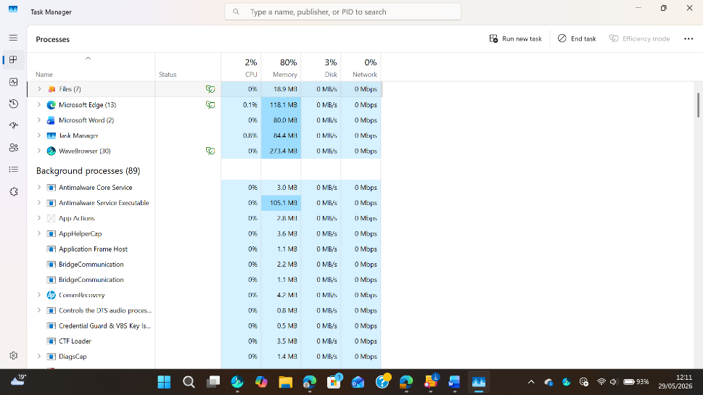
Figure 1: Task Manger

Application/Program Management:
Application or app management in a computer is responsible for controlling the life cycle of software applications. Application management has many responsibilities such as installations, updates, execution, permissions, uninstallation and monitoring. Its primary responsibility is ensuring that software runs efficiently. It is responsible to keep track of extracting files, keep check for updates and downloads and applying software new features. Application management matters for system stability, security and also for the performance management prevents apps from crushing the entire computer by isolating memory, it also blocks the malicious apps for secure access. Use 1 reference minimum
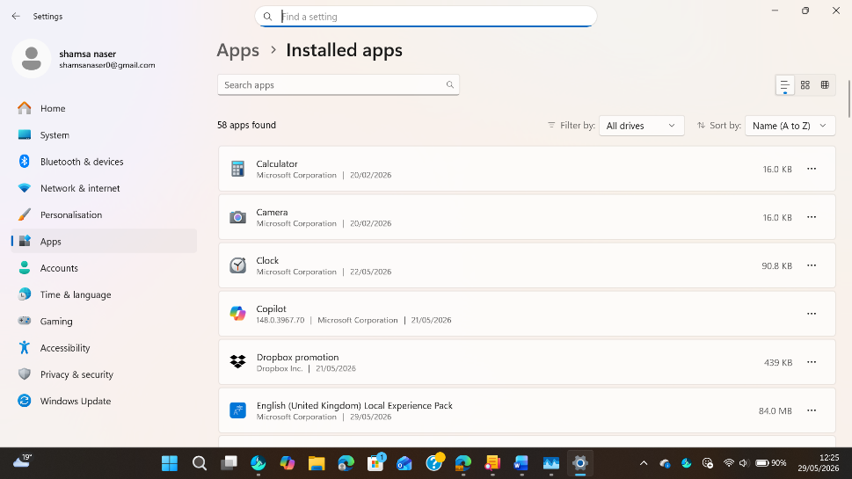
Figure 2: Application Manager

File/Directory Management:
File explorer or file management is responsible for managing files and folders. It manages how files are stored, organized, copied, deleted and searched. File directory management is the process of storing, locating, organizing, maintaining and controlling the access to files and folders on a computer storage system. File directory management helps with finding files, reducing duplicate files, improvement in collaboration, maintaining security, simplifying the backups and increase the productivity. In windows, file management can be explored via File Explorer; in macOS, via Finder; And in Linux, via Files Nautilus (use 1 reference)

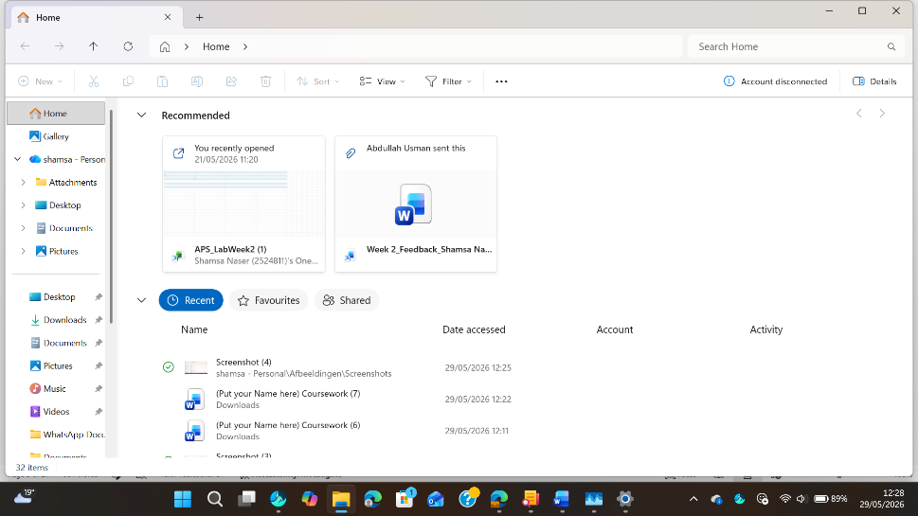
Figure 3: File Explorer

Device Management:
In an operating system, Device management is the process of controlling Coordinating, and monitoring hardware components, including network adapters, storage devices, keyboards and printers. The operating system relies
On device drivers to enable communication between devices and programmes.it also handles input output operations, resource allocation and hardware performance to facilitate the efficient and reliable operation of the system. (use 1 reference)
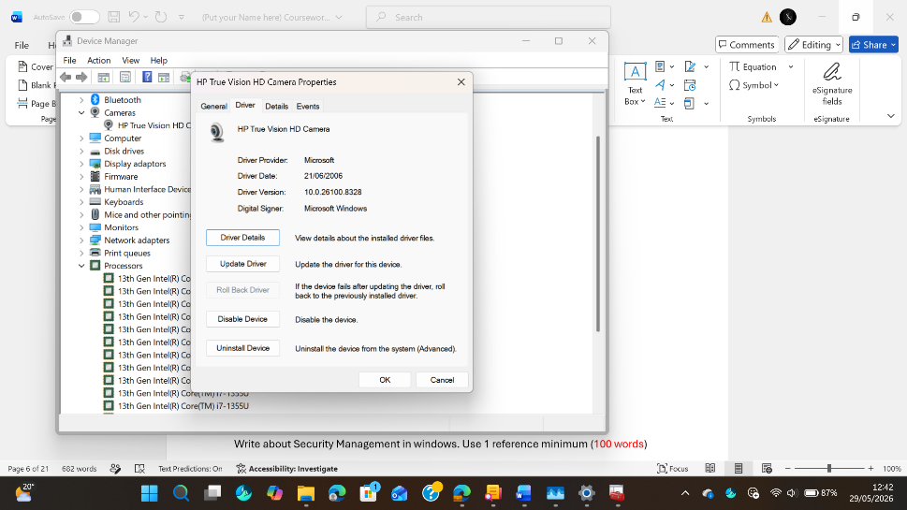
Figure 4: Device Management

Security Management:
Security management is an operating system refers to the set of policies,
Procedures, and mechanisms that protect system resources, data and the user information from unauthorised access, malicious software and other cyber threats.
The operating system, security management provides security by authentication, access control, encryption, a firewall and frequent security update. Good security management will increase the integrity, confidentiality and availability of the system while reducing the vulnerability and risks of cyber-attacks. (3 references)
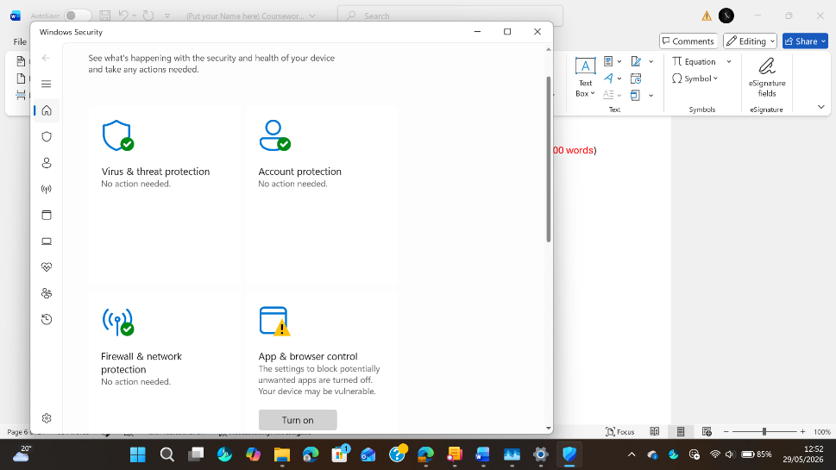
Figure 5: Windows Security Management

Use of Windows OS CLI commands:
The windows operating system includes commands in the Command-Line interface (CLI) for system administration, trouble shooting and resource management via Batch and Power Shell. These commands enhance efficiency by enabling users to accomplish tasks in less time than relying on the graphical user interference. (add 2 references)

Example 1:
A Dir /s command in the windows operating system will list all the files and folder in a directory including any subdirectories. To make a content of a storage locations efficiently viewable, organised and manageable for users and administrators.
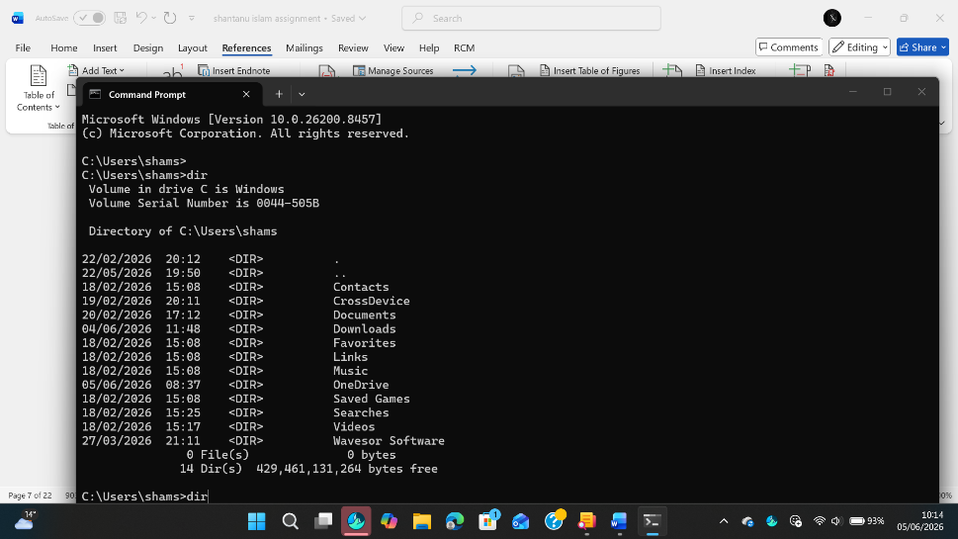
Figure 6: Dir

Example 2:
The cd (change Directory) command is one of the most frequently used command. The cd command is used to change the current working directory .The cd command is responsible for changing the current directory and navigates from one folder to another.it also allows access to files and subdirectories in different parts of the file system.
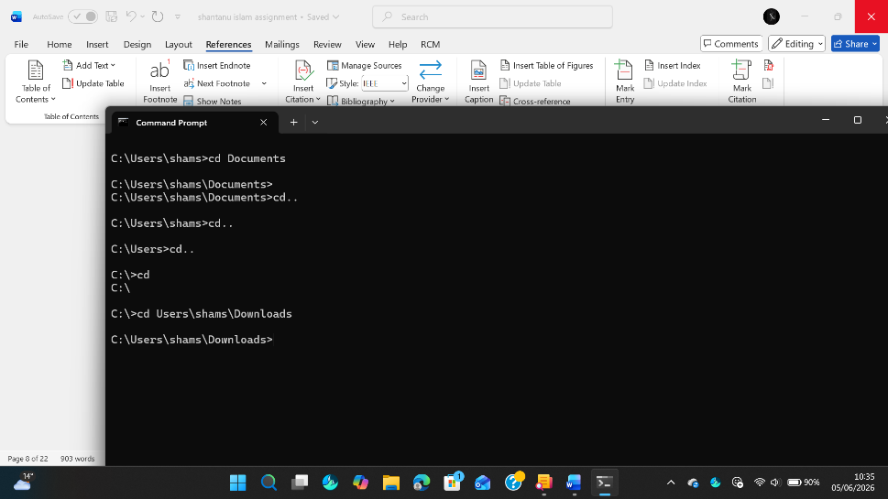
Figure 7: CD

Example 3
The mk dir command stands for Make Directory. It is used to create new directory or folder within the Windows file system.it is mostly used for the organization of files and for providing a structured storage space in the OS .If successful, the commands output is usually silent ,so the new folder is created in the location indicated, without any additional conformation messages .in case the folder already exists the system will show an error notification.
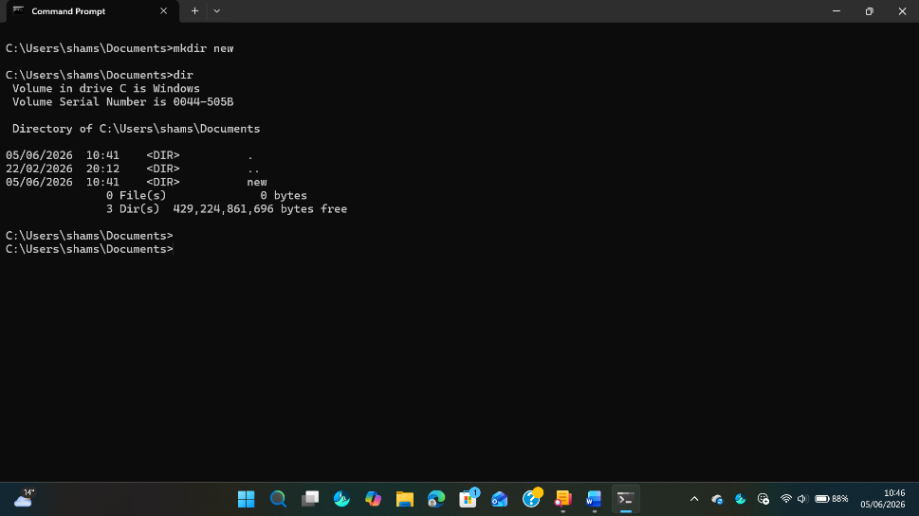
Example 4:
The rmdir command stands for Remove Directory.it is used to delete an empty directory. Rmdir only works on empty directories.

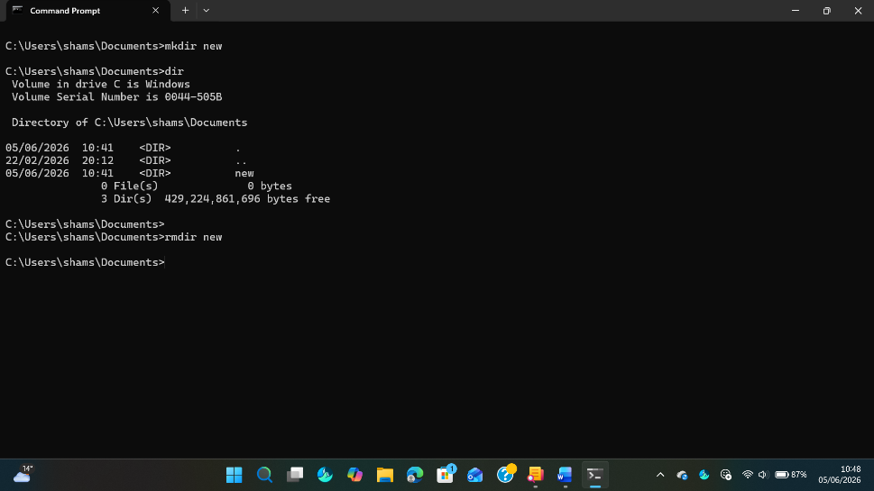
Figure 9: rmdir new

Example 5:
The rename command is used to change the name of a file or directory. If the command successful, it changes the name of the file and in case of failure an error message pop up such as no such file or directory or the system cannot find the file specified. Here my given command was successful, and it rename my previous folder named new to Yahya.
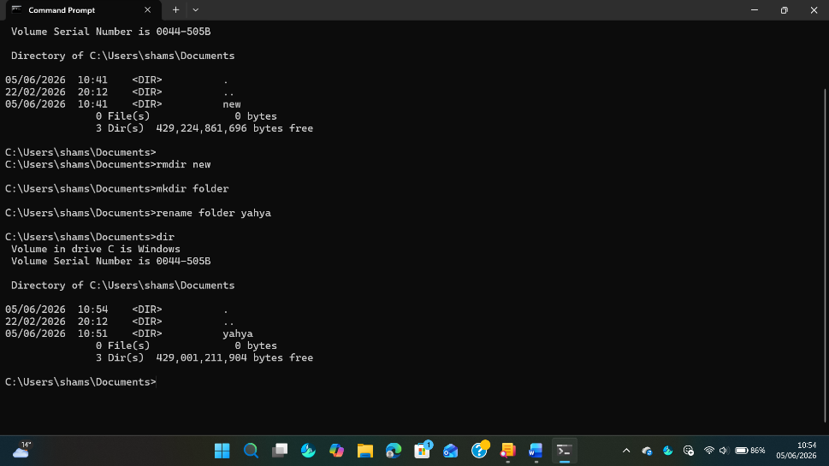
Figure 10: rename

Example 6:
The ipconfig command is used in windows operating systems to display and also manage a computers IP Network configuration.it helps us to see how your device is connected to a network and what network setting is in its usage.it is used to view your IP Address identify network adapters and their domain like Wi-Fi.

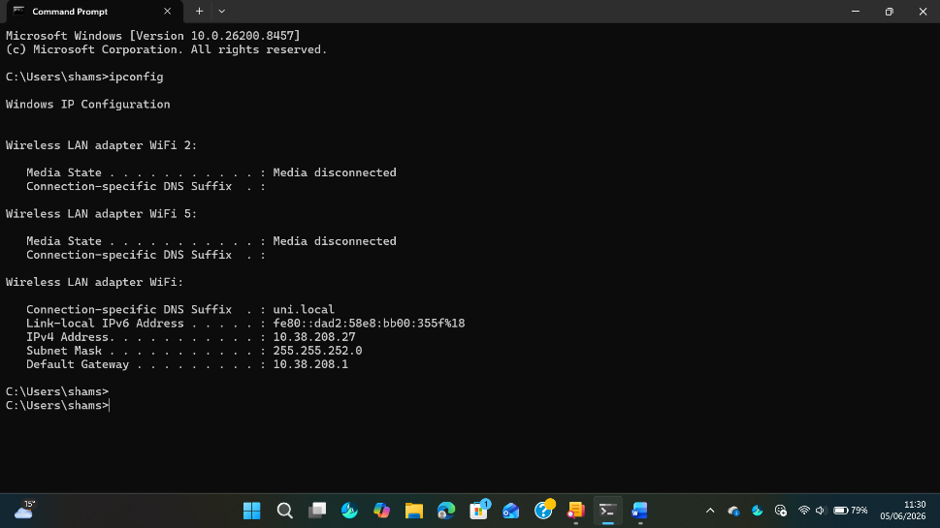
Figure 11: ipconfig

Example 7:
The command Ping is used to check network connections between computer and other devices such as website, server, or another compute. The intent of the command is to test network availability, response time and connection reliability.
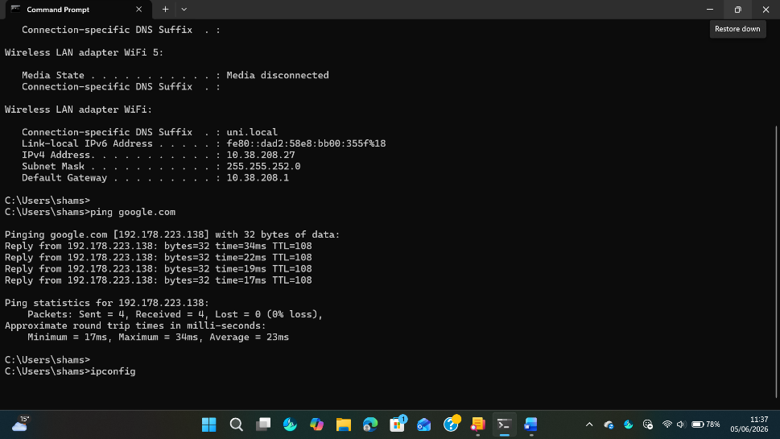
Figure 12: ping

Example 8:
The netstat is Network Statistics. This command shows information about the network statistics and network connections in the system.IT is used to view active Network connections, open ports on the system identify the servers on the device, keep check on network activity and resolve the suspicious connections. The output displays protocol Types, local and foreign IP Addresses, connection states and process identifiers.
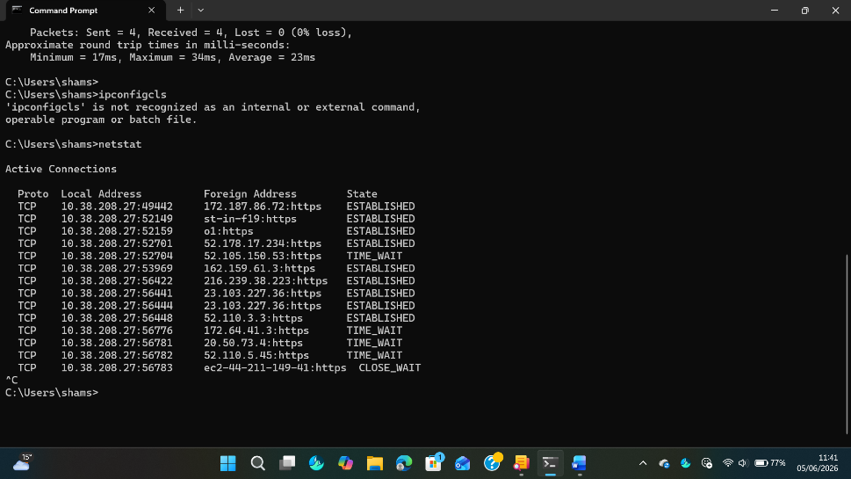
Figure 13: netstat

Example 9:
The system information command is used to display brief information about computers operating system configuration, showing hardware information. The system information view memory and processor details, checking system uptime and network information.
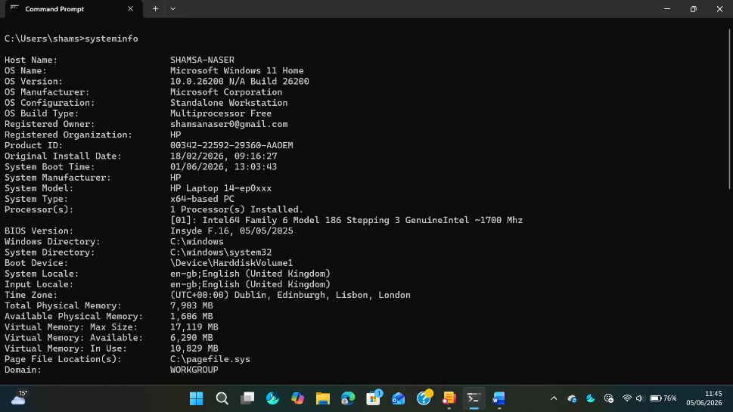
Figure 14: system information

Example 10:
The task list command is used to display all currently running tasks on your computer.it views all application running in the background also identify which programmes are using the system resources, usage of memory also helps, manage and monitor system activity.

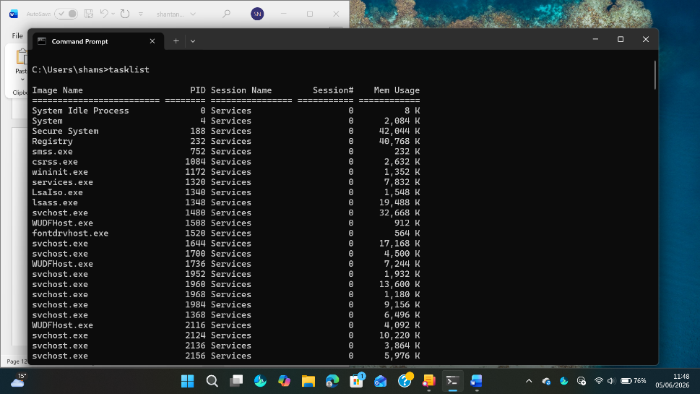
Figure 15: tasklist

Use of Linux OS CLI commands
Write about Linux CLI functions and applications. Use 2 references. (40 words)

Example 1:
Explain the command and output. (30 words)

Figure 16: Description

Example 2:
Explain the command and output. (30 words)
Figure 17: Description

Example 3:
Explain the command and output. (30 words)
Figure 18: Description

Example 4:
Explain the command and output. (30 words)
Figure 19: Description

Example 5:
Explain the command and output. (30 words)
Figure 20: Description

Example 6:
Explain the command and output. (30 words)
Figure 21: Description

Example 7:
Explain the command and output. (30 words)
Figure 22: Description

Example 8:
Explain the command and output. (30 words)
Figure 23: Description

Example 9:
Explain the command and output. (30 words)
Figure 24: Description

Example 10:
Explain the command and output. (30 words)
Figure 25: Description

Use of Windows OS scripts
Windows Batch Scripting is used to automate administrative and system-level tasks by executing a sequence of commands within the Commands Prompt environment. Batch files support essential programming constructs such as variables, user input, conditional statements, loops and arithmetic operations, making them suitable for lightweight automation in windows operating system. Use 2 references.

Example 1:
A batch script is a text file that contains a sequence of commands executed by the Windows Command Prompt. (150 words)
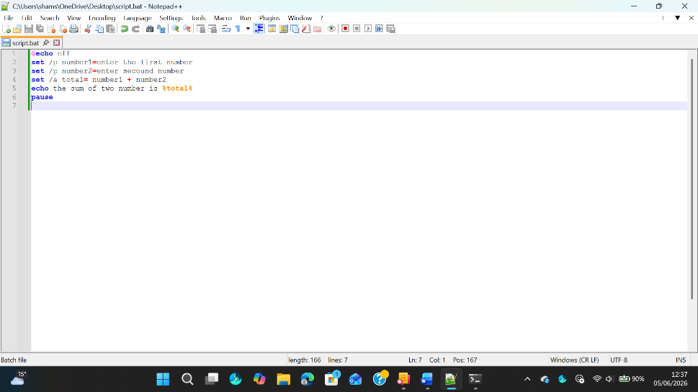
Figure 26: Description
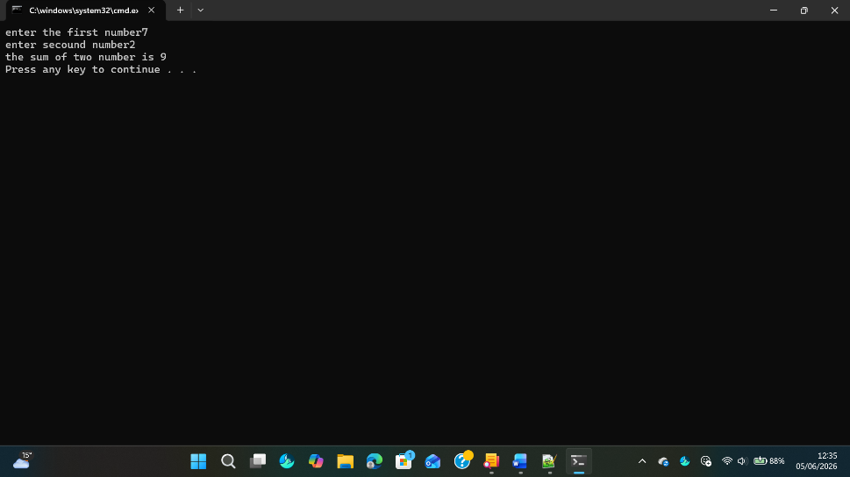
Figure 27: Description

Example 2:
Explain the script and output. (150 words)
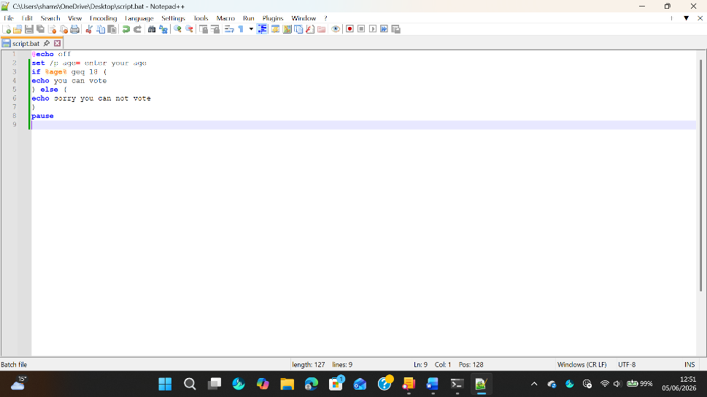
Figure 28: Description
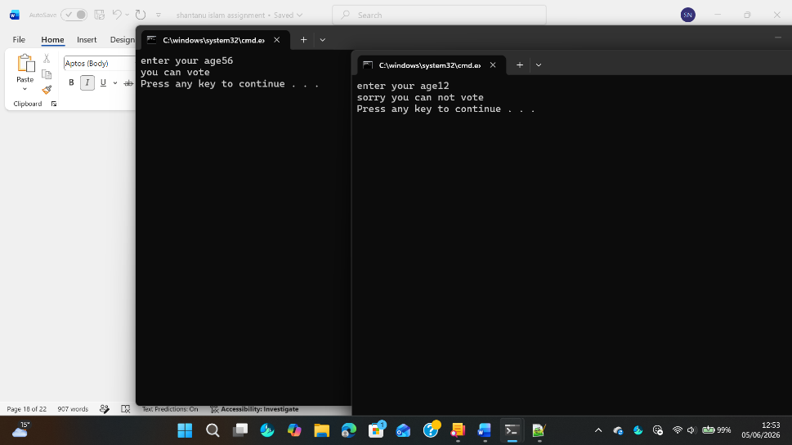
Figure 29: Description

Use of Linux OS scripts
Bash scripting in Linux is a powerful tool used for system automation, process control, and administrative task execution .it supports programming features such as variables, loops, conditional statements, user input and arithmetic operations, making it suitable for both simple an advanced system automations tasks. Bash is widely used in Linux environment because it allows direct interaction with the kernel and system resources through the terminal interface. Use 2 references.

Example 1:
Explain the script and output. (150 words)
Figure 30: Description
Figure 31: Description

Example 2:
Explain the script and output. (150 words)
Figure 32: Description
Figure 33: Description

Conclusion

The study of the command lines of Windows and Linux operating systems and the ability to write scripts illustrates the basics of automation in system administration today. While there are many other tools available for the windows operating system. Certain commands are very simple yet powerful, and they are a great way to use processes the files, networks, users and scheduled tasks, including the use of commands like dir, task list ping, net user and schticks. These tools help to streamline operations, allowing administrators to accomplish routine tasks quickly and with little manual effort.
Likewise, Linux Bash commands and scripts provide a very flexible and powerful system control and automation environment. The usage of commands like ps,is,ping, crontab, loops variables and conditions allow for advanced process management, system monitoring and task automation. The comparison of the two operating systems reveals that windows offer a more user-friendly CLS environment, whereas Linux offers more flexibility and scripting capabilities for system-level operations.

References

There are no sources in the current document.

Appendices
Online Course name:
Figure 34: Certificate of completion

