Asmut Price
Student number: 2021599
Date: 2nd December 2021
Word Count: 2574
Managing Enterprise in the 21st Century - BMSW4006

Table of Contents
Overview of Business……………………………………………………………………………....………………………………… 2
- Company Name
- Mission Statement
- Business Aim
- Business Objectives
- Legal
Product and Services…………………………………………………………………………………………………………………. 3
Marketing Strategy and PR plan……………………………………………………………………………………………. 4 - 5
Market Research and Findings.……………………………………………………………………………………………… 6 - 9
Operations……………………………………………………………………………………………………………………………….. 10
- Human Resources
- Physical Location
Financial Resources………………………………………….………………………………………………………………………. 11
- Cash Flow
SWOT analysis………………………………………………………………………………………………………………………….. 12
Future Plans……………………………………………………………………………………………………………………………… 12
Conclusion………………………………………………………..……………………………………………………………………… 13
References……………………………………………………………………………………………………………………………….. 14

Business Plan


Company name - Now Clothing


Mission statement
A mission statement outlines what services or goods the business provides (Cochran, et al., 2008). The mission statement for this business, it is to provide the latest street clothing, trainers, and accessories to customers, cutting out the difficulty.
Business Aims
To become Wales number one choice for designer drops.
Business Objectives
- To offer designer drops, faster, quicker, and easier. Remove the hassle of waiting in online queues.
- Create a PR and marketing plan that targets the age range between 12 – 30-year-olds. Once this has been created, then market the older age groups, specifically targeting parents, aunts/uncles, grandparents.
- To develop the company’s presence on digital platforms, predominantly using social media on a daily/weekly basis.
- To raise the business profile and have 500 followers, 5 influencers, by 12 months, through social media, such as Facebook, Snap Chat, Instagram, and online selling platforms such as Depop (Brown, 2012).
- To develop a regular client base of a minimum of 100 customers in 12 months.
- To increase the variety of products. Create at least 10 different sections within 12 months, including the number of items, variety, sizes, colours, gender, and designer labels.
Legal status
The legal status of this business is intended to be as a sole trader. This is because as a sole trader, the business is owned entirely by one person, grown by them and they are the sole owner of the company. If they have no assets, there is nothing to lose. As a sole trader they would be required to produce only one set of accounts each year as opposed to 2 set of accounts if it were a limited company. There would be more control as a sole trader as you are not accountable to anyone other than yourself and there is the power to make changes quickly.
There are also several disadvantages trading as a sole trader. It can be isolating. There is no support running the business, and there may be a requirement to work long hours along with limited finances. There would also be no one to share ideas with and the owner has the sole responsibility for any losses.
Description of Product and Services
Supplier of authentic designer and street wear, trainers, and jewellery. If you love designer brands such as Trapstar, Gucci, Nike, Jordan, or you know someone else who does, Now Clothing is the provider of jackets, track suits, snapbacks, hoodies, bottoms, trainers and much more. The only business in Wales to provide unique products, which are often sold out as soon as the drop takes place or are not available elsewhere in Wales.
Designer drops, which can be sought faster, quicker, and easier, with no hassle, with unique one offs which are often very sought after. Now Clothing aims to provide the latest street clothing, trainers, and accessories – cutting out the hassle of waiting online for the drop to take place and facing disappointment when items/s of your choice are sold out. Not having to go into the shopping centres, possibly not local to find the items you are looking for, all at reasonable, competitive prices, from the ease of your phone, tablet, pc!
When the drop takes place, there is a limited time to access. Now Clothing offers that window of opportunity at a less stressful and demanding pace, hassle free.

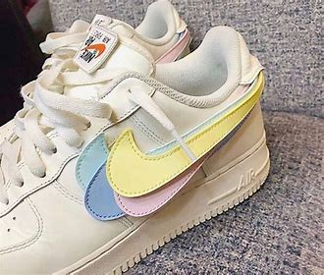

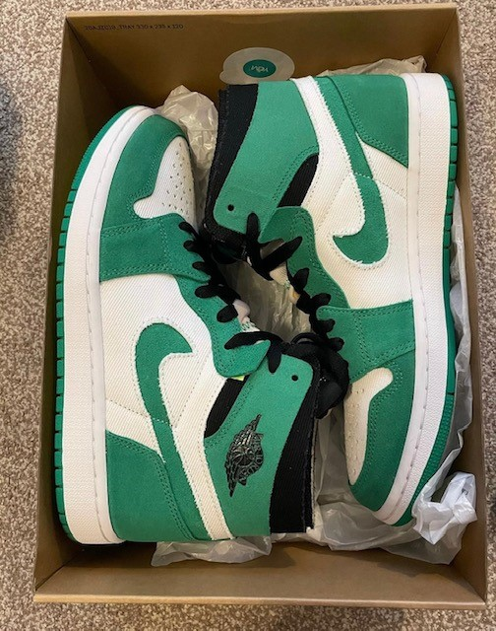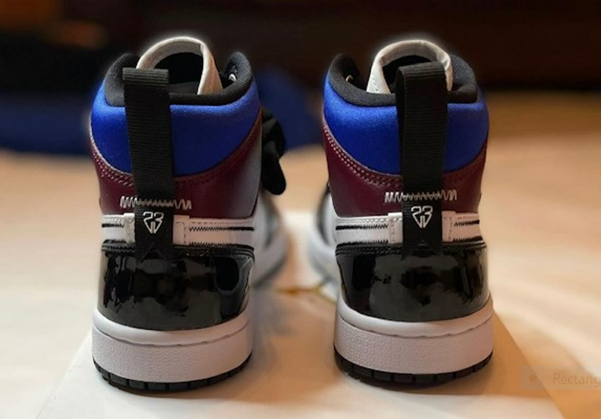

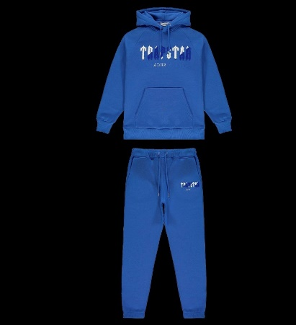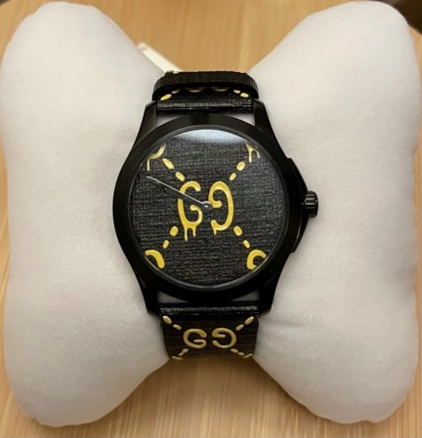
Marketing Strategy and PR Plan
The target market is multi-generational; however, the focus of the marketing plan will be aimed at what is described as ‘Generation Z’. These people are born in the late 1990’s or early 21st century, considered as being conversant with the use of digital technology, the internet, and social media from a very early age.
The second focus would be Generation Y – people born between the 1980’s and late 1990’s. They are normally seen as being familiar with digital and electronic technology (Turner, 2015).
Public relations are very important for businesses. It’s a means of getting your business out there by sharing information and updating with news of the business (Alan, 2020).
The marketing strategy needs to have clear and distinctive advertising messages and ensure that it is planned so that it grabs the attention of the customers (Ali & Anwar, 2021).
This marketing strategy's aim is to generate interest and create a buzz, getting potential customers excited about things to come.
This marketing strategy has 5 steps.
Step 1
To begin with, a business card has been created – aiming to make it attractive and snappy, detailing the website, the Instagram page and contact details.
FRONT OF BUSINESS CARD BACK OF BUSINESS CARD
- Designer drops
- Faster
- Quicker
- Easier
- Hassle free
- Unique one offs
 nowclothing@gmail.com
- @nowclothing1999

 www.nowclothing.co.uk
Step 2
NOW
CLOTHING
The next step of the marketing strategy is a countdown to encourage followers and recruit customers. This would take place prior to the official launch, with the aim of the countdown to generate interest.

Step 3
During countdown, information will be drip fed every week. This will help to generate interest and will incorporate a live fashion show encouraging followers to join the live events. The live event will be fun and exciting, displaying the business goods and offering freebies.
Step 4
Launch Day - Once the countdown has completed, its launch day – as this business will not have a physical location, it is important to take advantage of online platforms (Rabi, 2020). These online digital platforms will include social media such as Instagram, Snapchat, Facebook but also, websites such as Depop.
As part of launch day, to help promote the business, ‘tag a friend’ will take place. This consists of, for example, like the post, tag three friends into the post advertising the clothing and sharing the post on their page. All those who complete this, will enter a free prize draw. The aim of this promotion would be to advertise the business and help towards getting an increase in the number of followers.

Step 5
The clothing industry views an influencer as a model customer (Dobrinić, 2020). Collaborating with an influencer will also be another method used within this marketing strategy. This influencer would need to be a person or page that is popular amongst the group of people who you want to capture.
Unboxing – this is very popular amongst influencers and different companies. There is a whole ceremony involved in unboxing of new purchases. The packaging it comes in, the opening, a sneak preview – it all helps to build up to the excitement of it.
To help to build relationships, a loyalty card could also be introduced after a year of trading.
The products will be for sale on various sites including clothing sites such as Depop. Once established, the aim will be to develop a website for the company, displaying all products. The promotion will mainly take place via social media platforms, Instagram, Facebook, and Snap Chat. Further work will be undertaken via text message and what’s app message. A group will be developed from existing contacts and messages will be sent to all within the group, with details of the items for sale and any promotional information, directing them to the various digital platforms.


Market Research
Market research is integral for any business. Market research aims to limit risks and is considered normal practice (Hague, et al., 2004). For the purposes of this business plan, market research was conducted using a primary research method via quantitative research. Quantitative research focuses on the use of numbers and specific words using closed questions (Cohen, et al., 2000).
To carry out this research, a questionnaire was created which consisted of 11 questions.
These questions asked respondents about their age group, gender, location, favourite brands, their spend budget and the types of clothing or accessories they were interested in. It also asked respondents to rate in terms of importance what they wanted to buy.
The questionnaire was shared amongst the cohort studying Skills for the Workplace. However, as the response rate remained low, below 10, it was decided to share the questionnaire amongst family and friends who ranged between the ages of 14 – 45. The questionnaire ran for approximately two weeks and there a total of 20 responses.
Respondents were able to complete the questionnaire using a pc or mobile device and took an average of two minutes to complete. Internet based surveys and questionnaires are very popular as they can reach a wider audience far quicker than traditional methods (Menon & Muraleedharan, 2020).
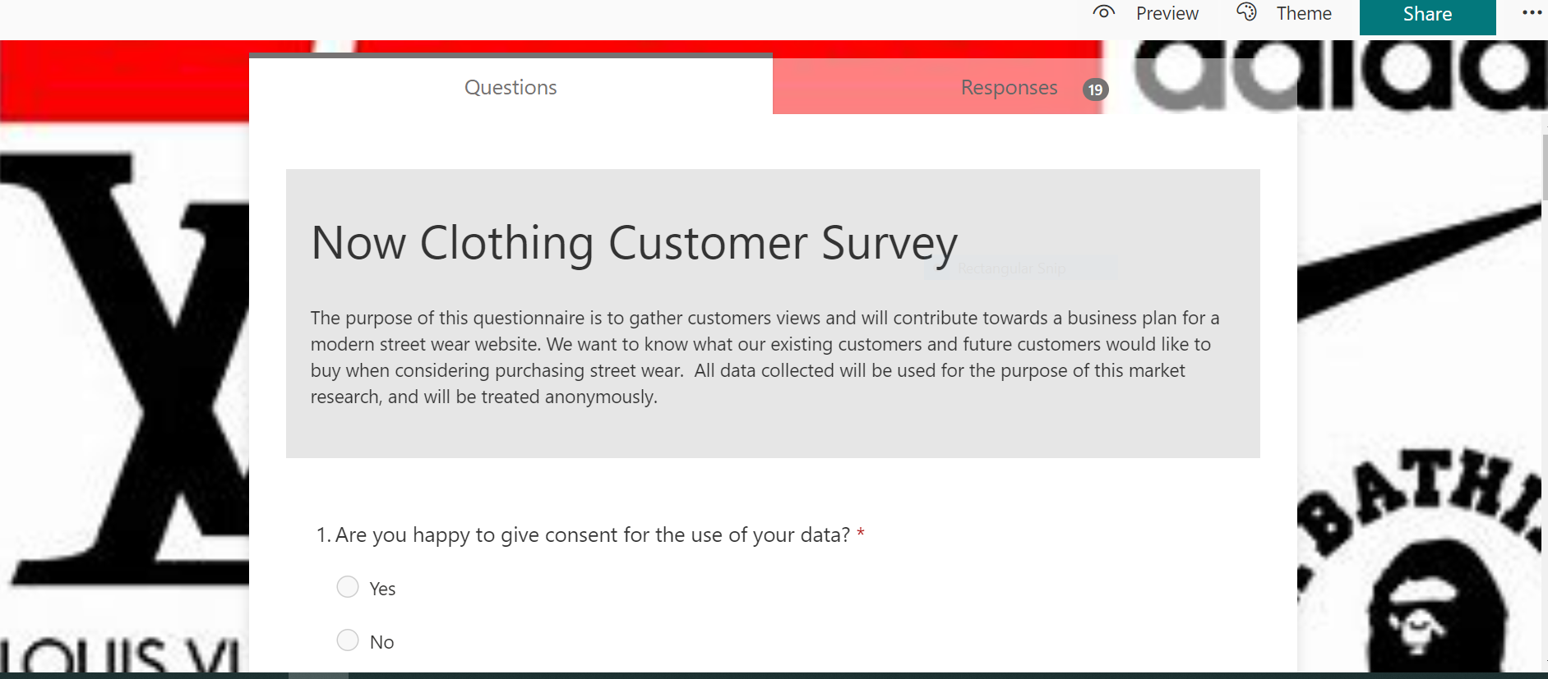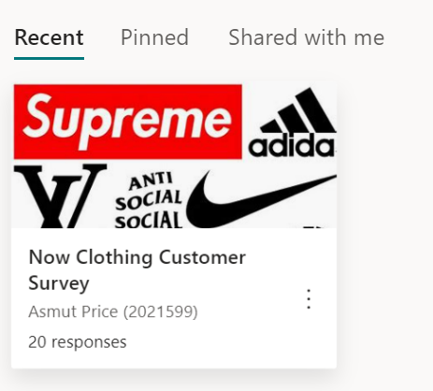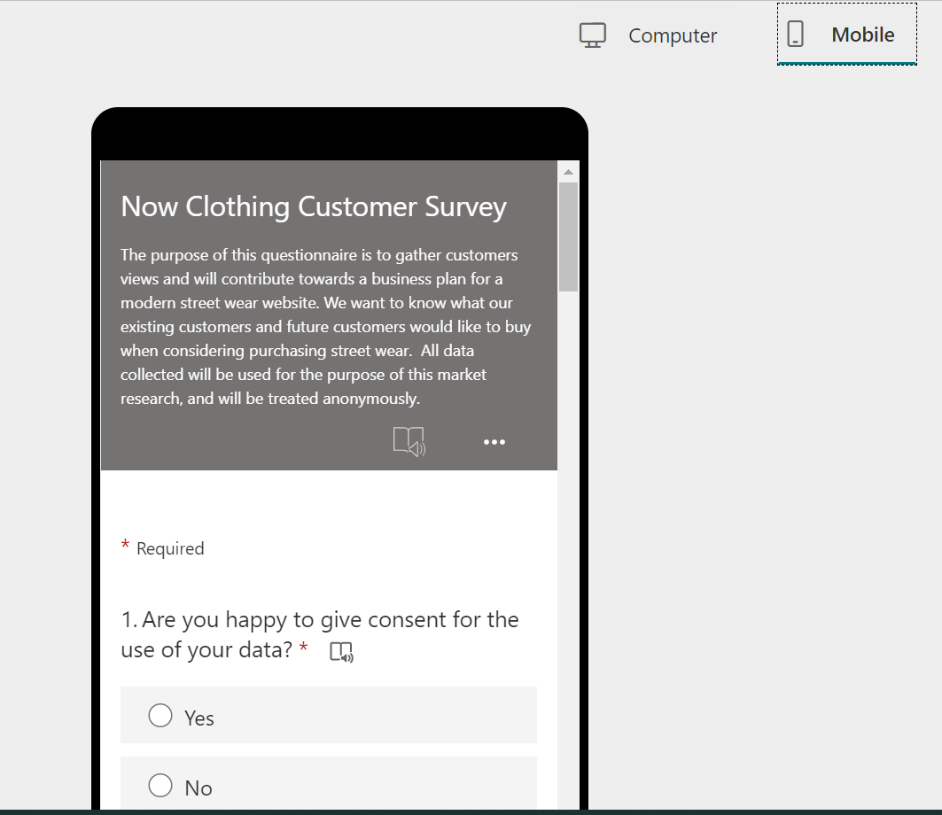
In line with General Data Protection Regulations, the opening questioned asked respondents if they consented to the use of their data, broad consent (Hallinan, 2020). 95% of respondents agreed.
Data Analysis
The initial questions related to information about the respondent, their gender, age group and where they lived.
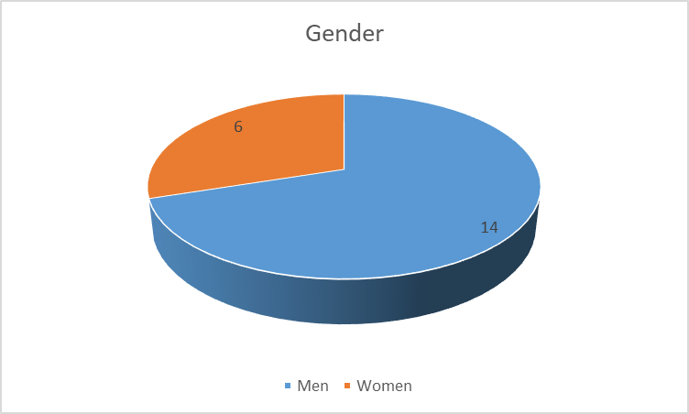
14 respondents were men, with 6 women.
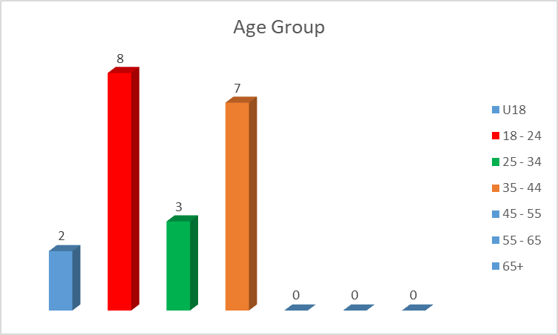
The most common age group to respond to the questionnaire was 18 – 24, followed by the age group 35 – 44.
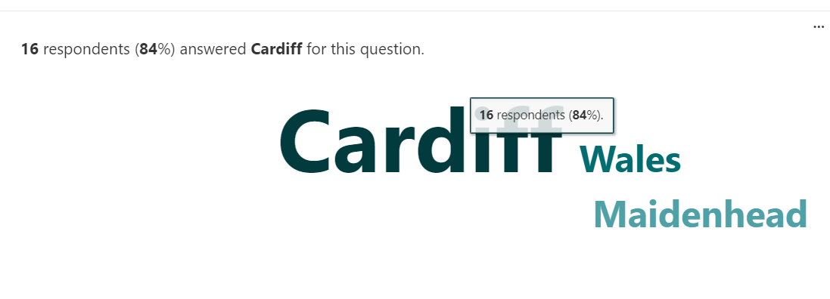
The final question relating to the individual asked where they lived. 16 respondents stated they lived in Cardiff, with 2 stating they lived in Wales and 1 in Maidenhead.
Two questions asked the respondents about the type of items they would be interested in purchasing.
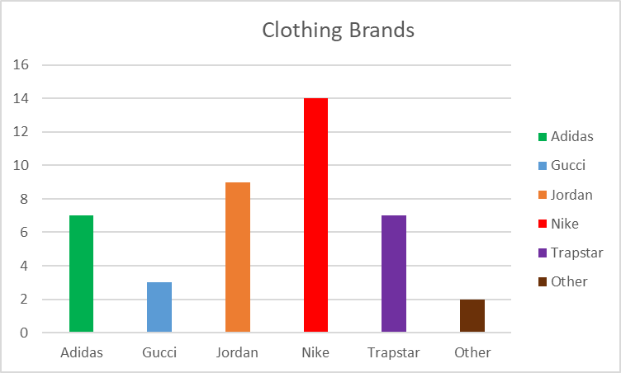
When asked about designer brands, the overwhelming favourite was reported as Nike, followed by Jordan, with Trapstar and Adidas in joint 3rd place.

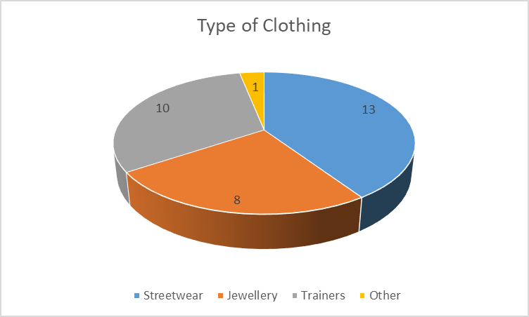
Streetwear was the most popular type of clothing – joggers, hoodies, jackets. The second most popular was identified as trainers.
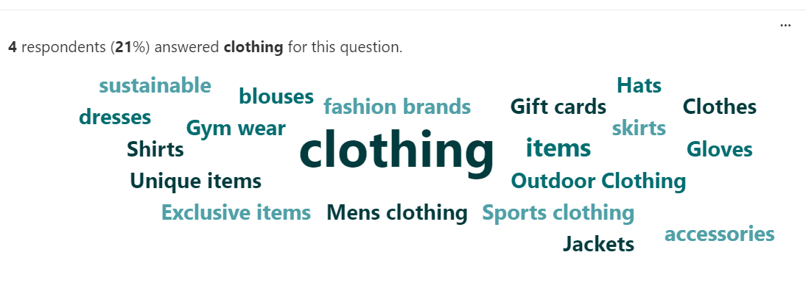
Respondents were asked about what other items they may be interested in purchasing on the website, with clothing being the most sought after.
Respondents were asked about what sizes in clothing and trainers they were interested in.
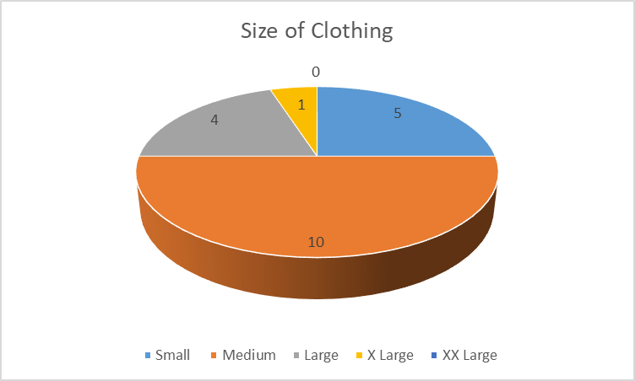
The most common size in clothing was found to be medium.
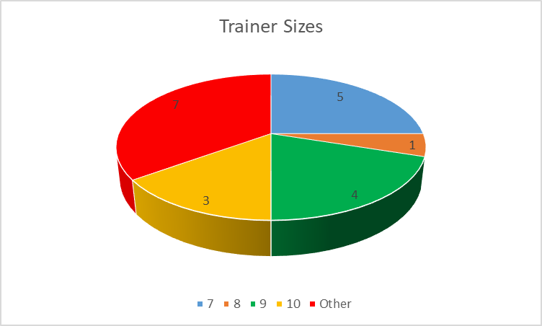
Size 9 in trainers was the most sought after. The findings also reported to have interest in smaller than size 7 and bigger sizes than a 10.
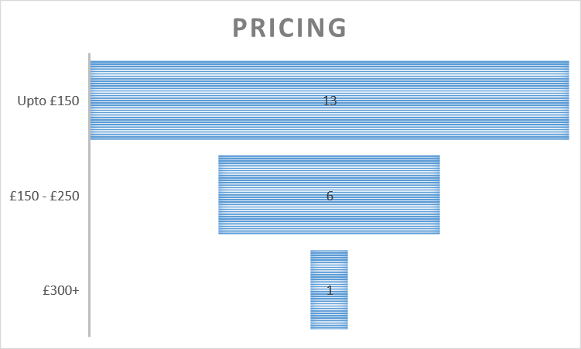
This question asked about price range showed that 13 respondents were content to spend up to £150, with 6 stating between £150 – £250 and only 1 £300+.
Respondents were asked to rate a variety of factors in terms of importance, when deciding to buy from Now Clothing, with 1 being the lowest importance and 5 the highest. Factors included size, trainers, price, colours etc.
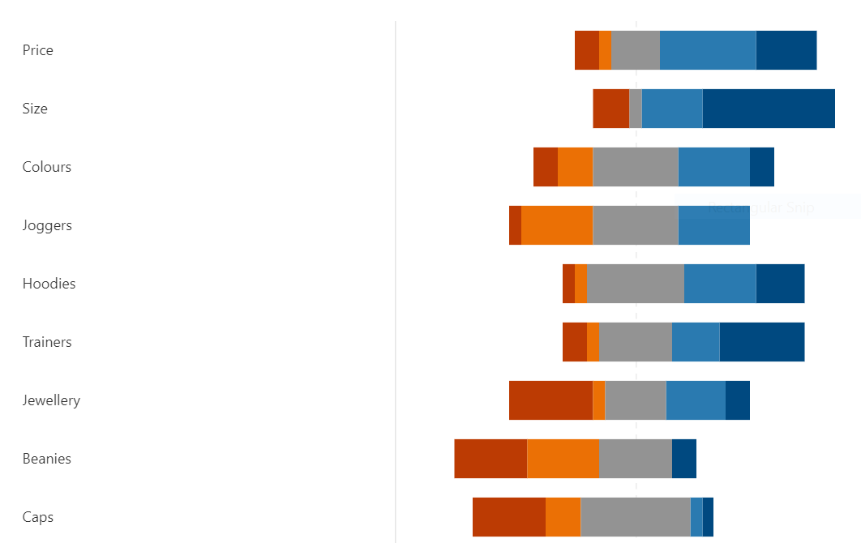

Size, trainers, and price were the most important factors.
This market research has contributed towards the business plan as it evidenced:
- Nike, Jordan and Trapstar are the most popular brands, with streetwear and trainers the most sought-after goods.
- Size is clearly an important factor and is therefore vital to ensure that the most sought-after sizes are available to purchase.
- And pricing needs to be pitched at the correct level.
The market research has endorsed the business plan and reinforced the basis of the business.
It is important to acknowledge that the correct sizes and brands are bought.

Operations
Human Resources
At the time of start-up, no extra staffing will be required. However, following 12 months trading an extra position may be required.

The role of an admin assistant would include managing incoming and outgoing communication, ensuring all items sold are posted within a timely manner and ensure that all communications and social media pages are updated. A maximum of 20 contractual hours a week. Options for recruitment can include an apprentice, either through local higher education institutions or via the Department of Works and Pensions. Before this takes place, ACAS, the Advisory, Conciliation and Arbitration Service will be contacted to seek guidance on employment and contract advice. The pay grade will be in line with the UK’s national minimum wage.

Physical Location
As this business is an online business only, there will be no requirement to have a physical location. However, after 12 months of trading, during the review, it may be necessary to look at storage options for stock.

Financial Resources
The pricing strategy consists of ensuring competitive prices. This would involve under cutting other similar businesses.
Competitor analysis would need to be carried out. By knowing what else is available on the market similar to the business, pricing can be set to ensure that is cheaper than the competitors, however still retaining a profit margin.
Cash Flow Forecast
Cash flow is the heart of your business as this could determine whether the business “makes or breaks it” (Opiela, 2006).
The cash flow involved in establishing and running this business at set up are quite minimal. Setting up social media platforms do not generally have a cost attached to them. However, to purchase the stock to begin trading, will require a financial start-up of £1,000. The finance will be sourced via savings already prepared for the business.
Initially, all profits made from sales will be returned into the business to help cash flow and to purchase further items. At the six-month point, a review will take place to ascertain profit, loss, sales, and stock take. By month 12, after a full year of trading, it is forecast yielding a profit of £10,660, with a 63% profit margin.
The predicted income over the first 12 months is £16,900 which includes the initial £1,000 start up investment. The predicted expenditure is £6,240.
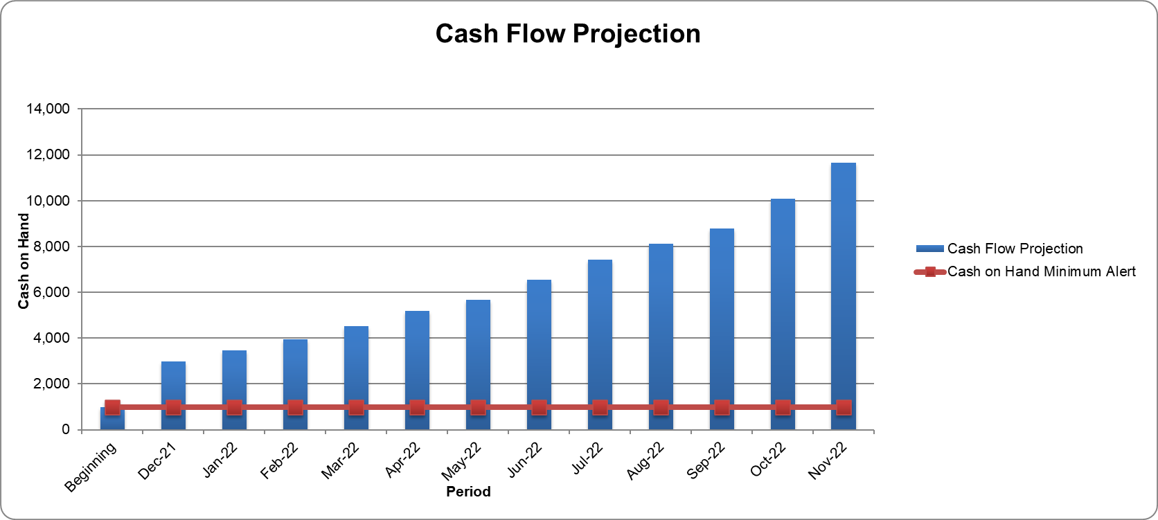

SWOT Analysis

Future Plans
Additional pieces of enterprise ideas include:
Designing own branded clothing – t-shirts, jeans, hoodies, and caps.

Conclusion
To conclude, this is a current and up to date business plan which is financially viable as shown in the cash flow projection. There is evidence from the quantitative research conducted to indicate that there is a demand for streetwear, specifically joggers, hoodies, and trainers and designer brands that include Nike, Adidas and Trapstar.
The cash flow forecast indicates a good profit margin of 63% based on this business plan.
There is capability of expanding the business in terms of resources, which includes increasing the number of employees, variety of products and brands available and the introduction of own branded items.

References

Alan, G. A. E., 2020. New Communication Approaches in the Digitalized World. Newcastle upon Tyne: Cambridge Scholars Publishing.

Ali, B. J. & Anwar, G., 2021. Marketing Strategy: Pricing strategies and its influence on consumer purchasing decision. International journal of Rural Development, Environment and Health Research (, 5(2), pp. 26 - 39.
Brown, E., 2012. Working the Crowd : Social Media Marketing for Business. s.l.:British Informatics Society Limited.
Cochran, D. S., David, F. R. & Gibson, C. K., 2008. A Framework for Developing an Effective Mission Statement. Journal of Business Strategies, 25(2), pp. 27 - 39.
Cohen, L., Manion, L. & Morrison, K., 2000. Research Methods in Education. 5 ed. London: Routledge.
Dobrinić, D., 2020. The Influence of Chatbots on Advertising Campaign Performance. International Journal of Marketing Science, Volume 3, pp. 18 - 34.
Hague, N., Hague, P. N. & Morgan, C.-A., 2004. Market Research in Practice: A Guide to the Basics. London & Sterling: Kogan Page Limited.
Hallinan, D., 2020. Broad consent under the GDPR: an optimistic perspective on a bright future. Life Sciences, Society and Policy, 16(1), pp. 1 - 18.
Menon, V. & Muraleedharan, A., 2020. Internet-based surveys: relevance, methodological considerations and troubleshooting strategies. General Psychiatry, 33(5).
Opiela, N., 2006. Keeping Small-Business Cash Flow on Track. Journal of Financial Planning, 19(7), pp. 26-28,30-32.
Rabi, M., 2020. Social Media Marketing for Online Graphic Clothing Business, s.l.: Bachelor’s thesis.
Turner, A., 2015. Generation Z: Technology and Social Interest. The Journal of Individual Psychology, 71(2), pp. 103 - 113.

