New Building Dwelling: Technical Report with Drawings
1. The timber panels are proposed as an offsite solution but the client is confused by the terminology.
i) Clearly define the term Offsite Construction.
Offsite Construction is a term that refers to the elements of a structure that are constructed at a different location to where they will be situated and installed. There will be factories offsite where components are assembled and then transported to site once complete. Offsite construction can bring many benefits to a construction project such as significant time-efficiencies, improved safety for workers and the public, reduced waste and better quality components. However, offsite construction can be expensive to implement in a construction project. This is due to the initial set-up costs, followed by the costs of maintaining the factories and transportation costs.
ii) Describe the four main categories of offsite construction giving an example of how each method could be incorporated into the proposed house.
There are four main categories of offsite construction where components are made in factories and transported to site. Firstly, panelised construction is a category which involves the offsite construction of wall, floor and roof panels, allowing for faster installation times and improved quality. In relation to the proposed house, prefabricated panels can be used for the walls with pre-installed insulation and cladding.
The second category of offsite construction is volumetric construction. Volumetric construction involves the creation of three-dimensional modules offsite in a controlled factory before transported to the project location. When transported to site for installation, the modules will be fully completed with interior and exterior finishes. Volumetric systems can be non-structural, meaning that the proposed house can be incorporated with pods. For example, volumetric pods can be used for the bathrooms where plumbing services are also implemented.
Another category of offsite construction are sub-assemblies and components. This category involves smaller components created offsite that don’t fall under previous categories. Some examples of components include stairs, doors, windows, steel elements and mechanical/electricidal systems. For the proposed house, using offsite construction for the electrical and plumbing systems can be beneficial to the project for efficiency in the installation as the systems would be designed to fit the specific layout.
Lastly, the fourth category of offsite construction is hybrid systems. Hybrid systems are structures that incorporate both panelised and modular construction. Using hybrid systems allow for extra flexibility within a construction project, most importantly with respect to building design, panel or module fabrication and transportation options. An example of how this can be incorporated into the proposed house is by using prefabricated wall panels and modular roof trusses. The prefabricated wall panels and modular roof trusses would be assembled offsite and transported to the project location with insulation, sheathing and window/door openings already installed. After quick assembly onsite, the interior and exterior finishes will be completed.

2. Produce neatly drawn, proportionate and suitably annotated sections and sketches that illustrate the materials and methods for the detailing of the following building elements and construction inter-faces. Ensure that detailing shows how the design will meet the current Building Regulations for a domestic new-build giving particular attention to thermal performance of the building fabric.
i) The Ground floor Construction, detailing and junctions with external walls
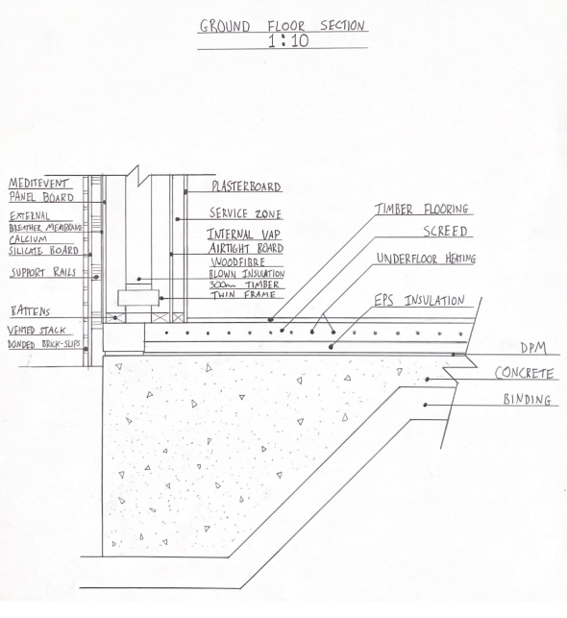
ii) A detailed section and plan detail showing a window opening in the external wall
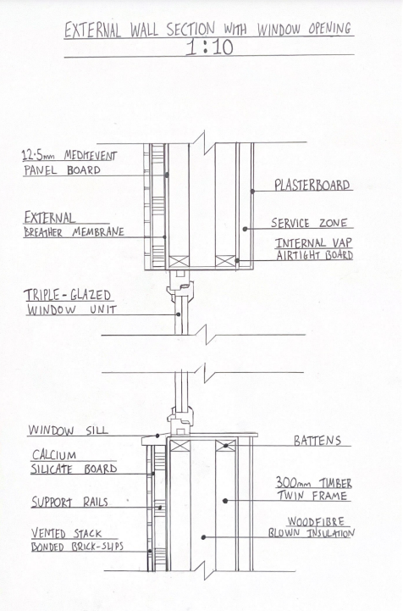
iii) Eaves detailing & main roof structure – indicating appropriate weathering, fixing and laps
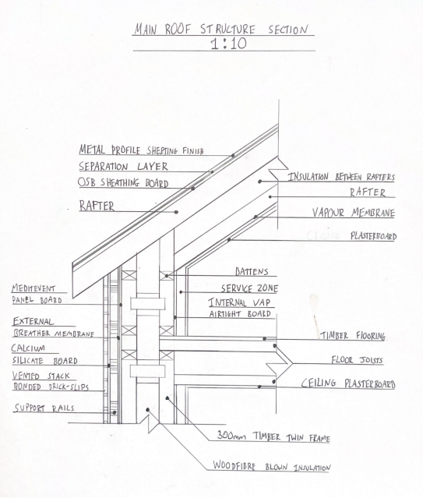
3. The Client wishes to compare the wall construction of brick and block v’s the new proposed construction. Draw a typical wall section for each making comparisons on thickness, thermal performance and structure.
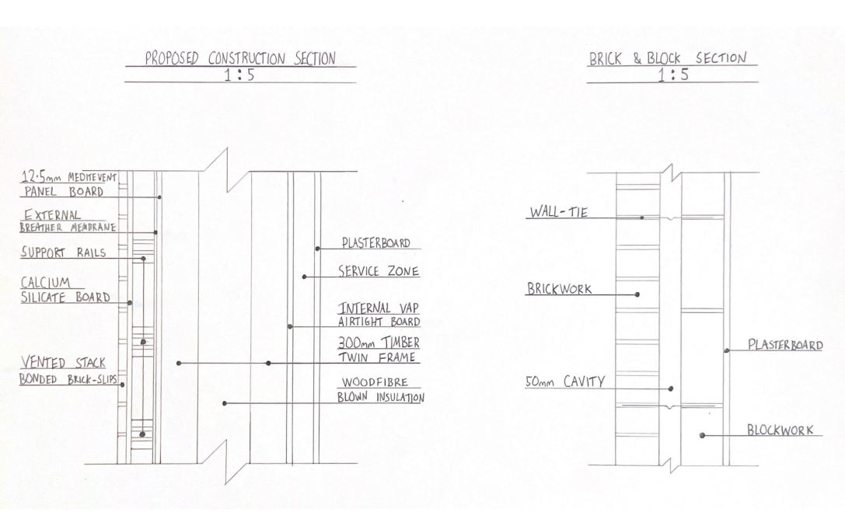
The above image shows section drawing details of the walls of the proposed construction and a typical brick and block construction, both drawn at a scale of 1:5. The drawings help emphasise the contrasts between the two wall constructions, with differences in the thickness, thermal performance and structure. The first clear contrast between the two is the wall thickness. The proposed construction has a much greater thickness compared to the brick and block wall. The proposed construction consists of a 300mm timber twin frame, with an additional interior service zone and brick-slips finish on the exterior. Whereas, A brick and block wall typically consists of bricks and blocks both around 100mm thick and a 50mm cavity in between.
The thickness of the walls plays a major role in the thermal performance of both constructions. Thick walls generally have a better thermal performance than thinner walls, due to heat transferring at a slower rate. This means that the proposed construction will have a better thermal performance compared to the brick and block wall. Furthermore, there are other features of the proposed construction that benefit its thermal performance. The proposed construction consists of 300mm woodfibre blown insulation between the twin frame panels. The 50mm cavity on the brick and block construction is a lot thinner in comparison. Also, woodfibre blown insulation has great thermal qualities such as its high thermal mass which prevents heat escaping in cold weather.
In terms of the structure between the proposed construction and the brick and block wall, the two vary in how they are assembled. The timber in the proposed construction is lightweight allowing for quick assembly and flexibility, however will be less durable in comparison to the brick and block wall due to poor fire and moisture resistance. Also, since the typical brick and block wall will be heavier than the proposed construction, a more sturdy foundation would be required.
References
Designingbuildings.co.uk. (2017). Off-site construction - Designing Buildings Wiki. [online] Available at: https://www.designingbuildings.co.uk/wiki/Off-site_construction.
www.designingbuildings.co.uk. (n.d.). Prefabricated structural panels. [online] Available at: https://www.designingbuildings.co.uk/wiki/Prefabricated_structural_panels.
Algeco. (2020). What is Modular Construction? | Algeco. [online] Available at: https://www.algeco.co.uk/modular-buildings/what-is-modular-construction.
Vertex BD Software. (2023). The Facts About Off-site Construction: Hybrid Construction Systems. [online] Available at: https://vertexcad.com/bd/2023/01/04/the-facts-about-off-site-construction-blog-4-hybrid-construction-systems/.

‌

‌

‌

‌

