Noemi Bregolin (2030799)

LCCB4005
Global business environment

LEXUS
CHALLENGES AND SUSTAINABLE ADVANTAGES

INTRODUCTION……………………………………………………….……p2
MAIN BODY……………………………………………………………….…p2
- SWOT ANALYSIS……………………………………………………….p2
  - Strengths……………………………………………….……….p2
  - Weaknesses………………………………………….………...p3
  - Opportunities ……………………………………….………….p3
  - Threats…………………………………………….……………p4

- PESTLE…………………………………………………………..……….p4
  - Political and Legal………………………………………..……...p4
  - Economic………………………………………………….…......p5
  - Social……………………………………………………....……..p5
  - Technological……………………………………………...…….p5
  - Environmental……………………………………………....……p5

- PORTER 5 FORCES…………………………………………………….p6
  - Threat of New Entrant…………………………………………p6
  - Bargaining power of supplier………………………………….p7
  - Bargaining power of Buyers…………………………….…….p7
  - Threat of Substitutes…………………………………………..p7
  - Industry Rivalry…………………………………………………p7

- VALUE CHAIN……………………………………………………………p8
  - Primary Activities………………………………………………...p8
  - Support activities………………………………………………...p9

CONCLUSION………………………………………….…………………..p10
REFERENCES……………………………………………………………..p11

INTRODUCTION

Lexus does not have a long history behind it. Despite the Toyota brand founded Lexus in 1983 (Clifford J, b, 2019), it still managed to conquer automakers worldwide with a combination of luxury, elegance and reliability, efficiency.

In this report, the challenges in the automobiles business environment (particularly for Lexus) are evaluated by first defining the SWOT, PESTLE, Porter's Five Forces, and Value Chain analysis.
Finally, we'll focus on the company's advantages linked with the sustainability of Lexus.

MAIN BODY

- SWOT ANALYSIS

"A swot analysis explores the relationship between the environmental influences and the resources and capabilities of an organisation compared with its competitors." (Johnson 2016, p 116)

1.2 STRENGTHS (Shastri A., 2021)

Lexus is associated with Toyota, which is considered the best in technology, mechanism production and performance.
Moreover, the brand is attributed as a machine of superior design and excellent reliability since produced by Japanese technology.
Lexus' innovative elegance and design efficiency is reproduced in a wide range of cars, usually combined with compact dimensions to provide excellent driving ease.
The vast models on the market, such as sports cars and SUVs, broaden the sales target of the vehicle by providing a different use and other performance.

Lexus focuses on innovation, paying particular attention to technological aspects such as autopilot, alternate energy vehicles, etc.

1.3 WEAKNESSES (Shastri A., 2021)

The first weakness of the brand is a large amount of attrition in the automobile industry. Lexus is a new brand and entered the market-facing giants such as Germans and Italian brands, who have already affirmed their presence.

Another downside is the lack of variety of diesel engines compared to competitors. Toyota spends little on Lexus for promotions in the mainstream media compared to its competitors. For this reason, the brand has had limited visibility even if a considerable amount of funds is spent on advertising.

There are also the limitations of SUV models compared to competitors Audi and BMW. Lexus turns out to have only one type of SUV, which is not enough to cope with the variety of rivals. (Bhasin H.,2019)

1.4 OPPORTUNITIES (Shastri A., 2021)

Growing demand:
If there is an increase in demand for luxury cars in emerging economies, Lexus is reaching a good level of notoriety in European countries. However, given that the economy is growing in Asian countries, the European brands might be a risk by entering the Asian market.

The number of wealthy people is increasing and is expected to reach 10% more in China and India over the next two years, enhancing the demand for luxury cars accordingly.

Macroeconomic factors such as 'unemployment index, inflation, savings, investment and disposable income' are all favourable to Lexus as they increase the chance of purchasing luxury cars. Moreover, the company's profitability is accordingly rising as transportation costs are getting lower in the Middle East and Asia.

The awareness of the technical aspect helps the company look towards the future. Lexus is engaging in research concerning technological innovation (such as automation) to also extend the research in the green market and renewable. The aim now is to face the environmental challenge with a 'zero emission' project (Lexus, 2021),

Online customers
By investing a large amount of money in online channels, the company creates the opportunity to project itself into online propaganda, analysing its customers and gaining returns from its investments. (Shastri A., 2021)

1.5 THREATS (Shastri A., 2021)

Some of the threats may present as a lowering of the barriers to entry. This makes it easier for competitors to enter the market, thus increasing the presence of European companies such as Mercedes Benz and Audi in the luxury car market.

The rising in fuel prices is a significant problem as people are starting to opt for green cars or alternate energy cars. Moreover, the cost of raw materials has also risen, leading to an incline in production prices.

Counterfeit is a significant problem since low-quality reproductions threaten Lexus in low-income regions. (Shastri A., 2021)

- PESTLE

2.1 POLITICAL and LEGAL (Wondershare EdrawMax, 2021)

Due to the numerous accidents happening for those who have a car or a motorcycle, the governments of several nations introduced different laws to increase road safety and ensure the security of passengers. For this reason, launching a business in the automotive sector has become more complex.

To protect the environment, the government became interested in the emission statistics of different vehicle brands. Fossil fuels, such as diesel oil, are the most polluting sources, followed by carbon emissions, specifically carbon dioxide generated by vehicles.

Brands like Toyota and Lexus, closely linked to the Japanese market, are experiencing difficulties and uncertainties due to Brexit. As Hawes explains, the automobile industry is "increasingly nervous and exasperated" (Burgess R., 2019). UK car sales fell by 6.8% in 2018 and 9.1% at the end of 2019 because of British political uncertainty in the absence of a diesel policy (Burgess R. 2019).

The political situation between Japan and China proves cold due to Japan's colonial past. Therefore, a peaceful resolution is set to avoid provocation between the two countries. However, the instability is present due to a relationship of mistrust amongst the countries that appear as a "cover" of the relationship between the United States and Japan by Japan and as tolerance by China for the Japanese policy.
And Japan is, in fact, in an intermediary situation with China which already represents 22.9% of the total exports of Japan. (...) (Aoyama R., 2021),

2.2 ECONOMIC (Bush T, 2019)

The auto industry is set to increase its profits due to the enhanced demand for cars and luxury goods in economically developing countries. One of the reasons is the growth of disposable income, increasing the number of wealthy individuals.
As explained in the political section, border taxes and emerging markets further challenge car industries must face.

2.3 SOCIAL (Bush T, 2019)

Understanding customer behaviours (which is affected by the culture) makes it possible to understand the demand for products.
The cultural and social background is changing with the level of education of people and their habits. A well-known cultural phenomenon is a rise in driving in emancipated countries such as the United States and Canada. It is common for families to own more than one vehicle.

2.4 TECHNOLOGICAL (Bush T. (2019)

Technological factors hugely impact sales, allowing the brand to renovate and improve different areas. Of course, one of the biggest concerns is reducing emissions, improving safety, and developing automation. Lexus indeed is expanding its horizons in the field, for example, by introducing an emergency brake assist system to reduce the frequency of accidents.

2.5 ENVIRONMENTAL

As we have dealt with in the political section, carbon dioxide emissions are the main factor of pollution and global climate change to such an extent that governments can completely ban motor vehicles, opting for more environment-friendly choices. Britain and California are directed towards this choice, while Japan didn't turn toward the electric. (Doodley and Ueno, 2021)
Since Lexus focuses mainly on hybrid Japan viewpoint is currently favourable to the company, even if it can become a challenge in the future, unless Lexus can reach a zero-emission goal.

- PORTER 5 FORCES (Ashraf R, 2019)
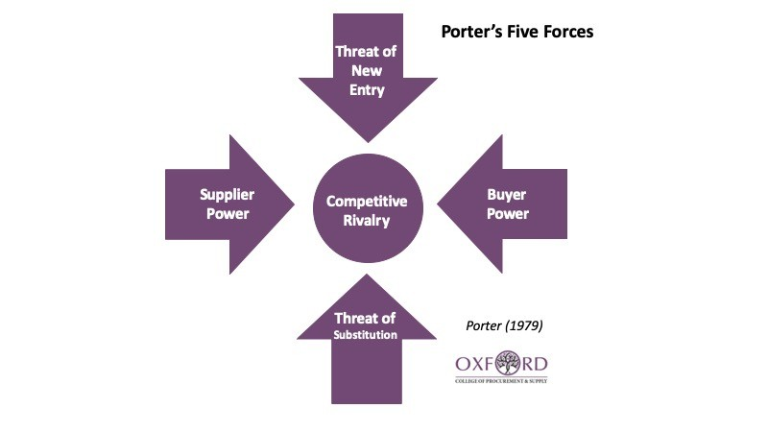

Available at <https://www.oxfordcollegeofprocurementandsupply.com/wp-content/uploads/2019/08/Porters-Five-Forces.jpg>

3.1 Threat of New Entrant
Weak

Entering the automotive sector is not accessible due to the great demand for capital. In addition, competitors would have to face the name and reputation of established companies.
A further obstacle would be the economic barriers to safeguard the national market. But, on the other hand, factors in favour are the innovation that new competitors can bring and the ease with which they could access suppliers. However, Lexus is holding up well to the competition with giants like Mercedes Benz and Audi, precisely because there is the idea that "Lexus offered better value and greater reliability" (Pavlik T., 2020) with an accessible price and an elegant design.

3.2 Bargaining power of supplier
Weak

The purchasing power is low due to the significant presence of suppliers in the cooling, electrical, braking, and fuel supply system.
As Fisher explains, Lexus and Toyota are designed and assembled in the same factories and often use the same components (Fisher A., 2010).

Toyota relies on local suppliers worldwide and buys from 200 different component suppliers in Japan.
For example, it relies on Magnuson Products, IPT Performance Transmission, Goodridge Fluid Transfer Systems in the Detroit plant. (Lioudis N, 2021)

However, Toyota and Lexus can produce components within their own company. Toyota owns downstream suppliers such as The likes of Nippon Denso Co., which manufactures air conditioners, and Aisin Seiki Co., which produces components and systems for automobiles. (Lioudis N, 2021)

3.3 Bargaining power of Buyers
Strong

As Clifford describes, Lexus was at the top of several rankings, based on the survey of car owners in the UK.
The attachment of individual buyers is due to Lexus's quality, reliability, and performance. (Clifford J. a, 2019),
This is remarkable from the brand considering that the power of the buyer in the automotive industry is high for the number of individuals and corporations, for the ease with which buyers can change brands and for the criteria with which the vehicle is chosen (Ashraf R, 2019).

3.4 Threat of Substitutes
Weak

There are many transportation alternatives. However, the threat of substitutes depends on brand convenience and sustainability.
As mentioned previously, Lexus' customers can hardly derive the same utility from substitutes in terms of quality, performance, price, and service.

3.5 Industry Rivalry
Very Strong

The rivalry is intense for the moderate number of solid competitors, given that it is a matured industry where the customer segmentation is similar for each brand.
Furthermore, the barriers also lead the brand to remain within the automotive sector, leading to immense loss. For this reason, a car luxury company would hardly leave the market, maintaining the high competition.

- VALUE CHAIN (Johnson G, 2017, p 108-109)

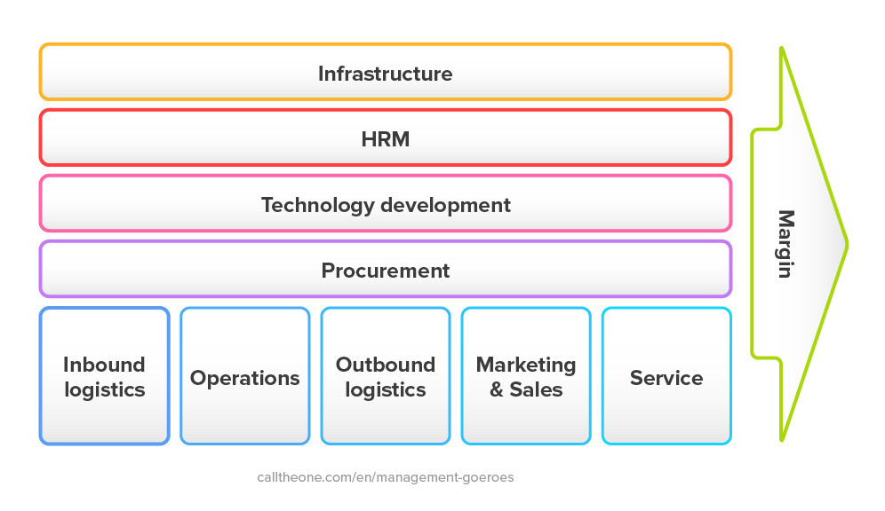

Available at <https://www.calltheone.com/storage/blog/3/2012/12/16/value-chain-michael-porter-1.jpg>

  - PRIMARY ACTIVITIES:

As cited by Johnson, primary activities are related to the 'creation or delivery of a product or service.' (Johnson G, 2017, p 108-109)

Inbound Logistics:

It's essential to build good relations with suppliers, such as E.K.Kanoo for Lexus, as their support is required to receive, store, and deliver the product (Ebrahim K. Kanoo, ND).

Operations:

This stage is critical for converting raw materials into finished products. Machining, packing, assembling, and testing are examples of operational activities (Johnson G, 2017, p 109). E.K.Kanoo is noted for its trustworthiness, which stems from its efficient systems. E.K.Kanoo has a dedicated workforce of over' 2,600 professionals', and it focuses on providing training to accomplish organisation expectations and customer satisfaction (Ebrahim K. Kanoo, ND).

Outbound Logistics:
Material handling, warehousing, scheduling, and distribution are all examples of outbound logistics tasks that convey a product to a client (Johnson G, 2017, p 109).
Lexus has many showrooms in the United Kingdom, with 46 shops (Clifford J, 2015).

Marketing & Sales:
At this point, Lexus will emphasise the benefits to urge clients to buy. This phase includes "sales administration, advertising and selling' (Johnson G, 2017, p 109).

Service:
Lexus' pre-sale and post-sale services are crucial in building customer loyalty. Lexus provides highly 'installation, repair, training, and spare' (Johnson G, 2017, p 109) since, as previously stated, the brand is known for its high level of dependability and service quality.

4.2 SUPPORT ACTIVITIES

Procurement

Procurement involves the acquisition of inputs such as equipment, goods and services, and other items required to produce the final piece. As a result, Lexus can achieve scale advantages through this phase.

Technology development

Lexus understands the value of technological integration in manufacturing, delivery, advertising, and management of human resources (e.g. automation software, technology-supported customer service, product design research and data analytics)

Human resource management

Lexus can evaluate different aspects of human resource management, including "recruiting, managing, training, developing, and rewarding people" (Johnson G, 2017, p 109).

Infrastructure

Planning, finance, quality control, information management, and the structure of an organisation are all part of the corporate infrastructure. Lexus can increase its market position by regulating these operations.

CONCLUSION (Lagas B, 2015)

Having analyzed the internal and external situation of Lexus, it is now possible to define the advantages of its sustainability.
First, it is possible to reduce fuel consumption and, consequently, the nation dependence on oil.
The great convenience is diminishing energy-related costs and protecting the environment (by cutting down energy consumption and waste).

The performance of a hybrid is superior in many aspects compared to that of a regular engine, by being quieter but also economical in managing fuel and maintenance costs.

Considering the technological efficiency of Toyota, the ideal safety equipment and maintenance costs, the reduced consumption and high-performance engines, Lexus can easily compete with brands such as BMW, Audi and Mercedes.
(Pavlik T.,2020)

Sustainability has a favourable impact on eco-conscious buyers' minds, which can help to boost a brand's image and market position, attracting new customers and increasing consequently the company’s sales.

REFERENCES

Aoyama R., (2021), Japan walks on a tightrope with its China policy, Estasiaforum, Available at <https://www.eastasiaforum.org/2021/05/20/japan-walks-on-a-tightrope-with-its-china-policy/>

Ashraf R (2019), Porter’s Five Forces of the Automotive Industry, LinkedIn, available at <https://www.linkedin.com/pulse/porters-five-forces-automotive-industry-rizwana-ashraf-1c?articleId=6595636157462253568>

Bhasin H. (2019), SWOT analysis of Lexus, Marketing91, Available at: <https://www.marketing91.com/swot-analysis-lexus/>

Burgess R. (2019), Will Brexit kill the British car industry?, Autocar, Available at <https://www.autocar.co.uk/opinion/industry/will-brexit-kill-british-car-industry>

Bush T. (2019), PESTLE Analysis of the Automotive Industry, PESTLE ANALYSIS, Available at <https://pestleanalysis.com/pestle-analysis-of-the-automotive-industry/>
Clifford J. a, (2015), Lexus UK Dealers, Lexus UK Magazine, Available at <https://mag.lexus.co.uk/lexus-uk-dealers/>

Clifford J. b, (2019), Lexus History: A Lesson in luxury, Lexus UK, Available at <https://mag.lexus.co.uk/lexus-history/>

Clifford J, (2019), Seven honours for Lexus in the 2019 Driver Power survey, Lexus UK Magazine, Available at <https://mag.lexus.co.uk/lexus-2019-driver-power-survey/>
Doodley and Ueno (2021), Why Japan Is Holding Back as the World Rushes Toward Electric Cars, The New York Times,
Available at <https://www.nytimes.com/2021/03/09/business/electric-cars-japan.html>

Ebrahim K. Kanoo, (N.D.), About Us, available at <https://ekkanoo.com/about-us>
Fisher A., (2010), Toyota and Lexus: A Tale of Twin Brands, CBS NEWS, Available at <https://www.cbsnews.com/news/toyota-and-lexus-a-tale-of-twin-brands/>

Johnson G, (2017), Exploring Strategies, Eleventh Edition, Harlow: Pearson.

Lagas B (2015), Five Benefits of Embracing Sustainability and Green Manufacturing, NIST, Available at <https://www.nist.gov/blogs/manufacturing-innovation-blog/five-benefits-embracing-sustainability-and-green-manufacturing>

Lexus (2021), The Lexus Environment, Available at: <https://www.lexus.eu/environment>

Lioudis N, (2021), Who are Toyota’s ™Main Suppliers, Investopedia, Available at <https://www.investopedia.com/ask/answers/060115/who-are-toyotas-tyo-main-suppliers.asp>

Pavlik T., (2020) Why Do People Choose Lexus Over BMW and Other Luxury Brands?, MotorBiscuit, Available at <https://www.motorbiscuit.com/why-do-people-choose-lexus-over-bmw-and-other-luxury-brands/>

Shastri A., (2021), Comprehensive SWOT Analysis of Lexus – Japan’s Top-Selling Luxury Car Company, The Digital School, Available at: <https://iide.co/case-studies/swot-analysis-of-lexus/>

Wondershare EdrawMax (2021),Automobile Industry PESTEL Analysis, Available at <https://www.edrawmax.com/article/automobile-industry-pestel-analysis.html>

