Business Plan for

< Paw4Home Cafe>

Produced By:
GROUP MEMBERS:
Student Name | Student No.
Galina Borisova | 2243589
Iulia Tanase | 2230512
Mihaita Ionut Manda | 2232074
Marin Marius Enache | 2241513

Dated: 17/11/2024
Module Name: Entrepreneurship
Module Code: BMIH5001
Lecturer Name: Charlotte Joyner

AI Declaration:
We assure you that this essay is the result of our individual work only. As for this work, none of the AI tools were used in writing. All the research was done from academic sources mainly Google Scholar, reports and trustable sources to ensure that the research carries the highest standards of research.

1. EXECUTIVE SUMMARY
Paw4Home Café is an innovative pet café located in the vibrant area of Battersea in Southwest London. Standing at two stories tall and with a seating capacity of 80, it is sure to offer a hospitable environment to guests, both animal and human. Customers will be able to enjoy a variety of cold/hot drinks, pastries, and grilled sandwiches. Unlike the competition, we stand out by being the only café in the area to feature both cats and dogs.

The café is in partnership with the Battersea Dogs and Cats Animal Shelter to address the problem on animal welfare and find homes for these poor animals. Paw4Home is situated in an active area with high foot fall where there would be a large and diverse market in the families, professionals, tourists, and animal lovers that pass by every day.

The competitive advantage lies in our execution in seamlessly integrating pet adoption with a seamless café experience. The presence of our animals creates a warm, inviting atmosphere that is statistically shown to act as a therapeutic environment that reduces stress and improves mental health which is enhanced further by offering a selection of high-quality refreshments alongside it. Paw4Home organises events such as children’s birthday parties and adoption days, providing not only entertainment but also a sense of community which allows customers to enjoy their time and be certain they are contributing to animal welfare whether that is just by buying a drink or adopting a pet.

In the first year, the expected net profit is £101,400. The revenue streams include entrance fees, the sales of beverages, pastries, and sandwiches, and pet related products and services.

To thrive and ensure we meet business goals, the owners own funds of £50,000 as starting capital and obtained a further £30,000 from small business grants as well as a £20,000 loan through credit/ debt. This will aid in achieving short-term goals of establishing a loyal customer base, increase awareness on the issue of unwanted pets in the area and how this café stands a solution to that, and reaching a state of financial stability.
In conclusion, Paw4Home café aims to become a leading destination for pet lovers not just in Battersea but also throughout London. There is a huge issue with unwanted pets without homes and Paw4Home is an innovative solution to that problem by combining pet adoption with a unique café experience. The business supports animal welfare, enhance community engagement and customer well-being by fostering a welcoming and relaxing environment.

Table of Contents

 |  |  | PAGE
1. | Executive Summary |  | 1
2. | The Business Idea |  | 5
3. | The Team |  | 7
4. | Market Research |  | 10
5. | Marketing Plan |  | 13
6. | Key Resources |  | 14
7. | Finances & Start-Up Support |  | 17
APPENDICES:
Appendix A |  |  | SWOT Analysis
Appendix B |  |  | PESTLE Analysis
Appendix C |  |  | Copy of Pitch Supporting Material

2. THE BUSINESS IDEA

2.1 The Product/Service

Business Overview
Paw4Home Café situated in Battersea, Southwest London which operates in the industries of hospitality and animal welfare.

Following the pandemic, Battersea’s latest figures reveal a 54% increase in young unwanted animals coming into care (Battersea, 2024). The business aims to address the need for finding homes for these unwanted pets (cats and dogs) by combining pet adoption with the setting of a traditional café. The café caters to families, professionals, tourists, and animal lovers who are looking for a relaxing and engaging environment in which they can enjoy high-quality refreshments featuring pastries from Gail’s bakery, and where they can interact with the animals which is statistically shown to lower stress levels (NewsInHealth, 2018).

By offering a wide variety of cold and hot drinks, pastries and grilled sandwiches. Paw4Home also organise children’s birthdays and host events for pet adoption. The café sets itself apart from the already few other cafes which offer a similar service by featuring both cats and dogs in its experience.

Value Proposition, Features and Benefits:
- The environment created by the animals creates a warm and inviting atmosphere that is statistically shown to reduce stress and improve mental health acting as a therapeutic environment.
- Paw4Home is the only café in the area to offer both cats and dogs. They will be separated on different floors with 15 tables on each one. The cats are on the ground floor where the main serving area is while the dogs are in the large floor below. Both floors are equipped with comfortable seating, instagrammable themes for the rooms and quality pet toys from Pets4Home.
- Community engagement through the business’ events centred around children’s birthdays and adoption days helps support the mission of building a community around the issues on animal welfare that can help to mitigate them by spreading awareness to Paw4Home’s feasible solution which will lead to less pets without homes.

2.2 SWOT Analysis Summary

Strengths
Paw4Home’s strengths lie in its ability to combine a high-quality café service with the opportunity to interact and adopt cats and dogs from the Battersea Cat and Dog Home. Other factors that play into our strengths include the vibrant location of Battersea where the café is based, the two-level design that separates the cats and dogs on different floors, the mission and the delicious refreshments that further encourage repeat visits and loyal customers.

Weaknesses
The weaknesses lie in the high operational costs that include the pricey rent and compliance expenses based around accommodating pets as well as the need to invest significantly in marketing due to the specialised brand and having to reach the right customer base because of it.

Opportunities
With the increasing trend of owning a pet, Paw4Home café can capitalise on the demand effectively with its pet friendly services. Opportunities for additional revenue can include franchising the business out and selling branded products to raise additional finance that can be reinvested back into the business. Partnerships with local businesses and organisations can enhance visibility and support the spread of Paw4Home’s key message.

Threats
The threats lie in the competition from other pet friendly businesses and our compliance with strict health and safety regulations which further increase costs. Finally, our brand image must always be that of a positive and safe environment which we must protect by offering an exceptional service to every customer who walks in.

3. THE TEAM

3.1 Key Personnel

Name and Company Position: Galina - Manager
Skills and Experience: Experience as Front of House Manager, handling multiple responsibilities, ranging from general duties towards customers to taking responsibility for colleagues’ actions and assisting team members in improving and developing themselves throughout their shifts.

Role and Responsibilities: As a Café Manager, Galina will be responsible for producing and managing employee schedules and reviewing performance of employees regularly.

Name and Company Position: Marin - Barista
Skills and Experience: Experience as a Chef, handling foods and beverages behind the counter, in a fast-paced environment. This experience gained Marin a wide range of skills working as a team, and time-management.

Role and Responsibilities: As a Barista, Marin will take responsibility for the preparation of drinks such as coffees, lattes, cappuccinos, espressos, and tea drinks.

Name and Company Position: Iulia – Pet Carer
Skills and Experience: Although there is no specific experience in the pet caring industry for Iulia, she has a lot of general experience and a standard level of knowledge when it comes to animal needs, expectations, and the proper care for them.

Role and Responsibilities: As a Pet Carer, Iulia will be responsible for scheduling feeding times for the animals, scheduling sleep/exercise, noting down details of status and medical health, and writing reports and forms of adoption.

Name and Company Position: Mihaita – Accountant

Skills and Experience: Experience as an Analyst, handling data and statistics within a company relying on such data to record financial and performance APIs.

Role and Responsibilities: As an Accountant, first of all Mihaita will handle duties such as analysing data from the business’ performance and formulate financial reports.

3.2 Skills Gaps & Key Partners

3.2.1 Additional Staff Requirements (Roles and Responsibilities):
- Shift Supervisor – Required to oversee employees in the manager’s stead and train others where necessary.

- Busser – Essential to keeping café clean and operational, cleaning and preparing cutlery, dishes, and tables after each use, lightening the load from baristas.

3.2.2 Training and Development:

- Customer Service training consisting of practising scenarios and preparation for obstacles. Provided by a shift supervisor (Tannenbaum, et al., 1992).

- Health & Safety training which will provide knowledge and practical experience on handling food and drink products safely. Provided by a shift supervisor (Weinstock, 2012).

3.2.3 Outsourced Support / Key Partners:

- Simply Coffee Shops – This organisation is an essential for the pet café as it will provide the installation of the building and its interior, making it more efficient in designing and constructing the business. The reason for choosing this organisation lies behind its credibility, as it has a track record of installing over 300 different shops, and former work with major commercial brands and clients (SimplyCoffeeShops, 2024).

- Battersea Dogs and Cats Home – This organisation is essential due to the need and unique selling point of animals for adoption. With their main headquarters being close to our café, we can have them supply our dogs and cats that we could offer for adoption (Battersea, 2024).
4. MARKET RESEARCH

4.1 Market Information, Trends and External Factors

Market Statistics: The coffee and tea processing industry in the UK generated roughly around two billion (GBP) British pounds in 2014, increasing to £15 billion annual revenue by 2023. In 2022, UK companies had managed to even sell around 33 thousand tons of roasted coffee, making it a significant increase from previous years (Ridder, 2023).

Recently, businesses have been migrating towards more sustainable practices, as consumer demands rise in environmentally friendly products and ingredients. Hence, café businesses such as Costa and Caffe Nero have begun to introduce by-products such as Soy, Coconut, and Almond milk options (Levy, et al., 2016).

The most significant external factors which will impact this café would be the market competition. Regardless of the unique and non-existent pet-adoption feature, being able to attract consumers to a fresh coffee business will be difficult in a nearly-saturated market, meaning that marketing strategies and planning will have to become a priority.

4.2 Customer Profiles

- We would target individuals aged 18-25, being a sport-enthusiast including sports such as cycling, jogging or football, outdoor and relaxing hobbies, and preference for natural brands (meaning interests in sustainability).
- We would target individuals aged 30-45, with interests or affection towards animals such as cats and dogs, passionate towards change and adapting to new things, preferring company over loneliness, and able to conform to new experiences.
- We would target individuals aged 50-70+, with interests in the importance of morning nutrition, hobbies of reading books and newspapers, and significant preferences towards conversations and having someone to talk things with.

4.3 Competitor Profiles

- JavaWhiskers –
  - Difference: Limited to Cats, Limited Children in Café, Priority on Cats
  - Strength: By focusing on one single pet, cats, they can maximise their comfort and luxury, and satisfy their needs easily
  - Weakness: Will limit the attracted customers to cat-enthusiasts, expensive to enter the café itself or book a reservation
  - USP Comparison: Our café will provide more diverse choices and flexibility in pets, with cheaper entry fees.
  - Competitive Edge: Our café will be more affordable and flexible, attracting a wider range of customers

- Lady Dinah’s Cat Emporium –
  - Difference: This café attracts cat enthusiasts more, and emphasises on love for felines with no proper plan for adoptions
  - Strength: Able to focus heavily on similar customer profiles, enhancing their marketing capabilities
  - Weakness: Limited to cats, expensive to enter the café, not as accessible as customers would need a café to be
  - USP Comparison: Our café will be more diverse in choices and flexible, with cheaper entry fees
  - Competitive Edge: We will have a cheaper entry fee, making us more affordable and ensure we are flexible with customers in adopting pets, allowing us to focus on more diverse customer profiles

- Whiskers & Cream Home Cat Café –
  - Difference: No intention to allow adoption as they have a fixed 10 resident cats in their café
  - Strength: By keeping 10 cats and focusing on them, they could have created their backstories and allow customers to know more about them and their interests
  - Weakness: Focuses on cats only and fixed on 10 cats, limiting the amount of customers and also not even allowing children under 11 years of age to interact with the cats as easily
  - USP Comparison: Our USP provides a more diverse service, not limited to cats, and allows children to be present too, to interact with dogs and cats
  - Competitive Edge: We can have a more diverse customer base and accept customers of any age, as long as they are capable of taking care of the pets

5. MARKETING PLAN

Product: The primary product of the business is the café experience along with live pet interaction, where people can enjoy coffee and other drinks in a pet-friendly business environment. Pet-themed various products, such as pet accessories, t-shirts, etc. The main product of the business is related to pets and animals (Christine Yvette Tardif-Williams and Binfet, 2023).
Price: The business sets a minimum entry fee for time spent in the place. It also sets the price of beverages to be very high or premium, offering the customers unique value. The business also offers a premium membership for people who always visit the zone. The business also sometimes follows a discount system for special events. The business also focuses on people who have an average income or higher income and who are passionate about pet adoption (Carey, 2015).
Place: The physical location of the business is next to an adoption hub, offering a good location for customers who are interested in adopting activities. The place of the business is designed with various cozy and charming features. A strong website and various social media platforms appear daily for pet engagement, updates on adoptable animals, and future events. The main place of the business is dependent on physical place.
Promotion: The promotional method of the business always focuses on digital marketing. The business follows social media marketing. The business continues paid ads on FACEBOOK, INSTAGRAM, PINTEREST, etc. The business also continues its marketing activities with a FACEBOOK page. Another promotional method is a collaboration with the adoption center. The business also concentrates on influencer marketing. Celebrity endorsement can be the best and most effective marketing method for the business. The business also can focus on referral programs to increase the customer base. The business also ought to focus on the email newsletter which can be effective for the business growth. Using the email newsletter, the business can send the business update to the targeted customer. The business also should concentrate on the local news media. The business also needs to make a website for the business and also needs to do SEO (search engine optimization) activities to gain organic traffic to the business (Roblyer et al., 2020).
6. KEY RESOURCES
Paw4Home Cafe occupies a suitable location in Battersea, London, a lively neighbourhood with people owning pets and tourists looking for the creativity. Located near the Battersea Cat & Dog Home Animal Shelter, the cafe extends the idea of animal adoption by giving its visitors an opportunity to interact with shelter animals. This partnership means that Paw4Home Cafe is not just a café, but a social enterprise as well. In return for a £6,500 monthly rent, the premises are located in a large two-story building with comfortable conditions for both people and animals (Melkamu, 2021).

6.1 Premises

The interior layout optimises customer engagement with animals, featuring distinct spaces for different animal experiences:
- Ground Floor: The main coffee area is designed to offer tea, coffee and meals with the addition of friendly, adoptable cats for patrons to interact with. This section provides capacity for 15 tables where the customers can enjoy their coffee together with adorable cats which make the atmosphere happy and calm.
- Basement: Housed in the basement and exclusively for dogs, the basement level is also designed to be as stimulating as the upper levels for dog engagement. This open space allows the guests to interact with the available dogs for adoption in a secure and friendly environment. With another 15 tables, this level offers a specialty environment for dogs and the encouragement of attachment to the animals and the chance of adoption (Melkamu, 2021).
The general arrangement of Paw4Home Cafe consists of indoor and outdoor dining area, sections for pets and adequate storage space which makes the environment secure and stimulating. Making pets and people comfortable to mingle ensures that the visitors receive the best experience hence creating a sense of belonging and ownership of the animals.

6.2 Equipment

To maintain exceptional standards of service and seamless operations, Paw4Home Cafe has invested in essential, high-quality equipment to support both customer needs and efficient workflow:
- Coffee Machines and Grinders: Paw4Home Cafe will employ two professional espresso machines and grinders from Espresso Solutions. Every espresso machine costs £2,500, which guarantees the quick and qualitative coffee delivery, grinders for £500 each offer freshly ground coffee, enhancing café experience for coffee lovers. Espresso Solutions were selected for their dependable service and maintenance service delivery to avoid hitches (Alajhar et al., 2022).
- Kitchen Appliances: Some of the vital appliances in the kitchen will include ovens for cooking, blenders, refrigerator for storing food, and dish-washers for washing dishes. For about £5,000, this equipment was purchased from Nisbets; it is crucial to ensuring that all services delivered meet the required efficiency and quality, which is expected of a cafe like this (Alajhar et al., 2022).
- Pet Play and Rest Area Equipment: In order to ensure that pet friendly zones are safe for the pets, some pieces of furniture for the zones will be play mats, safety gates and furniture. £1000 has been set aside for these items which have been bought from Pets at Home since they are long lasting and friendly to pets. These additions make pet friendly spaces comfortable for pets and customers gain satisfaction knowing their pets are comfortable (Alajhar et al., 2022).
- Point of Sale (POS) System: A POS system is crucial for the proper organisation of orders and fast payment processing in a modern world. The Square POS system costs about £1,200 and it has features that can help small business needs to execute the transactions fluently and give quick services to the customers. With this system, there will be efficient operation, and the human resource can be utilised to offer the best services (Torlak et al., 2019).

6.3 Key Suppliers

Paw4Home Cafe partners with reliable suppliers to ensure a consistent quality of products and to uphold its adoption-focused mission, creating a positive reputation for the brand:
- Coffee Beans: The coffee beans to be used in the cafe will be purchased from Coffee Compass and will be organically grown, and of the highest quality at £15 per kilogram. In the first month Paw4Home Cafe plans to use about 30 kg of beans for their coffee. This supplier choice is an indication of the quality and the ethical nature of the supplier which the cafe targets in the market (Torlak et al., 2019).
- Pet Products: Paw4Home Cafe sells pet foods from Natural Pet Store – organic and hypoallergenic that are suitable for pets with sensitive stomachs. This partnership guarantees that quality pet treats, and other needs will be provided, which should cost approximately £500 monthly.
- Bakery and Snack Supplies: Newly baked pastries and snacks are the specialities of Paw4Home Cafe serving a wide range of customers. Bakeries will be purchased from Gail’s Bakery monthly at £2000 and will assist in enhancing the appearance of the café where consumers are likely to enjoy the beverages sold in the café (Torlak et al., 2019).

These chosen suppliers and quality equipment are important to the achievement of the objectives of Paw4Home Cafe, which is the sale of food with the support of animal shelter. Combined, they generate appeal to the customers, promote adoption of the pets and sets Paw4Home Cafe apart from other cafes within the competitive market in London.
7. FINANCES AND START-UP SUPPORT

EXPENDITURE | Year 1  £
Company Registration | 500
Rent/Rates | 60,000
Staff Wages | 120,000
Travel/Accomodation | 5,000
Telephone (mobile) | 1,200
Broadband | 1,800
Utilities | 3,600
Marketing and materials | 20,000
Insurance | 4,000
Capital Expenditure/Equipment | 30,000
Training & Development | 5,000
Accounting/Legal | 7,000
Outside Services | 3,000
Stock/Materials Purchases | 25,000
Bank Charges | 500
Office Consumables | 2,000
Loans Repayments | 10,000
Total Expenditure | 298,600
INCOME | Year 1  £
Entrance Fees | 100,000
Food and Beverages | 120,000
Pet Products/ Services | 80,000
Capital Introduced | 50,000
Funding | 30,000
Loans/Borrowing | 20,000
Total Income | 400,000

YEAR ONE PROFIT/LOSS | £
Total Income | 400,000
Total Expenditure | 298,600
Profit/Loss | £101,400

7.1 Financial Summary

The financial plan was developed by considering the market analysis and quotations provided by the identified suppliers and service providers to make sure that the plan prepared for the actualisation of the business is achievable (Torlak et al., 2019).
- Expenditures: The major costs include cost of wages for staff, cost of rent and capital costs associated with acquiring equipment required to establish the café and pet facilities. The costs of marketing and materialisation are high, which indicate a forceful approach to brand awareness and customer outreach in the first year.
- Income Projections: Revenue sources are divided into three broad categories; coffee and other beverages, food products, and pet related services. These projections have been made using low daily activity rates and benchmarking with similar establishments in analogous regions.

Start-Up Support: Start-up resources consist of equity funding by the owners and other outside sources of funds. Owners’ own funds of £50,000 offer a starting capital, while other £30,000 were obtained from small business grants for developing innovative start-ups in the hospitality industry. Credit and debt include a planned £20,000 loan taken to help absorb the first expenses of running the company.

APPENDICES

Appendix A – SWOT Analysis

Strengths: Paw4Home Cafe is a café providing the high-quality services together with the option to meet the cats and dogs that are available for adoption through Battersea Cat & Dog Home. It is located in Battersea, an area that gets a lot of traffic, and the two levels for cats and dogs respectively increase customer interaction which makes customers keep coming back (Benzaghta et al., 2021).
Weaknesses: The major issues are high operating costs, rent, and other related compliance expenses associated with pet accommodations. As a specialised brand, Paw4Home Cafe may need to spend a large amount of money to market it to the right audience or those who are most likely to support the cause of animal rights and protection (Puyt et al., 2023).
Opportunities: With growing tendencies of families owning pets, Paw4Home Cafe should seize the opportunity to provide for the demand of pet friendly services. Franchising or selling products with the company’s logo on them are other opportunities for revenue sources. As a result of partnerships, the visibility and support for the adoption mission of the community programs and partnerships are boosted due to the collaborations with local businesses and organisations (Benzaghta et al., 2021).
Threats: Some of the threats include competition from other pet-friendly cafes, business cycles that may affect discretionary expenses and tight health and safety standards that are associated with pet-friendly business. Policies and ensuring that the environment is positive and safe are crucial in order to eliminate adverse effects on reputation (Puyt et al., 2023).
Appendix B – PESTLE Analysis

Political  - Environmental Policies: Including policy and law on businesses, restricting ingredients and products harming the environment.  - Labor Regulations: Including policy and law on businesses, restricting actions and bias against employees, emphasising on wellbeing of employees. | Economic  - Consumer Demand and Behaviour: Customers/consumers always adapt and change their minds most of the time, which is why the café needs to consider this and prepare for meeting new demands and expectations.  - Market Competition: The coffee market in the UK is almost saturated, which is why competition is key to rising up on top over other competitors.
Social  - Changing Lifestyles: Cafes need to be on the lookout for consumers changing lifestyles or certain lifestyles becoming the new norm, as they can either come towards coffee or go away from it.  - Health Consciousness: Coffee is not necessarily 100% healthy, so keeping that in mind, some consumers will most likely be advised to stay away from it. If this becomes a norm, it will be damaging to businesses. | Technological  - Automated Brewing Systems: Automated brewing systems such as kitchen coffee-makers are becoming more and more common, meaning consumers will use coffee shops less if they find other systems to be more convenient.  - Sustainable Packaging Solutions: Adapting to consumer expectations is important, as introducing sustainable packaging solutions may attract more environmentally-focused consumers, expanding the customer demographics.

Legal: Discrimination against employees, pets, and foods are prohibited under the local laws, rules, and regulations. This is because the constant update of these regulations reduces legal implications that may harm the reputation and functioning of the cafe (Buye, 2021).

Environmental: Adopting sustainable products like waste management and environmentally friendly products are in tandem with consumers’ expectations. Environmental responsibility ensures that conscious customers are attracted to the firm while at the same time ensuring that Paw4Home Cafe is socially and ecologically responsible (Casañ et al., 2021).
Appendix C – Copy of Pitch Supporting Material

Galina Borisova PPT Presentation:

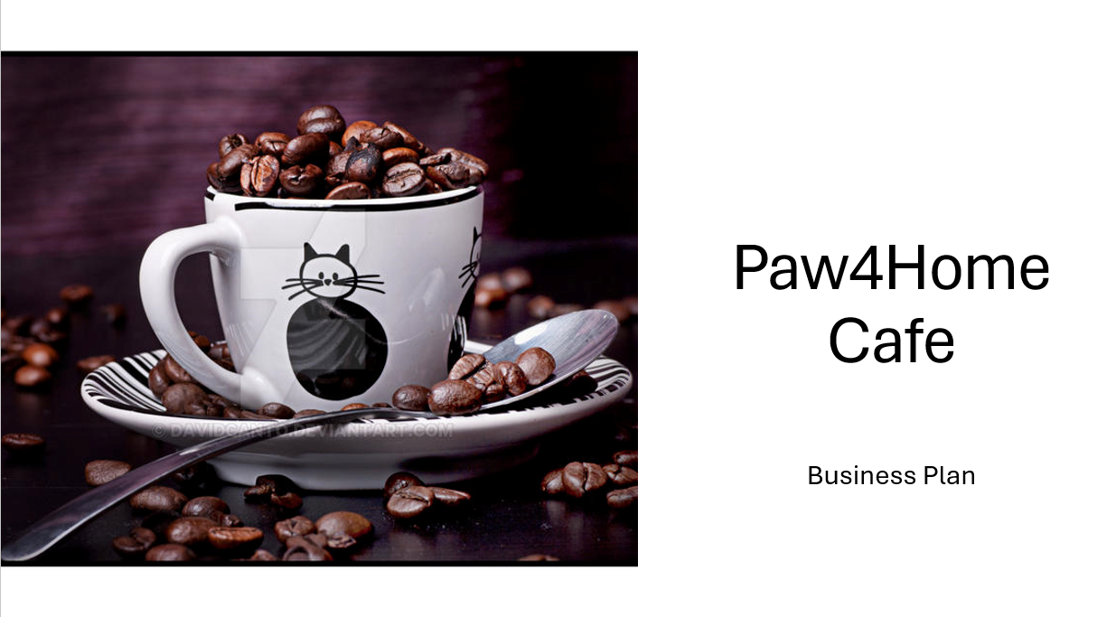
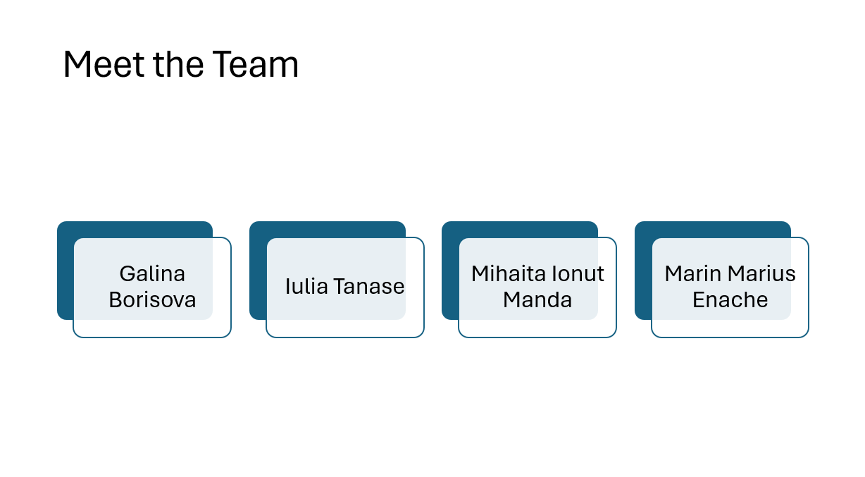
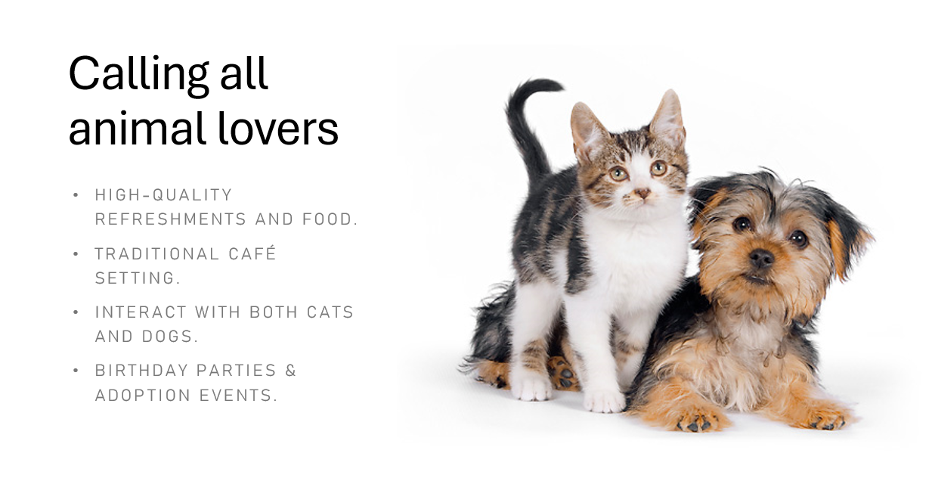
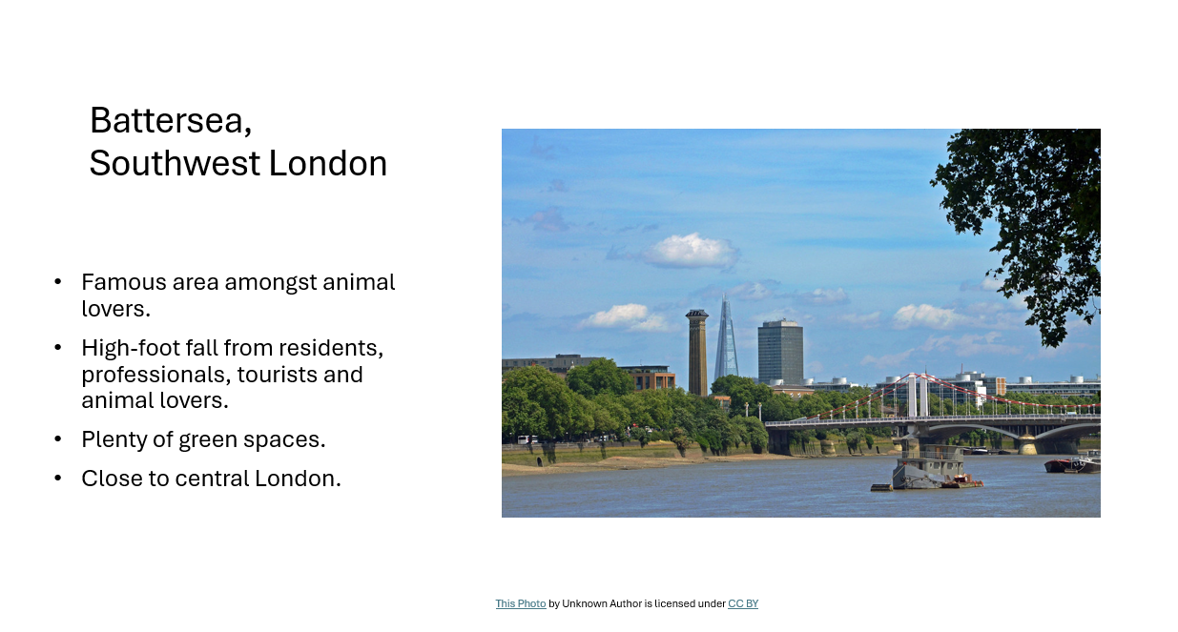
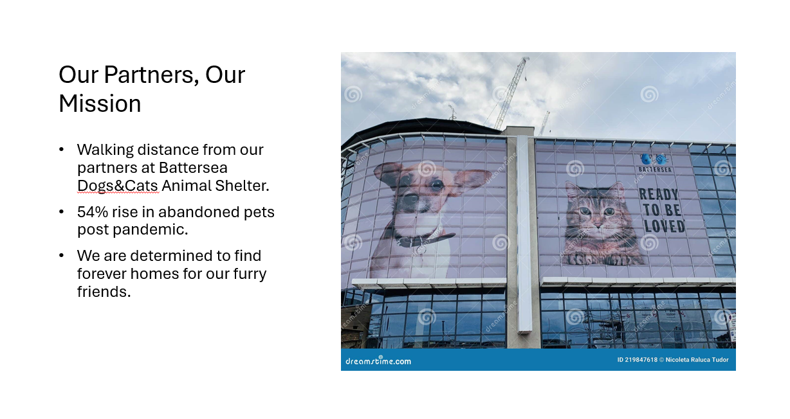
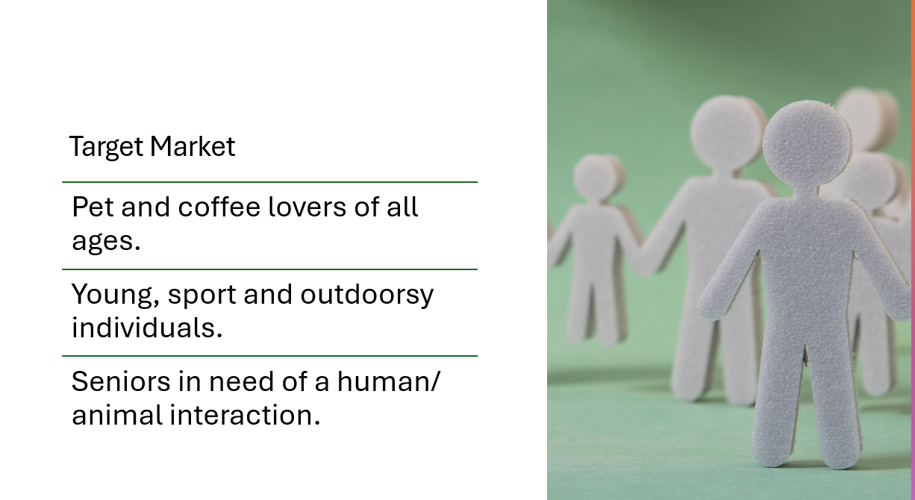
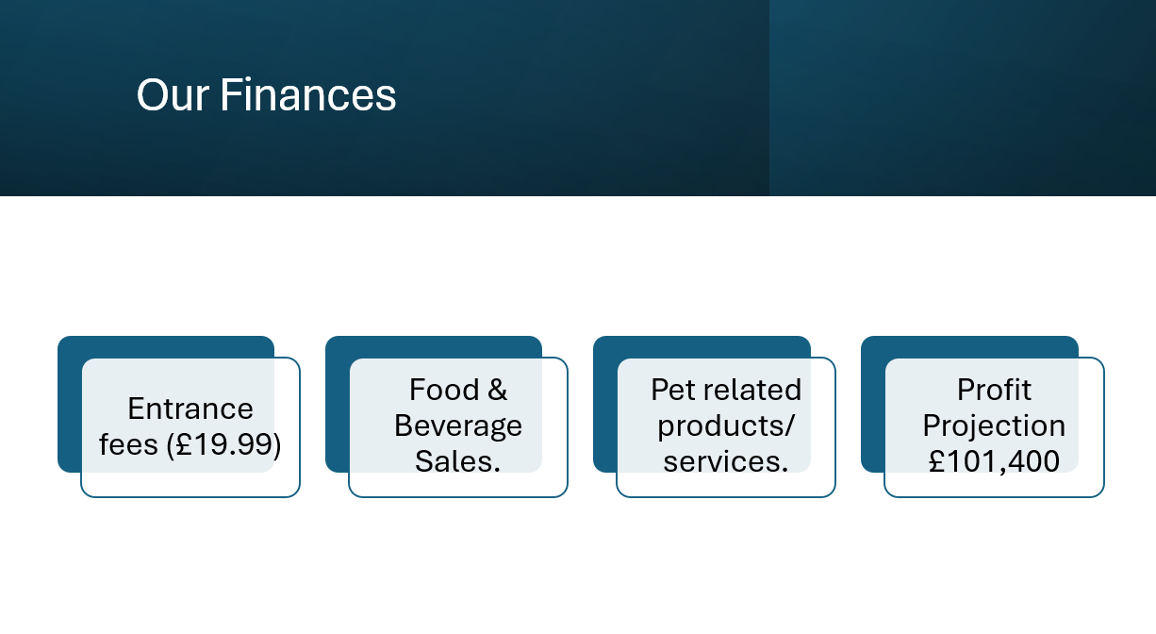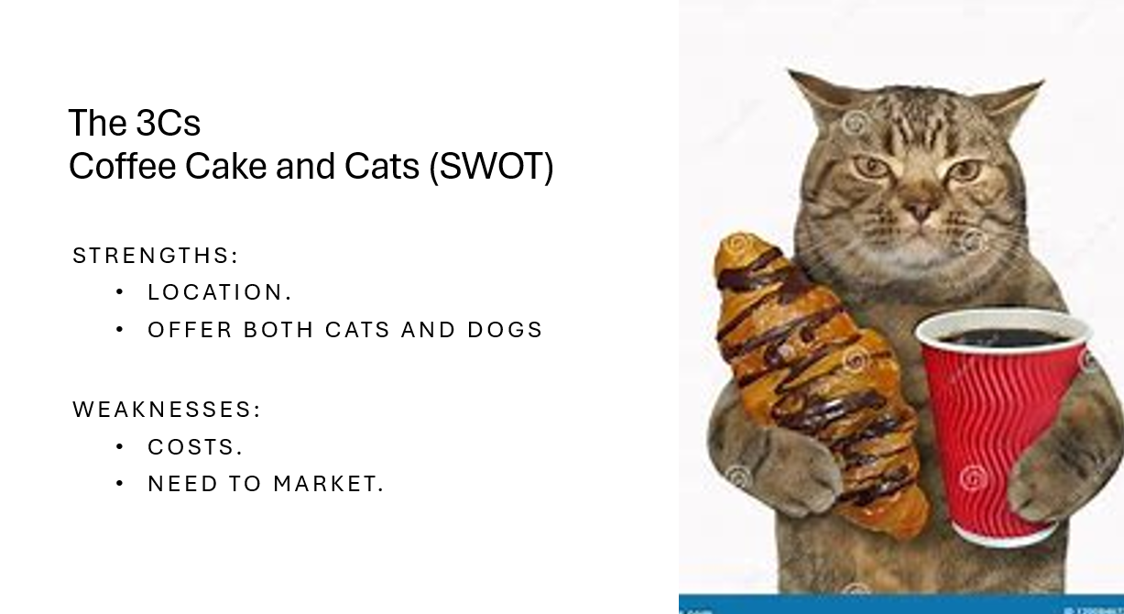
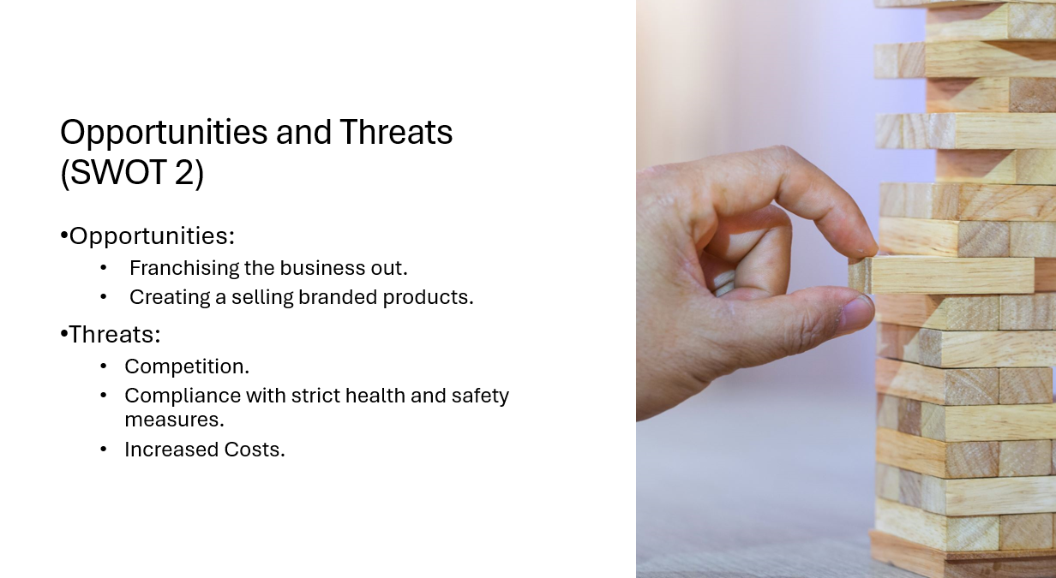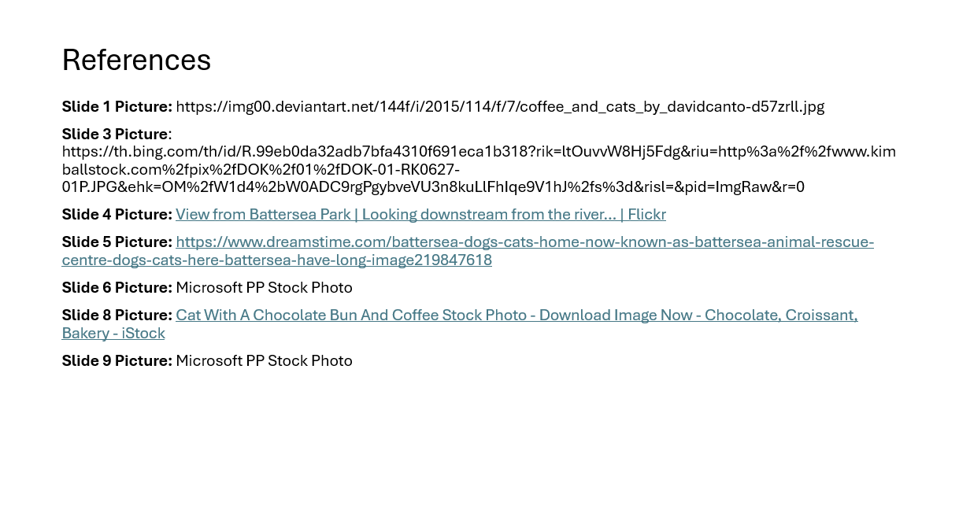

Iulia Tanese PPT Presentation:



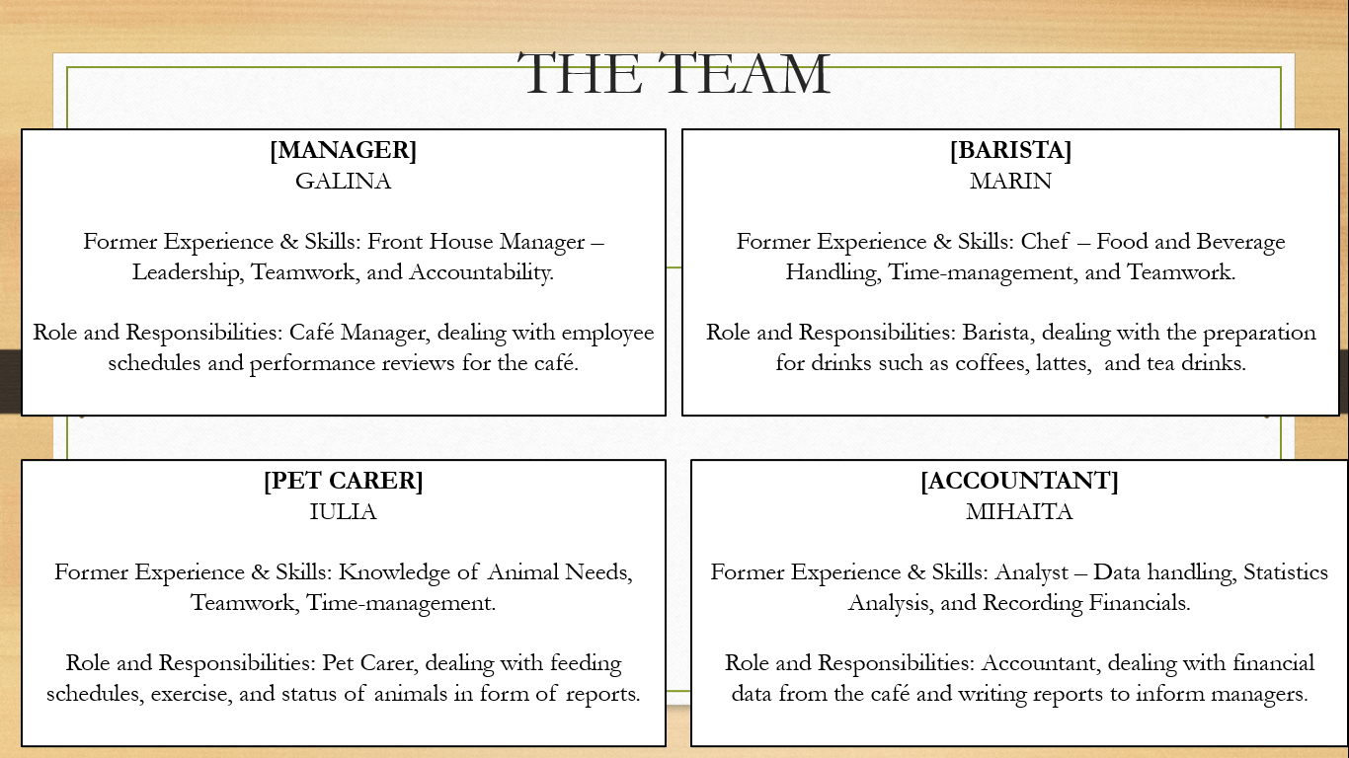
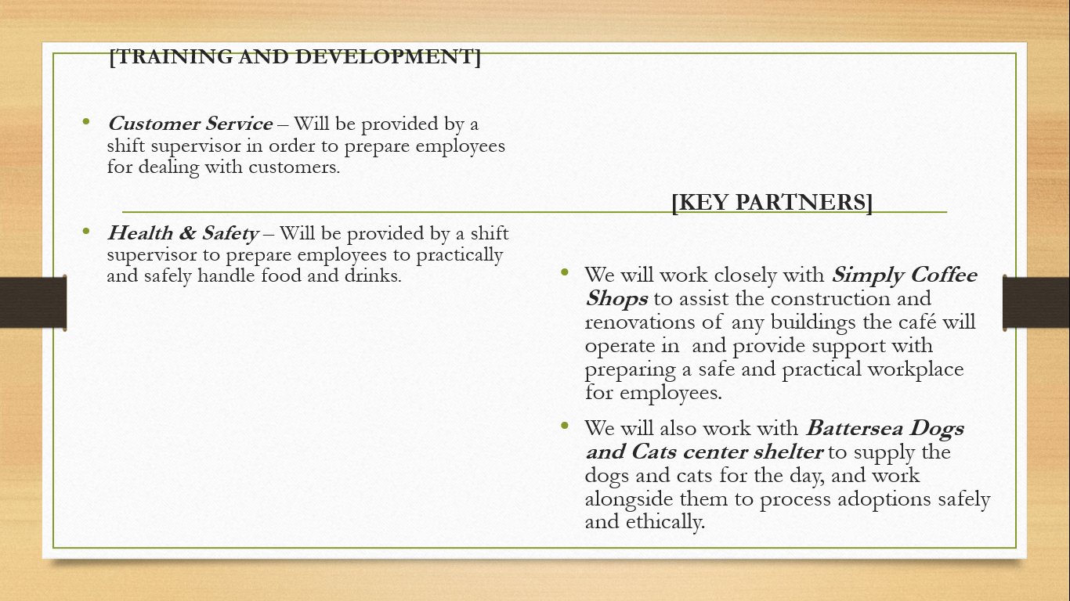

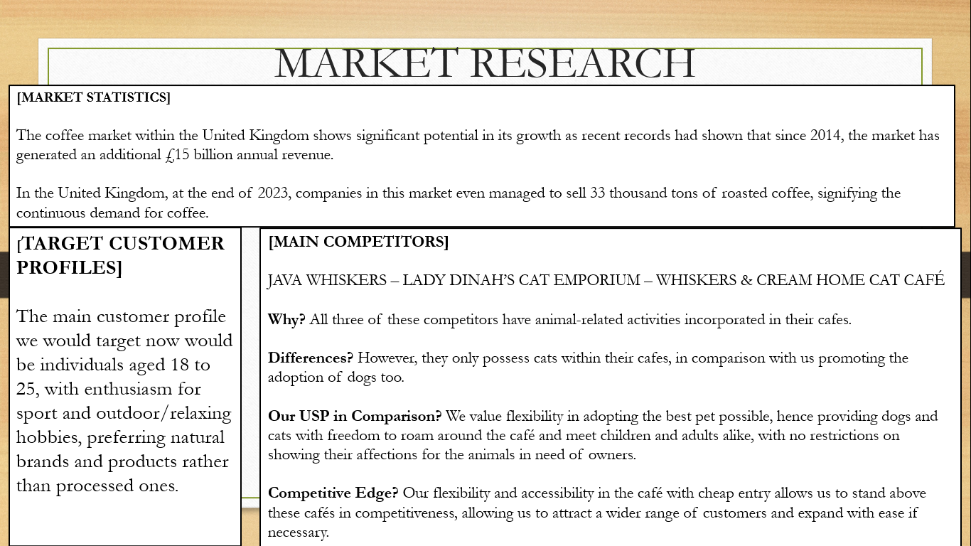
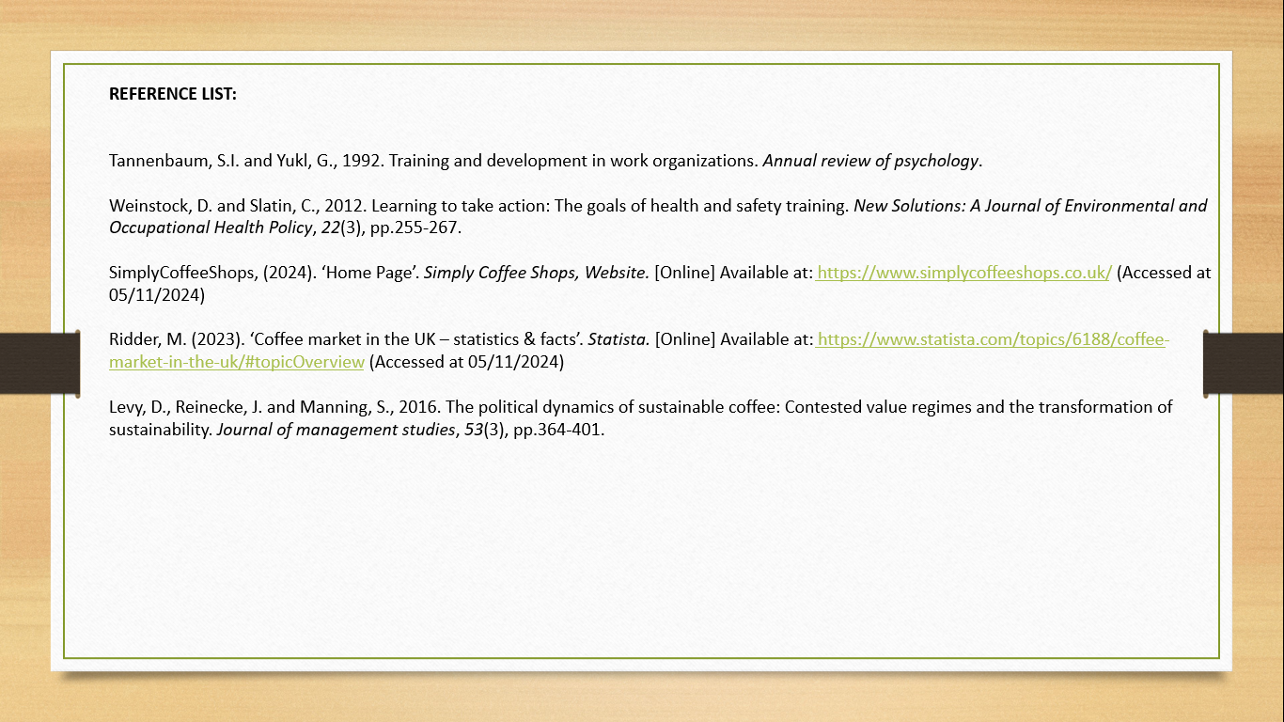

Marin Marius Enache Presentation:

Introduction
The chosen business name for the context is Paws & Coffee where people can enjoy coffee when engaging with adorable puppies and cats. The café is located next to a pet adoption center that makes a specific advantages for people to bond with pets and regard adopting these pets.

Marketing Plan
Product: The primary product of the business is the café experience along with live pet interaction, where people can enjoy coffee and other drinks in a pet-friendly business environment. Pet-themed various products, such as pet accessories, t-shirts, etc. The main product of the business is related to pet and animals (Christine Yvette Tardif-Williams and Binfet, 2023).
Price: The business sets a minimum entry fee for time spent in the place. It also sets the price of beverages to be very high or premium, offering the customers unique value. The business also offers a premium membership for people who always visit the zone. The business also sometimes follows a discount system for special events. The business also focuses on people who have an average income or higher income and who are passionate about pet adoption (Carey, 2015).
Place: The physical location of the business is next to an adoption hub, offering a good location for customers who are interested in adopting activities. The place of the business is designed with various cozy and charming features. A strong website and various social media platforms appear daily for pet engagement, updates on adoptable animals, and future events. The main place of the business is dependent on physical place.
Promotion: The promotional method of the business always focuses on digital marketing. The business follows social media marketing. The business continues paid ads on FACEBOOK, INSTAGRAM, PINTEREST, etc. The business also continues its marketing activities with a FACEBOOK page. Another promotional method is a collaboration with the adoption center. The business also concentrates on influencer marketing. Celebrity endorsement can be the best and most effective marketing method for the business. The business also can focus on referral programs to increase the customer base. The business also ought to focus on the email newsletter which can be effective for the business growth. Using the email newsletter, the business can send the business update to the targeted customer. The business also should concentrate on the local news media. The business also needs to make a website for the business and also needs to do SEO (search engine optimization) activities to gain organic traffic to the business (Roblyer et al., 2020).

Conclusion
In conclusion, the main theme of the report is business ideas for a cozy café where customers can enjoy drinks when engaging with their pets. The marketing plan of the business is very strategic and helps the business to grow for a long time. The business always focuses on digital marketing techniques to attract customers.

Mihaita Ionut Manda PPT Presentation
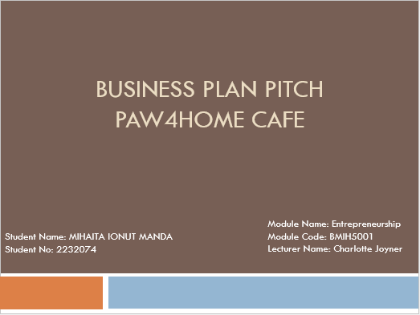

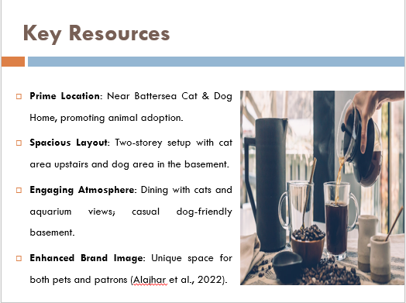

Essential Resources for Operational Success
Paw4Home Cafe, situated in Battersea, London close to the Battersea Cat & Dog Home Animal Shelter also supports its mission of animal adoption. The two storey cafe has ample of space and is suitable for patrons with pets and other ordinary customers. The ground floor contains 15 tables for meals which are served in the warm café area where guests can communicate with the cats that are up for adoption, this space also contains aquariums with fish to help create a tranquil environment. The basement that is designed for dogs, has 15 tables and provides a casual ambience for patrons to interact with available dogs. This layout enhances the image of Paw4Home Cafe and makes the space stimulating for people and animals (Alajhar et al., 2022).

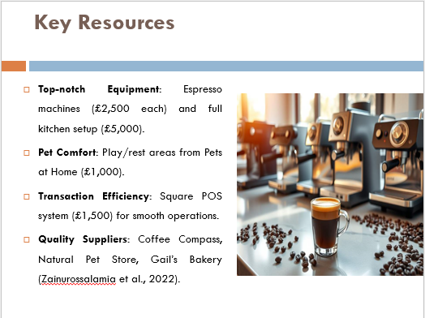

The main operational equipment includes high quality commercial espresso machines and grinder which are bought from Espresso Solutions, and each unit costs £2,500. Every Nisbets package contains all kitchen facilities needed to prepare food and goes for about £5000. Pet play and rest areas contain products bought at Pets at Home that will make pets feel at home and safe which costs approximately £1000. A new point of sales system from Square that costs approximately $1500 is purchased to enhance the conduct of transactions (Zainurossalamia et al., 2022).
They include Coffee Compass for fair trade coffee beans at £15 per kg, Natural Pet Store for organic, hypoallergenic products for pets at £500 per month and Gail’s Bakery for fresh pastries daily at £2,000 per month. These resources guarantee Paw4Home Cafe presents a differentiated and valuable proposition, based on quality and the cause of animal rights in London’s saturated cafe scene.

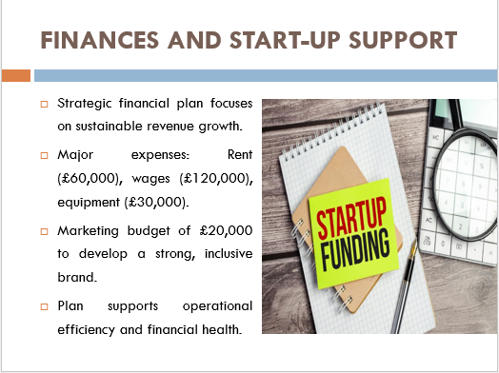

Financial Strategy and Projections
The financial plan of the pet coffee shop is strategically developed in order to sustain the business and generate reasonable revenue during the first year of its operation. Major expense costs are rent amounting to £60,000, wages for staff £120,000, and capital expenditure of £30,000 for café and pet equipment. Moreover, the initial and ongoing marketing cost of £ 20000 has been allocated to create and develop the brand which will focus on the diverse customers.

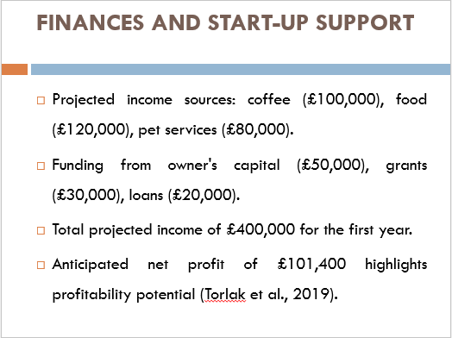
Potential sales from coffee, food products and pet care services are expected to be £100 000, £120 000 and £ 80 000 respectively. These are supported by £50,000 owners’ capital, £30,000 from small business grants, £20,000 in loans and with overall projected annual income of £400,000.
This brief analysis of the café’s financial management predicts £101,400 in net profit for the first year of operation and shows the café’s great potential for profitability. Proper distribution of resources and effective financial management also point out that the shop is ready for successful work and viability (Torlak et al., 2019).

REFERENCE LIST:
Battersea Org Uk, N.A. (2024) ‘Battersea’s latest figures reveal 54% increase in young unwanted animals coming into their care as a rate of pets neutering decreases’, Available at: Battersea's Latest Figures Reveal 54% Increase in Young Unwanted Animals Coming into Their Care As Rate of Pets Neutering Decreases | Battersea Dogs & Cats Home

NewsInHealth, N.A. (2018) “The Power of Pets Health Benefits of Human-Animal Interactions”, Available at: https://newsinhealth.nih.gov/2018/02/power-pets

Alajhar, N.A. et al. (2022) ‘Implementing quality management tools to improve customer’s journey at café’, Open Journal of Business and Management, 10(4), pp.2045-2090. Available at: 10.4236/ojbm.2022.104105

Benzaghta, M.A. et al. (2021) ‘SWOT analysis applications: An integrative literature review’, Journal of Global Business Insights, 6(1), pp.54-72. Available at: https://pdfs.semanticscholar.org/1ce6/a88073a1fedd93547b395c7b1898970736ad.pdf?_gl=1*tut8zr*_ga*NDAzNjE4MjY3LjE2ODkwNjE1NDY.*_ga_H7P4ZT52H5*MTY4OTkyNjM2Ny4yLjEuMTY4OTkyNjQwMi4yNS4wLjA

Buye, R. (2021) ‘Critical examination of the PESTEL analysis model’, Project: Action Research for Development.

Casañ, M.J. et al. (2021) ‘A collaborative learning activity to analyze the sustainability of an innovation using PESTLE’, Sustainability, 13(16), p.8756. Available at: https://doi.org/10.3390/su13168756

Melkamu, M. (2021) ‘Develop business plan for small business: Entrepreneurship perspective’, Proceedings on Engineering, 3(3), pp.365-372. Available at: https://d1wqtxts1xzle7.cloudfront.net/68875907/12-libre.pdf?1629893415=&response-content-disposition=inline%3B+filename%3DProceedings_on_Engineering_Sciences.pdf&Expires=1729931267&Signature=R6wdObgRWN1lan5FmWYWYZRjxIrRXKkkKcKK63ul2Fo6vUe~1XZ4Ix8ww70RTcmbOJmKbYxANjYhll8YUFvBTuUiqZ0zW7CNmTPpDiBLX82wfcfwQMQHpUgxn2fte5JKggZjqmjqP6ufHOayzxvFCl2pKrPXgXKXhSEMtml~-gD8jMKpuzSJW2rcF64k7i4Y3D1rZhtLDqoZSiSUZwUpg~U5Yq81j613e2iZOPYDSvvNl~HlzcbyJnOolREOjx7BCtJs2dEcF-vy77tZThjpUbMjawE9Fz4Ibx2FWV0oUxdXM0a~QPBDrO4LPm1ldUCFUgKcECbTPgJRwJgZir7VVQ__&Key-Pair-Id=APKAJLOHF5GGSLRBV4ZA

Puyt, R.W. et al. (2023) ‘The origins of SWOT analysis’, Long Range Planning, 56(3), p.102304. Available at: https://doi.org/10.1016/j.lrp.2023.102304

Torlak, N.G. et al. (2019) ‘Impact of operations management strategies on customer satisfaction and behavioral intentions at café-restaurants’, International Journal of Productivity and Performance Management, 69(9), pp.1903-1924. Available at: https://doi.org/10.1108/IJPPM-01-2019-0001

Zainurossalamia, S.Z. et al. (2022) ‘Impact of operational activities on customer satisfaction in cafes and restaurants: A mediating role of infrastructural elements’, Innovative Marketing, 18(4), pp.13-24. Available at: https://repository.unmul.ac.id/bitstream/handle/123456789/55305/Artikel_Innovative%20Marketing.pdf?sequence=1

Battersea, (2024). ‘What We Do’. Battersea, Website. [Online] Available at: https://www.battersea.org.uk/what-we-do (Accessed at 09/11/2024)

Douglas, J., Douglas, A., Cano, M. and Moyes, D., 2018. Investigating the success of independent coffee shops and cafes in the UK: Findings from a pilot study. In proceedings of the 21st Excellence in Services International Conference, Paris.

Hu, S., Hsu, C. and Zhou, Z., 2022. Security education, training, and awareness programs: Literature review. Journal of Computer Information Systems, 62(4), pp.752-764.

Levy, D., Reinecke, J. and Manning, S., 2016. The political dynamics of sustainable coffee: Contested value regimes and the transformation of sustainability. Journal of management studies, 53(3), pp.364-401.
Ridder, M. (2023). ‘Coffee market in the UK – statistics & facts’. Statista. [Online] Available at: https://www.statista.com/topics/6188/coffee-market-in-the-uk/#topicOverview (Accessed at 05/11/2024)

Carey, R. (2015). Hawaiian volcanoes : from source to surface. Washington, D.C: American Geophysical Union.
Christine Yvette Tardif-Williams and Binfet, J.-T. (2023). Virtual Human-Animal Interactions. Taylor & Francis.
Roblyer, M.D., McDaniel, M., Webb, M., Herman, J. and Witty, J.V. (2020). Findings on Facebook in higher education: A comparison of college faculty and student uses and perceptions of social networking sites. The Internet and Higher Education, [online] 13(3), pp.134–140. doi:https://doi.org/10.1016/j.iheduc.2010.03.002.

