  - Academic and Employability Skills Essay

Student:
Jitariu Stefan
Teacher:
Suneth Fernando
Course:
Academic and Employability Skills

Table of Contents
Introduction 3
Skills evaluation 6
HE Learning 6
Employability 7
Action plans 9
Short term goals 9
Long term goals 9
Application 10
Conclusion and Evaluation 11
Appendices 13
References 14
Bibliography 14

Introduction
We live in a world where technology dominates every aspect of our everyday life. From waking up with an alarm that comes from our phone, to daily reminders, checking our calendar and even speaking to a robot that understands and gives feedback. My name is Stefan Jitariu and I can honestly say that technology and the internet have drastically changed my life. I have had the opportunity of owning a PC from the age of 7. Of course, I was not really interested in what it can do, I was only interested in the games I can play. It goes without saying that I broke it a lot of times and I remember my father, who was an electrical engineer at the time, saying that I should learn why I broke it and find a solution to fix it. Years have passed and my interest from games moved to how the computer works, how the internet works and I developed a passion for cybersecurity and trying to understand it on a deeper level. Seeing that technology evolved at a rapid rate I lost interest in other subjects in high school and I would go home and research how firewalls work. My father noticed these changes and encouraged me to learn more about it, but also focus on high school. When I was 16, I was looking for a summertime job just like everyone at my age and I was surprised to see that even the public library asked for a basic to intermediate knowledge in technology. The library changed their old system of borrowing books and registering them manually to a computerized system that used Office. I was eager to start and I can say that I learned a lot of new things that summer. “In my career I have frequently been involved in hiring library technology employees. My experience ranges from being the sole person to interview and hire non-exempt staff, to serving on and chairing search committees for professional exempt and tenure-track faculty librarian technology positions. Sometimes others seeking to hire for such positions will ask my advice. Here then, is my opinion on how to hire the best library technologist you possibly can.

It goes without saying you will be looking for someone with technology skills. The big question however is what technology skills? I have seen too many advertisements asking for someone with what seems every conceivable technology skill currently in use. It is almost as if those hiring either want one person that can do the work of four, or they really do not know what they are asking for. It is very important therefore, even if you are not a technology expert yourself, to do your homework and make sure your library technology position and advertisement are focused on the correct technology skills that are really needed to accomplish your goals for the position.” (Ratledge, 2011)
After I left the clerk position, I was sad, truth be told, because I could have learned so much more. I am grateful though, because the owner thought me a lot of necessary skills that I missed and desperately needed. He explained in detail what skills I needed for what I wanted to do in the future, as well as showing me tips and tricks for writing an astonishing CV.
I have also made a PowerPoint presentation regarding my development throughout my first year studying Cloud Computing. I talk a little bit about a few skills that I think are needed for success.
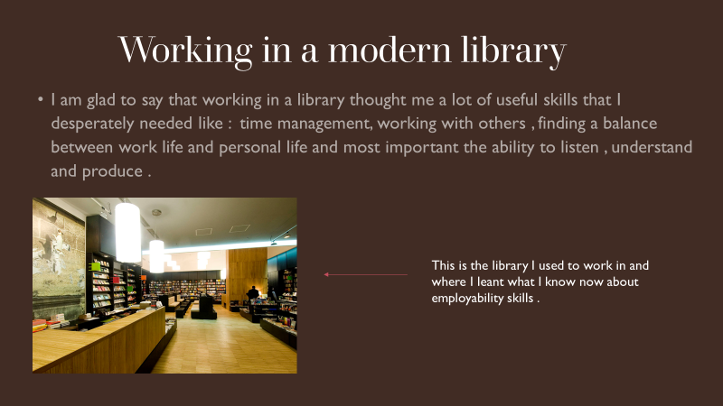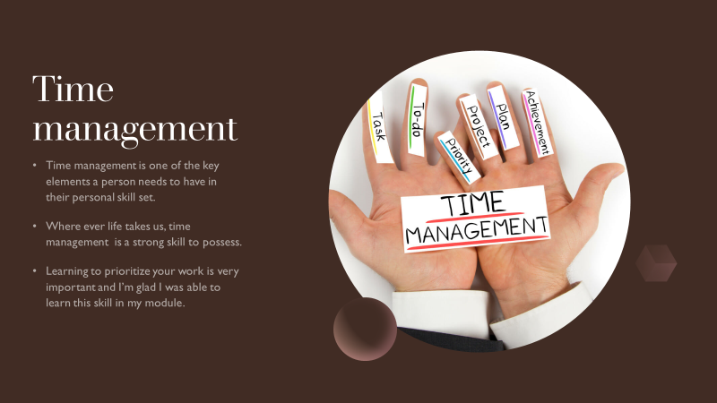

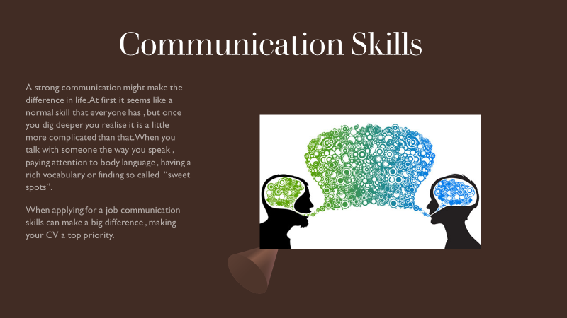

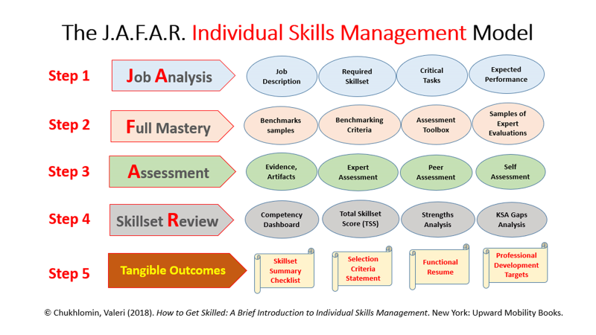
What I have learned after making this PowerPoint presentation is that I can manage my time and I can stay focused, but I also learned that a strong skill set to have is communication. Apparently, it can make a huge difference and I am not talking just about applying for a job, but life in general. Learning how to properly introduce yourself, pay attention to detail and keeping the conversation going can make a huge difference. From now on I will pay more attention on how I speak, because attention to detail is extremely important. I strongly believe that everybody can be a successful person, but very few have the will to learn the skills needed for success.
“The vision: what is success? -- Start with yourself -- Undersanding your personal performance -- Successful self-management -- Successful problem-solving and task management -- People skills -- Thinking outside the box -- The art of reflection -- Personal records: recording reflection and achievement -- Successful job applications -- Drawing it together.
With structured, reflective and practical activities, this text seeks to enable students to think creatively and constructively about personal, academic and career goals. Individuals are encouraged to identify what success really means to them and to plan a path towards achieving their aims.” (Cottrell, 2010)

Skills evaluation

HE Learning
Having a degree is very important in life. From a young age we learn basics, we develop special skills without realizing it. As we grow, we stumble upon the things we learned as kids but this time they are explained in detail. A very good example would be communication. We learn to talk with a very basic understanding.
First, we start with the letters of the alphabet, making simple words and sentences. After we are thought that communication is a complex process in which two people exchange ideas and there are a lot of small things to take into consideration. Body language and the tone of somebody’s voice can give you the upper hand in life.
Higher education is beneficial for everyone, no matter the age, because it develops people. It gives them the knowledge necessary in life, identifies the skill gaps and it fixes those gaps making a strong and prosper community that will only get stronger and grow.
In my opinion everyone should have access to higher education, because it gives them a better chance in life. Unfortunately, it can be really stressful and if we don’t have support, financial and mental, many students tend to get overwhelmed and choose to drop out. This is more and more common in our days because they think that having a minimum wage job for the rest of their lives is going to better than spending time and effort to get a degree. Little of them know that most universities have special people designed to help students by simply talking to them, listening to their problems and finding a solution.
“This study examines the profiles of self-regulation of learning, peer learning and peer support among students. The study investigates whether the profiles differ in terms of reported study-related exhaustion. Students completed a questionnaire regarding their use of self-regulation of learning and peer learning and perceived peer support and study-related exhaustion. Four different student profiles were found. The profiles differed in terms of self-reported study-related exhaustion. Self-regulated students with a low level of peer learning and low perceived value of peer support reported the lowest levels of study-related exhaustion, whereas students with self-regulation problems, a high level of peer learning and high perceived value of peer support reported the highest levels of study-related exhaustion. The results showed that problems in self-regulation were positively related to self-reported study-related exhaustion. Identifying different student profiles helps to recognise students who may need more support in studying.” (Räisänen, 2020)

Employability
Employability is strongly related to higher education learning and it refers to the skill set a person has, amongst personal attributes and achievements that make that person more likely to succeed and get a job. When applying for a job, employers look for someone special, that stands out from other people. They look for someone that has their life planned out, someone that has special skills and attributes that can help out the company in the long run. What makes you stand out from the rest, if you possess something unique can and will give you an advantage in life. Remaining competitive and being able to adapt are also really important skills to have, as they are rare and employers will look for those qualities in a person. Many students don’t think about employability as much as they need to and don’t see it as an important factor, but the truth is quite the opposite. Employability should be considered important even in the early stages of higher education, because once you have completed said education, you will receive a diploma. That degree will help you , but only if you know how and when to use it.
“In summary, the concept of employability provides a useful framework for analysing national and urban labour markets and related policies in a variety of different circumstances and for both those in and out of work. A narrow supply-side view of employ- ability skills and attributes can help to identify relevant sets of skills and policies for certain people in particular circumstances. However, a broader concept of employability also allows the additional consideration of vital demand, personal circumstances and other factors that influence the employability of people in a particular labour market, or at a particular time, and so are fundamental to those people gaining or changing employment.” (McQuaid, 2005)
After doing a SWOT Analysis ( Section 6 ) , I have noted that I need to work on a few skills that are really important for my domain of work. Time management is a strong skill that I manage to learn while working in the public library and will be useful to me when I apply for a job in cybersecurity. While I am still getting my degree I need to work on multitasking, because it’s really important to be able to to multiple things at once and get them done quickly. I strongly believe that my positive attitude towards any sort of challenge will give me the edge over my competition as well as being a good and strong leader. I have the passion of learning new things and developing more skills that will help me in life.
Compared to my initial PowerPoint presentation I realized that threats are all around me and I need to keep staying focused and set a number of goals for myself. I need to keep pushing myself so I can become the best in what I want to do and setting a couple of deadlines would be beneficial. One last thing I know I need to work on is my patience. I need to keep my head straight and never forget what I work for and the amount of hard work that needs to be put it.
“What is patience? Humans and other animals often make decisions that trade off present and future benefits. Should a monkey eat an unripe fruit or wait for it to ripen? Should I purchase the iPhone at its debut or wait for the price to drop in a few months? In these dilemmas, large gains often require long waits, so decision makers must choose between a smaller, sooner reward and a larger, later reward.

It sometimes makes sense to choose the smaller, sooner alternative, for example in a very rich environment, but in many natural situations, waiting for the larger, later option produces the best long-term outcome. The ability to wait for larger, later rewards in these situations is called patience — also called self-control or delayed gratification — whereas preference for smaller, sooner rewards is called impulsivity. Nonhuman animals experience the patience versus impulsivity dilemma in many contexts, including foraging for food, searching for mates and territories, investing in offspring, and cooperating with others.” (R.Steven, 2008)

Action plans

Short term goals

My short term goals would be to finish my higher education and get a diploma. Meanwhile I can work on multitasking and being able to remain calm in every situation I encounter. While I study I want to be able to do some extracurricular work and maybe enroll in other courses that will help me get a job in cybersecurity.

Long term goals
My long term goals would be to work in cybersecurity and be able to lead and teach others, having my own company and being able to solve any issue I may stumble upon without experiencing issues. Being able to deal with threats of any kind would mean that I mastered every skill set I need while meeting the goals I have set for myself.

SKILLS | TASKS | TIME FRAME | RESOURCES
Multitasking | Try and solve more things at the same time correctly and efficiently. | Deadline would be on 20 September 2020. | Time and implementing deadlines.
Patience | Exercise on dealing with stressful situations and seeing proper solutions. | As soon as possible as it is a matter of upmost urgency. | Patience

Application
In times like these you can never be too safe. Protecting your data is really important and luckily there are many ways we can keep our data safe and sound.
We can start by regularly backing up our data and saving it on removable USB Sticks that we can store in a safe that only you have access to. Another good thing to do is encrypting our data so it’s not so vulnerable against viruses and virtual attacks. We can put a password on everything and keep those passwords in the safe and our brains and last but not least we can use VPN.
Even if we take all of these measures there are still ways for hackers to get into our system with a number of hacks and methods that put our data at risk. One example would be Spyware, that is pretty much untraceable. One mouse click on a shady website put all of our data at risk. That virus can turn into a ransomware attack, which means we can get blocked out of our own system and we need to pay the attackers a sum of money so we can get the password.
This is why it is important to always back up our data and store it on a disk or USB Stick and keep it somewhere safe.

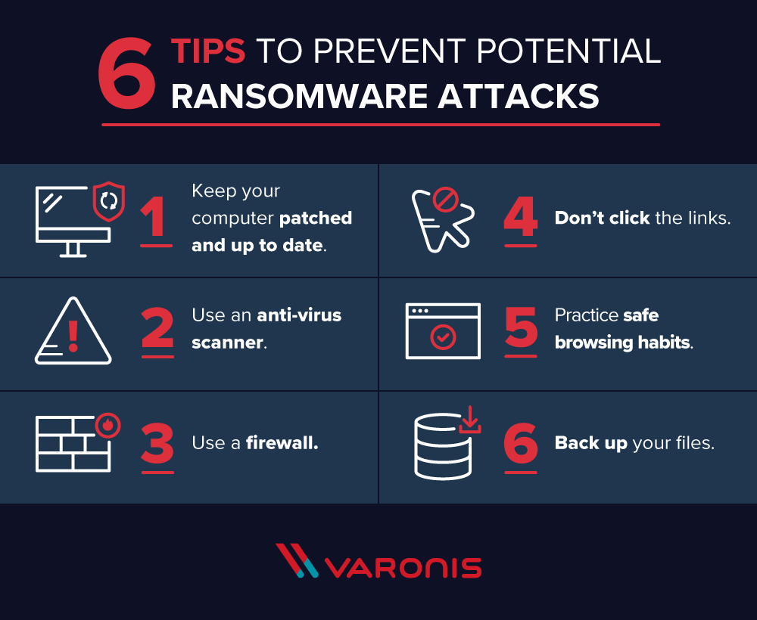

Time management is really important in our lives because it dictates the flow of our work. When done properly, there should be a perfect balance between personal life and work life. All of the tasks and deadlines should be accounted for and should be allocated every day. Higher education stimulates productivity, but it’s also supposed to make us choose between tasks and develop a sense of time management. When talking about employability, time management is a must, as most employers look for someone that can manage tasks in a given amount of time while also keeping calm and collected. I have decided to allocate at least 4 hours every day to finish homework and higher education related tasks, keeping calm and taking regular breaks to ensure that the brain works at full capacity. I also tend to brainstorm and plan my day early in the morning and keep my tasks on a notepad. After finishing each task I cross it off and prepare for the next one. Stress is not much of an issue because the difficulty of the tasks is low and I do take regular breaks. Sticking to our plan is really important, because if we deviate from our path, we can get overwhelmed and we may not be able to finish our work or meet a deadline.

Conclusion and Evaluation

In conclusion this module really helped me realize what I want to do after I finish university as well as give me an insight. I learned that I have a lot of useful skills and that I need to improve some. I realized that I can manage my time really well and I can work with others, as well as being a strong and devoted leader. The only thing holding me back now is my multitasking ability and my patience.
As soon as I master these skills, I will be ready to work in cybersecurity. I have attached my personal development plan below, which has been done by me at the beginning of this course and it’s quite interesting to see that now I have other goals in mind and that I can manage different tasks and set a number of deadlines for myself without being distracted.

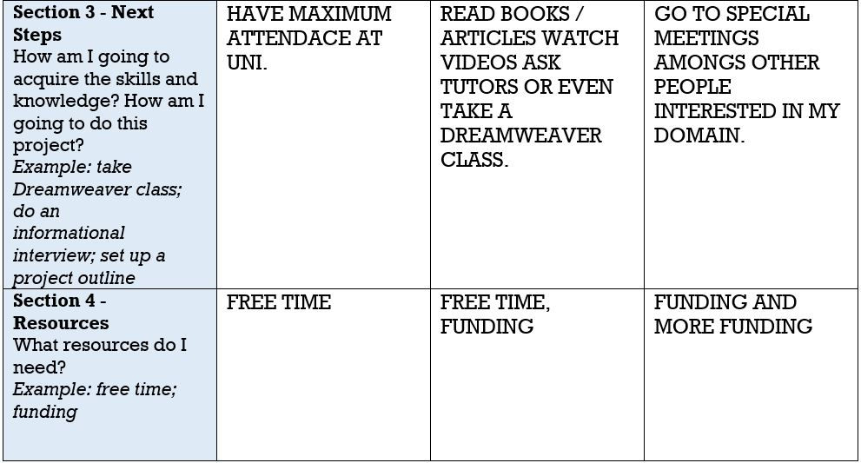
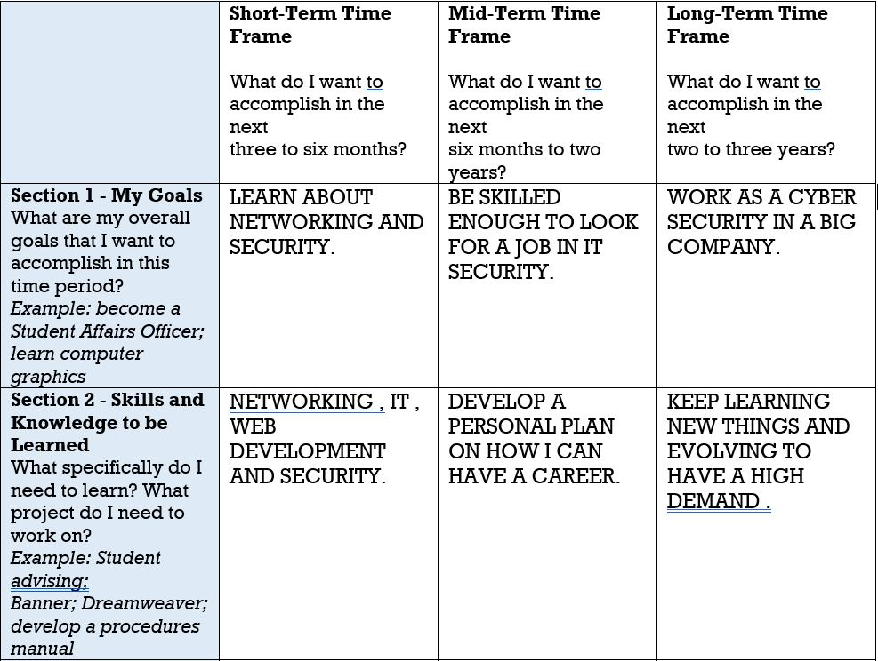

Appendices
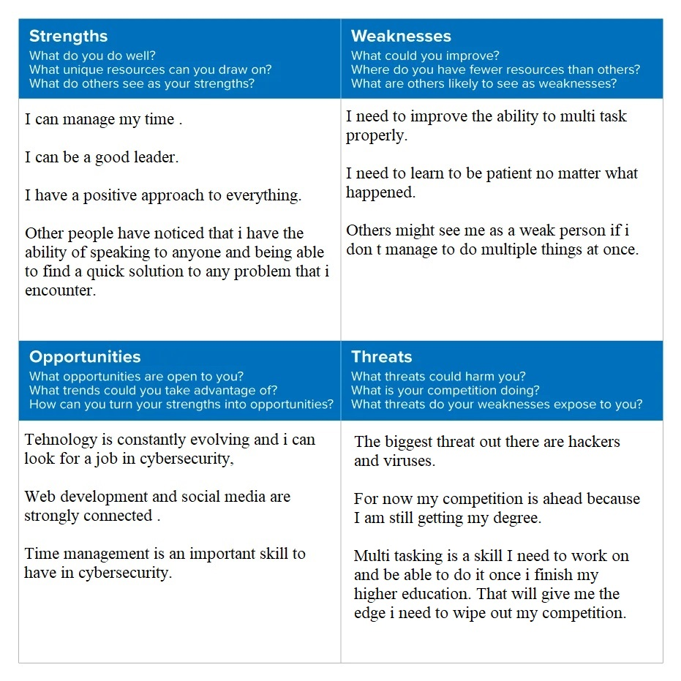

References
Cottrell, S., 2010. Skills for success : the personal development planning handbook. 2nd ed. s.l.:Basingstoke: Palgrave Macmillan.
McQuaid, R. W., 2005. Urban Studies. Introducing Employability, February, 42(2), pp. 191-195.
R.Steven, J., 2008. Current Biology. Patience, January, 18(1), pp. R11-R12.
Räisänen, M., 2020. Active Learning in Higher Education. Study-related exhaustion: First-year students’ use of self-regulation of learning and peer learning and perceived value of peer support, 1(3), p. 173–188.
Ratledge, D., 2011. Technology. Memphis: Tennessee Libraries.

Bibliography
Cottrell, S., 2010. Skills for success : the personal development planning handbook. 2nd ed. s.l.:Basingstoke: Palgrave Macmillan.
McQuaid, R. W., 2005. Urban Studies. Introducing Employability, February, 42(2), pp. 191-195.
R.Steven, J., 2008. Current Biology. Patience, January, 18(1), pp. R11-R12.
Räisänen, M., 2020. Active Learning in Higher Education. Study-related exhaustion: First-year students’ use of self-regulation of learning and peer learning and perceived value of peer support, 1(3), p. 173–188.
Ratledge, D., 2011. Technology. Memphis: Tennessee Libraries.

