Qualification: CIPD Diploma in Applied Human Resources

Module Name: Coaching and Mentoring in the Organisation

Assignment Coaching and Mentoring

Word Count: 2774

Student Name: Tara Jeffreys
Student Number: 2005784
CIPD Membership Number: 80931290

By signing below, I confirm that the work/evidence presented is my own, unaided work. I understand the regulations pertaining to candidate malpractice and the action that may be taken as a result.

Signed: Tara Jeffreys
Date: 14/05/21

LO 1 Understand the concepts of coaching and mentoring

Coaching over the past 30 years has been dominated by “the sports model” often referring to the work of Timothy Gallwey, Harvard tennis captain turned guru and his work in a series of books “The inner game” although this model has been transferred to the business world, there is debate among academics of the effectiveness of the model in modern business, Erik de Haan, writes that he believes the model is fading as it does not take into consideration underlying personal issues, he states “underpinning the simplest of leadership issues are emotions, anxieties and personal traits” In his work de Haan traces the origins of coaching back to the 15th centaury and horse drawn transportation and how this symbolises taking people where they want to go. (E, de Haan,)
Professor of coaching and mentoring at Sheffield Hallam University, Bob Garvey has researched the origins of mentoring and writes that it can be traced back over 3,000 years, when Homer wrote about a friend and advisor to Telemachus, the son of Odysseus. Garvey also mentions there is a reference to mentoring through history including French King Louis XIV, where he was mentored by expert and author named Fenelon (Personnel today)

According to the CIPD coaching and mentoring are development approaches based on the use of one to ones to enhance skills, knowledge or work performance (CIPD, 2020)
The Cambridge dictionary defines coaching as “the act of giving special classes in sports, a school subject or work-related activities, especially to one person or a small group” and defines mentoring as “the act or process of helping and giving advice to a younger or less experienced person, especially in a job or school”
Coaching and mentoring in business is about releasing potential, to allow leaders to effectively coach and mentor there are several models that have been developed by academics to develop these skills.

GROW Model – this was developed 1n 1980’s by Sir John Whitmore, probably the most well-known model. This model has developed to TGROW model

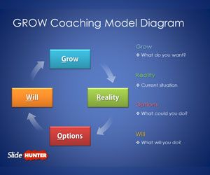
This Photo by Unknown Author is licensed under CC BY

OSKAR Model – this was developed by Marl McKergow and Paul Z Jackson in 2000
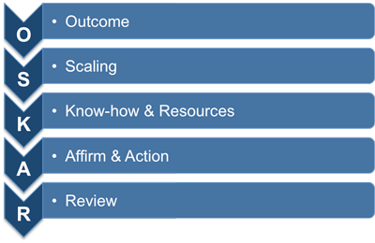
Fuel Model – developed by Zenger and Stinnett

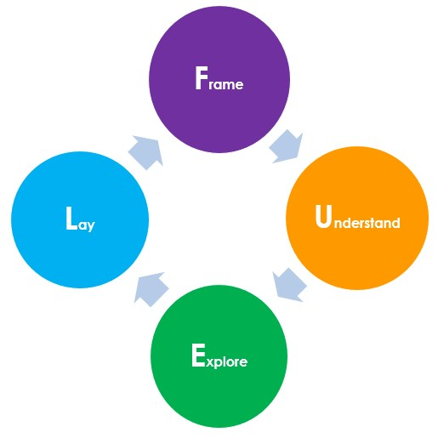

Clear Model – developed by Peter Hawkins in 1980’s

CLEAR Coaching Model
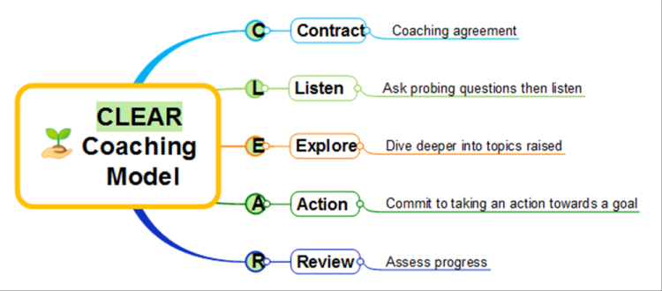

When reviewing coaching and mentoring there are several similarities and differences between both, and they are referred to as a combined topic

Mentoring | Coaching
- Tends to be longer term relationship  - Important to build rapport between mentor and mentee  - An informal approach  - Meetings are held as and when required  - Agenda tends to be set by the mentee  - A supportive process  - More around developing technical skills or professional development | - Tends to short term relationship  - Rapport is not as important, however dies require open and honest approach  - A more structured approach  - Regular scheduled meetings  - Agenda tends to be set by the coach  - Predominately goal set  - Based on more specific personal development i.e., behaviors

When considering when to coach or when to mentor, you should think about what the desired outcome or end goal is. To be effective both coaching and mentoring require, trust, respect and confidentiality.

Coaching and counselling share similarities in terms of contracts, the main differences from coaching and counselling are counselling requires a formal qualification to practice to masters degree, the counselling follows a medical model and sometimes works alongside medical teams, counselling is based on retrospective behaviors. Counsellors require licensing and is a far more formal process, there is a stigma that attaches to counselling that does not attach to coaching or mentoring. When comparing relationships in coaching and mentoring and counselling, coaching and mentoring base on trust and sometimes a sharing of mutual information, whereby counselling must maintain of level of professional distance and must maintain boundaries between client and counsellor. (www.positivepsychology.com)

One to one training does not require a rapport or relationship between the trainer and trainee unlike coaching and mentoring, one to one training is a short-term relationship that involves the sharing of knowledge, information and skills, the training topic is usually set by the trainer and can involve referring to personal experiences.

LO2 The different ways coaching, and mentoring can be implemented in organisations

There are 3 main types of coaching styles recognised within business they are
- Autocratic Coaching
- Democratic coaching
- Holistic Coaching

Autocratic
This style of coaching is highly directive, and is likened to a dictatorship, a “my way or the highway” approach. This style is a very strict one-way communication style where the coach controls the situation and does not allow input from the coachee. This style is very results driven and focuses on the aim or objective. This style can be useful in a new or inexperienced team and is useful for delivering strong results quickly and it creates discipline, commitment and structure to succeed. The style can have a negative effect on morale as the coachee can feel insignificant, stifled or overlooked.

Democratic
This style is based on a 2-way communication, the coach explains the ‘why’ aims and objectives, however this approach encourages coachee led solutions. The coachee feels empowered and it generates a good buy in as they feel in control. It develops collaborative working; however, this approach can take longer to see results.

Holistic
This style is referred to as “laissez-faire” the style is coachee led and it allows the coachee to follow their own path. It encourages a sense of connection and creates an environment where the coach is not necessarily an authority figure. This style can take longer to see results

The question is often asked which style is best? The answer is, no one style is best, an effective leader will tailor their coaching style based on the situation and find the right balance. The leader must look at the project, the team involved and the objective.

There are several types of mentoring styles which can be implemented within an organisation, the 3 most common are
- Traditional
- Reverse
- Career and leadership development

Traditional mentoring
Is a tried and tested approach to mentoring, comprising of regular one to one meeting, usually the mentor is more senior level and mentee is junior level. This type of mentoring increases engagement is a strong foundation for talent management and promotes the sharing of knowledge.

Reverse mentoring
This is similar to traditional, however as the title states the roles are reversed and this is where someone of a more junior level would mentor a more senior level. This approach improves diversity and inclusion, helps with the retention of millennials and increases engagement.

Career and Leadership development
The process of interaction between the organisation and the individual to allow the employee to grow their career.

According to the CIPD line managers are more likely to take on the responsibility of delivering coaching and mentoring (CIPD, 2020) Although there is some debate around the effectiveness of line managers as coaches due to the existing relationship between line managers and staff, to be an effective coach or mentor there needs to be some distance and impartiality. Coaching is not something that gets delivered to the coachee, in order to be effective at coaching and mentoring the line manager must create the right coaching culture.

The risks when considering line manager coaching
- Groupthink – people who work together tend to think along the same lines, the better the working relationship the more apparent this becomes
- Inequality on who gets coaching – due to time constraints line managers may select who receives coaching either based on poor performance or those with greater potential, this may result in the former feeling “picked on’ and the latter resulting in team members feeling left out
- Culture – line managers may have the lack of confidence in dealing with difficult individuals
- Skill level – line manager may not have the right skills to coach, misconceptions are that coaching skills can be taught in an intensive training session (Clutterbuck,2012)

Despite the barriers around line manager coaching, there are still lots of benefits around line manager coaching “to get the best from your employees, you need to be more than a manager, you need to be a coach” (Simpson,2014)
- More committed team – in a coaching culture teams are encouraged to peer coach as they are having “buy in”
- Improved team performance – engaged people deliver a better performance
- Better working relationships – removed the fear factor, makes line managers more approachable
- Increased idea generation – confidence to make suggestions
- Improved communication – relationships build 2-way communication
- Investing time to gain time – the rewards outweigh the time invested in coaching

Coaching and mentoring strategies need to link into an organisations strategic objectives, such as HRD, Learning and development, wellbeing, performance management, talent and succession planning, monitoring and evaluating. Due to the COVID 19 pandemic most organisations have moved to remote working and the majority of learning is now completed online, care must be taken to manage the balance of online learning, preventing ZOOM fatigue.

When implementing coaching and mentoring in an organisation there are 2 approaches Internal and external and can be formal or informal

Internal
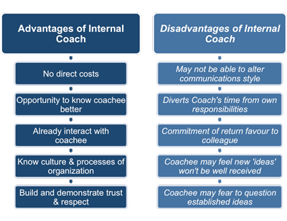
External
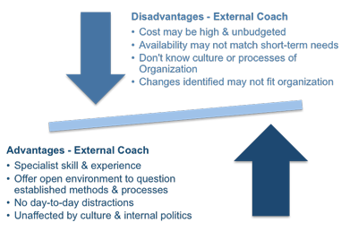

Whether the approach an organisation takes to coaching and mentoring is internal or external, there are regulations and codes of practice that must be adhered to

GDPR 2018 (General Data Protection Regulations)
Internal or external coaches within an organisation must ensure GDPR compliance, by obtaining consent to hold any personal data, have a safe process for disposal of personal information and have a process to deal with and breaches within 72 hours.

Confidentiality
Within coaching and mentoring the expectation for confidentiality is to “respect confidentiality of all client’s information except as authorised by client or required by law” (Brock, 2006) Coaching and mentoring should be a safe environment, when using third parties some organisations require an NDA to be signed.

Ethical Practice
In some circumstances coaches may face an Ethical Dilemma, whereby they must break confidentiality as the coach has a legal obligation to disclose to a third party should the client, engage in illegal behavior, are a danger to themselves or if there is a risk to national security

There are several officiating bodies in relation to coaching and mentoring, the downside to this is there is not one overarching body which results in a lack of consistency and variation in code of practice.
- (AC) Association for Coaching
- (ICF) International Coaching Federation
- (ILM) Institute of Leadership and Management
- (EMCC) European Mentoring and Coaching Council
- (APECS) Association for Professional Executive Coaching and Supervision
- (IAC) International Association of Coaching
- (WABC) Worldwide Association of Business Coaching

To support effective coaching and mentoring a coaching contract is normally established, the contract can either be written or verbal, this is established prior to the coaching commencing. The contract establishes roles and responsibilities, timescales for sessions and clarifies any costs that may occur. The contract can be fluid and change when needed, however it is always there as a point of contact through the relationship.

LO3 The potential benefits of coaching and mentoring in organisations

Having and effective coaching and mentoring programme in an organisation can benefit an organisation by creating a positive culture, develops the employee and line managers which in turn has a positive effect on an organisation’s performance. Key stakeholders that benefit from coaching and mentoring in an organisation are
- Employee / Mentee/Coachee
- Coach ./ Mentor
- The Organisatiion
- Shareholder
- Customers
- Suppliers
“Companies are moving away from traditional command and control practices and toward a model in which managers give support and guidance rather than instructions”

In a modern business coaching is a fundamental part of a leader’s role is to coach, to create the right culture for coaching and mentoring, leaders should follow the following steps
- Explain the why – ensure the leaders buy in to the coaching process to ensure sustainability and the right culture, explain the operational benefits
- Model the correct behavior – to embrace coaching and mentoring by managers, you must embrace it yourself and help change to an open mindset
- Build Capability – develop the team to change and get a coaching style of leadership
- Remove barriers – old habits die hard, make brave changes to existing barriers (HBR, 2019)

Benefits to Coachee / Mentee
- Establish and Act toward achieving goals – define goals and work towards them, both technical and behavioral
- Increased level of engagement – through one-to-one feedback and encouragement, improves employee retention
- Safe place – the ability to talk through sensitive issues to allow time to gain perspective
- Deeper level of learning – embeds learning through self-reflection and feedback on how they are perceived by others and the ability to improve on specific behaviors
- Build personal awareness – coach to support in identifying blind spots
- Support for improving a specific skill set

Benefits to Coach / Mentor
- Give time to save time – investing time to coaching to improve capability
- Better communication – 2-way communication through improved relationships
- More engaged team – engaged teams perform better
- Personal job satisfaction
- Own personal development

Coaching and mentoring helps individuals feel engaged, invested and valued, this leads to increased productivity and a reduction in labor turnover. Coaching can help spotlight talent and allows individuals to shine, therefore addressing issues within and organisation. Employees who feel listened to and valued will flourish, only 15% of workers worldwide feel fulfilled. Coaching and mentoring is about creating a workplace to allow people to thrive. There are 3 fundamental human needs, Autonomy, relatedness and competence, if all three are met this ensures work is satisfactory (Ryan, Deci, 2000)

Most organisations use coaching and mentoring; however, this is not always the right solution, the majority of coaching is carried out by line managers and 15% is carried out by external companies. Coaching internally can often be deemed as wooly and not implemented correctly can have a h=negative impact.

The key to effective coaching having a positive impact on an organisations objective is to integrate it with the business strategies. The use of coaching and mentoring has grown considerably in the last 10 years (Grant, Curtayne and Burton, 2009)
It is often difficult to measure the benefits of coaching and mentoring, as often the results are intangible. Investing in coaching and mentoring can be costly and senior leaders often want to know what impact this is having on an organisations performance and how this can be measured, a lot of the time it is impossible to see the return on the investment in coaching and mentoring.an example of a measurable return on investment is from Signet jewelry group, whereby following the implementation of a coaching and mentoring programme they saw an increase if sakes of 8%, versus the industry average seeing a decline of between 10 – 15%..
Coaching and mentoring is not a one stop shop to solve all issues, organisations should think about the why and what they want to improve and then indicators can be put in place to measure success, ensuring all key stakeholders are involved. Effective coaching and mentoring is a collaborative partnership. (CIPD, 2013)

A study into the impact of coaching in the NHS found the following examples of improvements,
Following coaching a chief pharmacist made a saving of £333k in staff costs

A line manager found following coaching her direct report improved her efficiency by a third

Following coaching there was an increase in home treatments from 10% to 20% (employment-studies.co.uk)

Refences

Brock, V, 2006, where do we align our ethical code?

CIPD, 03/08/20, Coaching and mentoring factsheet, Chartered Institute of Personnel Development, London

CIPD Podcast, 02/07/13, Is coaching actually solving problems for organisations, Chartered Institute of Personnel Development, London

Clutterbuck, 2012, Why line manager coaching often doesn’t work and what to do about it

Employment-studies.co.uk/Evaluation of coaching on the NHS

Grant,A M, Curtayne, L,& Burton, G, 2009, Executive coaching enhances goal attainment, resilience and workplace wellbeing, the journal of positive psychology

Haan, E, Relational coaching

Harvard Business Review, 2019, The leader as coach

www.insala.com

Personnel today, 22/04/08, origins of coaching, origins of the species

Positivephsycology.com

Ryan R M, Deci, E L 2000, The “what” and “why” of goal pursuit, human needs and the self determination of behavior, psychological inquiry

Simpson, M, 2014, Unlocking potential, 7 coaching skills that transform, individuals, teams and organisations, Grand Harbor Press

LO3 Understand the potential benefits of coaching and mentoring in organisations

