University of Wales Trinity Saint David
School of Engineering

Stress Analysis and Dynamics
ACMA5010
Designing an overhead gantry crane

By
Gareth Gimblett
1910095

BEng Manufacturing Systems Engineering
April 2021



Contents
Summary 3
Introduction 4
1. Calculations for the minimum second moment of area 5
1.1 Choosing a suitable beam section 8
2. Assumptions made in calculations 11
3. Strain gauge development 11
3.1 Different configurations of strain gauges 12
3.1.1 Quarter-bridge 12
3.1.2 Half bridge 13
3.1.3 Full bridge 13
3.2 Different types of strain gauge 14
3.3 Future developments 14
4 Strain gauge placement 14
References 18

Figure 1 - Diagram of EOT components 4
Figure 2 – I beam dimensions 8
Figure 3- Weight calculator 9
Figure 4 - 10M beam calculations 9
Figure 5- Deflection diagram 9
Figure 6 - Deflection diagram 10
Figure 7 - 20M Beam calculations 10
Figure 8- Wheatstone bridge 12
Figure 9- Typical strain gauge 13
Figure 10- Positioning of strain gauges 15
Figure 11- Beam diagram forces 15
Figure 12 - Compressive stress direction 16
Figure 13- Tensile stress direction 16
Figure 14 - Position of strain gauges on girder 17

Summary

This report assesses the design of a cost effective, under running single girder gantry crane. A suitable section of steel girder will be recommended based on the second moment of area calculated from provided and assumed parameters.
The background and application of strain gauges to monitor stresses in the girders will be outlined then advanced considerations explored with future developments in the technology of strain measurement.
The positioning and translation of these values will be considered. With sites for the gauge placement identified and justified.

Introduction

An Electric overhead traveling (EOT) crane is one of the most common variants of overhead crane used in industry today. Particularly where heavy loads are handled indoors.
They comprise of two parallel sections of steel (runway beams) with a bridge girder section, housing the lifting crab, trolley frame, hoist etc. This bridge girder is supported by two motorised end trucks on wheels to enable a XYZ movement.
They can be either top running or underhung.
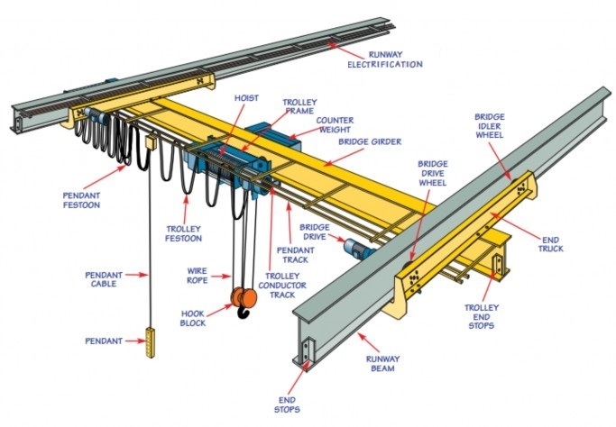
The components of the underhung gantry crane are shown in the below diagram. This type of application is used for lighter loads typically <10 tonnes
Figure 1 - Diagram of EOT components

This report explores the design of a overhead gantry crane which when lifting a 5000kg load the deflection in the centre of the bridge section must not exceed 10mm, and also considers the strain monitoring systems to be applied to ensure that safe operating limits are not exceeded.

1. Calculations for the minimum second moment of area
See below for photo of handwritten calculations.
Equation 1
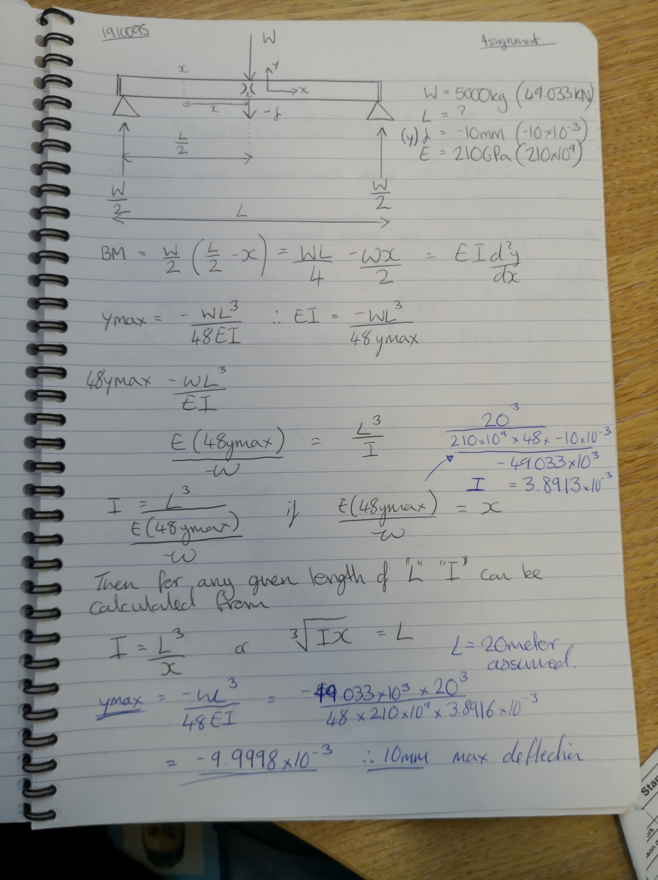

Equation 2
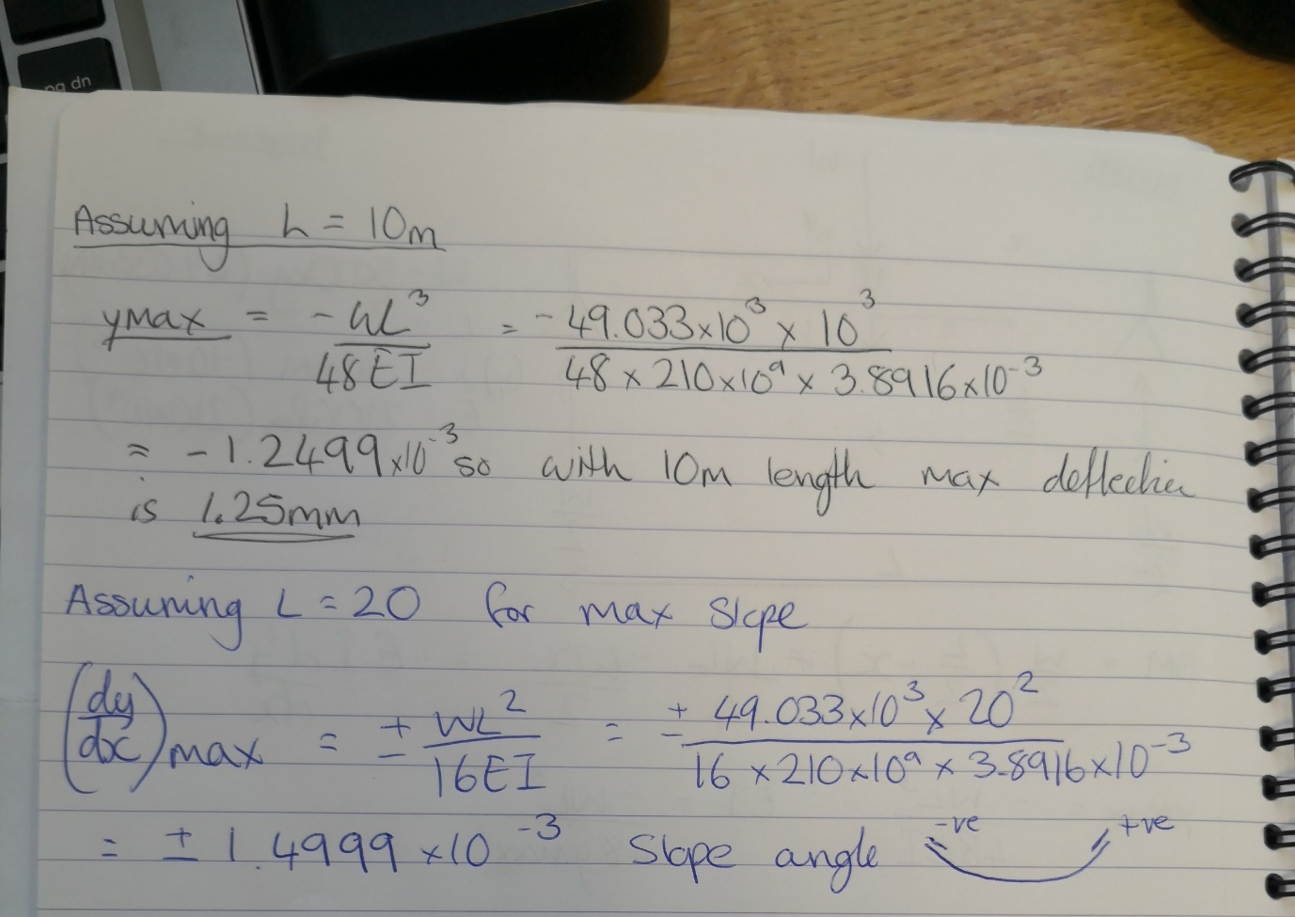

Equation 3 – derivations
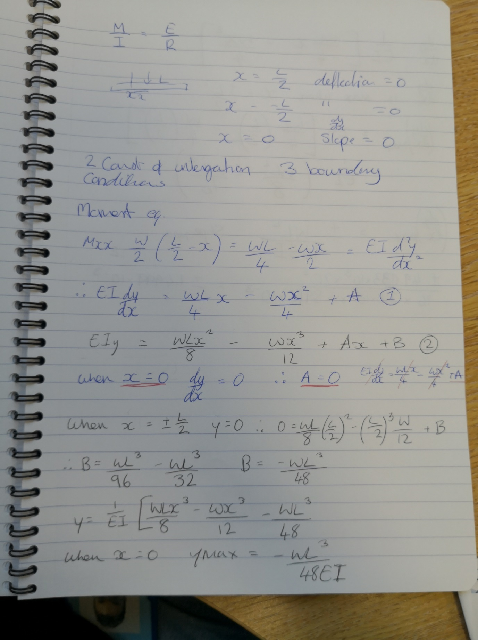
Through calculations obtained a value for I of 3.89136x10-³ m⁴
Confirmed that this value would produce a max deflection in a 20M section of Beam of 10mm
With a maximum slope of 1.5X10⁻³

1.1 Choosing a suitable beam section
The following section was chosen for the bridge girder by considering the value obtained for I and considering a safety factor to allow for a tolerance in the allowable stress limit.

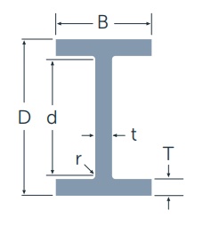
Figure 2 – I beam dimensions
Table 1 universal been sizes with chosen beam highlighted
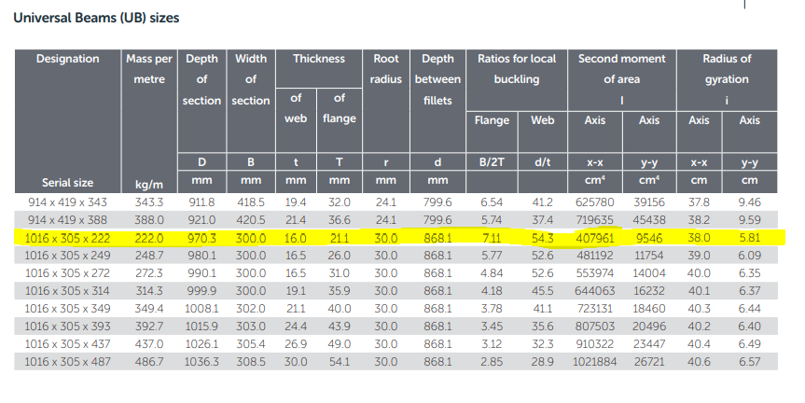

This design load of 50kN with a Factor of safety 1.1 should be able to safely support 55kN. This additional factor of safety requirement is the reason for selecting the beam section above. The ability to adapt the crane to other application which require a larger section for strength.

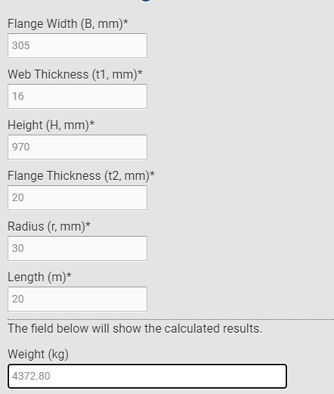
Figure 3- Weight calculator
Using analysis tools, the proposed values were inputted to visualise the deflections calculated.
By choosing 10 meters for the first calculation this resulted in a deflection of just 1.2mm

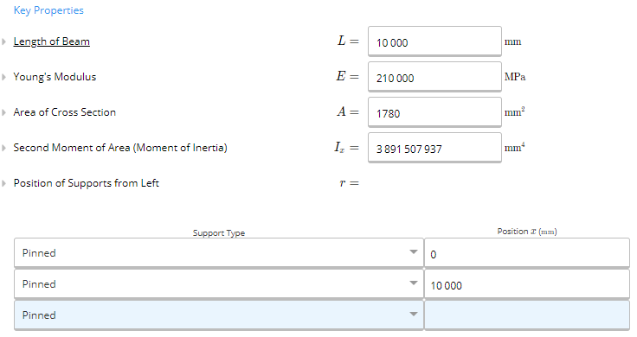
Figure 4 - 10M beam calculations

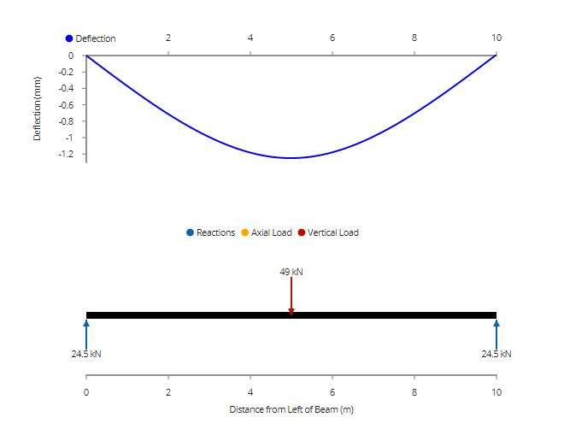
Figure 5- Deflection diagram
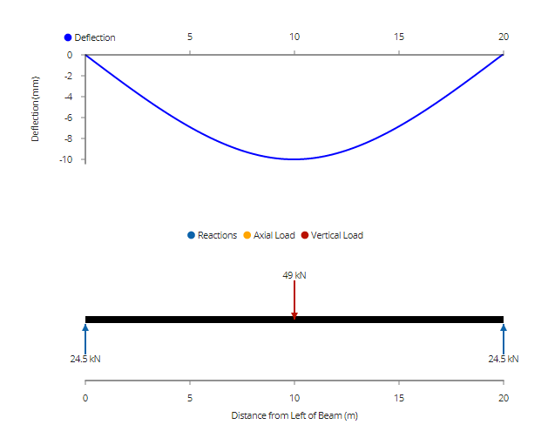
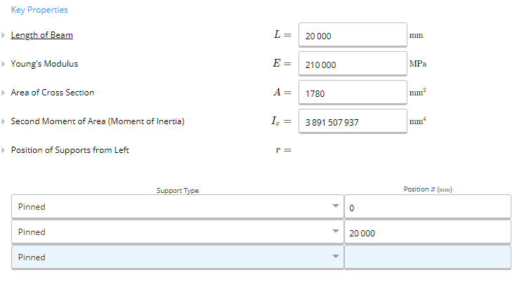
The desired max deflection of 10mm was achieved with a beam length of 20M
Figure 6 - Deflection diagram
Figure 7 - 20M Beam calculations

2. Assumptions made in calculations

The calculations performed give a formula in which for any given value of L the second moment of area I can be calculated.
It is also important to understand there are several factors for the real-world application of the numbers derived from the calculations.
Assumptions as follows:
- E & I are not functions of x therefore do not change along the length of the beam. So, for any given point of X values of E & I are constant.
- The origin is considered as the CenterPoint of the beam length. Although readings can be taken from any position of (X) along the beam it is known that the maximum deflection (y) occurs when (X) = 0 [9]
- Only the weight / force acting of the load being lifted has been taken into consideration. The additional weight of the crab assembly (trolley frame, hoist and counterweight etc) have not been used in the calculations.
- The properties of the beam are subject to manufacturing tolerances as per BS 5950-1:2000 later superseded by BS EN 1993-6:2007 Eurocode 3. Design of steel structures. Part 6 Crane supporting structures
  - 3.2.5 Structural steel Tolerances [1]
- It was also assumed that the idler and drive wheels are free from any slip or rotational friction forces.
  - Maximum force exerted on the wheels arises when the crab assembly is at the far left or far right position.
- The measurement of the load action on the Centrepoint of the bridge girder is taken as a static load free from vibration or swing which would translate into a transverse force through the idler and drive wheels.
- The environment is free from ambient or process induced temperature fluctuations.

3. Strain gauge development

The origin of the strain gauge dates to 1938 when it was invented by Professor Arthur Ruge
to assist his graduate with their investigations into earthquake stress on elevated water tanks. The gauge comprised of a wire of high resistance bent into a zigzag and glued to hold this form. When affixed to a test area a movement of the surface under stress resulted in a change in the resistance of the circuit.
This simple concept has since been utilised in a vast array of commercial and industrial applications. From weighing scales to industrial cranes. [2]
The strain gauge continued development throughout the 1900s. In the 1970s the first use of a silicone semiconductor was seen in gauges developed for the automotive industry, taking advantage of the piezoresistive properties of silicone. The electrical resistivity of the semiconductor changes when a mechanical strain is applied to it. [10]
This development resulted in a smaller size gauge at a reduced cost. Further benefits of the semiconductor gauge are an increased sensitivity and gauge factors, with better elastic properties. However, there are limitations, these types of gauge are more sensitive to changes in temperature – this thermal output signal emitted is termed apparent strain – it is important to note that this output is separate from the mechanical load on the material being monitored.
There are strain gauge designs which act to mitigate this thermal output by compensating for the thermal expansion coefficient of the material – these are said to have a matched temperature response.
A further disadvantage is the non-linear resistance to stain relationship. A 10-20% deviation from the straight-line equation is not uncommon. These limitations can also be mitigated through use of computer-controlled instrumentation. [3]
These fluctuations in temperature can be the output of a process or just changes in the ambient measuring environment.

3.1 Different configurations of strain gauges

One of the core specifications of a strain gauge is the gauge factor (GF). This is the change in resistance measured proportionally to the change in strain measured by length changes.
The average GF for metal-based gauges is circa 2 but the specific value can be obtained from the specification supplied by the manufacturer.
Small changes in length translate to very small measurable resistance changes so for the strain sensor a reading to be accurate the device needs to be capable of measuring these tiny changes in resistance. Strain gauges use a Wheatstone bridge layout as shown below in fig 8.
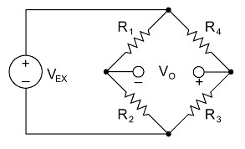
Figure 8- Wheatstone bridge
The three varying formations of strain gauges are quarter-bridge, half-bridge and full-bridge. These being defined through the positioning / type of strain being measured and the configuration of the Wheatstone bridge.[4]
3.1.1 Quarter-bridge
This is used for the measurement of Axial or bending strains, it requires both a quarter and a half bridge dummy / completion resistor to complete the Wheatstone bridge circuit.
There are two different types of strain gauge configurations.
Type 1 - consists of a single active strain gauge affixed to the material being measured in the same direction as the principle stress or strain. The accuracy of this type can be negatively impacted through temperature variations.
Type 2 – In addition to the above it also contains a passive strain gauge which is not affixed to material but should be mounted in close thermal contact to it. Commonly mounted perpendicular to the principle stress or strain. This in effect compensates for fluctuations in temperature, to produce more reliable readings.
3.1.2 Half bridge
By utilising both strain gauges in an active half bridge configuration this doubles the strain sensitivity of the bridge.
Type 1 – again used to measure axial or bending strains. Only requires a half bridge dummy / completion resistor in order to complete the circuit. It should be noted that R3 in fig 8 in this configuration acts to compensate for the effect of Poisson’s ratio (the measure of deformation of a material perpendicular to the applied force direction) [4]
Type 2 – Also requires a half bridge / dummy completion resistor. R4 in this configuration is actively measuring tensile strains. Whereas R3 in measures the compressive strains.
3.1.3 Full bridge
All 3 variations take account of temperature fluctuations with a view to lessen the effects.
Type 1 – bending strain
Type 2 – bending strain
Type 3 – axial strain
Only Type 2 & Type 3 act to compensate the effects of Poisson’s ratio. Which is the ratio of expansion and compression of a material’s dimensional properties under an applied strain.
The most widely used type of strain gauge is electrical resistance introduce in 1939 by Ruge and Simmons. An example of which is shown in Fig 9, this common construction uses a thin formed section of foil or wire to increase the surface area of the gauge, this is sandwiched between a backing layer and a laminate layer. The gauge is then affixed to the substrate to be assessed to ensure a translation of the strain from the component to the gauge – the resistance output of which is fed to instrumentation to analyse the stress.
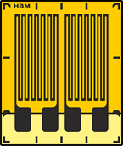
Figure 9- Typical strain gauge

There are various aspects to be considered when choosing a strain gauge- physically the size of the grid relates to the material being monitored. Shorter grids are more suited at defining the gradient of a strain and the extreme notch stresses – linked to the fatigue of welded joints. [5]Larger grids which translates to a larger surface area act to increase the gauges fatigue lifecycle.

3.2 Different types of strain gauge

There are various geometries of strain gauges available with some suited better for different stresses and principle directions. The simple linear strain gauge consists of a single measuring grid which can only measure the strain of a single direction. By altering the number of grids and the angular arrangement a strain gauge can be utilised for a specific measuring application, these gauges are termed rosettes and are used for tension and biaxial stress, when the direction of the principle stress are known.
By arranging two linear grids in parallel the bending of beams can be measured.

3.3 Future developments

Recent development into the use of Fibre optics for rosette strain sensors just like the proportional relationship a metal foil strain gauge shows, a section of optical fibre (Fibre Bragg grating) FBG which is modified to produce a wavelength to measure a change when subjected to a strain. The process to create this produces a length of optic cable which is capable of sensing hundreds of strain measurements. [12]
Further advancements in strain measuring technology with an aim of increasing versatility without the need to sacrifice the range and sensitivity can be seen from MA O’Mara et al [6] and the development of Two-dimensional layered materials (2DLMs) Conductive graphene nanosheets [7] These types of strain sensors could have wider applications in fields of biomechanics.

4 Strain gauge placement
There are various critical points on this crane which need to be monitored with strain gauges for advanced warning of overweight lifts and to conduct analysis on the effects of long-term fatigue. [8]
Firstly to ensure that the item being lifted does not exceed the limits of the lifting equipment a load cell could be attached to the lifting hook – this is a digital indicator which gives a readout of the weight and can read up to 300 tonnes. These devices include a strain gauge which measures the force required to produce distortion in the load pin.
The best choice for measuring the stresses in the beams are double linear strain gauges which when affixed to the structure can monitor the stresses and strains being applied at key points during operation.

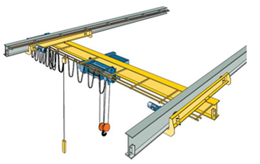
L1.1
G2.1

G2.2

G2.3

G2.4

G1.4

G1.3

G1.2

G1.1
Figure 10- Positioning of strain gauges
L1 = Load cell connecting the load pin and the lifting hook
G1.1 -G1.4 & G2.1 – G2.4 = Double linear gauges across the top and bottom surface of the runway beams.
G3.1 & G3.2 – Double linear gauges
It is important to consider Euler–Bernoulli bending theory. Which states that the maximum tensile strain is at the top (or bottom) surface of the beam. It also states there is zero tensile strain in the centroid of the cross section (neutral axis) a simply supported beam like this would experience a compression of the top surface and a tension on the bottom surface. Therefore, these key positions of strain require gauges affixed to monitor the stresses exhibited.
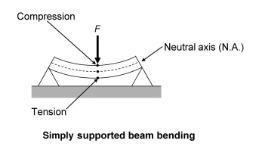
Figure 11- Beam diagram forces

In order to monitor this then the first gauges will be placed at equidistance points along the runway beams on the top and the bottom surfaces to compare the compressive and the tensile loads.
Arrows pointing towards each other show the compressive forces
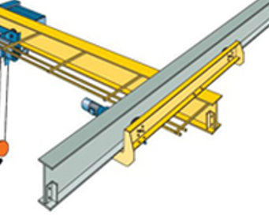
Figure 12 - Compressive stress direction
Figure 13- Tensile stress direction
Arrows pointing away from each other show the tensile forces, these forces acting on the bottom surface of the beam.

Position of gauges on the bridge girder to monitor the forces in the bending moments along the length of the girder at X position
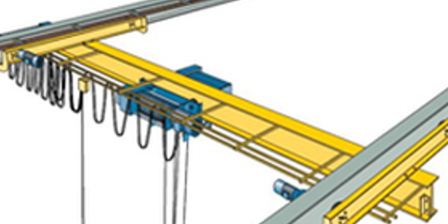
Figure 14 - Position of strain gauges on girder

G3.2
G3.1

These gauges can all be connected to a strain indicator and recorded such as the Model P3 Strain Indicator and Recorder from Vishay precision group [13] which can take readings from all configurations of strain gauges simultaneously. These devices are also capable of recording and storing readings on removal flash memorable. These reading can be taken 1 per channel per sec taken at specified time stamps. So long-term fatigue can be monitored.
It is important to note that the gauges and recorder systems must be calibrated correct to avoid any erroneous readings.
The application of strain gauges to an EOT crane is of utmost importance for safe and reliable operational monitoring.

References

[1] | “Eurocode 3 - Design of Steel Structures - Part 6_ Crane Supporting Structures,” Scribd.com. [Online]. Available: https://www.scribd.com/document/328256627/Eurocode-3-Design-of-Steel-Structures-Part-6-Crane-Supporting-Structures. [Accessed: 23-Apr-2021].
[2] | “Invention of the strain gauge, Arthur Ruge, 1938,” Mit.edu. [Online]. Available: http://museum.mit.edu/150/82. [Accessed: 23-Apr-2021].
[3] | Omega.co.uk. [Online]. Available: https://www.omega.co.uk/literature/transactions/volume3/strain.htML. [Accessed: 23-Apr-2021].
[4] | K. E. Evans, “Poisson’s Ratio,” in Polymer Science and Technology Series, Dordrecht: Springer Netherlands, 1999, pp. 183–186.
[5] | C. M. Sonsino, W. Fricke, F. de Bruyne, A. Hoppe, A. Ahmadi, and G. Zhang, “Notch stress concepts for the fatigue assessment of welded joints – Background and applications,” Int. J. Fatigue, vol. 34, no. 1, pp. 2–16, 2012.
[6] | N. Author, “Graphene-based strain sensor can detect a feather’s touch – Physics World,” Physicsworld.com, 16-Jun-2020. [Online]. Available: https://physicsworld.com/a/graphene-based-strain-sensor-can-detect-a-feathers-touch/. [Accessed: 23-Apr-2021].
[7] | K. Manna, L. Wang, K. J. Loh, and W. Chiang, “Printed strain sensors using graphene nanosheets prepared by water‐assisted liquid phase exfoliation,” Adv. Mater. Interfaces, vol. 6, no. 9, p. 1900034, 2019.
[8] | P. Frankovský, I. Delyová, P. Sivák, P. Kurylo, E. Pivarčiová, and V. Neumann, “Experimental assessment of time-limited operation and rectification of a bridge crane,” Materials (Basel), vol. 13, no. 12, p. 2708, 2020.
[9] | E. J. Hearn, Mechanics of materials volume 1: An introduction to the mechanics of elastic and plastic deformation of solids and structural materials, 3rd ed. Oxford, England: Butterworth-Heinemann, 1997.
[10] | J. Langham Thompson Ltd., “Semiconductor strain gauges,” J. Sci. Instrum., vol. 40, no. 5, pp. 267–267, 1963.
[11] | L. M. Wyatt, V. Coveney, C. Riddiford, and R. Sharpe, “Materials, properties and selection,” in Mechanical Engineer’s Reference Book, Elsevier, 1994, pp. 7-1-7–180.
[12] | “NASA Technical Reports Server (NTRS),” Nasa.gov. [Online]. Available: https://ntrs.nasa.gov/citations/20160001627. [Accessed: 23-Apr-2021].
  [13] | Vishaypg.com. [Online]. Available: http://www.vishaypg.com/docs/50002/50002.pdf. [Accessed: 23-Apr-2021].

Figure 1 - Diagram of EOT components 4
Figure 2 - I beam dimension https://britishsteel.co.uk/media/40495/british-steel-sections-datasheets.pdf 9
Figure 3- Weight calculator https://www.machinemfg.com/h-i-beam-weight-calculator/ 10
Figure 4 - 10M beam calculations https://clearcalcs.com/freetools/beam-analysis/au 10
Figure 5- Deflection diagram 10
Figure 6 - Deflection diagram 11
Figure 7 - 20M Beam calculations 11
Figure 8- Wheatstone bridge https://ni.scene7.com/is/image/ni/wheatstone2?scl=1 13
Figure 9- Typical strain gauge https://www.hbm.com/fileadmin/mediapool/images/products/sensors/strain-gauges/y-series/sg_1-DY41-6_001.png 14
Figure 10- Positioning of strain gauges 16
Figure 11- Beam diagram forces https://www.sciencedirect.com/topics/engineering/bending-stress 16
Figure 12 - Compressive stress direction 17
Figure 13- Tensile stress direction 17
Figure 14 - Position of strain gauges on girder 18

