UNIVERSITY OF WALES Trinity St David
LONDON
CertHE Skills for the Workplace
Problem Solving and Decision Making
Lecturer: Nadeem Mirza

Oksana Mrsic (2131895)
THERM 3/GROUP 2 (WEEKEND)

Table of Contents
Executive summary 2
Introduction 3
The workplace problem 4
Situation analysis model 5
Solutions 6
The pros and cons of the solution 6
Solution implementation Plan 6
Plan for communicating with stakeholders. 7
Strategies for monitoring and reviewing. 8
Conclusion 9
References 10
Appendix. 11

Executive summary
The problem that dentists face at work is that education and practice of dental therapy are not the same all over the country. Dental professionals need to be able to identify and analyses problems quickly, come up with solutions that get to the root of the problem, and take the right steps to fix the problem. It can be used in a few steps to set up a national system for dental education: awareness, desire, knowledge, ability, and reinforcement. For a national dental education system to be put into place, it needs to be well-planned and coordinated, with everyone involved.
Some solutions include making a national system for dental education, making it easier to get dental care, and teaching people more about oral health.
SWOT analysis can be used to figure out what's going on and come up with solutions that will work.
Each solution has its pros and cons, but setting up a national system for dental education would likely have the biggest effect on making sure dental education is the same everywhere.
To deal with these problems, there needs to be a concerted effort to standardize dental therapy education. This includes setting clear requirements for licensure, scopes of practice, and continuing education.
Monitoring and reviewing can be done with the help of key performance indicators, surveys, and ways to get feedback (Mcclelland, 1988).
The most important information in this text is that it is important to address the concerns of dental organizations and dentists and work together to integrate dental therapy into the oral health care system.
The ADKAR model is a change management tool that helps people and organizations understand and deal with change.
Monitoring and reviewing the structure on a regular basis can help find places where it could be better and make sure it lasts long enough to change with the needs of the dental industry (Straus, 2002).

Introduction
Problem solving is a step-by-step process that involves defining the problem and looking for information. The goal of solving a problem is to find and use an alternative, usually to a problem that is clear and well-structured. Critical thinking is a more general term for reasoning that can lead to an endless number of answers.
The process of critical thinking involves putting together a situation and showing why a solution makes sense.
Critical thinking and problem-solving have also usually been thought of as belonging to different fields. Critical thinking comes from the field of behavioural science, while problem-solving comes from maths and science (Belton and Stewart, 2003). Even though there is a difference between critical thinking and problem-solving, the two terms are often used interchangeably in real life. Also, tests often cover the same ground or measure both skills.
Problem-solving is defined as recognizing the issue, being able to get background information, coming up with possible solutions, identifying and assessing the method, and showing problem-solving attitudes. It's easy to get stuck in the same old ways of thinking rather than coming up with new ideas (Ziegenfuss, 2002).
Qualified dental team members offer different types of oral health care. Problem-solving skills are crucial in any organization, including dental practices. Dental professionals are responsible for providing basic preventive and restorative treatments and may encounter various challenges and problems during their work. These challenges include patient emergencies, difficult cases, technical issues, and interpersonal conflicts. Effective problem-solving skills enable dental professionals to identify and analyze problems quickly, develop solutions that address the root cause of the problem, and take appropriate action to resolve the issue. This helps to ensure that patients receive high-quality care and that the practice runs smoothly. Furthermore, effective problem-solving skills can help in the workplace to enhance their professional reputation, build trust, and improve job satisfaction. Ultimately, prioritizing problem-solving skills are better equipped to provide quality care, improve outcomes, and achieve long-term success.

The workplace problem
One major problem facing dental professionals like therapists is the lack of uniformity in dental therapy education and practice across the whole country. While some practices have fully integrated dental therapists into their oral healthcare system, others have placed restrictions on their scope of practice or have not yet adopted dental therapy (Yang, Chen and Wanchek, 2017).
This lack of uniformity challenges dental therapists who may need to relocate or practice in different places. This can also limit the availability of dental therapy services in certain areas. Another challenge is the resistance from some dental organizations and dentists who may see dental therapy as a threat to their profession (Barnes et al., 2019). They might contend that dental therapists' lack of dental training and experience limits their ability to be accepted and integrated into the oral healthcare organization.
Furthermore, dental therapy may not be a comprehensive solution to improving oral healthcare access and addressing disparities (Yang, Chen and Wanchek, 2017). While dental therapists can provide basic services, more specialized care may still be needed that only dentists can provide. This means dental therapy should be integrated within a larger oral health care system, including dentists and other professionals.
To overcome these challenges, there needs to be a concerted effort to standardize dental therapy education. This includes establishing clear licensure requirements, scopes of practice, and continuing education requirements. It is also important to address the concerns of dental organizations and dentists and work collaboratively to integrate dental therapy into the oral health care system (Barnes et al., 2019). Lastly, dental therapy should be integrated within a larger oral health care system, including dentists and other professionals, to ensure comprehensive and equitable access to services.
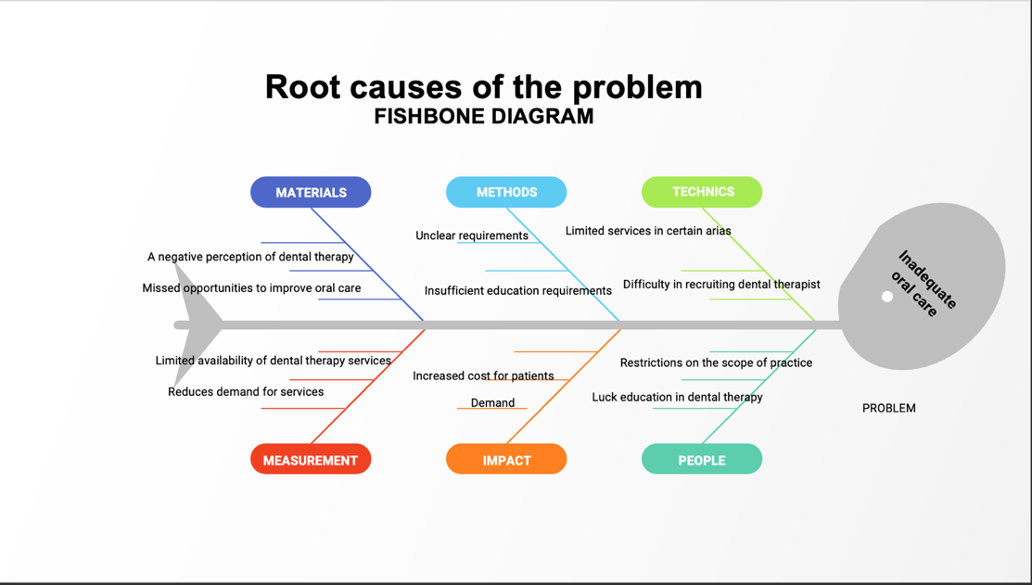
By gathering and analyzing this information, it will be possible to filter out the possible causes and identify the actual root causes of the problem. This will enable dental therapy organizations to develop targeted and effective solutions to address the issue.

Situation analysis model
SWOT analysis identifies and assesses threats associated with an organization, project, business plan, activity, strengths, weaknesses, and opportunities. An example of how SWOT analysis could be used to analyze the situation caused by the problem is:
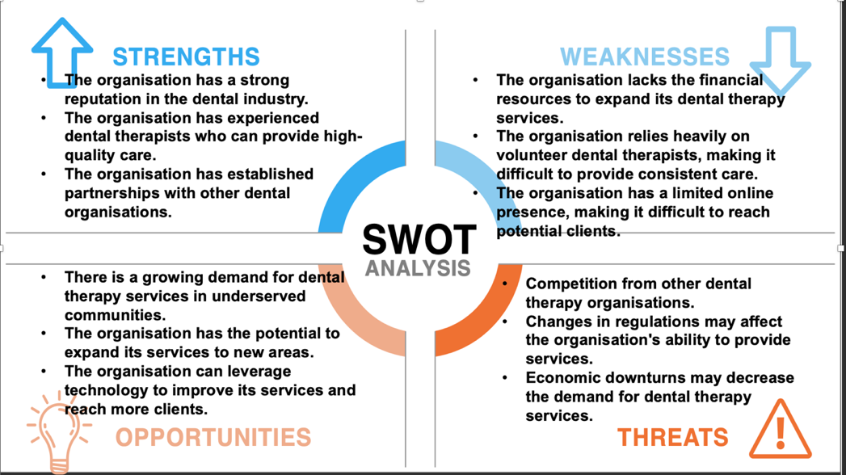

Solutions
- Establishing a national dental education system: A national dental education system could help to ensure that all dental practitioners are adequately trained and that there is uniformity in dental education and practice across the country.
- It is essential to improving dental health outcomes. This could be accomplished by expanding coverage to include dental care and increasing funding for community health centres.
- Improving oral health literacy is essential to ensure that individuals know the importance of dental care and how to access it. This could be accomplished by providing educational materials and resources.

The pros and cons of the solution
The three solutions proposed above to solve the problem of lack of uniformity in dental education and practice in dental therapy are all viable options, but each has pros and cons.
- Establishing a National Dental Education System: The main advantage of this solution is that it would ensure uniformity in dental education and practice.
- Increasing Access to Dental Care: this would ensure that more people have access to dental care, which could improve dental health outcomes.
- Improving Oral Health Literacy: The main advantage of this is that it would empower individuals to take charge of their dental health by providing them with the knowledge and resources they need to access dental care.
Based on these pros and cons, it is difficult to identify a single solution as the most appropriate. However, establishing a national dental education system would likely have the most significant impact on ensuring uniformity in dental education (England, n.d.). It would ultimately ensure that all dental practitioners are adequately trained and that there is uniformity in dental education and practice across the board.

Solution implementation Plan
ADKAR model is an alteration organization instrument that helps individuals and organizations understand and manage the change process. Awareness, Desire, Knowledge, Ability, and Reinforcement are the five stages in this model. The ADKAR model could be applied to implementing a national dental education system in the following ways:
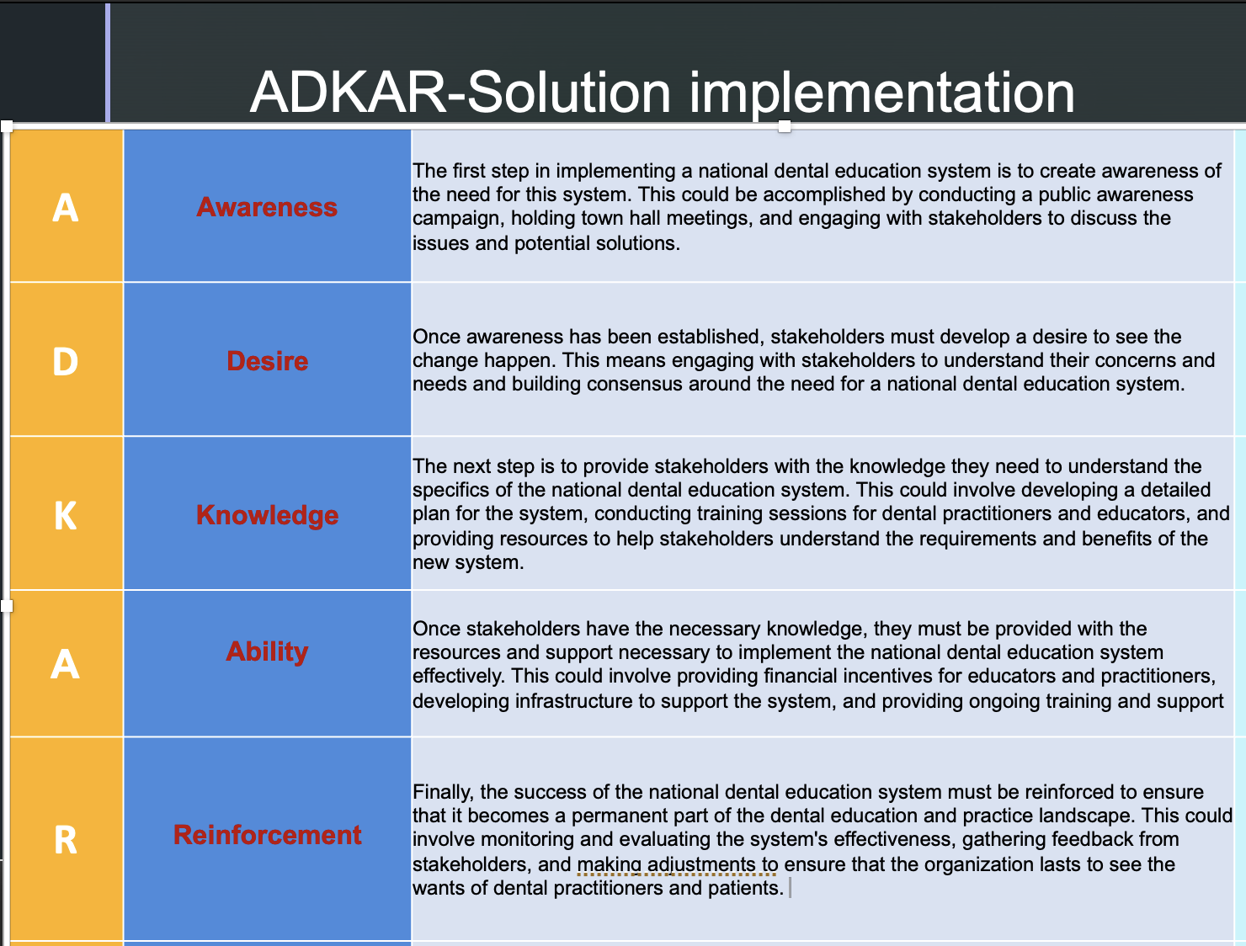
By applying the ADKAR model, stakeholders can work together to implement a national dental education system effectively and ensure that all dental practitioners are adequately trained and that there is uniformity in dental education and practice.

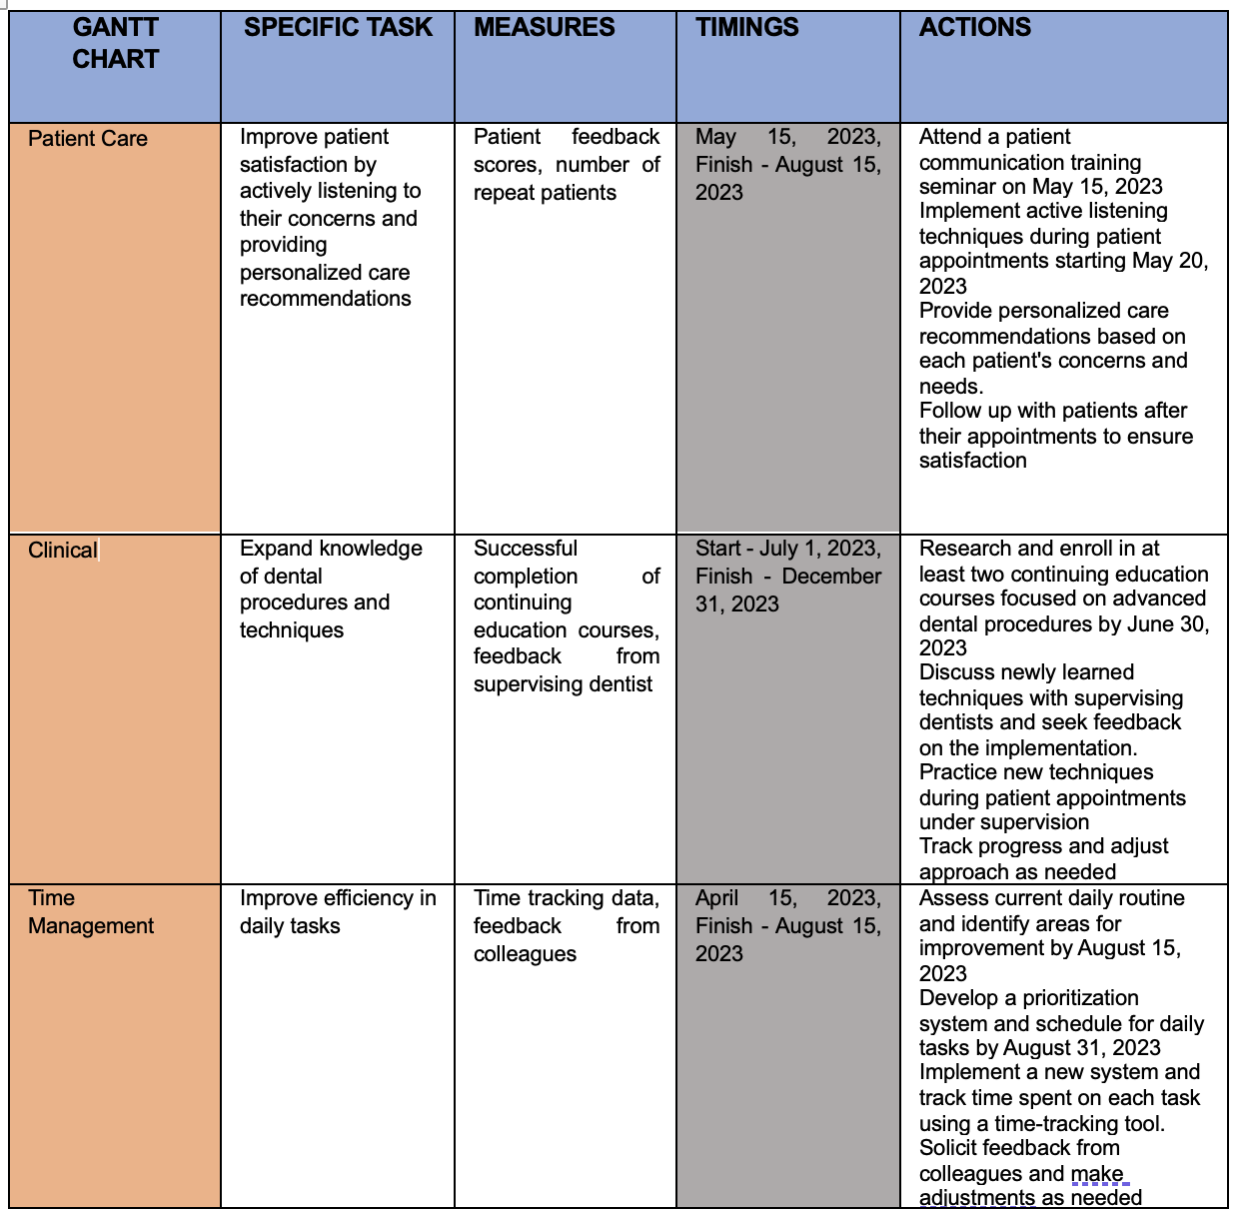

Plan for communicating with stakeholders.
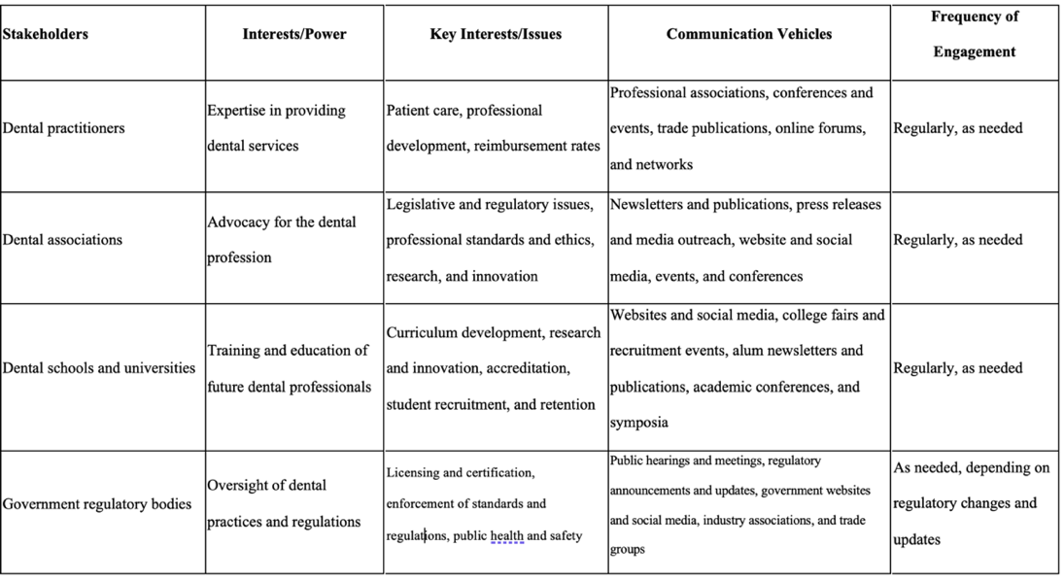
Here are some comments on each stakeholder:
- Dental practitioners: Professional associations, conferences and events, trade publications, and online forums and networks are most relevant to dental professionals. These communication channels allow them to stay up to date on industry trends, connect with peers, and share knowledge and best practices.
- Dental associations: Newsletters and publications, press releases and media outreach, website and social media, and events and conferences are most relevant to dental associations. These communication channels allow them to communicate with members and the public on key issues related to the dental industry.
- Dental schools and universities: Websites and social media, college fairs and recruitment events, alum newsletters and publications, and academic conferences and symposia are most relevant to dental schools and universities. These communication channels allow them to engage with students, and industry partners and share information on curriculum development, research and innovation, and student recruitment and retention (England, n.d.).
- Government regulatory bodies: Public hearings and meetings, regulatory announcements and updates, government websites and social media, and industry associations and trade groups are most relevant to government regulatory bodies (England, n.d.). These communication channels allow them to share updates on licensing and certification, standards and regulations, and public health and safety related to the dental industry.

Strategies for monitoring and reviewing.
Monitoring and review techniques are essential to ensure that the implementation of an education system is effective and meets its intended goals. Here are some monitoring and review techniques that could be used:
- KPIs are critical measures that provide insight into the effectiveness of a national education system.
- Surveys and feedback mechanisms: Surveys and feedback mechanisms can help to gather feedback from stakeholders about the effectiveness of the education system. Surveys could be conducted to gather feedback about the system's effectiveness. In contrast, feedback mechanisms could be established to gather feedback about the quality received.
- Data analysis: Data analysis can provide insight into the effectiveness of the education system. For example, data analysis could be used to identify trends and outcomes in different regions or among different populations, which could then be used to adjust the system as necessary.
- Peer review: Peer review can help ensure education programs meet established standards. Peer review could involve the establishment of a peer review committee to evaluate education programs and provide feedback on areas for improvement.
- Independent evaluation: Independent evaluation can objectively assess the effectiveness of the education system. Independent evaluation could involve hiring an external consultant to evaluate the system and provide recommendations for improvement.
Using these monitoring and review techniques, stakeholders can ensure that the education system is effective and meeting its intended goals. Regular monitoring and review can help to identify areas for development and guarantee that the organization continues to meet its desires.

Conclusion
In conclusion, implementing an education system requires a well-planned and coordinated effort that involves all stakeholders. The ADKAR model delivers a valuable outline for handling the alteration process while monitoring and review techniques help to ensure that the system is effective and meeting its intended goals. By creating awareness, building desire, providing knowledge, developing the ability, and reinforcing the change, stakeholders can work together to implement a national education system that meets their needs. Regular monitoring and review can help to identify areas for improvement and ensure that the structure lasts to evolve and encounter the changing requests for the workplace.

References

Barnes, E., Bullock, A., Chestnutt, I.G., Cowpe, J., Moons, K. and Warren, W. (2019). Dental therapists in general dental practice. A literature review and case‐study analysis to determine what works, why, how and in what circumstances. EuropeanJournalofDentalEducation.doi:https://doi.org/10.1111/eje.12474.
Belton, V. and Stewart, T.J. (2003). Multiple criteria decision analysis: an integrated approach. London: Kluwer.

England, N. (n.d.). NHS England» Building dental teams: Supporting the use of skill mix in NHS general dental practice – long guidance. [online] www.england.nhs.uk.Available at: https://www.england.nhs.uk/long-read/building-dental-teams-supporting-the-use-of-skill-mix-in-nhs-general-dental-practice-long-guidance/.[Accessed 2 Apr. 2023].‌

Mcclelland, D.C. (1988). Human Motivation. Cambridge: Cambridge University Press.

Practice Plan Limited. (n.d.). Solving Problems Creatively in Your Dental Practice. [online] Available at: https://onlineservices.practiceplan.co.uk/k/resource-library/strategy-and-planning/solving-problems-creatively-in-your-dental-practice[Accessed 2 Apr. 2023].

Straus, D.A. (2002). How to Make Collaboration Work. Berrett-Koehler Publishers.
‌Yang, Y.T., Chen, B. and Wanchek, T. (2017). Dental Therapists: A Solution to a Shortage of Dentists in Underserved Communities? Public Health Reports, 132(3), pp.285–288. doi:https://doi.org/10.1177/0033354917698114.
‌Ziegenfuss, J.T. (2002). Organization and management problem solving: a systems and consulting approach. Thousand Oaks: Sage Publications.

Appendix.



