Choice of international market entry and market entry strategy
Global market strategy

Jingwei You
2702297
5/3/2018

contents
Executive summary 3
1.0 introduction 3
1.1 report remit 3
1.2 background of Jordan 3
1.3 Theoretical review 3
1.3.1 High and low context culture 3
1.3.2 National culture 4
2.0 main body 5
2.1 Comparison between Jordanian and British Cultures 5
2.1.1 Power distance 5
2.1.2 Individualism 6
2.1.3 Masculinity 6
2.1.4UNCERTAINTY AVOIDANCE 7
2.1.5LONG TERM ORIENTATION 7
2.1.6 INDULGENCE 8
2.2 Other factors that should be paid attention to in business communication 8
2.2.1 Religion 8
2.2.2 Social etiquette 9
3.0 Conclusion 10
Reference 10

Executive summary
With the rapid development of the global economy, the international trade are more frequent.
Many companies face the problem of market choice and entry strategy when they enter the international market.
This paper mainly analyzes the choice of international market entry and market entry strategy by HCC company,and the results are presented to the readers.

1.0 introduction

1.1 report remit
The main objectives of this report are:
·Research which international market is suitable for HCC company
·Explore what kind of market strategy HCC companies should adopt

1.2 background of Japan
Japan is the island country located in East Asia, composed of Japanese islands, the Ryukyu Islands and Ogasawara Islands 6852 Izu Islands, an area of about 378 thousand square kilometers. The land is surrounded by sea and throughout the Pacific Rim, west of the Korean Peninsula and northeast Chinese, north of Kamchatka Peninsula, southwest of Taiwan and the eastern Chinese. The population is 126 million.(C. W. Nikoru 1940)
Japan is the third largest economy in the world. It is also a member of the group of seven and one of the advanced countries in the world. It is mainly based on the huge growth of Japanese economy after World War II. At present, Japan's scientific research ability, industrial base and manufacturing technology are among the highest in the world of [16], and is the world's fourth largest exporter and importer of [17]. In 2015, Japan's per capita GDP convertibility to nearly forty thousand dollars in accordance with international exchange rate, and the per capita national income was about thirty-seven thousand dollars. The human development index has also maintained an extremely high level of [18]. In addition, the strength of Japan in the cultural industry is also in the forefront of the world, along with the tourists attracted by this, also made considerable output value.(JapanGov, 2018)

1.3 Theoretical review

1.3.1 Pestel analysis
PESTEL analysis model, also known as "big environment analysis", is an effective tool for analyzing macroscopical environment. It can analyze not only the external environment, but also all the forces that impact the organization. It is a method to organize the investigation of exterior influencing factors, each letter represents a factor, can be divided into 6 factors: political factors, economic factors,social factors, technological factors, environmental factors and legal factors .
·Political: it refers to the political forces that have practical and potential impact on the activities of the organization and the relevant policies, laws and regulations.
·Economic: it refers to the external economic structure, industrial layout, resource status, economic development level and future economic trend.
·Social: it refers to the historical development of the members of the organization, cultural traditions, values, educational levels and customs and habits.
·Technological: technology elements include not only those inventions that cause revolutionary changes, but also the emergence and development trend and application prospects of new technologies, new processes and new materials related to the production of enterprises.
·Environmental: an element of an organization's activity, product, or service that can interact with the environment.
·Legal: an integrated system of external laws, regulations, judicial status and civic awareness of law.
(Jurevicius, O. 2013)
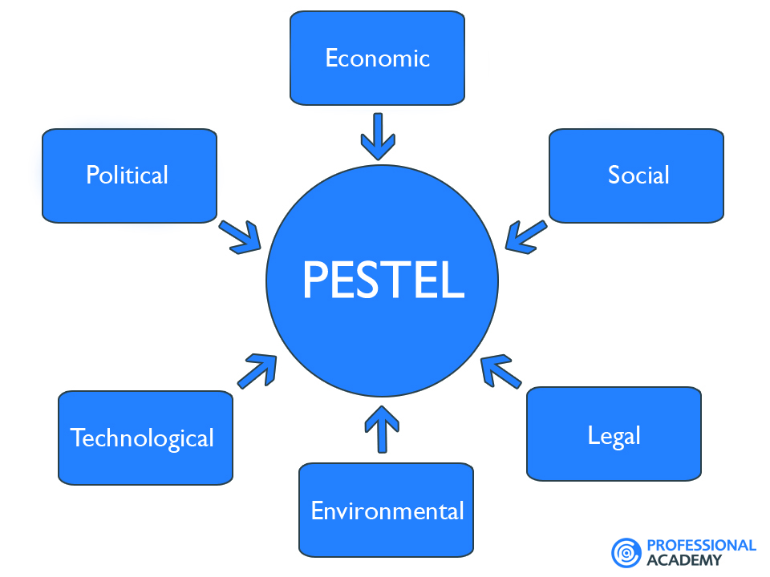
(Academy, 2018)

1.3.2 Market entry strategy theories
(1) export entry mode, including indirect export and direct export;
Indirect exports are exported through a variety of foreign trade institutions located in the country, or foreign enterprises in their own branches. The characteristic of indirect export is the separation of business internationalization and enterprise internationalization. Low risk, less investment, easy management and weak control.
Indirect export form
·Foreign agency office in the country
·Large trading company
·Various export management companies: small specialized management companies based on regional or product specialization
·The export of foreign channels and operational capabilities has been established by another export enterprise.

(2)Direct export refers to the international marketing activities of the product manufacturers with different degrees of direct participation in their export products. The manufacturer holds some or all control over the management and management of its export products.
The characteristic of direct export is that the demand of input resources is high and the risk is great.
(Michalski, E., 2015.)

- FDI
FDI is The abbreviation of Foreign Direct Investment. It means a country's investor (natural person or legal person) invested capital or other production elements across the border to acquire or control the corresponding business management right as the core, and to gain profits or scarce production factors for the purpose of investment activities.
There are three main methods of international investment, the first is direct a new multinational companies in foreign countries, which is Greenfield; second is the establishment of international joint ventures, also known as Joint Venture; the third is cross-border M&amp;A, where M&amp;A is merger&amp; acquisition.
(Alfaro, L., Chanda, A., Kalemli-Ozcan, S. and Sayek, S., 2004.)

2.0 main body

2.1 Pestel analysis of Japan market

2.1.1 Political
Japan is a monarchy. But the incumbent emperor Akihito has almost no right to speak in the political development of the country. He is a puppet - a symbol - but there are five powerful political parties in this country:
·The Democratic Party of Japan (DPJ)
·The people's Party (PNP)
·The Liberal Democratic Party (LDP)
·The Social Democratic Party (SDP)
·New clean government party (GM)
In Japan, the prime minister is elected, and the prime minister is the country's actual leader and is responsible for the country's operation. Especially in political and economic law.
Japan's politics is very stable and very clean. According to the latest corruption perceptions index report (figure below): Japan's incorruptible score is 73 points, ranking the 20 among all the countries in the world.
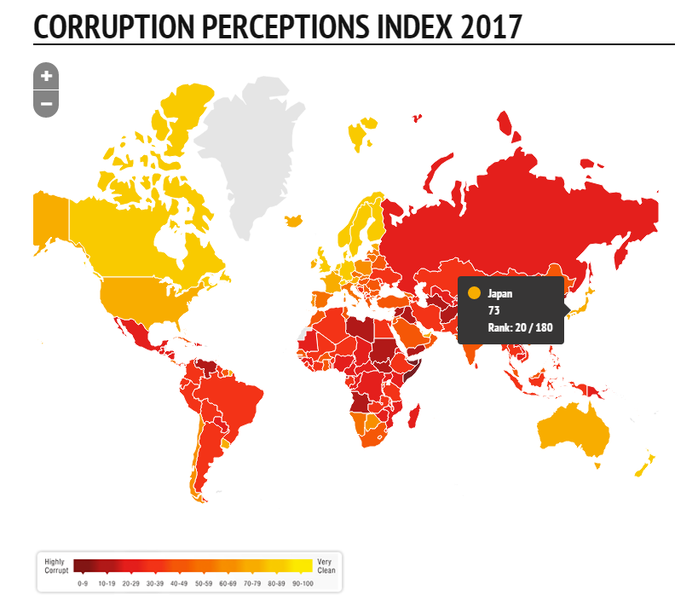
(e.V., 2018)
The stable political environment enables HCC to be assured of transnational trade. Meanwhile, honest officials can make HCC focus on trade itself, and do not need to worry about the problems beyond trade.

2.1.2 Economic
Japan's economy is strong. In fact, it is the top five in the world's largest economy. However, Japan's GDP growth rate is very low, as well as the high density of the population. Japan's unemployment rate is rising (5%). This is a very low number compared with other countries, but for the Japanese, this is very high and worrying. (Economic Outlook, Apr 2004) Generally speaking, the Japanese consumption level is high.
For HCC, Japanese consumers can easily afford the cost of buying imported lamb. So entering the Japanese market is a good choice for HCC.

2.1.3 Social
The population of Japan is now more than 127 million, and the changes in science, industry and sociology have experienced an alarming rate of growth over the past 100 years.
Japanese are very particular about diet and like to eat high quality meat. The Hokkaido area is very fond of mutton. At the same time, the livestock industry in Japan is not developed, and the local mutton production is very small, most of which rely on imports. (Insidejapantours.com, 2018)This is a golden opportunity for HCC. The HCC that entered the Japanese market did not face the pressure from its competitors.The densely populated population will bring a lot of potential customers.

2.1.4 Technological
Japan is becoming one of the leading industrial technologies. In terms of technology expenditure, Japan ranks second in the main industrialized countries, supporting its position as a technological country. By March 2008, they had 827000 researchers in the field of science and technology, and the total expenditure of research and development in 2007 amounted to 18 trillion and 900 billion yen, which is equivalent to 3.67% of Japan's gross domestic product.(Oxfordscholarship.com, 2018)

2.1.5 Environmental
The large population of Japan is concentrated around Tokyo. This is a helplessness, for most of the territory of Japan is annexed by mountains and forests. There are few territories suitable for human habitation.(SAITO, M., 1990.)
And Japan is in the region of the earthquake belt, which is easily affected by the tsunami and the earthquake. Because housing and development are closely related to the population, they will face huge risk of loss if natural disasters occur. These environmental factors restrict the development of animal husbandry in Japan, providing opportunities for HCC's export of lamb to Japan.

2.1.6 Legal
The civil code of Japan, founded in 1896, was deeply influenced by the German and French civil code and emphasized law and order rather than individual freedom. At the same time, their labour and corporate laws are based on the European system. When HCC is engaged in trade in Japan, the law they abide by is not very different from that in Britain. This is undoubtedly conducive to the operation of the company.(Encyclopedia Britannica, 2018)

2.1.7 The reason of choose Japan market
To sum up, Japan is a politically stable and economically developed country. People have enough purchasing power to pay for the price of imported mutton. At the same time, Japan has a large population, which means that the number of potential customers in the market is equally unnegligible. The special geographical environment of Japan has made the local animal husbandry underdeveloped. HCC does not have to be subject to too much market competition. At the same time the HCC don't have to let the legal Europeanization consider many legal problems, when they sale lamb in Japan.So the Japanese market is a market with great potential and great benefit. This is the reason why the author chooses the Japanese market.

2.2 Market entry strategy choice
Through the analysis of the case and the investigation of the Japanese market. The author suggests that HCC adopt an export model for indirect exports.The main reasons are the following two points:
1.Japan's trading company is very powerful
The early representative of the international trade company is the British East India Company, and the modern typical is Japan's integrated business. Japan comprehensive company funded, especially a galaxy of talents information network, extending in all directions, 24 hours to keep running. They are engaged in both internal and external trade, from marketing research to market development, from marketing, management consulting to hedging and credit in foreign exchange, from participation in manufacturing to distribution, and so on, and have made great progress in promoting the import and export trade of Japanese products. Many small and medium-sized enterprises in foreign countries, and even the products of some large enterprises, have entered the Japanese market through them. They control nearly 60% of Japan's foreign trade.So the choice of Japan's international trading companies can reduce the risk of market entry. With the help of their help, HCC can enter the Japanese market without pressure.
2. quickly open the market
In the case, HCC has temporarily lost the European market because of Britain's removal from Europe. This means that 93% of HCC's mutton products are in urgent need of a buyer. HCC has no time to waste, although direct exports can be directly traded with customers, without the cost of intermediate links, and not restricted by middlemen.( ) But it will take a lot of time. HCC's mutton will become not fresh and affect the quality of the product. This is unacceptable to HCC.
By means of indirect export, HCC can borrow the quality channels of the Japanese international trade company and understand the consumer. This can help HCC quickly build brand image in the hearts of Japanese consumers and sell the mutton to them.

3.0 Conclusion
To sum up, the author believes that HCC company can choose to enter the Japanese market. This is a market with great potential and weak competition. HCC is likely to get a huge profit here. On the other hand, if HCC chooses to enter the Japanese market, the author suggests that HCC adopt an export model of indirect exports. Cooperate with Japan's international trade company to open up the Japanese market.

Reference
Academy, P. (2018). Marketing Theories - PESTEL Analysis. [online] Professionalacademy.com. Available at: https://www.professionalacademy.com.

Jurevicius, O., 2013. Pest & pestel analysis. Strategic Management Insight, 13, p.2013.

Michalski, E., 2015. Foreign market entry strategy. Acta Scientiarum Polonorum. Oeconomia, 14(2).

Alfaro, L., Chanda, A., Kalemli-Ozcan, S. and Sayek, S., 2004. FDI and economic growth: the role of local financial markets. Journal of international economics, 64(1), pp.89-112.

C. W. Nikoru 1940-
1st ed. Tokyo ; New York ; London : Kodansha International 1997

JapanGov. (2018). The Government of Japan - JapanGov. [online] Available at: https://www.japan.go.jp.

e.V., T. (2018). Corruption Perceptions Index 2017. [online] www.transparency.org. Available at: https://www.transparency.org/news/feature/corruption_perceptions_index_2017.

Economic Outlook, Apr 2004, Vol.28(3), pp.34-35 [Peer Reviewed Journal]

Insidejapantours.com. (2018). Social conventions - Japanese Culture | Inside Japan Tours. [online] Available at: https://www.insidejapantours.com/japanese-culture/social-conventions.

Oxfordscholarship.com. (2018). Technology and Industrial Development in Japan: Building Capabilities by Learning, Innovation and Public Policy - Oxford Scholarship. [online] Available at: http://www.oxfordscholarship.com/view/10.1093/acprof:oso/9780198288022.001.0001/acprof-9780198288022 .

SAITO, M., 1990. Production of enterotoxin by Clostridium perfringens derived from humans, animals, foods, and the natural environment in Japan. Journal of food protection,53(2), pp.115-118.

Encyclopedia Britannica. (2018). Japanese law. [online] Available at: https://www.britannica.com/topic/Japanese-law
.

