Essential Academic and Employment Skills for a Data and Business Analyst

A successful career as a Data and Business Analyst requires a combination of technical, analytical, and professional skills. During higher education, students develop academic skills such as research, critical thinking, report writing, problem-solving, and data interpretation. These skills are highly valued by employers because they support evidence-based decision-making and effective communication of business insights [1].

 Data Analysis, 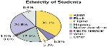 Statistical Skills,  Communication skills,
This Photo by Unknown Author is licensed under CC BY-SA
This Photo by Unknown Author is licensed under CC BY
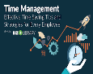 Time Management,  Technical Skills,  Teamwork
This Photo by Unknown Author is licensed under CC BY-SA-NC
Figure 1. Key Skills for Data and Business Analysts

Technical proficiency is particularly important in data analytics. Analysts must be able to collect, clean, analyse, and visualise data using software tools and programming languages. According to Davenport and Harris, organisations increasingly rely on analytical capabilities to gain competitive advantages through informed decision-making [2].
Communication skills are equally essential. Data analysts must explain complex findings to managers and stakeholders who may not have technical knowledge. Strong presentation and report-writing abilities ensure that analytical insights can be understood and applied effectively [3].
The development of these skills during university will directly support my career after graduation. Academic research skills will help me evaluate data sources critically, while teamwork and communication skills will enable collaboration with colleagues across different departments. Furthermore, technical skills such as data visualisation, database management, and statistical analysis will allow me to identify trends and provide recommendations that improve organisational performance [4].
Artificial Intelligence (AI) tools can also support professional development by assisting with data analysis, coding, and information gathering. However, analysts must apply critical thinking to verify AI-generated outputs and ensure accuracy [5].
Overall, continuous development of analytical, technical, and interpersonal skills will enhance employability and prepare me for a successful career as a Data and Business Analyst.

DATA & BUSINESS ANALYST

Technical Skills Analytical Skills Professional Skills

Excel Critical Thinking Communication
SQL Research Skills Leadership
Python Problem Solving Teamwork
Power BI Data Interpretation Management

Fig 2: Data and Business Analyst Skill Set Created by Vivian Nnadozie
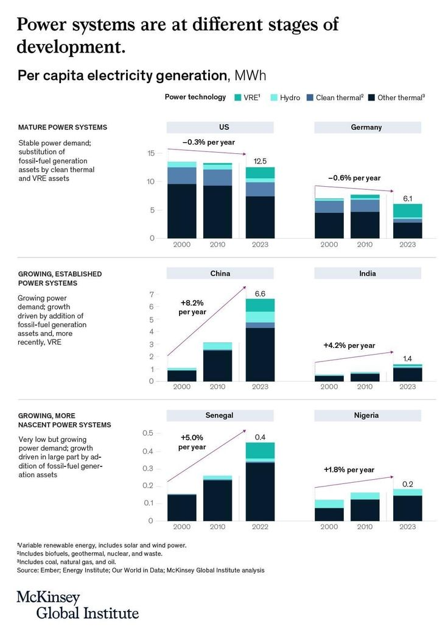
Fig 3: infographic From IBM Database for Power systems at different stages of development created by McKinsey Global Institute

References
[1] J. Cottrell, The Study Skills Handbook, 5th ed. London, UK: Red Globe Press, 2019.
[2] T. H. Davenport and J. G. Harris, Competing on Analytics: The New Science of Winning. Boston, MA, USA: Harvard Business School Press, 2007.
[3] M. A. Herschel and V. M. Miori, “Skills needed for business analytics professionals,” Journal of Business Analytics, vol. 3, no. 2, pp. 115–128, 2020.
[4] IBM, “What is a Business Analyst?”, 2024. [Online]. Available: https://www.ibm.com/topics/business-analyst. [Accessed: 22-Jun-2026].

Figures

Fig 1: Key Skills for Data and Business Analysts

Fig 2: Data and Business Analyst Skill Set Created by Vivian Nnadozie

Fig 3: Mckinsey Global Institute “Power systems are at different stages of development”,. Forbes Accessed 22nd of June 2026 [Online] at https://www.pinterest.com/pin/ibm-data-infographic--209065607695958314/

