Appendix One: Observation Form (with criteria)

Lesson: _____________ | Group One  Present: __ / 8 | Group Two  Present: __ / 8 | Group Three  Present: __ / 8 | Group Four  Present: __ / 7
Frequency of verbal participation.
Frequency of non-verbal participation.
Frequency of using classroom Welsh resources.
Frequency of using the Welsh language.
Criteria:
Frequency of verbal participation:
- Asking and/or answering relevant questions about Welsh.
- Contributing to verbal discussions on the Welsh topic.
Frequency of non-verbal participation:
- Hands up to ask and/or answer a relevant question about Welsh, but does not get picked to share their thought.
- Display of engaged body language (nodding in response instead of verbally responding, engaged eye contact with those speaking about Welsh, etc).
Frequency of using classroom Welsh resources:
- Getting up to gather Welsh resources to support their learning.
- Identifying and using the Welsh displays on the walls to support their learning.
Frequency of using the Welsh language:
- Asking and/or answering questions in Welsh.
- Writing Welsh words and phrases (1 = word, 2 = phrase).
- Saing Welsh words or phrases (1 = word, 2 = phrase).

Appendix Two: Questionnaire (with results)

- Do you enjoy learning the Welsh language?
- Do you attend Welsh club?
- Do you use Welsh outside of school with family or friends?
- Do you think it’s important to use Welsh outside of the classroom?
- Should Helpwr Heddiw sessions be longer?
- Do you think there are enough Welsh displays around the classroom to help you learn Welsh?
- Do you think there are enough Welsh displays around school to help you learn Welsh?
- Should we have more special Welsh days in school?
- Would you like to learn more about Welsh traditions and culture?
- In your honest opinion what are three words you would use to describe learning Welsh in school?

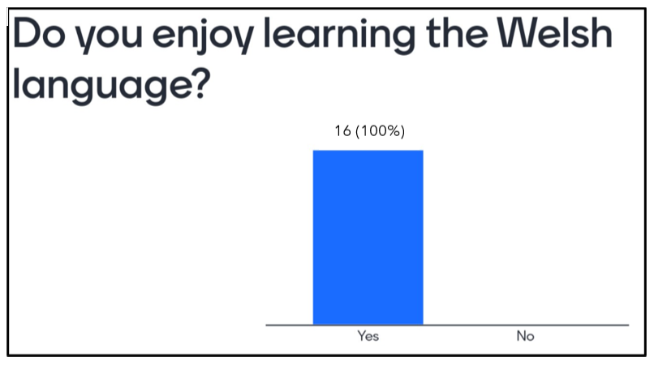
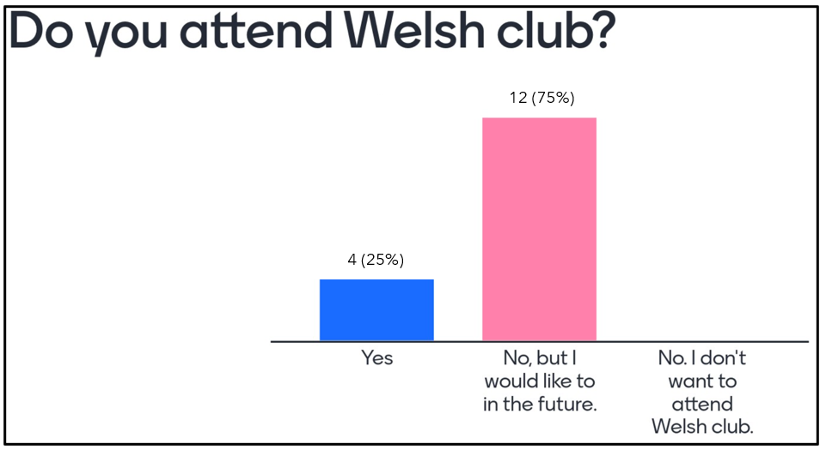
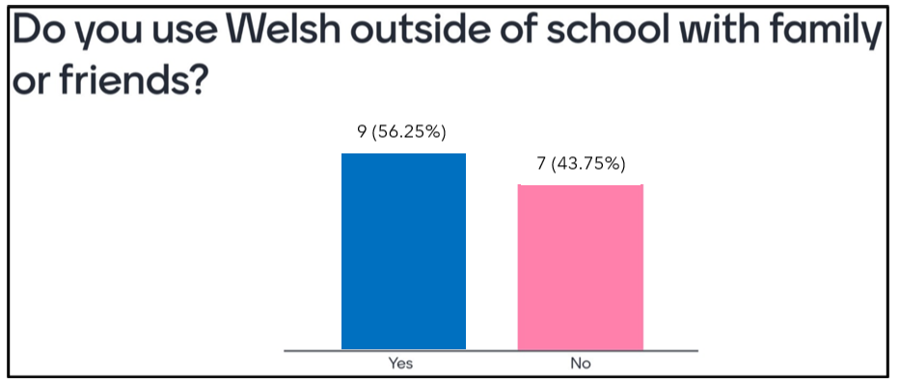
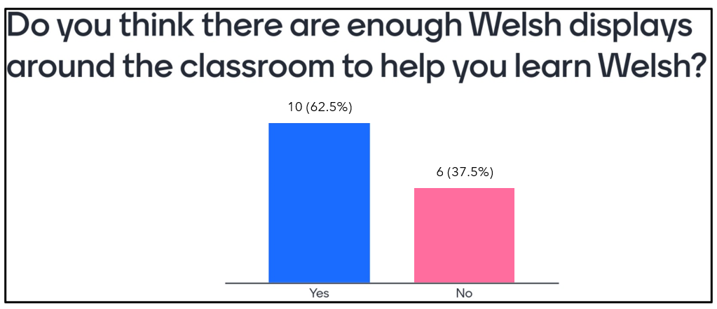
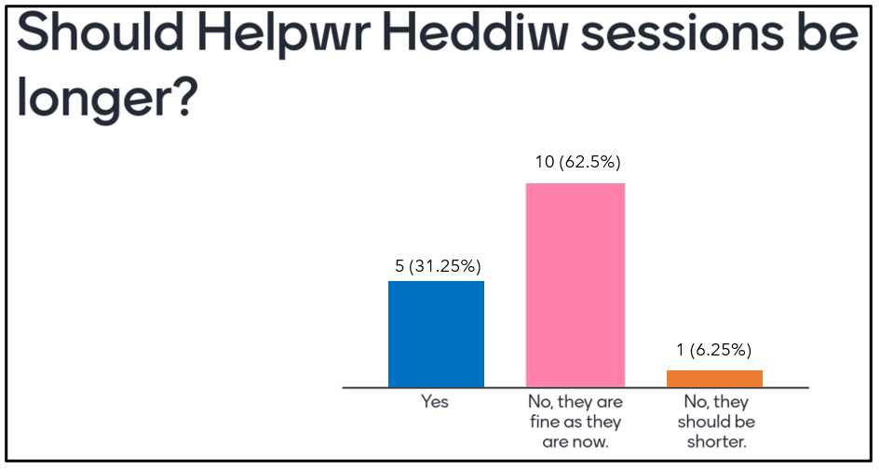
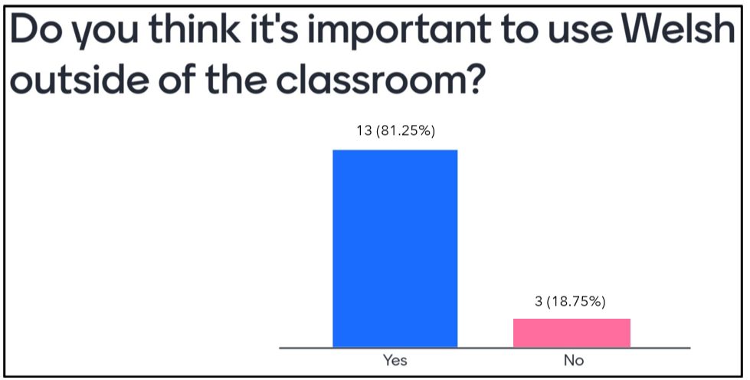
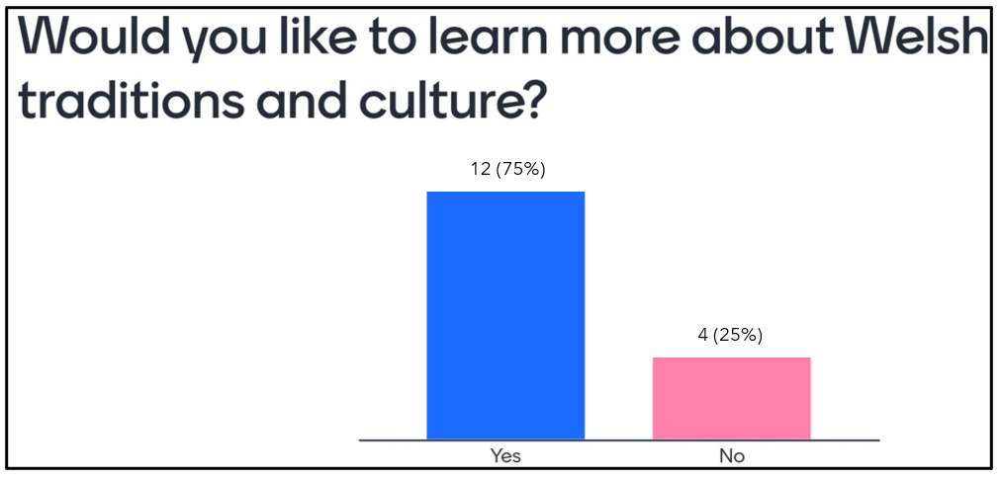
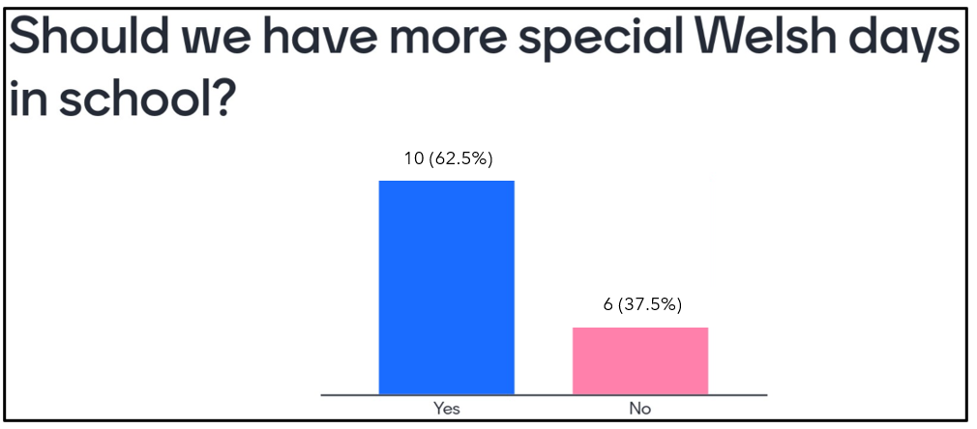
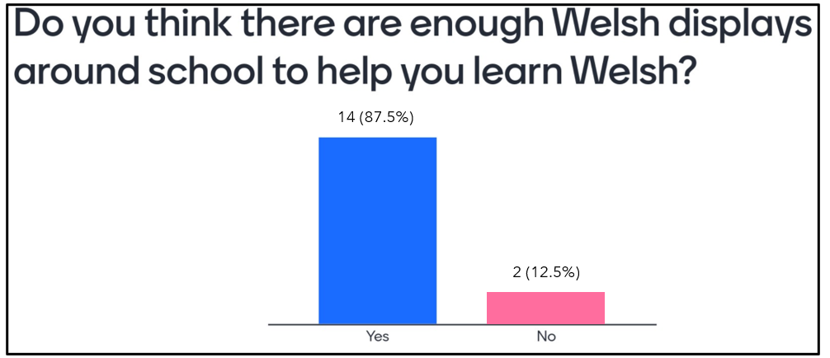
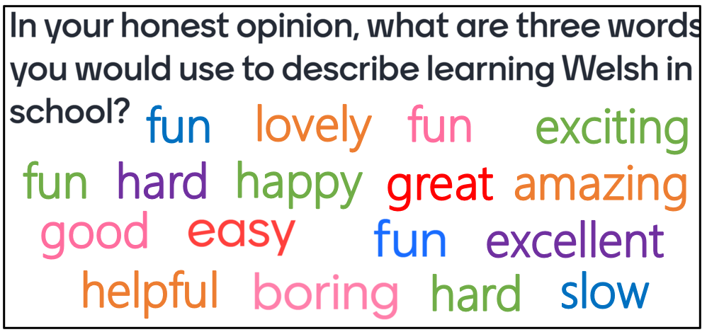
Appendix Three: Interview Questions

- Do you like learning Welsh? Why? Why not?

- Do you think there are any benefits to learning Welsh? Why? Why not?

- What have you enjoyed the most about learning Welsh so far in Year 2?

- What would you like to learn in Welsh? A certain theme, topic, interest?

- How can Welsh sessions become more enjoyable and interesting for you? Do you prefer learning in a certain way – through games, songs, videos, writing, reading, speaking?

- Can you suggest a way to encourage pupils to use (more) Welsh in school?

Appendix Four: Consent Form

Dear Parent / Guardian,
My name is Joanna Bonney and I am studying for a Primary PGCE qualification at University of Wales Trinity Saint David. I am currently a student teacher at [School A] and am teaching in your child’s class.
As part of my university module, I must conduct a research project within my placement school. I would like to invite your child to participate in my research project. The title of the project is ‘What are the attitudes held by Year 2 pupils towards the Welsh language, in the context of classroom engagement?’. The aim of this project is to identify the pupil’s honest opinions of the Welsh language and to discover how pupils best prefer learning the language. Through your child’s participation, I hope to ascertain the greatest methods for encouraging student engagement in learning the Welsh language.
Through a mixture of observations, questionnaires and interviews, I will be able to draw a valid conclusion. All data will be recorded and stored on my password-protected university laptop. All names will be kept strictly confidential. Your child’s participation in this study is completely voluntary so you or your child can withdraw from the study at any stage, along with any data being permanently deleted and removed from the research project. Your child will also be asked to give their assent before the beginning of the study.

After careful and precise analysis of the data obtained from the observations, questionnaires and interviews, I would be happy to provide you with a copy of the findings at your request. The results of the research will be discussed in a university assignment that will contribute to my PGCE degree. Once I have analysed the data and the assignment has been marked, all of the data will be destroyed.
If you are happy for your child to participate in this research project, please fill in the consent form on the back of this letter. I thank you in advance for your time. If any questions do arise, feel free to contact me at your convenience.
Yours sincerely,
Joanna Bonney 16th April 2024

Consent Form
Research Question: What are the attitudes held by Year 2 pupils towards the Welsh language, in the context of classroom engagement?
Name of Researcher: Joanna Bonney

Please initial box:
- I confirm that I have read and understand the information letter dated 16th April 2024 for the above study.
- I understand that my child’s participation is voluntary and that I am free to withdraw my child from the study at any time, without giving any reason.
- I understand that my child can choose to withdraw at any time, without giving a reason.
- I understand that the information given by my child will be used in a university assignment.
- I understand that my child’s name will not appear at any time.
- I agree for my child to take part in the above study.
Child’s name |  | Parent Signature |  | Date
When completed, please return this consent to Joanna Bonney by the 22nd of April.
Thank you.

Appendix Five: Ethics Approval Form

APPLICATION FOR ETHICAL APPROVAL

RESEARCH STUDENTS
This form is to be completed by the student within SIX months for full-time students and TWELVE months for part time students, after the commencement of the research degree or following progression to Part Two of your course.

Once complete, submit this form via the MyTSD Doctoral College Portal at (https://mytsd.uwtsd.ac.uk).

This document is also available in Welsh.

RESEARCH STAFF ONLY
All communications relating to this application during its processing must be in writing and emailed to pgresearch@uwtsd.ac.uk , with the title ‘Ethical Approval’ followed by your name.

STUDENTS ON UNDERGRADUATE OR TAUGHT MASTERS PROGRAMMES should submit this form (and receive the outcome) via systems explained to you by the supervisor/module leader.

In order for research to result in benefit and minimise risk of harm, it must be conducted ethically. A researcher may not be covered by the University’s insurance if ethical approval has not been obtained prior to commencement.

The University follows the OECD Frascati manual definition of research activity: “creative work undertaken on a systematic basis in order to increase the stock of knowledge, including knowledge of man, culture and society, and the use of this stock of knowledge to devise new applications”. As such this covers activities undertaken by members of staff, postgraduate research students, and both taught postgraduate and undergraduate students working on dissertations/projects.

The individual undertaking the research activity is known as the “principal researcher”.

Ethical approval is not required for routine audits, performance reviews, quality assurance studies, testing within normal educational requirements, and literary or artistic criticism.

Please read the notes for guidance before completing ALL sections of the form.

This form must be completed and approved prior to undertaking any research activity. Please see Checklist for details of process for different categories of application.

SECTION A: About You (Principal Researcher)
1 | Full Name: |  | Joanna Bonney
2 | Tick all boxes that apply: |  | Member of staff: | ☐ | Honorary research fellow: | ☐
 | Undergraduate Student | ☐ | Taught Postgraduate Student | ☒ | Postgraduate Research Student | ☐

3 | Institute/Academic Discipline/Centre: | Yr Athrofa
4 | Campus: | SA1 Swansea Waterfront Campus and Innovation Centre
5 | E-mail address: | 2300724@student.uwtsd.ac.uk
6 | Contact Telephone Number:
 | For students:
7 | Student Number: | 2300724
8 | Programme of Study: | PGCE Primary
9 | Director of Studies/Supervisor: | Stephen Hadley. Sonny Singh.

SECTION B: Approval for Research Activity
1 | Has the research activity received approval in principle?  (please check the Guidance Notes as to the appropriate approval process for different levels of research by different categories of individual) |  | YES | ☒ | NO | ☐
 |  |  |  |  | Date
2 | If Yes, please indicate source of approval (and date where known): Approval in principle must be obtained from the relevant source prior to seeking ethical approval | Research Degrees Committee |  | ☐
2 |  | Institute Research Committee |  | ☐
2 |  | Other (Stephen Hadley) |  | ☒ | 14/03/24

SECTION C: Internal and External Ethical Guidance Materials
 | Please list the core ethical guidance documents that have been referred to during the completion of this form (including any discipline-specific codes of research ethics, location-specific codes of research ethics, and also any specific ethical guidance relating to the proposed methodology). Please tick to confirm that your research proposal adheres to these codes and guidelines. You may add rows to this table if needed.
1 | UWTSD Research Ethics & Integrity Code of Practice | ☐
2 | UWTSD Research Data Management Policy | ☐
3 | Ethical Guidelines for Educational Research, fourth edition (2018) | ☒

SECTION D: External Collaborative Research Activity
If there are external collaborators then you should gain consent from the contact persons to share their personal data with the university. If there are no external collaborators then leave this section blank and continue to section E.
1 | Institution
2 | Contact person name
3 | Contact person e-mail address
4 | Is your research externally funded? |  | YES | ☐ | NO |  | ☐
5 | Are you in receipt of a KESS scholarship? |  | YES | ☐ | NO |  | ☐
6 | Are you specifically employed to undertake this research in either a paid or voluntary capacity? | Voluntary | YES | ☐ | NO | ☐
7 |  | Employed | YES | ☐ | NO | ☐
8 | Is the research being undertaken within an existing UWTSD Athrofa Professional Learning Partnership (APLP)? | If YES then the permission question below does not need to be answered. | YES | ☐ | NO |  | ☐
9 | Has permission to undertake the research has been provided by the partner organisation? | (If YES attach copy)  If NO the application cannot continue | YES | ☐ | NO |  | ☐

Where research activity is carried out in collaboration with an external organisation
10 | Does this organisation have its own ethics approval system? | YES | ☐ | NO | ☐
 | If Yes, please attach a copy of any final approval (or interim approval) from the organisation (this may be a copy of an email if appropriate).

SECTION E: Details of Research Activity
1 | Indicative title: | What are the attitudes held by Year 2 pupils towards the Welsh language, in the context of classroom engagement?
2 | Proposed start date: | 14/03/24 | Proposed end date: | 31/07/24
Introduction to the Research (maximum 300 words per section)
Ensure that you write for a Non-Specialist Audience when outlining your response to the points below:
- Purpose of Research Activity
- Proposed Research Question
- Aims of Research Activity
- Objectives of Research Activity
Demonstrate, briefly, how Existing Research has informed the proposed activity and explain
- What the research activity will add to the body of knowledge
- How it addresses an area of importance.
3 | Purpose of Research Activity  The purpose of the research activity is to discover the attitudes held by Year 2 pupils towards the Welsh language.
4 | Research Question  What are the attitudes held by Year 2 pupils towards the Welsh language, in the context of classroom engagement?
5 | Aims of Research Activity  This research activity aims to examine the perspectives of Year 2 pupils towards the Welsh language with consideration to their engagement within the classroom. Despite the Welsh Government's ambitious target of achieving one million Welsh speakers by 2050, there has been a concerning rise in negative attitudes surrounding the Welsh language in the media. Therefore, I aim to determine whether this prevailing opinion extends to the Year 2 setting as well.
6 | Objectives of Research Activity  I will carry out interviews, questionnaires and observations to gain an understanding of the learner’s existing attitudes and experiences regarding the Welsh language, including their level of engagement and motivation for learning. I will explore the motivators and barriers that impact learners' engagement with the Welsh language within the classroom setting, considering factors such as teaching methods, curriculum design, and peer interactions.  I will conduct interviews, administer questionnaires, and make observations to comprehend the learners' current attitudes and experiences concerning the Welsh language, encompassing their level of engagement. I will investigate the factors influencing learners' engagement with Welsh within the classroom, taking into account elements like teacher involvement and the learning environment influence.
Proposed methods (maximum 600 words)
Provide a brief summary of all the methods that may be used in the research activity, making it clear what specific techniques may be used. If methods other than those listed in this section are deemed appropriate later, additional ethical approval for those methods will be needed. You do not need to justify the methods here, but should instead describe how you intend to collect the data necessary for you to complete your project.
7 | For this project, I will employ a blend of quantitative and qualitative methods. I will observe a Year 2 classroom, noting the pupil's engagement and participation in Welsh language learning. Additionally, I will conduct semi-structured interviews with a simple random sample of pupils, using open-ended questions to encourage exploration as they express their personal views of their Welsh language development. Alongside this, all pupils will respond to a paper questionnaire following the Likert Scale concerning the research question. Data from observations and questionnaires will be manually recorded, while interviews will be audio-recorded. The observation data will be analysed in reference to The Leuven Scale, whereas the interviews and questionnaires will be analysed to identify any trends and similarities between pupil opinion as well as any unexpected results. Consent will be obtained from adult participants and parents/legal guardians on behalf of their child, with verbal assent sought from pupils. Participants will have the option to withdraw at any point.
Location of research activity
Identify all locations where research activity will take place.
8 | A primary school in South Wales.
Research activity outside of the UK
If research activity will take place overseas, you are responsible for ensuring that local ethical considerations are complied with and that the relevant permissions are sought. Specify any local guidelines (e.g. from local professional associations/learned societies/universities) that exist and whether these involve any ethical stipulations beyond those usual in the UK (provide details of any licenses or permissions required). Also specify whether there are any specific ethical issues raised by the local context in which the research activity is taking place, for example, particular cultural and/or legal sensitivities or vulnerabilities of participants. If you live in the country where you will do the research then please state this.
9

10 | Use of documentation not in the public domain: Are any documents NOT publicly available? | NO | ☒
10 |  | YES | ☐
11 | If Yes, please provide details here of how you will gain access to specific documentation that is not in the public domain and that this is in accordance with the current data protection law of the country in question and that of England and Wales.

 | Does your research relate to one or more of the seven aims of the Well-being of Future Generations (Wales) Act 2015? | YES | NO
12 | A prosperous Wales | ☐ | ☒
13 | A resilient Wales | ☐ | ☒
14 | A healthier Wales | ☐ | ☒
15 | A more equal Wales | ☐ | ☒
16 | A Wales of cohesive communities | ☐ | ☒
17 | A Wales of vibrant culture and thriving Welsh language | ☒ | ☐
18 | A globally responsible Wales | ☐ | ☒
19 | If YES to any of the above, please give details:
 | This research project centres on gaining an understanding of the attitudes of Year 2 pupils towards the Welsh language. The goal is to gain insights into how to make learning Welsh more captivating and engaging. By doing so, I aim to contribute to the idea of a vibrant and flourishing Welsh language.

SECTION F: Scope of Research Activity
 | Will the research activity include: | YES | NO
1 | Use of a questionnaire or similar research instrument? | ☒ | ☐
2 | Use of interviews? | ☒ | ☐
3 | Use of focus groups? | ☐ | ☒
4 | Use of participant diaries? | ☐ | ☒
5 | Use of video or audio recording? | ☒ | ☐
6 | Use of computer-generated log files? | ☐ | ☐
7 | Participant observation with their knowledge? | ☒ | ☐
8 | Participant observation without their knowledge? | ☐ | ☒
9 | Access to personal or confidential information without the participants’ specific consent? | ☐ | ☒
10 | Administration of any questions, test stimuli, presentation that may be experienced as physically, mentally or emotionally harmful / offensive? | ☐ | ☒
11 | Performance of any acts which may cause embarrassment or affect self-esteem? | ☐ | ☒
12 | Investigation of participants involved in illegal activities? | ☐ | ☒
13 | Use of procedures that involve deception? | ☐ | ☒
14 | Administration of any substance, agent or placebo? | ☐ | ☒
15 | Working with live vertebrate animals? | ☐ | ☒
16 | Procedures that may have a negative impact on the environment? | ☐ | ☒
17 | Other primary data collection methods. Please indicate the type of data collection method(s) below. | ☐ | ☒
 | Details of any other primary data collection method:  (this box should expand as you type) | ☐ | ☒
If NO to every question, then the research activity is (ethically) low risk and may be exempt from some of the following sections (please refer to Guidance Notes).

If YES to any question, then no research activity should be undertaken until full ethical approval has been obtained.

SECTION G: Intended Participants
If there are no participants then do not complete this section, but go directly to section H.

 | Who are the intended participants: | YES | NO
1 | Students or staff at the University? | ☐ | ☒
2 | Adults (over the age of 18 and competent to give consent)? | ☒ | ☐
3 | Vulnerable adults? | ☐ | ☒
4 | Children and Young People under the age of 18? (Consent from Parent, Carer or Guardian will be required) | ☒ | ☐
5 | Prisoners? | ☐ | ☒
6 | Young offenders? | ☐ | ☒
7 | Those who could be considered to have a particularly dependent relationship with the investigator or a gatekeeper? | ☐ | ☒
8 | People engaged in illegal activities? | ☐ | ☒
9 | Others. Please indicate the participants below, and specifically any group who may be unable to give consent. | ☐ | ☒
 | Details of any other participant groups:  (this box should expand as you type) | ☐ | ☒

Participant numbers and source
Provide an estimate of the expected number of participants. How will you identify participants and how will they be recruited?
10 | How many participants are expected? | There will be a maximum of 31 participants in total. 30 pupils during the observation and questionnaires and 5 pupil participants during the interviews. There will be one staff participant in a separate interview.
11 | Who will the participants be? | Participants will be pupils from a Year 2 primary class in South Wales and their class teacher.
12 | How will you identify the participants? | I will use the pupils in a Year 2 class who have provided assent to this research project. Once the participants have been identified, their parents/legal guardians will be contacted providing information on the research project and asking for consent. All pupils who have been given consent from their legal guardians and have provided assent will be involved in the observations and questionnaires. For the interviews, a simple random sample of 5 pupils will be selected.

 | Information for participants: | YES | NO | N/A
13 | Will you describe the main research procedures to participants in advance, so that they are informed about what to expect? | ☒ | ☐ | ☐
14 | Will you tell participants that their participation is voluntary? | ☒ | ☐ | ☐
15 | Will you obtain written consent for participation? | ☒ | ☐ | ☐
16 | Will you explain to participants that refusal to participate in the research will not affect their treatment or education (if relevant)? | ☒ | ☐ | ☐
17 | If the research is observational, will you ask participants for their consent to being observed? | ☒ | ☐ | ☐
18 | Will you tell participants that they may withdraw from the research at any time and for any reason? | ☒ | ☐ | ☐
19 | With questionnaires, will you give participants the option of omitting questions they do not want to answer? | ☒ | ☐ | ☐
20 | Will you tell participants that their data will be treated with full confidentiality and that, if published, it will not be identifiable as theirs? | ☒ | ☐ | ☐
21 | Will you debrief participants at the end of their participation, in a way appropriate to the type of research undertaken? | ☒ | ☐ | ☐
22 | If NO to any of above questions, please give an explanation

 | Information for participants: | YES | NO | N/A
24 | Will participants be paid? | ☐ | ☒ | ☐
25 | Is specialist electrical or other equipment to be used with participants? | ☐ | ☒ | ☐
26 | Are there any financial or other interests to the investigator or University arising from this study? | ☐ | ☒ | ☐
27 | Will the research activity involve deliberately misleading participants in any way, or the partial or full concealment of the specific study aims? | ☐ | ☒ | ☐
28 | If YES to any question, please provide full details

SECTION H: Anticipated Risks

Outline any anticipated risks that may adversely affect any of the participants, the researchers and/or the University, and the steps that will be taken to address them.

If you have completed a full risk assessment (for example as required by a laboratory, or external research collaborator) you may append that to this form.
1 | Full risk assessment completed and appended? |  | Yes | ☐
1 |  |  | No | ☒
2 | Risks to participants  For example: sector-specific health & safety, emotional distress, financial disclosure, physical harm, transfer of personal data, sensitive organisational information
 | Risk to participants:  - Physical or psychological harm.  - Emotional distress.  - Potential for discomfort and disagreement.  - Disturbance to relationships with staff.  - Risk that participants may feel coerced into giving positive or biased responses. | How you will mitigate the risk to participants:  - I will adhere to child protection and safeguarding regulations. I will ensure the informed consent and assent processes are robust and thorough e.g. clarity regarding the purposes, benefits and risks of taking part in the research, ensuring that young people fully understand their own position in relation to the research, and their right to withdraw from it at any time. I will establish positive communication with parents and any gatekeepers of provision that the young people attend. Work collaboratively with them in promoting an understanding of the research purposes, and the rights of the young people participating in it, and those that chose not to do so. I will ensure that interviews are conducted on a one-to-one basis in a safe and private space, in which participants can express themselves freely without fear of recrimination from staff or peers. I will ensure robust procedures for maintaining the confidentiality and anonymity of all participants in the research. I will avoid revealing any stigmatising information regarding any of the participants, ensuring that their participation remains confidential. I will ensure procedures for data storage are in accordance with university procedures and ethical guidelines.  - I will ensure access to appropriate support should this become evident and reconsider/revise the approach being taken. I will work with gatekeepers in clarifying the availability of support services for those participating in the research. I will work collaboratively with gatekeepers in exploring any issues that may arise in the interviews which may be a cause of distress to each of the young people taking part in the research. I will be clear with the young people regarding the conduct of the interviews, the area to be covered, and their rights to stop the interview or withdraw from it at any time. Consult with staff, parents/guardians, to gain an understanding of the personal circumstances of the young people participating in the research in order to ensure that the interviews are conducted in a sensitive way, and that the interview subject matter does not cause distress. I will ensure, as fully as possible, that participants understand the nature of the research, its purposes, and possible implications in order to avoid misunderstandings and manage expectations. Ensure regular follow-up communication with participants in order to reaffirm consent and to update them on the progress of the research.  - To avoid discomfort and disagreement during the focus group discussion, I will develop a discussion guide which will define the parameters and scope of the questions being discussed. Participants will be given a participant information sheet intended to remind them of the following: Context and background to the research; Purpose of the discussion; Research questions; Informed Consent; Specific questions/statements to be addressed; Use of the data gathered in the discussion; Closure and briefing on the use of the information and data gathered in the discussion. I will moderate the discussion, providing reminders throughout as to the purpose of the discussion so as to ensure professional decorum is maintained in line with UWTSD codes of conduct. During the discussion about the project content, if group members begin to be critical in a way that exposes participants to any degree of risk to the reputation of individuals or UWTSD, I will remind group members of their obligations with regard to professional conduct.  - I will ensure clarity with all young people and staff/gatekeepers regarding the aims and focus of the research. I will minimise disturbance of day-to-day activities within the provision due to the research project. I will ensure the confidentiality and anonymity of those participating in the research at all times. I will ensure appropriate and secure storage of data. I will reassure participants that the information that they provide will not be disclosed without their consent. I will ensure interviews are conducted in a suitably confidential environment. I will work with gatekeepers to promote an understanding of the nature of the research, and to gain assurances that the young people’s participation in it is fully supported and will not result in recrimination by staff or peers.  - Prior to the group interview, participants will be provided with a participant information sheet with which informed consent will be sought. To avoid the risk of participants feeling coerced, a debrief and synopsised transcript of the discussion will be available to participants following the discussion.
3 | If research activity may include sensitive, embarrassing or upsetting topics (e.g. sexual activity, drug use) or issues likely to disclose information requiring further action (e.g. criminal activity), give details of the procedures to deal with these issues, including any support/advice (e.g. helpline numbers) to be offered to participants. Note that where applicable, consent procedures should make it clear that if something potentially or actually illegal is discovered in the course of a project, it may need to be disclosed to the proper authorities
4 | Risks to the investigator  For example: personal health & safety, physical harm, emotional distress, risk of accusation of harm/impropriety, conflict of interest
 | Risk to the investigator:  - Allegations while conducting interviews.  - Accusations of fabrication or falsification of data.  - Concerns of coercion.  - Participants may wish to withdraw.  - A possible conflict of interests between the researcher and participants.  - A confidentiality breach due to data being released accidentally  - Risks relating to the possibility of unexpected negative emotions of the interviewees. | How you will mitigate the risk to the investigator:  - I will ensure access to a suitable space that secures the confidentiality of the participant contributions, whilst also being visible to other colleagues.  - I will clarify with participants regarding access to transcripts of interviews or field notes. I will ensure debriefing with participants to include recapping on and clarifying where necessary the contributions that they have made. I will work with gatekeepers to promote a comprehensive understanding of the nature of the research project.  - It will be made explicit that participants are free to disengage and that in that event, this will not impact on assessment or outcomes of their programme of study.  - In the case of withdrawal from the student group, discussions would be conducted with the remaining participants and new participants will be recruited, if necessary, who will be fully briefed, and whose informed consent will be sought. For the case of a withdrawal from the staff group, a nominee will be sought in the relevant department/specialism.  - Where there is a potential conflict of interest between the researcher and the participants, for example, the researcher may be involved in some aspect of the assessment of participants' work, the researcher will not assess that participant’s work.  - The research will be stored on the UWTSD cloud and any recordings, data or transcript will be password protected in electronic folders on UWTSD systems and subject to university protocols. However, GDPR statements will be included in any participant information and consent and the researcher has completed training on GDPR and will ensure that all records are kept in secure cloud locations as a precaution and not on any hard drive.  - I will be cautious about the places to have interviews and choose quiet and public places. The participants will be assured that all of their personal data is securely stored in a safe place such as using password-protected software. All the related laws and regulations should be carefully studied before the research activities to avoid unintentional misconduct that arouses suspicion and antagonism from authorities.
5 | University/institutional risks  For example: adverse publicity, financial loss, data protection
 | Risk to the University:  - Reputational damage. | How you will mitigate the risk to the University:  - I will ensure adherence to the UWTSD code of ethics and research standards and commonly agreed standards of good practice. I will ensure compliance with data storage regulations, university guidelines and security procedures. I will ensure that research methodology is robust and that methods are appropriate. I will adhere to the UWTSD code of conduct (and also the EWC code of conduct if you are a teacher). I will establish clarity regarding procedures on reporting disclosures in field work settings. I will work with partners to promote a comprehensive understanding regarding the nature of the research in order to avoid misunderstandings and manage expectations.
6 | Environmental risks  For example: accidental spillage of pollutants, damage to local ecosystems
 | Risk to the environment:  - Use of paper Travel - carbon footprint | How you will mitigate the risk to environment:  - This research activity will mostly use electronic systems reducing the need for bleached paper and need for travel.

 | Disclosure and Barring Service
 | If the research activity involves children or vulnerable adults, a Disclosure and Barring Service (DBS) certificate must be obtained before any contact with such participants. | YES | NO | N/A
7 | Does your research require you to hold a current DBS Certificate? | ☒ | ☐ | ☐
8 | If YES, please give the certificate number. If the certificate number is not available please write “Pending”; in this case any ethical approval will be subject to providing the appropriate certificate number. | 001071593958

SECTION I: Feedback, Consent and Confidentiality

1 | Feedback  What de-briefing and feedback will be provided to participants, how will this be done and when?
 | On request, I will be able to share headline findings from my research to my participants.
2 | Informed consent  Describe the arrangements to inform potential participants, before providing consent, of what is involved in participating. Describe the arrangements for participants to provide full consent before data collection begins. If gaining consent in this way is inappropriate, explain how consent will be obtained and recorded in accordance with prevailing data protection legislation.
 | Adult participants will receive a paper form containing information about the research project, as well as be provided with a verbal explanation to address any queries. Written consent will be obtained at the start of the project and participants will have the right to withdraw at any stage. In addition, children will provide verbal assent following age-appropriate discussions about the research project. Parents/legal guardians will give full consent after receiving the project information. Children will be reminded of their verbal withdrawal right throughout the project.
3 | Confidentiality / Anonymity  Set out how anonymity of participants and confidentiality will be ensured in any outputs. If anonymity is not being offered, explain why this is the case.
 | Appropriate BERA (2018) and EWC guidelines will be followed. All participants will remain anonymous, and confidentiality will be a high priority. No personal data will be collected. As such, the School, staff and pupils' names will not be identifiable and will instead be referred to as ‘School A’, ‘Pupil A’, ‘Teacher A’ and so on.

SECTION J: Data Protection and Storage

 | Does the research activity involve personal data (as defined by the General Data Protection Regulation 2016 “GDPR” and the Data Protection Act 2018 “DPA”)? | YES | NO
1 | “Personal data” means any information relating to an identified or identifiable natural person (‘data subject’). An identifiable natural person is one who can be identified, directly or indirectly, in particular by reference to an identifier such as a name, an identification number, location data, an online identifier or to one or more factors specific to the physical, physiological, genetic, mental, economic, cultural or social identity of that natural person. Any video or audio recordings of participants is considered to be personal data. | ☒ | ☐
 | If YES, provide a description of the data and explain why this data needs to be collected:
2 | Throughout the interviews, I will use my phone to capture audio recordings of the pupils and their class teacher as they articulate their opinions. Once the data has been analysed and becomes unnecessary all evidence will be securely deleted. These files will be exclusively available to me and will be stored on my password-protected phone.
 | Does it involve special category data (as defined by the GDPR)? | YES | NO
3 | “Special category data” means sensitive personal data consisting of information as to the data subjects’ –  (a) racial or ethnic origin,  (b) political opinions,  (c ) religious beliefs or other beliefs of a similar nature,  (d) membership of a trade union (within the meaning of the Trade Union and Labour Relations (Consolidation) Act 1992),  (e) physical or mental health or condition,  (f) sexual life,  (g) genetics,  (h) biometric data (as used for ID purposes), | ☐ | ☒
 | If YES, provide a description of the special category data and explain why this data needs to be collected:
4

 | Will data from the research activity (collected data, drafts of the thesis, or materials for publication) be stored in any of the following ways? | YES | NO
5 | Manual files (i.e. in paper form)? | ☒ | ☐
6 | University computers? | ☐ | ☒
7 | Private company computers? | ☐ | ☒
8 | Home or other personal computers? | ☒ | ☐
9 | Laptop computers/ CDs/ Portable disk-drives/ memory sticks? | ☐ | ☒
10 | “Cloud” storage or websites? | ☐ | ☒
11 | Other – specify:  Audio recordings of the interviews will be stored on my personal phone, but will later be destroyed when no longer needed for analysis. | ☒ | ☐
12 | For all stored data, explain the measures in place to ensure the security of the data collected, data confidentiality, including details of backup procedures, password protection, encryption, anonymisation and pseudonymisation:
 | All data will be kept in my password-protected personal computer. All participants will be given a unique identifier to ensure confidentiality and this list will be kept securely in the password-protected folder. If any cloud storage is needed, the University Office 365 system will be used, which will be encrypted and the data in the cloud will be anonymised. The data will be stored until receipt of the project result and then deleted. Participants will have the right to ask to see what data is held relating to them and these data will be deleted immediately if the participant requests this, in which case the data will not be used in the project. The interview audio recordings will be recorded and stored on my password-protected phone, where they will then be permanently deleted once analysed. I will ensure procedures for data storage are in accordance with university procedures and ethical guidelines.

 | Data Protection
 | Will the research activity involve any of the following activities: | YES | NO
13 | Electronic transfer of data in any form? | ☒ | ☐
14 | Sharing of data with others at the University outside of the immediate research team? | ☒ | ☐
15 | Sharing of data with other organisations? | ☐ | ☒
16 | Export of data outside the UK or importing of data from outside the UK? | ☐ | ☒
17 | Use of personal addresses, postcodes, faxes, emails or telephone numbers? | ☐ | ☒
18 | Publication of data that might allow identification of individuals? | ☐ | ☒
19 | Use of data management system? | ☒ | ☐
20 | Data archiving? | ☐ | ☒
21 | If YES to any question, please provide full details, explaining how this will be conducted in accordance with the GDPR and Data Protection Act (2018) (and any international equivalents, where appropriate):
 | Each participant’s electronic consent form and data from interviews, class observation and questionnaire will be stored in a secure place in a password-protected personal computer or the University Office 365 system which will be encrypted. All personal identification information will be removed or anonymised during transcription. Signed informed consent forms in paper form will be kept in a locked file cabinet and will be unavailable to anyone except the researcher. On receiving the feedback and mark for this piece of work, the signed informed consent forms will be destroyed and audio-recording data will be deleted.
22 | List all who will have access to the data generated by the research activity:
 | Only the researcher will have access to the raw data, such as the interview notes. No raw data will be shared. Participant anonymity will be prioritised at all points. Only the findings will be shared with the participants, upon request, and the UWTSD examiners of this research project.
23 | List who will have control of, and act as custodian(s) for, data generated by the research activity:
 | The researcher.
24 | Give details of data storage arrangements, including security measures in place to protect the data, where data will be stored, how long for, and in what form. Will data be archived – if so how and if not why not.
 | Each participant’s electronic consent form and data from interviews, class observation and questionnaire will be stored in a secure place in a password-protected personal computer or the University Office 365 system which will be encrypted. All personal identification information will be removed or anonymised during transcription. Signed informed consent forms in paper form will be kept in a locked file cabinet and will be unavailable to anyone except the researcher. On receiving the feedback and mark for this piece of work, the signed informed consent forms will be destroyed and audio-recording data will be deleted.
25 | Please indicate if your data will be stored in the UWTSD Research Data Repository (see https://researchdata.uwtsd.ac.uk/ ). If so please explain. (Most relevant to academic staff)
 | This does not contribute to the repository.
26 | Confirm that you have read the UWTSD guidance on data management (see https://www.uwtsd.ac.uk/library/research-data-management/) | YES | ☒
27 | Confirm that you are aware that you need to keep all data until after your research has completed or the end of your funding | YES | ☒

SECTION K: Declaration
The information which I have provided is correct and complete to the best of my knowledge. I have attempted to identify any risks and issues related to the research activity and acknowledge my obligations and the rights of the participants.

In submitting this application I hereby confirm that I undertake to ensure that the above named research activity will meet the University’s Research Ethics and Integrity Code of Practice which is published on the website: https://www.uwtsd.ac.uk/research/research-ethics/
1 | Signature of applicant: | Joanna Bonney | Date:  14/03/24

For STUDENT Submissions:
2 | Director of Studies/Supervisor: | Sonny Singh | Date:  21/03/24
3 | Signature: |  | Date:  21/03/24

For STAFF Submissions:
4 | Academic Director/ Assistant Dean: |  | Date:
5 | Signature: |  | Date:

Checklist: Please complete the checklist below to ensure that you have completed the form according to the guidelines and attached any required documentation:
☒ | I have read the guidance notes supplied before completing the form.
☒ | I have completed ALL RELEVANT sections of the form in full.
☒ | I confirm that the research activity has received approval in principle
☐ | I have attached a copy of final/interim approval from external organisation (where appropriate)
☐ | I have attached a full risk assessment (where appropriate) ONLY TICK IF YOU HAVE ATTACHED A FULL RISK ASSESSMENT
☒ | I understand that it is my responsibility to ensure that the above named research activity will meet the University’s Research Ethics and Integrity Code of Practice.
☒ | I understand that before commencing data collection all documents aimed at respondents (including information sheets, consent forms, questionnaires, interview schedules etc.) must be confirmed by the DoS/Supervisor, module tutor or Academic Director.

RESEARCH STUDENTS ONLY
Once complete, submit this form via the MyTSD Doctoral College Portal at (https://mytsd.uwtsd.ac.uk).

RESEARCH STAFF ONLY
All communications relating to this application during its processing must be in writing and emailed to pgresearch@uwtsd.ac.uk , with the title ‘Ethical Approval’ followed by your name.

STUDENTS ON UNDERGRADUATE OR TAUGHT MASTERS PROGRAMMES should submit this form (and receive the outcome) via systems explained to you by the supervisor/module leader.

