Driving Simulation; How simulation software can improve lean manufacturing practice in motorsport
Driving simulators aim provide an accurate representation of real- world driving, in order to save time and money by cutting down on running the real car. Using this simulator to test vehicle setups and train drivers both eliminates the costs of transporting and running the car and eliminates the risks of injury and vehicle damage by through crashing the car. The aim of this study is to demonstrate the use of simulator programs and data acquisition software in replicating real- world driving and therefore saving money by reducing the need for real world testing.
Contents

Lean Management 1
Method 1
Rfactor 2 2
Motec 2
Motec data analysis 3
Conclusion 5
Sources 5

Lean Management
The main aim of Simulation Models in motorsport is to allow a company to enable a company to operate on a lean management principle. Lean management is described as ‘waste identification and elimination’ (Charron, Voehl, 2014). This includes removing processes during day to day operation that waste either time or money, from the logistics chain. This is especially prudent in motorsports as the short notice turnarounds and the large distance logistics operations involved in the sport require efficient time management. Also, as money saved through logistics can be invested into vehicle development, using lean management principles can have a direct impact on event performance. Lean manufacturing developed through manufacturing companies such as Toyota with the aim of reducing manufacturing and delivery time (Krafcik 1988). For example, systems that would check for faults in machined parts mid production and removing these faulty parts from the production line were designed by Sakichi Toyoda to eliminate waste and therefore cost (Becker, 2019). When applying these principles to motorsport, waste or faulty parts can be thought of as damaged components in a vehicle due to engine wear or crash damage. However, instead of removing the parts from a production cycle, introducing simulation software can remove the risk of damaging the parts altogether. Also, using simulation software does not use fuel, or tyres. Simulation software has an upfront cost due to buying the software and hardware needed to run it, but the only upkeep costs are the costs of the staff needed to supervise and run the simulation. These running costs are far lower than a real- world testing session.

Method
The aim of this study is to demonstrate the use of simulation models in motorsport and how using simulation can act as a substitute for real world driving. Simulation software will be used to compare three drivers with differing levels of driving ability, from a high level to a beginner level. The data from the simulations will be analysed and feedback generated based on the comparisons between the three drivers. This is to prove the value of simulation for learning and developing as a driver.
Each driver will run a 22-lap stint in the same car on the same circuit. The times from this stint, as well as the data collected from the car, will be analysed using Motec, and comparisons will be drawn between the drivers to determine where each driver an improved. The data of each driver can also be interpreted in isolation from the other drivers in order to point out any problems with the individual’s driving, such as working out why a mistake was made that resulted in a crash. The 22-lap stint length was chosen to account for anomalous laps to ensure that the data from each driver was consistent lap to lap. Each driver will run their stint on a separate day to ensure the hardware is operating at the same temperature, to prevent any decrease in hardware performance.
The simulator hardware consists of a formula 4 monocoque repurposed for use as a simulator rig. A direct drive wheel and loadcell pedals are used in the rig to increase the fidelity, as the wheel and pedals can replicate the feedback and forces of the real car.

Rfactor 2
Rfactor 2 is a motorsports simulation package that acts as the base simulation software for this study. The software uses laser scanned track maps, which accurately replicate the surface of a track, including the bumps, elevation changes and defects of the road. This means that the simulated car can react to the track surface the same way in the simulator as in real life. Paired with the replicated suspension dynamics, tyre dynamics and aerodynamics, the fidelity of the simulation is high enough that accurate comparisons can be drawn to real world driving in the same car.
The particular version of Rfactor2 used in this study is using the Base Performance Simulator package, which provides an improved interface and additional vehicles. The vehicle used in this study is the GP2 car from 2016. This vehicle was chosen as the downforce of this vehicle improves the drivability, helping more inexperienced drivers feel more comfortable at higher speeds. The stiffness of the car’s suspension also makes the car more stable under braking and acceleration, reducing the chance of an accident.
The circuit chosen for the study is the Brands Hatch Indy circuit from Kent, in the UK. This is a simple, short circuit with a variety of corners and elevation changes, allowing the drivers to quickly become familiar with the circuit and confident enough to product consistent lap times. This is key as the more usable laps each driver produces, the more comparable each driver’s data is as the true pace of the driver can be more accurately gauged and more relevant advice can be given.

Motec
Motec is a data acquisition and analysis software package that can be used to analyse both real world data, and data from certain simulation programs. The data from a stint in a vehicle can be extracted from either the simulation program or the data logger from the real car, and measurements of throttle position, latitudinal and longitudinal g-force, and speed of the vehicle can be displayed as time- distance graphs. The user can choose to isolate a single lap of a circuit or view multiple laps overlaid over one another. Different sets of data from the same circuit can be overlaid, allowing the user to compare the same lap recorded at different times during the day, in different weather conditions, or with different drivers. Because the simulator records the same data as the real- world data logger, conclusions drawn from the simulator can be applied to real world driving. Looking at Figure 1, the data is shown as time- distance graphs. Under each worksheet there are multiple categories of data graphs such as suspension data. On the lower right- hand side there is a map of the circuit, Brands Hatch Indy. The user can click on specific points on the map in order to view the corresponding readout from the time- distance graphs. In the graphs below, the study will focus on corr. speed, which is the vehicle speed at any given point on the circuit, and throttle position, which shows how hard the throttle is pressed.
Motec can also be used to adjust the setup of the car. Values such as suspension geometry can be adjusted and the changes can be displayed on the time distance graphs. Also, the overlaying feature on this program can be used to compare different setups without running the real car.

Motec data analysis
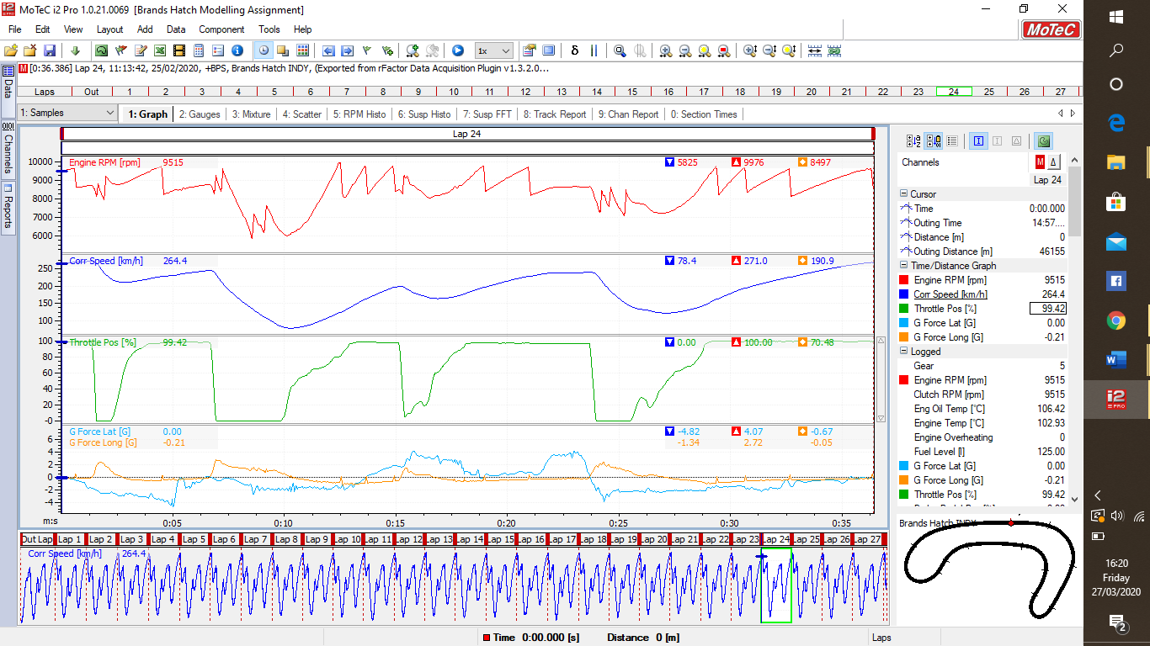
Each driver used the simulator for a stint, and the data from that stint was put into a Motec project. The Motec software allows the user to interpret the data in order to inform a driver where they can drive faster. For example, on the lap shown in figure 1, the data shows hesitation on the throttle on the exit of the last corner, evidenced by the throttle position graph. This shows that applying the throttle sooner would potentially be quicker.
Figure 1- Motec data from the first of the three drivers. Data displayed includes throttle position, G force and speed of the vehicle.
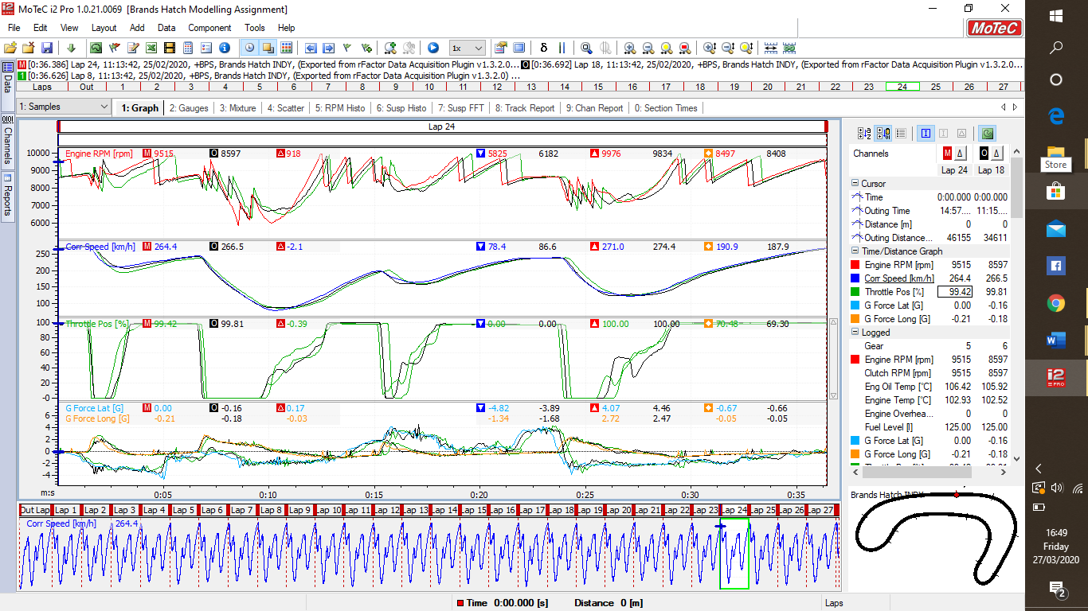
The next progression of analysing the data form this stint is to overlay lap data from a range of laps. This can be used to show the overall pace from the stint, instead of one- lap pace. This accounts for any mistakes, or anomalous quick corners, that would not be representative of the drivers actual pace. Figure 2 shows the comparison between three laps of the first driver’s stint. The fastest lap is a 36.5 second lap, and the slowest is a 36.7 second lap. Looking particularly at the throttle position graph, the conclusion that can be drawn is that the acceleration is not consistent lap- to- lap. This is because the throttle application is not smooth and similar each lap. This means on some laps it takes longer to reach the same speed as other laps. This accounts for the two tenths that separate the fastest and slowest laps displayed. Applying this to the real vehicle, the application of the throttle displayed on the slower lap would place increased wear on the engine if repeated over the course of the stint due to the increased RPM. This shows a potential benefit of taking this approach of testing compared to real world driving. Driving in such a way that increases engine wear can be observed and corrected in the simulator without damaging the real engine.
Figure 2- Motec data from three laps of the first driver's stint. Laps of similar times were seleted.
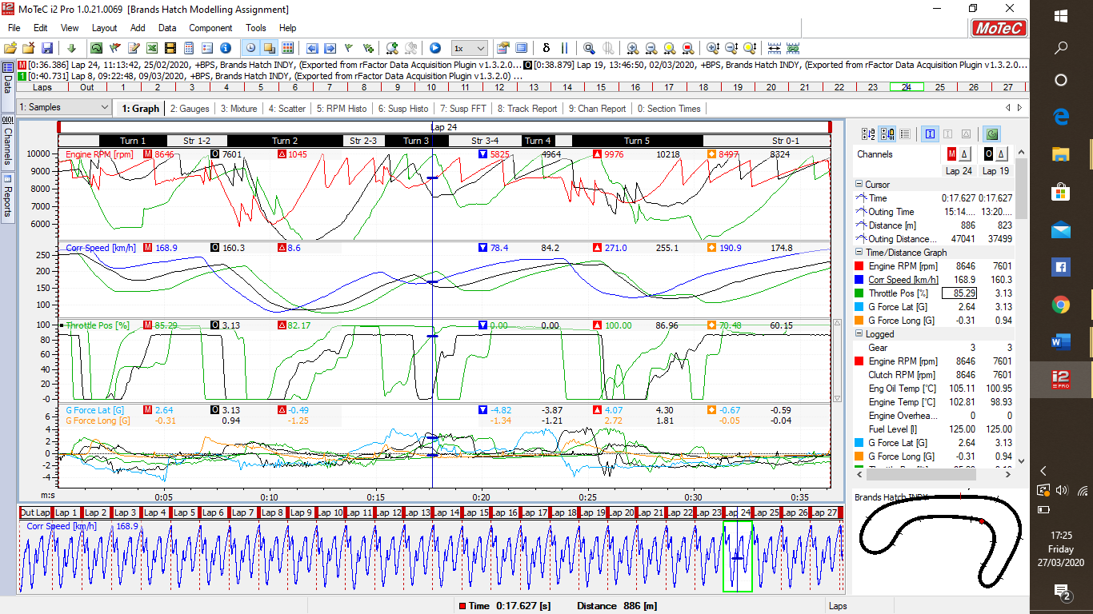
The next stage of this study was to compare the three driver’s lap times in order to determine where each driver can gain more lap time. The other two driver’s lap data was loaded into Motec and overlaid onto the time distance graph. As only one lap from each driver can be displayed on this overlay, the quickest lap time was chosen from each driver.
Figure 3- Motec data showing the overlay of each driver's quickest lap time.
The times are displayed in figure 3. Driver 1’s time was 36.3, driver 2’s time was 38.8, and driver 3’s lap time was 40.7. The most useful time- distance graph in this figure is the throttle position graph, as this graph is one of the most informative of driver input. Looking at the slowest lap time, it is clear looking at throttle position that one of the most significant barriers to quicker lap times for driver 3 is the noticeable hesitation to apply the throttle. This is shown by comparing driver 3’s data to driver 1, there is a large difference in the time the throttle is applied. Looking at the corr. speed graph above, this clearly results in a lover speed on corner exit.
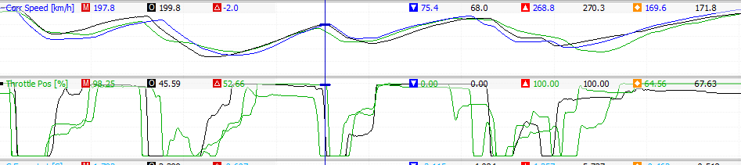
Looking at driver 3’s three fastest laps in isolation, it is also clear that there is an inconsistency in the application of the brakes. Whilst brake pedal application is not displayed in this graph, it is possible to see where brake inputs are, following the sudden drop in throttle inputs at corner entry. Using this, it is possible to summarise that the driver is not picking braking points, fixed points the driver uses every lap. Advising the driver to use braking points would improve his lap time. Drawing this conclusion in the simulator is key as driving the real car with this level of inconsistency in the braking zones could result in an accident, as the driver could easily misjudge the braking point when they have no visual reference to use.
Figure 4- Motec data overlay of driver 3's three fastest laps
Looking at driver 2 in comparison to driver 1, the biggest factor in the two second difference in lap time is the early braking points that driver 2 is using. This means that, looking at the corr. Speed graph in figure 3, driver 2 does not at any point reach the same speed as driver 1 before they have to brake for the next corner. Looking at the delay between the braking of driver 1 and driver 2, it is possible to conclude that driver 2 is braking for the next corner later than driver 1 by a significant amount. This seems symptomatic of overdriving, which is when a driver pushes beyond their, or the vehicles ability in order to gain lap time. This usually ends up losing the lap time and consistency as it increases the likelihood of making small regular mistakes such as missing braking points and pressing the throttle too early. Driver 2, therefore, would be advised to push less in the car, and aim for consistency as opposed to lap time.
Teams could use this analysis to determine the driver most suitable for the team. Asking each driver to run a stint in the simulator and looking for both lap time and consistency could help a team identify the performance level of a driver without risking the real vehicle. The simulator also allows teams to control variables such as ambient and track surface temperatures and ensure all potential drivers are given an equal chance to perform well when being tested.
Also, during times of extreme external conditions such as the current Covid-19 situation, teams are not able to test vehicles due to circuits being closed. At the time of writing, most governments are placing countries on lockdown, meaning restricted travel closure of most nonessential facilities, including race circuits. Using the simulator means that teams can test and potentially develop both vehicles and drivers whilst being unable to travel to real world locations.

Conclusion
In summary, using simulator data can be used as a substitute for real world driving in some circumstances, and can be used to improve the lean manufacturing in a motorsports company. Simulation can be used for driver development and learning without producing waste expenditure and waste in the form of damaged or worn components.

Sources
Becker, R. M. “Lean Manufacturing and the Toyota Production System” accessed 27/03/2020 p. 1-2
Charron, R. Harrington, H. J. Voehl, F. Wiggin, H. 2014 “The Lean Management Systems Handbook” p.2-4
Krafcik, J. F. 1988. “Triumph of the Lean Production System.” MIT Sloan Management Review 30 (1): 41.

