Finding full-text articles for your assignments using EBSCO’s GreenFILE (linking with other EBSCO databases). GreenFILE is a database which draws on the connections between the environment and a variety of disciplines such as agriculture, education, law, health and technology.
First, you will need to go through the Library’s website to gain access to the full-text articles in GreenFILE. To do this, type UWTSD or http://www.uwtsd.ac.uk/ into your internet explorer.
Select Quick Links, then Swansea Library and Learning Resources. Select Online Library from the left-hand side of the screen. Then select Swansea Online Library. Then under the heading A-Z Listings of Online Resources, click on the box Databases A-Z. If you hover your cursor over each title, you can view descriptions of the databases.
Scroll down the list of databases and select the database you wish to view i.e. GreenFILE.
You’ll be taken to the screen where you can search GreenFILE. Select Choose Databases.
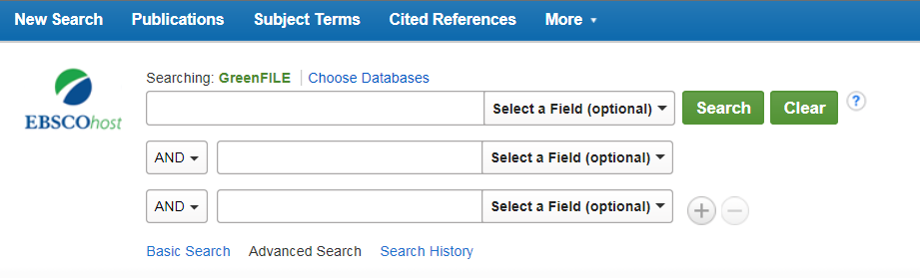
Select Academic Search Premier, Business Source Complete and Humanities Source to generate a larger field of results. Now you will be searching these databases, as well as GreenFILE. Select OK.
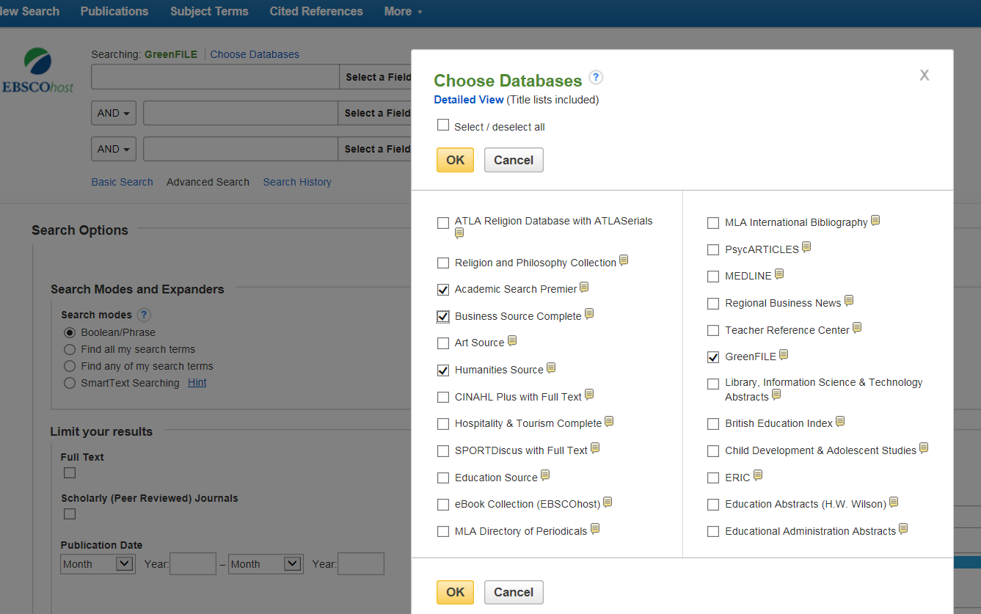

In the search box, type in keywords to describe the topic you are looking for and select Search:
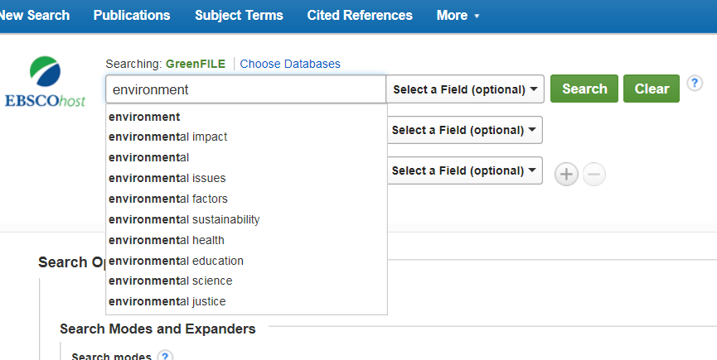
You’ll be taken to a new screen:
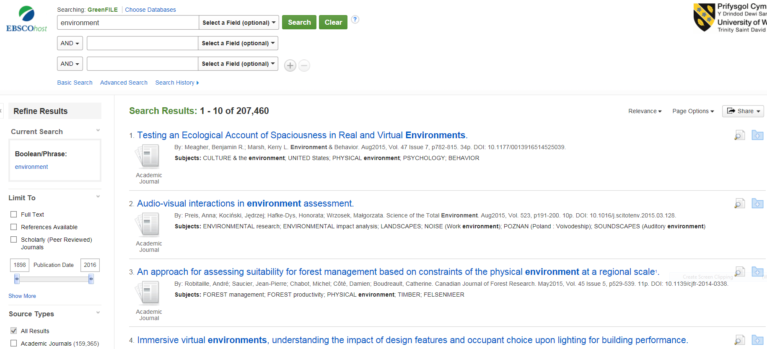
You can refine the amount of results by selecting Full-text, References Available and Scholarly/Peer Reviewed Journals.
You can also refine the date range of the articles you wish to view.

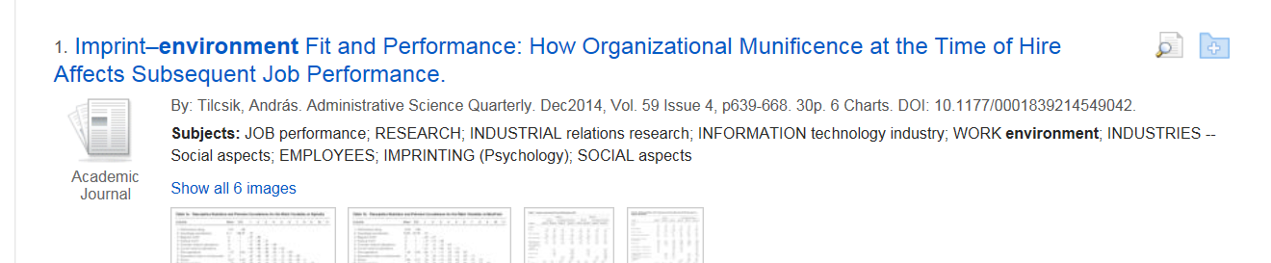
On the right-hand side of the article’s title you will find a spy glass and a folder.
Click on the spy glass and you will be shown a summary of the article.
Click on the folder and you can add the article to a folder to email to yourself.

By selecting the title of the article you wish to view , you will be taken to a page which looks like this:

To view the full-text, select PDF Full Text.

The Subject Terms can be helpful, providing new terms to use in your search. If you click on a subject term, you’ll be taken to a fresh search.
You can save and/or add the article to your folder from this page. You can also email the article to yourself from here too.
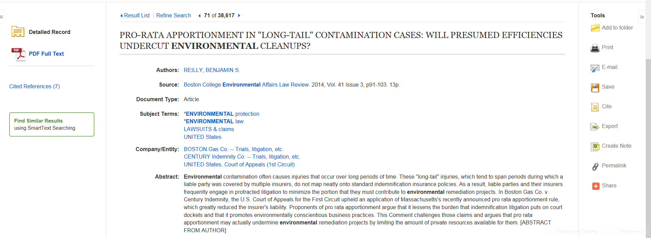
Please contact me if you would like help finding information for your assignments. Ask for me at counter in the Owen Library, email suzanne.taylor@uwtsd.ac.uk or phone (01792 481141).
Suzanne Taylor (Subject Librarian)

