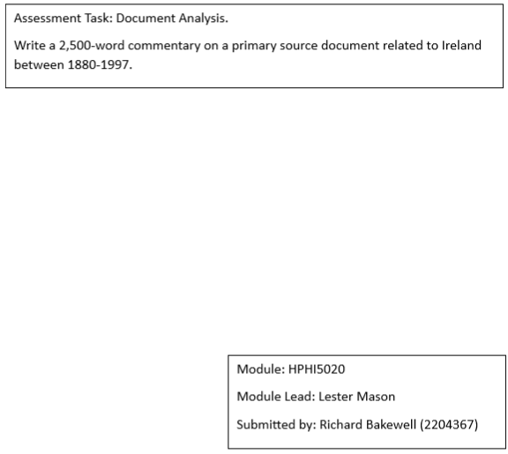
- Introduction: An analysis of the Proclamation of the Irish Republic
On Easter Monday, 24th April 1916, approximately 1500 men and women from the Irish Volunteers, Irish Citizen Army, and women's republican paramilitary organisation Cumann na mBan seized key areas in Dublin. The leaders declared the right of Irish citizens to own Ireland in a Proclamation document. The rebellion ended with unconditional surrender on April 29 to avoid further bloodshed in the face of overwhelming British forces (Bhreathneach-Lynch, 1999). Casualties included 220 civilians killed and 600 wounded, 134 soldiers killed and 384 wounded, and 64 rebels killed (Mason, 2024). The British establishment imposed martial law, executed reputed leaders, and arrested thousands throughout Ireland (O Hadhmaill, 2021). The Proclamation was central to the uprising, outlining the principles for building the Republic and serving as its founding document (Frost, 2017). It aimed to represent the Irish people's enduring desire for self-governance and their moral right to sovereign control over their destinies (O’Donoghue, 1963). The initial response in Dublin was disbelief and opposition rather than immediate popular support.
The Rising was motivated by centuries of British rule, Irish rebellions, a resurgence in the nationalist movement, and the delayed Home Rule Bill implementation due to World War One. The timing of World War One was advantageous, and support was garnered from Germany. If the Dublin uprising had succeeded, it was anticipated that the rest of the country would have joined in rebellion. The leaders knew the uprising might fail, but they still signed the Proclamation, sacrificing their lives. The principles in the Proclamation, along with the leaders' imprisonment and execution, united the Irish people and boosted support for independence, leading to the rise of the Sinn Fein party in subsequent elections. These events had a lasting impact on the nationalist movement.
This report will critically examine the Proclamation's authorship, motivations, context, and content before reflecting on its legacy. Research was conducted using available resources and books, including Easter Rising 1916: The Irish Rebellion by Charles Townshend, 1916, The Long Revolution by Doherty and Keogh and The Revolution in Ireland, 1879-1923 by D.G. Boyce.

- AUTHORS
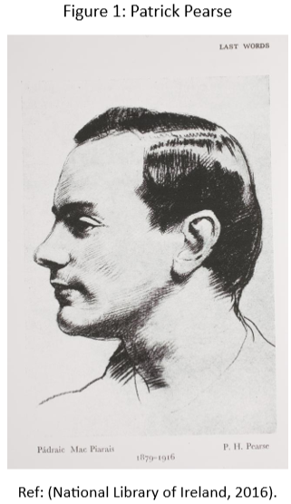
With contributions from others, especially James Connolly and Thomas MacDonagh, Patrick Pearse composed the Proclamation (See Appendix A). Pearse’s prominent role in the Volunteers and widespread admiration led to his appointment as the president of the Provisional Government (National Library of Ireland, 2016; Townshend, 2015, p. 412). Thomas Clarke’s wife, on the other hand, consistently asserted that Clarke had assumed the role of President (Townshend, 2015, pp. 224-225). Pearse (see Figure 1) was born in 1879 in Dublin. He grew up as a devout Catholic and developed a keen interest in the Irish language and literature, becoming a member of the Gaelic League. Pearse leaned towards moderate nationalism and initially endorsed the Home Rule Bill in 1912. However, he also warned about the possibility of a revolution if the bill was not implemented. In November 1913, he was involved in establishing the Irish Volunteers and later assumed the Director of Military Operations. Eoin MacNeill was the leader and had intended to use the Volunteers to back the Irish Parliamentary Party (IPP), the principal political party in Ireland. In December 1914, Pearse joined the Irish Republican Brotherhood (IRB), and by September 1915, he had become a member of the Supreme Council, playing a crucial role in planning the Rising. After surrendering, he faced a court-martial and was executed in Kilmainham Jail on May 3rd (National Library of Ireland, 2016; Townshend, 2015, p. 412; Hughes, 1994, p. 38.). Pearse's stance within the republican movement was solidified through his political writings, for example, during the Dublin lockout in 1913 and his final article, The Sovereign People. Pearse embodied the national movement's cultural and political dimensions within a single individual (Metscher, 2001).
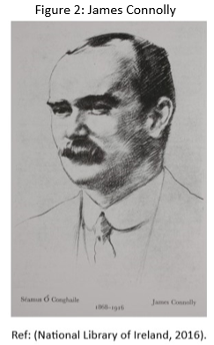
The leaders were not disadvantaged people. Pearse was a headmaster, MacDonagh was a university lecturer, Ceannt worked for Dublin Corporation, and Plunkett came from a prosperous Dublin family. Clarke and MacDermott were the only lifelong supporters of Irish republicanism among the seven (University College Cork, 2024a). Connolly (see Figure 2) was a key figure, serving as the Vice President of the Provisional Government of the Irish Republic and commander of all Republican forces in Dublin during the Rising. He had military experience from serving in the British army and was a Marxist union leader who founded the Irish Citizen Army (National Library of Ireland, 2016). Connolly was a socialist activist who adopted republicanism shortly before the Rising (Embassy of Ireland, 2024).

- MOTIVATIONS AND REASONS BEHIND THE PROCLAMATION
The following outlines the main reasons and motivations for this pivotal event. The Rising was planned after the IRB decision in August 1914 to rebel against British rule before the end of World War One (O’Donoghue, 1963). Pearse and Connolly saw the Easter Rising as symbolically significant, with the Proclamation and the formation of a provisional government conveying a vital political message (Townshend, 2006). They supported using physical force to attain Irish independence due to the British government's decision to delay Home Rule for the duration of World War One (Metscher, 2001). The Rising resulted from a long history of British control and defiance in Ireland. In the early 1900s, Ireland was under direct rule from Westminster as part of the British Empire, established through the 1801 Act of Union after the rebellion in 1798 (O Hadhmaill, 2021). During this time, there were several political upheavals and nationalist movements in a world dominated by Empires (Embassy of Ireland, 2024). The issue of Home Rule for Ireland was a primary focus of political discussions in the late 1800s (Sayers, 2018). The Government of Ireland Act 1914 included provisions for Home Rule, but this was put on hold when World War One broke out. This decision prevented a potential conflict involving the Ulster Volunteer Force, which opposed home rule, and the Irish Volunteers, who aimed to establish a parliament in Dublin (O’Brien, 2018). Without the war, a civil war between Unionists and Republicans would have likely led to British intervention and troop deployment. 1916 Britain was involved in the war against Germany for nearly two years. The Republican perspective held that Britain's focus on its military involvement with Germany reinforced the belief that it presented an opportunity for Ireland to pursue independence (McMorran, 2019). Unionists joined the British army to defend the Empire, while some Irish nationalists fought, and others opposed the British (O Hadhmaill, 2021). Despite British politicians' resistance to his vision of Home Rule, John Redmond supported the British war effort (Sayers, 2018). The war also provided an opportunity to seek support from Germany (O Hadhmaill, 2021). Roger Casement sought German support for the nationalist struggle and was hanged for his involvement (Mitchell, 2012). The British planned to act against the Volunteers, but it was too late. Germany saw the potential for Britain to be weakened by internal conflict in Ireland. The nationalists expected German support in Ireland, but the British intercepted German naval codes and had informants, so the support never materialised. They had plans in place to move against the Volunteers. MacNeill, the leader of the Volunteers, tried to call off the Rising (see Appendix B and C), considering it ill-timed and strategically unsound. However, the other leaders decided to proceed despite the reduced number of Irish Volunteers and MacNeill's absence (McMaster, 2016; Hughes, 1994, p. 40; Sloan, 2013).
- WHERE WAS IT ANNOUNCED?
As president, Pearse publicly recited the Proclamation outside the General Post Office (GPO) on Easter Monday, where he and other leaders were stationed (O Hadhmaill, 2021). The exact location is debated, but it was likely near the entrance (Trinity College Dublin, 2022). The GPO was a critical communications centre in Dublin and symbolised British authority (RTE, 2024a).
- THE INITIAL REACTION
The rebellion caught Dubliners off guard with the poorly delivered oration and announcement by Pearse given to a small and nearly entirely bewildered crowd (O’Brien, 2022; Frost, 2017). The Catholic Church and the IPP criticised the Rising, which initially lacked widespread support in Dublin. Most people reacted with disbelief and hostility, with reports of prisoners being mocked and mistreated by the public (O Hadhmaill, 2021; Townshend, 2006).
During the Rising, only one edition of the Irish War News was released, featuring an editorial by Patrick Pearse aiming to disseminate information about the uprising (RTE, 2024b).
The reporting on the Rising was heavily restricted. The Cork Examiner denounced the Rising as regrettable and reckless, urging restraint by the British authorities. The Irish Independent condemned the planners and urged leniency for minor participants but not for the leaders. The Irish Times and Freeman’s Journal also held hostile perspectives on the Rising (University College Cork, 2024b). The Rising gained international attention, covering Europe, Australia, New Zealand, and the U.S. The New York Times, Chicago Tribune, and Washington Post had condescending tones about the rebellion, emphasising its romantic futility and the rebels' reliance on Roger Casement. The New York Times made errors in reporting the Irish rebellion (RTE, 2024b). It generated much interest in numerous other nations, especially those with a substantial Irish population, including Argentina (Galazzi, 2016). The British media had a generally negative perspective on the Rising, but some newspapers offered a more balanced view and urged moderation from the British government in their reaction. The Freeman's Journal and the Manchester Guardian expressed hope for moderation, while The Times criticised the Irish administration and urged firm handling of the rebels by British leaders (RTE, 2024b). The Manchester Guardian's portrayal of the uprising suggests it used the German connection to justify Germany's role in provoking violence in Ireland and to depict the Irish rebels negatively to hinder the growth of republicanism (McMorran, 2019).
- ANALYSIS OF THE PROCLAMATION DOCUMENT
The Proclamation, measuring approximately 76cm x 49cm, exists in only 50-60 original copies (University College Cork, 2024c). Few remain, as most were considered unimportant in the weeks after the Rising. The Proclamation was signed by Thomas Clarke, Patrick Pearse, James Connolly, Thomas MacDonagh, Sean MacDermott, Éamonn Ceannt and Joseph Plunkett (Connell, 2011). The printer used was poorly maintained, resulting in various fonts being used. The paper used was of low quality, and some letters in the headings had to be modified with sealing wax. British soldiers found copies in the press, later used as evidence against the Rising's leaders (Connell, 2011; Townshend, 2015, p. 378). They planned to produce 2,500 copies, but only around 1,000 were finished, and most were destroyed during the chaos (Bouch, 1936, pp. 43-52).
The Proclamation is a brief document packed with profound significance and symbolism. It should be noted that, apart from the title at the top, the text has no Irish language. The term Poblacht na h’Eireann was coined to signify the Irish Republic and is derived from the name of the old kingdom of Ireland. The aim was not to cause authority ambiguity but to promptly identify the document as a communication from the Provisional Government of the Irish Republic. This is affirmed by the final of its four title lines, which specifies it as a message to the people of Ireland (Frost, 2017). Éamon de Valera later used Saorstat Éireann to denote the Irish Republic, meaning Free State (Geoghegan, 2016). The document emphasises inclusivity, particularly in its mention of Irish men and women, highlighting the desire for women to play a significant part in the emerging republic. It also references the election of the national government through universal suffrage of all citizens, male and female, which was considered progressive in 20th-century Europe. The recognition of women's contribution to the nationalist movement, influenced by groups such as Cumann na mBan, is apparent in this comprehensive strategy (Geoghegan, 2016).
The text starts with a strong greeting, invoking God and the traditional leaders of the nation. It highlights the active role of the Rising leadership in the Proclamation and urges the people to unite under the banner of Ireland. The representation of Ireland as a young or old woman is often used in Irish poetry and is held in high esteem in the Aisling poem (Frost, 2017). The first paragraph emphasises the ideas of loyalty and expectation. Ireland is portrayed as a dedicated mother to loyal children, diligently preparing for action. The Proclamation speaks to the Irish people and the broader global community (Frost, 2017). The mention of support from Irish expatriates in America and their ‘gallant’ allies in Europe is made, with the latter not explicitly identified but alluding to the government of Germany. This line was possibly the most condemning for the leaders of the Rising, indicating that they were collaborating with Britain's adversary. It was expected that Germany would initiate an attack with troops, armaments, and supplies (Donoghue, 2018). The following paragraph mentioned that in the last three hundred years, the Irish had rebelled six times to demand national freedom and independence. The Proclamation stated that the 1916 Rising, the seventh endeavour in Irish history, marked the peak of an unstoppable and unavoidable pursuit of liberty. Emmet's 1803 rebellion inspired the Proclamation, influencing Pearse to emulate him with a new one (O’Donnell, 2003; Geoghegan, 2016). The Provisional Government proclaimed the Irish Republic a Sovereign Independent State, affirming it through armed conflict in front of the world. The Proclamation indicates that its assertions are rooted in a lengthy history of individual sacrifice (Donoghue, 2018; Frost, 2017). Historical events support the document's message about national independence, self-governance, ownership of the island, and rights that remain valid despite foreign occupation (Frost, 2017). The claim that Irish residents have the right to own Ireland shows the impact of the socialist and trade union leader James Connolly on its creation (Geoghegan, 2016). The third paragraph guaranteed religious and civil liberties for every citizen, along with equal rights and opportunities, regardless of past divisions imposed by a foreign government, such as the segregation of Protestants and Catholics in the North (Donoghue, 2018). The Proclamation metaphorically connects the bond between mother and child with political belonging, suggesting that all Irish individuals would receive fair and equal treatment in the recently formed nation (Frost, 2017; Geoghegan, 2016). The fourth paragraph mentioned that the Provisional Government, which was in the process of being established, would handle the domestic and military matters of the Republic on behalf of the people until a permanent National Government was established. The final paragraph requests that the Irish citizens show they are worthy of the magnificent future that awaits them (Donoghue, 2018).
The Proclamation expressed nationalist beliefs and declared the Republic a sovereign independent state, guaranteeing religious and civil freedom, class and gender equality, and opportunities for all citizens (Townshend, 2016, pp. 160-161). The Proclamation can be compared to the US Declaration of Independence, even though there are few similarities. The Declaration mainly consists of a list of complaints against British rule. The Proclamation briefly mentions the British government in Ireland. The Irish people's demand for self-government is based on their inherent rights (The Irish Times, 2016). This optimism was unfounded but inspired the spirit of 1916 and the fight for independence. Despite its flaws, it remains a powerful symbol today (Geoghegan, 2016).
- CONCLUSION
The Proclamation was the centrepiece of the rebellion and is considered a foundation document of the modern Irish Republic, proclaiming a country free of British rule and declaring equal rights and prospects for all citizens. It was a significant event in Ireland and globally, symbolising the revolutionary statement of national independence. The Rising initially lacked widespread support and was carried out by a small, secretive group advocating armed resistance. They sought help from wartime Germany and launched the initiative with little chance of success, fully aware of the self-sacrifice they were making. Initial reactions were generally hostile domestically and internationally. However, the Irish population eventually endorsed it. The execution of the leaders had a significant impact on this change of opinion. John Redmond foresaw this, opposing the executions, as did John Dillon MP, who also spoke about the effect of the executions on nationalist sentiments. The event was significant for Irish independence, along with the General Election of 1918, the First Dáil, the War of Independence, and the treaty negotiations of 1921. Two who took part in the Rising were arrested but escaped execution, namely Michael Collins and Eamon de Valera, who would be critical in these future events. The Rising led to a more committed revolutionary faction under the revived Sinn Féin party and, by 1918, had triumphed in the general election, displacing Home Rule support.

REFERENCES
Bhreathneach-Lynch, S. (1999) ‘Revisionism, the Rising, and Representation’, New Hibernia Review / Iris Éireannach Nua, 3(1), pp. 82–96. Available at: http://www.jstor.org/stable/20646283 (Accessed: 18 September 2024).
Bouch, J. (1936) ‘The Republican Proclamation of Easter Monday, 1916’, The Bibliographical Society of Ireland, 5(3), pp. 43-52. Available at: https://digitalcommons.usf.edu/cgi/viewcontent.cgi?article=1017&context=irish_publications (Accessed: 18 September 2024).
CAIN (2024) Original Proclamation of the Irish Republic 24 April 1916. Available at: https://cain.ulster.ac.uk/issues/politics/docs/pir24416.htm (Accessed: 28 September 2024).
Connell, J. (2011) ‘Proclamation of the Irish Republic’, History Ireland, 19(1), p. 66. Available at: http://www.jstor.org/stable/41000275 (Accessed: 21 September 2024).
Donoghue, D. (2018) ‘EASTER 1916’, Yeats Annual, 21, pp. 39–61. Available at: http://www.jstor.org/stable/90020738 (Accessed: 22 September 2024).
Embassy of Ireland (2024) Ambassador’s lecture on 1916 – University of Oxford. Available at: https://www.dfa.ie/irish-embassy/great-britain/news-and-events/2016/lecture-1916-oxford/ (Accessed: 25 September 2024).
Frost, C. (2017) ‘Summoning Sovereignty: Constituent Power and Poetic Prophecy in Ireland’s 1916 Proclamation of the Republic’, Constellations, 24(1), pp. 76–88. Available at: https://doi.org/10.1111/1467-8675.12268
Galazzi, M. (2016) ‘“Dublin Traitors” or “Gallants of Dublin” The Argentine Newspapers and the Easter Rising’, Estudios Irlandeses, 11(11), pp. 56–68. Available at: https://doi.org/10.24162/EI2016-6098
Geoghegan, H. (2016) The Proclamation the Spirit of 1916 Captured on a Piece of Paper. Available at: https://www.tcd.ie/news_events/articles/the-proclamation--the-spirit-of-1916-captured-on-a-piece-of-paper/#:~:text=The%20Proclamation%20became%20the%20embodiment,why%20it%20still%20resonates%20today (Accessed: 21 September 2024).
Hawkins, M. (2006) ‘The Easter Rising and the Fall to Freedom.’ Available at: https://www.eiu.edu/historia/Hawkins.pdf (Accessed: 25 September 2024).
Hughes, M. (1994) Ireland divided: the roots of the modern Irish problem. Cardiff: University of Wales.
Irish Independent (2016) The 11th hour: The wild rumours and atmosphere in Dublin on the eve of the Rising Available at: https://www.independent.ie/irish-news/the-11th-hour-the-wild-rumours-and-atmosphere-in-dublin-on-the-eve-of-the-rising/34222382.html (Accessed: 28 September 2024).
Mason, L. (2024) Ireland 1910-23. Available at: https://moodle.uwtsd.ac.uk/course/view.php?id=10563&section=4 (Accessed: 27 September 2024).
McMaster, J. (2016) ‘God and the Easter Rising’. Available at: https://www.tcd.ie/Chaplaincy/assets/pdf/ANNUAL-CHAPLAINS-LECTURE-2016.pdf (Accessed: 25 September 2024).
McMorran, K. (2019) ‘“A German Bred Revolt”: the Manchester Guardian’s perceptions of the Irish Easter Rising, 1916’, Irish Studies Review, 27(4), pp. 564–577. Available at: https://doi.org/10.1080/09670882.2019.1663607
Metscher, P. (2001) ‘Pearse and Connolly: Unity toward an Irish Republic’, Nature, Society, and Thought, 14(1), pp. 203-214. Available at: https://www.proquest.com/docview/1618935971?accountid=130472&parentSessionId=78r%2Fnge0pYNiP2DQfwVHEKSxW5%2FUH3lpMzLLRJEo66c%3D&pq-origsite=primo&sourcetype=Scholarly%20Journals (Accessed: 18 September 2024).
Mitchell, A. (2012) ‘A Strange Chapter of Irish History: Sir Roger Casement, Germany and the 1916 Rising’. Field Day Review, 8, pp. 4–21. Available at: http://www.jstor.org/stable/41932931 (Accessed: 25 September 2024).
Morrison, J. F. and Gill, P. (2016) ‘100 Years of Irish Republican Violence’, Terrorism and Political Violence, 28(3), pp. 409–416. Available at: https://doi/10.1080/09546553.2016.1155927
National Library of Ireland (2016) James Connolly, Vice-President of the Provisional Government of the Irish Republic. Available at: https://www.nli.ie/1916/exhibition/en/content/sevensignatories/jamesconnolly/ (Accessed: 28 September 2024).
National Library of Ireland (2016) James Connolly. Available at: https://www.nli.ie/1916/exhibition/en/content/sevensignatories/jamesconnolly/ (Accessed: 28 September 2024).
National Library of Ireland (2016) Patrick Pearse, President of the Provisional Government of the Irish Republic. Available at: https://www.nli.ie/1916/exhibition/en/content/sevensignatories/patrickpearse/ (Accessed: 20 September 2024).
O Hadhmaill, F. (2021) ‘The Easter Rising (1916) in Ireland and its Historical Context: The Campaign for an Irish Democracy’, The Palgrave Encyclopedia of Imperialism and Anti-Imperialism, pp. 629-669. Available at: https://doi.org/10.1007/978-3-030-29901-9_13
O’Brien, E. (2022) ‘Rereading the Rising: towards an understanding of the influence of “Easter 1916” on contemporary Ireland’, Irish Studies Review, 30(4), pp. 405–422. Available at: https://doi.org/10.1080/09670882.2022.2127468
O’Brien, M. (2018) ‘Fighting and Writing: Journalists and the 1916 Easter Rising’, Media History, 24(3–4), pp. 350–363. Available at: https://doi.org/10.1080/13688804.2018.1487778
O’Donnell, R. (2003) ‘Robert Emmet and the 1803 Rising in Ireland’, Historian (London), 79, pp. 34-38. Available at: https://www.proquest.com/docview/274976645?pq-origsite=gscholar&fromopenview=true&sourcetype=Scholarly%20Journals (Accessed: 22 September 2024).
O’Donoghue, F. (1963) ‘Plans for the 1916 Rising’, University Review, 3(1), pp. 3–21. Available at: http://www.jstor.org/stable/25504540 (Accessed: 20 September 2024).
RTE (2024a) Sites of 1916: The GPO. Available at: https://www.rte.ie/centuryireland/articles/sites-of-1916-the-gpo (Accessed: 25 September 2024).
RTE (2024b) Reporting the Rising: Press Coverage of Easter 1916. Available at: https://www.rte.ie/centuryireland/articles/reporting-the-rising (Accessed: 21 September 2024).
Sayers, B. (2018) ‘Easter 1916 and the Fenian Tradition’, Journal of Irish Studies, 33, pp. 63–71. Available at: https://www.jstor.org/stable/26547219 (Accessed: 18 September 2024).
Sloan, G. (2013) ‘The British State and the Irish Rebellion of 1916: An Intelligence Failure or a failure of response?’, Journal of Strategic Security, 6(3), pp. 328–357. Available at: https://doi.org/10.5038/1944-0472.6.3S.31.
The Irish Times (2014) Order cancelling 1916 Rising to be auctioned in Dublin. Available at: https://www.irishtimes.com/news/ireland/irish-news/order-cancelling-1916-rising-to-be-auctioned-in-dublin-1.1710205 (Accessed: 28 September 2024).
The Irish Times (2016) Proclamation ‘superior’ to US declaration of independence. Available at: https://www.irishtimes.com/culture/heritage/proclamation-superior-to-us-declaration-of-independence-1.2633740 (Accessed: 29 September 2024).
Townshend, C. (2006) ‘Making Sense of Easter 1916’, History Ireland, 2, pp. 40-45. Available at: http://www.jstor.org/stable/27725427 (Accessed: 21 September 2024).
Townshend, C. (2015) Easter 1916 : The Irish Rebellion. 3rd edn. London: Penguin.
Trinity College Dublin (2022) The Proclamation – The Spirit of 1916 Captured on a Piece of Paper. Available at: https://www.tcd.ie/news_events/articles/the-proclamation--the-spirit-of-1916-captured-on-a-piece-of-paper/#:~:text=The%20Proclamation%20became%20the%20embodiment,why%20it%20still%20resonates%20today (Accessed: 21 September 2024).
University College Cork (2024a) Chapter 3. The Leaders of the 1916 Rising. Available at: https://www.ucc.ie/en/theirishrevolution/collections/the-story-of-1916/chapter-3-the-leaders-of-the-1916-rising/ (Accessed: 21 September 2024).
University College Cork (2024b) The Role of the Press in 1916. Available at: https://www.ucc.ie/en/theirishrevolution/collections/the-story-of-1916/chapter-5-the-aftermath-of-the-1916-rising/the-role-of-the-press-in-1916/ (Accessed: 21 September 2024).
University College Cork (2024c) 1916 Proclamation of the Irish Republic. Available at: https://libguides.ucc.ie/1916Proclamation (Accessed: 22 September 2024).

BIBLIOGRAPHY
Augusteijn, J. (2002) The Irish Revolution, 1913-1923. Basingstoke: Palgrave.
Boyce, D.G. (1988) The Revolution in Ireland, 1879-1923. Basingstoke: Macmillan Education.
Martin, F. and Moody, T.W. (1967) The Course of Irish History. Cork: Mercier Press.
McGee, O. (2007) The IRB : the Irish Republican Brotherhood, from the Land League to Sinn Féin. 2nd ed. Dublin: Four Courts Press.
Townshend, C. (1983) Political violence in Ireland : Government and Resistance since 1848. Oxford: Clarendon.

APPENDIX
CONTENTS
- APPENDIX A: Original Proclamation of the Irish Republic 24 April 1916 (Page 2).
- APPENDIX B: Handwritten countermand by Eoin MacNeill for Easter Sunday 1916. (Page 4).
- APPENDIX C: Eoin MacNeill’s Countermanding Order appeared in the Sunday Independent the day before the Rising began on Easter Monday, 1916 (Page 4).

APPENDIX A: Original Proclamation of the Irish Republic 24 April 1916.
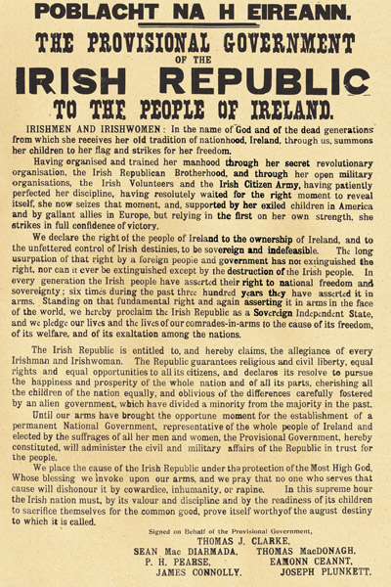
Ref: (CAIN, 2024)
APPENDIX B: Handwritten countermand by Eoin MacNeill for Easter Sunday 1916.
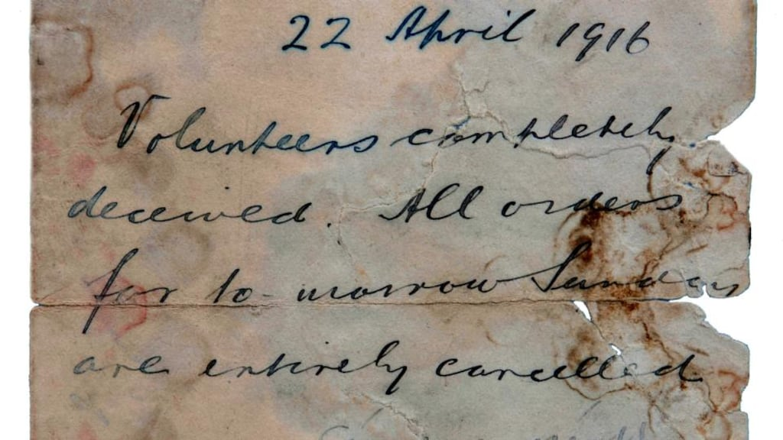
Ref: (The Irish Times, 2014).

APPENDIX C: Eoin MacNeill’s Countermanding Order appeared in the Sunday Independent
the day before the Rising began on Easter Monday, 1916.
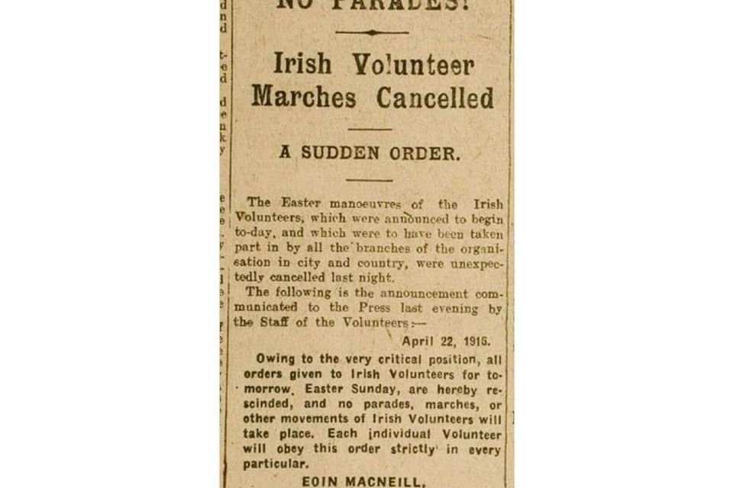
Ref: (Irish Independent, 2016).

