

Analysis of the internal and external environment of Sainsbury's department store

Written by：Songtao Fang

Student ID：2304106

RESUME
PERSONAL

Executive Summary
This report provides a comprehensive analysis of Sainsbury's internal environment, leveraging strategic management tools such as PESTEL, SWOT, Porter's Five Forces, and Porter's Value Chain analysis.

The PESTEL analysis evaluates the political, economic, social, technological, environmental, and legal factors impacting Sainsbury's operations. SWOT analysis identifies the company's strengths, weaknesses, opportunities, and threats, while Porter's Five Forces assesses industry competitiveness.

Porter's Value Chain analysis identifies key areas of competitive advantage and opportunities for improvement within Sainsbury's operations.
Based on the analysis, recommendations are made to Sainsbury's management, including investing in technology to enhance operational efficiency, expanding into emerging markets to drive growth, and prioritizing customer engagement initiatives to strengthen brand loyalty.

In conclusion, this report aims to provide actionable insights and strategic recommendations to Sainsbury's leadership to navigate challenges and seize opportunities in the dynamic retail landscape.
Contents
Executive Summary 2
1.0 Introduction 4
2.0 Main Findings 5
2.1 PESTEL analysis 5
2.2 SWOT analysis 14
2.3 Porter's five forces model analysis 18
2.4 Porter’s value chain analysis 21
3.0 Recommendations 23
4.0 Conclusions 24
5.0 Reference List 25

1.0 Introduction
Currently, the global economy is facing a series of challenges, including the rise of trade protectionism, intensifying geopolitical tensions, and the impact of the COVID-19 epidemic. These factors have slowed global economic growth and increased market uncertainty, which have affected various industries, especially the food retail industry (Munoz, 2023). As an indispensable part of people's lives, the food retail industry has been affected by It is directly affected by the global economic situation and also faces fierce competition within the industry.

Sainsbury's supermarket is one of the oldest retail brands in the UK. It was founded in 1869 and has a history of more than 100 years. The company is committed to providing customers with high-quality food and daily necessities, as well as an excellent shopping experience. As one of the major supermarket chains in the UK, Sainsbury's has a large number of stores across the country, covering a wide range of consumer groups. Its products cover fresh food, frozen food, groceries and other commodities to meet the needs of different customers.

However, as the global economic situation continues to change, Sainsbury's supermarkets are also facing new challenges. At the same time, the company continues to seek innovation in market competition and strives to improve its competitiveness to ensure that it maintains its leading position in the highly competitive retail market. In future development, Sainsbury's will continue to uphold its tradition of excellent service and high-quality products, be committed to meeting the changing needs of customers, and continue to adapt to changes in the global economy and the development of industry trends (Mullin, 2023).

2.0 Main Findings

2.1 PESTEL analysis
PESTEL analysis is a tool used to assess the impact of macro-environmental factors on an organization or industry. PESTEL represents six aspects: Politica, Economic, Social, Technical, Environmental, and Legal. These factors will affect the operations and strategies of enterprises to varying degrees (Smith, 2002).

First, by identifying potential threats and opportunities in the external environment, PESTEL analysis allows companies to better predict and assess risks and formulate corresponding strategic responses. Second, PESTEL analysis helps companies discover new opportunities in the market and seize business opportunities brought by market changes, thereby achieving business growth and development. Third, PESTEL analysis, as an important tool for strategic planning and decision-making, can help companies better understand and respond to changes in the external environment and improve their competitiveness and sustainable development capabilities (Johnson & Scholes, 2018).

PESTEL analysis helps companies comprehensively understand the external environment and identify factors that may affect business development. Through the analysis of these six aspects, enterprises can better formulate strategies, respond to risks, and seize opportunities, thereby improving competitiveness and adaptability.

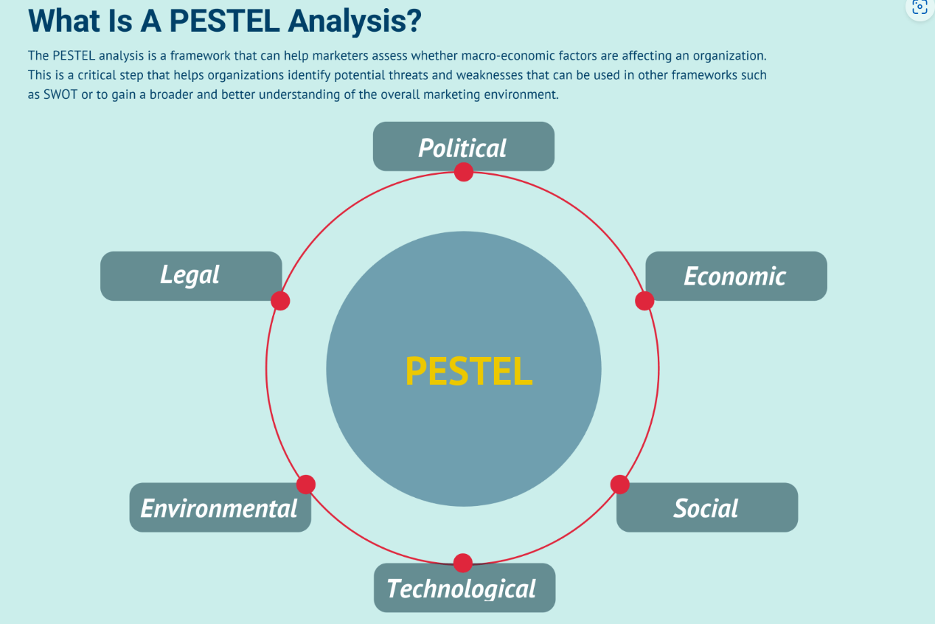

Figure 1
Political
Political factors involve the government's influence on the business environment, including government policies, regulations and legislation. In the case of Sainsburys supermarkets, political factors may include the following aspects.

First, the government ensures food safety through legislation and regulatory measures, and imposes strict requirements on the quality, storage and transportation of food sold in supermarkets. Any products that fail to meet food safety standards could face recalls and penalties, negatively impacting Sainsbury's supermarkets' reputation and operations. Second, the government formulates labor regulations to protect the rights and interests of employees and requires companies to provide reasonable working conditions and remuneration packages. Supermarkets need to comply with relevant regulations to ensure a safe working environment and welfare benefits for employees to avoid labor disputes and legal liability. Third, government tax policies have a direct impact on business operating costs and profitability. Tax incentives or VAT adjustments may affect supermarkets' cost and price strategies, thereby affecting consumer purchasing decisions (Fishe & Valero-Silva, 2013).

Political factors have a multifaceted impact on Sainsburys supermarkets. For example, supply chain stability and competitiveness are impaired. Because changes in trade and tax policies may affect the stability of the supply chain and increase operational risks and costs. At the same time, poor tax policies and trade policies may lead to an increase in the cost of imported goods and affect the price competitiveness of supermarkets (Smith, 2018).

Economic
Economic factors involve the impact of the macroeconomic environment on enterprises, including inflation, interest rates, unemployment, currency exchange rates and other factors. In the case of Sainsburys supermarkets, economic factors may include the following aspects.

First, changes in the inflation rate directly affect consumers’ purchasing power and price sensitivity. High inflation rates may lead to rising costs, and supermarkets face the challenge of commodity price adjustment and cost control. Second, changes in the macroeconomic environment may affect consumers’ shopping habits and consumption trends. For example, during economic downturns, consumers are more inclined to purchase lower-priced goods, posing challenges to supermarkets' product mix and pricing strategies (Main economic indicators. 2011).
Economic factors have a multifaceted impact on Sainsburys supermarkets. For example, high inflation rates and currency depreciation may lead to an increase in the cost of imported goods, increase supermarket operating costs, and pose challenges to profit margins (Mullin, 2023). In an economic downturn, consumers are more price-sensitive and are more demanding of supermarkets with fierce price competition. have an impact that may lead to a decline in market share.

Social
Social factors involve factors such as population structure, cultural values, lifestyles, and social preferences, which have an important impact on an enterprise's business activities and market demand. In the case of Sainsburys supermarket, social factors may include the following aspects.

First, changes in social values and lifestyles will affect consumers’ preferences for products and services. For example, increased consumer demand for healthy food, organic food and sustainable products poses new challenges to supermarket product portfolios and marketing strategies. Second, changes in modern lifestyles may affect consumers’ shopping habits and consumption behaviors. For example, the fast-paced lifestyle has caused consumers to pay more attention to convenient and fast shopping experience, and supermarkets need to optimize service processes and improve shopping experience (Li, 2019).

The impact of social factors on Sainsburys supermarket is mainly reflected in the following aspects. As consumers' demand for healthy food, organic food and sustainable products increases, supermarkets need to adjust their product mix and add products in healthy and environmentally friendly categories (Social policy and society. 2002). At the same time, in response to the fast-paced modern lifestyle , supermarkets can improve shopping convenience and experience and attract more consumers by introducing innovative service models such as online shopping and unmanned stores.

Technological
The impact of technological factors on Sainsburys supermarkets is mainly reflected in the following aspects. First, technological innovation and digital transformation can improve the operational efficiency of supermarkets, optimize processes such as inventory management and supply chain management, reduce costs, and improve profitability. Second, with the new competitiveness challenges brought about by scientific and technological progress, supermarkets need to increase technological investment, continue to innovate, improve market competitiveness, and maintain industry leadership (Leten & Looy, 2016).

In the future, the impact of technological factors on Sainsburys supermarkets will continue to deepen. Supermarkets need to pay close attention to technological development trends, strengthen technological innovation, and continuously improve digital capabilities and intelligence levels to respond to market changes and maintain competitive advantages.

Environmental
Environmental factors mainly refer to the impact of the natural environment on business operations and market environment, including weather changes, climate changes, environmental protection regulations, etc. (Global environmental change. 1990). In the case of Sainsburys supermarket, environmental factors may include the following aspects.

First, climate change has an impact on crop yields, logistics and transportation, and other aspects, which may lead to price fluctuations of agricultural products and affect supermarket procurement costs and supply stability. Second, consumers are increasingly paying attention to environmental protection and sustainability. Consumers are increasingly inclined to purchase environmentally friendly products. Supermarkets need to adjust their product mix and provide more environmentally friendly products to adapt to market demand.

The impact of environmental factors on Sainsburys supermarkets is mainly reflected in the following aspects. Climate change and resource scarcity may lead to unstable supply of raw materials, increase procurement costs, and affect supermarket supply chain management (Ackrill & Lake1993). At the same time, consumer demand for environmentally friendly products increases, and supermarkets need to increase their promotion of environmentally friendly products. Develop new products that meet environmental protection standards and enhance market competitiveness.

Legal
Legal factors refer to the laws, regulations and policies formulated by the government for business activities, including labor laws, consumer protection laws, competition laws, etc. In the case of Sainsburys supermarkets, legal factors may include the following aspects.

First, the government has strict regulatory requirements in the field of food safety. Supermarkets need to comply with relevant regulations and ensure that the products sold meet food safety standards to protect consumer health. Second, labor law stipulates various regulations on employment relationships, including wages, working hours, vacations, etc. Supermarkets need to abide by relevant laws, protect employees’ rights and interests, and maintain good labor relations (Johnson, & Thompson, 2015). Chapter Third, consumer protection laws stipulate various provisions for the protection of consumer rights and interests. Supermarkets need to abide by relevant laws and regulations, provide safe and reliable goods and services, and protect the legitimate rights and interests of consumers.

The impact of legal factors on Sainsburys supermarkets is mainly reflected in the following aspects. Failure to comply with laws and regulations may lead to compliance risks, face penalties and legal proceedings, and affect corporate reputation and operational stability (Brown & Wilson, 2018). At the same time, complying with consumer protection laws can help enhance consumer trust and increase brand loyalty. , promote sales growth.

2.2 SWOT analysis
SWOT analysis is a tool that evaluates the internal and external environment of an organization and is used to identify the organization's Strengths, Weaknesses, Opportunities, and Threats. SWOT analysis helps companies comprehensively understand their own situation, seize internal strengths and external opportunities, respond to internal weaknesses and external threats, and formulate reasonable strategies and decisions (Porter, 2020).

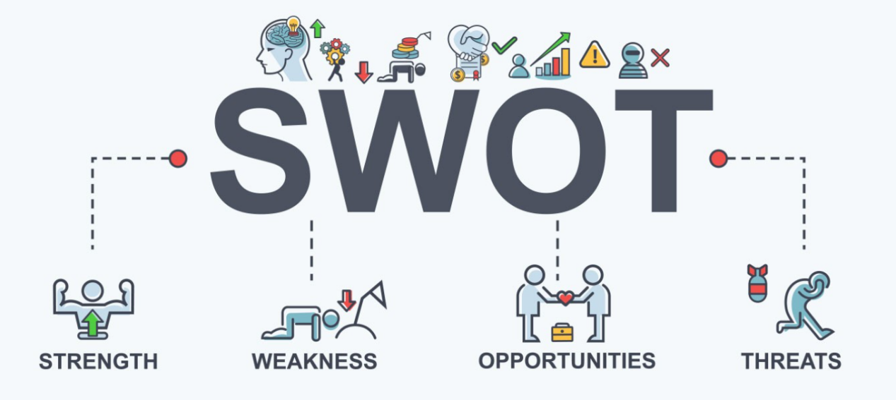

Figure 2

Strengths
Sainsbury's is one of the most well-known retail brands in the UK, with a wide customer base and a good reputation. Its long-standing market presence has earned it a solid market share. At the same time, Sainsbury's is committed to sustainable development and social responsibility, and has adopted a number of environmental protection measures and social welfare activities, which has enhanced consumers' favor and recognition of it. In addition, Sainsbury's provides a variety of products, covering food, household products, daily necessities and other fields. This diversified product portfolio enables it to appeal to consumers with different needs.

According to the asset management theory proposed by Markowitz, brand awareness is one of the most important assets of a company and can bring about growth in market share and value (Markowitz, 1952).

These advantages will provide Sainsbury's with important support in current and future competition. Brand recognition and a broad product portfolio enable it to attract more consumers, while a well-developed supply chain and focus on sustainability and social responsibility will help maintain its strong position in the market and provide for future expansion. A good foundation (Markowitz, 1959).

Weaknesses
Sainsbury's has strong dependence in certain aspects, such as a high market share in certain regions or product areas. Once it faces competition or market fluctuations, it may lead to a decline in performance. Facing competitive pressure from price wars, Sainsbury's may have difficulty maintaining higher price levels, thus affecting its profitability and brand position.

According to resource dependence theory, over-reliance on a certain market or resource may increase corporate risks. Therefore, Sainsbury's needs to diversify its business and markets and reduce dependence on specific markets or resources (Pfeffer & Salancik, 1978).

These weaknesses could have a negative impact on Sainsbury's performance and competitive position. Dependence and price competition may lead to a decline in profitability, while online competition and brand positioning issues may affect its market share and brand image (Humphrey & Boon, 2004). Therefore, Sainsbury's needs to actively respond to these issues and take measures to improve and optimize in order to Ensure its competitive position in the market.

Opportunities
As consumers' demand for online shopping continues to increase, Sainsbury's can attract more consumers by expanding its online business and providing more online shopping options and convenient services. (Grant, 2010). As society's attention to sustainability and environmental protection increases, Sainsbury's can establish a good corporate image and attract more consumers by strengthening social responsibility projects, such as reducing plastic packaging and promoting sustainable purchasing.

According to the theory of corporate social responsibility, Sainsbury's can establish a positive corporate image and enhance brand value and consumer loyalty by fulfilling social responsibilities (Carroll, 1991).

These opportunities may have a positive impact on Sainsbury's business development and market competition. By increasing online business and strengthening social responsibility, Sainsbury's can improve the company's competitiveness, profitability and brand value, laying a good foundation for future development.

Threats
First, Sainsbury's faces fierce competition from other retailers, such as Tesco, ASDA and Waitrose, who may snatch Sainsbury's market share through price cuts, promotions, etc. (Frederick, 1960). Secondly, changes in government policies and regulations, such as Tax policies, food safety standards, etc. may have an adverse impact on Sainsbury's operations and increase costs and risks.

These threats may adversely affect Sainsbury's business and market competition. By effectively responding to market competition and changes in policies and regulations, Sainsbury's can mitigate risks, protect corporate interests, and ensure future sustainable development (Carroll, 1999).

2.3 Porter's five forces model analysis
Five Forces Analysis is a framework proposed by Michael Porter in 1979. Its purpose is to define the degree of attractiveness of a market. Porter believes that the five forces that affect market attractiveness are individual economic aspects, not the overall economic aspect as generally believed. The five forces consist of aspects that closely affect a company's customer service and profitability. Changes in any force may attract companies to exit or enter the market. (Porter, 1979).

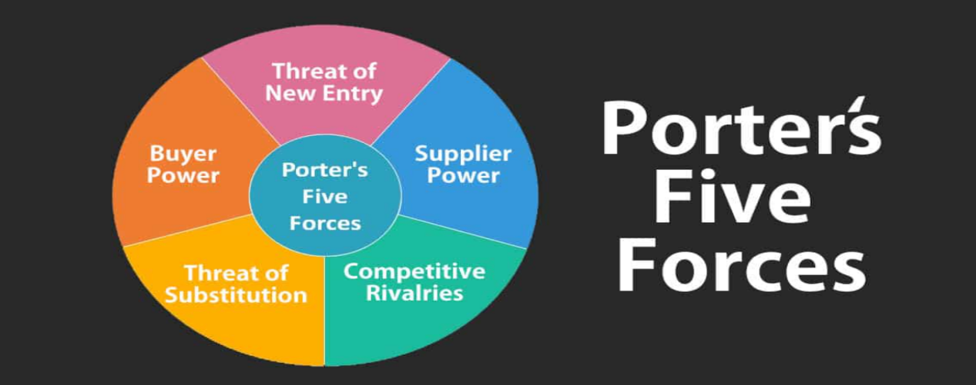
Figure 3
For Sainsbury's, we can use Porter's five forces model to analyze its internal and external environment and future impacts

Threat from competitors: The UK retail market is highly competitive and Sainsbury's has many competitors. This competition poses a threat to Sainsbury's and may lead to increased price competition and competition for market share (Pines, 2006).

Negotiating Power of Suppliers: Sainsbury's works with a variety of suppliers including food, drink, daily necessities and more. For some well-known brands and suppliers, they may have high negotiating power, affecting aspects such as price and quality.

Buyer’s Negotiation Power: British consumers are price-sensitive, but they are also concerned about product quality, service and shopping experience. Sainsbury's needs to remain price competitive while providing high quality products and services to meet consumer demand. (Aboubaker & Khayreddine, 2023).

Threat of substitutes: There are various substitutes in the UK retail market, including other supermarkets, convenience stores, online retailers and food delivery services. Consumers can choose other retailers or shopping methods.

Level of competition among existing competitors in the industry: The UK retail industry is highly competitive, with supermarkets striving to attract customers through price competition, product innovation and marketing activities.

The above analysis shows that Sainsbury's faces multiple challenges from the internal and external environment, including the threat of competitors, the bargaining power of suppliers and consumers, the threat of substitutes, and the degree of competition within the industry. (Hisan & Yusof, 2024).

2.4 Porter’s value chain analysis
Value chain, also known as value chain analysis, value chain model, etc. It was proposed by Michael Porter in his book "Competitive Advantage" in 1985. Porter pointed out that enterprises should develop unique competitive advantages and create higher added value for their goods and services. Business strategy is to structure the enterprise's business model and become a series of value-added processes. This series of value-added processes is the "value chain". ". (Porter, 1979).

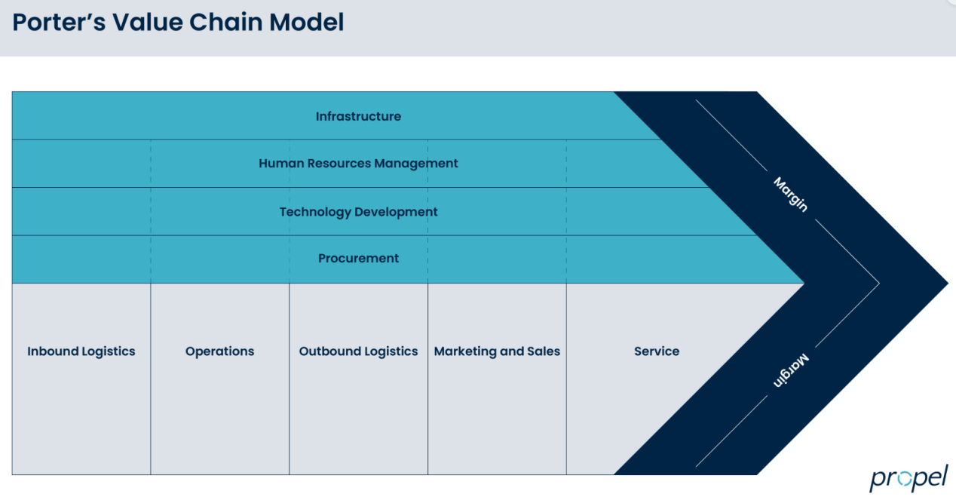

Figure 4

Support activities
Sainsbury's has a range of logistics facilities and warehousing facilities to support its supply chain management and distribution of goods. In the future, with the development of digital technology, Sainsbury's may need to invest in smart logistics and warehousing systems to improve efficiency and reduce costs (Ruan, 2020).

Technology plays an increasingly important role in the retail industry, and Sainsbury's needs to continuously invest in technology development, including online sales platforms, mobile applications, data analytics, etc., to improve customer experience and market competitiveness.

main activities
Sainsbury's needs to effectively manage its logistics network to ensure products are distributed to stores in a timely and efficient manner. In the future, Sainsbury's may need to optimize its logistics routes and distribution systems to improve transportation efficiency and reduce costs.

Marketing and sales activities are crucial to attracting customers and increasing sales. Sainsbury's needs to develop an effective marketing strategy including advertising, promotion and pricing strategies to attract and retain customers. In the future, Sainsbury's may need to strengthen the development of online sales channels and mobile applications to meet the needs of digital consumption (Koc& Bozdag, 2017).

Support activities
Procurement activities involve working with suppliers to obtain quality products and raw materials. Sainsbury's needs to build strong relationships with its suppliers and focus on the quality and cost of its products. In the future, Sainsbury's may need to optimize supply chain management to reduce procurement costs and improve product quality.

3.0 Recommendations
Sainsbury's can consider expanding into emerging markets and increasing product diversity to enhance the business's growth potential and revenue sources. By understanding the consumption habits and needs of different countries and regions, Sainsbury's can customize products and services to meet the needs of local consumers. At the same time, you can also consider cooperating with local suppliers to launch specialty products to enhance brand awareness and market share. Such initiatives help reduce market risks, expand business scope, and establish a more diversified and strong brand image globally.

With the increasing awareness of sustainable development, consumers are paying more and more attention to the environmental protection and social responsibility of products. As a result, Sainsbury's can expand its range of sustainable products and services to include organic food, environmentally friendly packaging, reducing food waste and more. By working with sustainable supply chain partners, launching green initiatives and actively participating in community activities, Sainsbury's can enhance its brand image and attract more environmentally conscious consumers.

Sainsbury's can further strengthen digital transformation and improve online shopping experience and services. This includes optimizing online ordering and delivery services, providing more mobile app functionality, and increasing digital payment options. By investing in advanced technologies and platforms, Sainsbury's can improve customer satisfaction, increase market share and improve operational efficiency.

4.0 Conclusions
Based on the above analysis, Sainsbury's supermarket faces challenges and opportunities in the current global economic environment. Political, economic, social, technological, environmental and legal factors affect its operations, and SWOT analysis shows its strengths, weaknesses, opportunities and threats in market competition. Porter's five forces model and Porter's value chain analysis reveal the company's position and competitive advantages in the industry. Therefore, Sainsbury's supermarket needs to respond to challenges through innovation, management optimization and strategic adjustment to achieve long-term development goals.

5.0 Reference List
Munoz, J. M. (Ed.). (2023). Digital entrepreneurship and the global economy. Routledge.

Mullin, R. (2023). Sainsbury’s: a campaign to raise money for schools and the environment. Henry Stewart Talks.

Smith, J. (2002). Understanding the Business Environment: A Comprehensive Guide to PESTEL Analysis. Harvard Business Review Press.

Johnson, M., & Scholes, K. (2018). Exploring the External Environment: PESTEL Analysis in Practice. Harvard Business Review.

Fisher, C. M. (Colin M. ), Lovell, A., & Valero-Silva, N. (2013). Business ethics and values : individual, corporate and international perspectives (Fourth edition). Pearson.

Smith, A. (2018). The Impact of Political Factors on Supermarkets: A Case Study Analysis. Harvard Business Review.

Main economic indicators. (2011). Organisation for Economic Co-operation and Development.

Mullin, R. (2023). Sainsbury’s: a campaign to raise money for schools and the environment. Henry Stewart Talks.

Li, C.-Y. (2019). How social commerce constructs influence customers’ social shopping intention? An empirical study of a social commerce website. Technological Forecasting & Social Change, 144, 282–294. https://doi.org/10.1016/j.techfore.2017.11.026

Social policy and society. (2002). Cambridge University Press.

Leten, B., Belderbos, R., & Looy, B. V. (2016). Entry and Technological Performance in New Technology Domains: Technological Opportunities, Technology Competition and Technological Relatedness. Journal of Management Studies, 53(8), 1257–1291. https://doi.org/10.1111/joms.12215

Global environmental change. (1990). Elsevier Science Ltd.

Ackrill, Kate., Bock, Gregory., & Lake, J. V. (1993). Environmental change and human health.

Johnson, L., & Thompson, R. (2015). Legal Factors and Their Impact on Supermarkets: An Analytical Study. Harvard Business Review.

Brown, C., & Wilson, D. (2018). The Influence of Legal Factors on Supermarket Operations: A Comparative Analysis. Harvard Business Review.

Porter, M. E. (2020). Competitive Strategy: Techniques for Analyzing Industries and Competitors. Harvard Business Review Press.

Markowitz, H. (1952). Portfolio Selection. The Journal of Finance, 7(1), 77-91.

Markowitz, H. (1959). Portfolio Selection: Efficient Diversification of Investments. John Wiley & Sons.

Pfeffer, J., & Salancik, G. R. (1978). The External Control of Organizations: A Resource Dependence Perspective. Harper & Row.

Humphrey, A., & Boon, E. (2004). Project Management: SWOT Analysis. British Journal of Management, 15(2), 113-124.

Grant, R. M. (2010). Contemporary Strategy Analysis: Text and Cases Edition. John Wiley & Sons.

Carroll, A. B. (1991). The Pyramid of Corporate Social Responsibility: Toward the Moral Management of Organizational Stakeholders. Business Horizons, 34(4), 39-48.

Frederick, W. C. (1960). The Growing Concern over Business Responsibility. California Management Review, 2(4), 54-61.

Carroll, A. B. (1999). Corporate Social Responsibility: Evolution of a Definitional Construct. Business & Society, 38(3), 268-295.

Porter, M. E. (1979). How Competitive Forces Shape Strategy. Harvard Business Review, 57(2), 137-145.

Dias, S., Espadinha-Cruz, P., & Matos, F. (2023). A Porter’s Five Forces Model Proposal for Additive Manufacturing Technology: A Case Study in Portuguese industry. Procedia Computer Science, 217, 165–176. https://doi.org/10.1016/j.procs.2022.12.212

Aboubaker Khoualed, & Khayreddine Bouzerb. (2023). Assessment of the Attractiveness of the Algerian Banking Market through the Application of Porter’s Five Forces Model. Management and Economics Review, 8(3), 332–341. https://doi.org/10.24818/mer/2023.10-06

Hisan, H., Badruddin, N. A., & Yusof, K. H. (2024). A Review of Malaysia’s Aerospace Manufacturing Post-COVID19 Pandemic Using Michael Porter’s Five Competitive Forces Model. E3S Web of Conferences, 477, 48-. https://doi.org/10.1051/e3sconf/202447700048

Pines, J. M. (2006). The economic role of the emergency department in the health care continuum: Applying Michael Porter’s five forces model to emergency medicine. The Journal of Emergency Medicine, 30(4), 447–453. https://doi.org/10.1016/j.jemermed.2006.02.001

Ruan, S. (2020). Research on Strategic Cost Management of Enterprises Based on Porter’s Value Chain Model. Journal of Physics. Conference Series, 1533(2), 22056-. https://doi.org/10.1088/1742-6596/1533/2/022056

Koc, T., & Bozdag, E. (2017). Measuring the degree of novelty of innovation based on Porter’s value chain approach. European Journal of Operational Research, 257(2), 559–567. https://doi.org/10.1016/j.ejor.2016.07.049

