Problem Solving and Innovation (BMSW4014)
Analysis of the factors impacting Starbucks in the UK

Lecturer name: Rhiannon Akers

Student name: Marius-Ionel Patrascu
Student id:2329813
Submission deadline:6 December 202
TABLE OF CONTENTS
INTRODUCTION 3
Internal Factors 4
SWOT Analysis 4
External Factors 6
PESTLE Analysis: 6
Microenvironmental Analysis 9
Porter’s Five Forces: 9
Recommendations 11
REFERENCES 13

INTRODUCTION

Figure 1 Starbucks Logo
Starbucks is an american coffee brand founded in 1971 by Starbucks was by Jerry Baldwin, Zev Siegl and Gordon Bowker. The company was founded on a strong determination to offer quality coffee to its customers accompanied by a tailored customer service. Due to its dedication and constant investment in business growth and development, Starbucks has managed to become one of the most powerful brands in the coffee market. The company has 38,000 coffee shops in the world and over one thousand coffee shops in UK only. It focuses on urban areas with access to middle to high income consumers. It has operations in America, Asia, Europe. The company has over fourteen million customers per day and over one hundred million customers per week.
This report uses various analytical tools such as SWOT, Pestel and Porter’s Five Forces to critically analyse what problems is Starbucks facing in the current business environment and how it chooses to respond to these problems. SWOT is used to analyse the internal capabilities of an organisation, PESTEL is employed to analyse the external factors in the environment that can have an impact on the operational activities of Starbucks and Porter’s Five Forces is used to analyse the macro-environment of Starbucks also known as competitive environment.

Internal Factors

SWOT Analysis
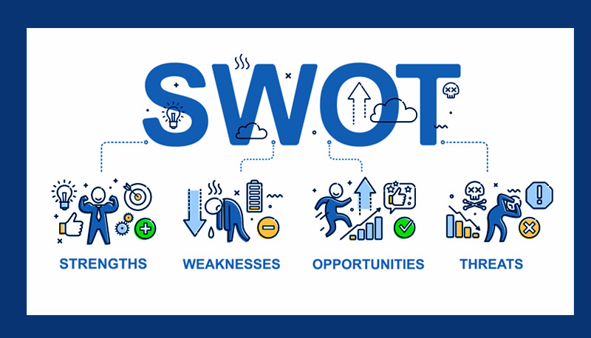
Figure 2 SWOT Analysis Illustration
Strengths:
- The company has a strong brand recognition due to its focus on quality and excellent customer service. Starbucks also developed a strong loyalty program that attracted customers and encouraged them to stay loyal to the brand for longer (BBC News, 2023). The loyalty program supports repeat purchases for customers and makes them feel appreciated by the brand (Mintel, 2023). The company also made sure to offer its customers a large portfolio of products, ensuring them that whatever drink they need, Starbucks is there to offer it.
Weaknesses:
- Some argue that one Starbucks’ weaknesses are its approach to premium pricing. This strategy limits consumers to those that can afford a four £ latte. During unfavourable economic times when discretionary spendings are limited, Starbucks can lose many customers due to their high pricing offerings. Other weaknesses that have been argued by other is Starbuck’s dependency on urban areas. Starbucks could increase market share by accessing suburban rural areas (Statista, 2023).
Opportunities:
Starbucks has many opportunities for further development and some of them include increasing demand for organic drinks, expansion into smaller cities and use of AI to enhance customer experience. The high demand for organic drinks can help Starbucks to attract new consumers and surprise the existing ones. Apart from satisfying consumers’ needs, Starbucks could also improve its brand image as a corporate citizen that takes part in the global call for improving diet to ensure a healthy lifestyle. Expanding into small cities can help Starbucks to increase market share, improve sales and therefore operational profit.
Threats:
Starbucks faces intense competition especially in less populated areas where other competitors had the courage to enter (Business Insider, 2024). Labour force can also act like a threat for the company as the quality of Starbuck’s customer service depends on its ability to secure enough workforce to meet customer demand. Raw materials acquisition can also act like a threat for the company. Starbucks plans the budget for raw materials to secure a positive profit and inflation keeps increases these costs, causing a hurdle for the company (Yahoo Finance, 2024).

External Factors

PESTLE Analysis:
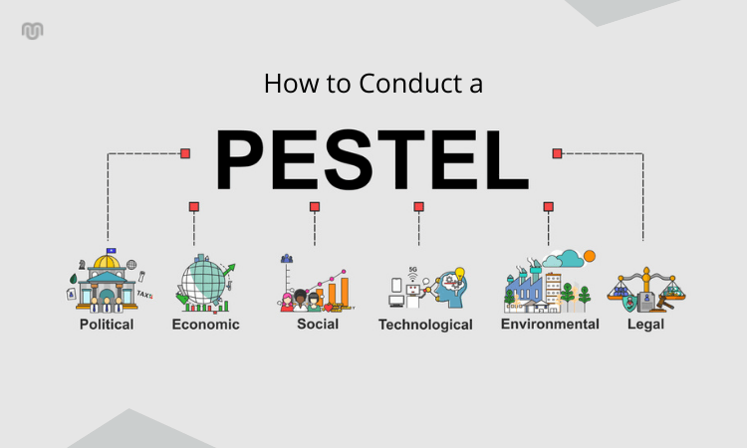
Figure 3 PESTLE Analysis
Political Factors
Starbucks operate in an international political environment, within which each country sets its own rules and regulations. These regulations regarding trade tariffs, wages, labour laws, consumer law impact the ability of Starbucks to generate positive profits. For example, after Brexit, when labour law changed and new trade regulations were introduced, Starbucks reported a decline in profits and had issues in securing enough workforce in its premises. This is because many migrant workers which were a significant part of Starbucks pool of employees, decided to leave the UK. During the pandemic, when businesses were closed due to lockdown, Starbucks lost millions of dollars in terms of profit (see graphic below) (Statista, 2024).
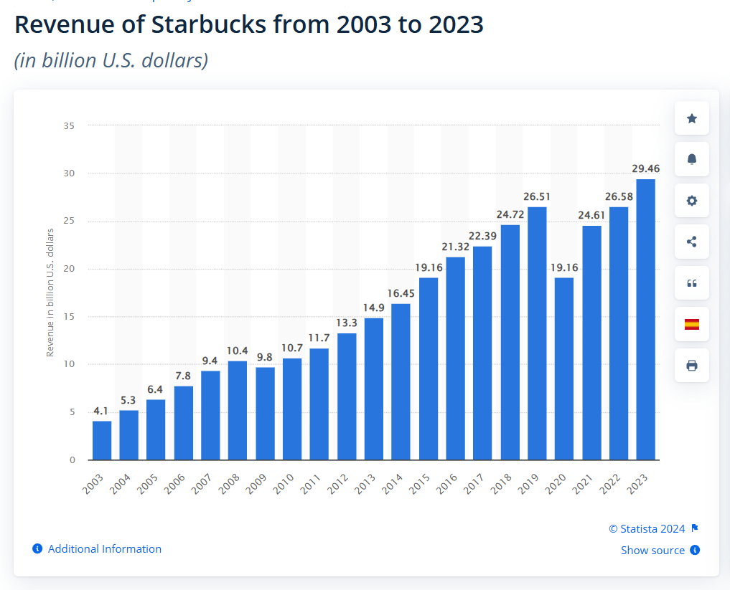
Economic Factors
The economic landscape of the United Kingdom has been going through tough times over the last few years. From Covid-19 to recovery post pandemic, to the Wars around the world, UK economy has been shrinking a lot, increasing inflation and cost of living for UK populations. This increase has been felt by businesses such as Starbucks through enhanced business rates, higher cost of materials, higher wages and decreased disposable income of consumers (Financial Times, 2023). During these challenging times, Starbucks took an interesting initiative. The company founded a customer wallet on its app. Customers can deposit money in their wallet to buy coffee or any other product. Starbucks can use those money for investment or covering up costs without relying on debt. Many have praised Starbucks model of operation during these tough times.

Social Factors
The demand for healthy product lines in the UK has been increasing over the last few years which made Starbucks introduce new sorts of products that do not enjoy much popularity now. However, even if a little bit difficult now, this initiative-taking response to consumer demand can help Starbucks in the future as it happens with many other organisations that saw and embraced change before happening (Reddy and van Dam, 2020).
Technological Factors
Starbucks is a leader in including digital tools in its business operations. The coffee brand has been using digital years for many years now as it helped the company to improve operational process and better understand customers. The company uses this shift to digitalization as an opportunity to improve competitive advantage, better known its consumers and improve strategic planning for the organisation. Customers are also part of Starbuck’s shift to digitalization through the app created by the company. They can use the app to make orders, have orders delivered to them, save loyalty points, receive rewards, check nearest Starbucks location, or deposit money into the app’s wallet (The Drum, 2023).
Environmental Factors
The United Kingdom along with the global world have made many calls for businesses of all kinds to change the nature of their business operation in such a manner that does not harm the environment, its people, and its resources. Starbucks has understood this call and its importance for brand reputation and made changes into its operational system to show customers its duty of care for the environment (The Times, 2023). Unlike many other companies that start their impact report with impact on the environment, in 2022, Starbucks focus was improving employees’ working conditions across its chain of operation. Employees working conditions is something that customers appreciate a lot when choosing a brand.
Legal Factors
Starbucks has been involved in two main lawsuits that are reported for us to analyse. One refers to one employment lawsuit, for which Starbucks paid twenty-five billion dollars as the company dismissed the employee based on racial discrimination. One is between Starbucks and an independent organisation that accuses Starbucks of lying about its ethically sourced coffee beans. According to those accusing Starbucks, the company still has many issues to resolve until this statement will be true. These lawsuits can damage the brand reputation of the coffee chain and can have a negative impact on its revenues.

Microenvironmental Analysis

Porter’s Five Forces:
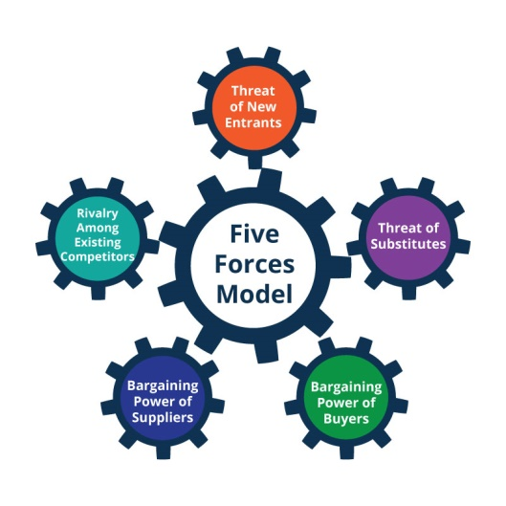
Figure 4 Porter's Five Forces
- Competitive Rivalry: Starbucks faces intense competition in the UK from both big players such as Costa as well as from small cafes (Dudovskiy, 2022).
- Threat of New Entrants: The coffee industry has moderate barriers to entry; however, it can be more difficult to establish a competitive presence for those small businesses with limited investment and resources.
- Bargaining Power of Suppliers: the bargaining power of suppliers is moderate now, however the current need of Starbuck for 100% ethically sourced beans can shift this power to a higher level for suppliers (Porter's Five Forces Team, 2022).
- Bargaining Power of Customers: Due to the intense level of competition in the coffee industry, buyers have a high bargaining power. However, Starbucks manages this efficiently by investing promotional activities, offers and constant product innovation.
- Threat of Substitutes: Starbucks treated this force very carefully and offered its clients a variety of choices to choose from in its stores. Once in-side customers can choose coffee, hot cholate, drinks, teas, milkshakes, and many other options (Strategic Analysis Hub, 2023).
Stakeholder Analysis
Stakeholder | Interests | Impact | Engagement Strategy
Customers | Quality, affordability, sustainability. | Drives sales and loyalty. | Offer affordable, healthy options; enhance loyalty programs.
Employees | Fair wages, growth opportunities. | Affects service quality. | Provide training, benefits, and positive culture.
Suppliers | Fair trade, sustainability. | Impacts costs and quality. | Build sustainable partnerships.
Government | Compliance with regulations. | Influences operations. | Ensure compliance, collaborate on sustainability.
Investors | Financial growth and stability. | Drives funding and growth. | Maintain transparency; highlight performance.
Competitors | Innovation and differentiation. | Affects market share. | Monitor trends; innovate to compete.
Communities | Jobs and ethical practices. | Builds reputation. | Engage in CSR and local investments.

Innovation Matrix
Dimension | Incremental | Disruptive
Products/Services | Affordable vegan options; seasonal items. | At-home premium coffee products.
Processes | Improve app efficiency; energy-saving tools. | AI for supply chain and demand prediction.
Customer Experience | Expanded loyalty rewards. | Immersive digital coffee experiences.
Market Expansion | Rural/suburban cost-efficient outlets. | Grocery store grab-and-go kiosks.
Sustainability | Discounts for reusable cups. | Zero-waste, carbon-neutral stores.

Recommendations

- Increase Veggie and Green sports Options.
Starbucks should expand its portfolio so that it offers more products from the plant-base given the current popular trend that seeks to have more plant-based products that are environmentally friendly. This would not only address the health consciousness of consumers and complement globalization objectives.
Ensure sustainable packaging and waste management to support environmental concerns hence making a comeback on the concern of consumer pressure and regulatory.

CONCLUSION
Therefore, Starbucks has the following challenges in the United Kingdom; Increased competition, The recession, and Changing consumer behaviour to healthier, environment-friendly products. PESTLE analysis identifies political, economic, and social aspects as influences on the Starbucks business, while SWOT helps in determining company’s strengths such as consumer brand recognition, and weaknesses, such as expensive products. It is noted that stakeholder analysis areas that it is crucial to have a good relationship with customers, employees, and supplier, as well as government bodies. Therefore, innovation – both sustaining and disruptive – must form a continued core of Starbucks’ strategic action in order to sustain market competitiveness; this is especially so in light of calls for the coffee major to increase its sustainability standing, as well as transform its digital services in line with the dynamic market.

REFERENCES
BBC News. (2023) Starbucks to open 100 new UK stores as profits rise. Available at: https://www.bbc.com/news/business-65012345.
Business Insider. (2024) China is Starbucks' 2nd Biggest Market, But Sales are Slumping. Here's Why. Available at: https://www.businessinsider.com/why-starbucks-is-struggling-in-china-sales-prices-competition-coffee-2024-8.
Dudovskiy, J. (2022) Starbucks Porter’s Five Forces Analysis. Available at: https://research-methodology.net/starbucks-porters-five-forces-analysis/.
Financial Times. (2023) Starbucks UK sales surge as coffee chain recovers from pandemic. Available at: https://www.ft.com/content/12345678-90ab-cdef-1234-567890abcdef.
Food Institute. (n.d.) Starbucks Has Big Plans for Smalltown America. Available at: https://foodinstitute.com/focus/starbucks-has-big-plans-for-smalltown-america.
Mintel. (2023) Coffee Shops - UK - Market Report. Available at: https://store.mintel.com/report/coffee-shops-uk-market-report.
Porter's Five Forces Team. (2022) Starbucks Porter's 5 Five Forces: 2022 Detailed Analysis. Available at: https://www.portersfiveforces.org/starbucks-five-forces-analysis/.
Reddy, G. and van Dam, R.M. (2020). Food, culture, and identity in multicultural societies: Insights from singapore. Appetite, [online] 149(1). doi: https://doi.org/10.1016/j.appet.2020.104633.
Starbucks (2024). Our Company. [online] Starbucks Coffee Company. Available at: https://www.starbucks.com/about-us/.
Statista. (2023) Number of Starbucks stores in the United Kingdom (UK) from 2005 to 2022. Available at: https://www.statista.com/statistics/297863/number-of-starbucks-stores-in-the-united-kingdom-uk/.
Strategic Analysis Hub. (2023) Porter’s Five Forces of Starbucks. Available at: https://strategicanalysishub.com/porters-five-forces-of-starbucks/.
The Drum. (2023) Starbucks UK sees strong sales growth, plans further expansion. Available at: https://www.thedrum.com/news/2023/03/15/starbucks-uk-sees-strong-sales-growth-plans-further-expansion.
Yahoo Finance. (2024) Starbucks (SBUX) Banks on Expansion Efforts Amid Rising Costs. Available at: https://finance.yahoo.com/news/starbucks-sbux-banks-expansion-efforts-172605417.html.

