Website summary
Dylan Jones
Student no: 2106499
Course: network and cyber security
Module: Introduction to web and database concepts
02/05/2022

Table of contents

Introduction 3
Requirements 4
Implementation 5
Validation 10
Evaluation 12
Usability 13
SEO: search engine optimisation 13
References 15
References 15
Appendices 16

Introduction

In this report you will find information regarding my website that I have created. I will be giving a break down of the website, why I made it and why that subject, I will be validating my html and css to make sure that there are no errors. I will be giving an evaluation as well that goes over the website and what features and accessibility are available. At the end of the report, you will find both my home page HTML and my CSS.

Requirements

My website is about Wales, the main purpose of the website is to allow people who have never been to get an idea of what they can do while visiting Wales, or they can use the website as a guide and travel around Wales at their pace. Not only is it for those who are visiting, it can be used by those who are merely interested in Wales but have no intention of going and would like to see what Wales has to offer without doing extensive research. The main subject that my website focuses on is traveling around Wales; mainly for tourists but this is used for anyone who views the website, regardless of where you are in the world. As I said, I am intending for the website to viewed by those who are visiting Wales for a holiday, any one of different age ranges can view the website and again there is no restriction that makes it so that only people outside of Wales can use it, it would be counterproductive.

Implementation
Index page/ Home page
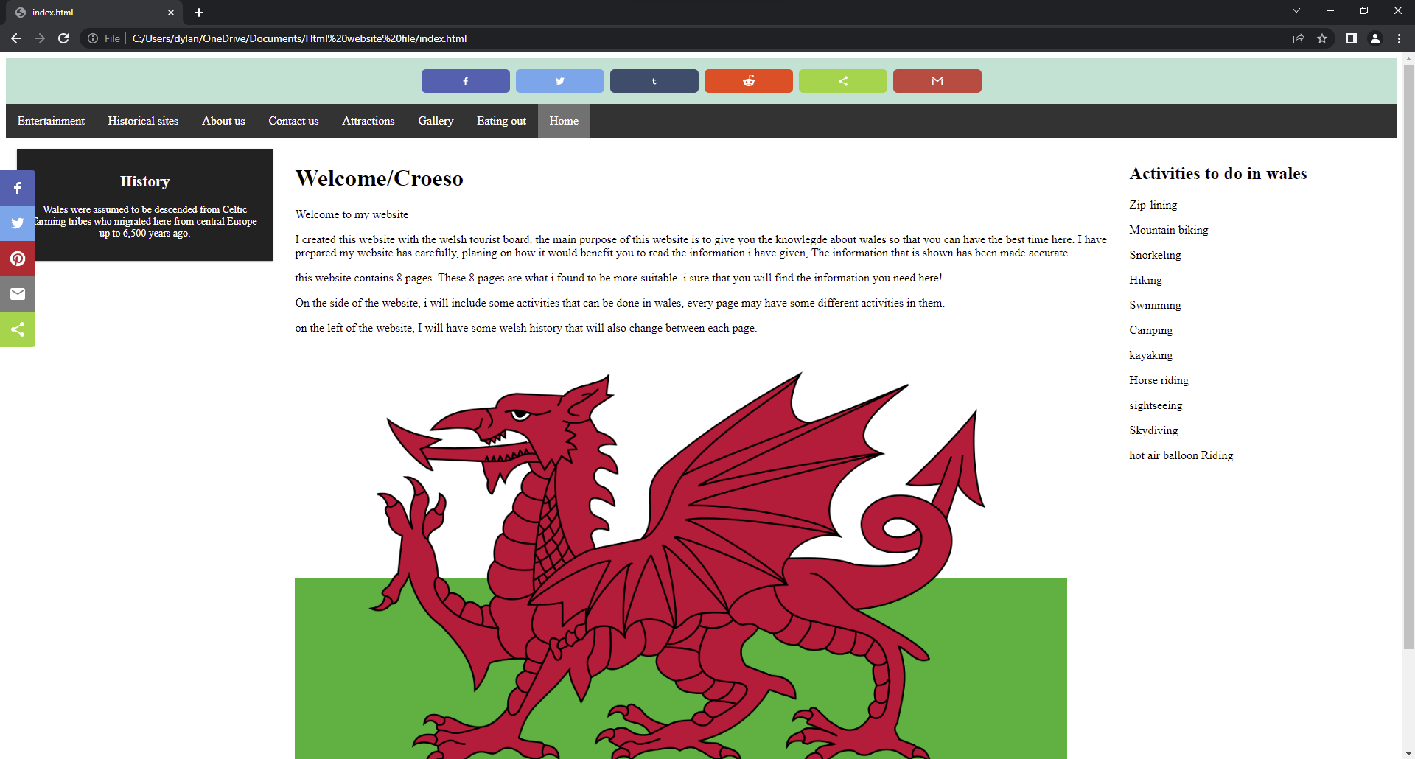
This is the home page or Index page. Here you are welcomed and given a brief description about what you can find on the website. i kept the first page brief as all the content is on the other pages. I have included a navigating system to allow users to go to any page as they please.
Attractions page
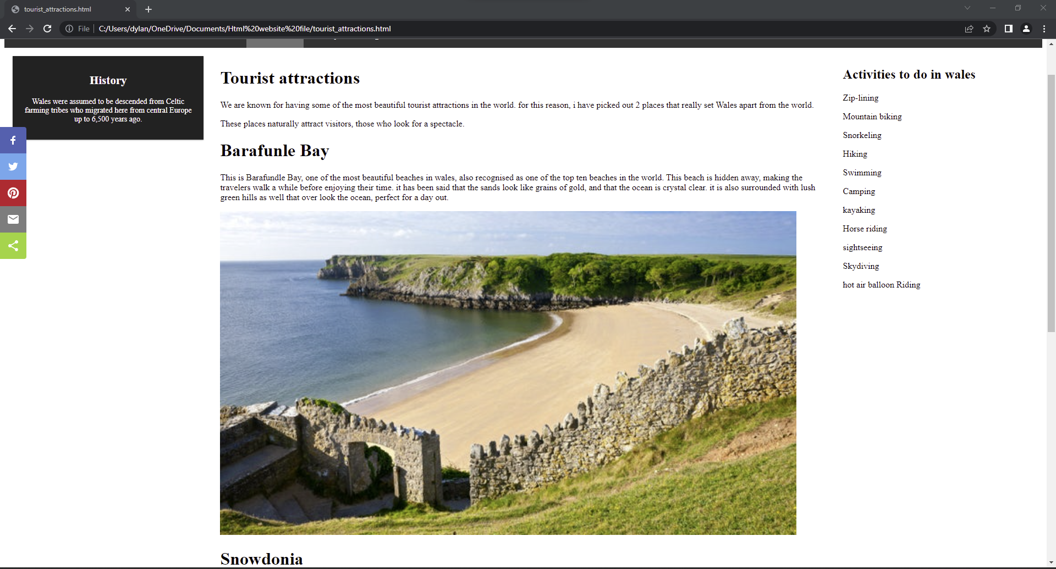
This is the attraction page, here the users can see what type of places are available for them to go and visit, I only included 2 – 3 images as I didn’t want the user to feel overwhelmed and also, I didn’t have a lot of space, so I only limited it to that many. I used popular places such as Barafundle bay which is one of the best beaches in the World, I shown an image of Snowdonia as well as that is also a popular place for people to visit.

Historical sites
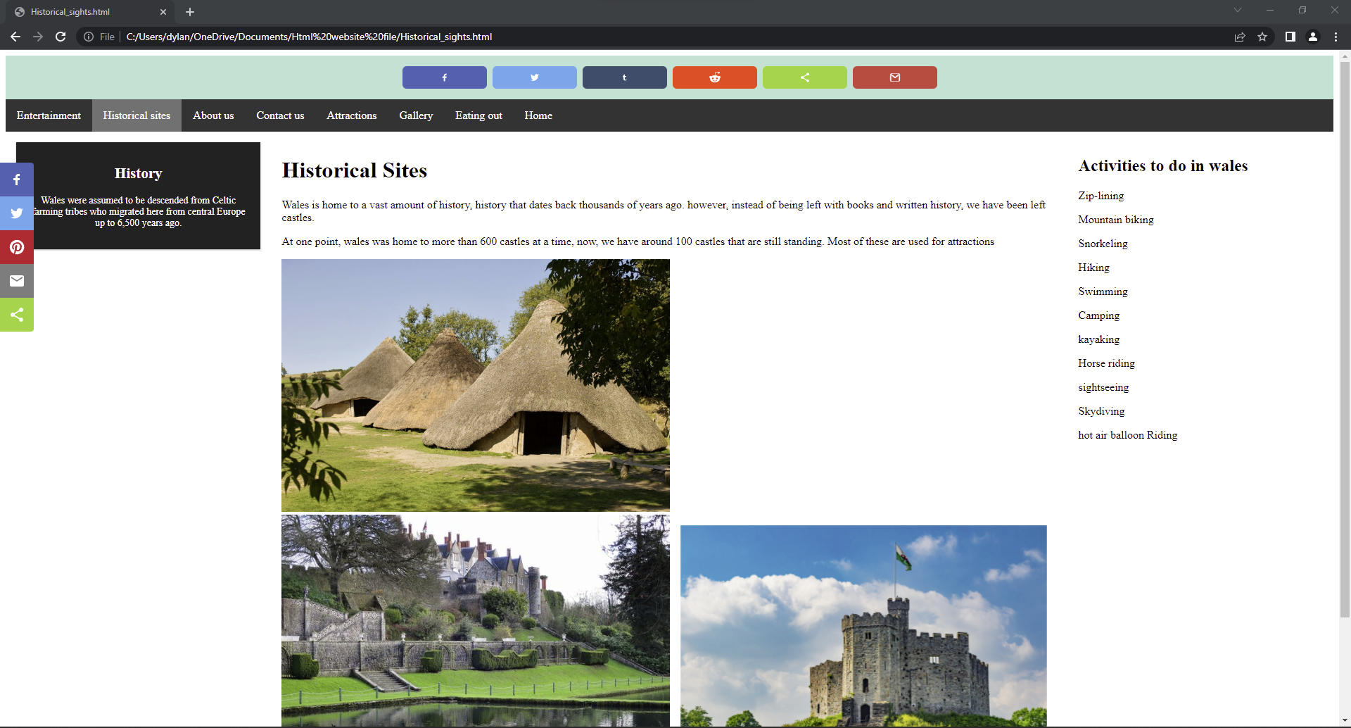
This is the historical sites page. Because Wales has a lot of history and heritage, I wanted to touch on it in the webpage. The images clearly show the amount of history that wales have, and from the look of them anyone would want to have a closer look.
Entertainment site
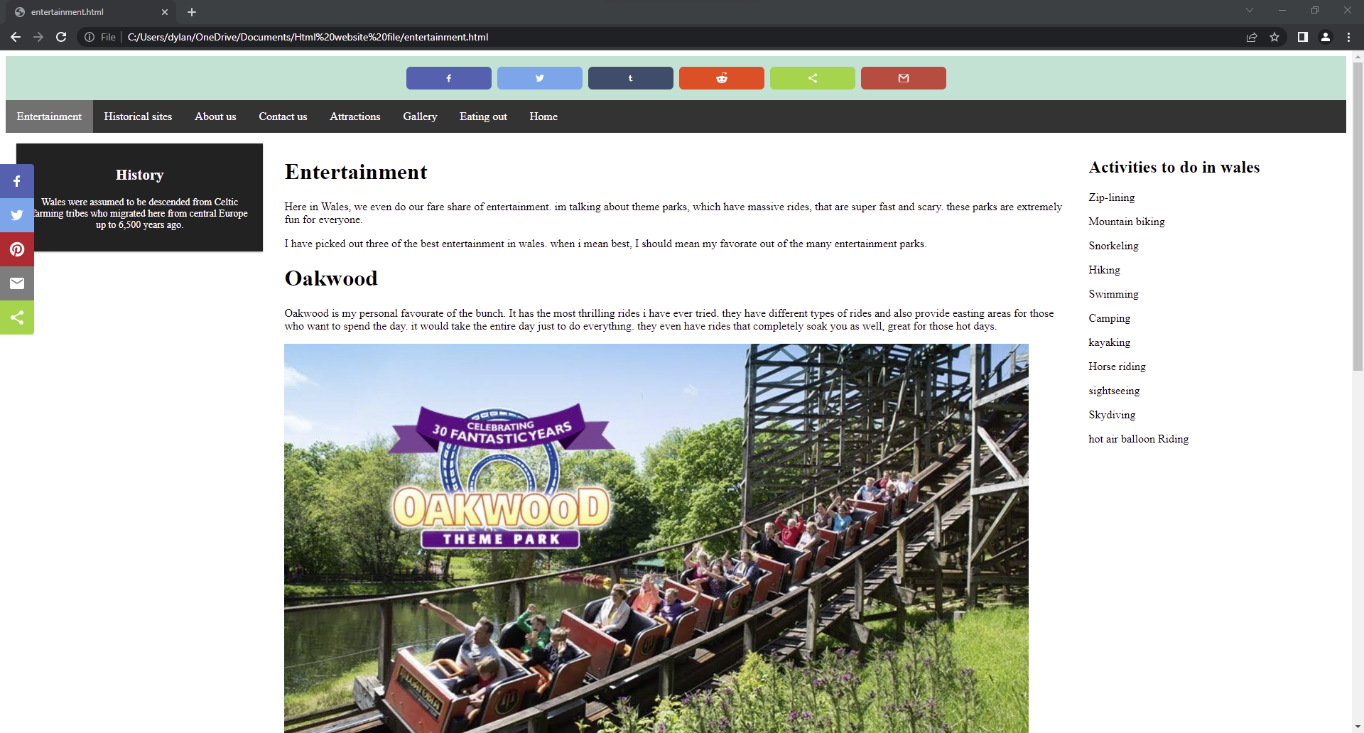
This is the entertainment page. In Wales we have some of the best rides and are extremely great for those adrenaline freaks out there. I included some fan favourites, such as Oakwood and an extremely fun place called folly farm.

Gallery page
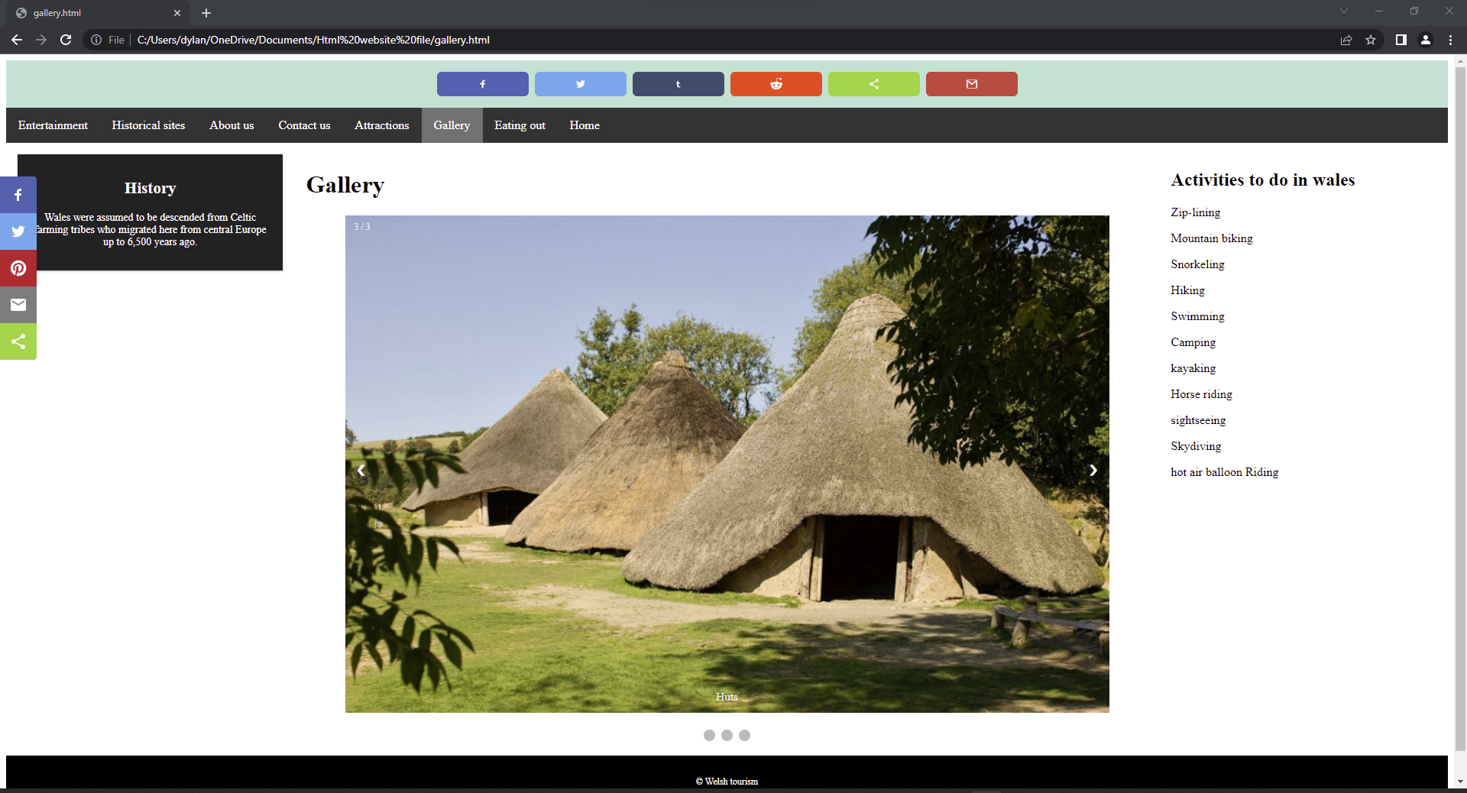
This is the gallery page, this is purely just to show of the images that I have used on the website, this slideshow only has 3 images, but they are completely different, and I would like to add more in the near future

Eating out page
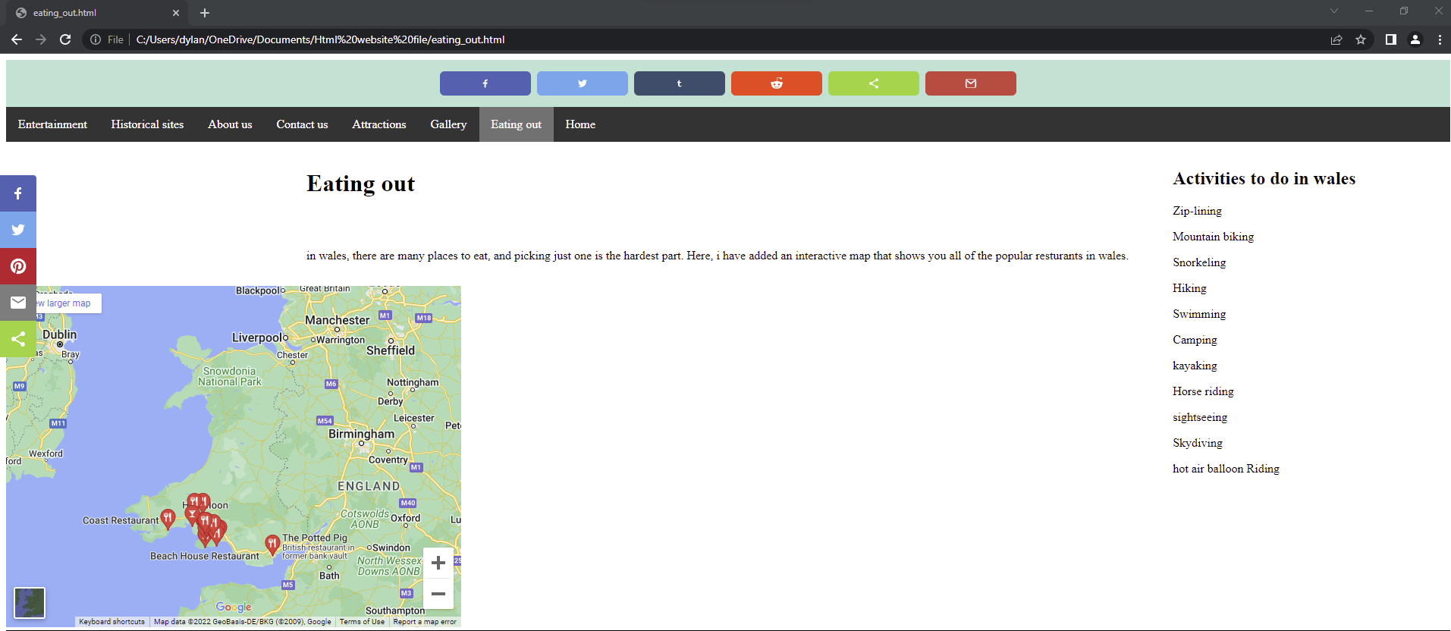
This is the Eating out page. It has a google map of Wales, but highlights the places serve food, some of them are the classical pubs, but some restaurants are mixed in there as well
Contact form page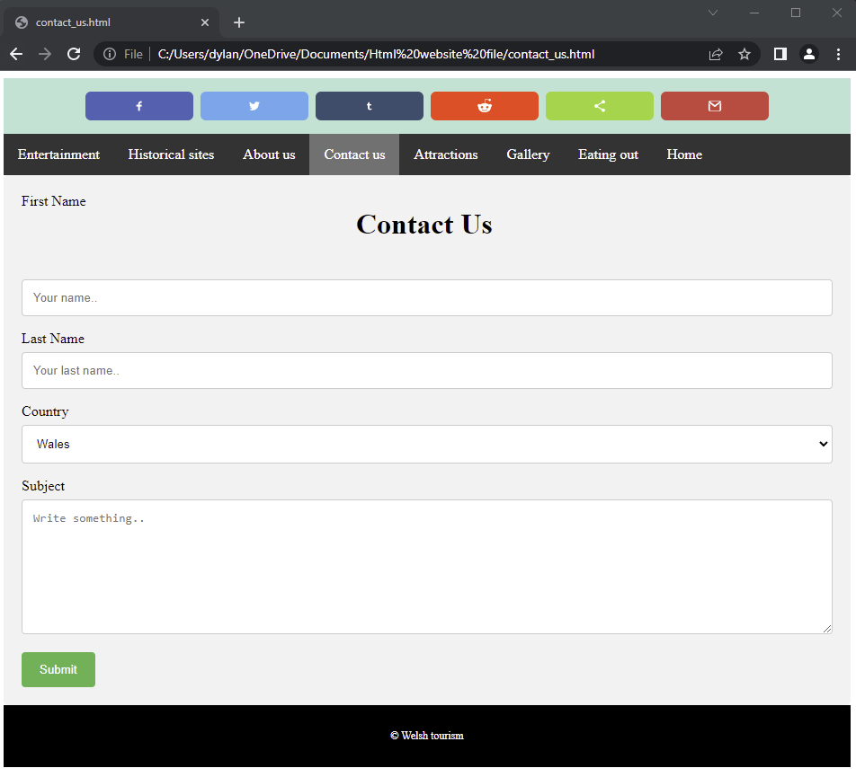
This is the contact form page. I haven’t made a submitted page just yet, but the idea for this is the user can write a request to staff and have them help them with anything the customer needs, it could be help with the website itself, or it could be to do with anything else that the user needs to know. This is just a small basic form, but soon, I would like to add more fields and a new page that responds to the submission of the form.

About us page
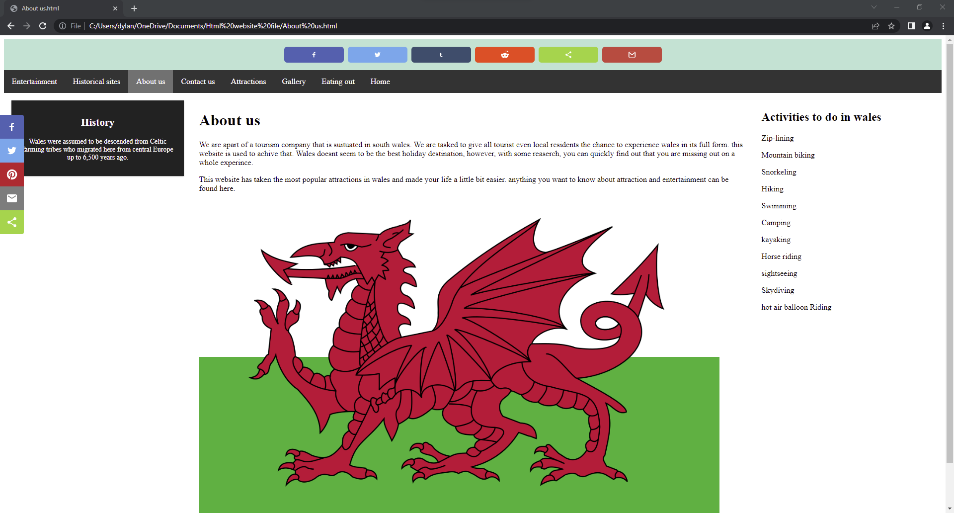
This is the about us page. This webpage has little information, just explains where we are based and a little about why we made the website.

Validation
HTML/ index.html
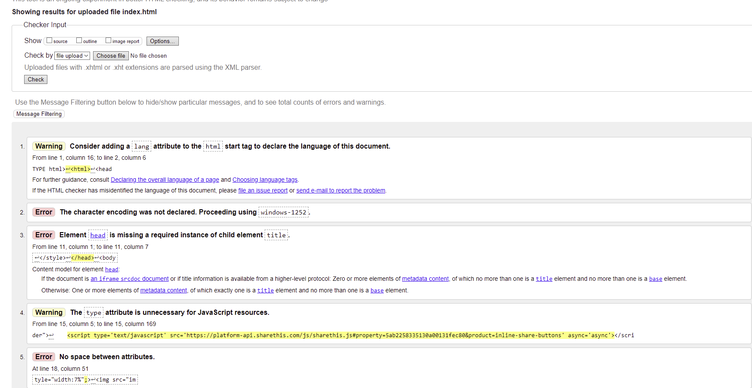
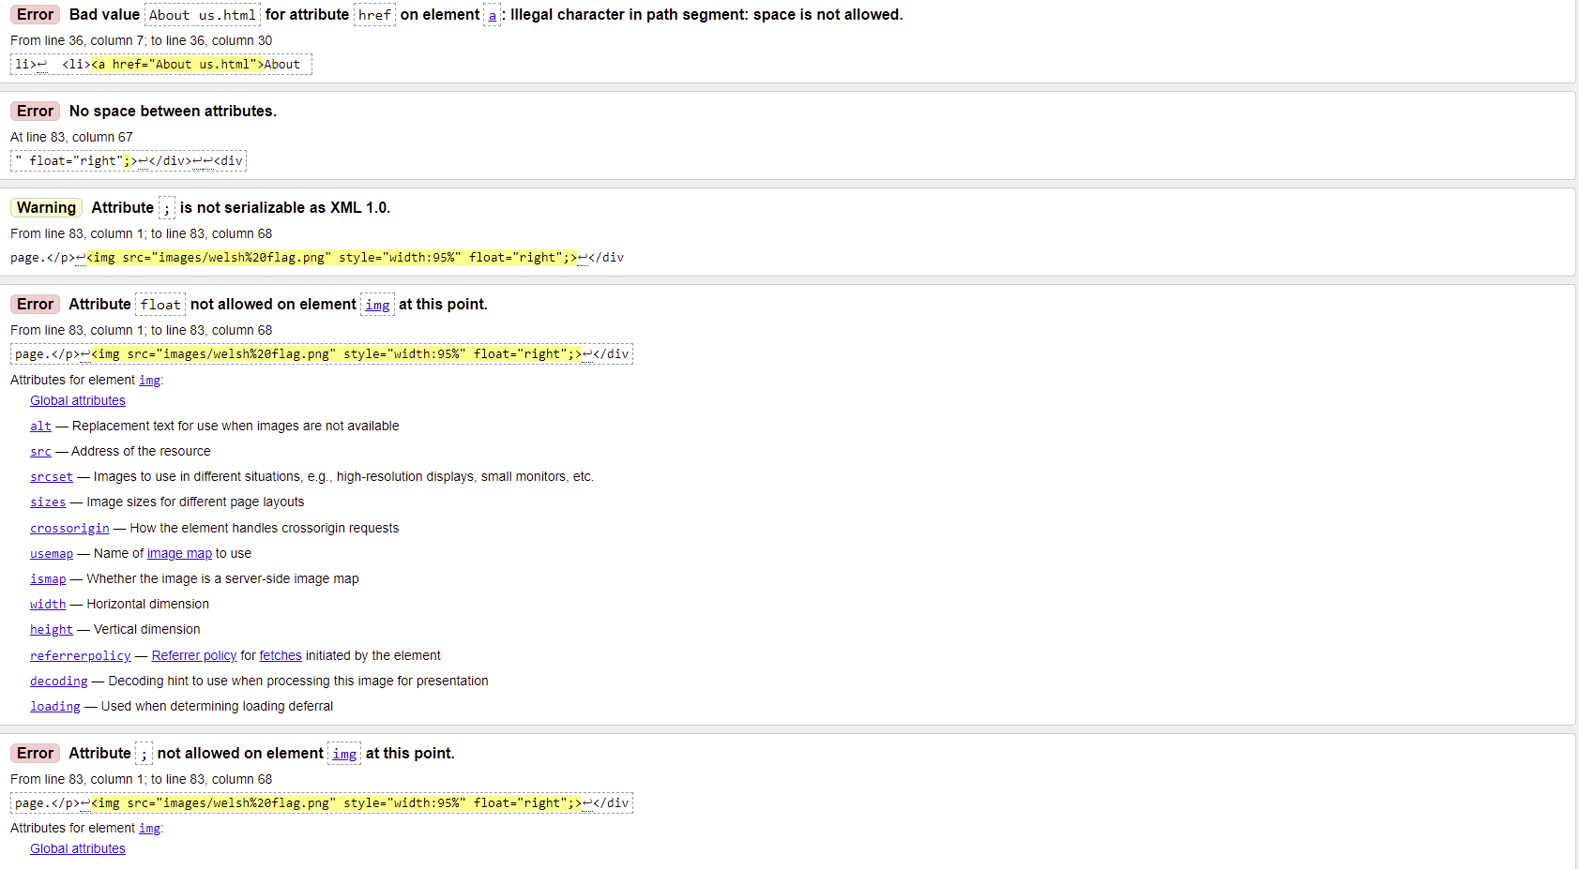
I have had quite a few Errors in this HTML file, upon further looking, the majority of the errors consists of not allowing elements and attributes. Some of the errors suggested that I add something to them or delete an element as they are interfering with things like the images and such, I will not be covering the warnings as I can’t seem to fix them.
Again, most of the errors are the same, and even though I can fix most of them, some will not go away. I have found that there isn’t a problem when I run the webpage, all of the images I use are fully functional, so some of the errors are misplaced, I think.
CSS/ Stylesheet.CSS
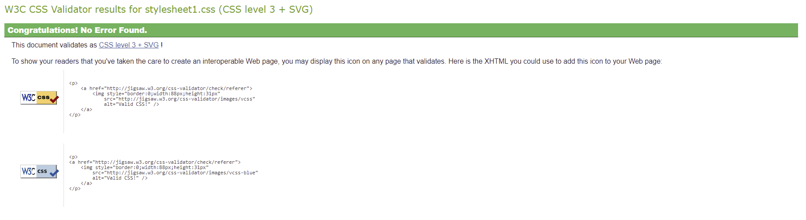
After using the Validator for the CSS, it was found that my code has no errors, which thankfully means i don’t need to change anything.

Evaluation
Website usability comes down to the user and their experience while using the website. it mainly comes down to how easy your website is to use, or can the user use the website easy enough to get what they need. The usability of a website can also mean how long it takes to get used to the webpage, which increases the time it takes for users to find what they need, they become used to the website and start understanding where things are specifically. Usability doesn’t fall just to one category of people, there are multiple users of different backgrounds which means that the webpage needs to be able to give them the ability to use the website without problems. It could be that you offer a product or something that requires them to regularly use the webpage, with each time they use the webpage, they must be able to learn how to effectively and efficiently find and use the product they want to get [1].
Website accessibility doesn’t just mean who can access the website, it also means those with impairments are able to use the website as well with very little complications. A majority of people have some impairment that makes their lives very difficult, and its just the cherry on top of the cake when they go on a website that doesn’t have the right accessibility for them. For example, for those who have a visual impairment or someone with bad eyes, making the text bigger, or bolder can help them greatly, if in fact they are completely blind, then adding a transcript could be of benefit, this will then help those with blindness to hear what the images or text say. The content that is on the webpages should not be on a timer, like in 3 seconds you will have moved to a new page without even processing the first, some proper can be quite slow, mainly elderly people. Elderly people may also struggle to understand the information if it is to complex, so I would make sure that the information is very clear and concise so that they don’t have to re-read everything. The most important thing I would say is, if you have accessibility options then they should be shown or said before the user starts wandering the webpages, as that could be the only thing they are looking for. There are also various areas that need to be approved for the accessibility features on the website to have the sign of approval. You have AA – 1.4.3 pass indicator which is for fonts below 18 points, AAA – 1.4.6 pass indicator which is also for fonts below 18 points, AA18 – this is for fonts over 18 points, AAA18pt – this is also for fonts over 18 points, Colour pass – this means that you follow a good colour pallet and don’t have too many contrasting colours, Colour diff – how readable your text would be when viewed in greyscale. [2]
SEO or search engine optimizations is the function that most search engines use, like google, yahoo, Firefox, Bing, and the like. Now, what this does is it in a way boosts your websites rating or ranking against other websites. For example, say if you are selling a product, let’s say plants, you sell premium plants that everyone can buy and grow huge plants, you are placed with not only other people who sell plants but also who sell plant related products and such. When I say rating, I mean it figuratively, like the more your page talks about plants the higher above other pages you’ll be. When you type words into the search box in google or Bing in reality, it is scanning the whole WWW for the keywords you typed, for example, if you typed Plant powder, then the webpage that has more instances will appear at the top, if you only have instance of this then you will be like 3 – 4 pages behind other websites. It also comes down to popularity, for example, websites like amazon will almost always be at the top because they sell a huge range of items. [3]

Usability
I have made my website as easy to use as I could make it, I have included a navigation system at the top of the page where it can be clearly seen, the text is white with a black background which is easily seen, the navigation takes you to the page that you click on. I have made it so that the website would follow a similar look and feel so that confusion would be avoided at all costs, I stuck with a simple colour palette as I myself do not like bold and big colours, white, black and a pastel colour makes a good palette. I will mention that the information I have included is very straight forward, I do however understand that there isn’t a lot of information that can be digested. The information is very concise but again if I added more, I think the users would be more than happy. There are some areas that I would like to improve, in the eating out page, the map is out of place, I would like to add more information, and some more images as well of different places as well.

SEO: search engine optimisation
I have used a wide range of SEO in my website, as my website was made for visiting Wales, I have included a range of information that people will be looking for. Each webpage included information about each topic, because each webpage has different content it would boost my website much higher. The images I have used also play a big part as well, this is because while users’ type, for example, Wales, my website should be quite high as on the search as my website is about Wales.

Accessibility
Under the WCAG 2.1 standards, I have added as many accessibilities features as possible that I could. Those with visual impairment will have an easy time, as I have not used a wild colour palette, my font is clean, and the colour is readable. As you can see in the image below, I have got check marks for one of my pages, it shows that my font and colour palette is clear enough to be seen clearly. I have also included in the CSS that when you use a mobile or computer, the webpage will change to fit that size.
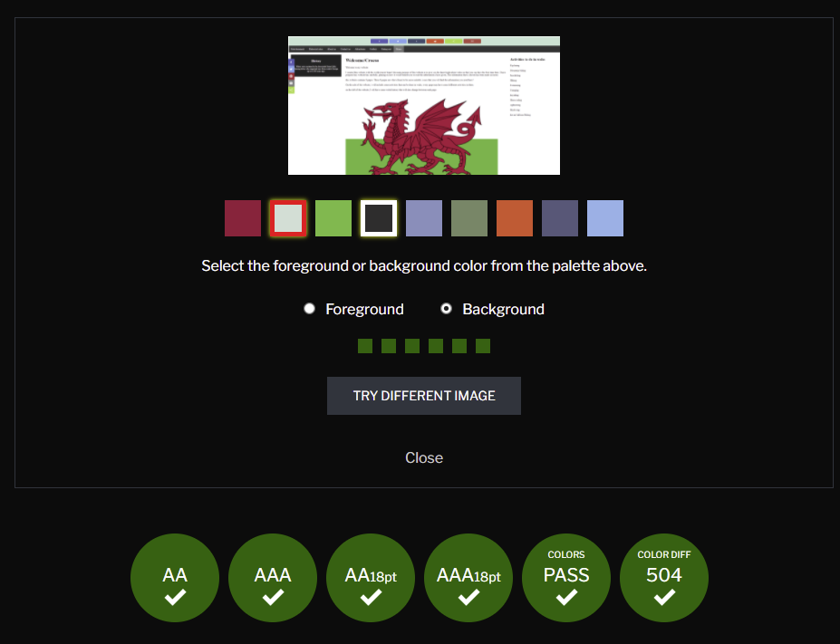

References

References

[1] | J. Brech, “Web Usability Definition,” Web wise wording, N/A N/A N/A. [Online]. Available: https://www.webwisewording.com/usability-definition/. [Accessed 28th april 2022].
[2] | unknown, “monsido,” [Online]. Available: https://monsido.com/web-accessibility. [Accessed 29 April 2022].
[3] | L. Baker, “How Does SEO Work,” SEJ, 17 December 2021. [Online]. Available: https://www.searchenginejournal.com/seo-guide/how-seo-works/#close. [Accessed 28 April 2022].
[4] | W3schools, “How TO - Slideshow,” [Online]. Available: https://www.w3schools.com/howto/howto_js_slideshow.asp. [Accessed 23 April 2022].
[5] Image of welsh dragon - https://www.istockphoto.com/photos/welsh-dragon
[6]Image of Snowdonia - https://felixsproll.com/photos/uk/snowdon-summit-sunrise-snowdonia-national-park-wales/
[7]image of Barafundle bay - https://www.nationaltrust.org.uk/stackpole/features/stackpoles-beaches-and-coastline
[8]castell henllys - https://www.visitwales.com/attraction/historic-site/castell-henllys-iron-age-village-2042269
[9]saint fagans - https://www.walesonline.co.uk/whats-on/arts-culture-news/st-fagans-named-best-museum-16528557
[10] folly farm - https://www.folly-farm.co.uk
[11] Oakwood -

Appendices
HTML/ Index HTML
<!DOCTYPE html>
<html>
<head>
<link rel="stylesheet" type="text/css" href="stylesheet1.css">
<meta name="viewport" content="width=device-width, initial-scale=1.0">
<style>
#myDiv {
border: 1px solid #FF0000;
}
</style>
</head>
<body>
<div class="header">
<script type='text/javascript' src='https://platform-api.sharethis.com/js/sharethis.js#property=5ab2258335130a00131fec80&product=inline-share-buttons' async='async'></script>
I used W3schools to help with the slideshow [4]
<div class="sharethis-inline-share-buttons"></div>
</div>
<div>
<ul>
<li><a href="entertainment.html">Entertainment</a></li>
<li><a href="Historical_sights.html"> Historical sites </a></li>
<li><a href="About us.html">About us</a></li>
<li><a href="contact_us.html">Contact us</a></li>
<li><a href="tourist_attractions.html">Attractions</a></li>
<li><a Href="gallery.html">Gallery</a></li>
<li><a Href="eating_out.html">Eating out</a></li>
<li><a class="active" href="index.html">Home</a></li>
</ul>
</div>
<div class="row">
<div class="col-3 col-m-3 menu">
<h2>Activities to do in wales</h2>
Zip-lining
<p>
Mountain biking
<p>
Snorkeling
<p>
Hiking
<p>
Swimming
<p>
Camping
<p>
kayaking
<p>
Horse riding
<p>
sightseeing
<p>
Skydiving
<p>
hot air balloon Riding
</div>
<div class="col-6 col-m-9">
<h1> Welcome/Croeso </h1>
<p> Welcome to my website</p>
<p> I created this website with the welsh tourist board. the main purpose of this website is to give you the knowlegde about wales so that you can have the best time here. I have prepared my website has carefully, planing on how it would benefit you to read the information i have given, The information that is shown has been made accurate.</p>
<p> this website contains 8 pages. These 8 pages are what i found to be more suitable. i sure that you will find the information you need here!</p>
<p> On the side of the website, i will include some activities that can be done in wales, every page may have some different activities in them.</p>
<p> on the left of the website, I will have some welsh history that will also change between each page.</p>
<img src="images/welsh%20flag.png" style="width:95%" float="right";>
</div>
<div class="col-3 col-m-12">
<div class="aside">
<h2> History </h2>
<p> Wales were assumed to be descended from Celtic farming tribes who migrated here from central Europe up to 6,500 years ago. </p>
<p> </p>
<p> </p>
</div>
</div>
</div>
<div class="footer">
<p> © Welsh tourism </p>
</div>
</body>
</html>

CSS/stylesheet
* {
box-sizing: border-box;
}
.row:after {
content: "";
clear: both;
display: block;
}
[class*="col-"] {
float: right;
padding: 15px;
}
html {
font-family: "Times New Roman", serif;
}
.header {
background-color: #B6E2D3;
color: #ffffff;
padding: 15px;
}
ul {
list-style-type: none;
margin: 0;
padding: 0;
overflow: hidden;
background-color: #333;
}
li {
float: left;
}
li a {
display: block;
color: #FFFFFF;
text-align: center;
padding: 14px 16px;
text-decoration: none;
}
li a:hover:not(.active) {
background-color: #111;
}
.active {
background-color: #111;
}
.aside {
background-color: #222;
padding: 15px;
color: #ffffff;
text-align: center;
font-size: 14px;
box-shadow: 0 1px 3px rgba(0,0,0,0.12), 0 1px 2px rgba(0,0,0,0.24);
}
.footer {
background-color: #000000;
color: #ffffff;
text-align: center;
font-size: 12px;
padding: 15px;
}
/* For mobile phones: */
[class*="col-"] {
width: 100%;
}
@media only screen and (min-width: 600px) {
/* For tablets: */
.col-m-1 {width: 8.33%;}
.col-m-2 {width: 16.66%;}
.col-m-3 {width: 25%;}
.col-m-4 {width: 33.33%;}
.col-m-5 {width: 41.66%;}
.col-m-6 {width: 50%;}
.col-m-7 {width: 58.33%;}
.col-m-8 {width: 66.66%;}
.col-m-9 {width: 75%;}
.col-m-10 {width: 83.33%;}
.col-m-11 {width: 91.66%;}
.col-m-12 {width: 100%;}
}
@media only screen and (min-width: 768px) {
/* desktop: */
.col-1 {width: 8.33%;}
.col-2 {width: 16.66%;}
.col-3 {width: 20%;}
.col-4 {width: 33.33%;}
.col-5 {width: 41.66%;}
.col-6 {width: 60%;}
.col-7 {width: 58.33%;}
.col-8 {width: 66.66%;}
.col-9 {width: 75%;}
.col-10 {width: 83.33%;}
.col-11 {width: 91.66%;}
.col-12 {width: 100%;}
}
input[type=text], select, textarea {
width: 100%;
padding: 12px;
border: 1px solid #ccc;
border-radius: 4px;
box-sizing: border-box;
margin-top: 6px;
margin-bottom: 16px;
resize: vertical
}
/* Style the submit button with a specific background color etc */
input[type=submit] {
background-color: #4CAF50;
color: white;
padding: 12px 20px;
border: none;
border-radius: 4px;
cursor: pointer;
}
/* When moving the mouse over the submit button, add a darker green color */
input[type=submit]:hover {
background-color: #45a049;
}
/* Add a background color and some padding around the form */
.container {
border-radius: 5px;
background-color: #f2f2f2;
padding: 20px;
}
* {box-sizing:border-box}
/* Slideshow container */
.slideshow-container {
max-width: 1000px;
position: relative;
margin: auto;
}
/* Hide the images by default */
.mySlides {
display: none;
}
/* Next & previous buttons */
.prev, .next {
cursor: pointer;
position: absolute;
top: 50%;
width: auto;
margin-top: -22px;
padding: 16px;
color: white;
font-weight: bold;
font-size: 18px;
transition: 0.6s ease;
border-radius: 0 3px 3px 0;
user-select: none;
}
/* Position the "next button" to the right */
.next {
right: 0;
border-radius: 3px 0 0 3px;
}
/* On hover, add a black background color with a little bit see-through */
.prev:hover, .next:hover {
background-color: rgba(0,0,0,0.8);
}
/* Caption text */
.text {
color: #f2f2f2;
font-size: 15px;
padding: 8px 12px;
position: absolute;
bottom: 8px;
width: 100%;
text-align: center;
}
/* Number text (1/3 etc) */
.numbertext {
color: #f2f2f2;
font-size: 12px;
padding: 8px 12px;
position: absolute;
top: 0;
}
/* The dots/bullets/indicators */
.dot {
cursor: pointer;
height: 15px;
width: 15px;
margin: 0 2px;
background-color: #bbb;
border-radius: 50%;
display: inline-block;
transition: background-color 0.6s ease;
}
.active, .dot:hover {
background-color: #717171;
}
/* Fading animation */
.fade {
-webkit-animation-name: fade;
-webkit-animation-duration: 1.5s;
animation-name: fade;
animation-duration: 1.5s;
}
@-webkit-keyframes fade {
from {opacity: .4}
to {opacity: 1}
}
@keyframes fade {
from {opacity: .4}
to {opacity: 1}
}

