
Module Title: Enterprise and Entrepreneurship

Module Code: LCLM 4006

Assessment: Individual Written Business Plan

Student Name: Humair Ul-Rahman

Student Number: 2521020

Lecturer’s Name: Dr Chung Lai Johnny Wan

Executive summary
Brunch and play will be a luxury play café specifically for children aged 0-5 and adults in Birmingham. The business will be a safe and stimulating environment for children to play alongside their carers who can enjoy luxury breakfast, brunch and lunch options.
The concept addresses a gap in the market in Birmingham and surrounding areas. Unlike traditional soft-play centres, Brunch and play will focus on educational and stimulating toys while children are always ground level and within their carers sight. While some play cafés do offer this, there are no play cafes in the Birmingham area that also offer luxury halal dining alongside the play aspect.
Revenue will be generated through play sessions, memberships, café and food sales, children's parties, private hire, events and potential classes or activities. The business will target primary Muslim carers. While everyone is welcome, marketing with target those with young children. The halal menu will target Muslim customers.
Marketing will focus on social media, local parenting networks, community partnerships and customer loyalty programmes. The long-term vision is to establish Brunch and play as a leading family destination in Birmingham, build a loyal customer base and create a scalable business model with potential for future expansion.

Table of contents

Title page……………………………………………1
Executive Summary……………………………….2
Table of contents………………………….….……3
Overview of the Business Idea…………….……4
Market Research…………………………………...6
Marketing Communications……………………...8
Financials……………………………………………9
Reference list……………………………………...10

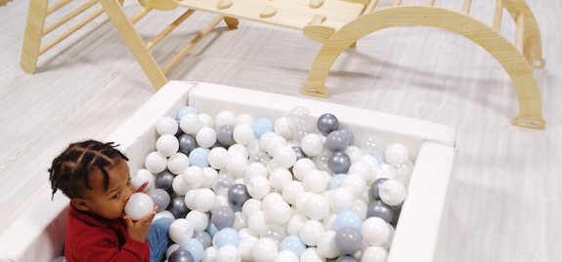
Overview of Business Idea
My business idea is a café and play area for under 5’s on the same floor in the same room. The café will offer fresh, homemade halal food options while carers can see their children playing in the play area a few feet away. There will also be an appropriate baby menu and a children’s menu. The venue will offer table seating, play only options, eat in only options, parties and exclusive hire. Brunch and play will be an asset to the community as it will offer discounted entry for mothers on maternity leave. We recognize that the maternity pay in UK can be limited for some and Brunch and Play is the perfect place for parents on maternity or paternity leave to eat good food and have a place that caters for their babies. We will have a sensory area dedicated to babies and children with sensory needs. Brunch and Play will offer three sessions a week dedicated to SEN children to offer them a safe space to play and access the play café. Brunch and play will have a social media presence from the start of our journey through all platforms such as Facebook, TikTok and Instagram. This will allow us to promote our business and ensure the local community are aware of all we have to offer.
(Softplayscout, 2026)
There are around 11 to 18 soft plays in Birmingham (Softplayscout, 2026) and there are around 800 halal food places in Birmingham (Checkmyhalal, 2026), however there are no play cafes that sell halal breakfast and brunch. The play cafe will offer a range of open ended, educational and stimulating toys for children aged 0-5. The play café will offer a range of hot and cold drinks, breakfast, brunch, lunch and other meals. We will aim to provide a range of fresh, tasty, inviting food. The food will be different to other halal food served in play areas in Birmingham as it will not be fast food. We will aim to make as much of the food in house as possible and we will focus on a healthy, nourishing menu.
The USP for this business would be ‘a dedicated family play café where parents can enjoy nutritious, high-quality halal breakfast and brunch while their children play in a safe, stimulating environment’. The business will be attractive to Muslim parents while still being inclusive of non-Muslim families. While there are many soft plays and play cafes in Birmingham and there are many halal cafes in Birmingham, the advantage comes from integrating children’s play with a healthier halal menu.
Legal format:
Business structure: Private Limited Company (Ltd)
Ownership: You would initially be the shareholder/owner
Management: You would be the director
Business activity: Children's play café providing indoor play facilities alongside halal breakfast, brunch and healthy food
Location: Birmingham, England
Purpose: Profit-making commercial business
I have chosen to set my business up as a limited company as it will be legally separate from the people who own it (Gov.uk, 2026). A limited company is the right option for my business as I want to grow my business with employers and may potentially raise external investments. I will also register the business with the local authority 28 days before trading as we will also be trading as a food business (Gov.uk,2026).

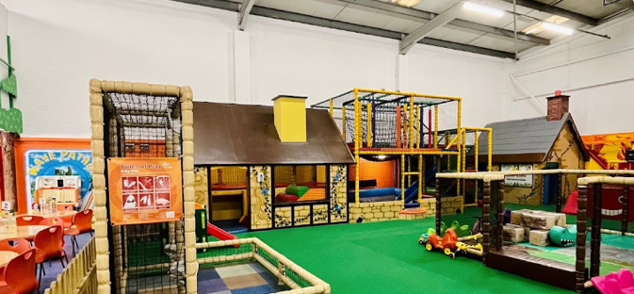
Market research
I have created a PESTEL analysis to display my research and findings.
(Softplayscout, 2026)
Political:
Opening a business in Birmingham can have political opportunities as there are many finance schemes and grants that could support a new business. I will continue to monitor Birmingham city council policies and research local business support.
Economic:
My business has two cost elements: hospitality and play. There are a lot of initial finance costs to consider such as: premises, play equipment, kitchen equipment, ingredients, utilities, insurance and employees. It is important to consider the national living wage has increased to £12.71 and may continue to rise (Gov.uk, 2026). We will focus on reducing risk through parties, events and advance bookings.
Social:
Birmingham’s 2021 census recorded 341,811 Muslims, representing 29.9% of the city’s population (Birmingham City Council, 2026). The is a large market to target the business towards. Although our play café will be inclusive to all, our social media market will focus on our halal food options alongside play.
Technological:
It is important to consider how we could use technology to our advantage. Ways we can use technology to support the business include online booking system, birthday bookings, card payment, social media marketing, digital loyalty cards, QR code menus, online reviews, email/SMS marketing and digital stock and accounting systems. Technology helps to reduce cost by ensuring we do most of the marketing on social media.
Environmental:
It is very important to us that we develop a sustainable business. We will: reduce food waste, buy local ingredients where practical, use recyclable packaging, avoid single use plastic, offer appropriate food portions and use energy efficient equipment.
Legal:
It is important for us to ensure all health and safety procedures, risk assessments, insurance and policies are followed as children will be using our facilities. In terms of food, we will follow food safety policies including hygiene and information about the 14 regulated food allergens (Gov.uk, 2026).
Overall conclusion
The PESTEL analysis concludes that Brunch and Play has a distinctive position in Birmingham due to being a combination of both a café and soft play centre. While the social environment is the biggest opportunity for the business, the economic environment represent the biggest challenges.


Marketing Communications
Social media will be our main marketing channel. The business will be media led, community focused and highly visual. We will ensure we have accounts on all big social media platforms such as TikTok, Facebook and Instagram. We will include content such as short videos showing the play area, videos of food and drinks being prepared, healthy children’s meal ideas, event decorations, parent reviews, new menu items and so much more. Our social media pages will become entertainment for all rather than simply advertisement for customers. We will focus on using lots of hashtags across all platforms to ensure our business can be searched for when carers are looking for play and food. Facebook is a good place to build a small community of local customers and encourage people to come together. Using social media to advertise allows us to reach influences and offer free visits in exchange for videos and reviews online. This allows our business to gain a wider reach. It is important for us to ensure social media is not only used to attract new customers but also encourage regular customers to leave reviews, follow the café, tag the café and subscribe to email lists. We will focus primarily on digital marketing.
(Facebook, 2026)

Financials
I would estimate that the business would require around £150,000 to launch. It is important to consider all factors such as premises, play equipment, café kitchen, furniture, initial stock, marketing and working capital. We would consider various funding sources such as start-up loans, bank loans, private investor, personal savings, community investment. The largest expenditure would be to refurbish the premises and buy play equipment. It is important for us to ensure high quality and safe play equipment for the children. The funding would include £25,000 start up loan, £50,000 bank loan, £50,000 business investor, £10,000 personal savings and £15,000 from crowdfunding. The main first-month expenses are estimated to include £10,000 for rent and deposit, £25,000 for refurbishment, £45,000 for play equipment, £15,000 for kitchen equipment, £7,000 for furniture, £3,000 for food stock, £2,500 for technology, £3,500 for insurance and professional fees, £5,000 for marketing and £10,000 for staff costs. A further £24,000 would be retained for utilities, contingency and working capital. These figures are estimates and would need to be confirmed through supplier quotations. We would use multiple sources of funding to support the business.

References
Soft Play Scout (2026) Soft Play Scout: Find soft play centres across the UK. Available at: https://softplayscout.co.uk/(Accessed: 18 October 2026).
Check my halal (2026) Check my halal. Available at: https://checkmyhalal.co.uk/ (Accessed: 18 October 2026).
GOV.UK (2026) Set up a business. Available at: https://www.gov.uk/set-up-business (Accessed: 18 October 2026).
GOV.UK (2026) Starting a food business. Available at: https://www.gov.uk/guidance/starting-a-food-business (Accessed: 18 October 2026).
Birmingham City Council (2026) Faith and religious communities: Population overview. Available at: Birmingham City Council (Accessed: 18 October 2026).
Birmingham City Council (2026) Business rates. Available at: Birmingham City Council business rates (Accessed: 18 October 2026).
GOV.UK (2026) Food business registration. Available at: GOV.UK food business registration (Accessed: 18 October 2026).
GOV.UK (2026) National Minimum Wage and National Living Wage rates. Available at: GOV.UK National Minimum Wage rates (Accessed: 18 October 2026).

