I confirm this essay is my own original work and does not include text created by a generative artificial intelligence tool.

Network Security Enhancement: Firewall Replacement Project

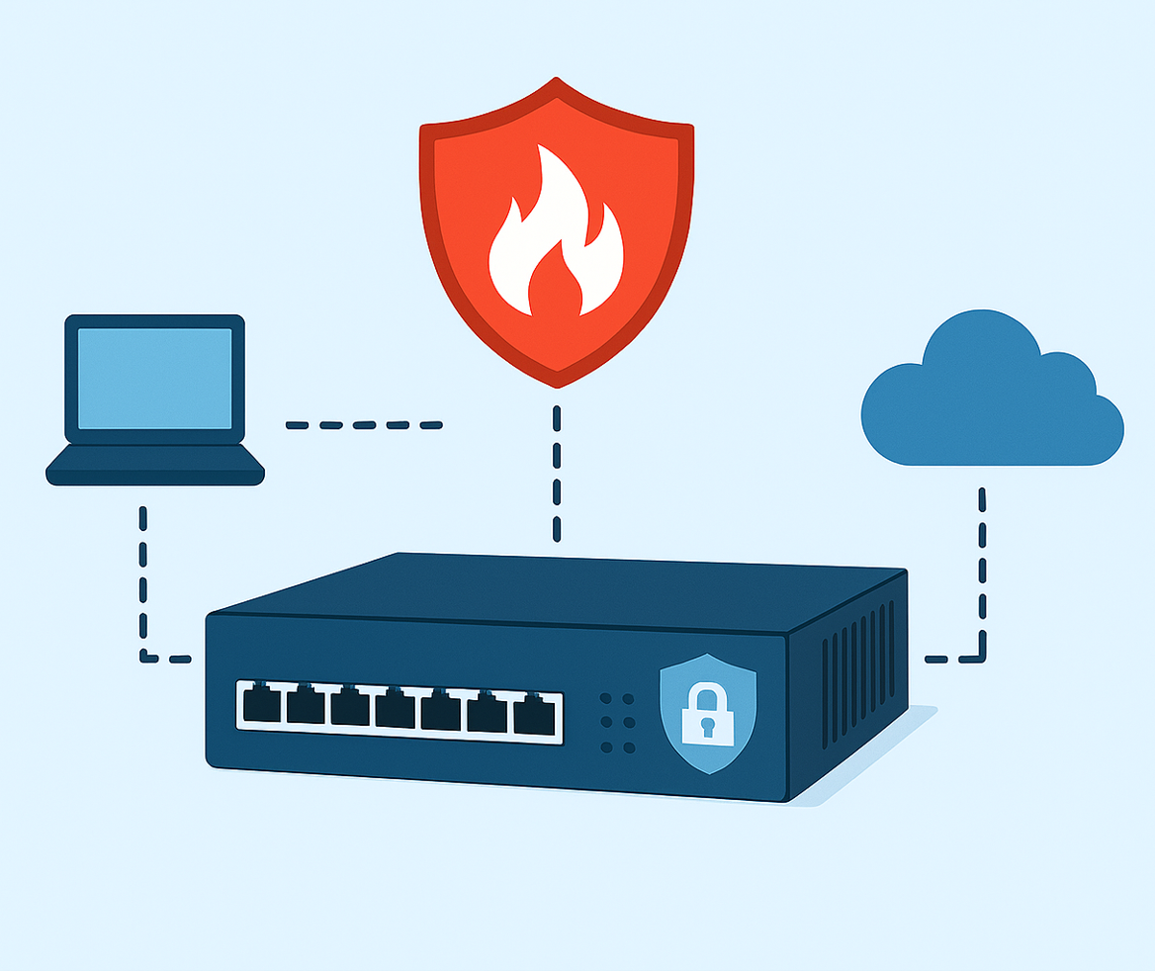
Introduction
Aneurin Bevan University Health Board (ABUHB) operates as a large, Multi-site National Health Service (NHS) organisation delivering acute, community and specialist services across several hospital sites. As clinical care modernises, it depends on reliable digital systems such as electronic patient records, diagnostics, imaging, prescribing and secure links to national services. Network perimeter security is a key part of this setup. It manages internet access, shields internal systems from external threats, and secures data transfers. Because healthcare is increasingly targeted by cyber-attacks, having strong, up-to-date perimeter controls in place is vital for service continuity and patient safety. Research shows hospitals are vulnerable, and cyber-attacks can directly disrupt work and service delivery within clinical settings (Kruse et al., 2017). Keeping the network secure, supported and visible is therefore not just an IT task, it is the core fundamentals of the organisation.
At three break-out sites within ABUHB, Royal Gwent Hospital (RGH), Neville Hall Hospital (NHH), and Ysbyty Ystrad Fawr (YYF), the Cisco ASA 5500 series firewalls are now becoming end of life (EoL) and end of support (Cisco Systems, 2026). When relying on ageing, unsupported devices, this increases cyber and operational risk. Without signature updates and modern detection features, ABUHB has less visibility of application traffic and fewer tools to spot abnormal activity or respond to new threats. This also makes it harder to meet governance expectations. Evidence on hospital downtime shows that IT failures related to Cyber-attacks or infrastructure faults, can have an enormous impact on delaying treatments, interrupting diagnostics and adding increased pressure to services (ECRI, 2026). NHS clinical safety standards also expect digital risks to be managed in a structured, demonstrable way (NHS England, 2018; NHS, 2025). Continuing with unsupported perimeter equipment does not meet those expectations.
The issue is both strategic and operational. Strategically, the security architecture needs to be modernised to reduce exposure and align with current resilience standards. Operationally, if no action is taken, there is a real risk of unplanned outages, more difficult incident handling, and reputational damage. There is not only the age of the hardware, but the mismatch between what the current infrastructure can assure and what a modern NHS environment requires. The literature on digital change in healthcare stresses that planned, structured change is needed to keep complex systems safe and reliable (Hastings, 2025). Replacing the Cisco ASA firewall is therefore about resilience, and alignment with governance.
The proposed project is to replace the Cisco ASA firewalls with a new Palo Alto appliance at RGH, NHH, and YYF in stages. The aim will be to maintain configuration consistency to ensure service continuity, migrate safely within agreed-upon windows, strengthen the perimeter, and improve manageability and logging. Palo Alto application-aware features, including App-ID, provide greater control and better monitoring (Balamitran, 2026).
PRINCE2 will be used as the methodology to guide the project to completion. It offers clear governance, defined roles, stage control and formal risk and change practises (PRINCE2®, 2025). In an NHS enviroment where infrastructure change can affect clinical services, these controls provide predictable assurance and clear escalation routes. The essay will explain how PRINCE2 will be applied in practice and critically assess how well it fits the operational, technical and organisational challenges of modernising firewalls across several hospital sites.
Method
The project will use PRINCE2 as the core Methodology because it aligns with the risk profile of transitioning from near-EoL Cisco ASA appliances to Palo Alto PA-3410s at RGH, NHH, and YYF. PRINCE2 is chosen for its clear governance, stage control, explicit risk management and defined roles, which are essential where network changes directly support clinical systems (PRINCE2®, 2025). In the NHS, perimeter security is not just a background task, it enables access to records, diagnostics, prescribing, imaging, and national services. As a result, structured governance and documentation assurance are not just administrative burdens they are there to provide essential safety measures. A study showed that information technology (IT) health care that has firm governance and visible leadership reduces disruption and improves reliability during complex digital change (Laukka et al., 2020).
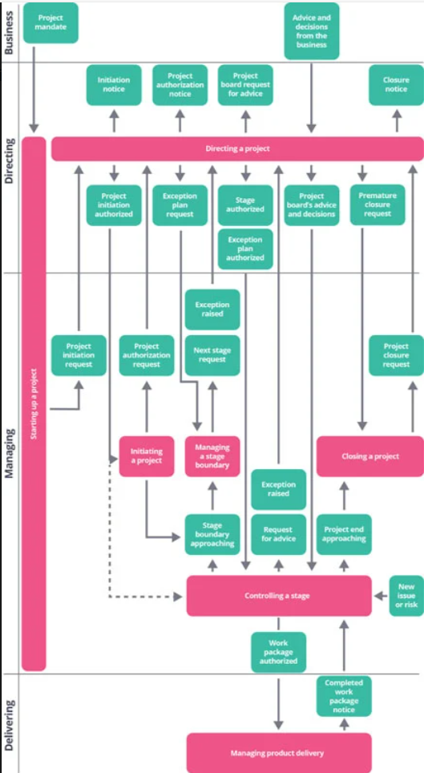
Figure1. The PRINCE2 Project Management process model (PRINCE2®, 2025).
As shown in Figure 1, the project will follow the PRINCE2 lifecycle from initiation through controlled stages, delivery, and closure. These processes create defined decision points and governance boundaries, ensuring each firewall migration stage is authorised, monitored and reviewed before progressing to the next stage. In low-risk-tolerance environments, this structured approach supports safe, transparent, and accountable delivery.
Other approaches were considered, like Agile, which offers flexibility, but risk tolerance at the network perimeter is low, and live experimentation is not appropriate in a hospital environment (The Risk Suite, 2024). Even a purely engineering-led approach without stage control would lack assurance and escalation. PRINCE2 principles, continued business justification, defined roles and responsibilities, manage by stages and manage by exception, provide predictable checkpoints, with clear escalation routes and executive oversight (PRINCE2®, 2025). These are essential when dealing with security-critical implementations (ECRI, 2026). While PRINCE2 can seem heavy on the documentation, it can be tailored so that control is maintained without adding unnecessary admin.
Governance will be set through a Project Board with Executive, Senior User and Senior Supplier. PRINCE2 defines governance responsibilities and separates strategic direction from day-to-day management (PRINCE2®, 2025). Executive accountability keeps cyber risk, continuity and financial exposure visible at a senior level. Agreed tolerances for cost, time, risk, and quality will enable management by exception, so that any issues during migration are escalated quickly. Research on digital transformation in healthcare shows how the importance of visible executive sponsorship provides delivery focus and risk ownership (Siwicki, 2025). Governance is not only a means of exercising control but also an indicator of the organisation's overall risk appetite.
Delivery will use the clear stage boundaries. PRINCE2 manage by stages principle requires formal approval before progressing between phases (PRINCE2®, 2025). The lifecycle will move from initiation and detailed planning to design, build and validation, then site-specific migration and then closure. Each hospital site cutover will run as a controlled stage with readiness criteria and a go/no-go decision before the change commences. Evidence on hospital downtime shows that a phased implementation reduces the risk of a widespread failure compared to a big-bang approach (Technology Equipment, 2025). Stage boundaries will act as operational safety gates, confirming testing, configuration checks and stakeholder readiness before the go-live change.
Delivery will be supported by structured PRINCE2, management products, including product-based planning, product description, risk and issue logs, quality criteria and a formal change control process (PRINCE2®, 2025). Key products will include the PID, detailed firewall High-level and low-level designs, Cisco ASA rule sets analysis outputs, migration scripts, rollback strategies, and post-implementation validation reports. Each of the products will have an acceptance criteria and technical sign-off. In complex NHS IT environments, traceable documents and quality checks are essential in reducing configuration errors and supporting any post-incident review (Wachter, 2016).
Stakeholder engagement will be managed as part of managing the change, not just as a communication task. PRINCE2 treats stakeholder engagement as a core practice requiring analysis and tailored engagement strategies (PRINCE2®, 2025). This project will affect Networks, Cyber Security, Clinical Safety Officers, Digital Business Continuity leads, Site Operational Managers, Change Advisory Board (CAB) representatives and third-party suppliers. Even though firewall replacement is infrastructure-focused, stakeholders influence the overall success of delivery. For example, operational managers must trust that the change windows are safe and that an adequate business continuity plan is in place for the duration. Cyber assurance teams must accept migration risk controls, and Network engineers must adopt new Palo Alto operational processes. Evidence suggests that structured early stakeholder involvement reduces resistance and improves the adoption of the digital change (Gagnon et al., 2012). Early technical and communication workshops with stakeholders, with open risk discussions, will support alignment.
The business case will be kept under review. PRINCE2 requires the case to remain valid at each boundary (PRINCE2®, 2025). The main justification for this project is risk mitigation, the removal of the soon-to-be-unsupported ASA devices, reduction of Cyber exposure, improved resilience and alignment with the organisation's standardised Palo Alto architecture. Healthcare cybersecurity research demonstrates that unsupported infrastructure increases operational and patient safety risk (Kruse et al., 2017). Highlight reports will track risk and resilience measures to ensure business justification remains sound.
Supplier work will be managed through clear work packages. PRINCE2’s roles and responsibilities principle outlines Senior supplier accountability and technical delivery (PRINCE2®, 2025). Third-party professional services for configuration and migration will be delivered under agreed statements of work, with clearly defined outputs, escalation routes, and day-to-day support requirements during change windows. Research on complex IT implementations shows that unclear Third-party accountability increases the likelihood of failure during the technical change windows (Oluwatosin Ilori, Nelly Tochi Nwosu and Henry Nwapali Ndidi Naiho, 2024). Clear lines between internal Networks and supplier engineers reduce ambiguity and risk.
Migrations will be phased by site, and a change request form detailing the required change, technical involvement, step-by-step processes, risk communication plan, and rollback procedures will be submitted to CAB for approval. PRINCE2’s change and progress practices require formal assessment and authorisation (PRINCE2®, 2025). Each change will run in agreed clinical windows with impact assessments and set communications. NHS Wales guidance reinforces that a structured CAB review for high-risk infrastructure change (NHS Wales, 2018).
Rollback plans will be fully documented and rehearsed prior to each go-live. PRINCE2’s risk practice requires planned responses and contingency planning (PRINCE2®, 2025). ASA configuration will be retained, Physical connectivity will remain in place for rapid reversion, and the change window will include a rollback trigger point when service degradation exceeds tolerance. Healthcare downtime demonstrates that a rapid rollback capability significantly reduces patient safety risk during IT outages (ECRI, 2026). Escalation routes to operational and clinical leads will be live throughout.
Project closure will follow the PRINCE2 framework to ensure that all management products are fully accepted, the operational handover is complete, and any lessons learnt are recorded for future digital infrastructure projects (PRINCE2®, 2025). Handover to business as usual (BAU) will include updated procedures and processes, configuration baselines, and revised service management support models aligned to the new Palo Alto estate. A structured benefit realisation review will be undertaken post-implementation to confirm that the projected outcomes, such as reduced cyber exposure, improved resilience, architectural alignment, and removal of the soon-to-be-unsupported assets, have been achieved. Benefits such as improved failover performance, reduced vulnerability findings, and increased operational consistency will be measured against redefined indicators agreed with Cyber, Networks and operational leads. Closing the project in a controlled manner provides assurance, accountability and demonstrates organisational value.
Discussion
PRINCE2 offers a clear and defendable way to manage the replacement of the Cisco ASA firewalls with Palo Alto devices across RGH NHH and YYF. This is especially important in a high-risk NHS environment where network security directly affects access to clinical systems. The PRINCE2 principle of continued business justification helps keep the core reason for the project visible at all times, removing unsupported equipment, reducing cyber risk and creating a standardised architecture (PRINCE2®, 2025). In the NHS, where digital systems are essential for patient care, this structured reason helps maintain transparency and supports senior leaders in making accountable decisions. The manage-by-stages and manage-by-exception principles also create controlled decision points before each site migration. Welsh government guidance states that major changes to healthcare services must be clearly planned, risk-assessed and properly governed (Welsh Government, 2023). PRINCE2 structure delivery method fits well with this requirement.
Although PRINCE2 methodology has its strengths, it can also become a weakness. PRINCE2 encourages tailoring and flexibility, but it still relies heavily on stage boundaries, documentation and formal processes (PRINCE2®, 2025). In technical firewall upgrades, where teams must check configuration parity, firewall rules and live traffic behaviour, there is a danger that too much paperwork can slow down practical work. Detailed documents can become a distraction from essential tasks such as testing and validating live services. While PRINCE2 includes risk management as a core part of the method, it stays high-level and qualitative. It does not guide teams on number-based analytical techniques. For a project involving cybersecurity controls and service outage risk, a more detailed analysis may be required to fully understand and manage the risks.
PMBOK-style risk processes can give a more reliable picture of the risk. PMI-aligned methods include structured steps for identifying risks, analysing them both qualitatively and quantitatively, planning responses and monitoring them throughout the project (STUDYLIB, 2017). These techniques use probability impact scoring and clear definitions of how risks should be managed. Using this approach for the Cisco ASA-to-Palo Alto migration makes it easier to model specific issues, such as incorrect network address translation (NAT) mappings, asymmetric routing, and increased operational pressure when sites are migrated one at a time. Instead of relying solely on descriptive risk logs, the scores help justify the order in which RGH, NHH, and YYF are migrated and clarify when to trigger a rollback. This analytical approach strengthens PRINCE2 governance by providing decision-makers with more detailed evidence.
Safe migration also requires robust change control that aligns with ITIL Change Enablement and formal CAB processes. PRINCE2 manages the project as a whole, while ITIL focuses on ensuring that live systems are protected during change deployments. Submitting detailed change requests for each migration, along with communication plans, test evidence, rollback processes and business continuity arrangements, ensures that the firewall upgrade is carried out safely. Having a CAB in place adds another layer of protection on top of what PRINCE2 already does, strengthening overall assurance and safeguarding live clinical services.
After the initial step of achieving configuration parity, further optimisation will be required to make the most of Palo Alto’s application-aware features. Vendor guidance explains that switching from port-based rules to APP-ID should be done gradually, using monitoring and Policy Optimiser tools, before tightening policies (Palo Alto Networks, 2026). This part of the work fits more closely with Agile, where changes are made in small, safe steps. Agile methods support controlled testing in lab environments, allowing teams to slowly enforce APP-ID rules once they understand the normal traffic patterns. In this way, PRINCE2 provides a strong overall governance structure, while Agile supports technical improvements after the main changeover.
Effective stakeholder engagement is also essential for safely delivering the firewall replacement. Using the Mendelow power-interest matrix gives a clear way to plan how each stakeholder group should be involved (Oxford College of Marketing, 2024).
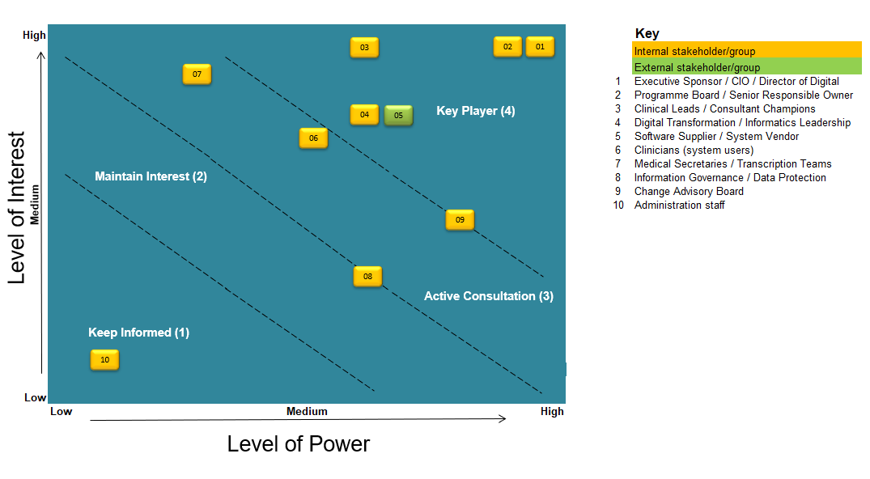
Figure 2. Stakeholder Power–Interest Matrix (ABUHB, 2025)
The mapped stakeholder positions are shown in Figure 2, which demonstrates how engagement levels differ by group's level of interest. Stakeholders with both High power and high interest, such as the Executive, Cyber Security leads, and the Clinical Safety Officer, will require regular and active involvement throughout planning, migration, and optimisation. This includes frequent highlight reports, risk dashboards and clear set tolerances so escalation routes remain visible and trusted. Stakeholders with high organisational power and low interest only need occasional updates so they remain informed without being overloaded. Audit Wales has highlighted that digital health organisations must show structure and meaningful stakeholder engagement (Wales, 2025). Reinforcing that infrastructure modernisation requires consistent communication and cannot rely on technical work alone. Although a firewall upgrade is an infrastructure change, any error could indirectly affect access to electronic patient records, diagnostic systems and prescribing applications. As a result, hazard logs must consider the risk of lost connectivity, slow performance or blocked application traffic. Embedding clinical safety checks within PRINCE2 governance ensures that both technical and patient safety risks are recognised and properly managed.
Future improvements will follow once the initial migrations are complete. App-ID optimisation, better Security Information and Event Management (SIEM) integration and further standardisation across sites will strengthen security and make support easier. Over time, removing older permissive rules and tightening policies will improve the organisation's visibility of application-level activity (Palo Alto Networks, 2026). Improving log forwarding to SIEM platforms will also enhance threat protection and support mandatory cyber resilience requirements (Welsh Government, 2021). Using a common firewall architecture across RGH, NHH, and YYF makes the environment simpler to maintain and provides a strong foundation for future improvements, such as advanced segmentation or a redesigned high-availability solution.
Overall, replacing the ageing Cisco ASA firewalls with modern Palo Alto architecture represents a necessary step in strengthening ABUHB cyber resilience, operational reliability and clinical safety. Using PRINCE2 provides the structured governance needed for a high-risk, multi-site infrastructure change, while using complementary practices such as CAB review, qualitative risk analysis and iterative optimisation ensures that the migration is both safe and robust. By combining strong technical controls with clear stakeholder engagement, clinical safety oversight, and future improvements, such as App-ID tuning and enhanced SIEM integration, the project will not only mitigate existing risks but also establish a more secure, standardised, and future-ready perimeter for the organisation.
Reference
ABUHB (2025) ‘Stakeholder Matrix’, Unpublished [Preprint]. Available at: Unpublished (Accessed: 1 March 2026).
Balamitran, G. (2026) ‘Strata by Palo Alto Networks | PA-3400 Series | Datasheet’. Available at: https://www.paloaltonetworks.com/apps/pan/public/downloadResource?pagePath=/content/pan/en_US/resources/datasheets/pa-3400-series (Accessed: 1 February 2026).
Cisco Systems, Inc. (2026) Cisco ASA 5500 Series Data Sheet - Cisco. Available at: https://www.cisco.com/c/en/us/products/collateral/security/asa-firepower-services/datasheet-c78-742475.html (Accessed: 19 January 2026).
ECRI (2026) When Healthcare Systems Go Dark: Why Digital Outage Preparedness Is a. Available at: https://home.ecri.org/blogs/ecri-blog/when-healthcare-systems-go-dark-why-digital-outage-preparedness-is-a-patient-safety-imperative (Accessed: 4 February 2026).
Gagnon, M.-P. et al. (2012) ‘Systematic Review of Factors Influencing the Adoption of Information and Communication Technologies by Healthcare Professionals’, Journal of Medical Systems, 36(1), pp. 241–277. Available at: https://doi.org/10.1007/s10916-010-9473-4.
Hastings, B.J. (2025) ‘Guidance for successful healthcare transformation: A systematic review of change management practices and outcomes’, Australian Journal of Management, 50(3), pp. 985–1005. Available at: https://doi.org/10.1177/03128962241307347.
Kruse, C.S. et al. (2017) ‘Cybersecurity in healthcare: A systematic review of modern threats and trends’, Technology and Health Care, 25(1), pp. 1–10. Available at: https://doi.org/10.3233/THC-161263.
Laukka, E. et al. (2020) ‘Identifying the Roles of Healthcare Leaders in HIT Implementation: A Scoping Review of the Quantitative and Qualitative Evidence.’, International journal of environmental research and public health, 17(8). Available at: https://doi.org/10.3390/ijerph17082865.
NHS (2025) Clinical Risk Management: its Application in the Deployment and Use of Health IT Systems - NHS Standards Directory. Available at: https://standards.nhs.uk/published-standards/clinical-risk-management-its-application-in-the-deployment-and-use-of-health-it-systems (Accessed: 3 February 2026).
NHS England (2018) DCB0160: Clinical Risk Management: its Application in the Deployment and Use of Health IT Systems - NHS England Digital. Available at: https://digital.nhs.uk/data-and-information/information-standards/governance/latest-activity/standards-and-collections/dcb0160-clinical-risk-management-its-application-in-the-deployment-and-use-of-health-it-systems/ (Accessed: 3 February 2026).
NHS Wales (2018) ‘NHS Wales Infrastructure Investment Guidance’. Available at: https://www.gov.wales/sites/default/files/publications/2020-03/nhs-wales-infrastructure-investment-guidance.pdf (Accessed: 15 February 2026).
Oluwatosin Ilori, Nelly Tochi Nwosu and Henry Nwapali Ndidi Naiho (2024) ‘Third-party vendor risks in IT security: A comprehensive audit review and mitigation strategies’, World Journal of Advanced Research and Reviews, 22(3), pp. 213–224. Available at: https://doi.org/10.30574/wjarr.2024.22.3.1727.
Oxford College of Marketing (2024) What is Mendelow’s Matrix and Why Is It Useful For Marketers? Available at: https://blog.oxfordcollegeofmarketing.com/2018/04/23/what-is-mendelows-matrix-and-how-is-it-useful/ (Accessed: 28 February 2026).
Palo Alto Networks (2026) Migrate Port-Based to App-ID Based Security Policy Rules. Available at: https://docs.paloaltonetworks.com/ngfw/administration/app-id/security-policy-rule-optimization/migrate-port-based-to-app-id-based-security-policy-rules (Accessed: 20 February 2026).
PRINCE2® (2025) PRINCE2® project management version 7 : global best practice for everyone aiming to enhance their project management skills. PeopleCert.
Siwicki, B. (2025) Digital Transformation 101: A handy primer | Healthcare IT News. Available at: https://www.healthcareitnews.com/news/digital-transformation-101-handy-primer (Accessed: 10 February 2026).
STUDYLIB (2017) PMBOK Guide 6th Edition: Project Management Body of Knowledge. Available at: https://studylib.net/doc/27599800/3.-pmbok-6th-ed-2017 (Accessed: 23 February 2026).
Technology Equipment (2025) Big Bang vs Phased Rollout in Networking - Equtechnology.com. Available at: https://www.equtechnology.com/big-bang-vs-phased-rollout-in-networking/ (Accessed: 2 February 2026).
The Risk Suite (2024) What are some common pitfalls to watch out for when implementing agile methodologies in high-risk projects? - The Risk Suite. Available at: https://rsuite.com/what-are-some-common-pitfalls-to-watch-out-for-when-implementing-agile-methodologies-in-high-risk-projects/ (Accessed: 13 February 2026).
Wachter, R.M. (2016) ‘Making IT Work: Harnessing the Power of Health Information Technology to Improve Care in England’. Available at: https://assets.publishing.service.gov.uk/government/uploads/system/uploads/attachment_data/file/550866/Wachter_Review_Accessible.pdf (Accessed: 16 February 2026).
Wales, A. (2025) ‘Digital Health and Care Wales – Review of Stakeholder Engagement Arrangements’. Available at: https://audit.wales/sites/default/files/publications/4751A2025_DHCW_Stakeholder_Engagement_Arrangements_Eng.pdf (Accessed: 28 February 2026).
Welsh Government (2021) The Network and Information Systems Regulations 2018: guidance to the health sector in Wales [HTML] | GOV.WALES. Available at: https://www.gov.wales/network-and-information-systems-regulations-2018-guidance-health-sector-wales-html (Accessed: 1 March 2026).
Welsh Government (2023) How to make changes to health services: guidance for NHS organisations | GOV.WALES. Available at: https://www.gov.wales/how-make-changes-health-services-guidance-nhs-organisations (Accessed: 20 February 2026).

